**VPP HOSTSTACK**



Contents

**I. Introduction** 4

1.1 description 4

***\* Release note \****

|  |  |  |
| --- | --- | --- |
| ***version*** | ***release date*** | ***content*** |
| *v1.0* | *2019-03-\*\** | *first edition* |
|  |  |  |
|  |  |  |
|  |  |  |
|  |  |  |

***\* Release Copyleft©free \****

**I. Introduction**

1.1 description

VPP’s host stack is a user space implementation of a number of transport, session and application layer protocols that leverage VPP’s existing protocol stack.

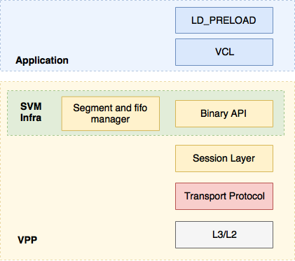

Figure 1 VPP HostStack architecture

four major components:

* Session Layer that accepts pluggable transport protocols.
* Shared memory mechanisms for pushing data between VPP and applications.
* Transport protocol implementations (eg. TCP, SCTP, UDP).
* Commons Library (VCL) and LD_PRELOAD library.