CARL’s NEUCOGAR Emotional State Matrix and Concept Graph Integration
This document presents a detailed view of CARL’s emotional state tracking and conceptual relationship mapping based on the NEUCOGAR model and cognitive architecture principles. The NEUCOGAR emotional state matrix represents core and derived emotions across key neurotransmitter dimensions, while the concept graph illustrates the network of CARL’s self-conscious thoughts, experiences, and conceptual relationships as recorded during a live testing session.

NEUCOGAR Emotional State Matrix
The NEUCOGAR emotional model is based on Lövheim’s Cube of Emotion, mapping dopamine, serotonin, and noradrenaline levels to a range of emotional states. CARL’s implementation places core emotions at the vertices of the cube, while deeper, unconscious emotional processing resides within its interior. The figure below shows CARL’s emotional trajectory, including real-time memory markers and current state.
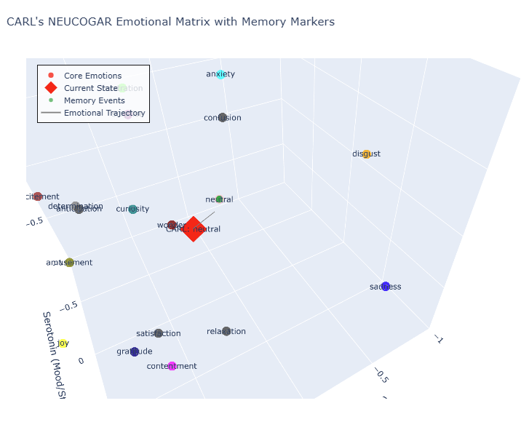

Concept Graph of Self-Conscious Thoughts
The concept graph provides a visual representation of CARL’s brain-like organization of thoughts and experiences. Nodes represent concepts or experiences, while edges indicate associations, co-activations, or temporal sequences. This network can be viewed in real-time during the ‘Run Bot’ process in CARL’s GUI. The structure reveals how CARL integrates self-conscious thoughts with environmental stimuli and emotional feedback.

Real-Time Emotional and Cognitive Integration
During live operation, CARL continuously updates both the NEUCOGAR emotional matrix and the concept graph. This allows for real-time monitoring of emotional shifts alongside the conceptual reasoning process. When the ‘Stop Bot’ function is pressed, CARL generates a session report summarizing emotional states, significant memory markers, and the evolution of core and derived emotions over the session.

Scientific and Academic Context
This integration draws on Bernard Baars’ Global Workspace Theory (GWT) and Giulio Tononi’s Integrated Information Theory (IIT), linking conscious awareness to distributed yet integrated processing of emotional and conceptual content. The NEUCOGAR model enriches this by grounding emotions in neurochemical correlates, facilitating scientifically informed emotional modeling for AI agents.

