ANA515 SU22 Practicum Assignment

Andrew Cutchin

2022-07-03

##Visualization 1

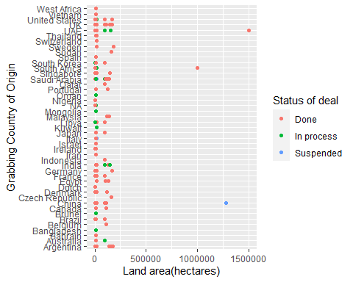

##Visualization 2

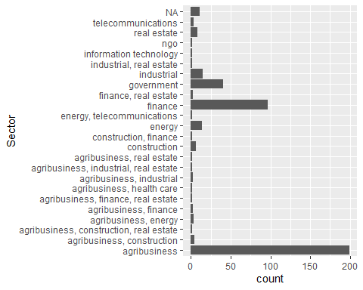

##Visualization 3

