Software requirements specification

PA Historical Finder

Harrisburg University of Science and Technology

CISC 397, Spring 2018

By Shannon Williams, Daniel Malinsky, Raekwon Harley, Edward Sampson, Sujan Tanniru

Table of Contents

1. Introduction 2

1.1. Purpose of the Requirements Document 2

1.2. Scope of the Product 2

1.3. References 2

1.4. Overview of the Remainder of the Document 2

2. General Description 3

2.1. Product Perspective 3

2.2. Product Functions 3

2.3. User Characteristics 3

2.4. General Constraints Assumptions and Dependencies 3

3. Specific Requirements 3

# Introduction

## Purpose of the Requirements Document

This document specifies the requirements for the software, being developed. The system, referred to as PA Historical Finder, is one that enables users to explore significantly historical information within Pennsylvania.

## Scope of the Product

The purpose of the software is to allow users to search for historical information and to view search results in an interactive interface.

Figure 1.0 shows a visual diagram representing the components that will be developed and or used within the overall software architecture.

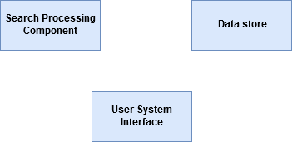

**Figure 1.0**

## References

This document references the User Software Specification for PA Historical Finder.

## Overview of the Remainder of the Document

The latter part describes the system’s functional and non-functional requirements.

# General Description

# Product Perspective

# Product Functions

# User Characteristics

# General Constraints Assumptions and Dependencies

# Specific Requirements