CAMERA HOLDER FOR RUNCAM 5 ORANGE
Jonathan Gomes
National Institute of Technology Goa
Goa,India
Affiliation
24mce1012@nitgoa.ac.in

Abstract - This paper presents the design and fabrication of a camera holder for the RunCam 5 Orange action camera intended for drone applications. The primary objective of the design was to provide a stable mounting solution that minimizes camera jitter and vibration during flight, thereby improving the quality of aerial imaging. The assembly consists of a camera mount and a support attachment designed using Fusion 360 CAD software. The components were manufactured using Thermoplastic Polyurethane (TPU) through 3D printing, taking advantage of the material's flexibility and vibration-damping properties. The developed holder offers a lightweight, cost-effective, and customizable solution for integrating action cameras with unmanned aerial vehicles (UAVs).

Introduction
Drones are widely used for aerial photography and videography, where camera stability plays an important role in capturing clear images and videos. Vibrations from motors and propellers can cause camera jitter, reducing the quality of the recorded footage.
To overcome this issue, a custom camera holder was designed for the RunCam 5 Orange action camera. The holder consists of a camera mount and a support attachment that securely connects the camera to the drone while reducing the transmission of vibrations. The design was created using Fusion 360 and manufactured using TPU through 3D printing due to its flexibility and The aim of this project was to develop a lightweight, low-cost, and customizable mounting solution that improves camera stability during flight.
II. DESIGN METHODOLOGY
The objective of this project was to design a camera holder for the RunCam 5 Orange and integrate it with a custom-built quadcopter. Since the camera was newly acquired and did not have a suitable mounting solution, a custom holder was developed to securely attach the camera while minimizing vibrations during operation.
The dimensions of the RunCam 5 Orange were measured using a vernier caliper and used to create a 3D model in Fusion 360. The design process began with the creation of a camera mount intended to hold the camera using a friction-fit mechanism. However, the initial design did not include a sufficient opening for camera insertion, making assembly difficult. Additionally, the mount had excessive wall thickness and inaccurate tolerances, resulting in an inefficient design. These shortcomings were identified and corrected in subsequent iterations.

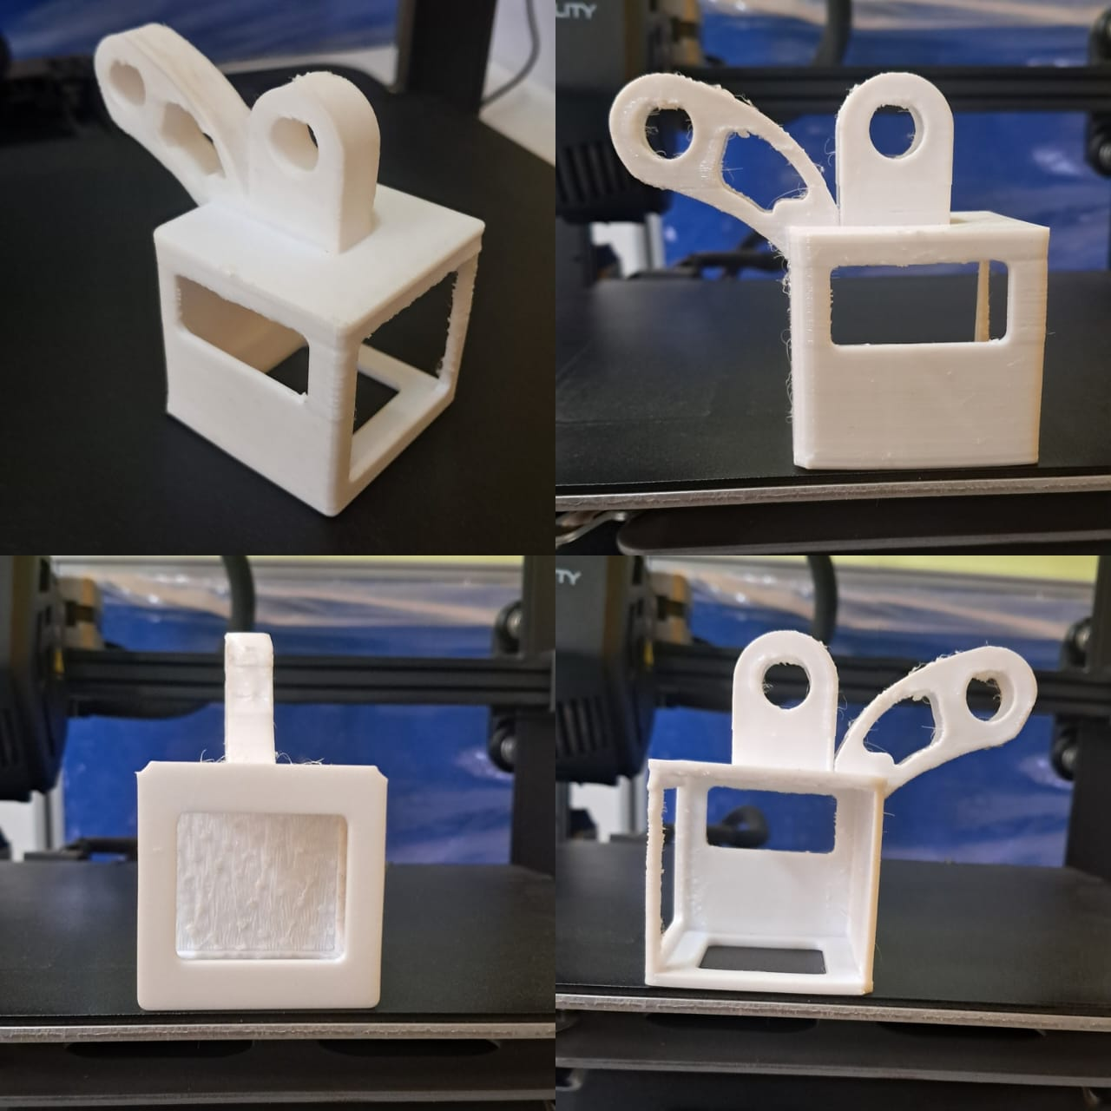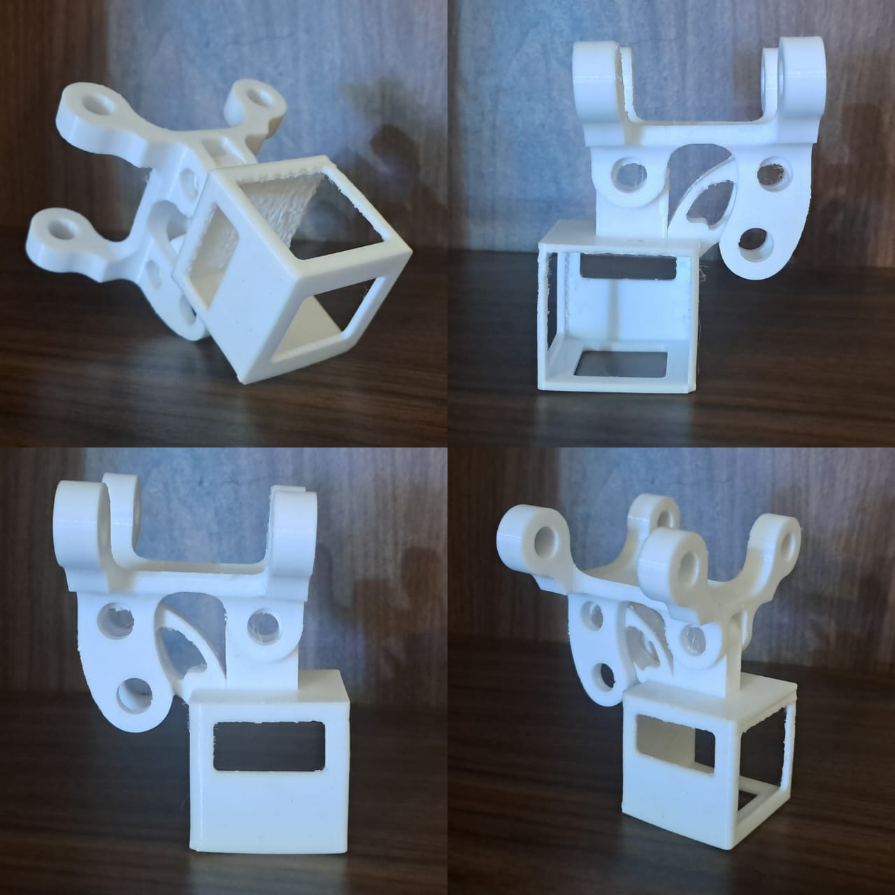
A support beam was also designed to connect the camera mount to the drone frame. The first version of the support beam was manufactured using PLA, but testing revealed that the component was fragile and prone to failure under loading. To improve durability and vibration damping, the design was modified and manufactured using TPU. Fillets and chamfers were incorporated into the support structure to reduce stress concentrations and improve overall strength.
The final assembly consists of a camera mount and a support attachment. The camera is secured using a friction fit based on precise dimensions and tolerances, while an additional zip tie is provided as a safety measure. The support attachment connects the camera mount to the quadcopter frame and provides structural support during operation.
The model was developed using Fusion 360 with sketches, extrude features, assemblies, fillets, and chamfers. The final components were fabricated using a Creality 3D printer. Ground testing was conducted to verify fitment, stability, and structural integrity of the assembly.
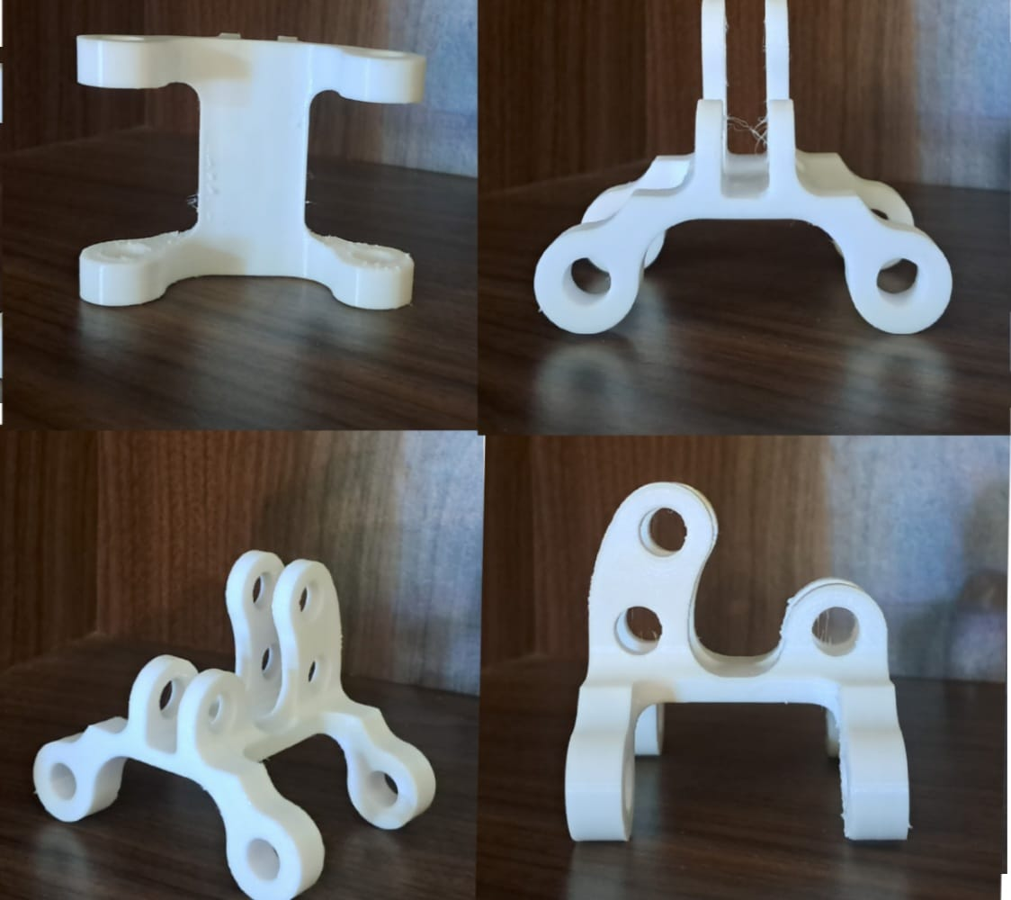
III. CAD Design and Dimensions:

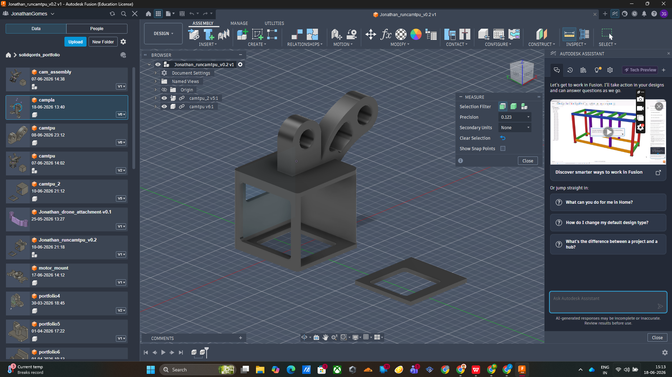
Figure1: camera mount

Dimensions:

A. Camera Mount Design
The camera mount was designed to securely hold the RunCam 5 Orange using a friction-fit mechanism. The camera dimensions were measured using a vernier caliper and used to create the CAD model in Fusion 360.
The mount has internal dimensions of 38.8 mm × 38.8 mm × 36.6 mm with a wall thickness of 2 mm. A 30 mm × 26 mm opening was provided at the bottom for screen access and weight reduction. Two mounting lugs with 10 mm diameter holes were added on the top to connect the mount to the support beam.
The final design provides a secure fit while remaining lightweight and easy to manufacture using 3D printing. Fig. 1 shows the CAD model of the camera mount.

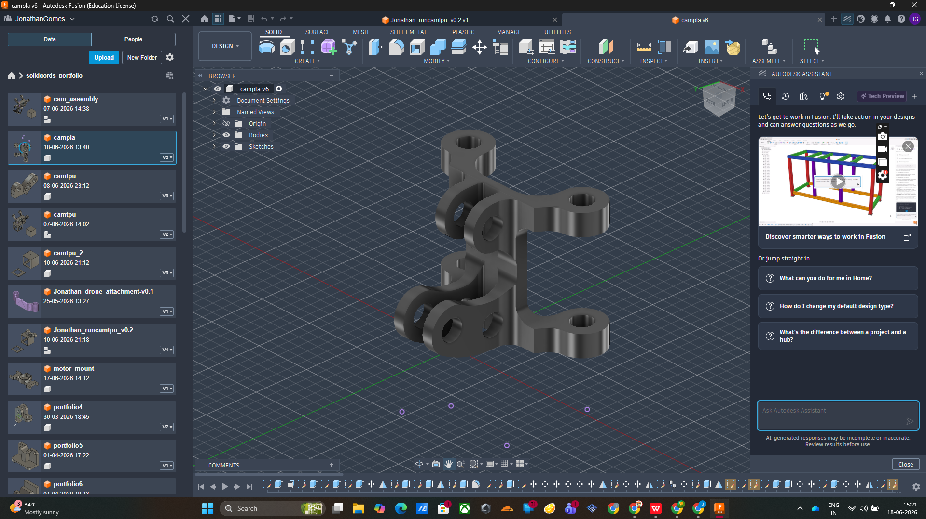
Figure2: support for camera mount.
Dimensionos:

B. Support Attachment Design
The support attachment was designed to connect the camera mount to the quadcopter frame while providing adequate strength and vibration damping. The component has an overall length of 60 mm and consists of two support arms connected through a central joint.
Each support arm has a thickness of 10 mm and contains a 10 mm diameter mounting hole. The distance between the centers of the outer mounting holes is 60 mm, while the distance between the joint holes is 40 mm. Fillets were incorporated into the design to reduce stress concentrations and improve durability.
The support attachment was modelled in Fusion 360 and designed to securely interface with both the camera mount and the drone frame. The CAD model of the support attachment is shown in Fig. 2.
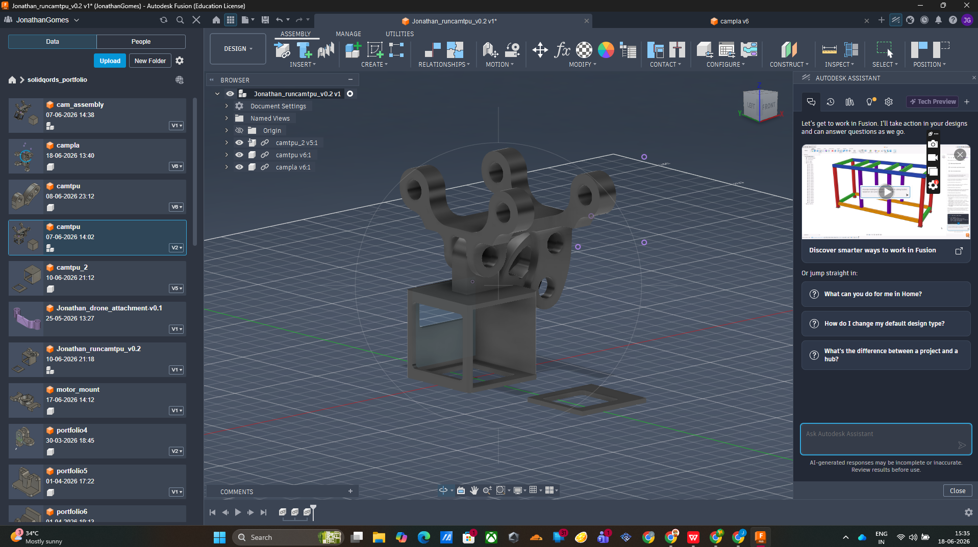
Figure3: entire mount system at 0 degrees

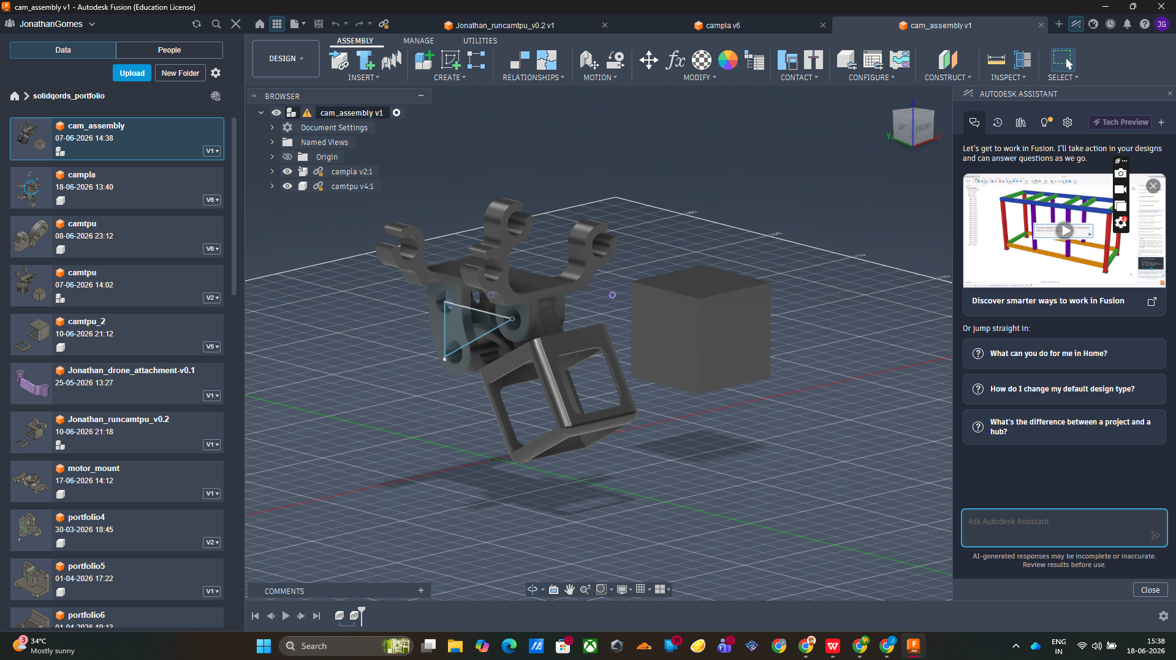
Figure4: system at an angle 30 degrees.

III. FABRICATION
The camera mount and support attachment were fabricated using a Creality FDM 3D printer. TPU filament was selected due to its flexibility, impact resistance, and vibration-damping properties. The CAD models created in Fusion 360 were exported as STL files and sliced before printing. After fabrication, the components were assembled and fitted onto the quadcopter frame for testing.
FILES[as in github page]:

Jonathan_compla_v0.3.stl

Jonathan_runcamtpu_v0.2.stl

IV. RESULTS AND DISCUSSION
The fabricated components were successfully assembled and mounted onto the quadcopter. The camera holder provided a secure friction fit for the RunCam 5 Orange while allowing easy installation and removal. Ground testing showed that the TPU support attachment effectively reduced vibrations and provided adequate structural support. The final design was lightweight, durable, and compatible with the drone frame.

V. CONCLUSION
A custom camera holder for the RunCam 5 Orange was successfully designed and fabricated using Fusion 360 and 3D printing technology. The final design consisted of a camera mount and a support attachment that securely connected the camera to a quadcopter frame. The use of TPU improved vibration damping and durability, making the design suitable for aerial imaging applications.

