/* add middle initial to candidate table and interview table, this field is optional hence the "not null" condition

is not mentioned */

alter table Candidate

add middleinit varchar(1);

select * from Candidate

alter table Interviewer

add middleinit varchar(1);

select * from Interviewer

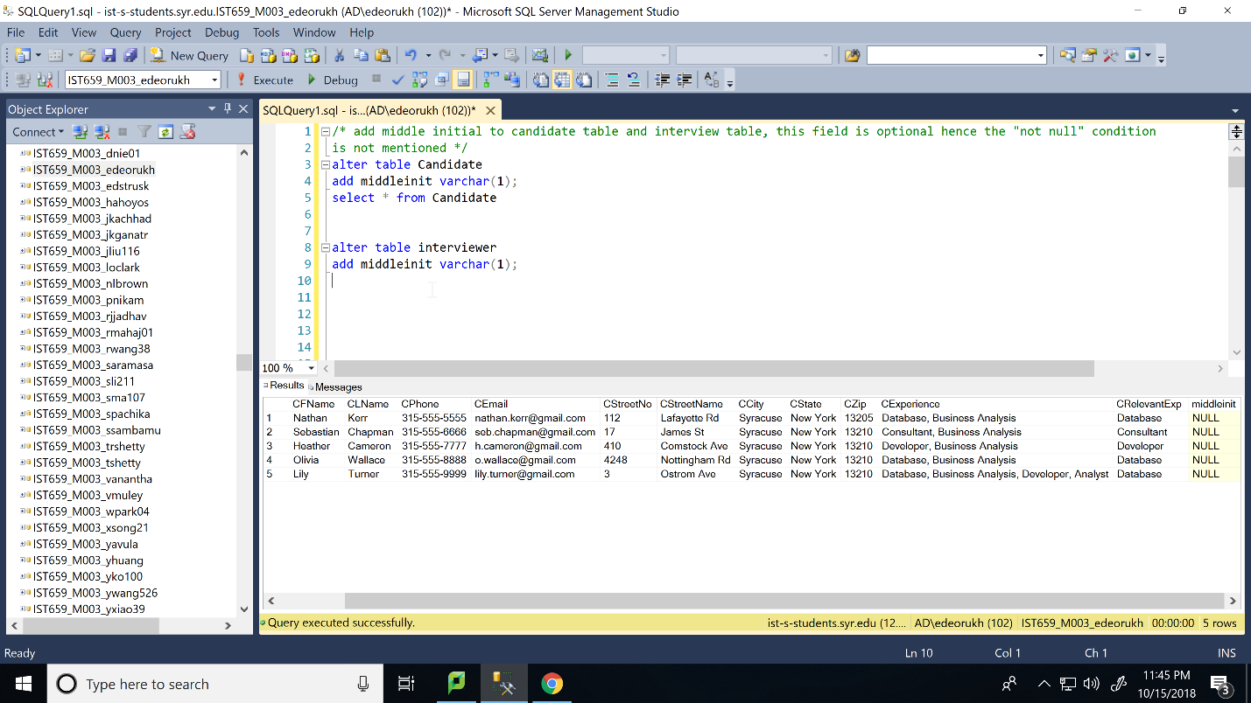

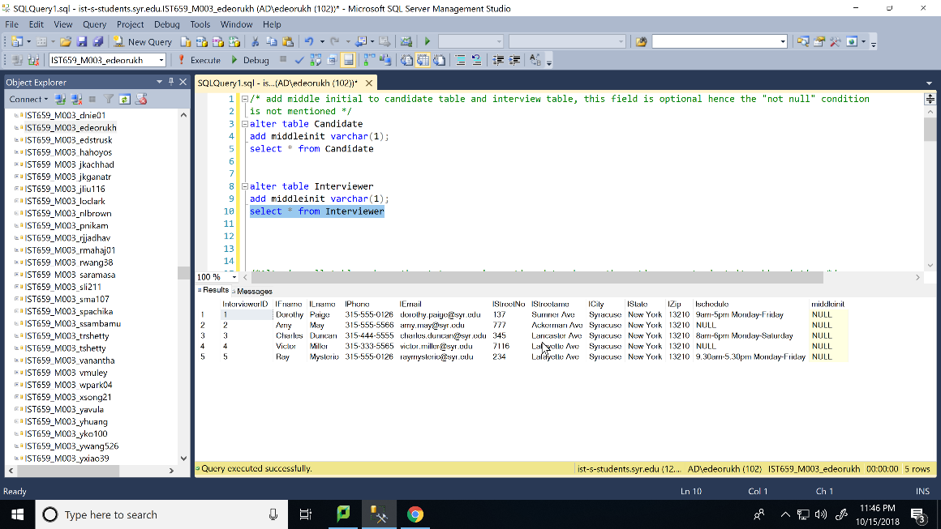

/*Altering tables to change the state name to its abbreviation*/

/* Data needs to be deleted before the columns can be modified */

alter table Candidate drop column CState ;

alter table Candidate add CState varchar(2);

/* adding data after making the column */

update Candidate set CState='NY' where CandidateID=1;

update Candidate set CState='NY' where CandidateID=2;

update Candidate set CState='NY' where CandidateID=3;

update Candidate set CState='NY' where CandidateID=4;

update Candidate set CState='NY' where CandidateID=5;

select * from Candidate

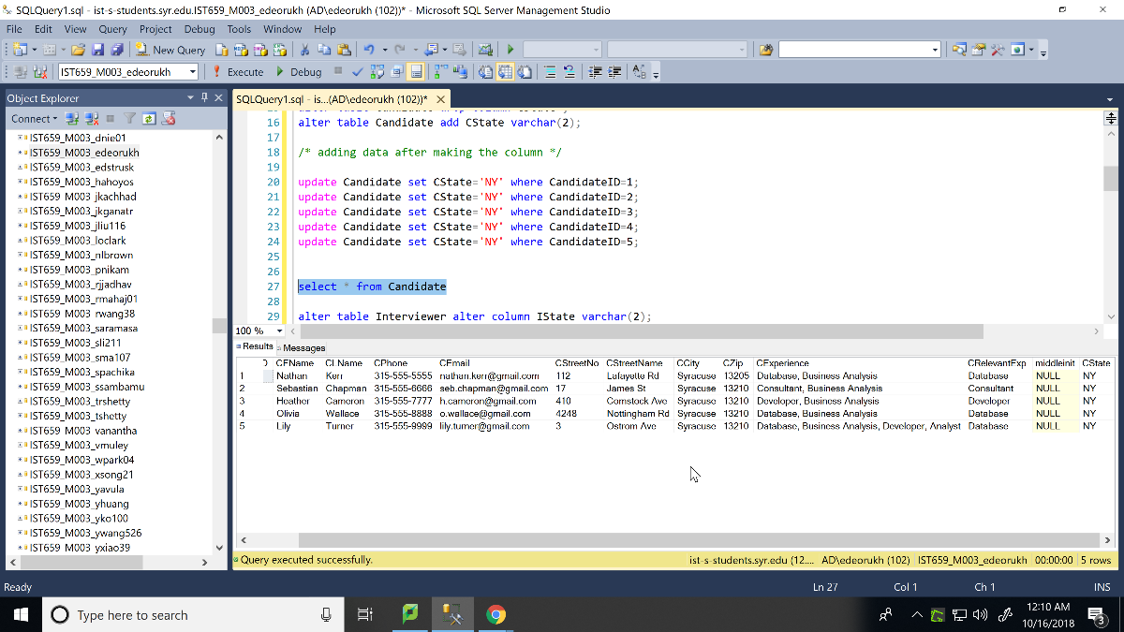

alter table Interviewer drop column IState ;

alter table Interviewer add IState varchar(2);

/* adding data after making the column */

update Interviewer set IState='NY' where InterviewerID=1;

update Interviewer set IState='NY' where InterviewerID=2;

update Interviewer set IState='NY' where InterviewerID=3;

update Interviewer set IState='NY' where InterviewerID=4;

update Interviewer set IState='NY' where InterviewerID=5;

select * from Interviewer

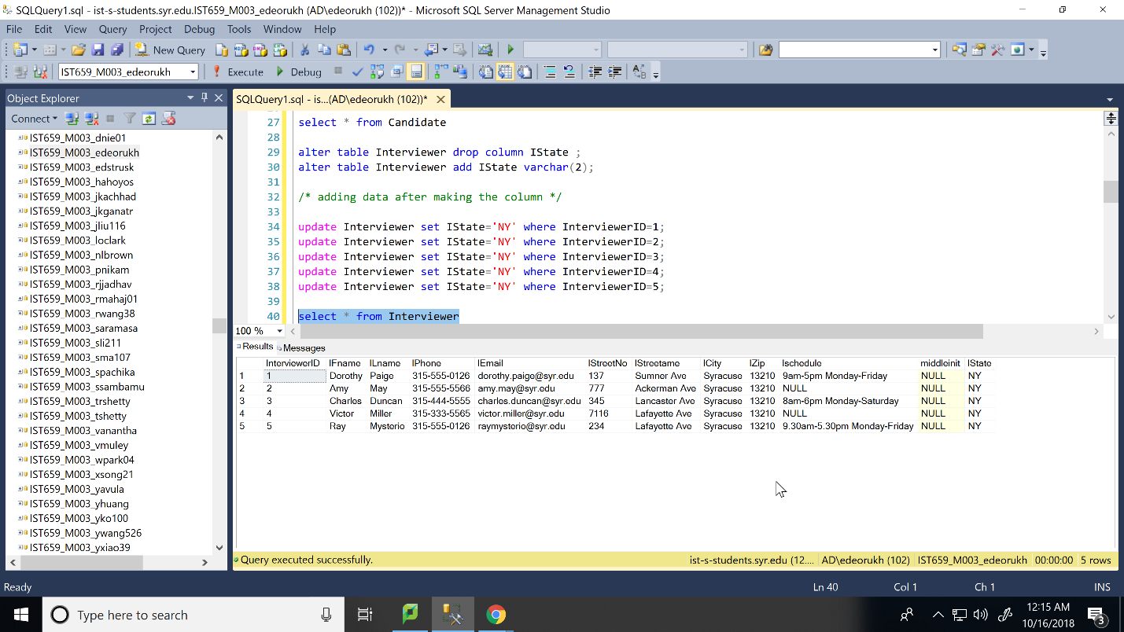

alter table Company drop column CoState ;

alter table Company add CoState varchar(2);

/* adding data after making the column */

update Company set CoState='NY' where CompanyID=1;

update Company set CoState='NY' where CompanyID=2;

update Company set CoState='NY' where CompanyID=3;

update Company set CoState='NY' where CompanyID=4;

update Company set CoState='NY' where CompanyID=5;

select * from Company

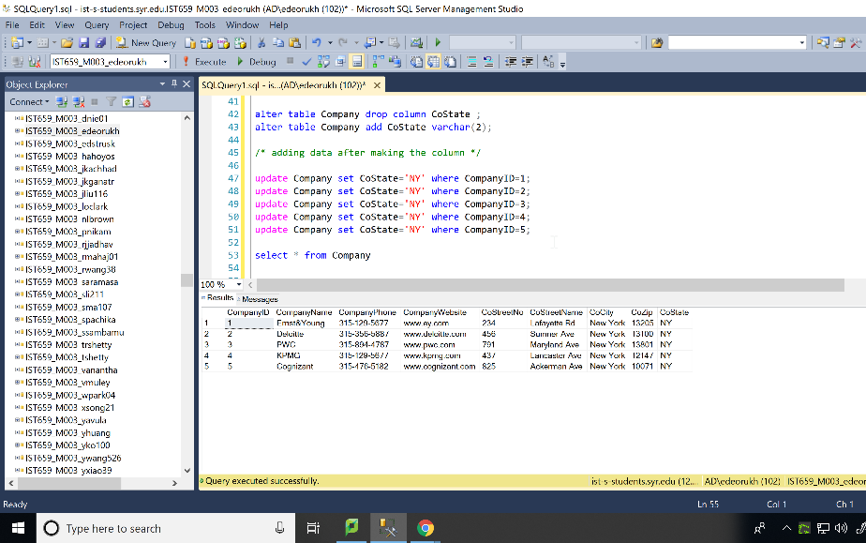

/* Candidates who live in area having zip code 13225. */

SELECT *

FROM Candidate

WHERE CZip=13225

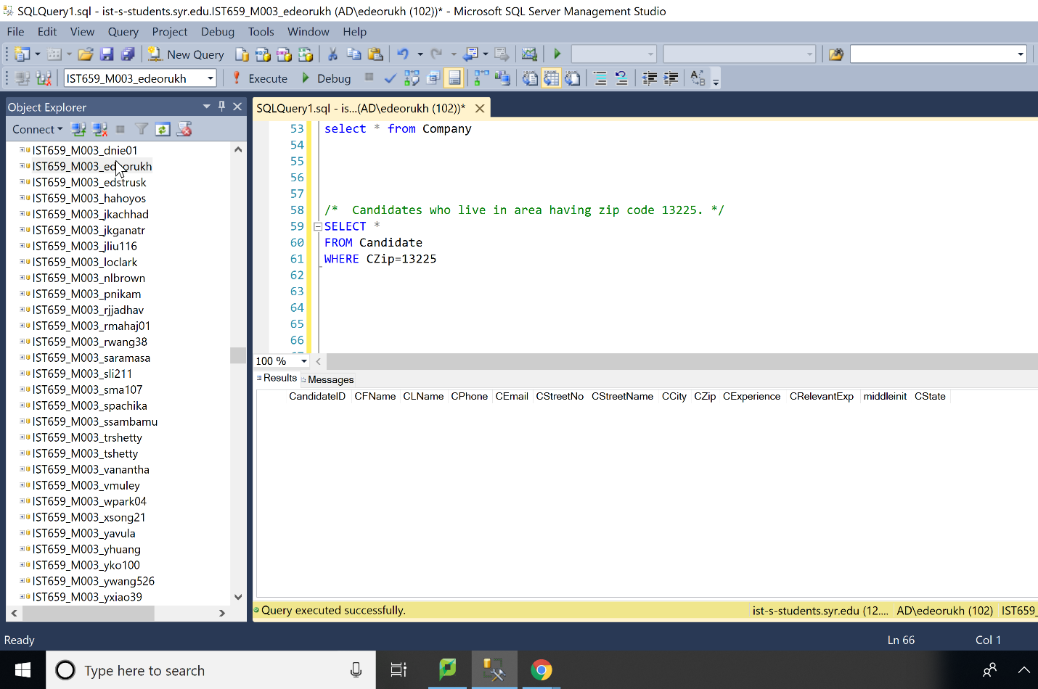

/* Displaying the Name, City and State of the Interviewers living on Lancaster Ave */

select IFname, ILname, ICity, IState

from Interviewer

WHERE IStreetame= 'Lancaster Ave';

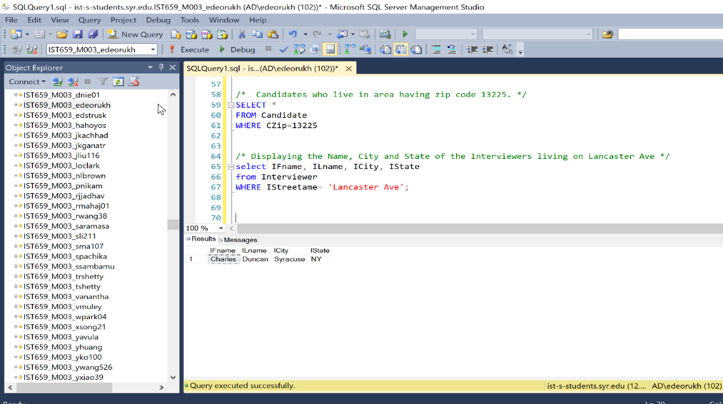

/* change the date of Interview 1 in interview table*/

/* Displaying the InterviewID and the PositionID of the Interviews on that date*/

update Interview

SET InterviewDate= '2013-09-28 00:00:00:000'

where InterviewID=1;

SELECT InterviewID, PositionID

from Interview

where interviewDate='2013-09-28'

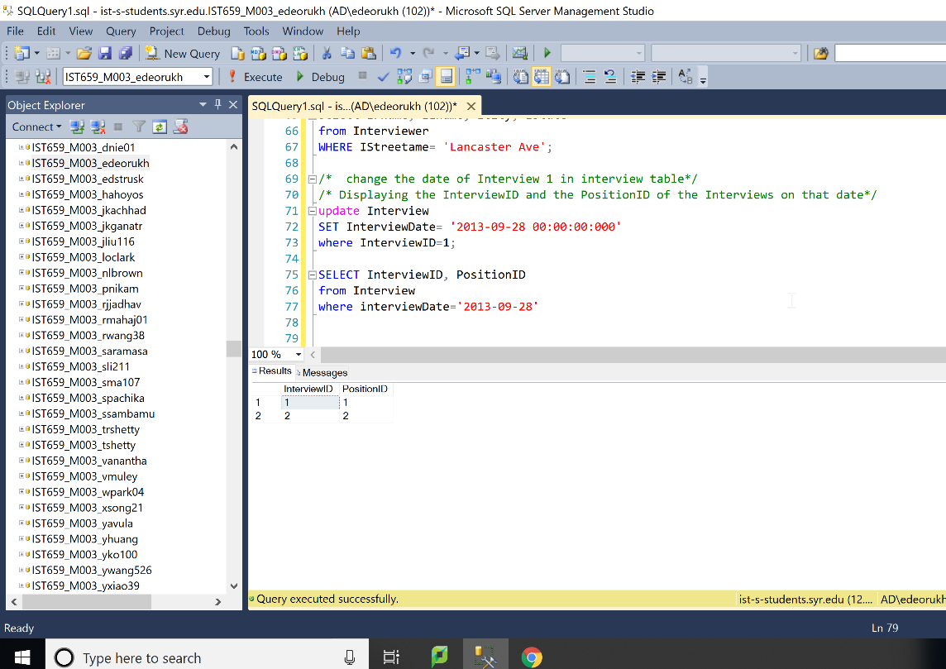

/* all position names and position available values in Position table that are not available for level “Executive”*/

select PositionName, PositionAvailable

from Position

where PositionLevel <> 'Executive'

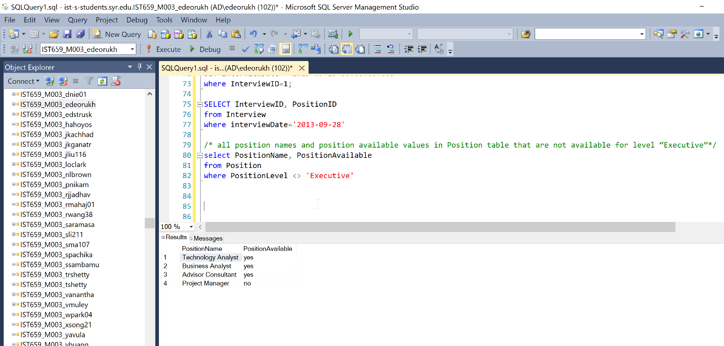

/* Interviews with more than 2 rounds*/

select InterviewID,CandidateID, InterviewDate

from Interview

where RoundNumber > 2

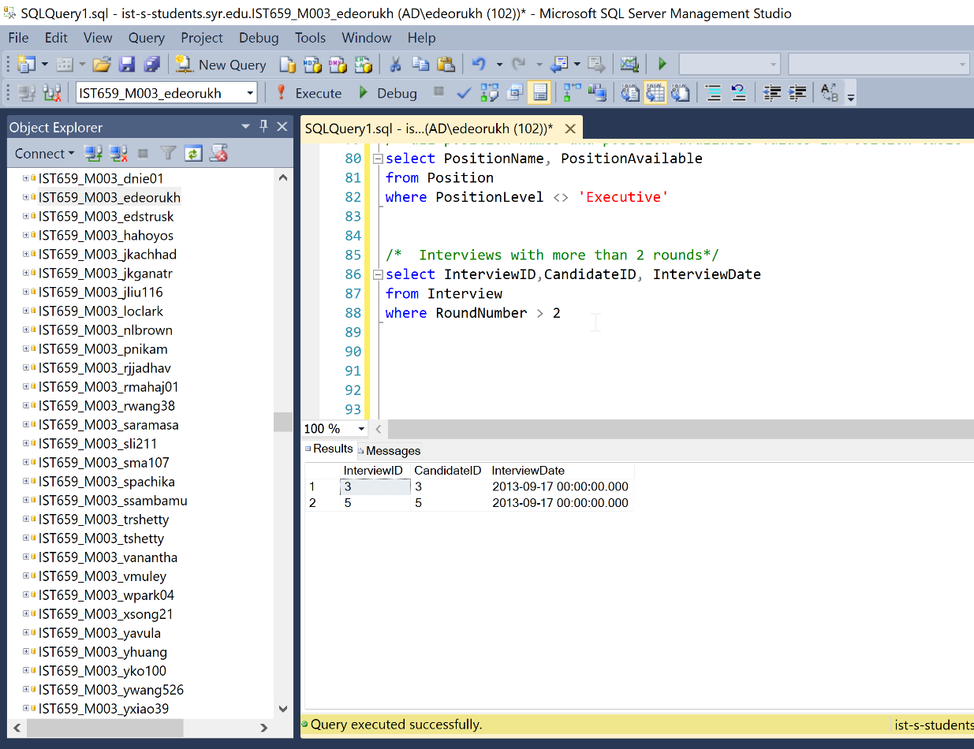

/*Count the number of candidate in each zip code. Show the zip code and the number of

candidates in each zip code. */

select CZip, count(CandidateID)

from Candidate

group by CZip

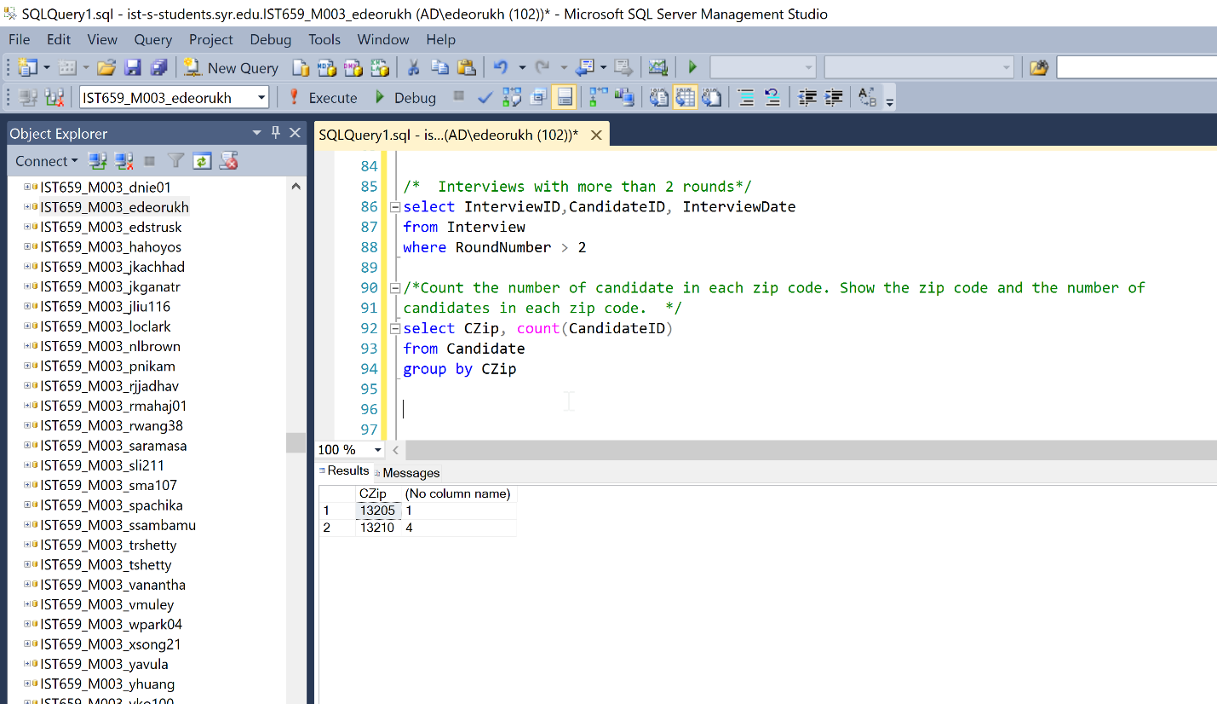

/* Sort interview table by number of the round number. Show interview ID and round

number. */

select InterviewID, RoundNumber

from Interview

order by RoundNumber

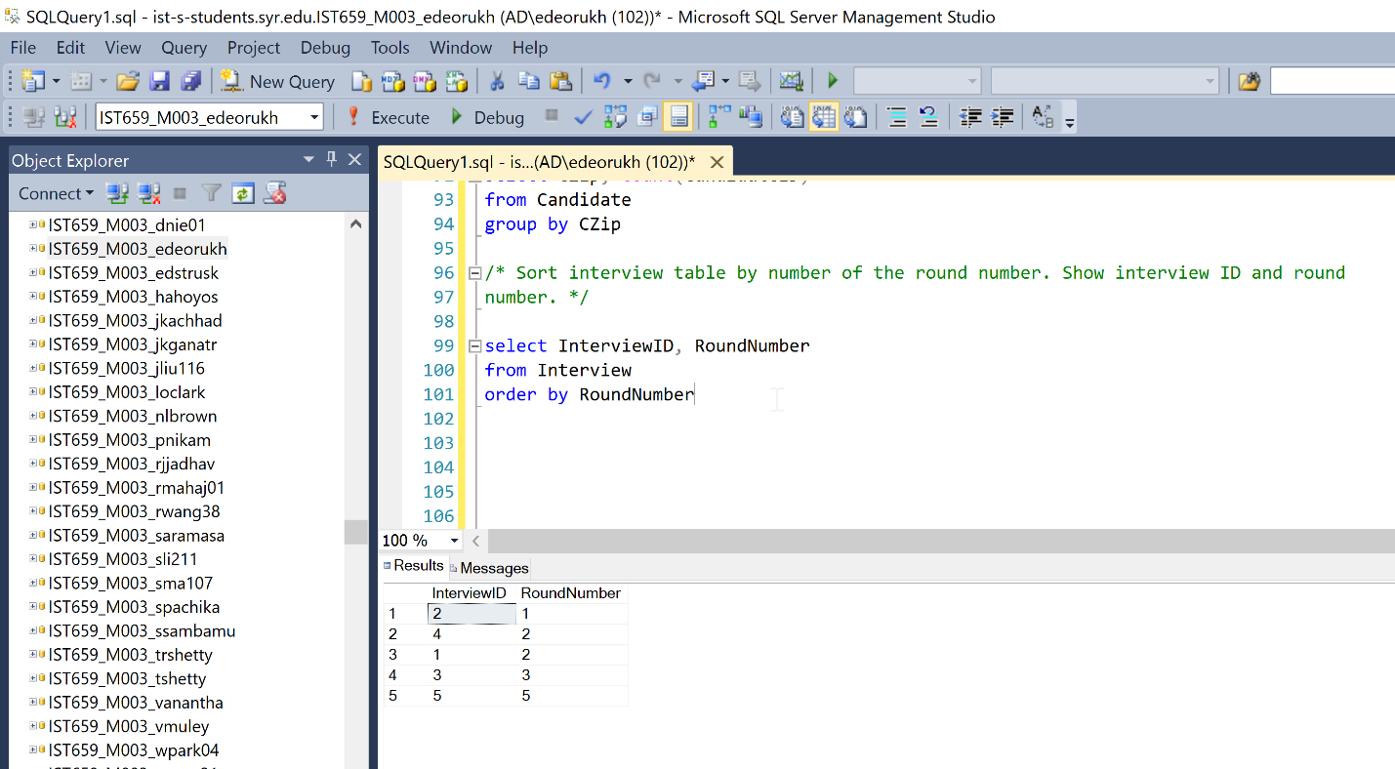

/* Sort interview by interview date. Show interview ID, Interviewer ID and the interview

date */

select InterviewID, InterviewerID, InterviewDate

from Interview

order by InterviewDate

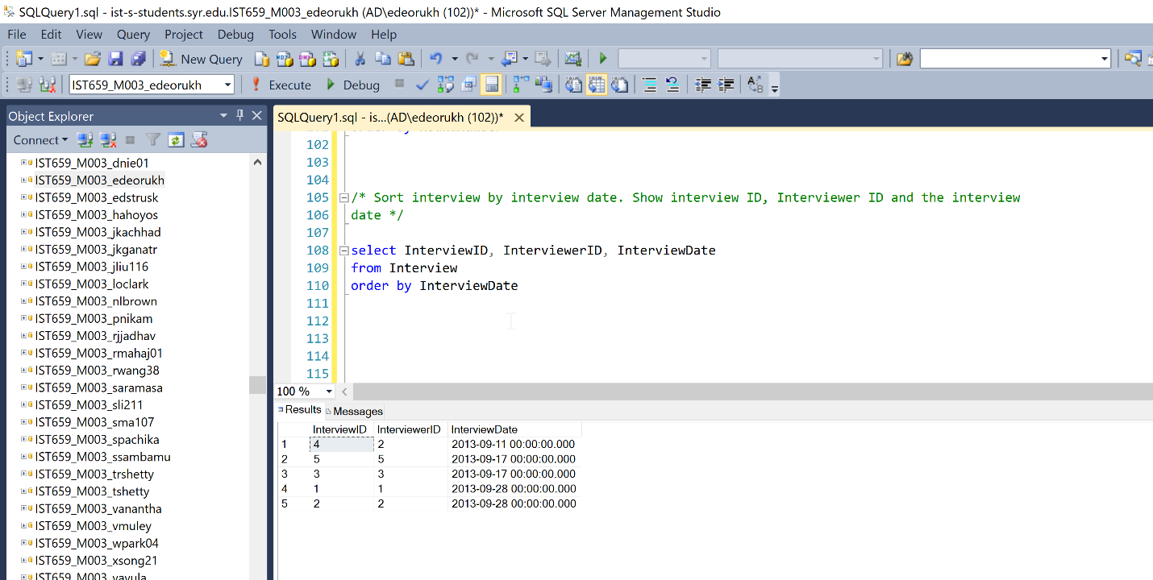

/*For each candidate, calculate the average, min, and max round number of the interviews that this candidate had.

Show CandidateId, average Round Number, min Round Number, and max Round Number. */

/* change datatype of roundNumber column */

alter table Interview

alter column RoundNumber integer

select CandidateID, AVG(RoundNumber) as Avg_Rounds, MIN(RoundNumber) as Min_Rounds, MAX(RoundNumber) as Max_Rounds

from Interview group by CandidateID

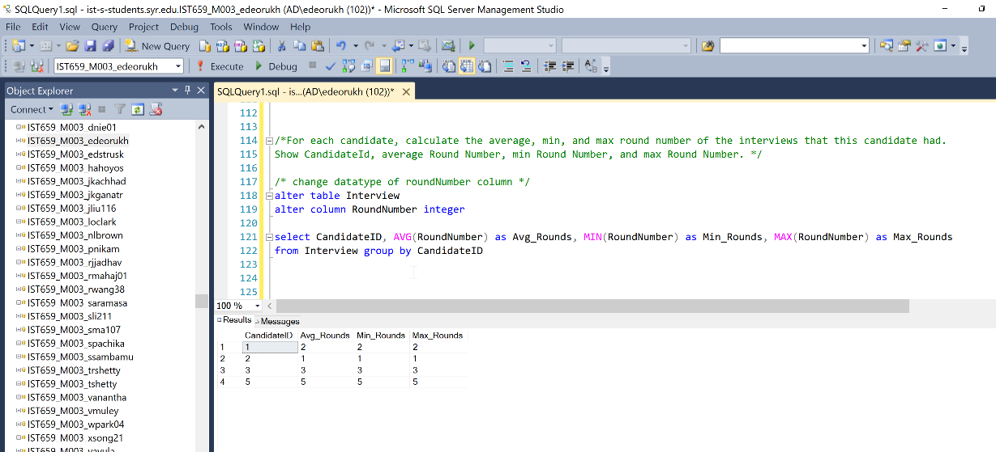

/* Find all candidates whose average round number of interviews is below 3 (i.e. average

round number equals 1 or 2). Show the CandidateID and average round number. */

select CandidateID, AVG(RoundNumber) as average

from Interview group by CandidateID

having AVG(RoundNumber) <3

