/\* Find all candidates who were interviewed for second round (Round Number = 2)

Internship position. Show each candidate’s details which includes candidate ID,

candidate name, phone number, candidate experience, and relevant experience \*/

select c.CandidateID, c.CFName,c.CLName, c.CPhone, c.CExperience, c.CRelevantExp, i.RoundNumber

from Candidate c inner join Interview i on c.CandidateID=i.CandidateID where i.RoundNumber=2;

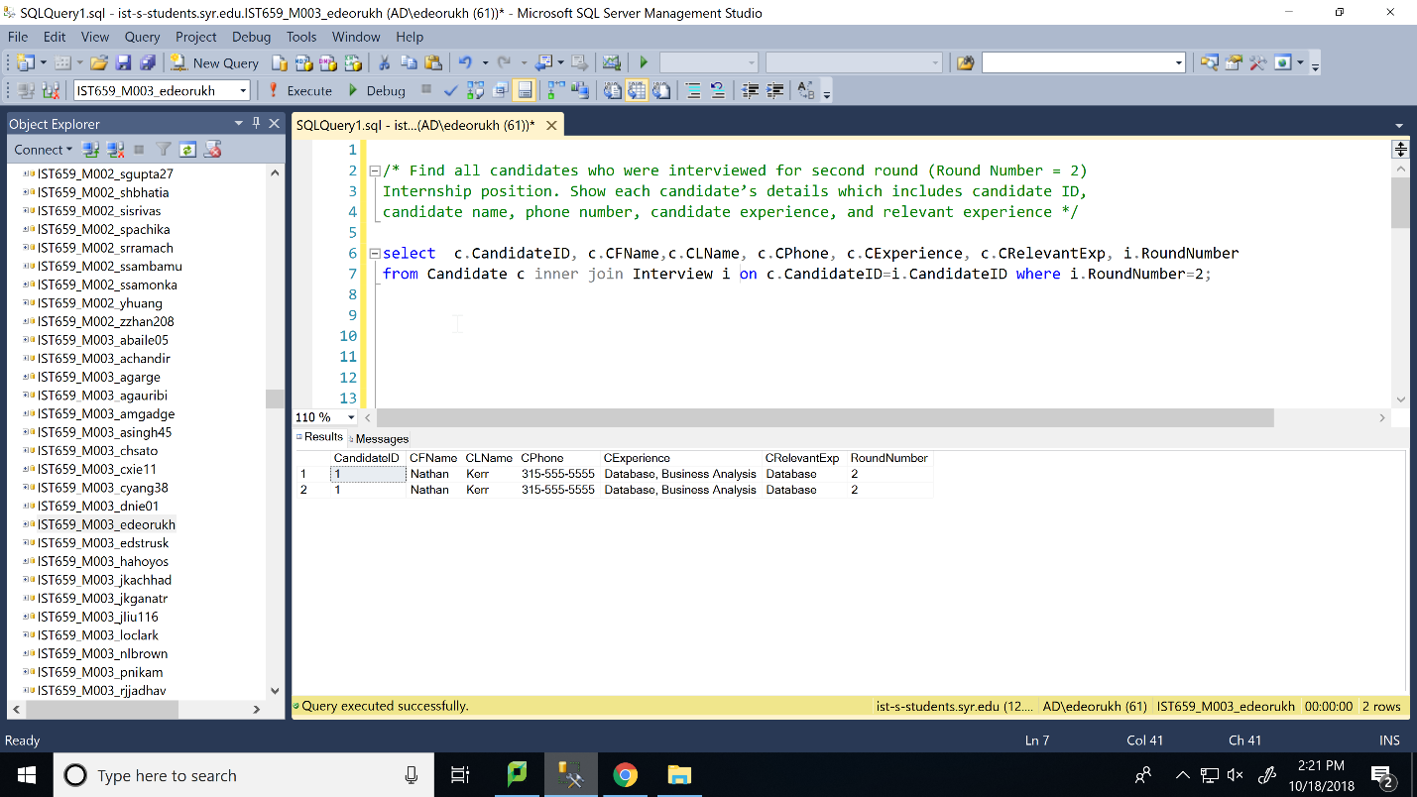

/\* Find all positions whose interviews were conducted by "Amy May"(interviewer).

Show the PositionId, position level, position name and position availability \*/

select p.PositionId, p.PositionLevel, p.PositionName,p.PositionAvailable, j.IFname, j.ILname

from Position p inner join Interview i on p.PositionID=i.PositionID

inner join Interviewer j on i.InterviewerID=j.InterviewerID where j.IFname='Amy' AND j.ILname='May'

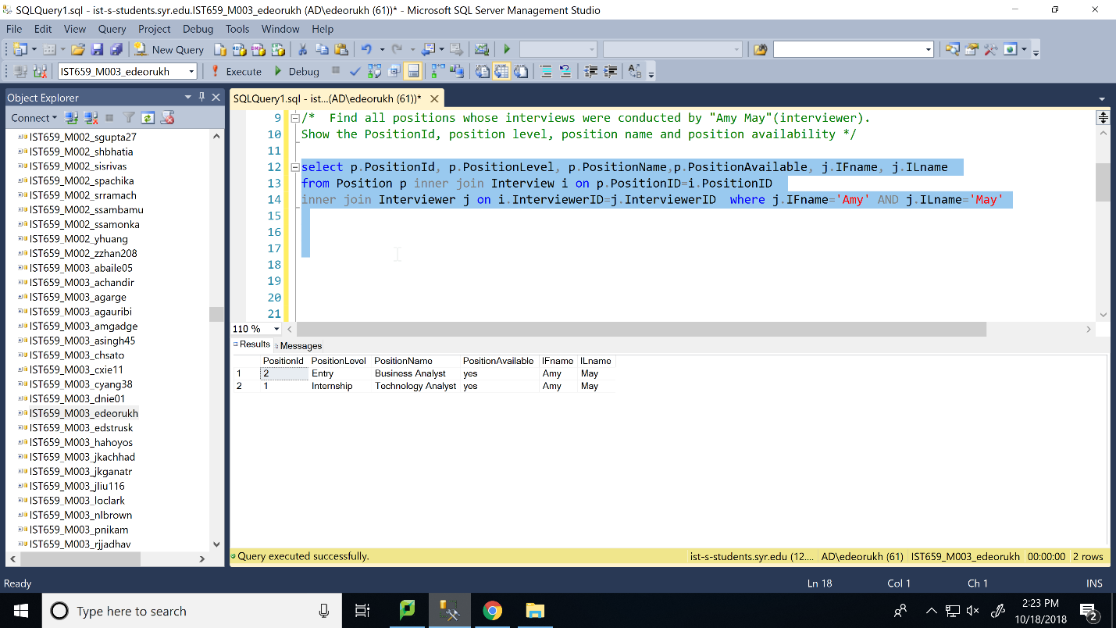

/\* Find all interviewers who conducted one or more second-round interviews. Show the

Interviewer details like Interviewer ID, Interviewer phone, Intervieweremail,

Interviewer address and schedule \*/

select k.InterviewerID, k.Iphone, k.Iemail,k.IStreetNo,k.IStreetame,k.Icity,k.Izip, k.Ischedule from Interviewer k inner join

Interview l on k.InterviewerID=l.InterviewerID where l.RoundNumber=2

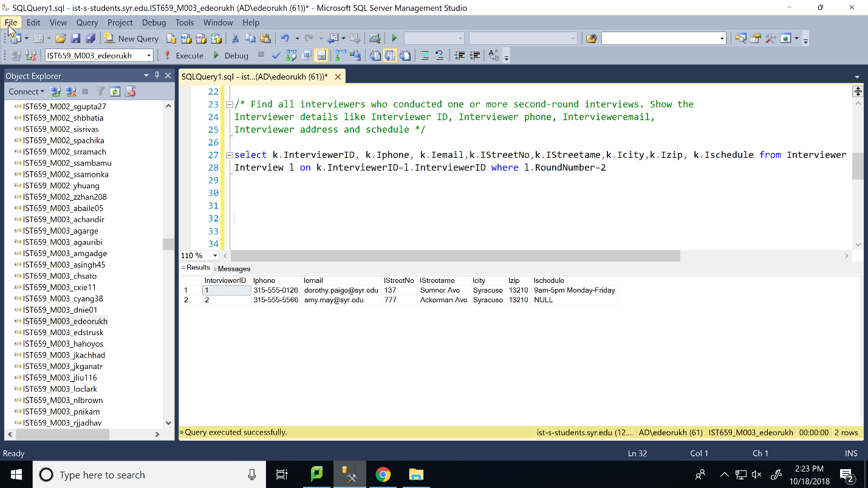

/\* Find all candidates who interviewed for the position “Advisory Consultant”. Show

Candidate details and interview details \*/

select m.\*,n.\* from Candidate m inner join Interview n on m.CandidateID= n.CandidateID

inner join Position o on n.PositionID=o.PositionID where o.PositionName='Advisor Consultant'

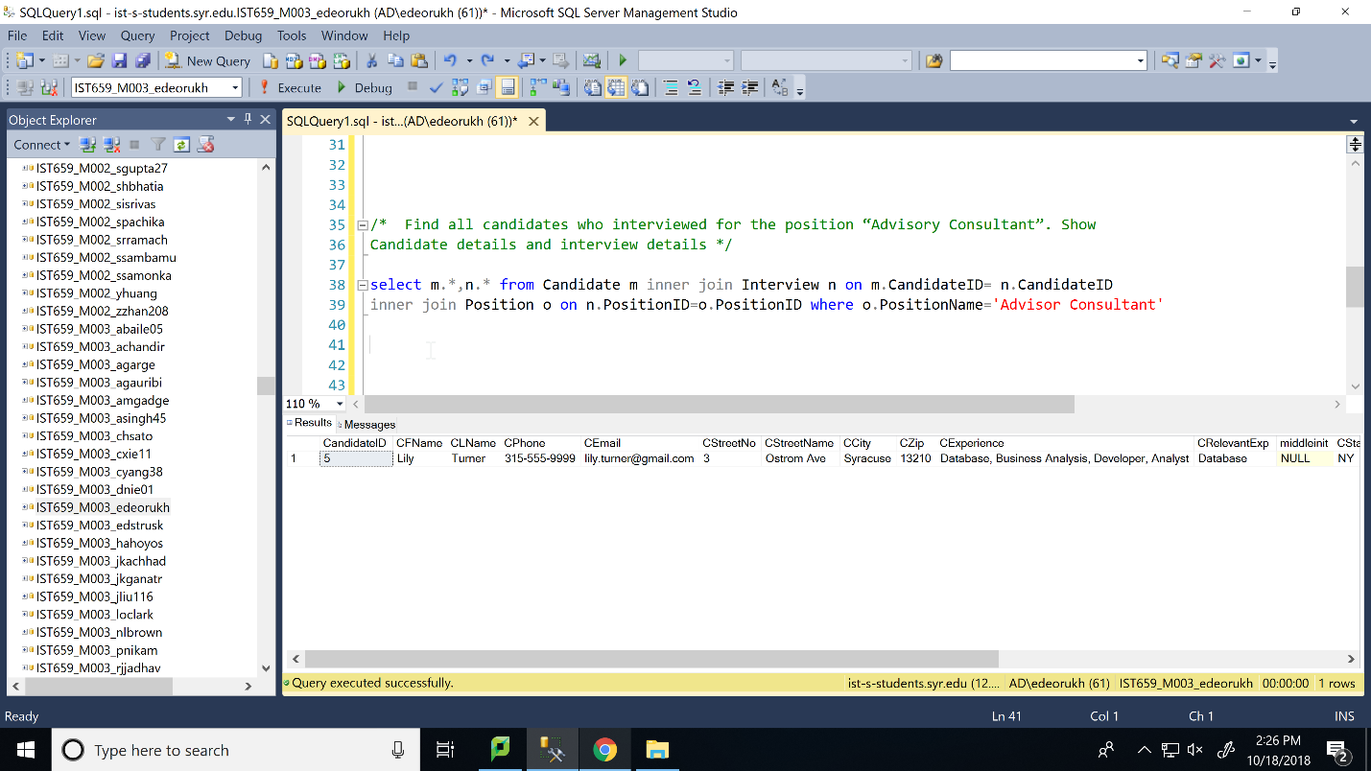

/\*Find positions for all the interviews that were conducted on September 28th, 2013.

Show the PositionId, position level, position name and position availability.\*/

select q.PositionID,q.PositionName,q.PositionLevel,q.PositionAvailable from Position q inner join Interview r

on q.PositionID=r.PositionID where r.InterviewDate = '2013-09-28'

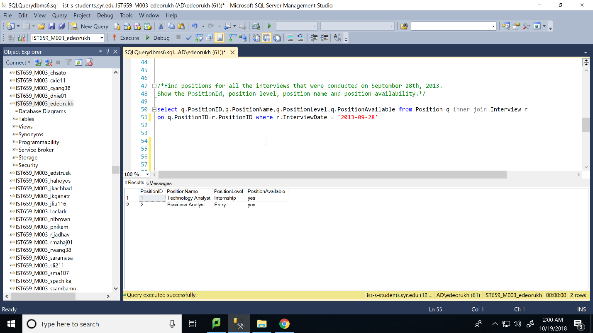

/\*Find all positions for which no interviews were conducted, and delete them from the

Position table. \*/

delete s from Position s left join Interview t on s.PositionID=t.PositionID where t.InterviewID is NULL

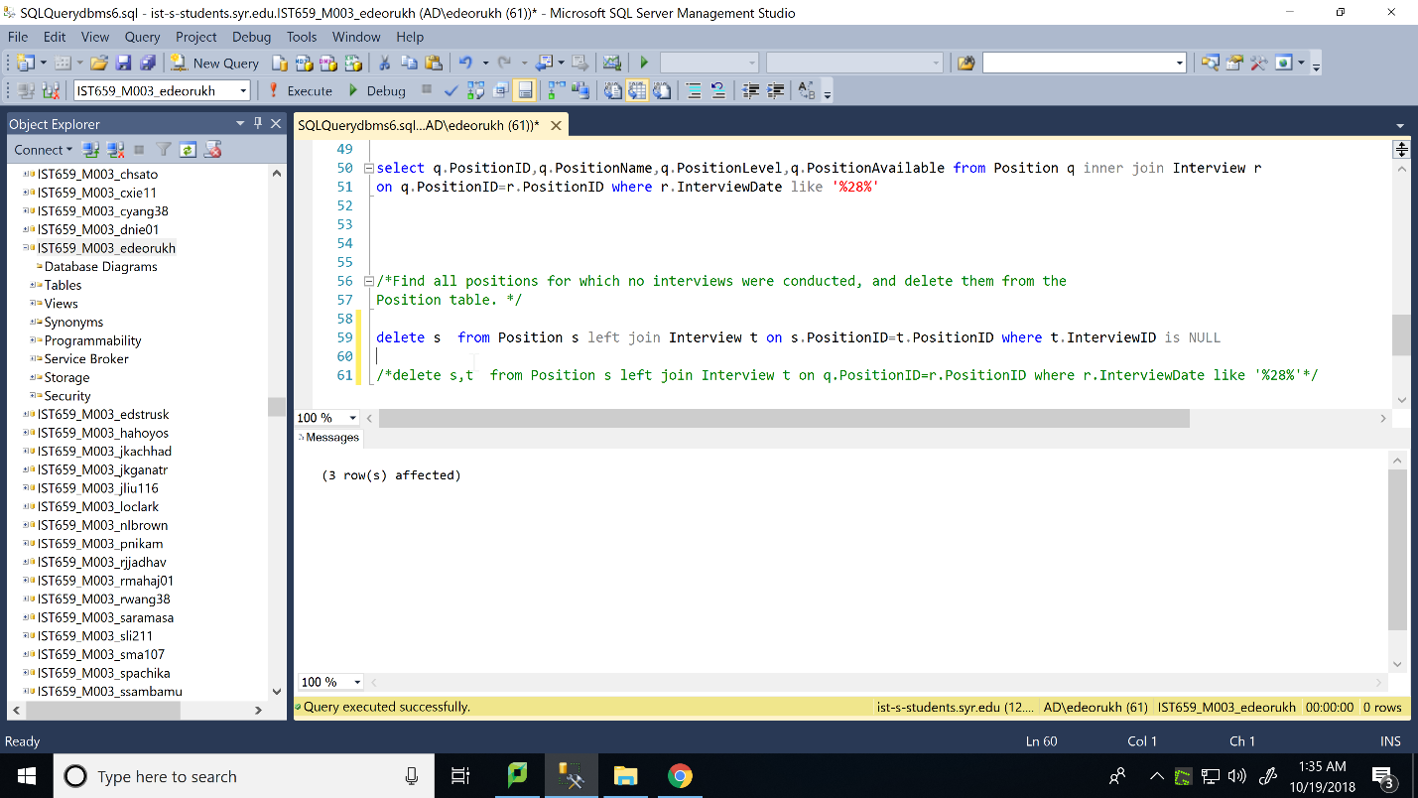

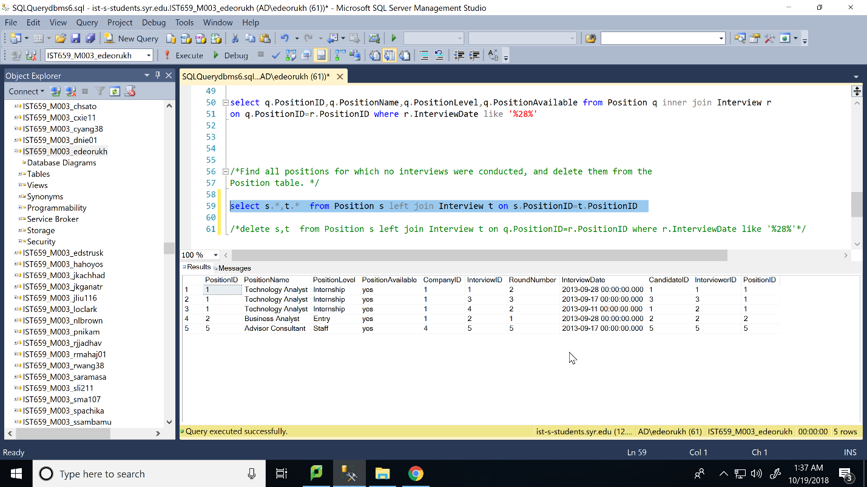

/\*Find the interviewer who conducted the interview for candidate "Heather Cameron".

Update this interviewer's phone number to 315-400-5000. \*/

update Interviewer set IPhone='315-400-5000' from Candidate u inner join Interview v on u.CandidateID=v.CandidateID

inner join Interviewer w on v.InterviewerID=w.InterviewerID where u.CFName like '%Heather%' AND u.CLName like '%Cameron%'

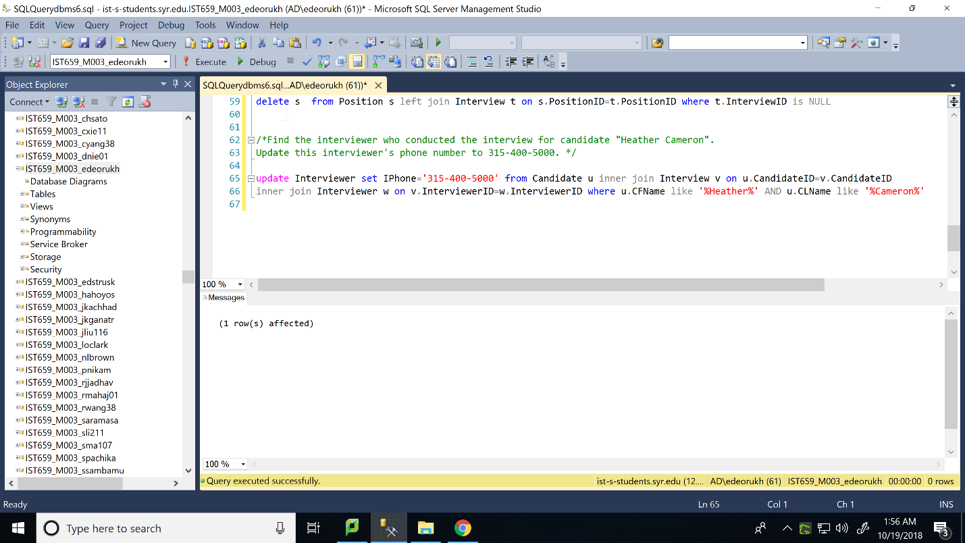

select \* from Interview

