Create a Master-Detail form (form/subform) that will allow you to add Company and their positions. Display all the Company attributes. Add a sub form for positions offered by the company and display all position attributes 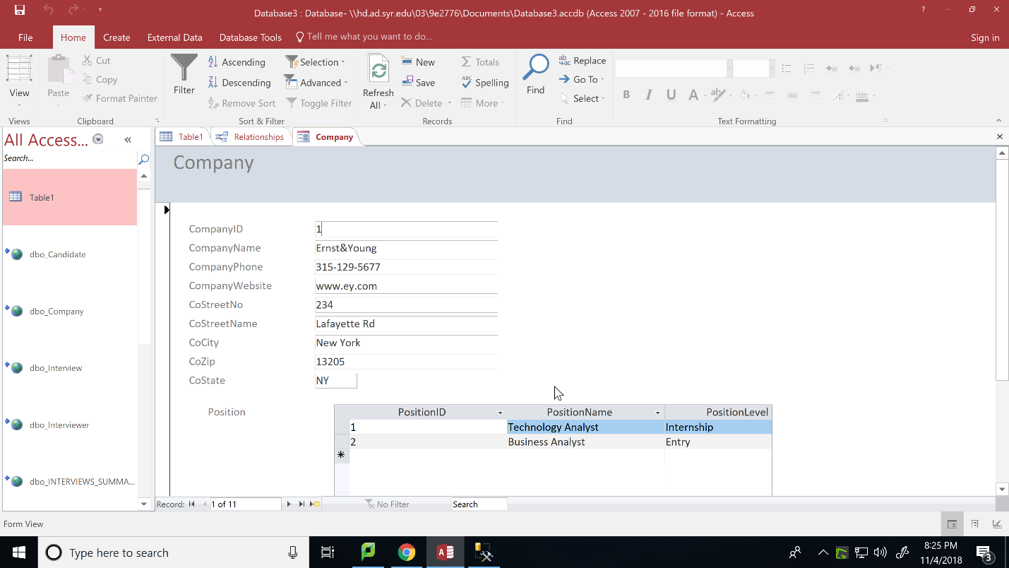

Adding a position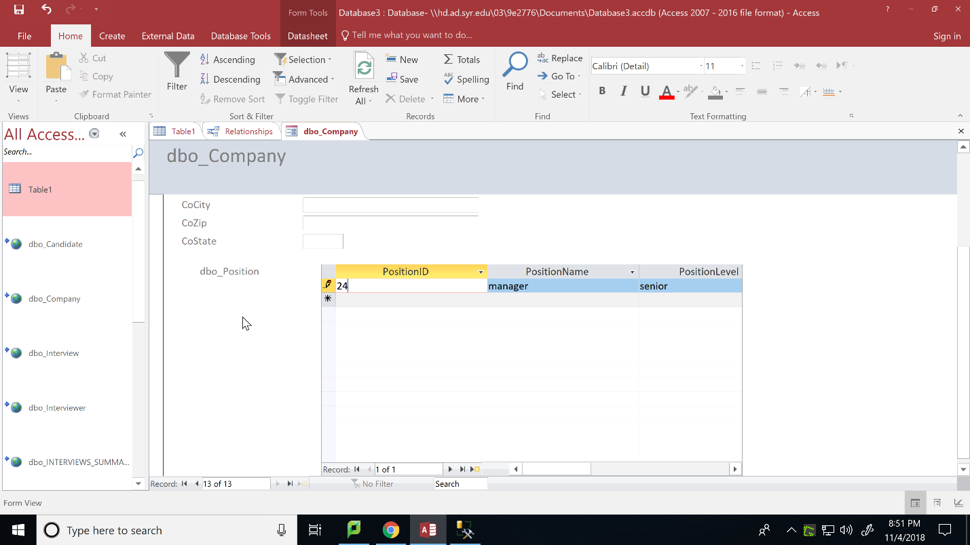

Position added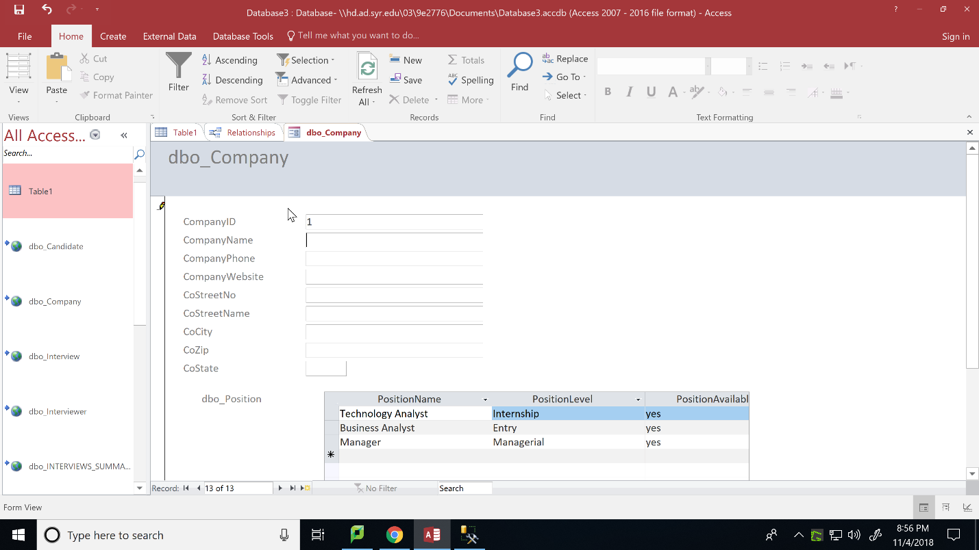

Deleting a position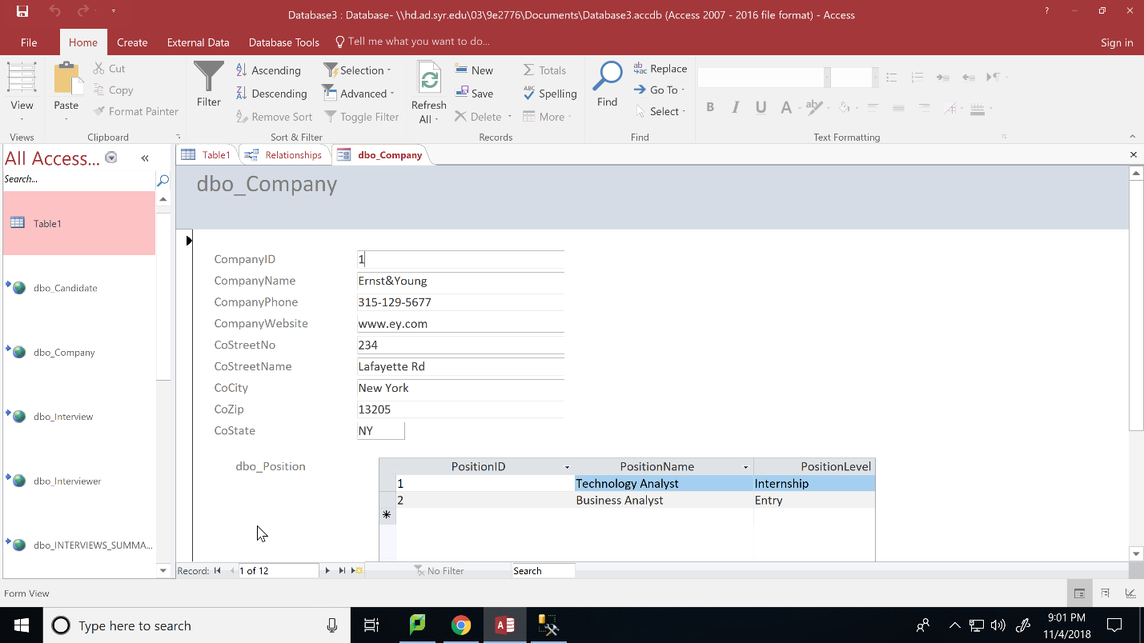

Button to delete company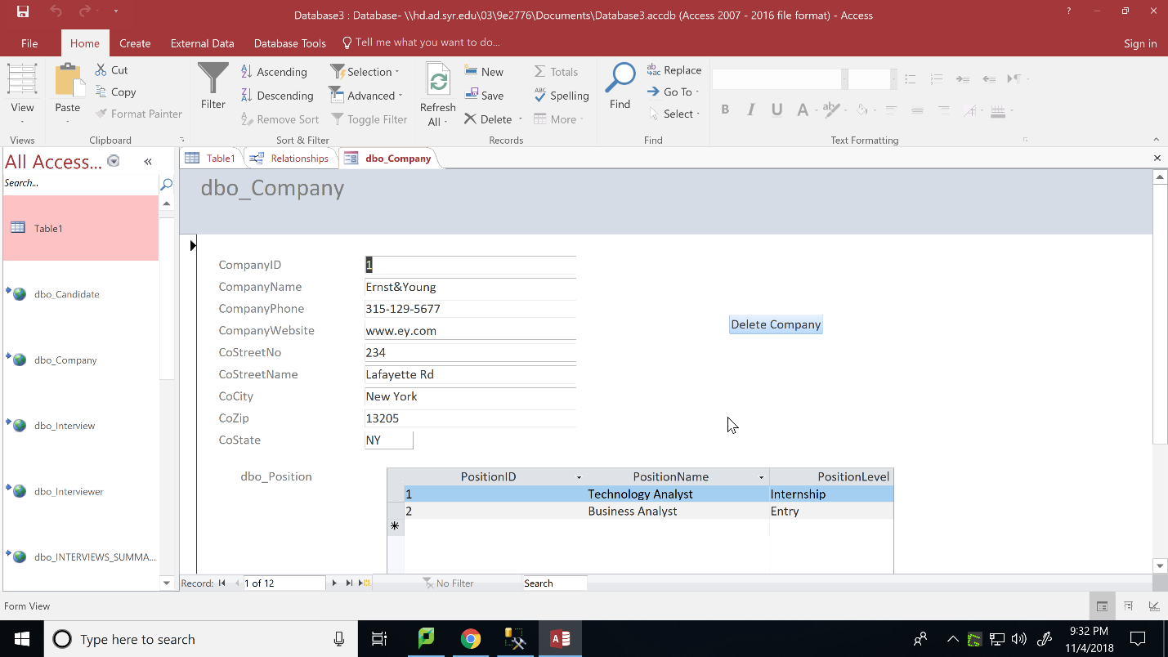

Deleting a company on the press of the button (I got an error because the companyID column is a foreign key to other tables and those tables will have to be dropped before I can drop company)

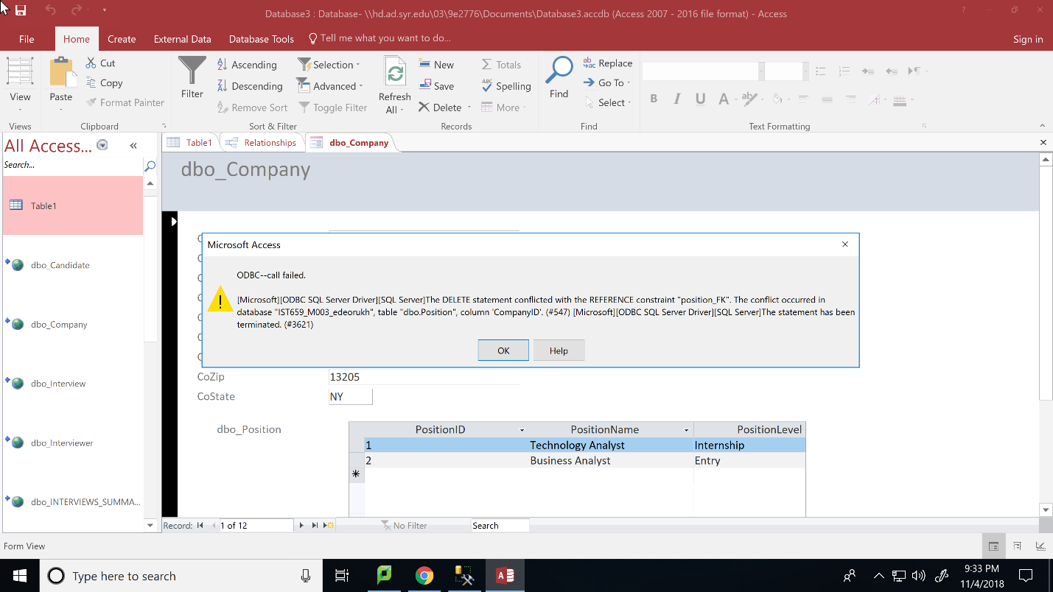

Create a master-detail form (form/subform) in MS Access that will allow you to select a particular Candidate and display the Interview details for that Candidate.

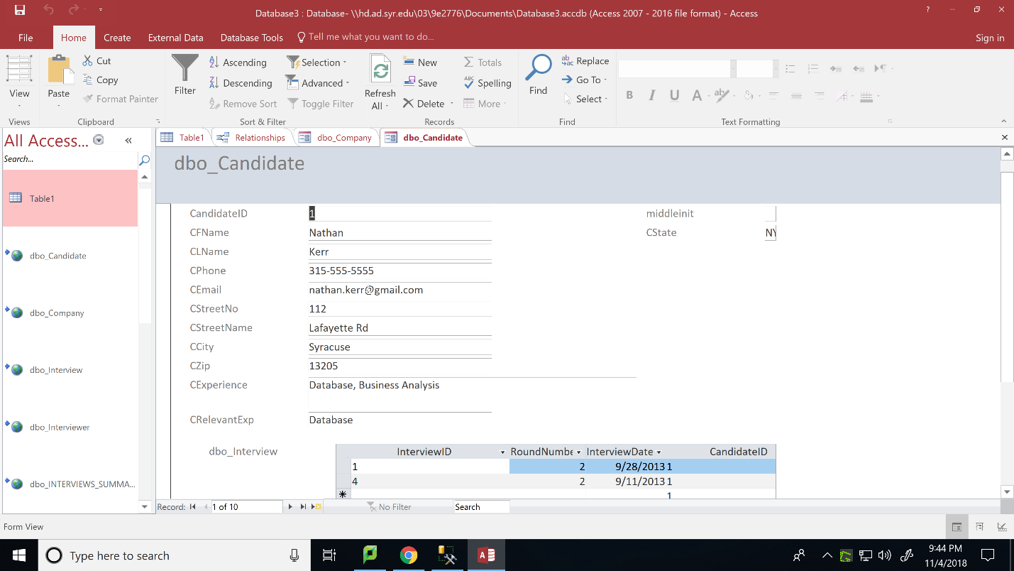

Create a report that lists all Interviews information including Interviewer ID, Interviewer’s last name and first name, Candidate ID, Candidate last and first name, Interview ID, and Interview date. Order the report by Interview Date. Also list all positions for which interviews were conducted displaying PositionID, Position name, Position Level.

