* Entity-Relationship Diagram for “Shopping Site Database”



* Customer Table

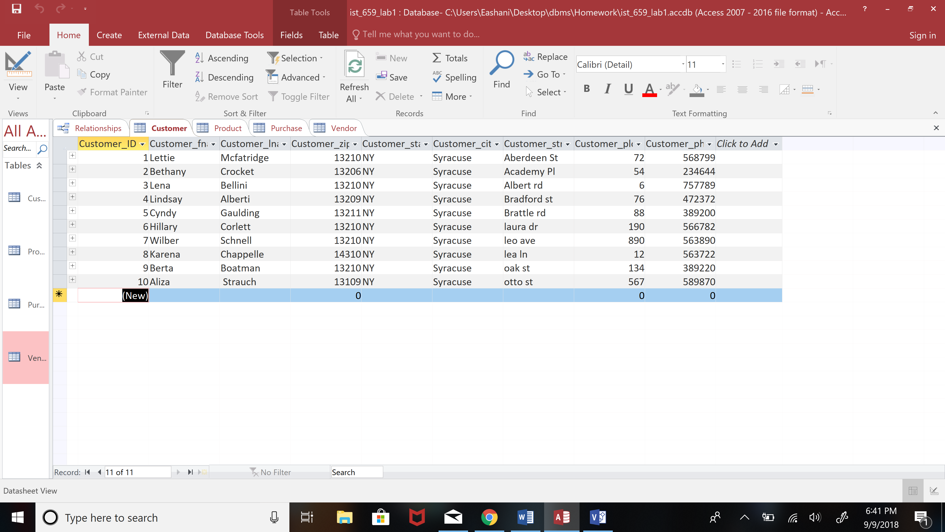

* Product Table

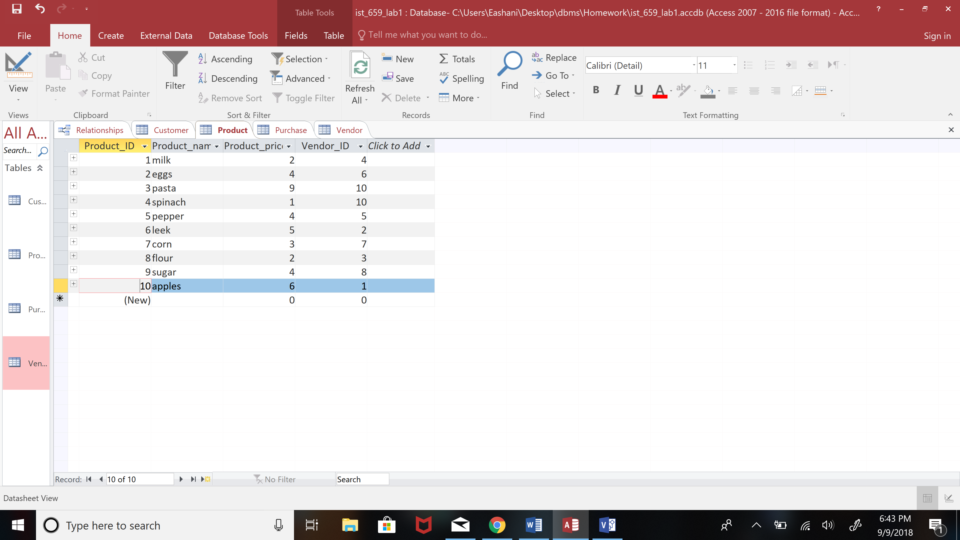

* Purchase Table

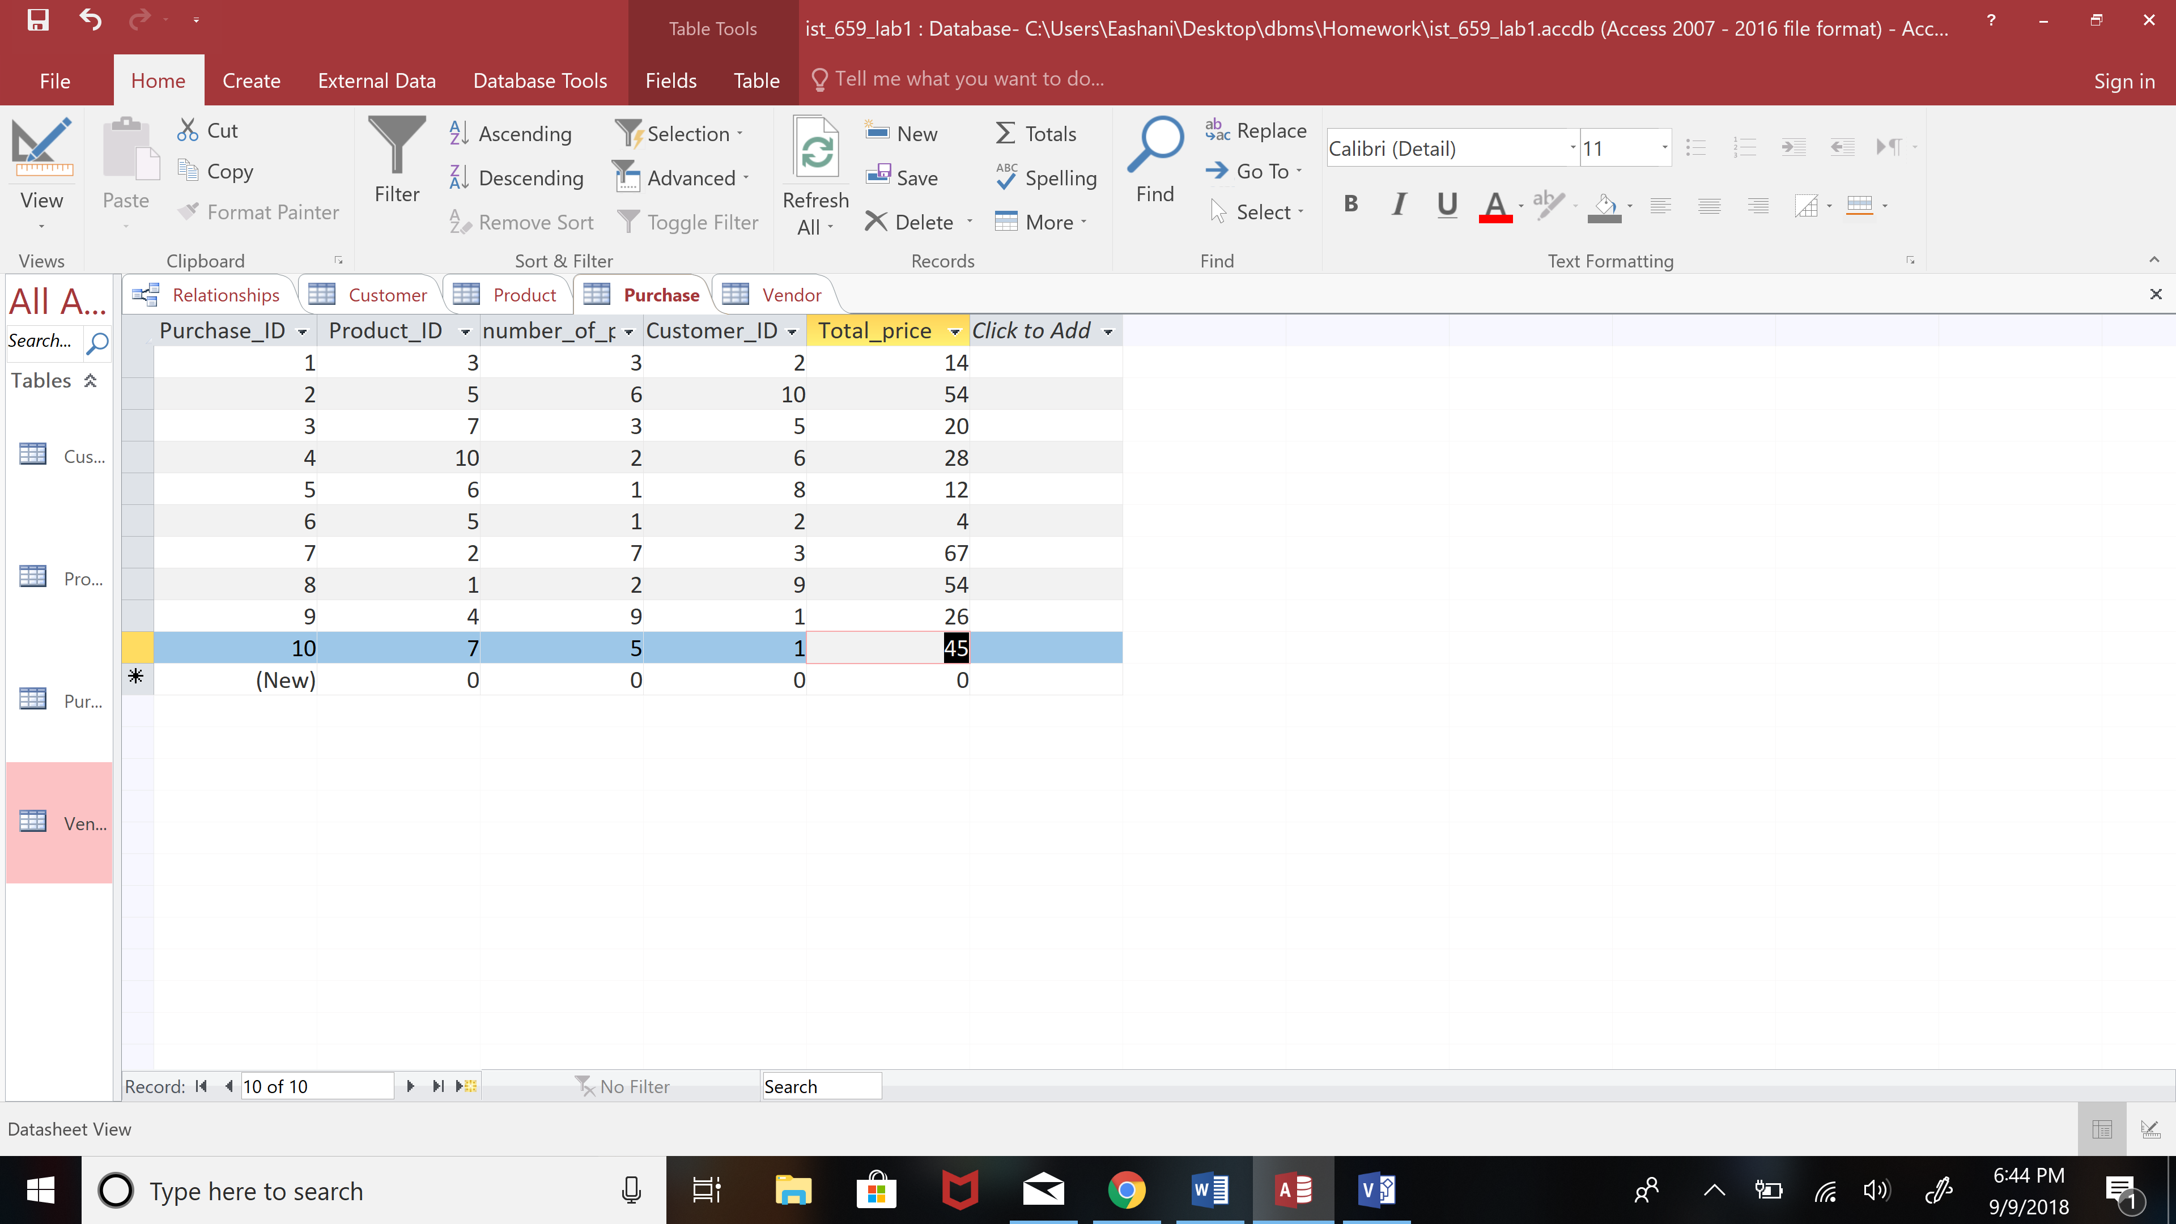

* Vendor Table

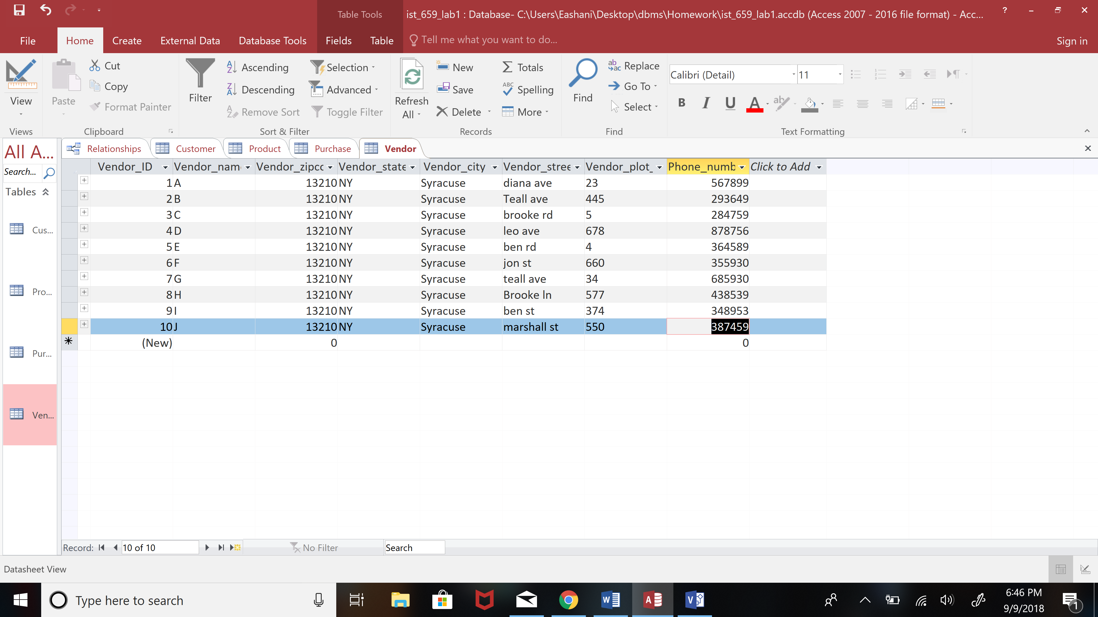

* Data Relationship mode

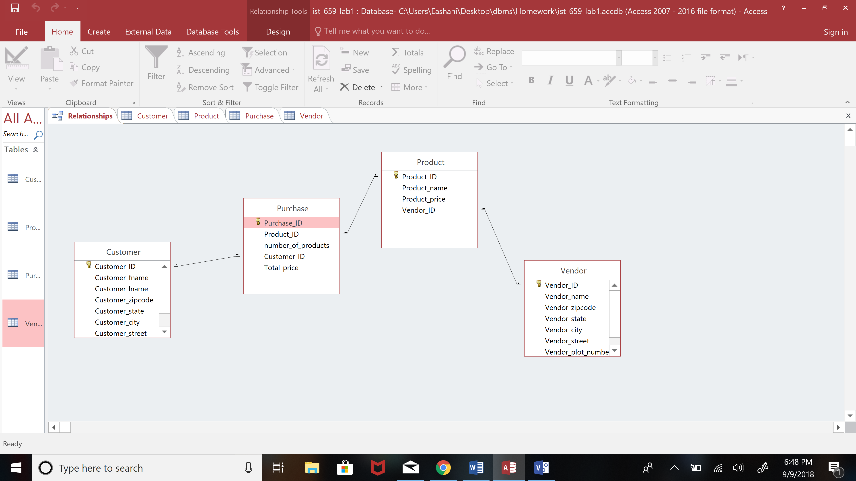

**Currently in this ERD every purchase can only have at most one type of product. If we want to allow a purchase to have more than one type of product, how would you change this ERD to accommodate this new need?**

The current ERD has a “one to many” relationship where one product can be in many purchase records but every purchase can have only one product. To change this to a “many to many” relationship, a new table needs to be created that

records each purchase with the Product ID as well as the Purchase ID. The primary key of this table will be a combination of the Product ID and Purchase ID.

This is the modified ERD with a “many to many” relationship

