

LAB MODULE 7

CSF3133 – Web-based Interface Design

Name: EASHENRAJ A/L NAGARAJAN

No Matric: S76773

Lecturer Name: Prof. Madya Ts. Dr. Wan Nural Jawahir bin Wan Yussof

7.1 Create transparent image text

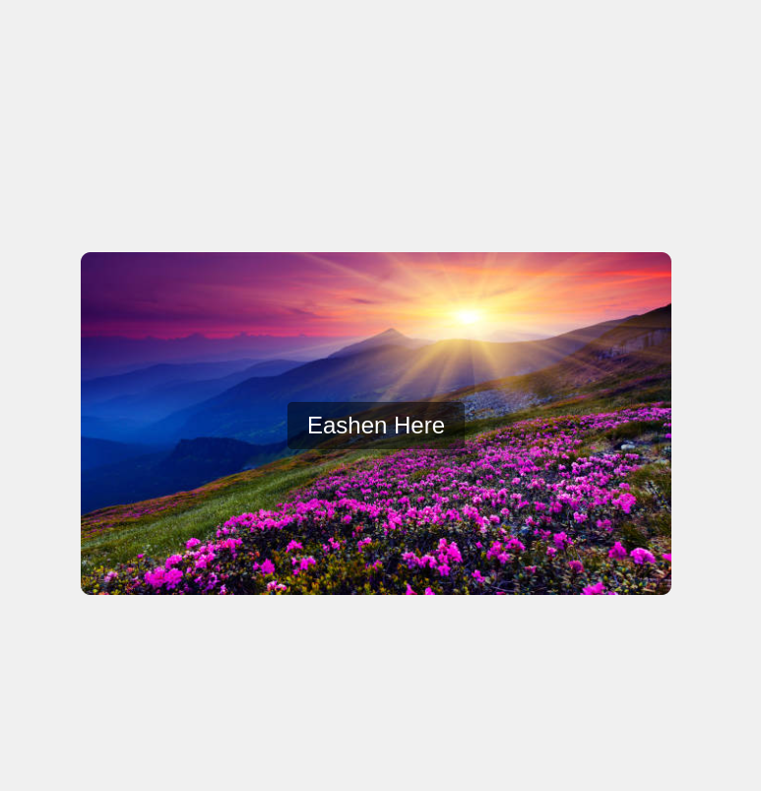

7.2 Create Form on Image
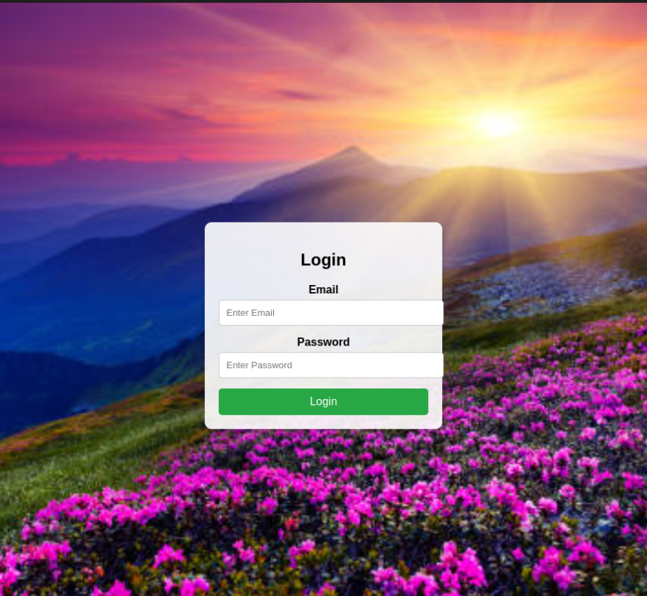

7.3 Side Navigation Buttons
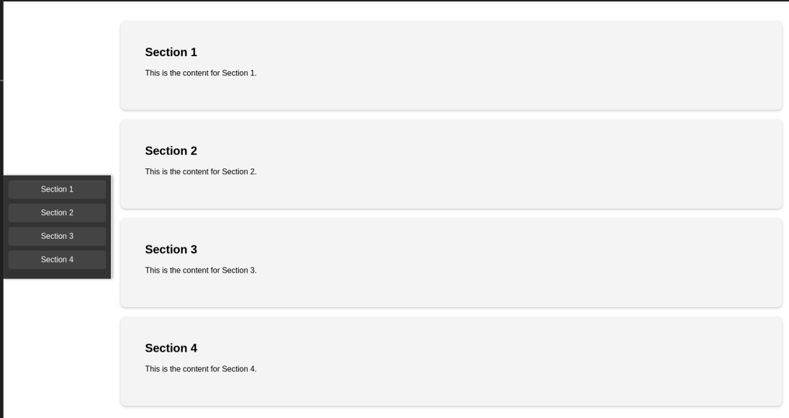

7.4 Automatic Slideshow
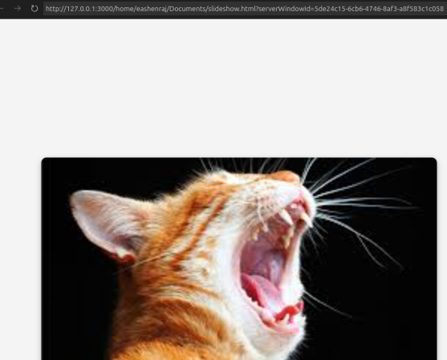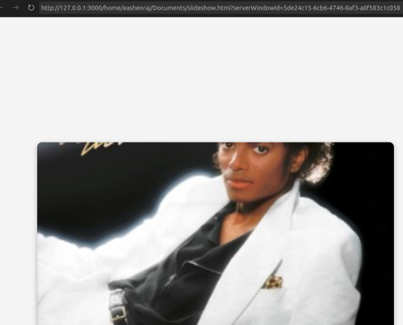

7.5 Create Profile Card
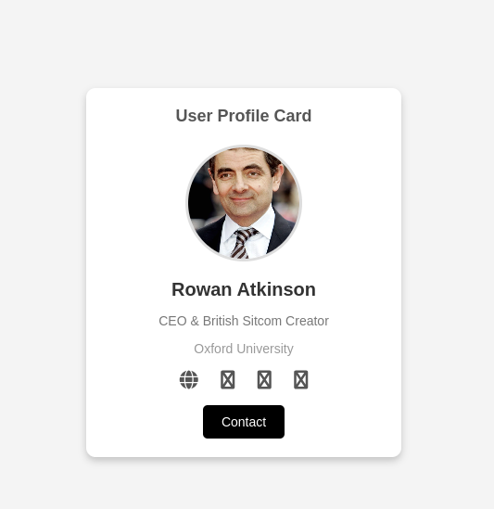
7.6 Progress Bar
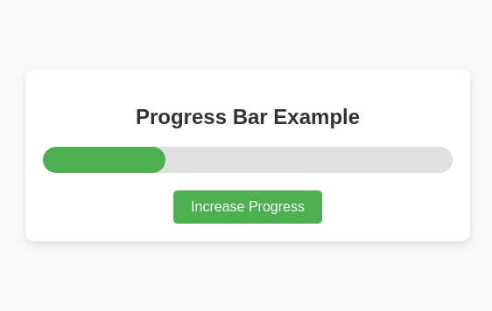

7.8 Lab Exercise

