<https://devpost.com/software/feedpakistan>

**Registration**

* Complete Name
* Complete Address
* Email
* Contact Number
* Type (Donor or Recipient) – radio button
* Username
* Password

**Login Form**

**Admin Dashboard**

* Number of donors
* Number of recipient
* Number of users

**Donor Information Management**

* Complete Name
* Complete Address
* Email
* Contact Number
* Username
* Password
* Account Status

**Recipient** **Information Management**

* Complete Name
* Complete Address
* Email
* Contact Number
* Username
* Password
* Account Status

**Food Donation Information**

* Donor Name
* Date
* Title
* Description
* Pickup Location
* Upload Documentation
* Status – pending, received, cancelled
* Remarks

**Request Food Assistance**

* Recipient Name
* Date of request
* Date of delivery
* Upload Documentation
* Status – pending, delivered, cancelled
* Remarks

**Donor Report**

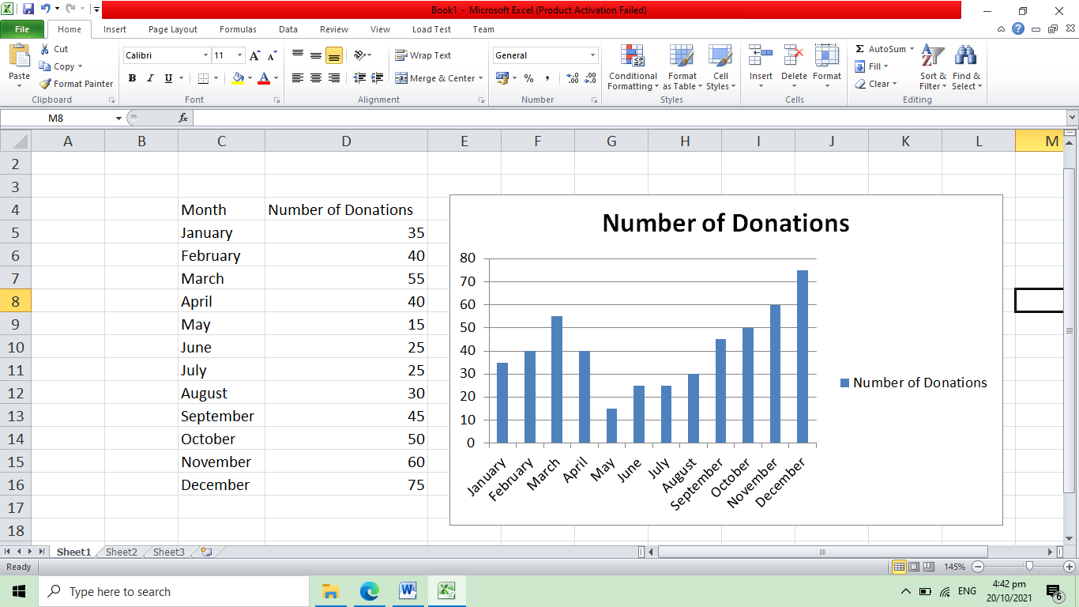

**Donor Account**

**List of donations**

* Donor Name
* Date
* Title
* Description
* Pickup Location
* Upload Documentation
* Status – pending, received, cancelled

**Add Donation – Form Only**

* Title
* Description
* Pickup Location

**Profile**

* Complete Name
* Complete Address
* Email
* Contact Number
* Username
* Password

**Recipient Account**

**List of Request**

* Recipient Name
* Date of request
* Date of delivery
* Upload Documentation
* Status – pending, delivered, cancelled
* Message

**Request Food Assistance**

* Message

**Profile**

* Complete Name
* Complete Address
* Email
* Contact Number
* Username
* Password