Experiment Design Document: E1 and E2
This document explains the experiment design for the no-failure baseline E1 and the failure robustness study E2. It also summarizes the four algorithms, the parameters used by each method, the tau decay selection for stigmergy, and the multi-agent reinforcement learning setup.

Algorithms Under Test
The study compares four algorithms. All algorithms use the same scenario definitions from config_experiments.py so that grid size, robot count, target count, robot radius, failure count, and random seeds are controlled across methods.

1. Centralized Search
The centralized method divides the grid into regions, assigns robots to those regions, and sends each robot a planned sweep path. It is centralized because partitioning and path assignment are computed before the mission. If a robot fails, remaining path segments can be reassigned to another robot.
- Main parameters: grid_size, n_robots, n_targets, n_failures, robot_radius, KAPPA, BASE_SEED.
- Important files: centralized_experiment.py, centralized_search.py, partitioning.py, lawnmower_pattern.py, robot.py.
- Primary behavior: coverage is structured and planned, so it should be efficient when the plan remains valid. Robustness depends on how well unfinished work is transferred after failures.

2. Stigmergy Random Walk
The stigmergy random walk method is decentralized. Each robot moves using local pheromone information and local coverage memory. Robots deposit pheromone as they move. Pheromone evaporates over time, which prevents old information from dominating the search forever.
- Main parameters: grid_size, n_robots, n_targets, n_failures, robot_radius, collision_radius, tau_decay, pher_min, pher_deposit, robot_seed.
- Important files: stigmergy_random_experiment.py, stigmergy_random_search.py, robot_random.py, stigmergy_common/pheromone.py.
- Primary behavior: exploration is stochastic and local. Multiple simulations are used for each environment layout because robot action choices can vary even under the same scenario.

3. Stigmergy Search
The stigmergy search method is also decentralized, but it uses a more directed pheromone-based movement policy than the random walk version. Robots still make decisions locally, deposit pheromone, avoid collisions, and use evaporation to make the pheromone field adaptive.
- Main parameters: grid_size, n_robots, n_targets, n_failures, robot_radius, collision_radius, tau_decay, pher_min, pher_deposit, robot_seed.
- Important files: stigmergy_search_efficient_experiment.py, stigmergy_search_efficient.py, robot_efficient.py, evaporation_experiment.py.
- Primary behavior: the algorithm tries to use stigmergy more efficiently, so it should reduce repeated coverage compared with a purely random stigmergy walk.

4. Multi-agent Reinforcement Learning
The multi-agent RL method uses a shared DQN policy. Each robot receives only a small local observation and chooses one of four movement actions. The same trained neural network is used by all agents, so the policy is shared while execution remains decentralized.
- Main parameters: grid_size, n_robots, n_targets, n_failures, robot_radius, policy checkpoint, robot_seed, DQN hyperparameters.
- Important files: multi_agent_rl_experiment.py, environment.py, model.py, train.py, visualization.py.
- Primary behavior: each robot acts from local observations. Coordination is learned indirectly through the reward signal and through observation of nearby agents.

Tau Decay Selection for Stigmergy
The stigmergy algorithms use pheromone evaporation. The evaporation time scale is controlled by TAU_DECAY.
In each time step, pheromone concentration decreases by multiplying
evaporation rate = $e^{- \frac{1}{TAU_DECAY}}$
A very small tau makes pheromone disappear too quickly, so robots lose useful information. A very large tau makes pheromone last too long, so old paths can continue to influence motion after they are no longer useful.
The implemented base formula is:
$$tau_decay =\frac{grid_size^2}{(n_robots * max(1, robot_radius))}$$
This formula scales with the area of the search space and inversely with the number of robots. A larger grid needs pheromone to remain informative for longer. More robots cover the grid faster, so pheromone can decay faster. The robot radius is included because a larger sensing radius increases the amount of space each robot can inspect.
The sensitivity analysis in stigmergy_evaporation_sensitivity_analysis.xlsx tested tau multipliers 0.5, 1.0, 2.0, 3.0, and 4.0 around this base value. The script evaporation_experiment.py used 10 grid sizes, matching robot counts from 5 to 50, 10 repeats, and target counts set to 2 times the number of robots. The output plot tau_decay_experiment.png compares mean completion steps across grid sizes for each multiplier.
Tau multiplier | Runs | Mean completion steps | Std | Min | Max
0.5 | 100 | 2804.45 | 1788.37 | 214 | 7000
1.0 | 100 | 2767.71 | 1741.29 | 241 | 6989
2.0 | 100 | 2762.86 | 1788.52 | 198 | 9149
3.0 | 100 | 2790.25 | 1818.63 | 258 | 7173
4.0 | 100 | 2792.46 | 1766.55 | 146 | 7115

The global means are very close. The 2.0 multiplier has the lowest overall mean in the spreadsheet, but the difference from 1.0 is small relative to the observed standard deviation. The best multiplier also changes by grid size, which means there is no single multiplier that clearly dominates all scenarios. For that reason, the experiments use the base tau formula with multiplier 1.0. This is simple, scale-aware, and avoids overfitting tau_decay to one subset of grid sizes.
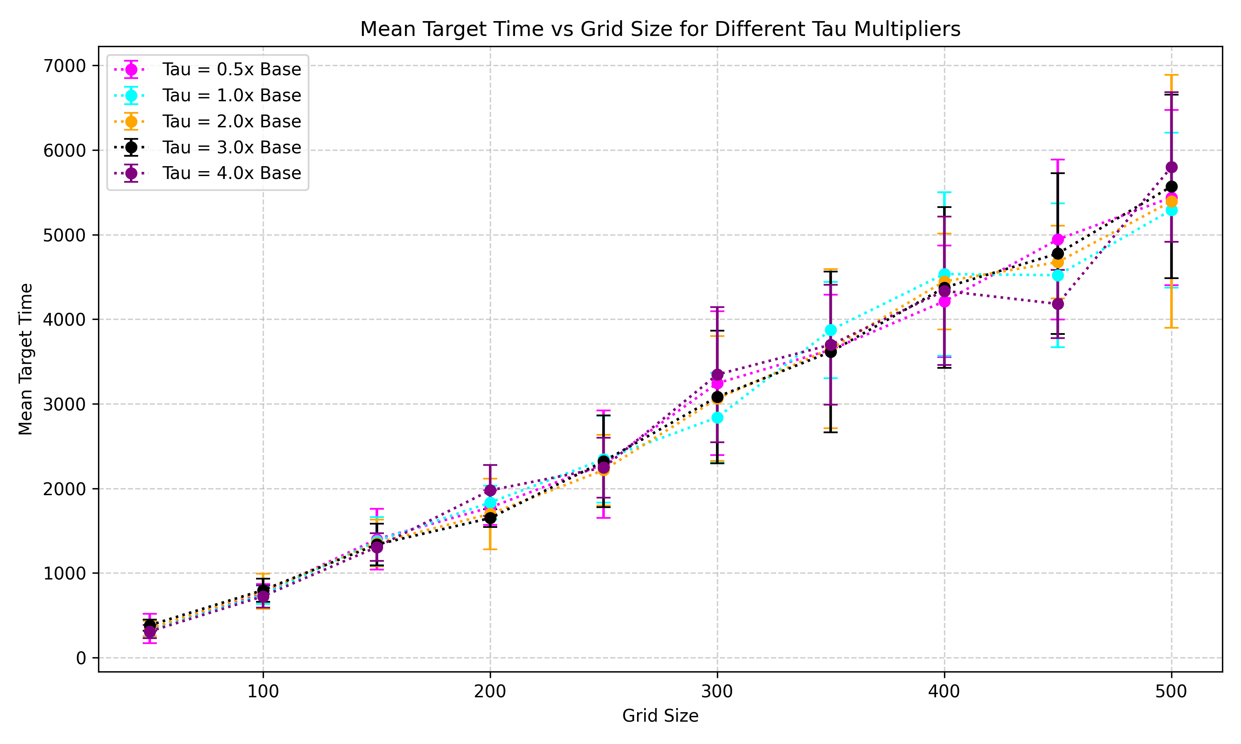
Figure: tau_decay_experiment.png, showing completion steps versus grid size for different tau multipliers.

Multi-agent RL Setup
The RL environment is a grid world with multiple agents and targets. During training, the environment is initialized with grid_size = 100, num_agents = 10, num_targets = 20, and num_obstacles = 0. During experiments, the environment is recreated using the scenario parameters from config_experiments.py.

Observation Space
Each robot receives a local 4 x 3 x 3 observation tensor. Although the tensor is 3 x 3, the code fills the center and four cardinal neighbor cells, which is a von Neumann local view. The four channels are obstacle or boundary, other agents, targets, and the robot own local memory. The memory channel tracks whether the robot has visited nearby cells before and is capped at 5 visits before normalization.

Action Space
Each robot chooses one of four actions: up, down, left, or right. Robots move one cell per timestep. Invalid actions are denied if they hit a boundary, obstacle, another robot, or produce a swap collision.

Reward Function
The reward is local to each robot. Every step starts with a small penalty of -0.1, which encourages the robot to finish quickly. If a robot attempts an invalid move or collision, it receives an additional -5.0 penalty. If it revisits a cell from its own memory, it receives an additional -0.05 penalty. If it reaches a target, it receives +10.0 and the target is removed from the environment.
This reward design encourages target discovery, discourages wasted motion, discourages collisions, and discourages repeated visits. It is decentralized during execution because each robot chooses actions from its own local observation. The policy is shared, but the input to the policy is local for each robot.

Training Process
Training uses a DQNPolicy network with a flattened 4 x 3 x 3 input, two hidden layers of 128 units, ReLU activations, and four output Q-values. The four outputs correspond to the four movement actions. A single shared policy network is trained from experiences collected by all agents.
Training episodes: 2000.
Episode length: 500 steps.
Batch size: 64.
Discount factor gamma: 0.99.
Learning rate: 1e-4.
Exploration: epsilon starts at 1.0, decays by 0.995, and stops at 0.05.
Target network update frequency: every 10 episodes.
Replay buffer capacity: 100000 transitions.
At each step, every agent selects an action using epsilon-greedy exploration. Each agent transition is stored in the shared replay buffer. Once the buffer has enough samples, random minibatches are used to train the shared policy with the standard DQN target. The target network provides stable target Q-values. The best checkpoint is saved to checkpoints/best_policy.pth, and the final checkpoint is saved to checkpoints/final_policy.pth.
During E1 and E2 evaluation, multi_agent_rl_experiment.py loads checkpoints/best_policy.pth if it exists. If it does not exist, the script warns that it is using uninitialized weights. For meaningful comparison, the trained checkpoint should be present before running the RL experiments.

Experiment Design
All algorithms use the scenario list generated by get_experiment_configs in config_experiments.py. The current design contains 10 scenarios. Each scenario pairs one grid size with one robot count, one target count, and one failure count. Target count is currently 3 times the robot count.
GRID_SIZES = [50, 100, 150, 200, 250, 300, 350, 400, 450, 500].
ROBOT_COUNTS = [5, 10, 15, 20, 25, 30, 35, 40, 45, 50].
TARGET_COUNTS = [10, 20, 30, 40, 50, 60, 70, 80, 90, 100].
ROBOT_RADIUS = 1.
NUM_EXPERIMENTS = 10 in each experiment runner.
NUM_SIMULATIONS = 10 for stigmergy random walk, stigmergy search, and multi-agent RL.

E1: No-failure Baseline
E1 measures normal performance with no robot failures. FAILURE_COUNTS is set to zero for every scenario. This establishes the baseline target discovery time, coverage time, percent coverage, and target discovery progress for each algorithm.
For centralized search, each scenario is run for 10 experiment seeds. For the stochastic algorithms, each environment layout is run with 10 simulation seeds, producing 100 runs per scenario. This separation matters because environment randomness and robot action randomness are both important for decentralized and learned policies.

E2: Failure Robustness
E2 measures robustness when some robots fail during the mission. FAILURE_COUNTS is set to nonzero values in config_experiments.py. E2 is divided into four sub-experiments based on when failures occur: early, middle, late, and mixed.
- early: failures are sampled between 10 percent and 30 percent of the failure timing bound.
- middle: failures are sampled between 40 percent and 60 percent of the failure timing bound.
- late: failures are sampled between 70 percent and 90 percent of the failure timing bound.
- mixed: failures are sampled between 10 percent and 90 percent of the failure timing bound.
The failure timing bound is based on grid size, active robots after failures, and robot radius. It uses a compact estimate of how many new cells a robot can reveal per step when moving one cell at a time:
new_cells_per_step = 2 * robot_radius + 1
failure_time_bound = ceil(slack * grid_size^2 / ((n_robots - n_failures) * new_cells_per_step))
The current slack value is 3.0. The timing bound is capped by max_horizon. This makes failures happen during a mission-relevant window instead of using fixed timestep values that may be too early for large grids or too late for small grids.

Seeding Design
The experiments use controlled seeds so that results are reproducible. The schedule seed is 42. For each experiment index, run_seed = schedule_seed + experiment_id. For stochastic simulations, robot_seed = run_seed * 1000 + simulation_id. This gives each environment layout and each robot action trial a deterministic but distinct seed.

Metrics Collected
n_targets_found: number of targets discovered by the end of the run.
t_targets: timestep when all targets are found, or the timeout horizon if not all targets are found.
t_coverage: timestep when full coverage is reached, or the timeout horizon if full coverage is not reached.
percent_coverage: final percentage of the grid covered.
mean_found: average target discovery progress over time.
failure_time_mode: E2 sub-experiment label, one of early, middle, late, or mixed.

Run Count Table
Algorithm | Experiment structure | E1 runs | E2 runs | Total E1 plus E2
Centralized | 10 scenarios x 10 experiments | 100 | 400 | 500
Stigmergy random walk | 10 scenarios x 10 experiments x 10 simulations | 1000 | 4000 | 5000
Stigmergy search | 10 scenarios x 10 experiments x 10 simulations | 1000 | 4000 | 5000
Multi-agent RL | 10 scenarios x 10 experiments x 10 simulations | 1000 | 4000 | 5000
Total |  | 3100 | 12400 | 15500
The full study contains 15500 runs: 3100 E1 runs and 12400 E2 runs. The E2 count is larger because it repeats the failure experiment under four failure timing modes.

Visited Cell Heatmap Comparison
The following four heatmaps compare the spatial coverage behavior of the algorithms under the same no-failure visualization configuration: a 100 x 100 grid, 10 robots, 5 targets, robot radius 1, and no robot failures. The images use the same robot and target placement for the comparison run, so the main difference is the movement policy used by each algorithm. Darker red cells indicate more repeated visits.
The strongest contrast is in revisit concentration. Stigmergy search has the lowest maximum revisit count at 19, while centralized search is very close at 20. Multi-agent RL reaches a maximum of 79 visits, and stigmergy random walk reaches 84 visits. In relative terms, the random walk hotspot is 4.42 times higher than stigmergy search and 4.2 times higher than centralized search. Multi-agent RL is also high at 3.95 times the centralized maximum. This suggests that the directed stigmergy search and centralized sweep distribute coverage more evenly, while random walk and the current RL policy spend more time revisiting local regions before spreading across the grid.
Algorithm | Max visits | Comparison insight
Centralized search | 20 | Structured sweep with low revisit concentration.
Multi-agent RL | 79 | 3.95 times the centralized max and 4.16 times the stigmergy search max.
Stigmergy random walk | 84 | Highest revisit hotspot, 4.2 times centralized and 4.42 times stigmergy search.
Stigmergy search | 19 | Lowest maximum revisit count, 5 percent lower than centralized.

Centralized search
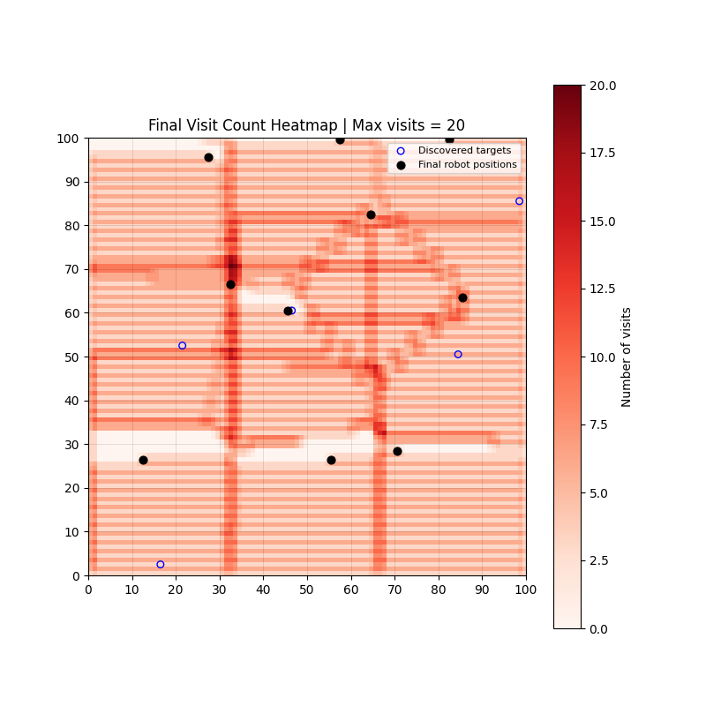
Figure 2. Centralized search visit-count heatmap. The maximum visit count is 20.

Multi-agent RL
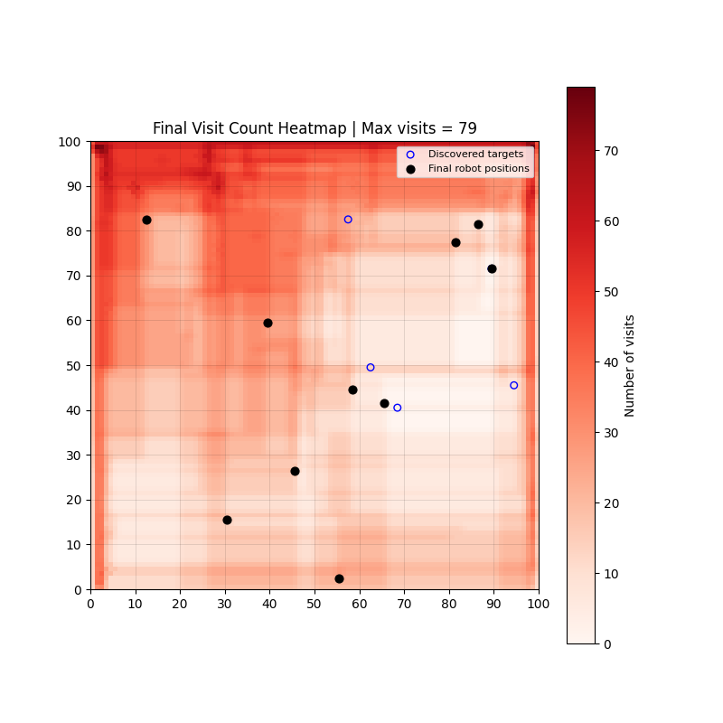
Figure 3. Multi-agent RL visit-count heatmap. The maximum visit count is 79.

Stigmergy random walk
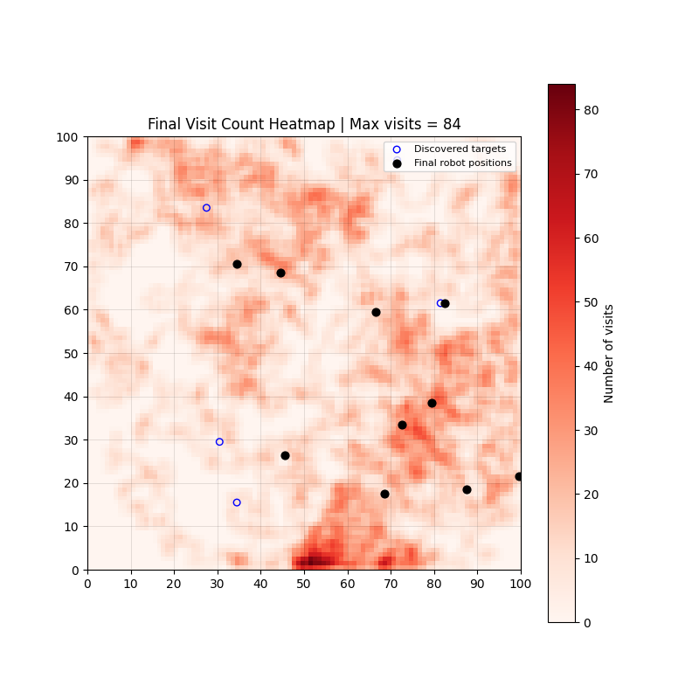
Figure 4. Stigmergy random walk visit-count heatmap. The maximum visit count is 84.

Stigmergy search
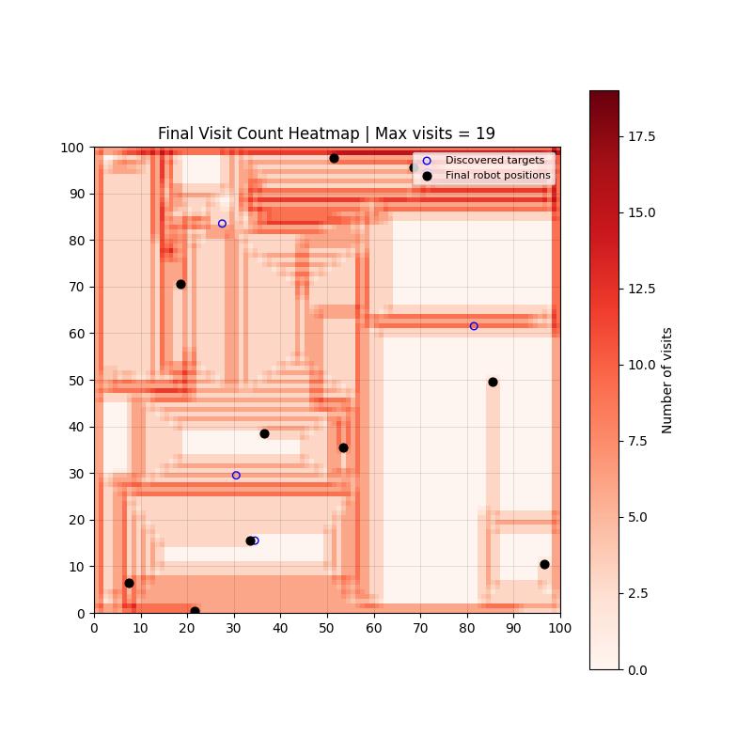
Figure 5. Stigmergy search visit-count heatmap. The maximum visit count is 19.

