1

Semantic Segmentation using Convolutional Neural Network

Eashwar Sathyamurthy | Dr. Mohammed Charifa
Robotics Engineer | Supervising Faculty
A. James Clark School of Engineering | Maryland Applied Graduate Engineering
University of Maryland | University of Maryland
College Park, USA | College Park, USA
eashwar@umd.edu | scharifa@umd.edu

Abstract—Human beings are easily able to identify and differentiate objects based of their cognitive skills. Cognitive skills like category formation, pattern recognition, working memory etc helps to segment and process visual information obtained through eyes. A machine process images in the form of matrix containing whole numbers which are known as pixels. Each pixel indicates the brightness levels at that particular location. As the machine does not posses cognitive capability to segment images, a convolution neural net is designed and built through which the machine learns to segment images. The segmentation performed is called semantic segmentation as it groups every pixel of the image into classes based on labels. The report explains in detail Convolution Neural Net architecture and how it can be used for semantic segmentation.

matrix. The dimensions are length, width and number of channels (R,G,B) of the input image. Generally, the input image is resized to the desired dimensions accepted by the CNN.

- Convolutional Layer

In the convolutional layer, convolution operation hap-pens between the kernel and the input image. Kernel is a 2D array whose elements are obtained from Gaussian distribution. An example of 3x3 Gaussian Kernel is given below[2]:
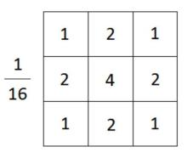

- INTRODUCTION

Over the years convolution neural net (CNN) has in-creased its horizon and made significant impact on pattern recognition and machine learning fields. CNN is one type of neural network which has one input layer, one output layer and two or more hidden layers. The hidden layers is a combination of convolution layers, pooling layers, ac-tivation functions, deconvolution layers, unpooling layers and a fully connected layer. The main distinction between a CNN and a regular neural net is that in CNN neurons handles input and output in three dimensions. An example of CNN is shown in the figure below[1]:
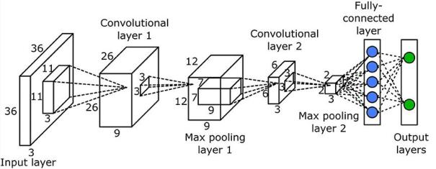

Figure 2: 3x3 Gaussian kernel

Mathematically, 2D convolution is represented as fol-lows:

1 1
X X
y[i; j] = h[m; n]:x[i m; j n]

m= n=

In convolution layer, the convolution operation is per-formed on all the pixels by sliding the kernel over the input image. The following image shows the convolution operation between the image and the kernel[3]:
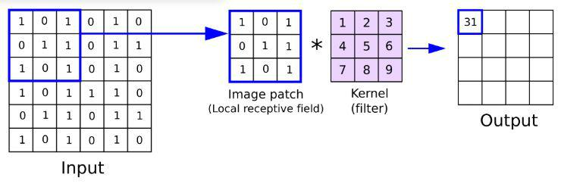

Figure 1: CNN Example

- DEFINITIONS

In this section, different layers of a CNN are explained in detail.

- Input Layer

The input to the input layer of the CNN is generally a color image in pixel form which is a three dimensional

Figure 3: Convolving kernel over the image

Typically, in most neural networks the dimensions of the image after performing convolution are maintained same. In order to do that it is important to understand

2

how convolution operation affects the dimensions of the image. The relation is given as follows:
OutputW idth = ^{IW} ^{KW + 2} ^{P} + 1

S

where I_{W} is the image width
K_{W} is the kernel width
P is number of padding bits

S = stride = number of pixels shift over the input image

OutputHeight = ^{IH} ^{KH + 2} ^{P} + 1

S

where I_{W} is the image width
K_{W} is the kernel width
P is number of padding bits

- Pooling Layers:

Pooling layers in a CNN is added after the convolutional layer. It reduces the size of the image by retaining only the important features in the image and neglecting the rest. Pooling layers have the following advantages:

- It reduces the number of parameters to train in a CNN.
- It prevents the neural net from over-fitting problem. Over fitting is a situation where the neural net mod-els the training data very well but fails to generalize the results on the testing data. This usually occurs due large number of parameters which lets the neural net detect all the patterns in an image but fails to learn from the patterns to generalize on the testing image. This can be observed when the neural net give more than 95% accuracy in training data but gives less than 50% accuracy in testing data.

Commonly used Pooling Layers: Average pooling and max pooling are the two most commonly used pooling layers in neural network.

  - Average Pooling: In average pooling, the av-erage value is selected from each patch of the feature map to obtained a reduced map size. The following image gives an example of average pooling[4]:
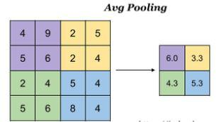

Figure 4: Average Pooling Example

In the above example, the feature map is of size 4x4 and the patch is of size 2x2 and stride = 2 and there are no padding bits. So, if we

apply the formula for resulting dimension of the feature map, we get the following:

OutputW idth = | I_{W} |  | K_{W}+2 P |  |  | + 1
 |  |  | S
= | 4 |  | 2+2 0 |  | + 1
= |  |  | 2 |  | + 1
OutputW idth = 2
OutputHeight = |  | I_{H} | K_{H}+2 P |  |  | + 1
 |  |  | S
= |  | 4 | 2+2 0 |  | + 1
 |  |  | 2

OutputHeight = 2

So, the output feature map will be of size 2x2. Let consider the first (violet) patch and calculate the average pooling output:

Outputvalue = ⁴ ⁺ ⁹ ⁺ ⁵ ⁺ ⁶ = 6:0 4

This process is repeated over the entire feature map to obtain the reduced 2x2 feature map output.

- Max Pooling: In max pooling, the maximum value is selected from each patch of the feature map to obtained a reduced map size. Max pooling is the most commonly used pooling layers. The following image gives an example of max pooling[4]:
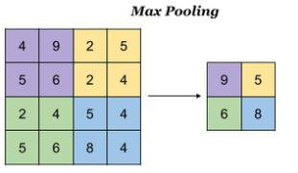

Figure 5: Max Pooling Example

As this is the same example used in average pooling, the output feature map size is 2x2. The following i s the max pooling output for the first (violet) patch of the feature map:

Outputvalue = max(4; 9; 5; 6) = 9:

- Unpooling Layers:

In CNN, inverse operation of pooling layers is not possible. But unpooling layers obtains the approximate inverse of pooling layers by storing the maximum value from each patch of the feature map in a set of switch variables during the pooling operation is being performed. These switch variables are again in unpooling layers to reconstruct the layer above into appropriate locations. The below picture shows unpooling:

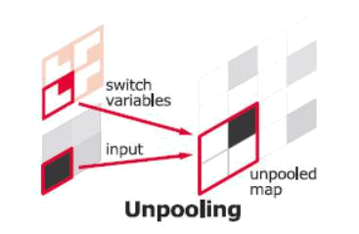

Figure 6

- Activation Functions:

As the name suggests, an activation function decides whether to activate a neuron or not based on calculating weighted sum and adding bias with it. In the case of a CNN, weighted sum is the output image obtained by convolving the kernel over the input image. Bias is a fixed value which is added pixel wise to the obtained output image. Activation function is applied to this output image which decides whether to select a particular pixel value and pass on to the next layer or not.

Need for Activation Functions: In neural networks, the weights (kernel in the case of CNN) and bias values constantly gets updated based on the error at the output. The values are updated using back-propagation algorithm. Activation functions makes the back propagation possible as the gradients are supplied along with errors to update the weight and bias values[5].

Different Activation Functions: There are different ac-tivation functions used in neural networks based on its applications. They are:

- Step Function: Step function is a threshold based activation function which outputs 1 for the values greater than a specified threshold or outputs 0 other-wise. Hence, 1 means the neuron gets activated and 0 means neuron gets deactivated. It is shown in the below figure:[7] The following conditional equations
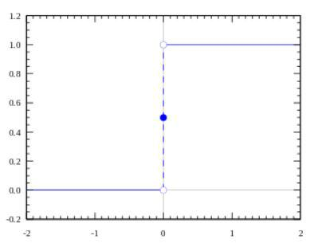

Figure 7: Step Function
3

defines step function:

Activation Function A = 1 if y threshold = 0 otherwise

Step function can be used as an activation function if the neural net is being used for binary classification where the output is just ”YES” or ”NO”. Typical example of such classification is determining the picture is of a dog or a cat.

But, step functions cannot be used as activation functions for multiple(more than 2) classifications as the neural net might give multiple 1’s and 0’s as output.

- Linear Function: Linear function means a straight line functions which is proportional to the input. The below figure shows the example:[7] The following
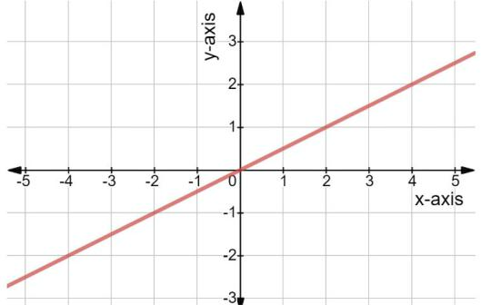

Figure 8: Linear Function

conditional equations defines linear function:

Activation Function A = c X

Linear function eliminates the multiple classification problem faced by employing step function as the activation function. As the activation function varies with input values, it can take many values not only 0 and 1. Hence, it can classify multiple classes.
The main disadvantage of linear function is the derivative becomes constant. This means that the gradient no longer varies with input. Hence, if there was an error in detecting the output, since the gradient is constant there will be constant change in the weights and bias values irrespective of inputs. This means that the neural net fails to learn.

Another disadvantage occurs due to linearity property. By, employing linear functions as activation functions to all hidden layers, the output will be a linear combination of hidden layers. Hence, multiple hidden layers can be combined into 1 hidden layer. Hence, by employing linear function only 1-hidden layer neural nets are possible.

- Sigmoid Function: The below picture shows the sigmoid function.[7]

The following conditional equations defines sigmoid function:
1
Activation Function A = ₁ ₊ _{e} _{x}

The sigmoid function is essentially a smoothened version of step function. This makes it far more
4
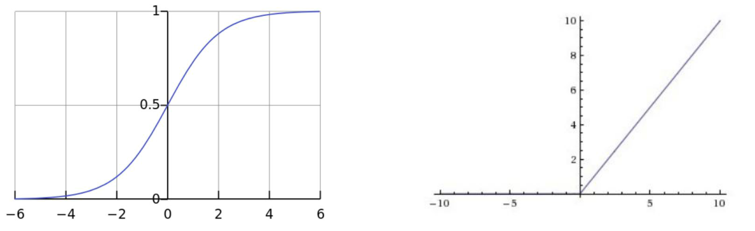

Figure 9: Linear Function _{Figure 11: Relu Function}

useful than step function. Firstly, sigmoid function is non-linear which eliminates the linearity problem. Secondly, it can take many values between 0 and 1 which makes it useful in multiple classification problems.

The only disadvantage of sigmoid function is that gradient of the points farther from origin approaches to zero which gives rise to vanishing gradients problem. This makes the neural net to learn very slowly and in worst case scenarios not learn at all.

- Tanh Function: The below picture shows the tanh function.[7]
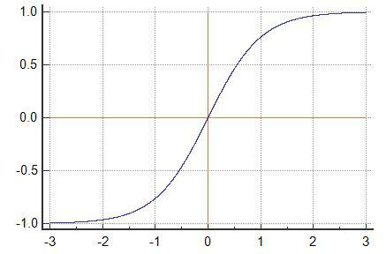

Figure 10: Tanh Function

The following conditional equations defines tanh function:
2
Activation Function A = ₁ ₊ _{e} ₂ _{x} 1

Tanh function is a scaled version of sigmoid func-tion. The gradient of the points farther from origin approaches slowly to zero than sigmoid function. But, tanh function also faces the problem of vanish-ing gradient.

- Relu: Relu stands for Rectified linear unit. It is one of the most commonly used activation function. The figure below shows the function:[7]

Relu is non-linear in nature as it remains zero for all the negative values for the function which allows neural net to have multiple layers. In addition to this, most of the neurons in the neural net never fire up due to the characteristics of Relu function. This makes the neural net lighter. This makes Relu function less computationally expensive than Sig-moid and Tanh functions.

The disadvantage of Relu function is that for nega-tive values the gradient remains remains zero. This means that some neurons in the neural net will not respond to the change in the output. This is called dying Relu problem.

- Fully Connected Layer:

In neural network, a fully connected later is that layer which connects the inputs of one layer to every activation unit of the next layer. Typically, a fully connected layer is present before the output layer. In a neural net each unit in a convolutional layer contains a feature of the input image essentially an edge. Hence, each convolutional layer is a collection of features of the input image. A fully connected layer holds the composite and aggregate features of all the convolution layers. Hence, a fully connected layer is a feature vector of the input image. The following figure shows an example of a fully connected layer:[8]
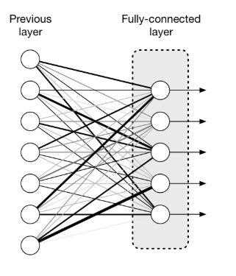

Figure 12: Fully Connected Layer

- Deconvolution Layer:

Deconvolution layers in CNN is used to represent the output data in the same dimensions as the input image but increasing the size of the output data. Deconvolution is a transpose operation of convolution.

In deconvolution, first the data is padded and separately according to the desired output size. The below figure shows the representation of data in padded and separated form to convert data of size 2x2 to 4x4:[11]

5

III. SEGNET ARCHITECTURE
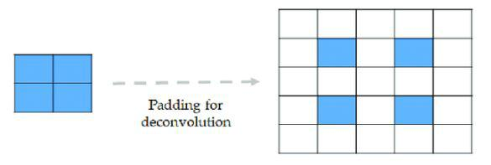

U-net is popularly used CNN for segmentation. The name U-net comes from the fact that the layers in the CNN are arranged in U shape. The below figure shows the U-net architecture:

Figure 13
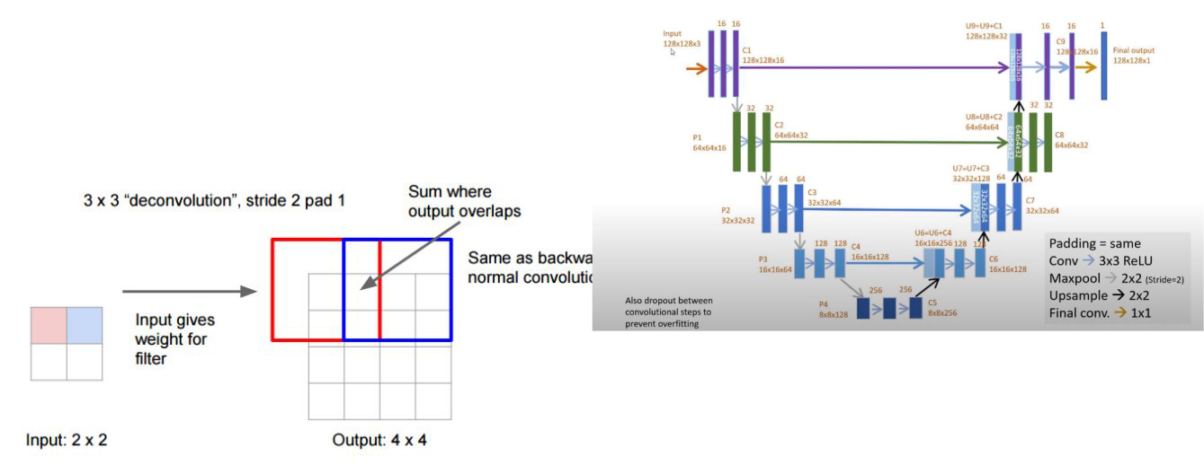

Then the kernel is made to slide over the padded representation to get 4x4 output data size.[12]

Figure 14

- Output Layer:

The output layer is the final layer of CNN. The output layer takes input from the fully connected layer and assigns probability to it. The assignment of probability is done through softmax activation function. Hence, the output layer outputs the probability of the probability of each class in the input image. The below image shows the softmax activation function present in output layer.[10]
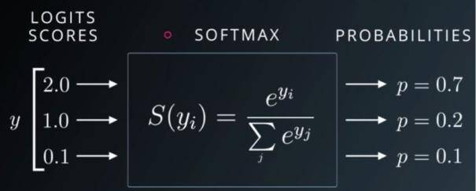

Figure 16: U-net Architecture

The U-net architecture consists of two path. They are:

- Contraction Path: The left half of the U-net where the layers are represented from top to bottom is called contrac-tion path. The contraction path consists of an input layer, sequence of convolution layers, Relu activation layers and max pooling layers. These series of layers reduce the size of the input image simultaneously increasing the number of channels.

  - Expansion Path: The right half of the U-net where the layers are represented from bottom to top is called ex-pansion path. The expansion path consists of sequence of deconvolution or up-convolution layers and concatenation with high resolution features from the contraction path and unpooling layers. The expansion path gives output data in the same size as the input image data. The expansion path increase the size of the contraction path output data simultaneously decreasing the number of channels.

 |  |  | IV. IMPLEMENTATION:
 | 1) | Language Used: Python 3.8
 | 2) | Packages Used: Tensorflow, Numpy, cv2
Figure 15: Softmax Activation Function Example | 3) | Software Used: Jupyter Notebook
Figure 15: Softmax Activation Function Example | 4) | Github |  | Link: | https://github.com/Eashwar-S/
 |  | Semantic Segmentation
 |  |  |  | V. RESULTS
 | Semantic segmentation was performed in two types of
 | datasets namely:
 | 1) | Binary class Semantic segmentation: In this the
 |  | input images contain only two classes and semantic
 |  | segmentation is performed to separate these two
 |  | classes.
 | 2) | Multi class semantic segmentation: In this the input
 |  | images contains 32 classes and semantic segmen-
 |  | tation is performed to separate 32 classes with
 |  | different colors.

6

- Binary class semantic segmentation results:

The datasets for binary class semantic segmentation were obtained from kaggle[13]. The input contain images of nuclei which needs to be separated from the back-ground. The U-net model was trained to obtain an accuracy of 96.4% over 13 EPOCHS. The below images shows the segmented results obtained from U-net for training, validation and testing data.
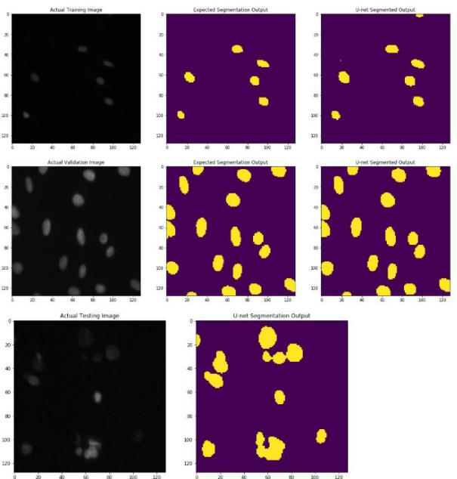

Figure 17: Binary class segmented output

Thus, U-net performs brilliantly in the case of binary class semantic segmentation. The following graphs shows the accuracy and loss of the model over number of EPOCHS over time.

Figure 18: Model loss and accuracy

- Multi class semantic segmentation results:

The datasets for binary class semantic segmentation were obtained from kaggle[14]. The input contain images containing 32 classes which needs to be segmented. In this case, there is a bit of pre-processing of label data needs to be done as now the output layer outputs 32 different images of 32 different classes. The 32 different outputs obtained from U-net needs to be compared with label data. But since the label data has 3 channels RGB, 3 channels of RGB needs to be converted to 32 channels with each channels representing one class. This is done by one-hot encoding.

The U-net model was trained to obtain an accuracy of 67.4% over 14 EPOCHS. The below images shows the segmented results obtained from U-net for training, validation and testing data.
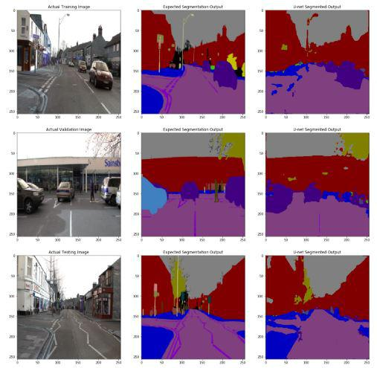

Figure 19: Multi class segmented output

Thus, U-net performs poorly in the case of multi class semantic segmentation. The following graphs shows the accuracy and loss of the model over number of EPOCHS over time.
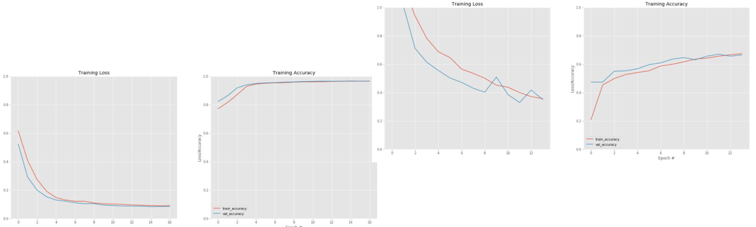

Figure 20: Model loss and accuracy

VI. TWEAKING OF HYPER PARAMETERS:

In convolutional neural network, the parameters which are declared before the neural net architecture and which can be used to control the learning of the neural networks are called hyper parameters. The hyper parameters used in the u-net architecture are:

- Batch size

- Learning Rate (L.R)

- Input image size

The below table shows the obtained accuracy and loss by tweaking the hyper parameters:

7

Tweaking Hyper parameters

Sno | Variation | Img | batch | L.R | IOU | Loss
 |  | size | size |  | Accu.
0. | Default | 256 | 8 | 0.001 | 48.5% | 1.8697
 |  | x256
1. | Increased | 256 | 1 | 0.01 | 48% | 2.5
 | learning | x256
 | rate
2. | Increased | 256 | 1 | 0.05 | 48.3% | 2.3
 | learning | x256
 | rate
3. | Increased | 512 | 1 | 0.01 | 48.3% | 2.4
 | Img size | x512
4. | Increased | 512 | 1 | 0.05 | 48.38% | 2.2
 | learning | x512
 | size
5. | Decreased | 128 | 1 | 0.01 | 48.45% | 1.65
 | Img size | x128
6. | Increased | 128 | 1 | 0.05 | 48.45% | 1.65
 | learning | x128
 | size
7. | Increased | 128 | 8 | 0.05 | 48.45% | 1.65
 | batch | x128
 | size
8. | Increased | 128 | 16 | 0.05 | 48.45% | 1.65
 | batch | x128
 | size
9. | Increased | 128 | 32 | 0.05 | 48.45% | 1.65
 | batch | x128
 | size

It is clearly seen that the accuracy and error of the model does not vary much by tweaking the hyper parame-ters.Hence, the U-net architecture can provide a maximum IOU accuracy of 48.45% and a minimum error of 1.65. For all the obtained results, the training took place for two EPOCHS only. After two EPOCHS, the architecture stops learning and accuracy and error remains same.

Figure 21: Segnet Architecture
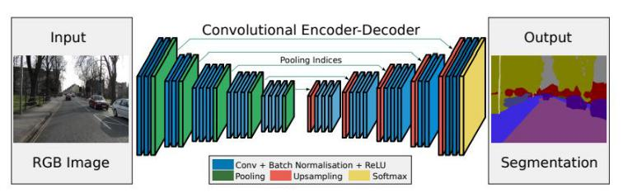

VIII. RESULTS FROM SEGNET ARCHITECTURE

Segnet architecture was trained and tested on bdd-dataset[16] and obtained a mIOU accuracy of 48.45% and a loss of 2.0201. The results obtained does not differ from U-net due to similarity in architecture.The following are the segmented results obtained by implementing the segnet architecture using tensorflow:
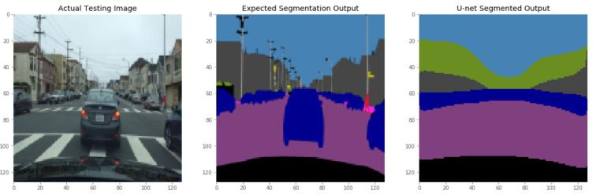

Figure 22: Segnet output
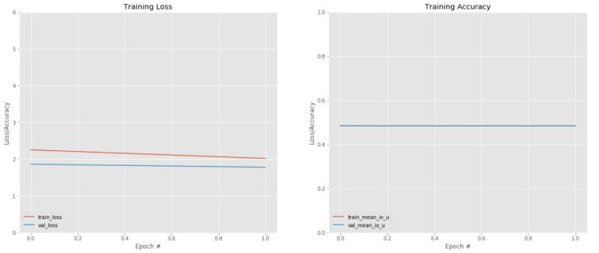

VII. SEGNET ARCHITECTURE

Segnet is designed to perform pixel wise segmentation more efficiently. It consists of an encoder network fol-lowed by a decoder network and finally a pixel classifi-cation layer. The encoder layer consists of 13 convolution layers similar to VGG16 for object classification. Since each encoder layer has a corresponding decoder layer, there are 13 convolution layers present in decoder layer.

Each encoder layer performs convolution operation to detect the features of the input image. Then, these are batch normalized to reduce the amount by which hidden unit values shift. Finally, a rectified linear unit (ReLU) activation is applied pixel wise followed by max pooling operation. Each decoder layer has a upsampling layer to increase the image size by a factor 2 followed by convolution process. The last decoder layer has a soft-max activation function which gives output images whose length is the number of segmented labels present. The figure below shows the segnet architecture[15]:

Figure 23: Segnet loss and accuracy

IX. RESULTS FROM RUNNING IN AWS

The following are the results obtained by running U-net model in AWS giving various tweaks to the hyper parameters:

- With Batch size of 16

Tweaking Hyper parameters

Sno | Classes | Img | batch | L.R | IOU | Loss
 |  | size | size |  | Accu.
1. | 41 | 256 | 16 | 0.01 | 48.45% | 2.8794
 |  | x256

8

U-net segmented Output U-net segmented Output
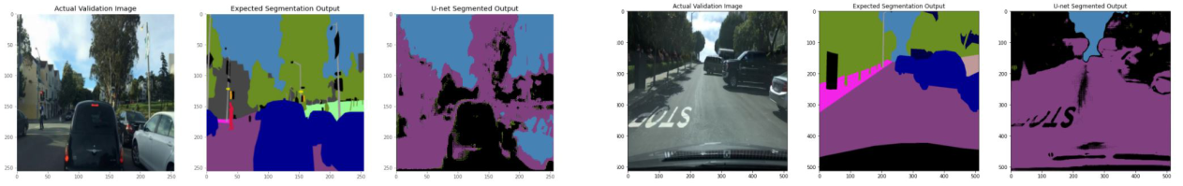

Figure 24: U-net segmented output

Figure 28: U-net segmented output

U-net MIOU accuracy and Loss
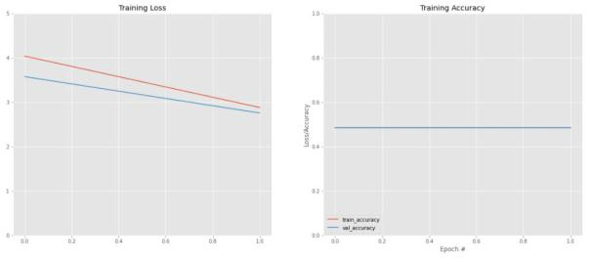

U-net MIOU accuracy and Loss
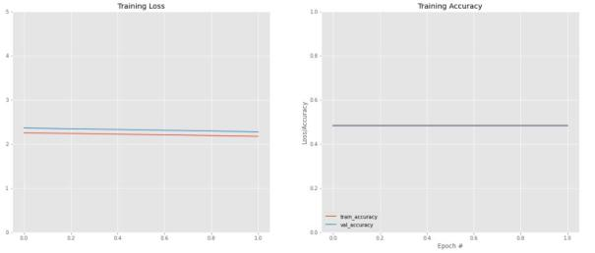

 | Figure 25: U-net segmented output |  |  |  |  |  |  |  |  |  |  | Figure 29: U-net segmented output
2) With increased batch size of 32: |  |  |  |  |  |  |  |  |  | 4) |  | With 20 classes:
 |  | Tweaking Hyper parameters |  |  |  |  |  |  |  |  |  |  | Tweaking Hyper parameters
 |  |  |  |  |  |  |  |  |  |  |  | Sno | Classes | Img |  | batch | L.R |  | IOU | Loss
 | Sno | Classes | Img |  | batch | L.R |  | IOU | Loss
 |  |  | size |  | size |  |  | Accu. |  |  |  |  |  | size |  | size |  |  | Accu.
 |  |  |  |  |  |  |  |  |  |  |  | 1. | 20 | 256 |  | 16 | 0.01 |  | 31.78% | 1.7894
 | 1. | 41 | 256 |  | 32 | 0.01 |  | 48.46% | 2.8746
 | 1. | 41 | 256 |  | 32 | 0.01 |  | 48.46% | 2.8746 |  |  |  |  | x256
 |  |  | x256 |  |  |  |  |  |  |  |  |  |  | x256
 |  |  |  |  |  |  |  |  |  |  |  | U-net | segmented | Output
 | U-net segmented Output
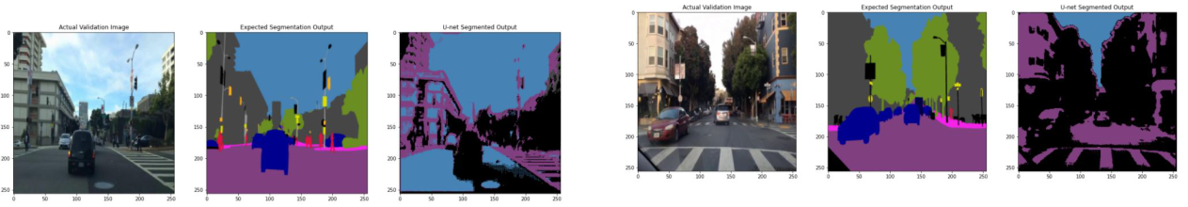

Figure 30: U-net segmented output
Figure 26: U-net segmented output

U-net MIOU accuracy and Loss
U-net MIOU accuracy and Loss
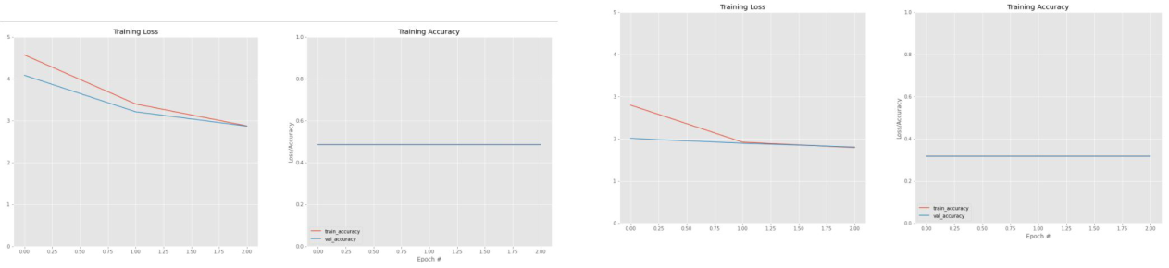

Figure 31: U-net segmented output

Figure 27: U-net segmented output

- With increased image size of 512 and batch size of 8:

Tweaking Hyper parameters

Sno | Classes | Img | batch | L.R | IOU | Loss
 |  | size | size |  | Accu.
1. | 41 | 512 | 8 | 0.01 | 48.41% | 2.1745
 |  | x512

 |  |  |  |  |  |  |  |  |  |  |  |  |  |  |  |  |  |  |  |  | 9
5) With 20 classes and batch size 32: |  |  |  |  |  |  |  |  |  | 1) With Batch size of 16
 |  | Tweaking Hyper parameters
 | Sno | Classes | Img |  | batch | L.R | IOU |  | Loss |  |  |  | Tweaking Hyper parameters
 |  |  | size |  | size |  | Accu. |  |  |  |  | Sno | Classes | Img |  | batch |  | L.R | IOU |  | Loss
 |  |  |  |  |  |  |  |  |  |  |  |  |  | size |  | size |  |  | Accu.
 | 1. | 20 | 256 |  | 32 | 0.01 | 31.73% |  | 2.1943 |  |  |  |  |  |  |  |  |  | Accu.
 |  |  | x256 |  |  |  |  |  |  |  |  | 1. | 41 | 256 |  | 16 |  | 0.01 | 48.45% |  | 2.3080
 |  |  |  |  |  |  |  |  |  |  |  |  |  | x256
 | U-net | segmented | Output |  |  |  |  |  |  |  |  |  |  | x256
 |  |  |  |  |  |  |  |  |  |  |  | Segnet | segmented | Output
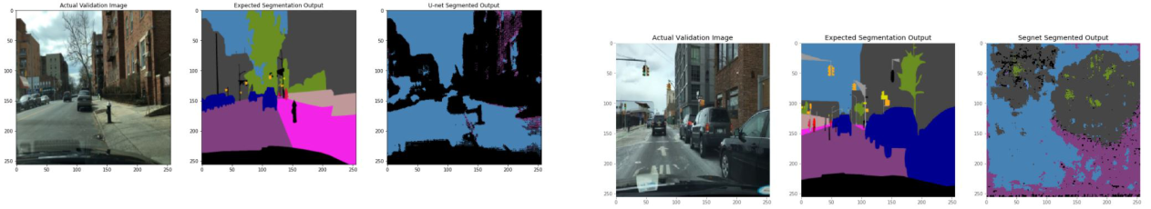

Figure 32: U-net segmented output

Figure 36: Segnet segmented output
U-net MIOU accuracy and Loss

Segnet MIOU accuracy and Loss
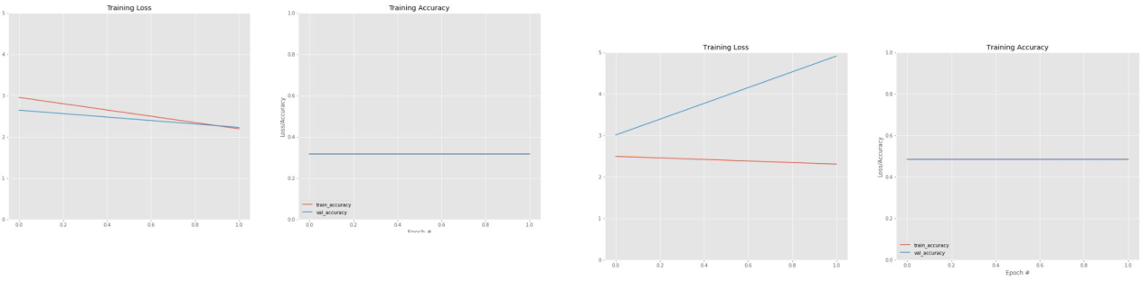

 | Figure 33: U-net segmented output
6) With 20 classes and image size 512: |  |  |  |  |  |  |  |  |  |  | Figure 37: Segnet segmented output
 |  | Tweaking Hyper parameters |  |  |  |  |  |  | 2) | With increased batch size of 32:
 | Sno | Classes | Img | batch | L.R |  | IOU | Loss | 2)
 |  |  | size | size |  |  | Accu. |  |  |  |  | Tweaking Hyper parameters
 |  |  |  |  |  |  |  |  |  |  | Sno | Classes | Img |  | batch | L.R |  | IOU | Loss
 | 1. | 20 | 512 | 8 | 0.01 |  | 31.70% | 2.01393
 |  |  | x512 |  |  |  |  |  |  |  |  |  | size |  | size |  |  | Accu.
 |  |  |  |  |  |  |  |  |  |  | 1. | 41 | 256 |  | 32 | 0.01 |  | 48.45% | 3.1875
 | U-net | segmented | Output
 |  |  |  |  |  |  |  |  |  |  |  |  | x256
 |  |  |  |  |  |  |  |  |  | Segnet segmented Output
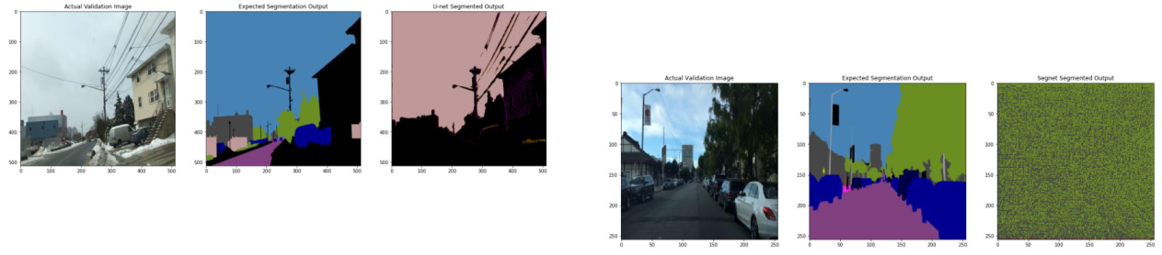

Figure 34: U-net segmented output

U-net MIOU accuracy and Loss
Figure 38: Segnet segmented output
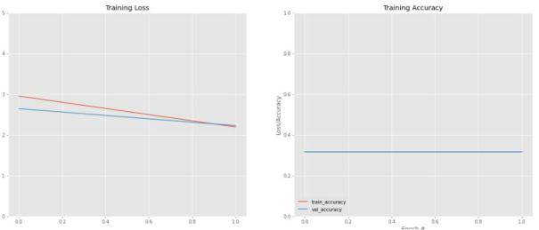

Segnet MIOU accuracy and Loss
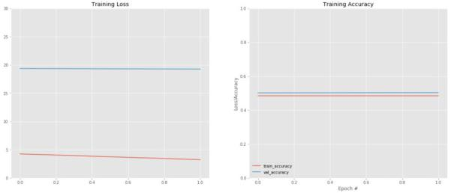

Figure 35: U-net segmented output

The following are the results obtained by running Seg-
net model in AWS giving various tweaks to the hyper Figure 39: Segnet segmented output parameters:
 |  |  |  |  |  |  |  |  |  |  |  |  |  |  |  |  |  | 10
3) With increased image size of 512 and batch size |  |  |  |  |  |  |  | 5) With 20 classes and batch size 32:
 | of 8: |  |  |  |  |  |  |  |  |  | Tweaking Hyper parameters
 |  | Tweaking Hyper parameters
 |  |  |  |  |  |  |  |  |  | Sno | Classes | Img |  | batch | L.R | IOU |  | Loss
 | Sno | Classes | Img | batch | L.R | IOU | Loss |  |  |  |  | size |  | size |  | Accu.
 |  |  | size | size |  | Accu.
 |  |  | size | size |  | Accu. |  |  |  | 1. | 20 | 256 |  | 32 | 0.01 | 31.73% |  | 1.8175
 | 1. | 41 | 512 | 8 | 0.01 | 48.42% | 2.3623 |  |  |  |  | x256
 |  |  | x512
 |  |  | x512 |  |  |  |  |  |  | Segnet | segmented | Output

Segnet segmented Output
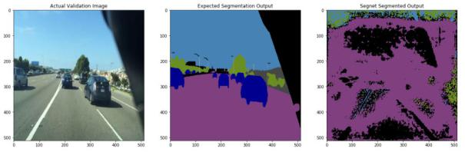

Figure 40: Segnet segmented output

Figure 44: Segnet segmented output
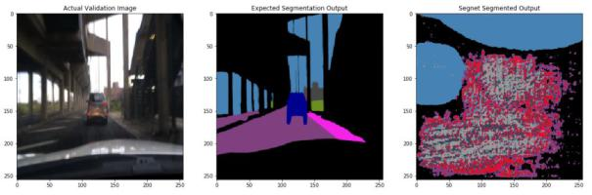

_{Segnet MIOU accuracy and Loss} Segnet MIOU accuracy and Loss
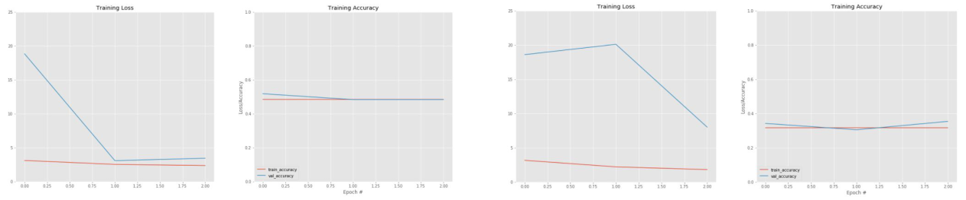

 | Figure 41: Segnet segmented output |  |  |  |  |  |  |  |  |  |  | Figure 45: Segnet segmented output
4) With 20 classes: |  |  |  |  |  |  |  |  |  |  | 6) With 20 classes and image size 512:
 |  | Tweaking Hyper parameters
 |  |  |  |  |  |  |  |  |  |  |  |  | Tweaking Hyper parameters
 | Sno | Classes | Img |  | batch | L.R |  | IOU | Loss
 | Sno | Classes | Img |  | batch | L.R |  | IOU | Loss |  |  | Sno | Classes | Img |  | batch | L.R |  | IOU | Loss
 |  |  | size |  | size |  |  | Accu. |  |  |  | Sno | Classes | Img |  | batch | L.R |  | IOU | Loss
 |  |  | size |  | size |  |  | Accu. |  |  |  |  |  | size |  | size |  |  | Accu.
 | 1. | 20 | 256 |  | 16 | 0.01 |  | 31.74% | 1.7805 |  |  |  |  | size |  | size |  |  | Accu.
 | 1. | 20 | 256 |  | 16 | 0.01 |  | 31.74% | 1.7805 |  |  | 1. | 20 | 512 |  | 8 | 0.01 |  | 31.70% | 1.7675
 |  |  | x256 |  |  |  |  |  |  |  |  | 1. | 20 | 512 |  | 8 | 0.01 |  | 31.70% | 1.7675
 |  |  | x256 |  |  |  |  |  |  |  |  |  |  | x512
 | Segnet segmented Output |  |  |  |  |  |  |  |  |  |  |  |  | x512
 |  |  |  |  |  |  |  |  |  |  | Segnet segmented Output
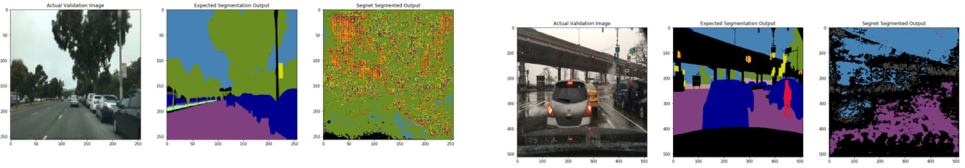

Figure 42: Segnet segmented output
Figure 46: Segnet segmented output

Segnet MIOU accuracy and Loss

Segnet MIOU accuracy and Loss
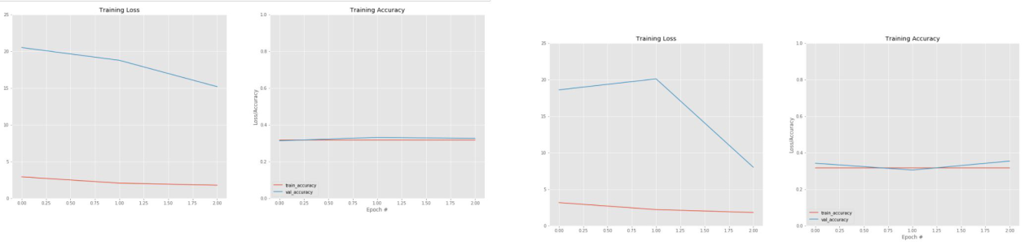

Figure 43: Segnet segmented output

Figure 47: Segnet segmented output

11

- CITYSCRAPES DATASET

Semantic segmentation was performed on Cityscrapes dataset which consisted of 5000 images and labels. 2975 images were used for training, 500 for validation and re-maining 1525 images were used for testing. The following are the results obtained by testing different architectures on the dataset. The training took a total of 22 EPOCHS.

- U-net

U-net architecture gave a maximum Mean IOU accu-racy of 53.29%. The following images shows the outputs obtained:

With 29 classes and batch size 16:

The following are the IOU accuracy of each class:

U-net IOU accuracy per class
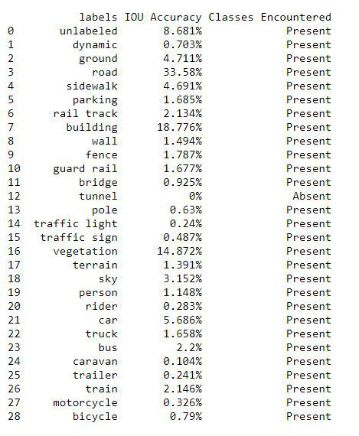

Tweaking Hyper parameters

Sno | Classes | Img | batch | L.R | IOU | Loss
 |  | size | size |  | Accu.
1. | 29 | 256 | 16 | 0.01 | 53.29% | 0.3350
 |  | x256

U-net segmented Output
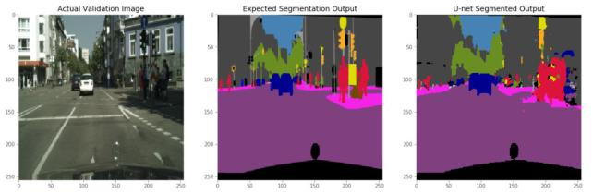

Figure 48: U-net segmented output

U-net MIOU accuracy and Loss
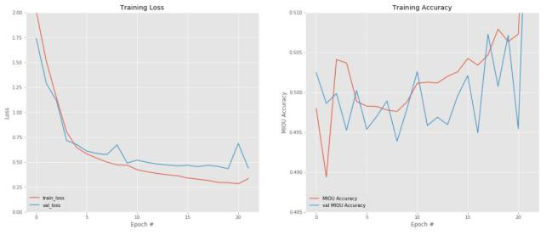

Figure 51: U-net IOU accuracy per class

- Segnet

Segnet architecture gave a maximum Mean IOU accu-racy of 47.37%. The following images shows the outputs obtained:

With 29 classes and batch size 16:

 |  |  | Tweaking Hyper parameters
 |  | Sno | Classes | Img | batch | L.R | IOU |  | Loss
 |  |  |  | size | size |  | Accu.
Figure 49: U-net Precision vs Recall Graph |  | 1. | 29 | 256 | 16 | 0.01 | 47.37% |  | 0.4943
U-net Precision vs Recall Graph |  |  |  | x256
U-net Precision vs Recall Graph | Segnet segmented Output
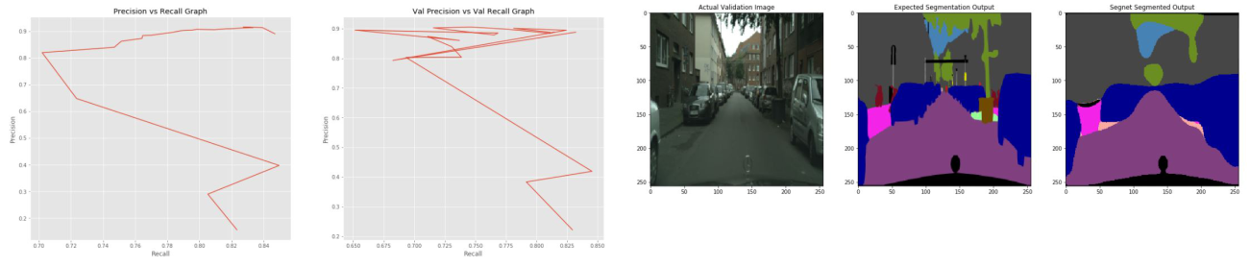

Figure 52: Segnet segmented output

Figure 50: U-net segmented output

12

Segnet MIOU accuracy and Loss C. ICnet

ICnet architecture gave a maximum Mean IOU accu-racy of 48.39%. The following images shows the outputs obtained:
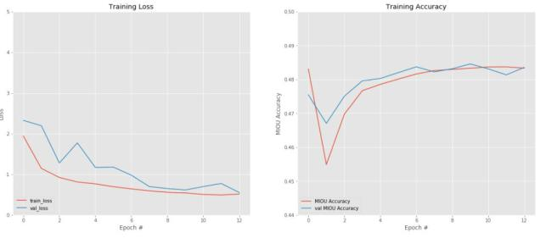
With 29 classes and batch size 16:

Tweaking Hyper parameters

Sno | Classes | Img | batch | L.R | IOU | Loss
 |  | size | size |  | Accu.
1. | 29 | 256 | 16 | 0.01 | 48.39% | 0.4134
 |  | x256

ICnet segmented Output

Figure 53: Segnet Precision vs Recall Graph
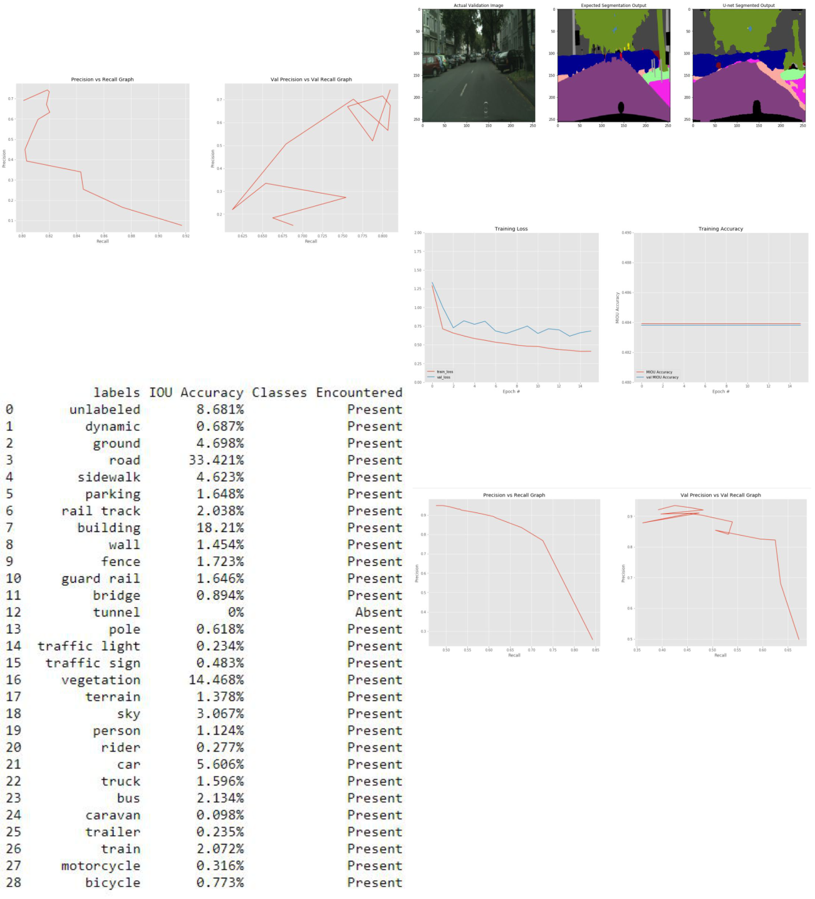

Segnet Precision vs Recall Graph

Figure 56: ICnet segmented output

ICnet MIOU accuracy and Loss

Figure 54: Segnet segmented output

The following are the IOU accuracy of each class:

Segnet IOU accuracy per class

Figure 57: ICnet Precision vs Recall Graph

ICnet Precision vs Recall Graph

Figure 58: ICnet segmented output

Figure 55: Segnet IOU accuracy per class

13

The following are the IOU accuracy of each class:

ICnet IOU accuracy per class
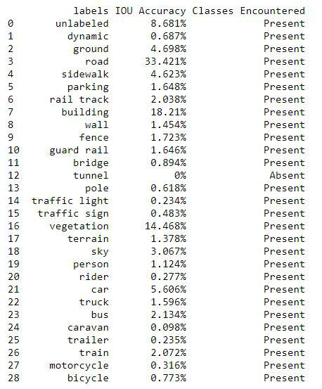

Figure 59: ICnet IOU accuracy per class

XI. REFERENCES:

https://www.expii.com/t/intro-to-linear-vs-nonlinear-functions-4318

- V, A. (2017, March 30). Understanding Activation Functions in Neural Networks. Retrieved July 02, 2020, from https://medium.com/the-theory-of-everything/understanding-activation-functions-in-neural-networks-9491262884e0

- KIDS, T. (2019, July 31). Fully-Connected Layer with dynamic input shape. Retrieved July 03, 2020, from https://medium.com/@tecokids.monastir/fully-connected-layer-with-dynamic-input-shape-70c869ae71af

- Singh, S. (2019, March 02). Fully Connected Layer: The brute force layer of a Machine Learning model. Retrieved July 03, 2020, from https://iq.opengenus.org/fully-connected-layer/

- Uniqtech. (2020, April 21). Understand the Softmax Function in Minutes. Retrieved July 03, 2020, from https://medium.com/data-science-bootcamp/understand-the-softmax-function-in-

minutes-f3a59641e86d

11) (PDF) A Deep Feature Learning Method for Drill Bits Monitoring Using the Spectral Analysis of the Acoustic Signals. (n.d.). Retrieved July 03, 2020, from https://www.researchgate.net/publication/327007086 A Deep Feature Learning Method for Drill Bits Monitoring Using the Spectral Analysis of the Acoustic Signals

- Daniil’s blog. (n.d.). Retrieved July 03, 2020, from http://warmspringwinds.github.io/tensorflow/tf-slim/2016/11/22/upsampling-and-image-segmentation-with-tensorflow-and-tf-slim/

1) | Layers of a Convolutional Neural Network. (2020, | 13) | 2018 Data Science Bowl. (n.d.). Retrieved July 06,
 | March 02). Retrieved from https://mc.ai/layers-of-a- |  | 2020, from https://www.kaggle.com/c/data-science-
 | convolutional-neural-network/ |  | bowl-2018/data
2) | MACMAC 51644 silver badges1414 bronze badges. | 14) | Jcoral. | (2019, | August | 25). | CamVid.
 | (1969, October 01). Understanding Gaussian |  | Retrieved | July | 06, | 2020, | from
 | Filter and how to plot it in 1-D. Retrieved from |  | https://www.kaggle.com/jcoral02/camvid
 | https://stackoverflow.com/questions/60462388/understanding15) |  | -Badrinarayanan, Vijay, et al. “SegNet: A Deep
 | gaussian-filter-and-how-to-plot-it-in-1-d |  | Convolutional Encoder-Decoder Architecture for
3) | Anh H. Reynolds. (2017, October 15). Convolu- |  | Image Segmentation.” ArXiv.org, 10 Oct. 2016,
 | tional Neural Networks (CNNs). Retrieved from |  | arxiv.org/abs/1511.00561.
 | https://anhreynolds.com/blogs/cnn.html | 16) | Profile, bdd-data.berkeley.edu/portal.html.
- Diterbitkan oleh Benny Prijono Lihat semua pos dari Benny Prijono, Prijono, D., Prijono, B., Lihat semua pos dari Benny Prijono, 14, P., Berkata:, P., . . . (wajib), N. (2018, April 03). Student Notes: Convolutional Neural Networks (CNN) Introduction. Retrieved June 26, 2020, from https://indoml.com/2018/03/07/student-notes-convolutional-neural-networks-cnn-introduction/

- Sakshi TiwariCheck out this Author’s contributed

articles., Sakshi Tiwari, amp; Check out

this Author’s contributed articles. (2018,

February 06). Activation functions in Neural

Networks. Retrieved June 26, 2020, from

https://www.geeksforgeeks.org/activation-functions-

neural-networks/

- Intro to Linear vs. Nonlinear Functions. (n.d.). Retrieved June 26, 2020, from

