Create a database with name : datastore and Scheme should be public

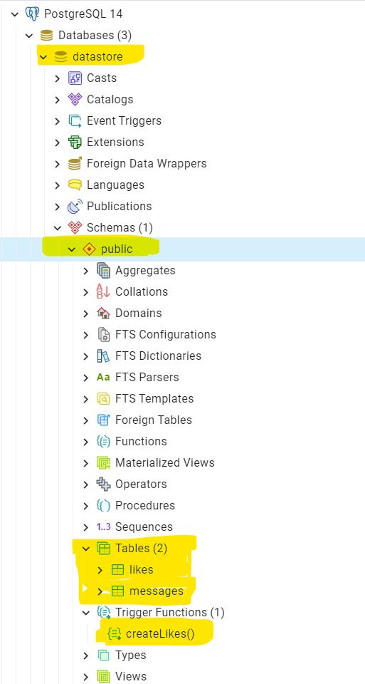

SQL code for messages ,likes and createlikes (trigger) is shared in git repository link .Please use that and create similar tables as shown in below screenshots

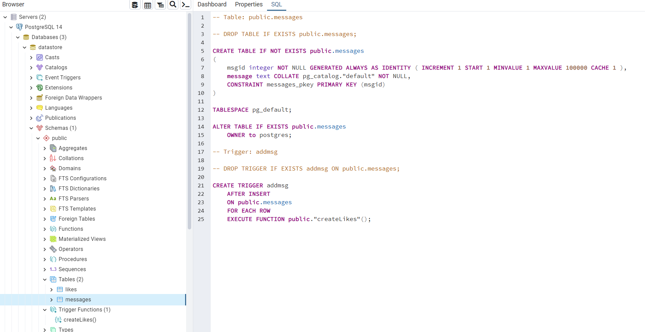

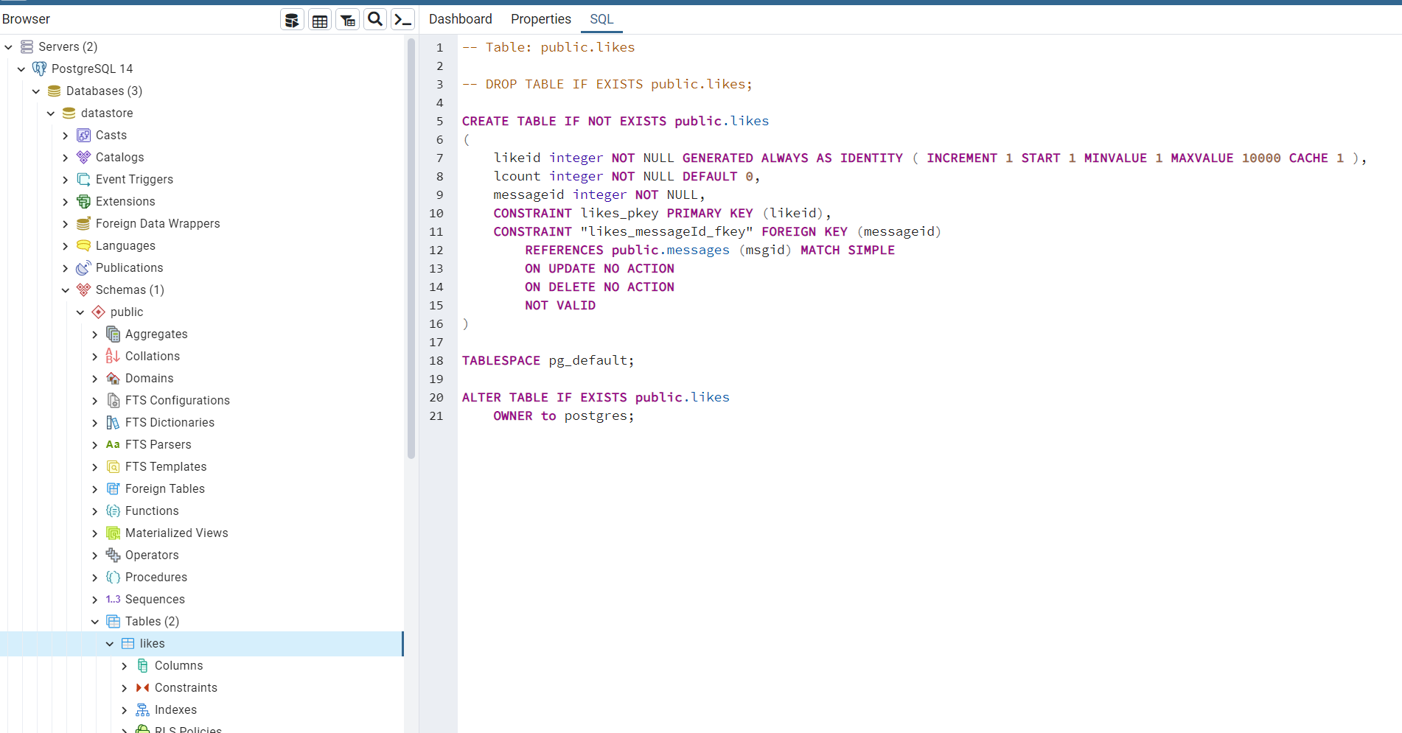

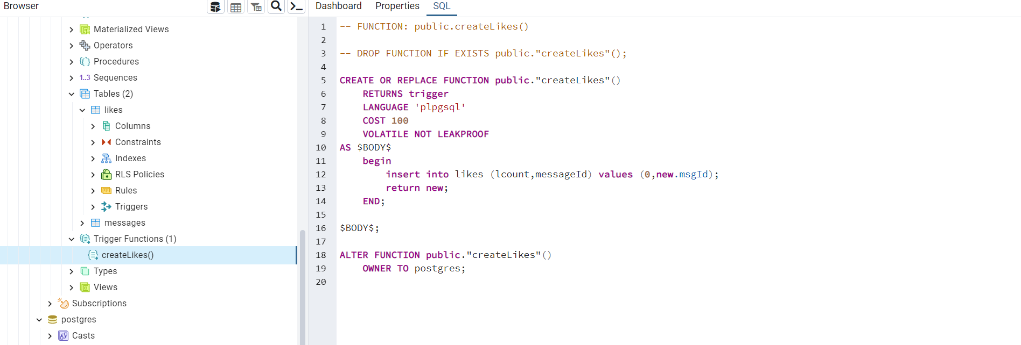

Setting flask APP

Connecting to data base

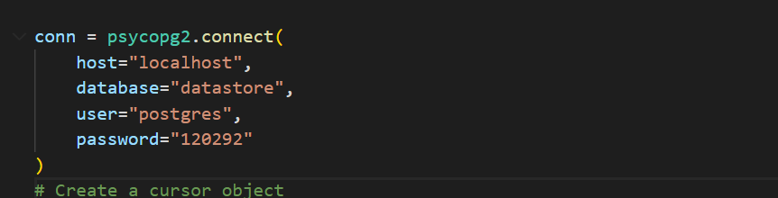

Please change the User name and password as per your pgadmin4 settings.

Creating flask environment is similar to standard flask venv setup as shown in the below link   
[Installation — Flask Documentation (2.2.x)](https://flask.palletsprojects.com/en/2.2.x/installation/)

Dependent modules

1.psycopg2

Pip install psycopg2

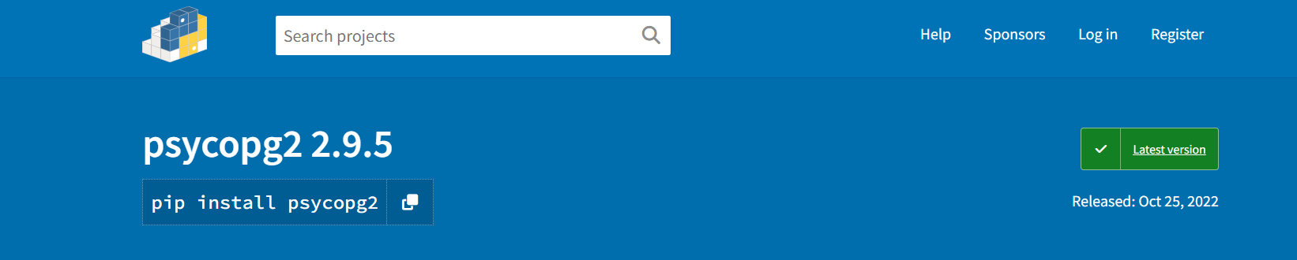

Use the following command to run the api

flask --app flaskAPI run --reload