Hong Kong Baptist University
Department of Computer Science

COMP4145 Business Intelligence, Decision Support and Project Development

Using GitHub Copilot in VS Code

Introduction to software development

Architecture
Frontend is the client-side part of the application that users interact with directly. It includes everything the user experiences visually on the screen, such as layouts, buttons, text, images, and overall design. Frontend developers primarily work with three core technologies: HTML (HyperText Markup Language) for structuring content, CSS (Cascading Style Sheets) for styling and layout, and JavaScript for adding dynamic functionality and interactivity.
Backend is the server-side part of the application that handles business logic, database interactions, and server configuration. It is responsible for processing requests from the frontend, performing operations, and sending back responses. Backend technologies include programming languages such as Java, Python, Node.js, or PHP, along with databases, APIs (Application Programming Interfaces), and server infrastructure.
By hosting both the frontend and backend on a server, the software application becomes accessible to users over the internet. There are two primary hosting approaches for web applications: integrated hosting, where frontend and backend are served from the same server; and externally hosted, where frontend and backend are deployed on separate servers.
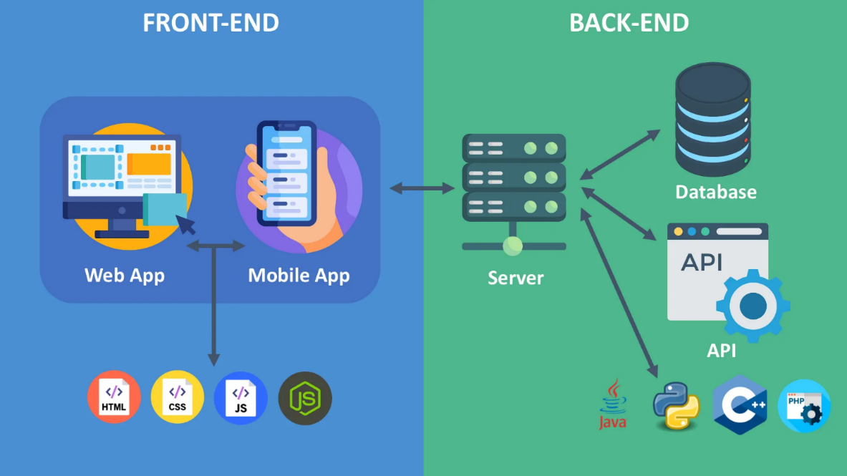

Software prototype development
Software prototype development involves creating an early model of a software application to demonstrate its features and functionalities. This process helps in visualizing the end product, getting feedback, and making improvements before full-scale development.

Vibe coding and GitHub Copilot in VS Code
Vibe coding is a new approach to software development that relies on AI to generate, refine, and debug code from natural language prompts. The term "vibe" refers to the intuitive, conversational nature of this approach, where developers describe what they want their software to do (the intent or "vibe") and allow AI to handle the technical implementation details.
It helps developers focus more on problem-solving and high-level design decisions rather than routine coding tasks, enabling faster prototyping and more efficient development cycles. However, successful implementation requires developers to maintain their understanding of the generated code and apply appropriate review and testing practices to ensure code quality and security.
In this lab, we are going to make use of vibe coding to create a simple web app. We are going to use GitHub Copilot in Visual Studio Code (VS Code).

Visual Studio Code (VS Code) is one of the most popular and versatile code editors in modern software development, designed to support developers working across multiple programming languages and platforms. Developed by Microsoft and released as open-source software, VS Code is a lightweight yet powerful code editor that runs on Windows, macOS, and Linux, providing a consistent development experience across different operating systems.
The strength VS Code lies in its multi-language support capabilities. While it comes with built-in support for JavaScript, CSS, and HTML, it can be extended to support virtually any programming language through its vast ecosystem of extensions. Whether developers are working with Python, Java, C++, C#, PHP, or other languages, VS Code can be configured to provide syntax highlighting, intelligent code completion, debugging, and other language-specific features.
GitHub Copilot, an AI-powered coding tool integrated into VS Code, provides code suggestions, explanations, and automated implementations based on natural language prompts and existing code context. It supports various AI models and coding assistants, including various versions of OpenAI's GPT, Anthropic's Claude, and Google's Gemini.

Common programming language: Java vs Python

Java
Developed by James Gosling at Sun Microsystems and first released in 1995, Java was designed with the revolutionary principle of "Write Once, Run Anywhere" (WORA), fundamentally changing how developers approach cross-platform software development. This principle enables Java applications to run on any device or operating system that supports the Java Virtual Machine (JVM), making it an ideal choice for building portable, scalable software solutions.
The architectural foundation of Java is built on object-oriented programming principles, emphasizing code reusability, modularity, and maintainability. With the ability to integrate with modern frontend technologies through RESTful APIs, Java becomes an excellent choice for full-stack development, where Java handles backend logic while communicating with frontend applications built using JavaScript frameworks.

Python
Python has emerged as one of the most popular and versatile programming languages in the modern software development landscape, renowned for its simplicity, readability, and extensive application domains. It excels in web development through frameworks like Django and Flask, data science and analytics with libraries like NumPy and Pandas, artificial intelligence and machine learning with TensorFlow and PyTorch.
Python's core characteristics center around its interpreted nature, dynamic typing, and syntax that resembles natural language. The backend strengths of python include excellent database connectivity, robust security features, and seamless integration with other technologies and services. While Python is not traditionally used for client-side web development, it can power frontend applications through frameworks like Streamlit for data applications or by serving as the backend for single-page applications built with JavaScript frameworks. Python's ability to generate dynamic HTML content and its integration with modern frontend technologies through APIs makes it a valuable component in full-stack development scenarios.

Comparison between Java and Python
Feature | Java | Python
Syntax | Uses curly braces {} and semicolons. Verbose and strict syntax rules. | Uses indentation to define blocks. Clean and beginner-friendly syntax.
Compilation | Compiled to bytecode, then run on the Java Virtual Machine (JVM). | Interpreted at runtime. It makes development faster.
Typing | Statically typed. Variable types must be declared explicitly. | Dynamically typed. Variable types are inferred and can change at runtime.
Performance | Generally faster due to Just-In-Time (JIT) compilation and JVM optimizations. | Slower because it's interpreted and dynamically typed, though performance can be improved.
Learning Curve | Steeper due to complex syntax and object-oriented structure. | Easier for beginners due to simplicity and readability. Often used as a first programming language.
Code Length | More verbose; simple programs often require multiple lines of boilerplate code. | More concise; same programs can be written in fewer lines.
Platform Independence | Runs on any system with JVM. "Write once, run anywhere" principle. | Runs using the Python interpreter, available on most platforms.
Use Cases | Suitable for enterprise applications, Android apps, large-scale systems, and backend development. Front end tools are HTML, CSS, and JavaScript (along with frameworks and libraries like React, Angular, or Vue.js) | Popular in data science, machine learning, automation, scripting, and web development.

Objectives
By finishing this lab session, you should be able to:
- Understand the concepts of software prototype development
- Understand the key functions of Copilot and how to execute code in a terminal environment
- Create and deploy simple projects using VS Code and Copilot

Tools
- Visual Studio Code (VS Code)
- GitHub Copilot
- Python

Part A: Before you get started

Get your GitHub education account
- Create a new GitHub account. If you have an existing GitHub account, you may skip this step.  https://github.com/ | 
- Click on your icon on the navbar, and choose Your Copilot. |   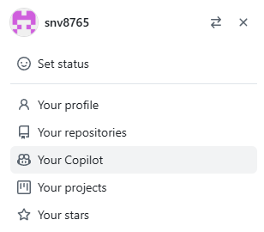
- Choose Billing and licensing, then choose Education benefits. | 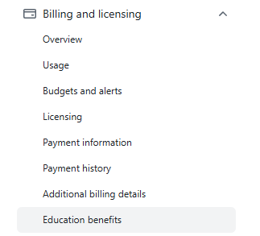
- Choose Start an application.  Fill in the information. If you are not using school email address for you GitHub account, choose Add it here to add it.  Choose Share Location, and Continue.  Then, upload a picture of your student ID card for the proof of your academic status.  After submitting your application, you should get the confirmation email after a few days. | 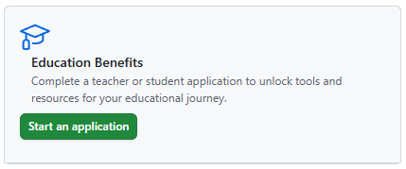  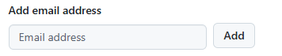
- You can redeem the copilot pro coupon after applying GitHub education.  For GitHub copilot free, it is limited to 2,000 code completions and 50 chat requests per month (approximately 80 completions per working day)  For GitHub copilot Pro, there is unlimited completions, access to premium models in Copilot Chat, access to Copilot coding agent.  You may add more models and save your changes.  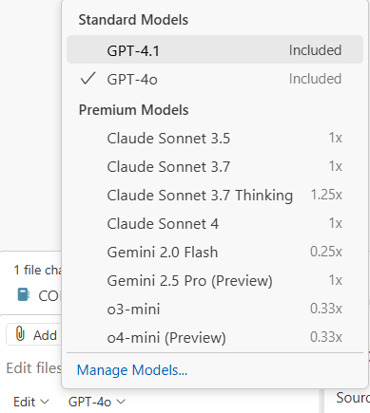 | 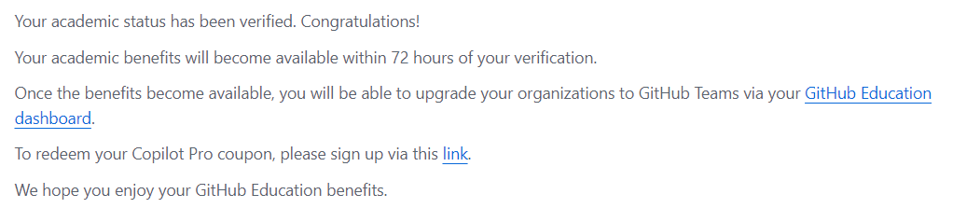  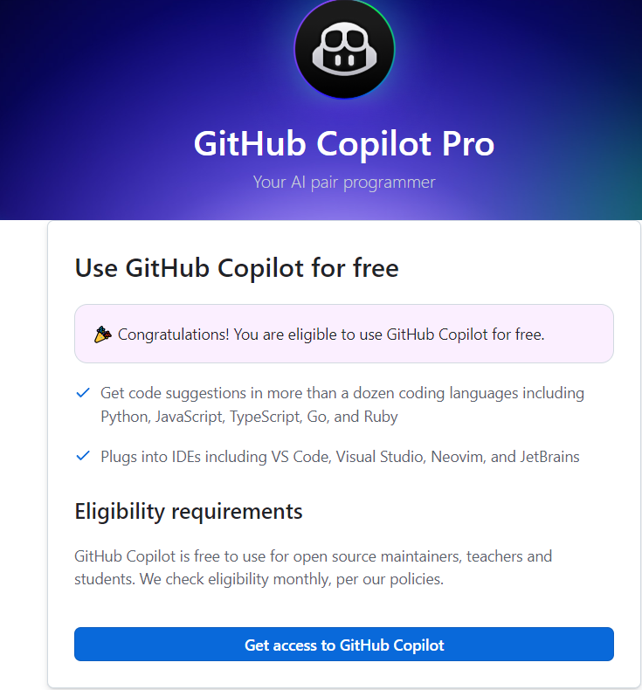  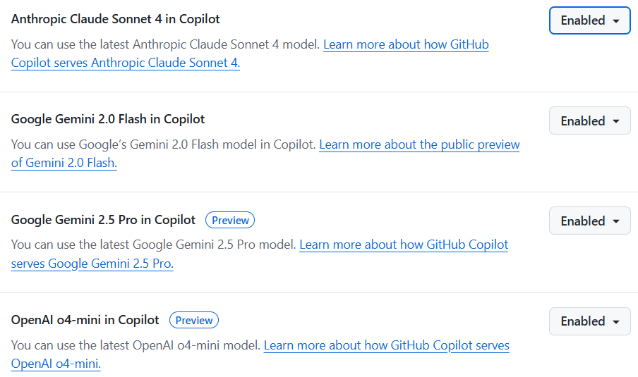

- Do check out if your education license is activated.  Go to:  https://github.com/settings/education/benefits  Check if your application is approved. Click “Link”. Review your setting, click “Complete and Save the settings”.  You will see a “congratulations!” statement.  Following this, re-login to your VS Code and test your copilot again.  You should see “unlimited” chat messages and “premium models” as shown below. | 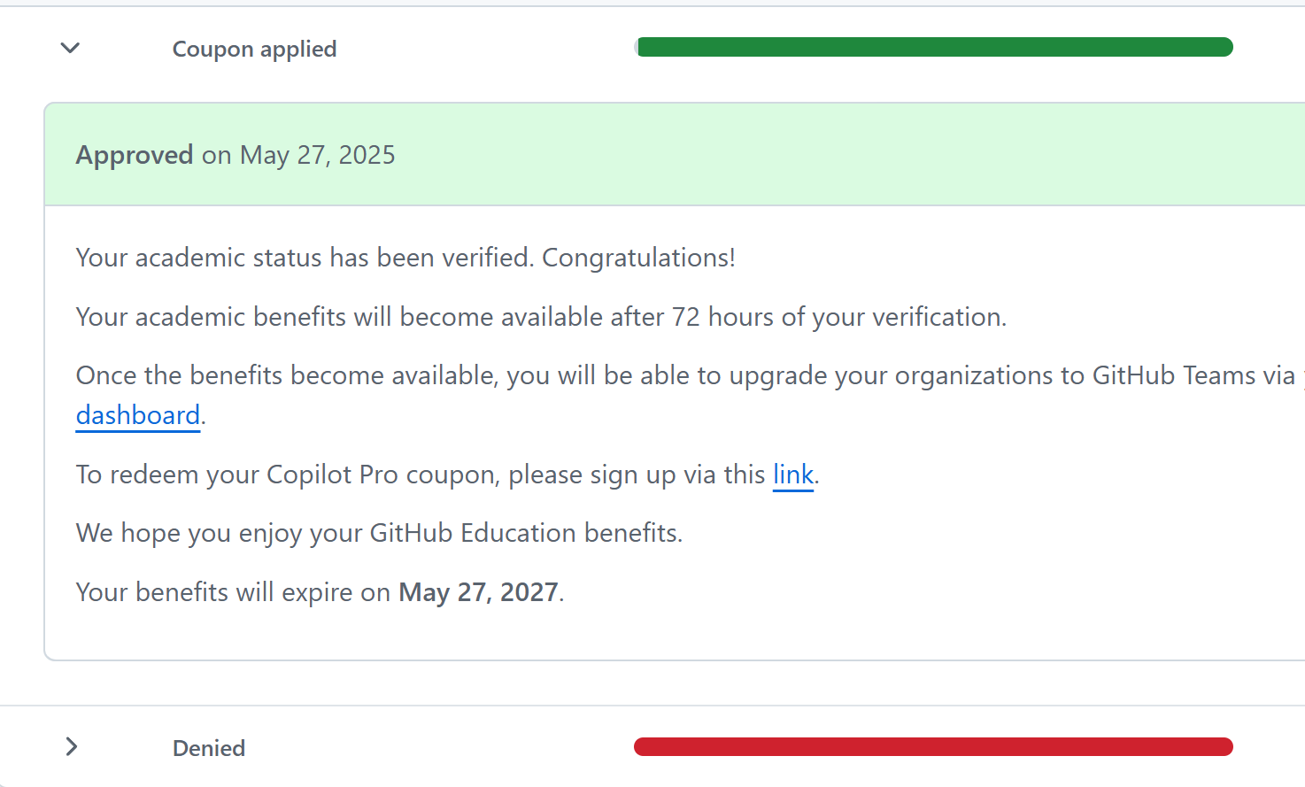

Activate GitHub Copilot Pro and set up in Visual Studio Code
(Remark: you can still use GitHub Copilot Free if your education account is not ready for use.)
- Open Visual Studio Code. Choose Set Up Copilot for Free, choose your theme, and then choose Sign in to Use Copilot Free. | 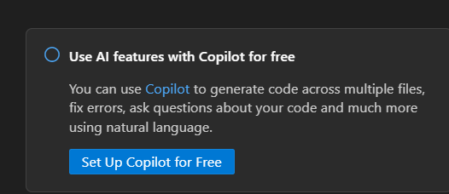  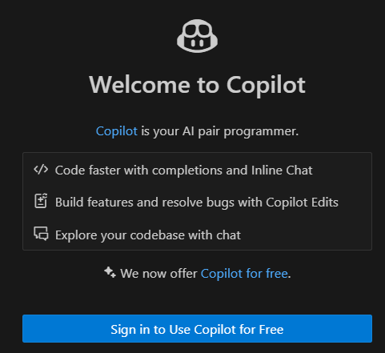
- Sign in to GitHub.  Select user to authorize VS Code by pressing Continue. | 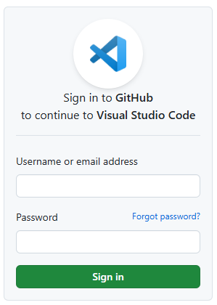  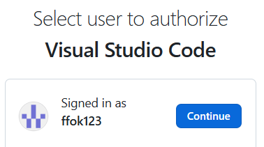
- Choose Open Visual Studio Code. | 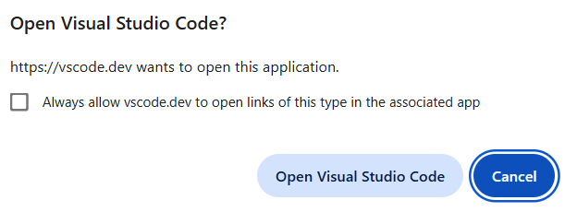
- Click on the Extension button  on the left navbar. Search the following, update or install (if not installed yet):  - GitHub Copilot  - GitHub Copilot Chat  - Python  - Python Debugger | 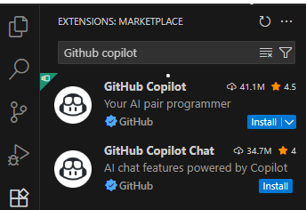  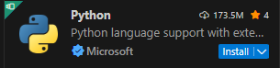  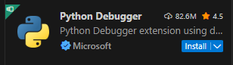

Part B: Create a simple python code
- Select Explorer 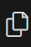 . Click Open Folder and then create a new folder named COMP4145_lab1_calculator. Then select that folder.  Trust the authors. | 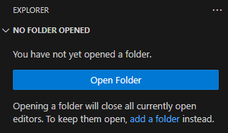  
- Create a python file:  Choose File, then New File.  Enter the filename test.py, and choose Create New File. | 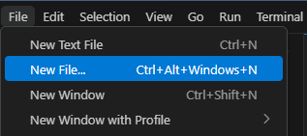  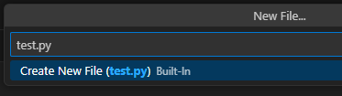
- Open Copilot Chat:  Click on the button, then choose Open Chat. Or use the Shortcut: Ctrl+Shift+I | 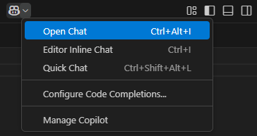

It directly lays in the right windows:
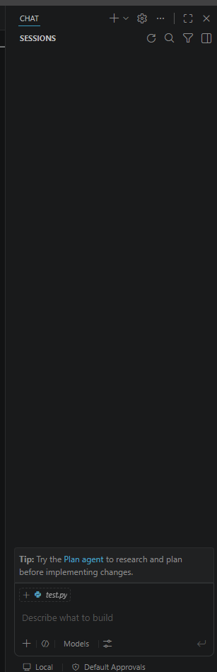

There are three modes for the Copilot: Ask, Edit, Agent.
Ask mode
- for answering questions about your codebase, coding, and general technology concepts.
Plan mode
- researches and outline multi-step plans
Agent mode
- for making autonomous edits across multiple files in your project
- determines the relevant context and tasks to accomplish the request
- useful for a less well-defined tasks that require invocation of tools and terminal commands.

- Choose Agent mode. | 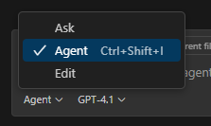
- Choose auto | 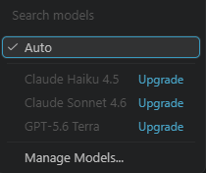
- Use the prompt:  “Create a simple calculator in Python with basic arithmetic operations” | 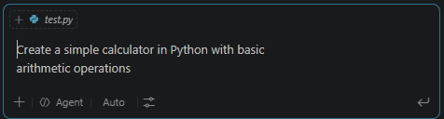
- Check and keep the changed file. | 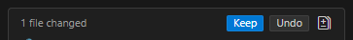
- Use the prompt:  “Run python test.py in the terminal”  Or click the allow to automatically test. | 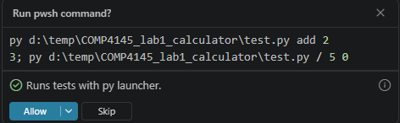  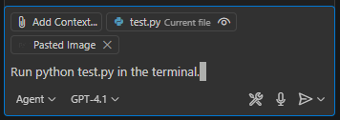
- Choose Continue, and then Select an existing Python Environment. Select your Python path. | 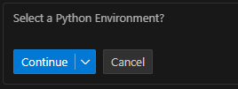  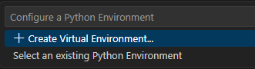  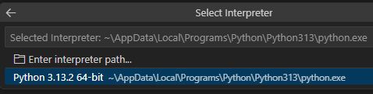
- Choose Continue to run the command. Then, the script should be run in the terminal. (comments: sometimes the results is not the same. For example like: 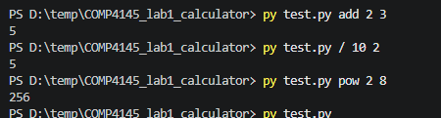  - if you need align with the example, you can directly use example as image prompt to ask it the desired format. | 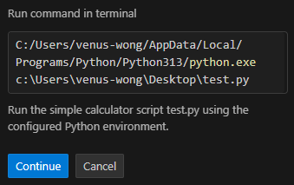  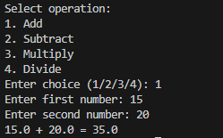

Part C: Create an interactive web page
- Use the prompt:  “I want to create an interactive web page, so users can click the calculator key. The application should be deployed in a local server” | 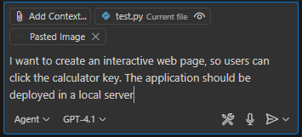  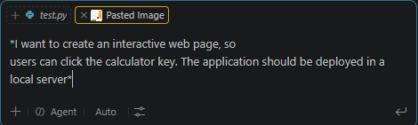  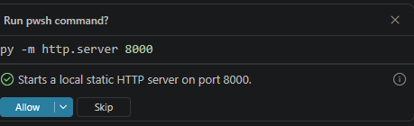  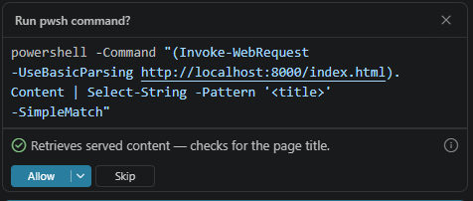
- Choose Continue to install flask. | 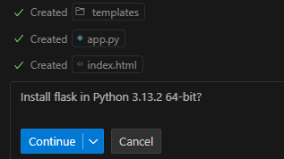

Flask is an open-source web framework written in Python. It is called a "micro-framework" because of its lightweight core and modular design, which provides essential web development tools without imposing rigid structural requirements. There are other popular frameworks, such as Django.
Flask is ideal for:
- Small to medium-sized web applications
- RESTful APIs and microservices
- Prototyping and MVPs (Minimum Viable Products)
- Learning web development with Python

Advantages of using Flask:
- Simplicity: Easy to learn and use, especially for beginners.
- Flexibility: Choose your tools and libraries.
- Modularity: Add only what you need.
- Community support: Extensive documentation and active developer community.

- Check and keep the changed files. | 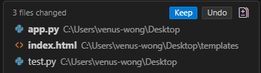
- Choose Continue. Click the button to insert the command into Terminal.  Click and open the URL, the calculator web app should appear in the browser.  Press CTRL+C if you want to quit. | 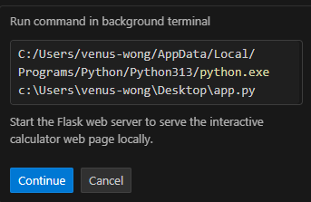  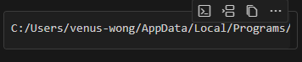  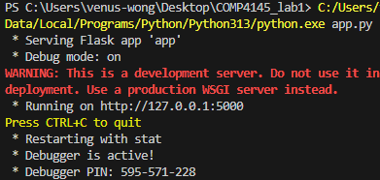  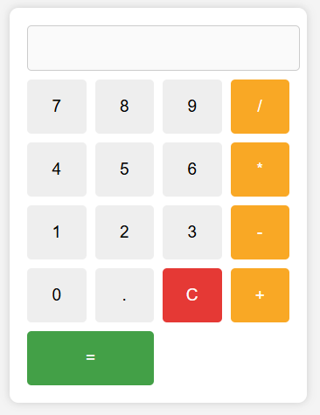

Part D: Create a large language model chat window
- Open Visual Studio Code.  Choose File, then New Window. | 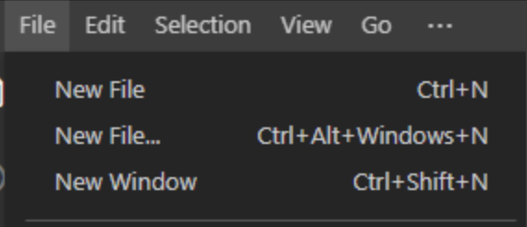
- Select Explorer .  Click Open Folder and create a new folder named COMP4145_lab1_chat. Then select that folder. Trust the authors. | 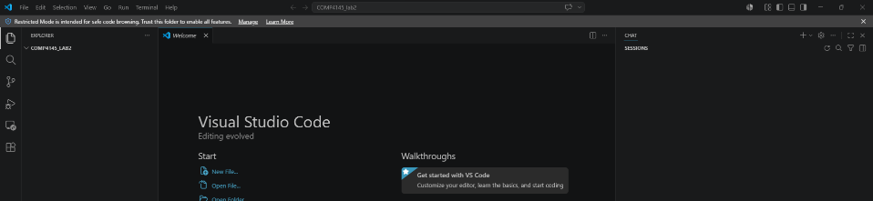  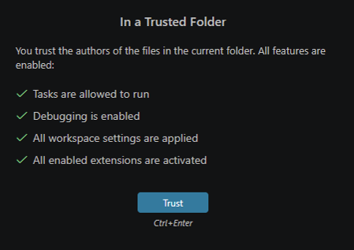
- Create a python file:  Choose File, then New File.  Enter the filename chat.py, and then choose Create New File. | 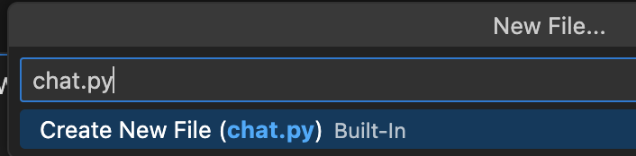
- Open Copilot Chat:

Click on the button, then choose Open Chat. Or use the Shortcut: Ctrl+Shift+I

- Choose Agent mode.

Choose Gemini 3.5 Flash for the model.
Auto mode
Thinking Effort: Medium
- Sign in to the HKBU GenAI Platform:  https://genai.hkbu.edu.hk/ | 
- After signing in, click the profile & Settings on the bottom-left corner. Then, choose API.  Click Generate to get your API key. To copy it, click the button. | 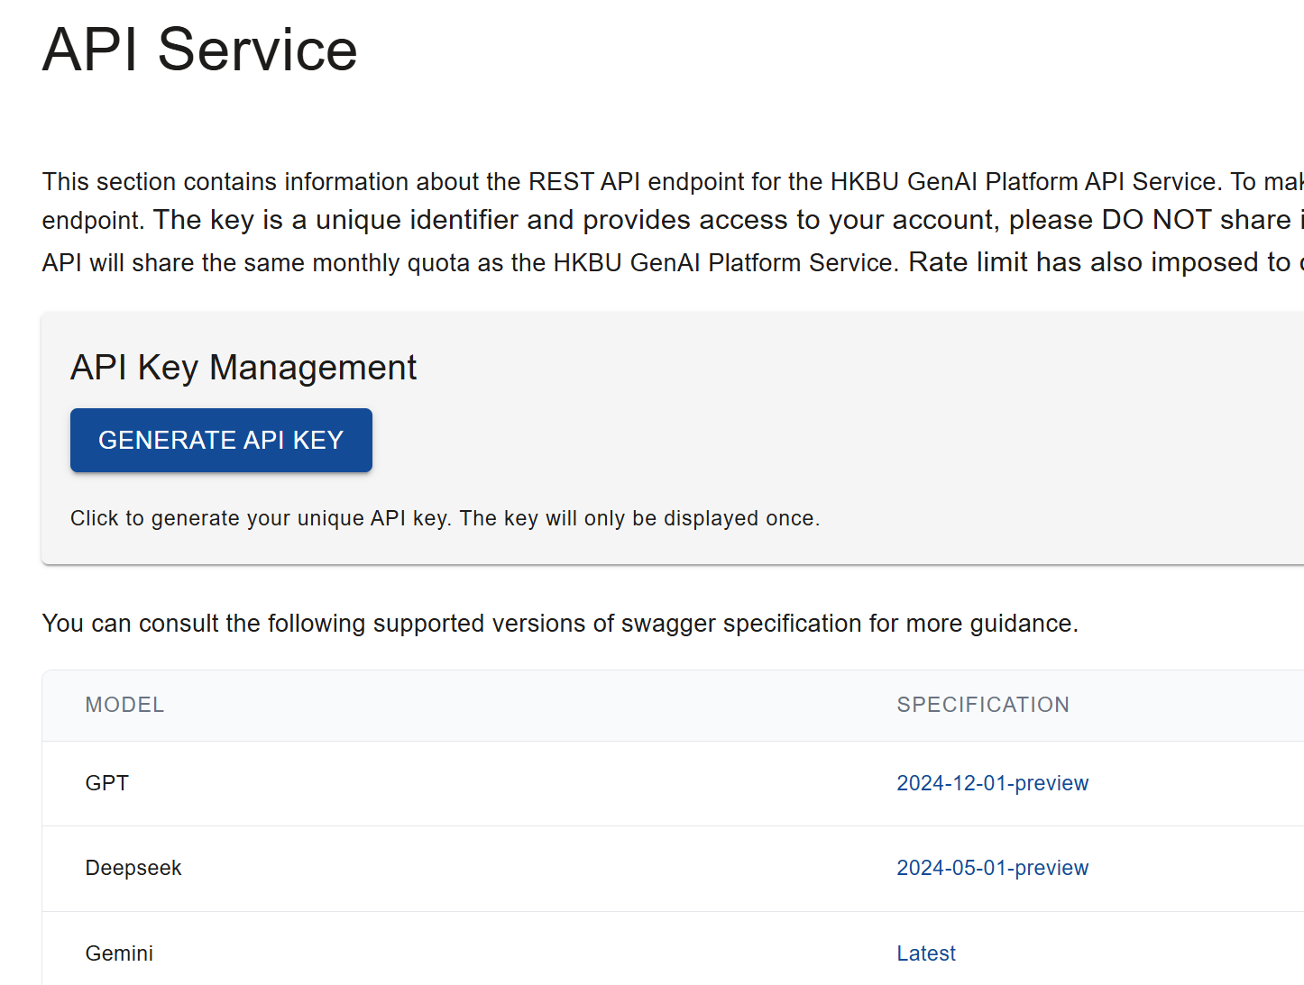  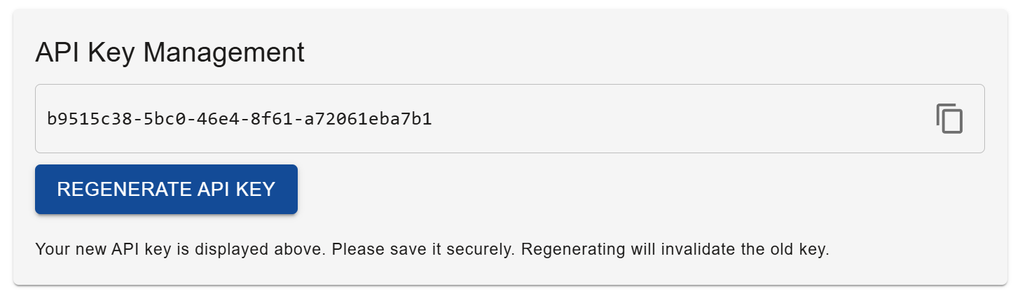
- Click on the specification link for the gemini-2.5-pro model.  You can then copy the endpoint URL, and the POST request path. | 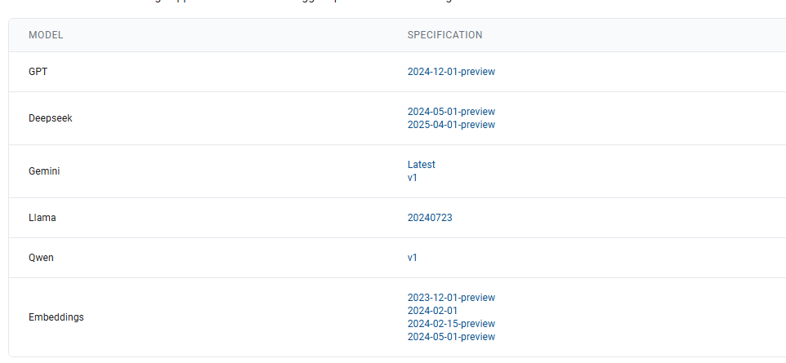  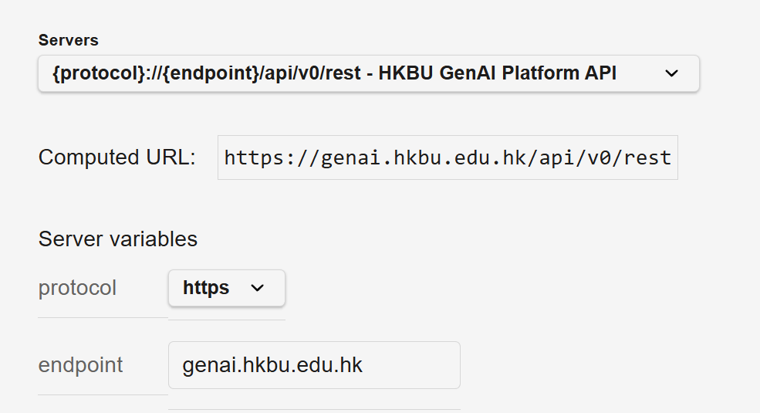  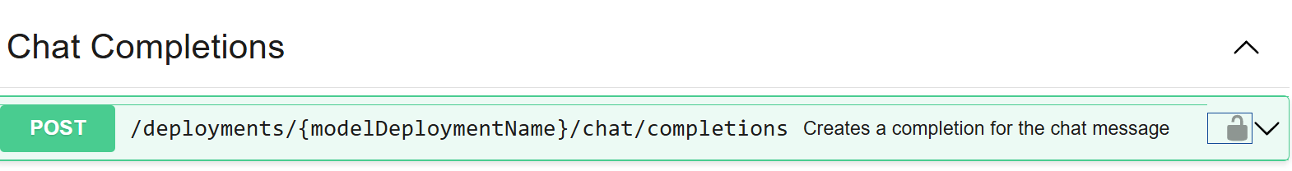
- In VS Code Copilot Chat, use the prompt:  “API key: (paste your API key)  API_URL = "https://genai.hkbu.edu.hk/api/v0/rest/deployments/gemini-2.5-pro/chat/completions?api-version=v1"  Help me create a large language model chat window in the terminal with the model gemini-2.5-pro.”  If you see error like 401, directly tell the error and let it repair this error: | 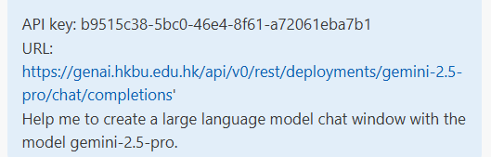
- You may ask copilot in the prompt, “run the script’ then click Continue or run command python app.py in the terminal  You may need to click “Allow” in permission request. | 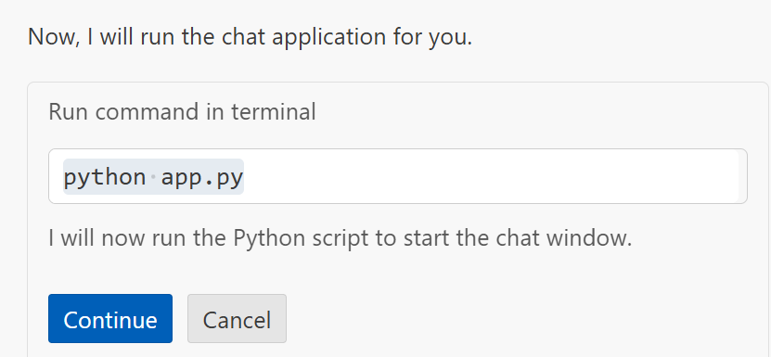  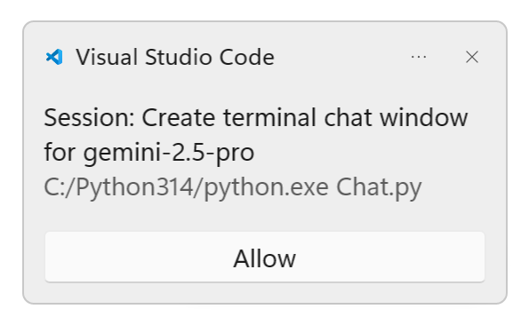
- You should see that you can chat with Gemini in the terminal. You may also create a virtual environment, or a browser that can link to Gemini 2.5 pro at home. Take note of the permission requirement in the lab.

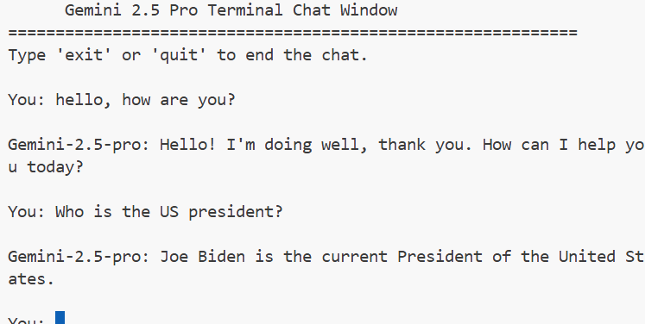

Appendix – Introduction to framework
A framework is a structured software foundation that offers reusable components and services, which developers can build upon with custom code to develop tailored applications. Rather than reinventing common functionality like user authentication, database connections, or HTTP request handling, frameworks provide these capabilities as ready-made components that developers can integrate and customize. This approach significantly reduces development time, minimizes the likelihood of bugs, and ensures that applications follow established best practices and security standards. Frameworks also promote consistency across projects and development teams, making it easier to maintain and extend applications over time.
Framework categories span different aspects of software development, each addressing specific technological needs. Frontend frameworks like React, Angular, and Vue.js focus on creating dynamic user interfaces and managing client-side application state. Backend frameworks such as Django, Flask, Spring Boot, and Express.js handle server-side logic, database interactions, and API development. Full-stack frameworks provide integrated solutions that cover both frontend and backend development, while specialized frameworks address specific domains like machine learning, mobile development, or game development. The choice of framework depends on project requirements, team expertise, and the specific technological challenges being addressed.
Wilson HKBU GenAI API Key: 6cf29f54-040f-4b69-9334-0ed298285d94

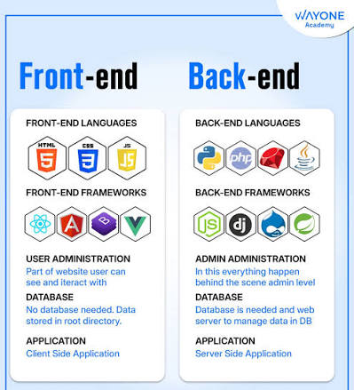

References

- https://aws.amazon.com/compare/the-difference-between-frontend-and-backend/
- https://www.ssw.com.au/rules/do-you-know-where-to-host-your-frontend-application/
- https://medium.com/@tahahisoglu/task-5-web-dynamics-illuminating-frontend-backend-authentication-authorization-and-proxies-eb6c7dcfa6bc
- https://code.visualstudio.com/
- https://code.visualstudio.com/docs/copilot/overview
- https://docs.github.com/en/enterprise-cloud@latest/copilot/get-started/what-is-github-copilot
- https://www.imaginarycloud.com/blog/python-vs-java
- https://www.guru99.com/introduction-to-java.html
- https://www.geeksforgeeks.org/python/introduction-to-python/
- https://dev.to/eric_walter/why-python-is-a-good-choice-for-backend-development-gpl
- https://expertbeacon.com/how-to-use-python-for-web-development-a-full-stack-developers-guide/
- https://dev.to/jlo128456/getting-started-with-flask-a-lightweight-framework-for-building-web-apps-in-python-2908
- https://www.geeksforgeeks.org/python/flask-tutorial/
- https://www.browserstack.com/guide/web-development-frameworks

