Hong Kong Baptist University
Department of Computer Science

COMP4145 Business Intelligence, Decision Support and Project Development

Deploying App on Streamlit Cloud

Introduction to Streamlit
Streamlit is an open-source Python framework for building interactive data web applications without requiring extensive web development knowledge. It automatically handles the web server setup, user interface rendering, and real-time updates, allowing developers to focus entirely on their data and application logic. It enables developers to go from a Python script to a fully functional web application in minutes rather than weeks. This rapid development cycle is particularly valuable in data science environments where quick prototyping, iterative development, and immediate visualization of results are essential.

Introduction to GitHub
GitHub is a cloud-based platform serving as both a hosting service for Git repositories and a comprehensive ecosystem for software project management.
Git is a distributed version control system (VCS), which tracks the history of changes as people and teams collaborate on projects together. As developers make changes to the project, any earlier version of the project can be recovered at any time.
A repository, or Git project, encompasses the entire collection of files and folders associated with a project, along with each file's revision history. The file history appears as snapshots in time called commits. The commits can be organized into multiple lines of development called branches. Using the command line or other ease-of-use interfaces, a Git repository allows for: interaction with the history, cloning the repository, creating branches, committing changes to save them, merging changes made on distinct branches, comparing changes across versions of code, etc.
Developers can work on their files locally, and continually sync these local changes with the central remote repository on GitHub. When developers collaborate with others and all need to work on the same repository at the same time, they continually pull all the latest changes made by the collaborators from the remote repository on GitHub and push back their own changes to the same remote repository on GitHub.
In this lab, we are going to create a single stock trading web app with Streamlit, as well as learning how to store the code in a repository on GitHub and deploy the app on Streamlit Cloud.

Objectives
By finishing this lab session, you should be able to:
- Understand the three ways to access Copilot chat
- Understand basic Git and GitHub workflow for sharing and versioning code
- Create and deploy simple projects on Streamlit Cloud

Tools
- Visual Studio Code (VS Code)
- GitHub Copilot
- Python
- GitHub
- Streamlit

Part A: Implement a single stock trading web app
- Go to “Default Apps” in windows, select “Google Chrome” as web browser.  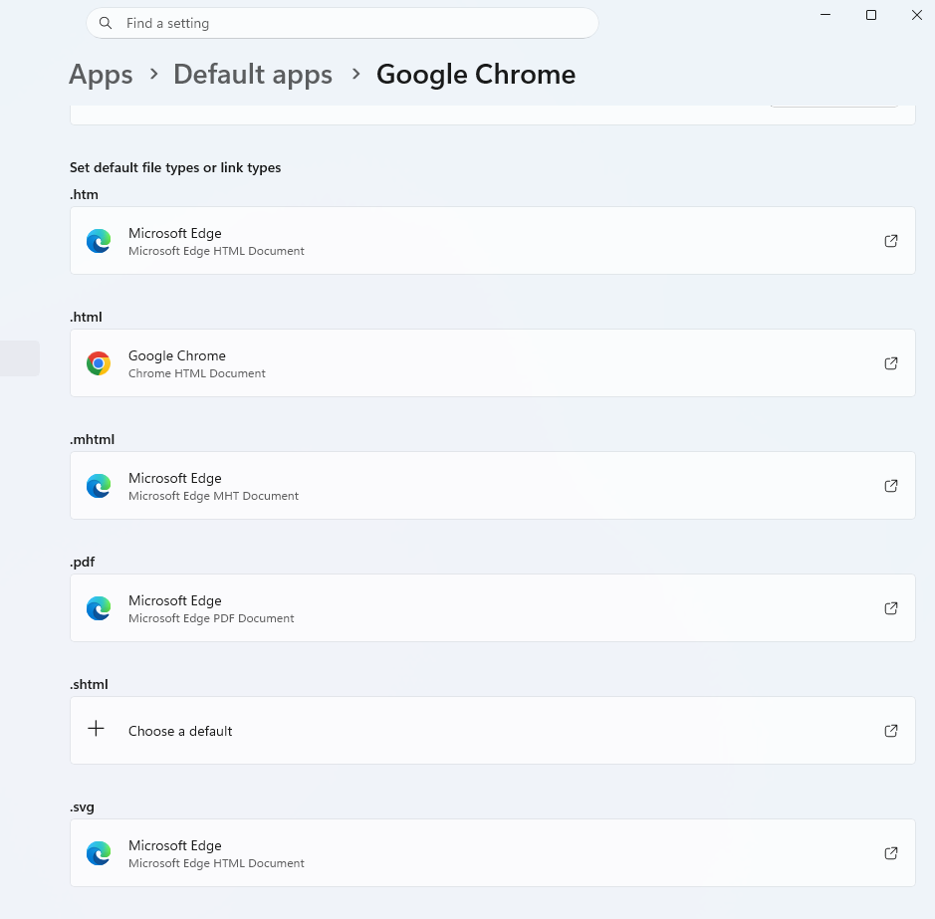 | 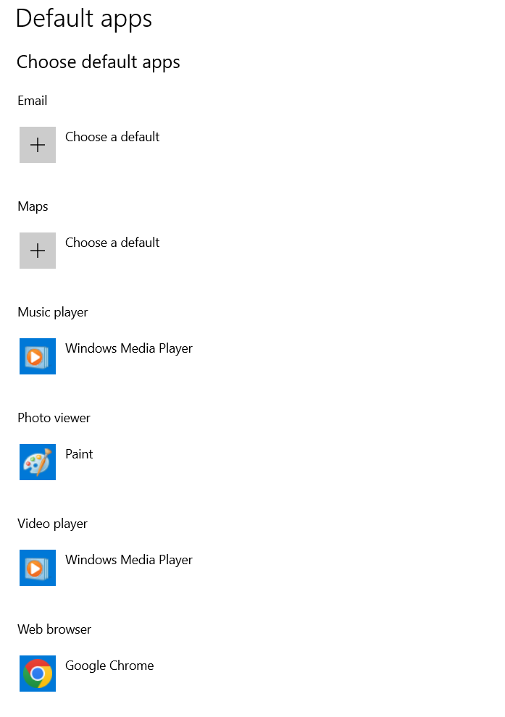
- Select Explorer .  Click Open Folder and then create a new folder named COMP4145_lab2. Then select that folder. Trust the authors. | 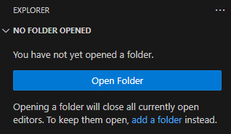  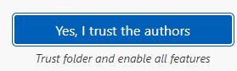
- Create a python file:  Choose File, then New File.  Enter the filename trading_strategy.py, and choose Create New File. | 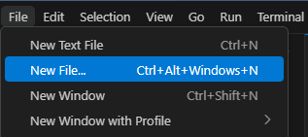  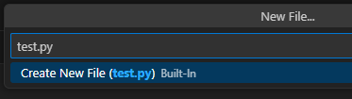
- Open Copilot Chat:  Click on the button, then choose Open Chat. Or use the Shortcut: Ctrl+Shift+I  Choose Agent mode.  Choose GPT-4.1 for the model. | 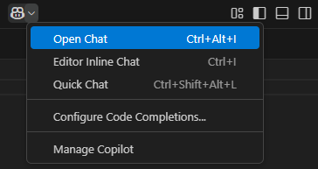  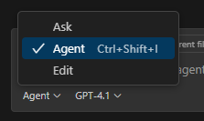  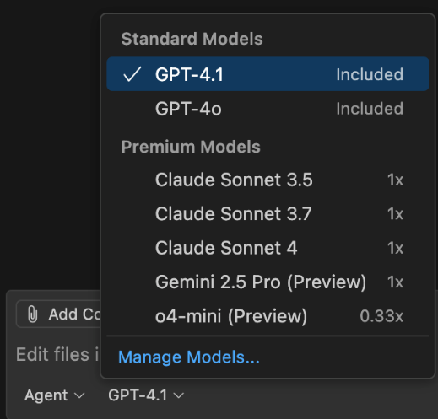
- Click on the link below to open the example code on Google Colab.
https://colab.research.google.com/drive/1G_vS2pADjCSbezG0tFyIhr-8ksWnx-Wh?usp=sharing

- Install all required packages:  Copy the first line of code in Part I of the Google Colab notebook.  Paste and use it as a prompt in the Copilot Chat.  Choose Continue to create a virtual environment.  Choose Continue to install the packages. | 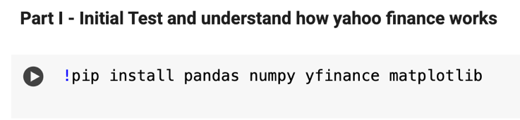  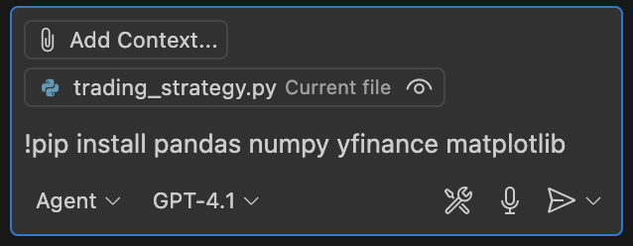  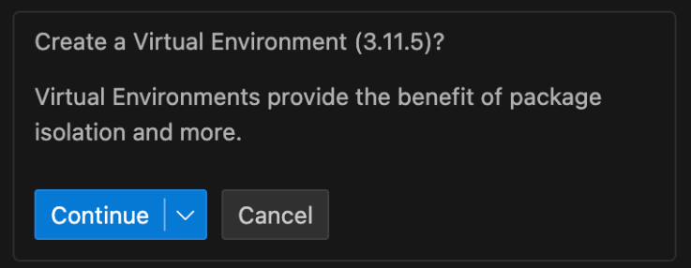  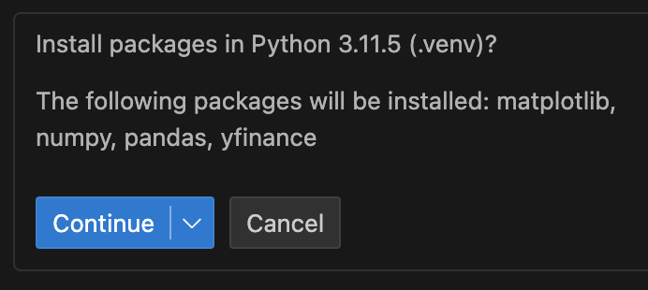

There are three ways to access Copilot chat:
Editor Inline Chat (Ctrl + I)
- ask questions and get suggestions directly in the editor
- scope the prompt to the code in the active editor
- allows you to stay in the flow of your work
Chat Window (Ctrl + Shift + I)
- have an ongoing, multi-turn chat conversation in a dedicated view on the side
- switch between different chat modes: ask questions, make code edits across files, or start an autonomous coding workflow
Quick Chat (Ctrl + Shift + Alt + I)
- ask a quick question without starting a full chat session on the side.

- Implement the code for Single Stock Trading Strategy:  Copy the code in Part II - Single Stock Trading Strategy Demo in the Google Colab notebook.  Paste the code in trading_strategy.py and ask question in the Copilot Chat about the code.  “What is the code about?”  “What does backtest and golden cross mean?”  “Which stock is selected?”  “What is the criteria for buy signal?”  “What is the criteria for sell signal?”  “Show me the part of coding for buy signal and explain briefly.”  Check and keep the code in the trading_strategy.py.  Press File “save”. | 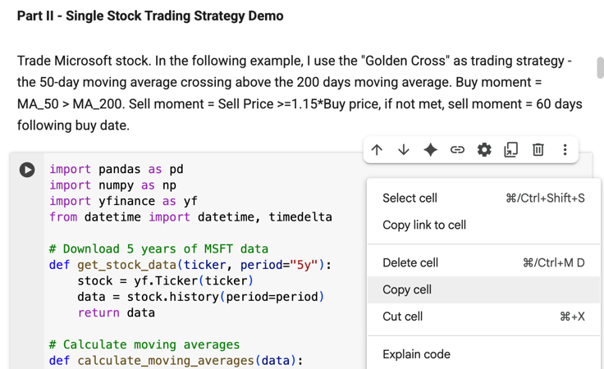  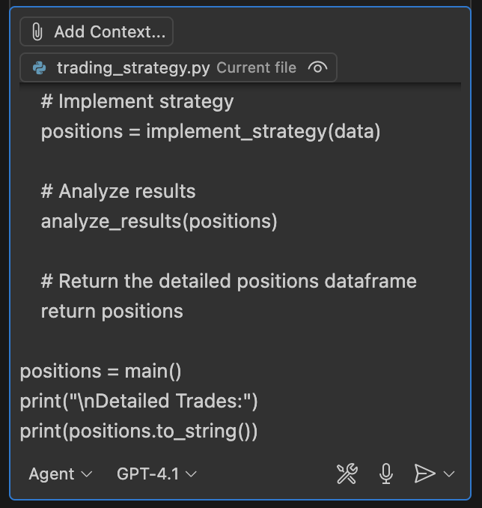  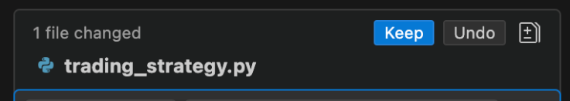
- Use the prompt:  “Run trading_strategy.py in the terminal”  Choose Continue to run the command. Then, the script should be run in the terminal.  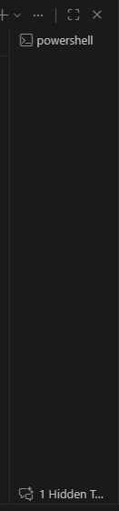  Sometimes in the hidden terminals | 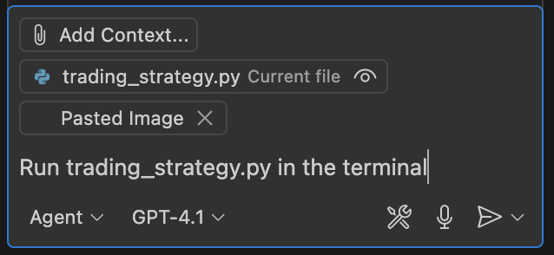  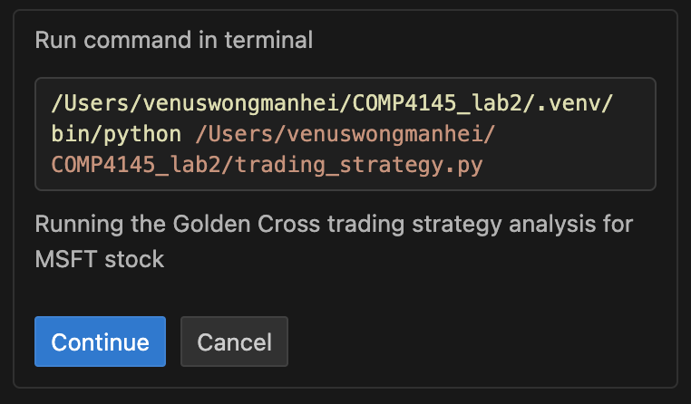  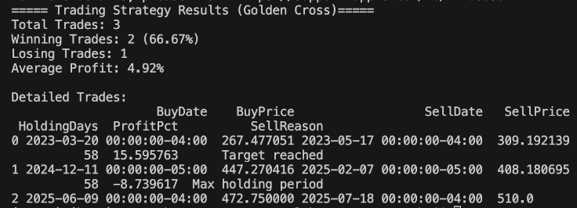
- Use the prompt:  “I am fine with the backend code now. I want to create a front end to display the result. It consists of price chat, trade statistics and detailed trade. The first page is price chart, showing the whole period, use line chart to show stock price, short-term MA, long-term MA. use two dots to use buy points and sell points. The second page is the overall trade statistics, summarizing the total of all trades. The third page shows the detailed trades record.”  Then, it will give recommendations on how to do that.  Remark: MA refers to moving average | 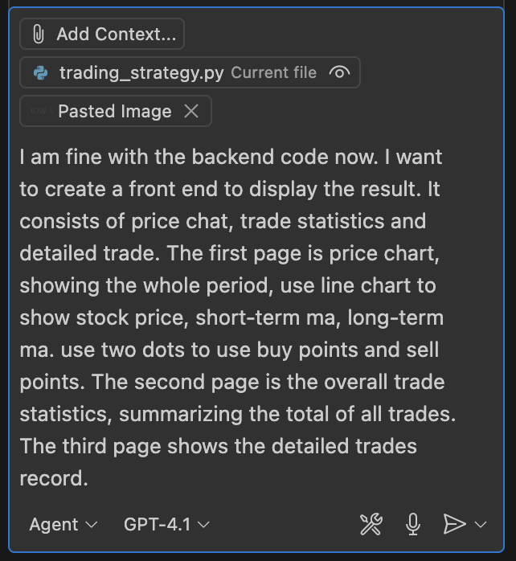
- Use the prompt:  “Proceed with Streamlit”  Choose Continue to install Streamlit.  Check and keep the changed files.  If you encounter errors, try to input the powershell command:  “& "C:/Program Files/Python313/python.exe" -m streamlit run app.py” | 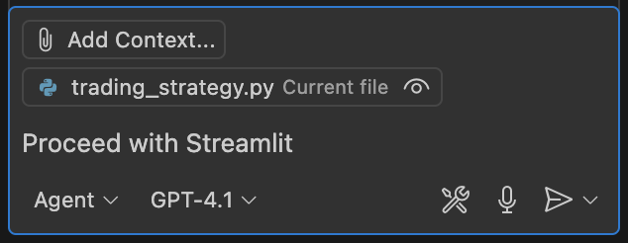  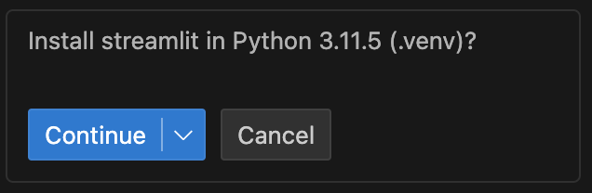  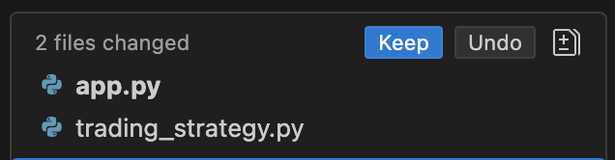
- Launch the frontend:  Click the button to insert the command into Terminal.  Leave the field for email blank, and press enter.  Then, the Streamlit app should be shown in your browser. If not, click and open the Local URL.  Press CTRL+C if you want to quit. | 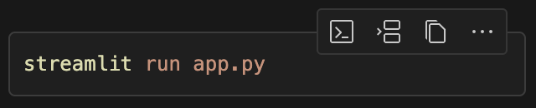  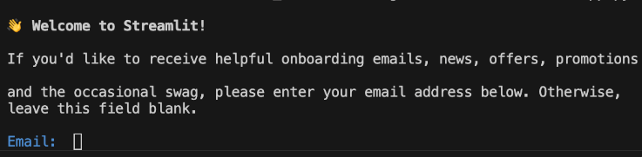  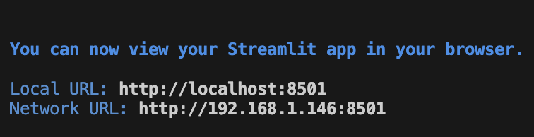  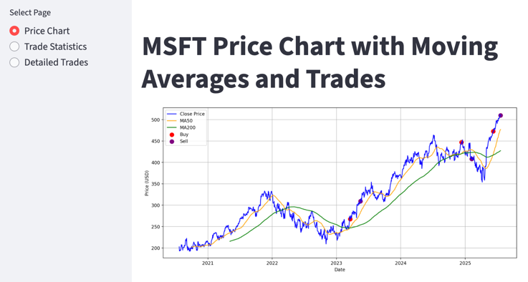

Part B: Upload to GitHub
- Create a GitHub repository:  Go to https://github.com and log in.  Click the + icon on the top right, then choose New repository.  Enter the name (e.g., COMP4145_lab2), set visibility (Choose Public), and click "Create repository" | 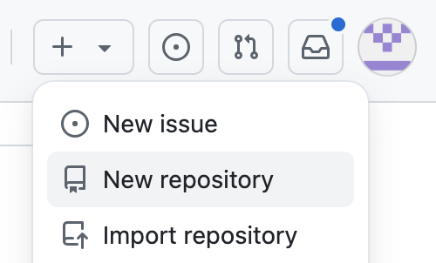  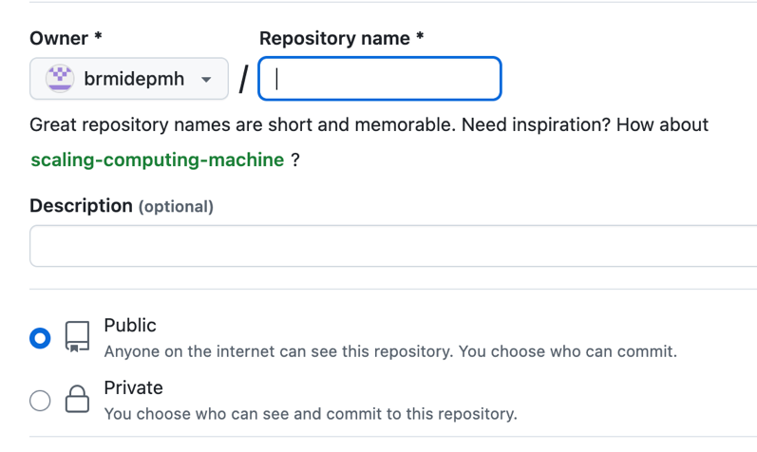  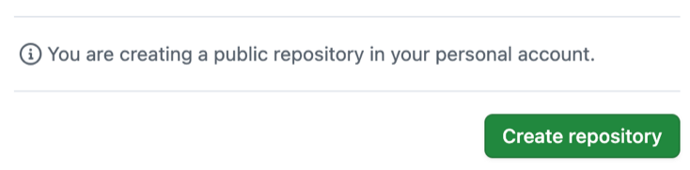
- Choose HTTPS under Quick setup.  Copy the code under “…or create a new repository on the command line”.  Paste into the terminal in VS Code and run. | 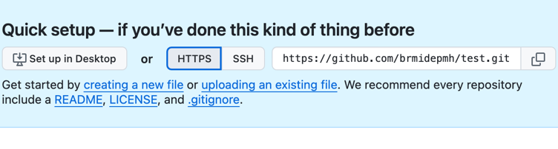  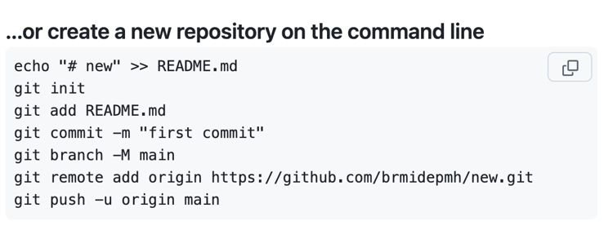
- In the terminal,  Add all files to be tracked:  git add  Save changes to the staged files with a descriptive message to local repository:  git commit -m "Commit message"  Update the git commit changes and send it to remote repository:  git push  Alternatively, to add, commit and push:  Select source control , click the + icon next to Changes. Enter the commit message and choose Commit. Then, choose Sync Changes. | 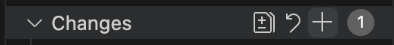  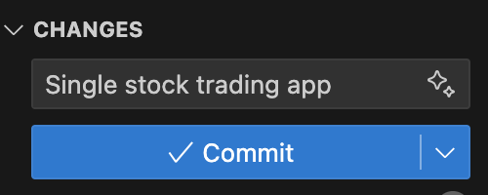  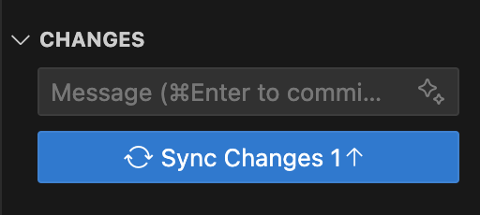
- After that, it should appear on your GitHub. | 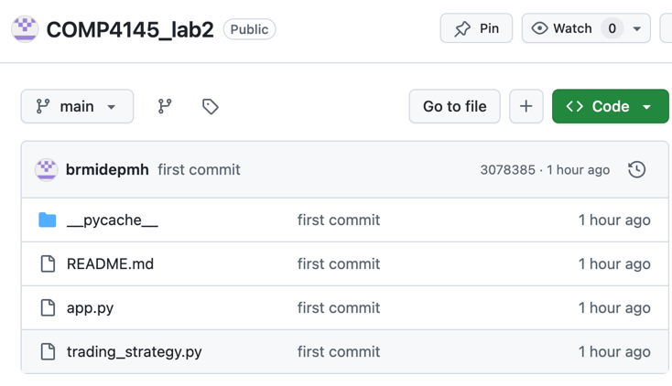

Part C: Deploy the app on Streamlit Cloud
- Sign in to Streamlit Cloud:  https://share.streamlit.io/  Choose Continue to sign-in, and then Continue with GitHub. | 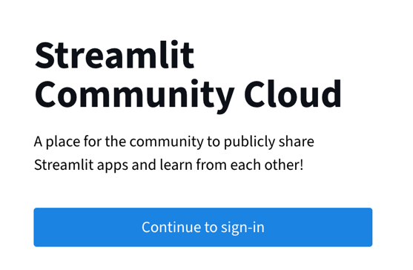  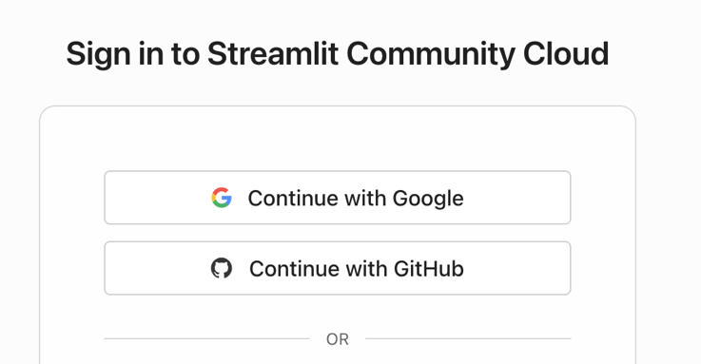
- Choose Authorize streamlit, then verify your email.  Choose Authorize streamlit, and then verify to confirm access. | 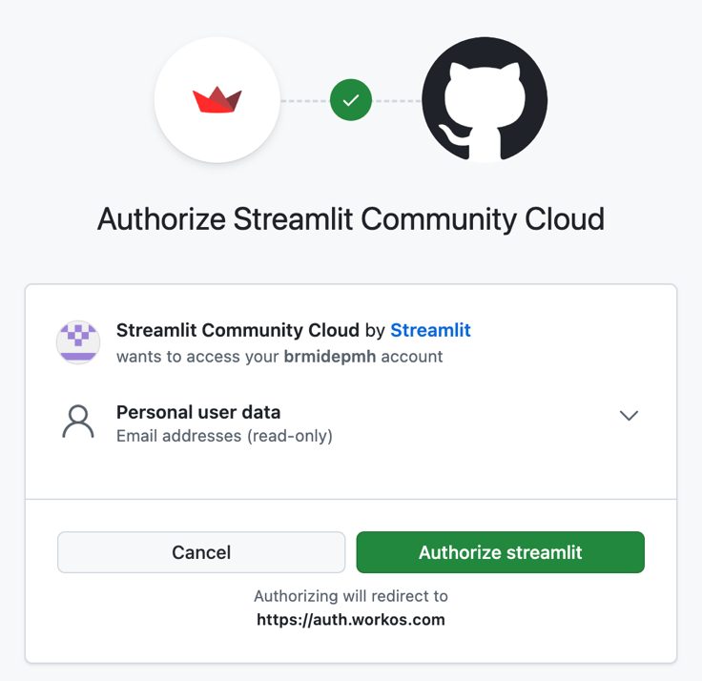  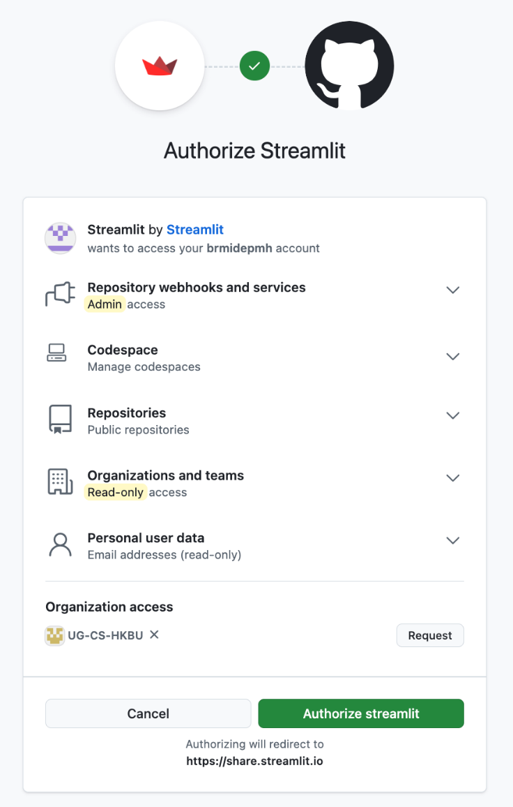
- Fill in your information. Then, choose Continue. | 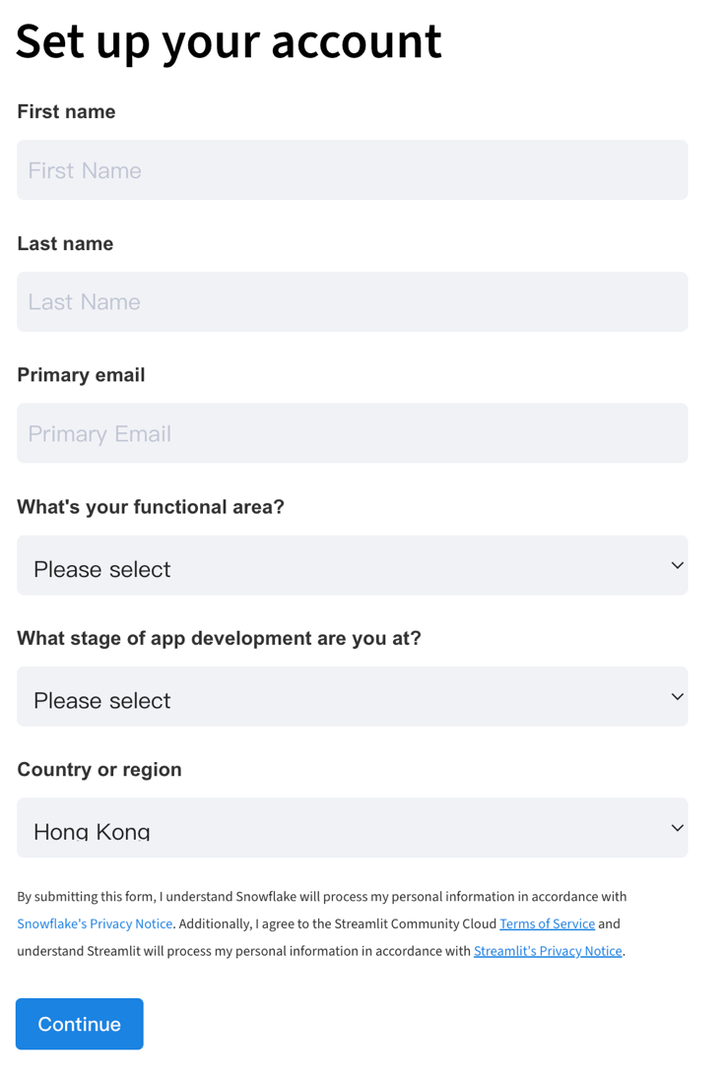
- In the terminal, launch the frontend:  streamlit run app.py  Choose Deploy on the top-right corner of the Streamlit app. Then, choose Deploy now inside the column of Streamlit Community Cloud.  If encounter errors, try:  “& "C:/Program Files/Python313/python.exe" -m streamlit run app.py” |   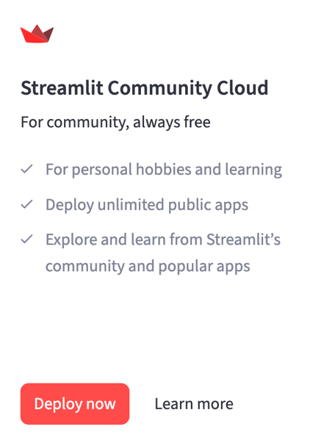
- Choose Deploy. | 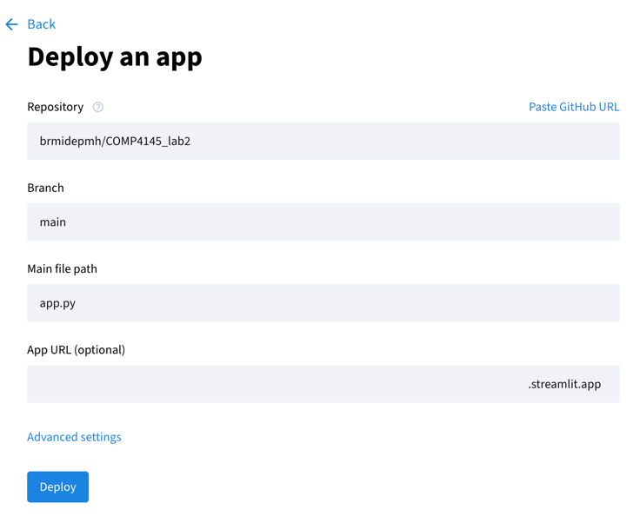
- A ModuleNotFoundError might occur. Try to use Copilot Chat to debug. Use the prompt:  “After deploying the app on streamlit, it shows:” (paste the error message)  Then, it will give you the reason and solution. Ask copilot to help creating and updating requirements.txt.  Check and keep the changed files.  Add, commit and push the changes (step 3 in part B). | 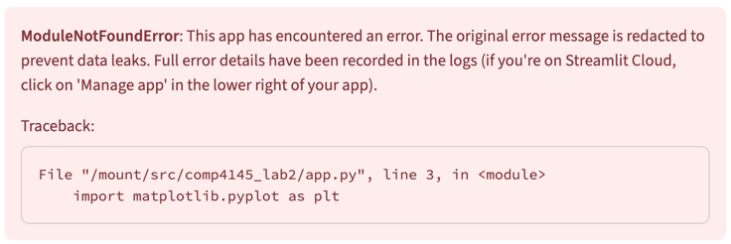  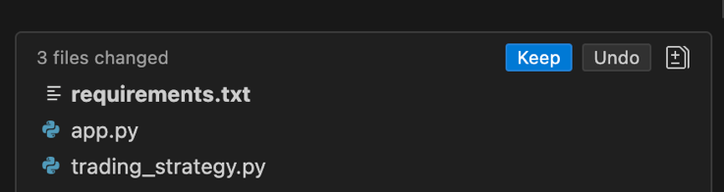
- After that, reload the website. The app should be successfully deployed on the Streamlit Cloud.  The app can now be easily accessed on the Streamlit Cloud. You can share it to others  with its link. | 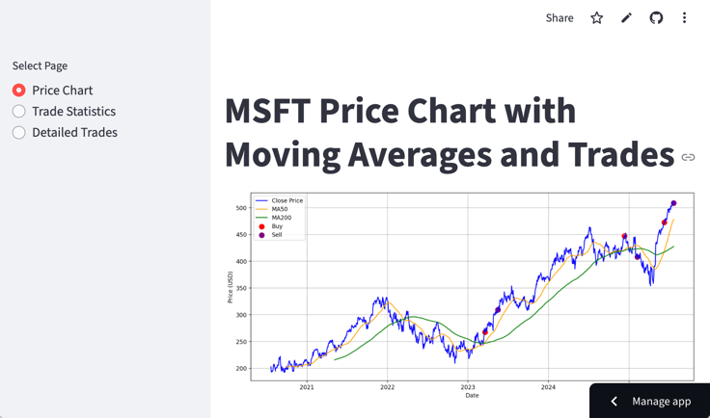  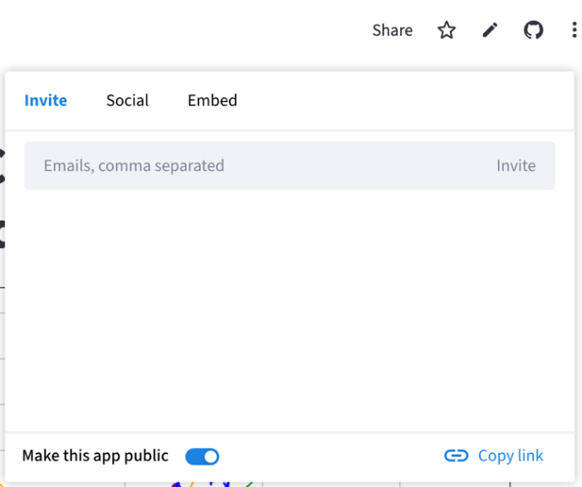
Now, you are a powerful app creator, backed by Microsoft CoPilot. I built a few apps and you may find from the below link:

https://share.streamlit.io/user/shihbunyu

Project Development 2 (PD2) Briefing Document – Idea 1
You work in a financial software development team. The team is now working on a new tool for a fintech startup aiming to help non-professional investors manage stock trading strategies.
Your task is to design and develop an enhanced product using the provided single stock trading app. The enhancement may include but not limited to portfolio analysis (support multiple stocks), database integration, advanced trading strategies, better visualization and LLM-enhanced analytics. You are expected to introduce three additional features. Discuss and evaluate your choices through planning and analysis.
You are responsible for providing a clear project record and communication to a team of 10 professionals including CEO, CTO, team members from both business team and technical team. Submit a Microsoft Word file which includes the project record and documentation stated below, in not more than 6 pages. You are welcome to use diagrams and tables for better illustration.
- Project description and planning
- Initial project update
- Final project update
- Discussion and reflection of the use of vibe coding
- A link to access your designed platform in Streamlit or other cloud platform.
Remarks: Yahoo Finance may have restrictions on the number of stocks queried or analyzed simultaneously. Therefore, you may have to limit analysis to <= 20 stocks. You are welcome to try other finance API / datasets.

Project Development 2 (PD2) Briefing Document – Idea 2
You are a skincare AI software development team. You are now working on a new tool for a skincare and health technology company aiming to help customers analyze skin conditions and receive personalized skincare recommendations.
Your task is to design and develop an enhanced product using the example of skin analysis application. The enhancement may include but not limited to comprehensive skin quality assessment, database, user access management, user history analytics, eCommerce stores, recommendation. You are expected to introduce three additional features. Discuss and evaluate your choices through planning and analysis.
You are responsible for providing a clear project record and communication to a team of 10 professionals including CEO, CTO, team members from both business team and technical team. Submit a Microsoft Word file which includes the project record and documentation stated below, in not more than 6 pages. You are welcome to use diagrams and tables for better illustration.
Project description and planning
- Initial project update
- Final project update
- Discussion and reflection of the use of vibe coding
- A link to access your designed platform in Streamlit or other cloud platform.

Remark: Your primary responsibility is to design the user interface, build the functionality, prototype, and provide comprehensive project planning documentation. Do note that improving image-to-text inference quality and model fine-tuning are strictly out of scope, as Google Gemini 2.5 Pro currently exhibits poor performance. Focus your efforts entirely on the prototyping and project management delivery rather than optimizing the underlying model.
Remark: It is understandable that there are overlaps among project description, initial week update and final week update

Prompt used for building a prototype:
“Write a single Python script using Gradio or Flask to create a simple web UI that runs in a local browser for quality checking skin. Leverage the API key and URL provided below.
API key: (paste your API key)
API_URL = "https://genai.hkbu.edu.hk/api/v0/rest/deployments/gemini-2.5-pro/chat/completions?api-version=v1"
Requirements:
- UI: A simple interface with an image upload button and a submit button.
- LLM Integration: Us the LLM API key and URL provided
- Output: Display the LLM's response on the UI, which must include:
  - Skin Cleanliness KPI (e.g., score out of 10)
  - Skin Quality KPI (e.g., score out of 10)
  - A brief description of the face image skin condition
  - Estimated age
- Single File: Keep all backend, API call, and UI code in one single .py file. Do not use Streamlit.”
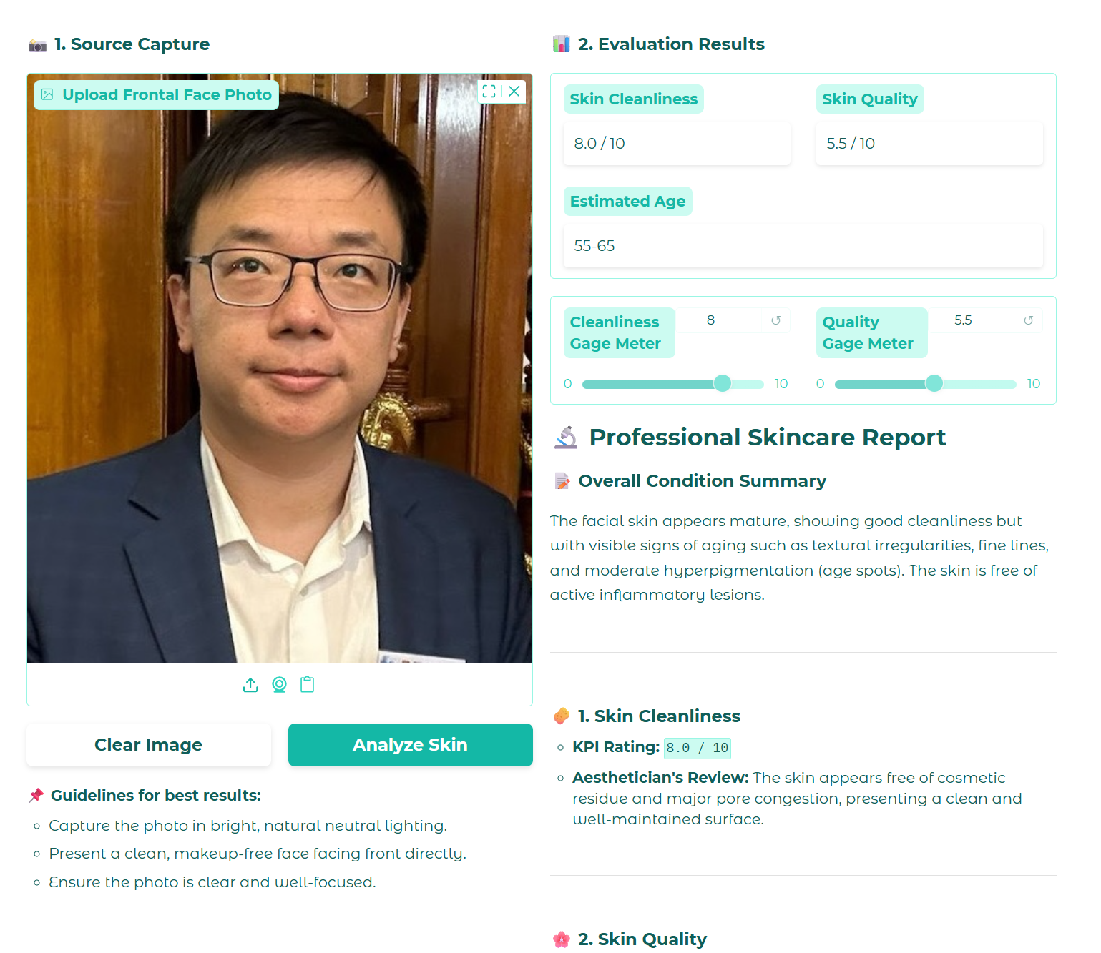

Submission Requirement:
- Choose Idea 1 or Idea 2
- Project description and planning: It outlines the project's goals, detail the planning process, including timelines, resource allocation, risk assessment, and a high-level design plan.
- Initial project update (Week 1): It focuses on accomplishments such as preliminary work, feature ideation, progress and early prototyping efforts. Make sure the entire team understand the current progress and the potential risks involved.
- Provide a scrum board before the start of Week 1.
- Provide a scrum board by the end of Week 1.
- Final project update (Week 2): It summarizes the work done of the completed project and demonstrate the final outcomes.
- Provide a scrum board by the end of Week 2.
- Discussion and Reflection: This discusses the use of vibe coding in the project development, focusing on the strengths (what works very well), and weaknesses (what does not work well). It may include comparisons between AI tools, key learnings from the projects and recommendations. Assessment rubrics:

Criteria | Excellent | Good | Fairly Good | Fail
Project Management and Requirements Analysis (25%) | Comprehensive, well-reasoned, insightful and easy to understand | Good coverage and justification | Some coverage, weak justification | Missing or highly insufficient
Design & Presentation (25%) | Clear diagrams, creative interface | Functional design with minor flaws | Minimal design effort shown | Poor or no design work
Feature Implementation (25%) | 3+ extra features, well-integrated | at least 2 extra features functioning well | poorly implemented | Most features missing or non-functional
Final Results & Reflection (25%) | Highly professional and confident demonstration, with strong critique of design, performance, and future direction | Clearly explained, with some reflection and future suggestions | Incomplete or limited reflection | Disorganized, poorly explained, or lacking reflection

Submission
Zip the whole project folder. Submit your report, zipped file, and the link of your Streamlit app to Moodle.
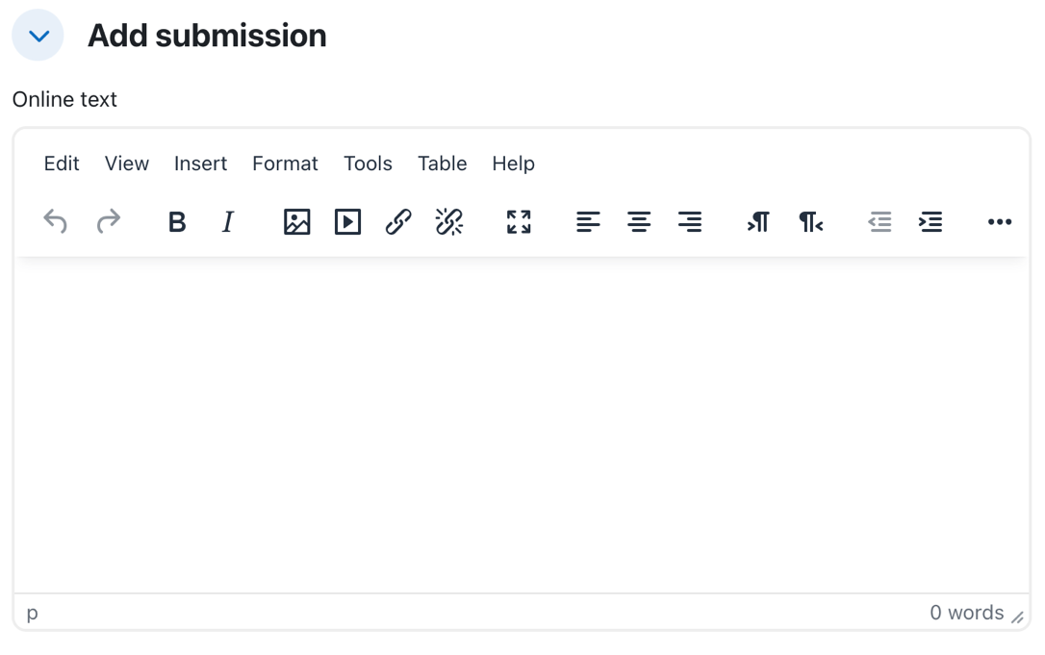
Put the link of your Streamlit app in the text box on Moodle
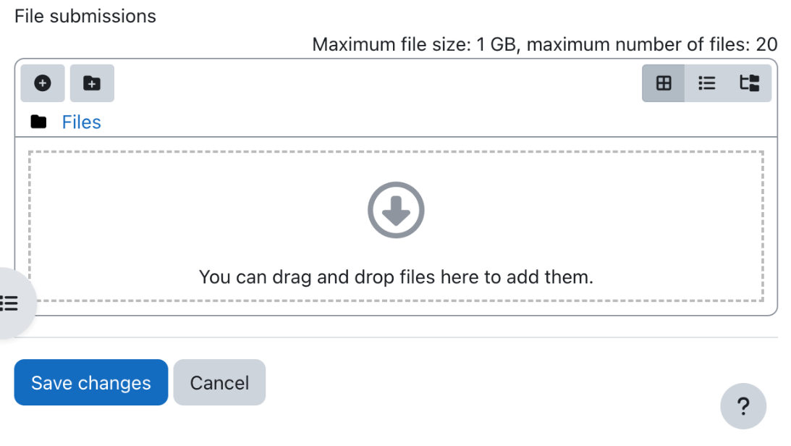
Add your report here

References

- https://docs.github.com/en/get-started/using-git/about-git#basic-git-commands
- https://docs.github.com/en/get-started/start-your-journey/about-github-and-git
- https://uibakery.io/blog/what-is-streamlit
- https://docs.streamlit.io/
- https://code.visualstudio.com/docs/copilot/chat/copilot-chat

