Keyword Matching and BM25 Baselines for Dataset Discovery
Yi | Baseline implementation and evaluation | October 28 2026

Summary
This work establishes reproducible keyword matching and BM25 reference systems for comparison with the team method. Neither lexical method is claimed as a new algorithm. The team method has not yet been evaluated in this study. BM25 provides a useful lexical baseline for discovering candidate datasets, but replacing keyword overlap with BM25 alone does not resolve the main coverage problem. On a retrospective 318-query evaluation partition, full-document BM25 reaches nDCG@10 = 0.104 and Recall@200 = 0.516, compared with 0.087 and 0.513 for keyword overlap. The ranking difference is modest and is not significant after adjustment for the three planned comparisons.
The larger changes come from query representation and available dataset information. On the same 313 queries, supplied keyphrases raise Recall@200 from 0.516 to 0.620. Adding the benchmark's existing structured task metadata raises Recall@100 from 0.421 to 0.595 on the 318-query partition. These interventions change the input information; they are not improvements to the BM25 formula itself.
This study combines a labeled DataFinder experiment with a larger, unlabeled Hugging Face catalogue. The first measures retrieval of known relevant datasets. The second tests whether the retrieval interface exposes useful candidates and where documentation-level matching remains insufficient.

1 Research Questions and Methods
The goal is to retrieve approximately 100-200 candidate datasets for subsequent profiling. The primary deliverable is a fixed baseline and a shared evaluation interface for the team method. Keyword overlap and standard full-document BM25 are the two primary references. Other configurations are supplementary sensitivity analyses, not the team method. The existing experiments characterize baseline performance, information sensitivity and failure modes.
Each document represents one dataset. For Hugging Face, available names, tags, column names and README text are indexed. For DataFinder, the document contains the dataset name and its supplied description and source-paper information. The benchmark experiments and HF experiments use separate corpora and are not pooled into one accuracy estimate.
The keyword baseline scores a dataset by the number of distinct normalized query tokens it contains: score(q,d) = |tokens(q) intersect tokens(d)|. Matching is OR-based. Repeating a word does not add keyword score, and all fields have equal weight in the concatenated baseline.
BM25 instead weights each matching term using its inverse document frequency, saturated term frequency and document-length normalization [5,6]. The initial configuration is k1 = 1.2 and b = 0.75. Both methods use Unicode normalization, lowercase tokens and a small fixed stopword list. English stemming, section cleaning and query processing are tested separately. Chinese character and bigram tokens are retained; no cross-language translation is performed.
Only positive-score documents are returned. Ties use dataset ID order, and an empty match is not padded with arbitrary candidates. Retrieval scores are relevance signals, not estimates of downstream training gain.

2 Data and Evaluation Protocol
The labeled experiment uses DataFinder's published description-and-title corpus and official relevance judgments [1,2]. The source snapshot is fixed to commit 18444c67611c1729af702faa79128a402a1643b2. Duplicate dataset IDs are merged, yielding 3,294 canonical documents. The 392 query IDs in the official qrels define the evaluation population.

Identity and Coverage Audit
Only whitespace normalization is allowed when aligning dataset IDs. In particular, FB15k-237 is not treated as equivalent to FB15k, correcting an alias assumption in the initial baseline. Thirty-four distinct positive IDs are absent from the corpus. Fifty-nine queries have at least one unreachable positive; three have no reachable positive. These positives remain in metric denominators rather than being silently removed. The macro recall ceiling imposed by corpus membership is 0.941 over all 392 queries. A separate fully mappable subset contains 333 queries.
The source test file and qrels are not identical query lists. Five qrel query IDs have no exact normalized match in the source query file; their sentence text is recovered by replacing underscores with spaces. They remain in the sentence experiment but are excluded from paired keyphrase comparisons.

Development and Statistical Analysis
A deterministic hash of the source abstract assigns 74 queries to development and 318 to a retrospective test partition. Every representation of an original query stays in the same group. An earlier baseline was already inspected on an overlapping subset, so this partition is not a pristine unseen test set. It supports controlled comparisons and dev-only parameter selection, not a strong generalization claim.
The parameter grid contains 12 settings: k1 in {0.6, 1.2, 1.8} and b in {0, 0.4, 0.75, 1}. Selection maximizes development Recall@100, using nDCG@10 for ties. Other ablations use fixed configurations, and their combinations are not searched. The archival DataFinder script uses k1 = 0.8, b = 0.4 and a year filter; our baseline differs and should not be described as a reproduction of the paper's reported numbers.
Metrics are macro nDCG@10, Recall@20/100/200 and MRR truncated at 200. Official judgments are binary known positives, not exhaustive relevance assessments. Unjudged documents contribute zero gain. Three planned contrasts use paired sign-flip tests with 20,000 randomizations, Holm adjustment, and 10,000 paired bootstrap resamples for unadjusted 95% intervals. Random seeds are fixed.
An independent TREC implementation agrees on 25,455 per-query metric values, with maximum absolute difference 1.1e-16. Eleven test groups also check BM25 against a separate implementation, baseline parity, field isolation, stemming, ties, missing positives and temporal filtering.

3 Baseline Retrieval Results
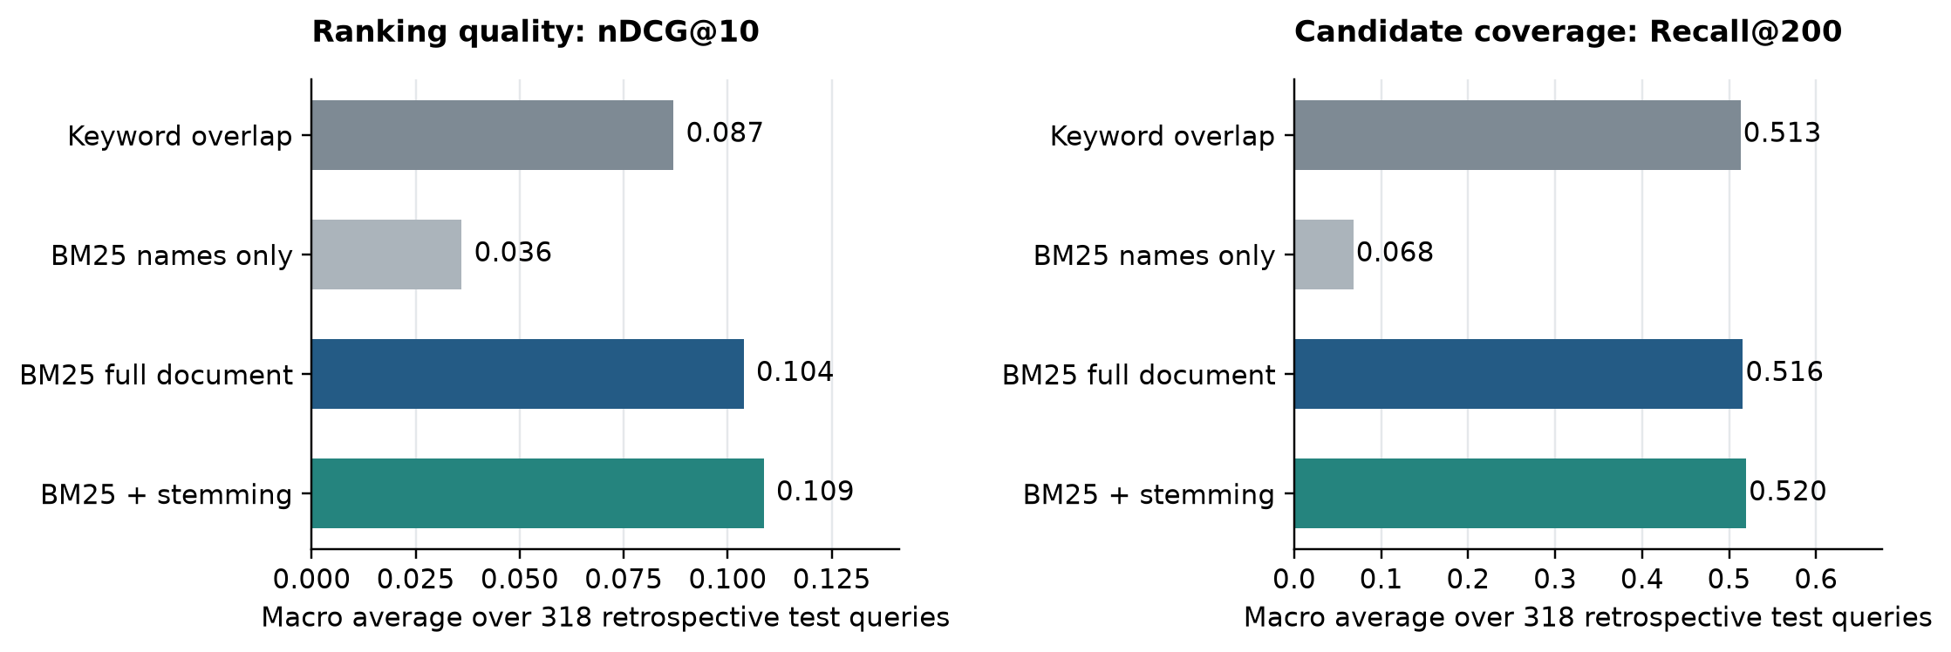
Figure 1. Keyword and BM25 variants on the same 318 retrospective test queries and 3,294 dataset documents. Both axes start at zero. Values are macro averages.
Method | nDCG@10 | R@20 | R@100 | R@200
Keyword overlap | 0.0869 | 0.1898 | 0.4242 | 0.5132
BM25 names only | 0.0360 | 0.0654 | 0.0680 | 0.0680
BM25 full document | 0.1038 | 0.2250 | 0.4210 | 0.5158
BM25 with stemming | 0.1086 | 0.2384 | 0.4414 | 0.5196

Names alone provide little access to natural-language needs: Recall@200 is 0.068. Full descriptions and paper information increase this to 0.516. BM25 improves the ordering of early results relative to keyword overlap, but the two methods recover almost the same share of known positives at a budget of 200.
The nDCG@10 difference between full-document BM25 and keyword overlap is +0.0169; the unadjusted paired bootstrap interval is [0.0003, 0.0340]. The Holm-adjusted randomization p-value is 0.159. The Recall@200 difference is +0.0027, with adjusted p = 0.869. Thus, the data do not support a statistically established improvement for these planned contrasts after correction. The interval is unadjusted, whereas the reported p-value is adjusted across contrasts.
Stemming raises Recall@100 from 0.421 to 0.441, but its planned comparison also fails the adjusted threshold (p = 0.184). A few better averages should therefore not be presented as a solved retrieval problem.
Across all 392 official qrel queries, keyword overlap and full-document BM25 reach Recall@200 of 0.5243 and 0.5272, respectively. These full-population summaries and the fully mappable subset are retained separately; they are not mixed with the 318-query results above.

4 Document and Parameter Ablations
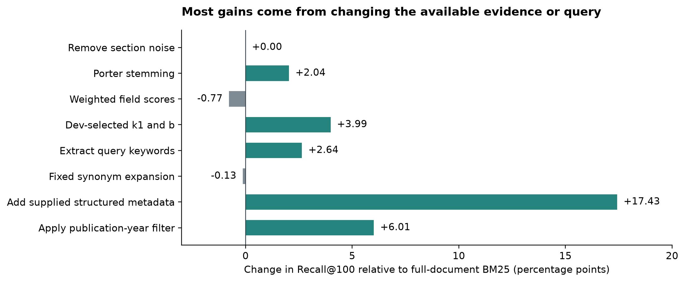
Figure 2. Changes in Recall@100 relative to full-document BM25. All comparisons use 318 queries. Query changes, additional metadata and year eligibility are different interventions and should not be interpreted as equivalent scoring modifications.
Variant | nDCG@10 | R@100 | R@200
Name and description | 0.0983 | 0.3892 | 0.4902
Full document baseline | 0.1038 | 0.4210 | 0.5158
Section cleaning | 0.1054 | 0.4210 | 0.5158
Porter stemming | 0.1086 | 0.4414 | 0.5196
Weighted field scores | 0.0874 | 0.4133 | 0.5234
Dev-selected parameters | 0.0989 | 0.4609 | 0.5374
Year eligibility filter | 0.1442 | 0.4811 | 0.5884
Add supplied task metadata | 0.1593 | 0.5953 | 0.6806

Basic section cleaning removes front matter, code blocks, table-of-contents links, citation/reference sections and placeholder lines. It barely changes this benchmark's candidate coverage, which is expected for a corpus of relatively short descriptions rather than full HF cards. Fixed field weights also do not consistently help. They sum independently normalized field scores (name 2, tags 1.5, other fields 1); this is not BM25F.
The dev-selected setting is k1 = 1.2, b = 0. It improves test Recall@100 to 0.461 while lowering nDCG@10 to 0.099, illustrating a ranking-versus-coverage tradeoff. Additional structured_info from the source benchmark gives the largest observed gain, but its provenance and transfer to automatically generated HF profiles require separate validation. The year-filter run removes datasets known to postdate the query and retains unknown-year records; it is a benchmark-eligibility sensitivity analysis.

5 Query Representation
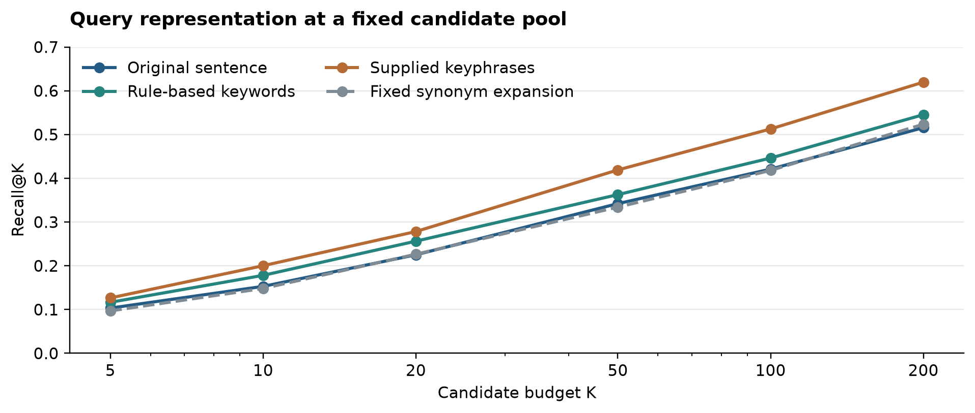
Figure 3. Recall as the candidate budget increases, using the same 313 test-partition queries for all four representations. Supplied keyphrases come from DataFinder's published query file; this experiment does not generate them automatically.
Query representation | nDCG@10 | R@100 | R@200
Original sentence | 0.1043 | 0.4210 | 0.5157
Rule-based keywords | 0.1227 | 0.4462 | 0.5454
Supplied keyphrases | 0.1341 | 0.5127 | 0.6197
Fixed synonyms | 0.1038 | 0.4180 | 0.5236

Rule-based keyword extraction removes a fixed list of request boilerplate, such as “we want to build a model,” while retaining the substantive terms. It raises Recall@200 by about 3.0 percentage points on this paired set. The supplied keyphrases produce a larger 10.4-point increase. This is evidence that how a training need is expressed can matter more than changing the lexical scoring rule alone.
The supplied keyphrase result is a representation comparison, not evidence that an online query parser will achieve the same performance. A parser needs its own evaluation, including whether it preserves task scope and constraints. The fixed synonym dictionary offers little Recall@100 improvement and should not be treated as a general semantic solution. Broad expansions may add ambiguous matches as well as recover missed vocabulary.
For the Data Engine interface, the useful next experiment is to retain both the original request and a compact task-focused query, then compare their union against either list alone. That fusion experiment has not been run here; the current results measure each representation independently.

6 Where Known Positives Are Lost
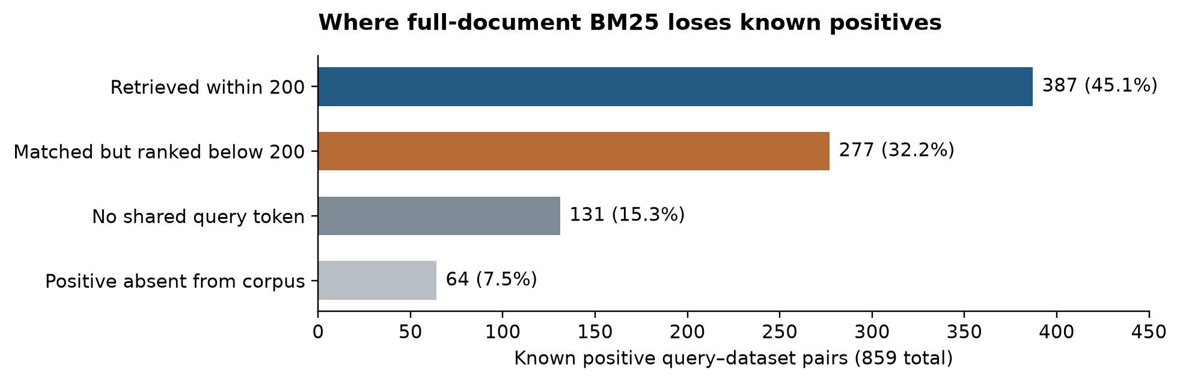
Figure 4. Deterministic error decomposition for full-document BM25 over 859 known positive query-dataset pairs in the 318-query partition. These pair-weighted percentages differ from macro query Recall@200.
Of the 859 known positive pairs, 387 are retrieved within 200. Another 277 share query terms but rank below the candidate budget. For 131, the query and available document share no retained token; 64 refer to a positive absent from the corpus. These are different failure mechanisms: ranking changes can address competition among matched documents, while lexical mismatch or missing corpus entries require additional representation or coverage.

An Illustrative Gain
For a query about unsupervised feature learning and sparsity, BM25 moves the labeled dataset STL-10 to rank 1. Keyword overlap places it outside the first five results. This is the largest positive nDCG@10 change in this partition, not a representative sample. Weighting discriminative terms can improve ordering when several documents share generic words.

An Illustrative Loss
For a named-entity-recognition query mentioning handcrafted features, keyword overlap ranks CoNLL-2003 second. BM25 moves it outside the top 10, while ranking other NER datasets first. This is the largest negative change in the same contrast. The alternative NER datasets may also be useful, but the available qrels do not establish their relevance. This case shows both the sensitivity to document wording and the limits of evaluating against non-exhaustive known positives.
The implication is to measure coverage at the intended 100-200 candidate budget and inspect failed queries, rather than evaluating only the first result. Re-ranking cannot recover a relevant dataset that never enters the candidate pool.

7 Search on a Larger Hugging Face Catalogue
The catalogue combines 5,000 card records sampled across 50 equal row intervals with 40 curated seed repositories, giving 5,040 unique IDs [3,4]. Six retrieval variants are run on 40 authored requests covering math, code, tools, dialogue, summarization, domain knowledge, languages, output formats and preferences. The benchmark corpus and this catalogue remain separate experimental settings.
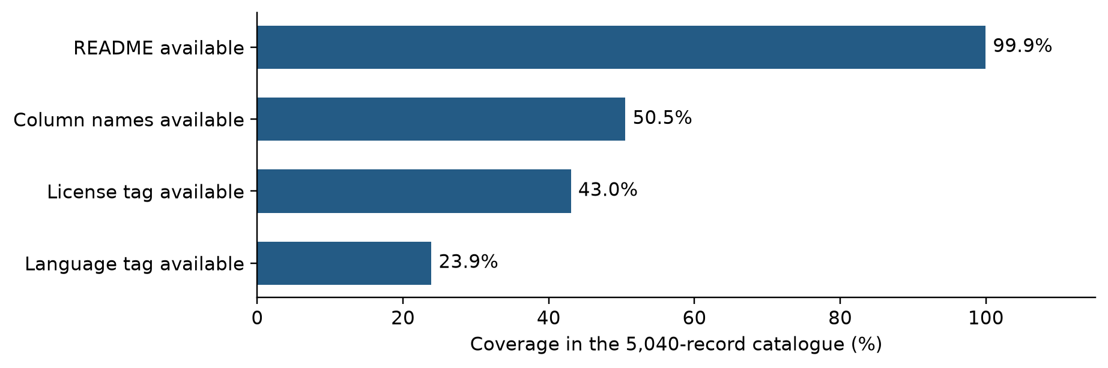
Figure 5. Metadata coverage in the saved catalogue sample. Availability does not establish field correctness. Column names are extracted only where supported by parsed card metadata.
The source viewer returned no truncated cells for the sampled pages. Five exceptionally long cards are locally capped at 100,000 characters, and three seed READMEs are unavailable. Raw pages, headers and hashes are saved. The observed catalogue repository head is unchanged before and after capture, but the viewer endpoint cannot pin a revision, so this is a cached capture rather than a guaranteed atomic repository snapshot.
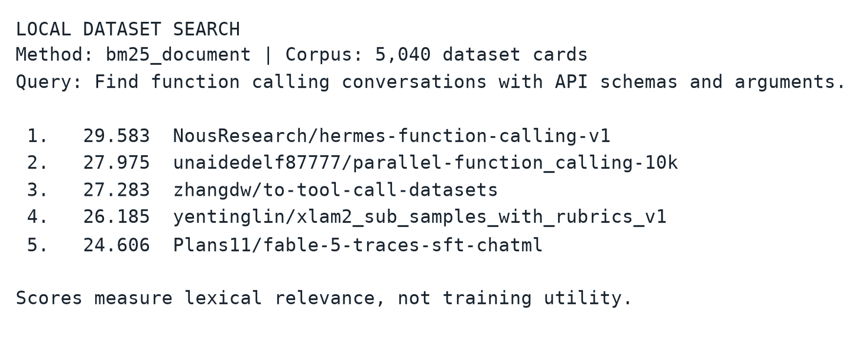
Figure 6. Recorded output from the local search command on the frozen catalogue. The figure renders actual printed output. Candidate exports link dataset IDs to their source URLs; complete Top-200 rankings are retained separately.
The full-document index builds in approximately 2.50 seconds; query P50/P95 are 0.58/2.44 ms over these 40 requests. These single-process warm timings include tokenization and ranking but exclude evidence construction. They do not establish production performance or 100,000-dataset scalability.

8 Case Review and Implications
The 40 project requests have no independent relevance gold labels. A pooled annotation table contains 645 unique query-dataset pairs from the first five results of six variants; relevance cells are left unjudged. Five selected first-ranked cards were inspected qualitatively with supporting passages. These observations are not used to compute precision or recall.
For school math problems, GSM8K documents multistep questions and natural-language solutions, supporting a task match. For function calling, the Hermes card documents conversations, structured outputs and API arguments. Neither documentation match validates correctness of the underlying examples.
The tutoring query retrieves claimtrace-ledger-dataset, whose card describes tutoring and wrong-attempt handling. That is a partial interaction match, but math-specific coverage and withholding final answers are not established. The scientific-summarization query retrieves GA-Bench, which pairs articles with graphical abstracts; this is a plausible domain match with a target-format mismatch.
Expanding the corpus changes the low-resource example substantially. For the identical Vietnamese legal QA request, the 40-seed index returns lex_glue first, while the 5,040-card index returns sailor2/Vietnamese_RAG. The latter declares Vietnamese and a LegalRAG configuration, but emphasizes RAG evaluation, so training suitability still requires checking. This is an illustrative coverage improvement, not a measured relevance gain over the whole catalogue.
Metadata checks on the top 10 results of three explicitly language-constrained requests find 12 tag-supported results, 15 tag contradictions and 3 unknowns. For the commercial-use request, five results have tags on the fixed compatibility list, one has an explicit non-commercial tag, and four remain unknown. These are declaration checks, not determinations of legal rights or sample properties. Unknowns should remain available for review.

Implications for the Next Experiment
Keep BM25 as an interpretable candidate generator and retain original-query retrieval as a reference. Evaluate compact-query extraction prospectively on new requests; the supplied keyphrase experiment shows potential but does not validate a parser. Compare lexical and semantic candidate coverage on the same snapshot, then test their union. Add independently reviewed task and constraint labels before reporting project-level accuracy. Finally, validate sample content, training splits, overlap and downstream utility after retrieval; a high lexical score is insufficient for those decisions.

9 Baseline Specification for Team Comparison
Yi provides the lexical baselines. The team method must be submitted as a separate run; no current result demonstrates its superiority. The primary comparison is against both keyword overlap and standard full-document BM25. Report supplementary variants separately, including the development-selected BM25 setting, so conclusions do not depend on choosing a weak reference after seeing results.

Inputs and Index Construction
Use one JSONL record per dataset, with a unique dataset_id. The indexed fields are name, description, tags, column_names and readme. Missing fields become empty strings and list values are joined by spaces. Both primary baselines concatenate the same fields with equal weight. In DataFinder these normalized fields contain the supplied dataset descriptions and paper information; the HF experiment contains dataset cards and metadata. Neither baseline reads training samples.
Basic cleaning removes HTML comments, script/style blocks, URLs and HTML tags; Markdown links retain their visible text. The tokenizer applies Unicode NFKC and lowercase, extracts ASCII letters and digits, and represents Chinese runs as characters and adjacent bigrams. The fixed stopword list is: a an the and or of for to in on with is are be this that dataset datasets data. Both primary methods use this identical processing. There is no stemming, translation, synonym expansion or query rewriting in the primary runs.
The implementation builds an inverted index mapping tokens to dataset IDs and term counts. Document length is the number of retained tokens, including repetitions. N is the number of documents, df(t) the number containing t, and avgdl the mean document length. Query terms are deduplicated for both methods.

Exact Scoring and Ranking
Keyword score is the number of distinct query tokens found in a document. It is an OR match, not a phrase or all-terms requirement. BM25 sums the following contribution once per distinct matching query token t:
IDF(t) = ln(1 + (N - df(t) + 0.5) / (df(t) + 0.5)).
Contribution(t,d) = IDF(t) times [tf(t,d) times (k1 + 1)] divided by [tf(t,d) + k1 times (1 - b + b times length(d) / avgdl)].
The fixed primary parameters are k1 = 1.2 and b = 0.75. Only positive scores are returned, in descending order; ties use ascending dataset_id. Return at most 200 candidates without padding empty matches. Raw scores across different methods are not calibrated or directly comparable.
The implementation is engine.py with NumPy arrays and NLTK Porter stemming for the optional stemming variant. It uses no external search server, embedding model, LLM, NLTK corpus download or model training. The supplementary parameter search uses only development queries and selects k1 = 1.2, b = 0; it remains distinct from the fixed primary BM25.

10 Reproduction and Comparison Interface

Offline Baseline Run
Use Python 3.12. From the repository root, create an environment with python3.12 -m venv .venv, activate it, then run python -m pip install -r requirements-baseline.txt. Run python baseline.py reproduce. Dependencies require an initial installation; the experiment itself uses only the included local benchmark files and does not contact Google Drive or Hugging Face.
The command rebuilds both primary indices, runs all 392 official queries, and exports ranked runs, per-query metrics and dev/test/all summaries into results/baseline/. It checks the 318-query test metrics against the frozen study values with an absolute tolerance of 1e-12. Latency is not expected to reproduce exactly across machines. The command records input SHA256 values, parameters and package versions in manifest.json.
For an individual search, run python baseline.py search --corpus data/benchmark_corpus.jsonl --query "math reasoning" --method bm25_document --top-k 5. Use --method keyword for the identical keyword baseline. The JSONL output includes query_id, dataset_id, rank and score. For project requests, the original search.py also supports --query-id p13 on the saved HF catalogue.

Team Run Contract
Export one JSONL object per query with query_id and results. Each results list contains dataset_id and score objects in ranked order, with at most 200 unique dataset IDs. A flat JSONL form with query_id, dataset_id, rank and score is also accepted. Rank order is authoritative; scores are retained for traceability. The evaluator rejects unknown queries, duplicate datasets and out-of-corpus IDs. Absent queries receive an empty ranking and are included in evaluation.
Run python baseline.py evaluate --run team_run.jsonl --name team_method. The evaluator writes metrics to results/baseline/team_method/ using the same qrels and metric code. Use --output-dir to keep independent runs. Compare the test summary with keyword and bm25_document under results/baseline/. Do not mix 313-query keyphrase results with 318-query sentence results.
The default benchmark directory is data. A custom directory must contain benchmark_corpus.jsonl, benchmark_queries.jsonl and benchmark_qrels.json with the same schemas; pass --data-dir to reproduce or evaluate. Custom data do not use the frozen-result assertion. The manifest fingerprints the exact inputs, so all compared runs can be checked against the same corpus and judgments.
Reproduce and evaluate report macro nDCG@10, Recall@20, Recall@100, Recall@200 and MRR@200. Missing corpus positives remain in recall denominators and unjudged items have zero gain. The full study and independent metric checks remain available through experiments.py and validate.py; requirements.txt includes their additional dependencies.

11 Fair Evaluation of the Team Method

Retrieval Comparison
Freeze the corpus, query text, query IDs, qrels and candidate budget before comparing methods. Run keyword overlap, fixed BM25, development-selected BM25 and the team method on the same test population. Select parameters using development queries only. Report which additional metadata, semantic representations or query processing the team method uses. An end-to-end system may use such features, but its advantage should be described as a system-level result; a same-input ablation is needed to isolate a scoring contribution.
Use Recall@100 and Recall@200 to assess candidate coverage and nDCG@10 to assess early ranking. Report paired query-level differences, uncertainty intervals and multiplicity-adjusted tests for predefined comparisons. The retrospective split here has prior exposure; a fresh evaluation set is needed for a prospective generalization claim. The current report contains baseline results only, with no fabricated team-method numbers.

Human Review
The proposed project evaluation pools the top five results of both primary baselines and the team method, deduplicates each query-dataset pair, hides method identity and randomizes presentation. Use relevance 0 for unrelated or unusable, 1 for partial fit, and 2 for suitable task fit. Separately record language, schema, split and license compatibility as supported, contradicted or unknown. Keep evidence passages and reviewer IDs. A second reviewer should independently assess a subset when available; single-reviewer judgments must be identified as such.
Compute nDCG@5 and the fraction of top-five results judged suitable on the same queries. The existing 645-pair annotation pool covers six lexical variants only; it must be expanded with the team output before being used for that comparison. Those cells are currently unjudged. This is a planned protocol, not a completed human study.

Downstream Training
A proposed controlled study selects a small number of trainable tasks and fixes the base model, held-out test data, sample or token budget, preprocessing, training steps and random seeds across retrieval methods. Apply the same dataset-selection rule to every method, such as the first ranked eligible dataset, with eligibility and a maximum inspection depth defined in advance. Record failures to find eligible data instead of silently selecting another convenient task.
If manual selection from top-k is part of the workflow, give every method the same review budget and criteria, and hide method identity. Otherwise the comparison confounds retrieval with extra human curation. Keep a no-additional-training reference, inspect overlap with test data, and report task-specific outcomes with repeated training seeds where feasible. No downstream training has been performed in this study; a retrieval gain is not yet evidence of training utility.

References
[1] Viswanathan et al. DataFinder. ACL 2023. https://aclanthology.org/2023.acl-long.573/
[2] DataFinder source and retrieval protocol. https://github.com/viswavi/datafinder/tree/18444c67611c1729af702faa79128a402a1643b2
[3] Librarian Bots. Dataset Cards With Metadata. https://huggingface.co/datasets/librarian-bots/dataset_cards_with_metadata
[4] Hugging Face Dataset Viewer rows API. https://huggingface.co/docs/dataset-viewer/rows
[5] Apache Lucene BM25Similarity. https://lucene.apache.org/core/9_12_1/core/org/apache/lucene/search/similarities/BM25Similarity.html
[6] Robertson and Zaragoza. The Probabilistic Relevance Framework. https://doi.org/10.1561/1500000019

