Competitive Adaptive Reweighted Sampling coupled with Partial Least Squares Regression

(CARS)

Version 2.0

Advisor: Professor Yi-Zeng Liang, yizeng_liang@263.net
Coder: Hong-Dong Li, lhdcsu@gmail.com
Date: Mar. 12, 2010.

Copyright & License
The CARS software is supplied subject to version 2 of the “GNU General Public License”. See the GNU General Public License for more details. CARS can be freely available to all non-commercial users. It can redistributed and/or modified under the terms of the GNU. The latest version can be freely available at: http://code.google.com/p/carspls/

Platform
The current version is coded and tested in MATLAB 7.6.0 in Window Operating Systems. If any questions about running this software, please feel free to contact us.

Research Center of Modernization of Chinese Medicines
College of Chemistry and Chemical Engineering
Central South University, Changsha 410083, P.R. China

1 Main functions
ID | File | Descriptions
1 | pls.m | Main program for building a PLSR model.
2 | plsval.m | Make predictions using PLSR model
3 | plscvfold.m | K-fold cross validation for choosing the number of latent variables
4 | plsmccv.m | Monte Carlo Cross Validation for choosing the number of latent variables
5 | Plsrdcv.m | Repeated Double Cross Validation
6 | carspls.m | Using CARS to conduct variable selection
7 | plotcars.m | Plot the results obtained from carspls.m
8 | scarspls.m | Simplified version of CARS: SCARS
2 Datasets

Corn_mp51.mat: www.eigenvector.com. This is the corn NIR data measured on mp5 instrument with moisture as the response.

3 Usage:
Please type help filename in the MATLAB prompt window for detailed information. For example:

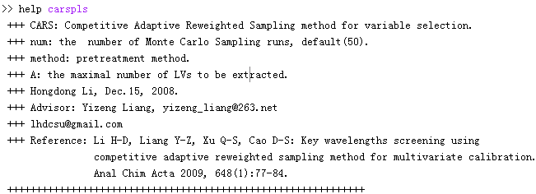4 Example script:
Along with the software, there are two example scripts, with filename example_nir.m and test_package_functions.m, which shows how to run CARS program to get the optimal combination of variables using a NIR dataset. Just run this program, and you will see how CARS works.

5 Reference：
[1] Li H-D, Liang Y-Z, Xu Q-S, Cao D-S: Key wavelengths screening using competitive adaptive reweighted sampling method for multivariate calibration. Anal Chim Acta 2009, 648(1):77-84.

