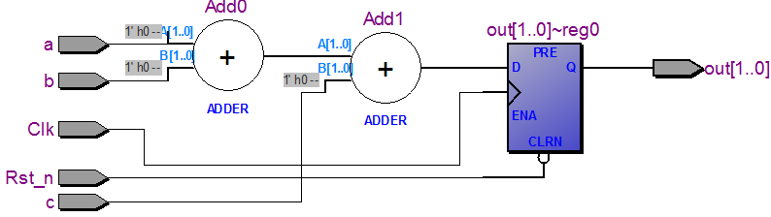

|  |
| --- |
| **module** block_nonblock**(**Clk**,**Rst_n**,**a**,**b**,**c**,**out**);**  **input** Clk**;**  **input** Rst_n**;**  **input** a**,**b**,**c**;**  **output** **reg** **[**1**:**0**]**out**;**    //out = a + b + c;    //d = a+b;  //out = d + c;    **reg** **[**1**:**0**]** d**;**    **always@(posedge** Clk **or** **negedge** Rst_n**)**  **if(!**Rst_n**)**  out **=** 2'b0**;**  **else** **begin**  d **=** a **+** b**;**  out **=** d **+** c**;**  **end**    **endmodule** |
|  |

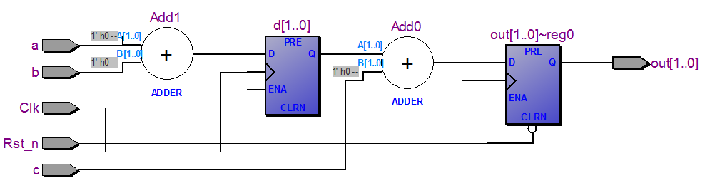

|  |
| --- |
| **module** block_nonblock**(**Clk**,**Rst_n**,**a**,**b**,**c**,**out**);**  **input** Clk**;**  **input** Rst_n**;**  **input** a**,**b**,**c**;**  **output** **reg** **[**1**:**0**]**out**;**    //out = a + b + c;    //d = a+b;  //out = d + c;    **reg** **[**1**:**0**]** d**;**    **always@(posedge** Clk **or** **negedge** Rst_n**)**  **if(!**Rst_n**)**  out **=** 2'b0**;**  **else** **begin**  out **=** d **+** c**;**  d **=** a **+** b**;**  **end**    **endmodule** |

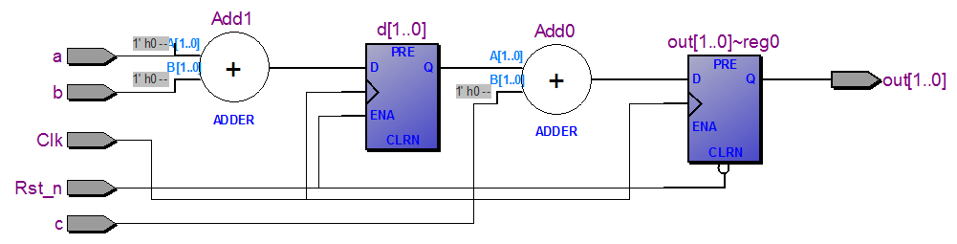

|  |
| --- |
| **module** block_nonblock**(**Clk**,**Rst_n**,**a**,**b**,**c**,**out**);**  **input** Clk**;**  **input** Rst_n**;**  **input** a**,**b**,**c**;**  **output** **reg** **[**1**:**0**]**out**;**    //out = a + b + c;    //d = a+b;  //out = d + c;    **reg** **[**1**:**0**]** d**;**    **always@(posedge** Clk **or** **negedge** Rst_n**)**  **if(!**Rst_n**)**  out **<=** 2'b0**;**  **else** **begin**  out **<=** d **+** c**;**  d **<=** a **+** b**;**  **end**    **endmodule** |

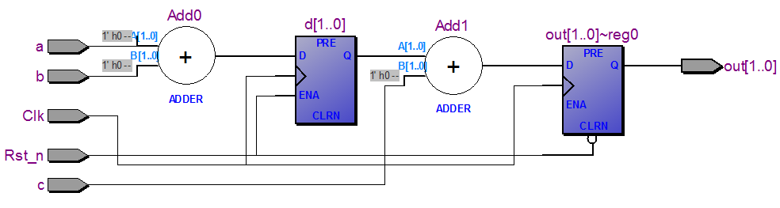

|  |
| --- |
| **module** block_nonblock**(**Clk**,**Rst_n**,**a**,**b**,**c**,**out**);**  **input** Clk**;**  **input** Rst_n**;**  **input** a**,**b**,**c**;**  **output** **reg** **[**1**:**0**]**out**;**    //out = a + b + c;    //d = a+b;  //out = d + c;    **reg** **[**1**:**0**]** d**;**    **always@(posedge** Clk **or** **negedge** Rst_n**)**  **if(!**Rst_n**)**  out **<=** 2'b0**;**  **else** **begin**  d **<=** a **+** b**;**  out **<=** d **+** c**;**  **end**    **endmodule** |







