**SCFIFO and DCFIFO IP Cores User Guide**

2014.12.17

**UG-MFNALT_FIFO**

[**Subscrib**](https://www.altera.com/servlets/subscriptions/alert?id=UG-MFNALT_FIFO)

[**e**](https://www.altera.com/servlets/subscriptions/alert?id=UG-MFNALT_FIFO)

**Send Feedback**

Altera provides FIFO functions through the parameterizable single-clock FIFO (SCFIFO) and dual-clock FIFO (DCFIFO) megafunction IP cores The FIFO functions are mostly applied in data buffering applications that comply with the first-in-first-out data flow in synchronous or asynchronous clock domains.

The specific names of the IP cores are as follows:

* SCFIFO: single-clock FIFO
* DCFIFO: dual-clock FIFO (supports same port widths for input and output data)
* DCFIFO_MIXED_WIDTHS: dual-clock FIFO (supports different port widths for input and output data)

**Note:** The term “DCFIFO” refers to both the DCFIFO and DCFIFO_MIXED_WIDTHS IP cores, unless specified.

# Configuration Methods

You can configure and build the FIFO IP cores with the following methods:

**Table 1: Configuration Methods**

**Method Description**

Using the FIFO parameter editor. Altera recommends using this method to build your

FIFO IP cores. It is an efficient way to configure and build the FIFO IP cores. The FIFO parameter editor provides options that you can easily use to configure the FIFO IP cores.

Manually instantiating the FIFO IP cores. Use this method only if you are an expert user. This

method requires that you know the detailed specifications of the IP cores. You must ensure that the input and output ports used, and the parameter values assigned are valid for the FIFO IP cores you

instantiate for your target device.

|  |  |
| --- | --- |
| **Related Information**  [**Introduction to Altera IP Cores**](http://www.altera.com/literature/ug/ug_intro_to_megafunctions.pdf)  Provides general information about the Quartus II Parameter Editor  © 2015 Altera Corporation. All rights reserved. ALTERA, ARRIA, CYCLONE, ENPIRION, MAX, MEGACORE, NIOS, QUARTUS and STRATIX words and logos are |  |
| trademarks of Altera Corporation and registered in the U.S. Patent and Trademark Office and in other countries. All other words and logos identified as trademarks or service marks are the property of their respective holders as described at www.altera.com/common/legal.html. Altera warrants performance of its semiconductor products to current specifications in accordance with Altera's standard warranty, but reserves the right to make changes to any products and services at any time without notice. Altera assumes no responsibility or liability arising out of the application or use of any information, | [**ISO**](http://www.altera.com/support/devices/reliability/certifications/rel-certifications.html)  [**9001:2008**](http://www.altera.com/support/devices/reliability/certifications/rel-certifications.html)  [**Registered**](http://www.altera.com/support/devices/reliability/certifications/rel-certifications.html) |

product, or service described herein except as expressly agreed to in writing by Altera. Altera customers are advised to obtain the latest version of device specifications before relying on any published information and before placing orders for products or services.

**www.altera.com**

101 Innovation Drive, San Jose, CA 95134

**Specifications**

# Specifications

## Verilog HDL Prototype

You can locate the Verilog HDL prototype in the Verilog Design File (**.v**) **altera_mf.v** in the **< Quartus II installation directory>\eda\synthesis** directory.

## VHDL Component Declaration

The VHDL component declaration is located in the **< Quartus II installation directory>\libraries\vhdl\altera_mf\ altera_mf_components.vhd**

## VHDL LIBRARY-USE Declaration

The VHDL LIBRARY-USE declaration is not required if you use the VHDL Component Declaration.

LIBRARY altera_mf;

USE altera_mf_altera_mf_components.all;

## SCFIFO and DCFIFO Signals

This section provides diagrams of the SCFIFO and DCFIFO blocks to help in visualizing their input and output ports. This section also describes each port in detail to help in understanding their usages, functionality, or any restrictions. For better illustrations, some descriptions might refer you to a specific section in this user guide. block, the read and write signals are synchronized to the rdclk and wrclk clocks respectively. The prefixes wr and rd represent the signals that are synchronized by the wrclk and rdclk clocks respectively.

**Figure 1: SCFIFO and DCFIFO IP Cores Input and Output Signals**

SCFIFO

data[7..0]

wrreq

rdreq

sclr

aclr

clock

almost_full

almost_empty

usedw[7..0]

empty

full

q[7..0]

DCFIFO

data[7..0]

wrreq

rdreq

wrempty

aclr

rdempty

rdusedw[8..0]

wrclk

wrusedw[8..0]

q[7..0]

rdfull

wrfull

rdclk

For the SCFIFO block, the read and write signals are synchronized to the same clock; for the DCFIFO

**SCFIFO and DCFIFO Signals**

**Table 2: Input and Output Ports Description**

This table lists the signals of the IP cores. The term “series” refers to all the device families of a particular device.® For example, “Stratix series” refers to the Stratix , Stratix GX, Stratix II, Stratix II GX, Stratix III, and new devices, unless specified otherwise.

|  |  |  |  |
| --- | --- | --- | --- |
| **Port** | **Type** | **Required** | **Description** |
| clock (1) | Input | Yes | Positive-edge-triggered clock. |
| wrclk(2) | Input | Yes | Positive-edge-triggered clock.  Use to synchronize the following ports:   * data * wrreq * wrfull * wrempty * wrusedw |
| rdclk (2) | Input | Yes | Positive-edge-triggered clock.  Use to synchronize the following ports:   * q * rdreq * rdfull * rdempty * rdusedw |
| data (3) | Input | Yes | Holds the data to be written in the FIFO IP core when the wrreq signal is asserted. If you manually instantiate the FIFO IP core, ensure the port width is equal to the lpm_ width parameter. |

1. Only applicable for the SCFIFO IP core.
2. Applicable for both of the DCFIFO IP cores.
3. Applicable for the SCFIFO, DCFIFO, and DCFIFO_MIXED_WIDTH IP cores.

**SCFIFO and DCFIFO Signals**

|  |  |  |  |
| --- | --- | --- | --- |
| **Port** | **Type** | **Required** | **Description** |
| wrreq (3) | Input | Yes | Assert this signal to request for a write operation. Ensure that the following conditions are met:   * Do not assert the wrreq signal when the full (for SCFIFO) or wrfull (for DCFIFO) port is high. Enable the overflow protection circuitry or set the overflow_ checking parameter to **ON** so that the FIFO IP core can automatically disable the wrreq signal when it is full. * The wrreq signal must meet the functional timing requirement based on the full or wrfull signal. * Do not assert the wrreq signal during the deassertion of the aclr signal. Violating this requirement creates a race condition between the falling edge of the aclr signal and the rising edge of the write clock if the wrreq port is set to high. For both the DCFIFO IP cores that target Stratix and Cyclone series (except Stratix, Stratix GX, and Cyclone devices), you have the option to automatically add a circuit to synchronize the aclr signal with the wrclk clock, or set the write_ aclr_synch parameter to **ON**. Use this option to ensure that the restriction is obeyed. |
| rdreq (3) | Input | Yes | Assert this signal to request for a read operation. The rdreq signal acts differently in normal mode and showahead mode.  Ensure that the following conditions are met:   * Do not assert the rdreq signal when the empty (for SCFIFO) or rdempty (for DCFIFO) port is high. Enable the underflow protection circuitry or set the underflow_checking parameter to **ON** so that the FIFO IP core can automatically disable the rdreq signal when it is empty. * The rdreq signal must meet the functional timing requirement based on the empty or rdempty signal. |
| sclr (1)  aclr (3) | Input | No | Assert this signal to clear all the output status ports, but the effect on the q output may vary for different FIFO configurations.  There are no minimum number of clock cycles for aclr signals that must remain active. |

**SCFIFO and DCFIFO Signals**

|  |  |  |  |
| --- | --- | --- | --- |
| **Port** | **Type** | **Required** | **Description** |
| q (3) | Output | Yes | Shows the data read from the read request operation.  For the SCFIFO IP core and DCFIFO IP core, the width of the q port must be equal to the width of the data port. If you manually instantiate the IP cores, ensure that the port width is equal to the lpm_width parameter.  For the DCFIFO_MIXED_WIDTHS IP core, the width of the q port can be different from the width of the data port. If you manually instantiate the IP core, ensure that the width of the q port is equal to the lpm_width_r parameter. The IP core supports a wide write port with a narrow read port, and vice versa. However, the width ratio is restricted by the type of RAM block, and in general, are in the power of 2. |
| full (1) wrfull (2), (4) rdfull (2)(4), | Output | No | When asserted, the FIFO IP core is considered full. Do not perform write request operation when the FIFO IP core is full.  In general, the rdfull signal is a delayed version of the wrfull signal. However, for Stratix III devices and later, the rdfull signal function as a combinational output instead of a derived version of the wrfull signal. Therefore, you must always refer to the wrfull port to ensure whether or not a valid write request operation can be performed, regardless of the target device. |
| empty (1)wrempty (2),  (4) rdrempty (2), (4) | Output | No | When asserted, the FIFO IP core is considered empty. Do not perform read request operation when the FIFO IP core is empty.  In general, the wrempty signal is a delayed version of the rdempty signal. However, for Stratix III devices and later, the wrempty signal function as a combinational output instead of a derived version of the rdempty signal. Therefore, you must always refer to the rdempty port to ensure whether or not a valid read request operation can be performed, regardless of the target device. |
| almost_full (1) | Output | No | Asserted when the usedw signal is greater than or equal to the almost_full_value parameter. It is used as an early indication of the full signal. |
| almost_empty (1) | Output | No | Asserted when the usedw signal is less than the almost_ empty_value parameter. It is used as an early indication of the empty signal. |

**SCFIFO and DCFIFO Parameters**

**Port Type Required Description**

usedw (1) Output No Show the number of words stored in the FIFO.

wrusedw (2), (4) Ensure that the port width is equal to the lpm_widthu

rdusedw (2), (4) parameter if you manually instantiate the SCFIFO IP core or the DCFIFO IP core. For the DCFIFO_MIXED_

WIDTH IP core, the width of the wrusedw and rdusedw ports must be equal to the LPM_WIDTHU and lpm_widthu_ r parameters respectively.

For Stratix, Stratix GX, and Cyclone devices, the FIFO IP core shows full even before the number of words stored reaches its maximum value. Therefore, you must always refer to the full or wrfull port for valid write request operation, and the empty or rdempty port for valid read request operation regardless of the target device.

The DCFIFO IP core rdempty output may momentarily glitch when the aclr input is asserted. To prevent an external register from capturing this glitch incorrectly, ensure that one of the following is true:

* The external register must use the same reset which is connected to the aclr input of the DCFIFO IP core, or
* The reset connected to the aclr input of the DCFIFO IP core must be asserted synchronous to the clock which drives the external register.

The output latency information of the FIFO IP cores is important, especially for the q output port, because there is no output flag to indicate when the output is valid to be sampled.

## SCFIFO and DCFIFO Parameters

This table lists the parameters for the SCFIFO and DCFIFO IP cores.

|  |  |  |  |
| --- | --- | --- | --- |
| **Parameter** | **Type** | **Requir ed** | **Description** |
| lpm_width | Integer | Yes | Specifies the width of the data and q ports for the SCFIFO IP core and DCFIFO IP core. For the DCFIFO_MIXED_WIDTHS IP core, this parameter specifies only the width of the data port. |
| lpm_width_r | Integer | Yes | Specifies the width of the q port for the DCFIFO_ MIXED_WIDTHS IP core. |
| lpm_widthu | Integer | Yes | Specifies the width of the usedw port for the SCFIFO IP core, or the width of the rdusedw and wrusedw ports for the DCFIFO IP core. For the DCFIFO_MIXED_  WIDTHS IP core, it only represents the width of the wrusedw port. |
| lpm_widthu_r (4) | Integer | Yes | Specifies the width of the rdusedw port for the  DCFIFO_MIXED_WIDTHS IP core. |

1. Only applicable for the DCFIFO_MIXED_WIDTHS IP core.

**SCFIFO and DCFIFO Parameters**

|  |  |  |  |
| --- | --- | --- | --- |
| **Parameter** | **Type** | **Requir ed** | **Description** |
| lpm_numwords | Integer | Yes | Specifies the depths of the FIFO you require. The value must be at least **4**.  The value assigned must comply with this equation,  2 LPM_WIDTHU |
| lpm_showahead | String | Yes | Specifies whether the FIFO is in normal mode (OFF) or show-ahead mode (ON).  For normal mode, the FIFO IP core treats the rdreq port as a normal read request that only performs read operation when the port is asserted.  For show-ahead mode, the FIFO IP core treats the rdreq port as a read-acknowledge that automatically outputs the first word of valid data in the FIFO IP core  (when the empty or rdempty port is low) without asserting the rdreq signal. Asserting the rdreq signal causes the FIFO IP core to output the next data word, if available.  If you set the parameter to **ON**, you may reduce performance. |
| lpm_type | String | No | Identifies the library of parameterized modules (LPM) entity name. The values are **SCFIFO** and **DCFIFO**. |
| maximize_speed | Integer | No | Specifies whether or not to optimize for area or speed. The values are **0** through **10**. The values **0**, **1**, **2**, **3**, **4**, and **5** result in area optimization, while the values **6**, **7**, **8**, **9**, and 10 result in speed optimization. This parameter is applicable for Cyclone II and Stratix II devices only. |
| overflow_checking | String | No | Specifies whether or not to enable the protection circuitry for overflow checking that disables the wrreq port when the FIFO IP core is full. The values are **ON** or **OFF**. If omitted, the default is **ON**. |
| underflow_checking | String | No | Specifies whether or not to enable the protection circuitry for underflow checking that disables the rdreq port when the FIFO IP core is empty. The values are **ON** or **OFF**. If omitted, the default is **ON**. Note that reading from an empty SCFIFO gives unpredictable results. |

1. Only applicable for the DCFIFO IP core.

**SCFIFO and DCFIFO Parameters**

|  |  |  |  |
| --- | --- | --- | --- |
| **Parameter** | **Type** | **Requir ed** | **Description** |
| delay_rdusedw (5)  delay_wrusedw(5) | String | No | Specify the number of register stages that you want to internally add to the rdusedw or wrusedw port using the respective parameter.  The default value of 1 adds a single register stage to the output to improve its performance. Increasing the value of the parameter does not increase the maximum system speed. It only adds additional latency to the respective output port. |
| add_usedw_msb_bit | String | No | Increases the width of the rdusedw and wrusedw ports by one bit. By increasing the width, it prevents the FIFO IP core from rolling over to zero when it is full. The values are **ON** or **OFF**. If omitted, the default value is **OFF**.  This parameter is only applicable for Stratix and Cyclone series (except for Stratix, Stratix GX, and Cyclone devices). |
| rdsync_delaypipe (5)  wrsync_delaypipe (5) | Integer | No | Specify the number of synchronization stages in the cross clock domain. The value of the rdsync_ delaypipe parameter relates the synchronization stages from the write control logic to the read control logic; the wrsync_delaypipe parameter relates the synchronization stages from the read control logic to the write control logic. Use these parameters to set the number of synchronization stages if the clocks are not synchronized, and set the clocks_are_synchronized parameter to **FALSE**.  The actual synchronization stage implemented relates variously to the parameter value assigned, depends on the target device.  For Cyclone II and Stratix II devices and later, the values of these parameters are internally reduced by two. Thus, the default value of **3** for these parameters corresponds to a single synchronization stage; a value of **4** results in two synchronization stages, and so on. For these devices, choose at least **4** (two synchronization stages) for metastability protection. |
| use_eab | String | No | Specifies whether or not the FIFO IP core is constructed using the RAM blocks. The values are **ON** or **OFF**.  Setting this parameter value to **OFF** yields the FIFO IP core implemented in logic elements regardless of the type of the TriMatrix memory block type assigned to the ram_block_type parameter. |

**SCFIFO and DCFIFO Parameters**

|  |  |  |  |
| --- | --- | --- | --- |
| **Parameter** | **Type** | **Requir ed** | **Description** |
| write_aclr_synch(5) | String | No | Specifies whether or not to add a circuit that causes the aclr port to be internally synchronized by the wrclk clock. Adding the circuit prevents the race condition between the wrreq and aclr ports that could corrupt the FIFO IP core.  The values are **ON** or **OFF**. If omitted, the default value is OFF. This parameter is only applicable for Stratix and Cyclone series (except for Stratix, Stratix GX, and Cyclone devices). |
| read_aclr_synch | String | No | Specifies whether or not to add a circuit that causes the aclr port to be internally synchronized by the rdclk clock. Adding the circuit prevents the race condition between the rdreq and aclr ports that could corrupt the FIFO IP core.  The values are **ON** or **OFF**. If omitted, the default value is OFF. This parameter is only applicable for families beginning from Stratix III series. |
| clocks_are_synchronized (5) | String | No | Specifies whether or not the write and read clocks are synchronized which in turn determines the number of internal synchronization stages added for stable operation of the FIFO. The values are **TRUE** and **FALSE**. If omitted, the default value is **FALSE**. You must only set the parameter to **TRUE** if the write clock and the read clock are always synchronized and they are multiples of each other. Otherwise, set this to **FALSE** to avoid metastability problems.  If the clocks are not synchronized, set the parameter to **FALSE**, and use the rdsync_delaypipe and wrsync_ delaypipe parameters to determine the number of synchronization stages required. |
| ram_block_type | String | No | Specifies the target device’s Trimatrix Memory Block to be used. To get the proper implementation based on the RAM configuration that you set, allow the Quartus II software to automatically choose the memory type by ignoring this parameter and set the use_eab parameter to **ON**. This gives the compiler the flexibility to place the memory function in any available memory resource based on the FIFO depth required. |

**SCFIFO and DCFIFO Functional Timing Requirements**

**Parameter Type Requir Description**

**ed**

add_ram_output_register String No Specifies whether to register the q output. The values are **ON** and **OFF**. If omitted, the default value is **OFF**.

You can set the parameter to **ON** or **OFF** for the

SCFIFO or the DCFIFO, that do not target Stratix II, Cyclone II, and new devices. This parameter does not apply to these devices because the q output must be registered in normal mode and unregistered in showahead mode for the DCFIFO.

almost_full_value Integer No Sets the threshold value for the almost_full port. When the number of words stored in the FIFO IP core is greater than or equal to this value, the almost_full port is asserted.

almost_empty_value (6) Integer No Sets the threshold value for the almost_empty port. When the number of words stored in the FIFO IP core is less than this value, the almost_empty port is asserted.

allow_wrcycle_when_full(6) String No Allows you to combine read and write cycles to an

already full SCFIFO, so that it remains full. The values are **ON** and **OFF**. If omitted, the default is OFF. Use only this parameter when the OVERFLOW_CHECKING parameter is set to **ON**.

intended_device_family String No Specifies the intended device that matches the device

set in your Quartus II project. Use only this parameter for functional simulation.

# SCFIFO and DCFIFO Functional Timing Requirements

The wrreq signal is ignored (when FIFO is full) if you enable the overflow protection circuitry in the FIFO parameter editor, or set the OVERFLOW_CHECKING parameter to ON. The rdreq signal is ignored (when FIFO is empty) if you enable the underflow protection circuitry in the FIFO MegaWizard interface, or set the UNDERFLOW_CHECKING parameter to ON.

If the protection circuitry is not enabled, you must meet the following functional timing requirements:

**Table 3: Functional Timing Requirements**

**DCFIFO SCFIFO**

Deassert the wrreq signal in the same clock cycle Deassert the wrreq signal in the same clock cycle when the wrfull signal is asserted. when the full signal is asserted.

Deassert the rdreq signal in the same clock cycle Deassert the rdreq signal in the same clock cycle when the rdempty signal is asserted. You must when the empty signal is asserted. observe these requirements regardless of expected behavior based on wrclk and rdclk frequencies.

(6) Only applicable for the SCFIFO IP core.

**SCFIFO and DCFIFO Output Status Flag and Latency**

**Figure 2: Functional Timing for the wrreq Signal and the wrfull Signal**

This figure shows the behavior for the

wrreq

and the

wrfull

signals.

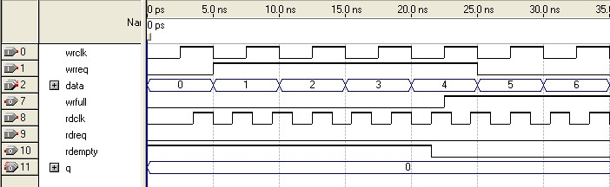

**Figure 3: Functional Timing for the rdreq Signal and the rdempty Signal**

The difference between the two modes is that for the SCFIFO, the wrreq signal must meet the functional timing requirement based on the full signal and the rdreq signal must meet the functional timing requirement based on the empty signal.

This shows the behavior for the

rdreq

the

rdempty

signals.

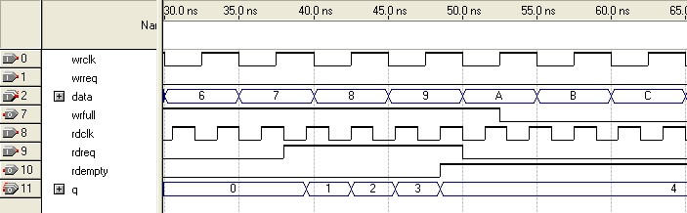

The required functional timing for the DCFIFO as described previously is also applied to the SCFIFO.

# SCFIFO and DCFIFO Output Status Flag and Latency

The main concern in most FIFO design is the output latency of the read and write status signals.

**SCFIFO and DCFIFO Output Status Flag and Latency**

**Table 4: Output Latency of the Status Flags for SCFIFO**

This table shows the output latency of the write signal (

wrreq

)

and read signal

(

rdreq

)

for the SCFIFO according

to the different output modes and optimization options.

**Output Mode**

**Optimization Option**

**(7)**

**Output Latency (in number of clock cycles)**

**(8)**

Normal

(9)

Speed

wrreq

/

rdreq

to

full

1

:

wrreq

to

empty

:

2

rdreq

to

empty

:

1

wrreq

/

rdreq

to

usedw[]

:

1

rdreq

to

q[]

1

:

Area

wrreq

/

rdreq

to

full

1

:

wrreq

/

rdreq

to

empty

: 1

wrreq

/

rdreq

to

usedw[]

: 1

rdreq

to

q[]

1

:

Show-ahead

(9)

Speed

wrreq

/

rdreq

to

full

:

1

wrreq

to

empty

3

:

rdreq

to

empty

1

:

wrreq

/

rdreq

to

usedw[]

:

1

wrreq

to

q[]

3

:

rdreq

to

q[]

1

:

Area

wrreq

/

rdreq

to

full

:

1

wrreq

to

empty

2

:

rdreq

to

empty

:

1

wrreq

/

rdreq

to

usedw[]

1

:

wrreq

to

q[]

2

:

rdreq

to

q[]

1

:

1. Speed optimization is equivalent to setting the ADD_RAM_OUTPUT_REGISTER parameter to ON. Setting the parameter to OFF is equivalent to area optimization.
2. The information of the output latency is applicable for Stratix and Cyclone series only. It may not be applicable for legacy devices such as the APEX® and FLEX® series.
3. For the Quartus II software versions earlier than 9.0, the normal output mode is called legacy output mode. Normal output mode is equivalent to setting the LPM_SHOWAHEAD parameter to OFF. For Show-ahead mode, the parameter is set to ON.

**SCFIFO and DCFIFO Output Status Flag and Latency**

**Table 5: LE Implemented RAM Mode for SCFIFO and DCFIFO**

**Output Mode**

**Optimization Option**

**(10)**

**Output Latency (in number of clock cycles)**

**(11)**

Normal

(12)

Speed

wrreq

/

rdreq

to

full

1

:

wrreq

to

empty

2

:

rdreq

to

empty

1

:

wrreq

/

rdreq

to

usedw[]

:

1

rdreq

to

q[]

1

:

Area

wrreq

/

rdreq

to

full

:

1

wrreq

/

rdreq

to

empty

: 1

wrreq

/

rdreq

to

usedw[]

: 1

rdreq

to

q[]

1

:

Show-ahead

(12)

Speed

wrreq

/

rdreq

to

full

1

:

wrreq

to

empty

3

:

rdreq

to

empty

:

1

wrreq

/

rdreq

to

usedw[]

:

1

wrreq

to

q[]

:

1

rdreq

to

q[]

:

1

Area

wrreq

/

rdreq

to

full

:

1

wrreq

to

empty

:

2

rdreq

to

empty

1

:

wrreq

/

rdreq

to

usedw[]

1

:

wrreq

to

q[]

1

:

rdreq

to

q[]

:

1

1. Speed optimization is equivalent to setting the ADD_RAM_OUTPUT_REGISTER parameter to ON. Setting the parameter to OFF is equivalent to area optimization.
2. The information of the output latency is applicable for Stratix and Cyclone series only. It may not be applicable for legacy devices such as the APEX® and FLEX® series.
3. For the Quartus II software versions earlier than 9.0, the normal output mode is called legacy output mode. Normal output mode is equivalent to setting the LPM_SHOWAHEAD parameter to OFF. For Show-ahead mode, the parameter is set to ON.

**SCFIFO and DCFIFO Metastability Protection and Related Options**

**Table 6: Output Latency of the Status Flag for the DCFIFO**

This table shows the output latency of the write signal (

wrreq

)

(

and read signal

rdreq

for the DCFIFO.

)

**Output Latency (in number of clock cycles)**

**(13)**

wrreq

to

wrfull

1

:

wrclk

wrreq

to

rdfull

2

:

wrclk

cycles + following n

rdclk

wrreq

to

wrempty

:

1

wrclk

wrreq

to

rdempty

2

:

wrclk

(15)

+ following n

rdclk

(15)

wrreq

to

wrusedw[]

2

:

wrclk

wrreq

to

rdusedw[]

2

:

wrclk

+ following n + 1

rdclk

(15)

wrreq

to

q[]

1

:

wrclk

+ following 1

rdclk

(15)

rdreq

to

rdempty

1

:

rdclk

rdreq

to

wrempty

1

:

rdclk

+ following n

wrclk

(15)

rdreq

to

rfull

:

1

rdclk

rdreq

to

wrfull

:

1

rdclk

+ following n

wrclk

(15)

rdreq

to

rdusedw[]

2

:

rdclk

rdreq

to

wrusedw[]

:

1

rdclk

+ following n + 1

wrclk

(15)

rdreq

to

q[]

:

1

rdclk

# SCFIFO and DCFIFO Metastability Protection and Related Options

The FIFO parameter editor provides the total latency, clock synchronization, metastability protection, area, and fMAX options as a group setting for the DCFIFO.

**Table 7: DCFIFO Group Setting for Latency and Related Options** This table shows the available group setting.

|  |  |
| --- | --- |
| **Group Setting** | **Comment** |
| Lowest latency but requires synchronized clocks | This option uses one synchronization stage with no metastability protection. It uses the smallest size and provides good fMAX.  Select this option if the read and write clocks are related clocks. |

1. The output latency information is only applicable for Arria® GX, Stratix, and Cyclone series (except for ®

Stratix, Stratix GX, Hardcopy Stratix, and Cyclone devices). It might not be applicable for legacy devices, such as APEX and FLEX series of devices.

1. The number of n cycles for rdclk and wrclk is equivalent to the number of synchronization stages and are related to the WRSYNC_DELAYPIPE and RDSYNC_DELAYPIPE parameters. For more information about how the actual synchronization stage (n) is related to the parameters set for different target device, refer to
2. This is applied only to Show-ahead output modes. Show-ahead output mode is equivalent to setting the

LPM_SHOWAHEAD parameter to ON

**SCFIFO and DCFIFO Metastability Protection and Related Options**

**Group Setting Comment**

Minimal setting for unsynchronized clocks This option uses two synchronization stages with

good metastability protection. It uses the medium size and provides good fMAX.

Best metastability protection, best fmax and This option uses three or more synchronization unsynchronized clocks stages with the best metastability protection. It uses the largest size but gives the best fMAX.

The group setting for latency and related options is available through the FIFO parameter editor. The setting mainly determines the number of synchronization stages, depending on the group setting you select. You can also set the number of synchronization stages you desire through the WRSYNC_DELAYPIPE and RDSYNC_DELAYPIPE parameters, but you must understand how the actual number of synchronization stages relates to the parameter values set in different target devices.

The **number of synchronization stages** set is related to the value of the WRSYNC_DELAYPIPE and RDSYNC_DELAYPIPE pipeline parameters. For some cases, these pipeline parameters are internally scaled down by two to reflect the actual synchronization stage.

**Table 8: Relationship between the Actual Synchronization Stage and the Pipeline Parameters for Different**

**Target Devices**

This table shows the relationship between the actual synchronization stage and the pipeline parameters.

**Stratix II, Cyclone II, and later Stratix and Cyclone Other Devices**

**Devices in Low-Latency**

**Version [1]**

Actual synchronization stage = value of pipeline parameter - 2 [2] Actual synchronization stage = value of pipeline parameter

The TimeQuest timing analyzer includes the capability to estimate the robustness of asynchronous transfers in your design, and to generate a report that details the mean time between failures (MTBF) for all detected synchronization register chains. This report includes the MTBF analysis on the synchronization pipeline you applied between the asynchronous clock domains in your DCFIFO. You can then decide the number of synchronization stages to use in order to meet the range of the MTBF specification you require.

**Related Information**

* [**Area and Timing Optimization**](http://www.altera.com/literature/hb/qts/qts_qii52005.pdf)

Provides information about enabling metastability analysis and reporting.

* [**http://www.altera.com/literature/hb/qts/qts_qii53018.pdf**](http://www.altera.com/literature/hb/qts/qts_qii53018.pdf)

Provides information about enabling metastability analysis and reporting.

**SCFIFO and DCFIFO Synchronous Clear and Asynchronous Clear Effect**

# SCFIFO and DCFIFO Synchronous Clear and Asynchronous Clear Effect

The FIFO IP cores support the synchronous clear (sclr) and asynchronous clear (aclr) signals, depending on the FIFO modes. The effects of these signals are varied for different FIFO configurations. The SCFIFO supports both synchronous and asynchronous clear signals while the DCFIFO support asynchronous clear signal and asynchronous clear signal that synchronized with the write and read clocks.

**Table 9: Synchronous Clear and Asynchronous Clear in the SCFIFO**

This table shows the synchronous clear and asynchronous clear signals supported in the SCFIFO.

**Mode**

Effects on status ports

Commencement of effects upon assertion Effects on the q output for normal output modes

Effects on the q output for showahead output modes

**Synchronous Clear (sclr)[3] Asynchronous Clear (aclr)(18)** Deasserts the full and almost_full signals.

Asserts the empty and almost_empty signals.

Resets the usedw flag.

At the rising edge of the Immediate (except for the q output) clock.

The read pointer is reset The q output remains at its previous and points to the first data value.

location. If the q output is not registered, the output shows the first data word of the SCFIFO; otherwise, the q output remains at its previous value.

The read pointer is reset If the q output is not registered, the and points to the first data output shows the first data word of location. If the q output is the SCFIFO starting at the first rising not registered, the output clock edge. [4]remains at its previous Otherwise, the q output remains its value for only one clock previous value. cycle and shows the first data word of the SCFIFO at the next rising clock edge. (19)

Otherwise, the q output remains at its previous value.

**SCFIFO and DCFIFO Synchronous Clear and Asynchronous Clear Effect**

**Table 10: Asynchronous Clear in DCFIFO**

This table shows the asynchronous clear supported by the DCFIFO.

**Mode Asynchronous Clear aclr (synchronize aclr (synchronize with read clock)**

**(aclr) with write clock) [5][6] , [7] , [8]**

**(21)**

Deasserts the wrfull The wrfull signal is The rdempty signal is

signal. asserted while the asserted while the read write domain is domain is clearing which clearing which nominally takes three cycles nominally takes of the read clock after the

three cycles of the asynchronous release of the

Effects on status ports write clock after the aclr input.

asynchronous release of the aclr input.

Deasserts the rdfull signal.

Asserts the wrempty and rdempty signals.

Resets the wrusedw and rdusedw flags.

Commencement of effects Immediate. upon assertion

Effects on the q output for The output remains unchanged if it is not registered. If the port is normal output modes [9] registered, it is cleared.

Effect on the q output for The output shows 'X' if it is not registered. If the port is registered, it is show-ahead output cleared.

modes (24)

**Recovery and Removal Timing Violation Warnings when Compiling a DCFIFO IP Core**

## Recovery and Removal Timing Violation Warnings when Compiling a DCFIFO IP

## Core

During compilation of a design that contains a DCFIFO IP core, the Quartus II software may issue recovery and removal timing violation warnings.

You may safely ignore warnings that represent transfers from aclr to the read side clock domain. To ensure that the design meets timing, enable the ACLR synchronizer for both read and write domains.

To enable the ACLR synchronizer for both read and write domains, on the **DCFIFO 2** tab of the FIFO MegaWizard Plug-In Manager, turn on **Asynchronous clear**, **Add circuit to synchronize ‘aclr’ input with ‘wrclk**’, and **Add circuit to synchronize ‘aclr’ input with ‘rdclk’**.

**Note:** For correct timing analysis, Altera recommends enabling the **Removal and Recovery Analysis**

option in the TimeQuest timing analyzer tool when you use the aclr signal. The analysis is turned on by default in the TimeQuest timing analyzer tool.

# Different Input and Output Width

The DCFIFO_MIXED_WIDTHS IP core supports different write input data and read output data widths if the width ratio is valid. The FIFO parameter editor prompts an error message if the combinations of the input and the output data widths produce an invalid ratio. The supported width ratio in a power of 2 and depends on the RAM.

The IP core supports a wide write port with a narrow read port, and vice versa.

**Figure 4: Writing 16-bit Words and Reading 8-bit Words**

words to the FIFO buffer increases the wrusedw flag to two and the rusedw flag to four. Four 8-bit read operations empty the FIFO buffer. The read begins with the least-significant 8 bits from the 16-bit word written followed by the most-significant 8 bits.

This figure shows an example of a wide write port (16-bit input) and a narrow read port (8-bit output).

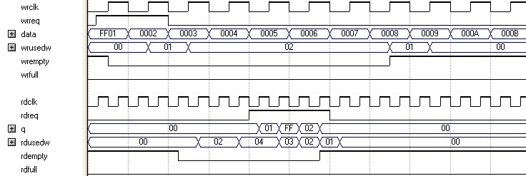

In this example, the read port is operating at twice the frequency of the write port. Writing two 16-bit

**Constraint Settings**

**Figure 5: Writing 8-Bit Words and Reading 16-Bit Words** to the FIFO buffer increases the wrusedw flag to four and the rusedw flag to two. Two 16-bit read operations empty the FIFO. The first and second 8-bit word written are equivalent to the LSB and MSB of the 16-bit output words, respectively. The rdempty signal stays asserted until enough words are written on the narrow write port to fill an entire word on the wide read port.

This figure shows an example of a narrow write port (8-bit input) with a wide read port (16-bit output).

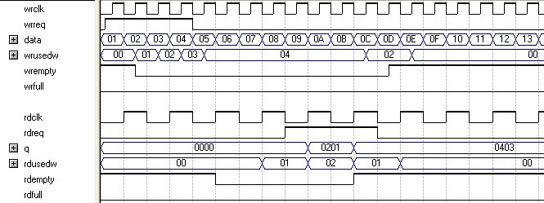

In this example, the read port is operating at half the frequency of the write port. Writing four 8-bit words

# Constraint Settings

When using the Quartus II TimeQuest timing analyzer with a design that contains a DCFIFO block apply the following false paths to avoid timing failures in the synchronization registers:

* For paths crossing from the write into the read domain, apply a false path assignment between the delayed_wrptr_g and rs_dgwp registers:

set_false_path -from [get_registers {*dcfifo*delayed_wrptr_g[*]}] -to [get_registers

{ *dcfifo*rs_dgwp* }]

* For paths crossing from the read into the write domain, apply a false path assignment between the rdptr_g and ws_dgrp registers:

set_false_path -from [get_registers {*dcfifo*rdptr_g[*]}] -to [get_registers { *dcfifo*ws_dgrp* }]

The false path assignments are automatically added through the HDL-embedded Synopsis design constraint (SDC) commands when you compile your design. The related message is shown under the TimeQuest timing analyzer report.

**Note:** The constraints are internally applied but are not written to the Synopsis Design Constraint File (**.sdc)**. To view the embedded-false path, type report_sdc in the console pane of the TimeQuest timing analyzer GUI.

If you use the Quartus II Classic timing analyzer, the false paths are applied automatically for the

DCFIFO.

**Note:** If the DCFIFO is implemented in logic elements (LEs), you can ignore the cross-domain timing

violations from the data path of the DFFE array (that makes up the memory block) to the q output

**Coding Example for Manual Instantiation** register. To ensure the q output is valid, sample the output only after the rdempty signal is deasserted.

**Related Information**

[**Quartus II TimeQuest Timing Analyzer**](http://www.altera.com/literature/hb/qts/qts_qii53018.pdf)

Provides information about setting the timing constraint

# Coding Example for Manual Instantiation

This section provides a Verilog HDL coding example to instantiate the DCFIFO IP core. It is not a complete coding for you to compile, but it provides a guideline and some comments for the required structure of the instantiation. You can use the same structure to instantiate other IP cores but only with the ports and parameters that are applicable to the IP cores you instantiated.

**Table 11:**

**Verilog HDL Coding Example to Instantiate the DCFIFO IP Core**

//module declaration

module dcfifo8x32 (aclr, data, …… ,wfull);

//Module's port declarations input aclr;

input [31:0] data;

.

.

output wrfull;

//Module’s data type declarations and assignments wire rdempty_w;

.

.

wire wrfull = wrfull_w; wire [31:0] q = q_w;

/*Instantiates dcfifo megafunction. Must declare all the ports available from the

megafunction and

define the connection to the module's ports.

Refer to the ports specification from the user guide for more information about the

megafunction's

ports*/

//syntax: <megafunction's name> <given an instance name> dcfifo inst1 (

//syntax: .<dcfifo's megafunction's port>(<module's port/wire>)

.wrclk (wrclk),

.rdclk (rdreq),

.

.

.wrusedw ()); //left the output open if it's not used

/*Start with the keyword “defparam”, defines the parameters and value assignments.

Refer to

parameters specifications from the user guide for more information about the megafunc

tion's

parameters*/

defparam

//syntax: <instance name>.<parameter> = <value> inst1.intended_device_family =

"Stratix III",

inst1.lpm_numwords = 8,

.

.

inst1.wrsync_delaypipe = 4;

endmodule

# Design Example

In this design example, the data from the ROM is required to be transferred to the RAM. Assuming the ROM and RAM are driven by non-related clocks, you can use the DCFIFO to transfer the data between the asynchronous clock domains effectively.

**Figure 6: Component Blocks and Signal Interaction**

( metastable effects). You must have a controller to govern and monitor the data buffering process between the ROM, DCFIFO, and RAM. This design example provides you the write control logic (**write_control_logic.v**), and the read control logic (**read_control_logic.v**) which are compiled with the DCFIFO specifications that control the valid write or read request to or from the DCFIFO.

This figure shows the component blocks and their signal interactions.

ROM

x

256

32

trclk

trclk

32

32

fifo_in

fifo_wrreq

fifo_wrfull

trclk

8

rom_out

rom_addr

Write

Control Logic

DCFIFO

32

x

8

Read

Control Logic

RAM

32

x

256

32

fifo_out

32

ram_in

32

q

9

word_count

8

ram_addr

fifo_rdreq

fifo_rdempty

rvclk

rvclk

rvclk

ram_wren

ram_rden

**Note:**

Both the DCFIFO IP cores are only capable of handling asynchronous data transferring issues

**Note:** This design example is validated with its functional behavior, but without timing analysis and gate-

level simulation. The design coding such as the state machine for the write and read controllers may not be optimized. The intention of this design example is to show the use the IP core, particularly on its control signal in data buffering application, rather than the design coding and verification processes.

To obtain the DCFIFO settings in this design example, refer to the parameter settings from the design file (**dcfifo8x32.v**).

The following sections include separate simulation waveforms to describe how the write and read control logics generate the control signal with respect to the signal received from the DCFIFO.

**Note:** For better understanding, refer to the signal names in Figure 6 on page 25 when you go through the

descriptions for the simulation waveforms.

**Design Example**

**Figure 7: Initial Write Operation to the DCFIFO IP Core**

**State Description**

IDLE Before reaching 10 ns, the reset signal is high and causes the write controller to be in

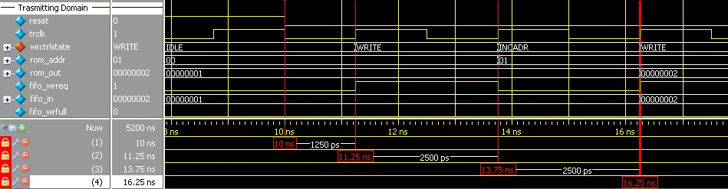

**Table 12: Initial Write Operation to the DCFIFO IP Core Waveform Description**

the IDLE state. In the IDLE state, the write controller drives the fifo_wrreq signal to low, and requests the data to be read from rom_addr=00. The ROM is configured to have an unregistered output, so that the rom_out signal immediately shows the data from the rom_addr signal regardless of the reset. This shortens the latency because the rom_out signal is connected directly to the fifo_in signal, which is a registered input port in the DCFIFO. In this case, the data (00000001) is always stable and pending to be written into the DCFIFO when the fifo_wrreq signal is high during the WRITE state.

WRITE The write controller transitions from the IDLE state to the WRITE state if the fifo_ wrfull signal is low after the reset signal is deasserted. In the WRITE state, the write controller drives the fifo_wrreq signal to high, and requests for write operation to the DCFIFO. The rom_addr signal is unchanged (00) so the data is stable for at least one clock cycle before the DCFIFO actually writes in the data at the next rising clock edge.

INCADR The write controller transitions from the WRITE state to the INCADR state, if the rom_ addr signal has not yet increased to ff (that is, the last data from the ROM has not been read out). In the INDADR state, the write controller drives the fifo_wrreq signal to low, and increases the rom_addr signal by 1 (00 to 01).

- The same state transition continues as stated in IDLE and WRITE states, if the fifo_ wrfull signal is low and the rom_addr signal not yet increased to ff.

**Figure 8: Initial Read Operation from the DCFIFO IP Core**

**State Description**

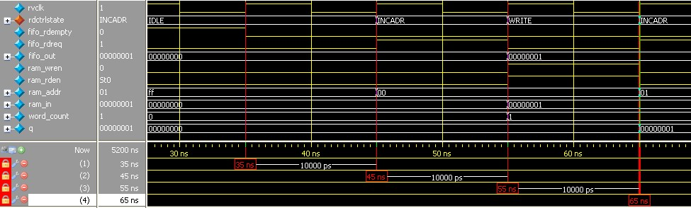

**Table 13: Initial Read Operation from the DCFIFO IP Core Waveform Description**

IDLE Before reaching 35 ns, the read controller is in the IDLE state because the fifo_rdempty signal is high even when the reset signal is low (not shown in the waveform). In the IDLE state, the ram_addr = ff to accommodate the increment of the RAM address in the INCADR state, so that the first data read is stored at ram_addr = 00 in the WRITE state.

INCADR The read controller transitions from the IDLE state to the INCADR state, if the fifo_

rdempty signal is low. In the INCADR state, the read controller drives the fifo_rdreq signal to high, and requests for read operation from the DCFIFO. The ram_addr signal is increased by one (ff to 00), so that the read data can be written into the RAM at ram_ addr = 00.

WRITE From the INCADR state, the read controller always transition to the WRITE state at the next rising clock edge. In the WRITE state, it drives the ram_wren signal to high, and enables the data writing into the RAM at ram_addr = 00. At the same time, the read controller drives the ram_rden signal to high so that the newly written data is output at q at the next rising clock edge. Also, it increases the word_count signal to 1 to indicate the number of words successfully read from the DCFIFO.

-- The same state transition continues as stated in INCADR and WRITE states, if the fifo_ rdempty signal is low.

**Design Example**

**Figure 9: Write Operation when DCFIFO is FULL**

**State Description**

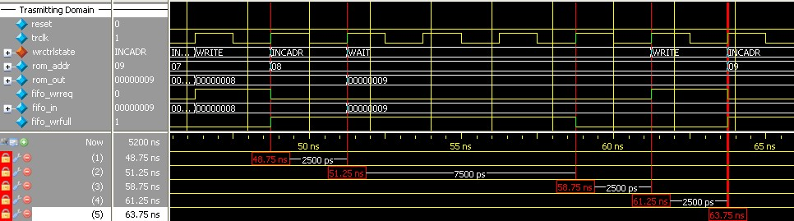

**Table 14: Write Operation when DCFIFO is FULL Waveform Description**

INCADR When the write controller is in the INCADR state, and the fifo_wrfull signal is asserted, the write controller transitions to the WAIT state in the next rising clock edge.

WAIT In the WAIT state, the write controller holds the rom_addr signal (08) so that the respective data is written into the DCFIFO when the write controller transitions to the WRITE state.

The write controller stays in WAIT state if the fifo_wrfull signal is still high. When the fifo_wrfull is low, the write controller always transitions from the WAIT state to the WRITE state at the next rising clock edge.

WRITE In the WRITE state, then only the write controller drives the fifo_wrreq signal to high, and requests for write operation to write the data from the previously held address (08) into the DCFIFO. It always transitions to the INCADR state in the next rising clock edge, if the rom_addr signal has not yet increased to ff.

-- The same state transition continues as stated in INCADR, WAIT, and WRITE states, if the fifo_wrfull signal is high.

**Figure 10: Completion of Data Transfer from ROM to DCFIFO**

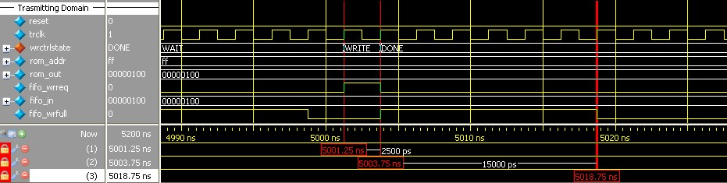

**Table 15: Completion of Data Transfer from ROM to DCFIFO Waveform Description**

**State Description**

WRITE When the write controller is in the WRITE state, and rom_addr = ff, the write controller

drives the fifo_wrreq signal to high to request for last write operation to DCFIFO. The data 100 is the last data stored in the ROM to be written into the DCFIFO. In the next rising clock edge, the write controller transitions to the DONE state. DONE In the DONE state, the write controller drives the fifo_wrreq signal to low.

-- The fifo_wrfull signal is deasserted because the read controller in the receiving domain continuously performs the read operation. However, the fifo_wrfull signal is only deasserted sometime after the read request from the receiving domain. This is due to the latency in the DCFIFO (rdreq signal to wrfull signal).

fifo_rdreq signal to low, and enables the write of the last data 100 at ram_addr =ff. The word_count signal is increased to 256 (in decimal) to indicate that all the 256 words of data from the ROM are successfully transferred to the RAM.

**Figure 11: Completion of Data Transfer from DCFIFO to RAM**

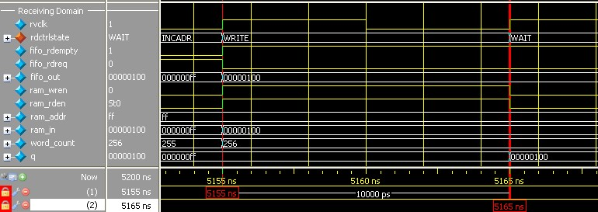

The

fifo_rdempty

signal is asserted to indicate that the DCFIFO is empty. The read controller drives the

The last data written into the RAM is shown at the q output.

**Note:** To verify the results, compare the q outputs with the data in **rom_initdata.hex** file provided in the design example. Open the file in the Quartus II software and select the word size as 32 bit. The q output must display the same data as in the file.

**Related Information**

[**DCFIFO Design Example**](http://www.altera.com/literature/ug/dcfifo_design_example.zip)

Provides all the design files including the testbench. The zip file also includes the .do script

( dcfifo_de_top.do) that automates functional simulation that you can use to run the simulation using the ModelSim-Altera software

**Gray-Code Counter Transfer at the Clock Domain Crossing**

# Gray-Code Counter Transfer at the Clock Domain Crossing

This section describes the effect of the large skew between Gray-code counter bits transfers at the clock domain crossing (CDC) with recommended solution. The gray-code counter is 1-bit transition occurs while other bits remain stable when transferring data from the write domain to the read domain and vice versa. If the destination domain latches on the data within the metastable range (violating setup or hold time), only 1 bit is uncertain and destination domain reads the counter value as either an old counter or a new counter. In this case, the DCFIFO still works, as long as the counter sequence is not corrupted.

The following section shows an example of how large skew between GNU C compiler (GCC) bits can corrupt the counter sequence. Taking a counter width with 3-bit wide and assuming it is transferred from write clock domain to read clock domain. Assume all the counter bits have 0 delay relative to the destination clock, excluding the bit[0] that has delay of 1 clock period of source clock. That is, the skew of the counter bits will be 1 clock period of the source clock when they arrived at the destination registers. The following shows the correct gray-code counter sequence:

000 ,

001 ,

011 ,

010 ,

110.... which then transfers the data to the read domain, and on to the destination bus registers.

Because of the skew for bit[0], the destination bus registers receive the following sequence:

000 ,

000 ,

011 ,

011 , 110....

Because of the skew, a 2-bit transition occurs. This sequence is acceptable if the timing is met. If the 2-bit transition occurs and both bits violate timing, it may result in the counter bus settled at a future or previous counter value, which will corrupt the DCFIFO.

Therefore, the skew must be within a certain skew to ensure that the sequence is not corrupted.

**Related Information** [**skew_report.tcl**](http://www.altera.com/literature/ug/skew_report.tcl)

Use the skew_report.tcl to analyze the actual skew and required skew in your design

# Document Revision History

This table lists the document revision history for this user guide.

**Document Revision History**

**Table 16: Document Revision History**

|  |  |  |
| --- | --- | --- |
| **Date** | **Version** | **Changes** |
| December 2014 | 2014.12.17 | * Clarified that there are no minimum number of clock cycles for aclr signals that must remain active. * Added Recovery and Removal Timing Violation Warnings when Compiling a DCFIFO Megafunction section. * Removed a note about ignoring any recovery and removal violation reported in the TimeQuest timing analyzer that represent transfers from the aclr to the read side clock domain in Synchronous Clear and Asynchronous Clear Effect section. |
| May 2013 | 8.2 | * Updated Table 8 on page 20 to state that both the read and write pointers reset to zero upon assertion of either the sclr or aclr signal. * Updated Table 1 on page 7 to note that the   wrusedw, rdusedw, wrfull, rdfull wrempty and rdempty values are subject to the latencies listed in Table 5 on page 18. |
| August 2012 | 8.1 | • Included a link to **skew_report.tcl** “Gray-Code Counter Transfer at the Clock Domain Crossing” on page 29. |
| August 2012 | 8.0 | * Updated “DCFIFO” on page 3, “Ports Specifications” on page 6, “Functional Timing Requirements” on page 14, “Synchronous Clear and Asynchronous Clear Effect” on page 20. * Updated Table 1 on page 7, Table 2 on page 10, Table 9 on page 21. * Added Table 4 on page 16. * Renamed and updated “DCFIFO Clock Domain   Crossing Timing Violation” to “Gray-Code Counter Transfer at the Clock Domain Crossing” on page 29. |
| February 2012 | 7.0 | * Updated the notes for Table 4 on page 16. * Added the “DCFIFO Clock Domain Crossing Timing Violation” section. |
| September 2010 | 6.2 | Added prototype and component declarations. |

**Document Revision History**

**Date Version Changes**

January 2010 6.1 • Updated “Functional Timing Requirements”

section.

* Minor changes to the text.

September 2009 6.0 • Replaced “FIFO Megafunction Features” section

with “Configuration Methods”.

* Updated “Input and Output Ports”.
* Added “Parameter Specifications”, “Output Status

Flags and Latency”, “Metastability Protection and

Related Options”, “Constraint Settings”, “Coding Example for Manual Instantiation”, and “Design Example”.

February 2009 5.1 Minor update in Table 8 on page 17. January 2009 5.0 Complete re-write of the user guide.

May 2007 4.0 • Added support for Arria GX devices.

* Updated for new GUI.
* Added six design examples in place of functional description.
* Reorganized and updated Chapter 3 to have separate tables for the SCFIFO and DCFIFO megafunctions.
* Added Referenced Documents section.

March 2007 3.3 • Minor content changes, including adding

StratixIII and Cyclone III information • Re-took screenshots for software version 7.0

September 2005 3.2 Minor content changes.

1. You can obtain the low-latency of the DCFIFO (for Stratix, Stratix GX, and Cyclone devices) when the clocks are not set to synchronized in Show-ahead mode with unregistered output in the FIFO parameter editor. The corresponding parameter settings for the low-latency version are ADD_RAM_OUTPUT_

   REGISTER=OFF, LPM_SHOWAHEAD=ON, and CLOCKS_ARE_SYNCHRONIZED=FALSE. These parameter settings are only applicable to Stratix, Stratix GX, and Cyclone devices.
2. The values assigned to WRSYNC_DELAYPIPE and RDSYNC_DELAYPIPE parameters are internally reduced by 2 to represent the actual synchronization stage implemented. Thus, the default value 3 for these parameters corresponds to a single synchronization pipe stage; a value of 4 results in 2 synchronization stages, and so on. For these devices, choose 4 (2 synchronization stages) for metastability protection.
3. The read and write pointers reset to zero upon assertion of either the sclr or aclr signal.
4. The first data word shown after the reset is not a valid Show-ahead data. It reflects the data where the read pointer is pointing to because the q output is not registered. To obtain a valid Show-ahead data, perform a valid write after the reset.
5. The wrreq signal must be low when the DCFIFO comes out of reset (the instant when the aclr signal is deasserted) at the rising edge of the write clock to avoid a race condition between write and reset. If this condition cannot be guaranteed in your design, the aclr signal needs to be synchronized with the write clock. This can be done by setting the **Add circuit to synchronize 'aclr' input with 'wrclk'** option from the FIFO parameter editor, or setting the WRITE_ACLR_SYNCH parameter to ON.
6. Even though the aclr signal is synchronized with the write clock, asserting the aclr signal still affects all the status flags asynchronously.
7. The rdreq signal must be low when the DCFIFO comes out of reset (the instant when the aclr signal is deasserted) at the rising edge of the read clock to avoid a race condition between read and reset. If this condition cannot be guaranteed in your design, the aclr signal needs to be synchronized with the read clock. This can be done by setting the **Add circuit to synchronize 'aclr' input with 'rdclk'** option from the FIFO parameter editor, or setting the READ_ACLR_SYNCH parameter to ON.
8. Even though the aclr signal is synchronized with the read clock, asserting the aclr signal affects all the status flags asynchronously.
9. For Stratix and Cyclone series (except Stratix, Stratix GX, and Cyclone devices), the DCFIFO only supports registered q output in Normal mode, and unregistered q output in Show-ahead mode. For other devices, you have an option to register or unregister the q output (regardless of the Normal mode or Show-ahead mode) in the FIFO parameter editor or set through the ADD_RAM_OUTPUT_REGISTER parameter.