**Statement of Work for The Energy Storage Rights**

**Produce for Computing Project @ANU**

Project Audit 1

Abstract

This is an ongoing project for Energy Storage Rights. It aims to create a platform that allows users to see the return of investment on potential sites for renewable energy technologies. The target users include small enterprises, organizations, individuals. The implementation includes Data Mining, Machine Learning, and Web development. In summary, an applicable and portable website app which can evaluate and utilize the renewable energy for potential users is our client’s desired outcome at the end of the project.

# Authorization

Author:

Approved By

Name ............................................................

# Document history

|  |  |  |  |
| --- | --- | --- | --- |
| **Version** | **Date** | **Revise by** | **Signature** |
|  |  |  |  |
|  |  |  |  |
|  |  |  |  |
|  |  |  |  |
|  |  |  |  |
|  |  |  |  |
|  |  |  |  |
|  |  |  |  |
|  |  |  |  |
|  |  |  |  |
|  |  |  |  |
|  |  |  |  |
|  |  |  |  |
|  |  |  |  |
|  |  |  |  |
|  |  |  |  |
|  |  |  |  |
|  |  |  |  |

**Contents**

Authorization 2

Document history 3

Background and Introduction 6

Vision and objectives 6

Background 6

Brief Introduction 7

Methodologies 7

Project Management 7

Web Development 7

Data Mining 7

Data Visualization 8

Machine Learning 8

Work allocation 9

Objectives and benefits 10

Objectives 10

Desired features 10

A user-friendly interface 10

Smart choices by system 10

How it benefits the client 11

Key stakeholders 12

Client and other stakeholder expectations 12

Make things better for the client and other stakeholders 13

Technical constraint and risk 14

Data reliability 14

Data compatibility 14

Lack of expertise 14

Data coverage 15

Project description and scope 16

Project Design 16

Data sourcing 18

Data normalization 19

Data Storage 19

Development kit and relations 19

Algorithm design 19

Phase1 19

Phase2 19

Phase3 20

Project timeline 21

Schedule 21

Deliverable 21

First deliverable: 21

Second deliverable 21

Third deliverable 21

Milestones 22

Project management 23

Change management 23

Inspection, test, integration, and acceptance 24

Reference 25

Appendix A- Change Request Form 26

Appendix B- Project schedule 27

# Background and Introduction

This project is acquired from Tudor Barbulescu (tudor.barbu7@gmail.com) and carried out under computing project courses including COMP3500, COMP4500, and COMP8715 from The Australian National University. This project team is led by project manager Yuanxin Ye (u5669371@anu.edu.au) and consist six other team members, Yunyuan Yu (u6092441@anu.edu.au), Yuanxin Ye (u5669371@anu.edu.au), Weiwei Liang (u6642464@anu.edu.au), Yufei Qian (u5981067@anu.edu.au), Peilin Song (u6225953@anu.edu.au), Dawei Zhang (u6302602@anu.edu.au), and Daoyu Li (u5912264@anu.edu.au).

## Vision and objectives

Our client, the team of Energy Storage Rights, wishes to develop an energy evaluation service that can find the best location to get the richest energy source in order to maximize the profit margin for our users, e.g. the real estate. The target users include small enterprises, organizations, individuals. In summary, an applicable and portable website app which can evaluate and utilize the renewable energy for potential users is our client’s desired outcome at the end of the project.

## Background

There is an ongoing trend of renewable energy technologies to be further developed in Australia. However, a platform which allows interaction between the technology developers and the potential user is absent. In 2017, coal still contributes 62% to Australian electricity generation. Thus, the potential of our application is brimming with opportunity.

## Brief Introduction

Deployment of renewable energy technologies in a different location often comes with advantage and disadvantage. The energy storage rights is a digital platform that will map, evaluate, promote and help investments in the development rights for energy storage pilot projects such as pumped hydro energy storage, floating solar pilots on lake or sea. Alongside with the platform is the energy storage rights app.

We strive to build up an application which used to evaluate and optimize the performance and potential of location viable for development of different renewable-energy technologies, this outcome will then be visualized to the target user.

## Methodologies

In this project, we will be primarily using the following methodologies:

### Project Management

### Web Development

The client is familiar with Reactjs and is highly recommend us to Reactjs, by acceptance of using Reactjs, this allows the client to be more aware and allow us to create a product that is more aligned with the client requirement. Web development with Reactjs to build up a dynamic web application. Reactjs is capable of reusability as its component creation. Reactjs is a robust and adaptable programming library.

### Data Mining

Data mining is essential for our project, many data acquired from a public source need to be normalized and standardized. Data mining is also the process to find hidden patterns and connections in a large dataset. Generally, data mining includes classification, clustering, regression, and prediction etc.

### Data Visualization

After data processing, we will display our outcome in different ways. Firstly, we will show detailed data in the map application based on user interaction. The application also will show patterns, trends, and correlations of information and data.

### Machine Learning

The outcome of our evaluation and prediction can vary in many aspects. Machine learning helps in identify patterns in enormous data and using that information in automatically decisions and predictions. Therefore, experiment with different machine learning algorithms and models is necessary in order to achieve a high learning rate with our given data.

# Work allocation

|  |  |  |
| --- | --- | --- |
| Team member | Role | Job description |
| Yuanxin Ye | Project manager, Front-end developer, quality assurance engineer | Responsible for web-development, agenda editing, and audit report writing. Doing research on energy source data and ReactJs. |
| Yunyuan Yu | Back-end developer, software developer | Responsible for audit report writing, back-end development and doing research on energy source data. Calculating the best location for getting renewable energy. |
| Weiwei Liang | Front-end developer, software developer | Responsible for audit  report writing, web-development  and agenda writing. |
| Daoyu Li | Back-end developer, database administrator | Responsible  for doing the data research for renewable energy location. Doing the research of map API. Using the energy database, calculating the best location. |
| Dawei Zhang | Front-end developer, web developer | Responsible for web-development. Doing the research on ReactJs. |
| Yufei Qian | Back-end developer, database developer | Responsible  for doing the data research for renewable energy location. Doing the research of map API. Using the energy database, calculating the best location. |
| Peilin Song | Front-end developer.web developer | Responsible for  web-development. Doing the research on ReactJs. |

# Objectives and benefits

## Objectives

Objective 1: Understand the project and make the assumption

Objective 2: familiar with programming develop language and environment.

Objective 3: Identify data source and collect data from a variable source.

Objective 4: Create a Todo App (This is a requirement from client that does not relate to this project.

Objective 5: Deliver an MVP which includes deliverables

to be added

## Desired features

### Two primary functions

For our web application, we are planned to have two function to allow the users to identify the suitable area for renewable energy technologies development.

For our first function, we need to calculate the return of investment by develop various kind of renewable technologies for the area selected by users. Then, we could use a similar algorithm to identify the top N locations that is suitable for development. To rank different locations, we will continue to use the return of investment as the parameter.

### A user-friendly interface

Area cover

Power output by month

Total power output

Total implementation cost

Annual value

Return of investment

Shown data usage

Rank suitable locations in certain area

### Smart choices by system

Nearest energy grid

Suitable locations for different technologies

Best combination

Analyze existing local developers

## How it benefits the client

Many potential customers are interested in renewable energy, our application can help to identify the high potential area for developing renewable energy. This allows for generating more interaction between the property owner and the renewable energy developer. Thus, parties involved including the sellers, buyers, and client are all benefit from this deployment.

# Key stakeholders

There are four potential stakeholders in this project.

As developers of the Energy Storage rights team, we are required to study relevant knowledge and algorithm, learn to have an empathetic mindset, construct and develop the website app. The team members are responsible for planning schedules and project milestones according to the abilities and competence of team members. Our team is expected to build an incremental software model based on the suggestions by the regular meeting with clients and tutors.

As our client, Tudor operates on Energy Storage rights, needs funding, relevant resources and customers for his company. He communicates with potential product users, interprets their expectations and extracts the requirements for our team. In addition, our client will also monitor the team’s progress and provide necessary data resources and technical support.

As our tutor, he needs to access and evaluate the progress and output of our project and provide suggestions and recommendations for us. Thus, we need to adjust the project direction and methods to meet the expectations of our tutor.

Like our users, they expect us to provide a valuable and useful product for them to maximize the profit they will gain. They have their respective expectations and demand for our software so we need to adjust our product to satisfy their expectations. On the other hand, they will provide feedback on our software for clients which will benefit future improvements in our product.

## Client and other stakeholder expectations

Our client expects ready to release a product with core functions at the end of this year. The product should have a web application to provide users with potential energy generated, implementation cost, gross profit in a different time period. In addition, it will provide a smart choice for a combination of renewable energy technologies. Our client needs us to provide an efficient algorithm with good quality data to produce a reliable solution.

## Make things better for the client and other stakeholders

As we mentioned before, a product with good quality data and the efficient algorithm will make a profit for client and users. Users able to find the best efficient choice combination of renewable energy to make a profit and save money.

# Technical constraint and risk

## Data reliability

A wide range of data sourcing is required before the actual mining and implementation processes. This means a large amount of data must be retrieved from different sources, such as searching through the internet which including government database or other individually collected data. However, due to the different methods and techniques used by different data collectors, the data may contain individual preferences and possible biases. Therefore, the reliability and quality of data will decrease which influence the further data analysis as well as the final outcomes. Additionally, most of the data are not up-to-date which leading to weak accuracy of existing data.

## Data compatibility

In order to achieve efficient machine learning process, merging and scrubbing all the founded data will be needed to reach a fixed standard. However, because of different data sources, the content of data may have issues to be merged together in terms of data quality, intended purposes, different attributes or scales. Hence, data cannot be merged unless the identifiers and data-items in every dataset are compatible. Moreover, the sourced data may not exactly satisfy the client’s needs, for example, data at a state-level scale will be far away from the precise position of a building.

## Lack of expertise

Since the majority of the team does not have relevant knowledge about React, the programming language used for website development of this project, it will take more time to achieve the ideal result. Furthermore, the backend team has not been trained or have sufficient experience with machine learning, the current skills may not capable enough to select the most suitable analyzing tools, algorithms, as well as matching between the methods and corresponding data. As a result, the final outcomes may be misrepresented or not precisely enough.

## Data coverage

Even though all the detailed information about potential sites of energy storage are expected, the reality is that not all the specific area has its own precise data offered. For example, a weather station is able to provide wind and rainfall data within a specific area, nevertheless, the place at the center of the weather station will be more accurate than the places at the edge of the station. This means not all the area are evenly covered, which results in possible bias included in the dataset, thus, decreasing the reliability and accuracy of the data.

# Project description and scope

## Project Design

The primary purposes of this project are data mining and data visualization. Therefore, to better manage and plan this project, we separate our team into front-end and back-end teams. Back-end team is responsible to source available data and translate the data in order for the machine learning algorithm. Front-end team is in charged to design the visual web platform and data visualization. However, the actual implementation can be difficult and complicated. The cooperation between each team is very important as the completion of each step is crucial for the next step to be carried out. In the diagram below, it shows criteria that required before taking each step.

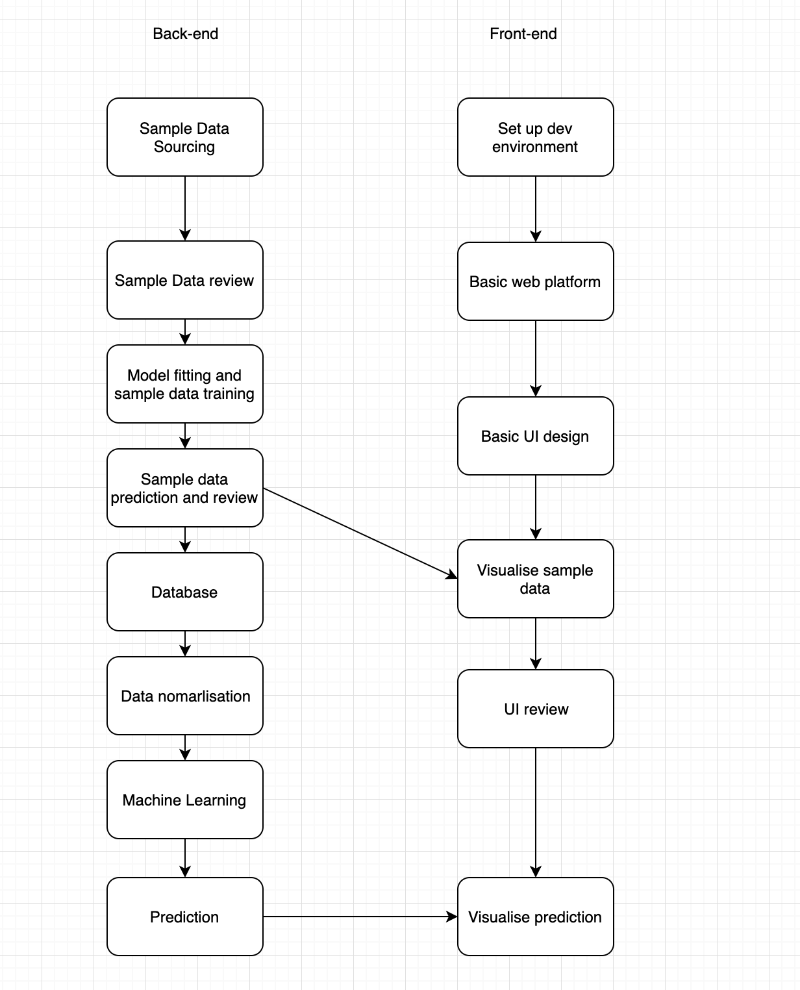

In the current stage, we have designed a methodology for data collection. The data collected are still under exploration level “Search for possible data source”.

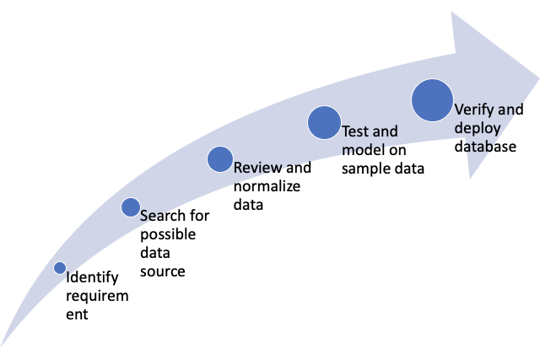

## Data sourcing

In this project, we aim to source all our data from public data source. There are several benefits to our client. Firstly, it saves the cost to develop. Secondly, public data allow the user to trace the data source to make the prediction more convincing. Therefore, most of our data are acquired from Australian Government Sites. For example, Geoscience Australia, the Australian Government Database provides many data including climate, solar, and energy grid. On the other hand, we require a map which allows the user to browse through, therefore, a map API would be a great choice to reduce the cost. Develop a functional map is redundant and costly. Many map API exists and allow for easy implementation and grant efficiency.

## Data normalization

In this stage, we realized that many data contained irrelevant information. An example would be climate data from the weather station. Name of the weather station would be redundant as it can be inefficient to machine learning. Another example is data can contain null value sometimes, we need to eliminate those data.

## Data Storage

To be determined

## Development kit and relations

## Algorithm design

Our algorithm is designed to do a basic calculation of cost and profit and use machine learning to find out the suitable renewable technologies that can be used in an area. We have category our development into four phases

### Phase1

Allow users to draw a shape in the map to locate the area they are interested to develop renewable energy technologies. Acquire a rectangle image around the selected area.

### Phase2

Climate data, Solar data are base on the different weather station, therefore, we need to come out with some algorithm to find out the data we need for the rectangle image we acquired in Phase1. In short, we need to find out the nearest weather station.

### Phase3

We then need to analyze the image to the categorized area for wind, solar, or hydro energy technologies. To do this, we plan to use a machine learning algorithm. Firstly, we provide a sample set to the model where the image is categorized manually. Secondly, we practice our model in test data. Lastly, it is possible that we need to have a different model for different area as they have different terrains and vegetation.

## Our data sources

## Our calculation

# Project timeline

## Schedule

Refer to **APPENDIX B**

## Deliverable

### First deliverable:

* The map is ready to use
* Part of the data normalization completed
* Dummy Data visualization
* Basic connection between front-end and back-end
* Logic of algorithm

### Second deliverable

* A basic algorithm is developed
* Completed data collection
* Calculate the return for respective technology
* User-friendly interface to display essential information

### Third deliverable

* Find the best combination of different technologies by machine learning
* Calculate the return for all combinations of technology
* A professional & fancy website

## Milestones

# Project management

## Change management

The change the executive's procedure in frameworks building is the way requesting, arranging, actualizing, and assessing of changes to a framework. Its fundamental objectives are to help the handling and trace the change to an interconnected set of components. In our project, each change request for each incremental should be logged and approved by the project manager. The change form is below on **APPENDIX A**.

## Task Tracking

## Decision making process

# Inspection, test, integration, and acceptance

# Reference

# Appendix A- Change Request Form

**Change Request Form**

|  |  |  |  |  |  |
| --- | --- | --- | --- | --- | --- |
| **1.) SUBMITTER - GENERAL INFORMATION** | | | | | |
| **CR#** |  | | | | |
| **Type of CR** | ☐ Enhancement | ☐ Defect |  | | |
| **Project/Program/Initiative** |  | | | | |
| **Submitter Name** |  | | | | |
| **Brief Description of Request** |  | | | | |
| **Date Submitted** |  | | | | |
| **Date Required** |  | | | | |
| **Priority** | ☐ Low | ☐ Medium | ☐ High | | ☐ Mandatory |
| **Reason for Change** |  | | | | |
| **Comments** |  | | | | |
| **Attachments or References** | ☐ Yes | ☐ No |  | | |
| **Link:** | | | | |
| **Approval Signature** |  | | **Date Signed** |  | |

|  |  |  |  |  |  |
| --- | --- | --- | --- | --- | --- |
| **2.) PROJECT MANAGER - INITIAL ANALYSIS** | | | | | |
| **Hour Impact** |  | |  | | |
| **Duration Impact** |  | |  | | |
| **Schedule Impact** |  | |  | | |
| **Cost Impact** |  | |  | | |
| **Comments** |  | | | | |
| **Approval Signature** | |  | | **Date Signed** |  |

|  |  |  |  |  |  |  |  |
| --- | --- | --- | --- | --- | --- | --- | --- |
| **3.) CHANGE CONTROL BOARD – DECISION** | | | | | | | |
| **Decision** | | ☐ Approved | ☐ Approved with Conditions | | ☐ Rejected | | ☐ More Info |
| **Decision Date** | |  | | | | | |
| **Decision Description** | |  | | | | | |
| **Conditions** | |  | | | | | |
| **Approval Signature** |  | | | **Date Signed** | |  | |

# Appendix B- Project schedule

