**Breathing Life Back into a Toy Company: A Study on Toys R Us and Information Systems**

Team 3

Zachary Weldon. Sedrick Thompson, Erin Smith, Carson Pierce, Gabriel Smith

**Abstract**

Toys R Us was a major toy store for several years. Often described as a category killer, this company was the largest toy seller until companies like Amazon began to rise in power. Unable to keep up with competitive pricing and quantity, Toys R Us went bankrupt and closed in 2021. In the past few years, Toys R Us has begun rebuilding itself, mainly focusing on small mall outlet stores.

The goal of this research paper is to determine what resources Toys R Us could use to rebuild itself and make it into a competitive business once more. This research paper describes several information systems, noting what they do and the benefits of each system. Some third-party businesses offer their own information systems for companies to use. This research paper uses SWOT analyses to compare these information systems or the tools that an information system can utilize to determine which resources may be the most useful for a new company. This information will be used to create a new company with the intent on making Toys R Us a competitor in the current market.

Throughout our research, we found several different types of information systems that a company would need to be successful, and some of these systems often overlapped in their duties. For example, the Human Resources Management system and Management Information Systems are both responsible for ethical employee treatment, however the Management Information System acts over the Human Resources Management System to perform its necessary functions. Using the information that we gathered, we discussed several different types of information systems such as Product Information Systems, Transaction Processing Systems, and Marketing Information Systems and how they were important to a company’s structuring. After discussing the information systems, a SWOT analysis was developed for items within the information systems category to further discuss each system’s usefulness. The final object within this paper was a new design for Toys R Us that utilized the best features within each information system and compiled them together to create one large company.

Table of Contents

**Brief Overview**4

**Background**5

**Objectives**7

**Information Systems**7

Product Information Management Systems7

Management Information Systems8

Marketing Information Systems9

Security Systems10

Human Resources Management Systems11

Customer Relation Management Systems13

Point of Sale Information Systems14

Transaction Processing Systems15

Artificial Intelligence15

**Procedure**17

**Results (Swot Analyses)**18

Product Information Management Systems SWOT18

Management Information Systems SWOT18

Marketing Information Systems with User Input SWOT19

Marketing Information Systems with Company Input SWOT20

Security Systems SWOT21

Human Resources Management Systems SWOT22

Customer Relations Management Systems SWOT23

Point of Sale SWOT24

Transaction Processing Systems SWOT26

Legal Systems SWOT26

**Proposal for a New Business Design**28

**Suggestions for Future Projects**31

**Conclusions**32

**References**33

**Brief Overview**

There have been many major companies that have closed in recent years due to failure in keeping up with the competitive market. Toys “R” Us is one such company that this research will focus on. The goal of this project is to determine what information systems would be needed to help Toys “R” Us succeed as it reemerges back into the market. This research paper consists of a brief history of Toys "R" Us and its downfall, what information systems the company utilized, and what information systems are available now that can help the company regrow.

**Background**

Toys “R” Us was a successful toy company for several years. The company had always been able to win over both children and adults with their attractive modular toy displays in their brick-and-mortar stores. However, as online shopping through competitors such as Amazon began to become much easier and cheaper for customers, Toys “R” Us began to struggle with attracting customers until it finally closed 2018. The toy company has begun working on reopening locations as of 2021 and is attempting to reestablish a hold on the market. The biggest factor in determining their success will be the information systems that are available to them, and how they choose to utilize these systems. Many new information systems providers have emerged over the past few years, and with artificial intelligence becoming much more sophisticated, Toys “R” Us has several methods at its disposal to become successful.

Toys "R" Us began as a small carpenter’s shop that created items such as strollers and cradles for couples with newborn children. By 1957, Charles Lazarus officially rebranded his business into Toys “R” Us and began to capitalize on post-war family growth (Blakemore, 2023). Toys “R” Us was incredibly popular due to having a large selection of toys to choose from. One of the biggest reasons for the company’s success was this large selection of toys that included popular toys at the time like Barbie, Rock ‘Em Sock ‘Em Robots, and any form of movie merchandise. In fact, Toys “R” Us became so influential in its field that it became classified as a “category killer” (Blakemore, 2023). A category killer is any business that has a large focused selection on a particular product and can create such a competitive pricing market that other smaller businesses cannot feasibly keep up with (Chen 2022). Toys “R” Us was given this classification because of both how much more it sold than the traditional family-owned toy stores at the time, and how it eliminated these competitors through its incredible hold on the toy market (Blakemore, 2023).

Unfortunately for Toys “R” Us, it couldn’t keep its grip on the toy market as the rise in e-commerce became one of its biggest threats. Amazon became a major competitor against Toys “R” Us as it was able to offer better prices on products and an overall simpler and more convenient experience. Initially, Toys "R" Us created their own website to rival Amazon, but this attempt was not successful (de Oca, 2020). The toy company then decided to create a partnership with Amazon in hopes of improving toy sales. This too was a failure as Amazon began selling toys from other companies, causing Toys “R” Us to break away from the contract (de Oca, 2022). Due in part to the rise of competition both from brick-and-mortar stores, as well as a large debt that the company had accrued, Toys “R” Us filed for bankruptcy in 2017 (de Oca, 2020) and closed its last stores. In 2021, Toys ‘R’ Us began to reopen stores. Most of these locations are just small outlets in malls, but there have been some plans to bring the stores back to their full scale.

**Objectives**

This research is focused on the different information systems utilized in Toys “R” Us that could affect its success as its stores reopen. We will focus on several information systems such as product information management, marketing information system, executive information systems, and legal systems to determine how these systems could help the company develop once more. In addition, there are many ways that these systems may be improved to produce an overall stronger company. It was due to the lack of things like a strong e-commerce platform and poor management oversight that Toys “R” Us collapsed. Therefore, it is necessary to determine just how important factors such as these are to the development and success of businesses. Our goal is to look at several different information systems designers across this category to determine which systems are the most efficient, offer the most freedom in system design and adjustment, and determine what new features could be utilized on Toys R Us since three years have passed since its closing.

**Information Systems**

There are many different information systems that work together to make a company successful. These systems range in objectives from marketing to executive, but they all play a vital role in the company’s success. This section will describe some of these systems and their roles in a company, and will also discuss some major examples of information systems designed by companies.

**Product Information Management Systems**

Product information management (PIM) systems are designed to store information about the company in a database. The information stored is geared toward company marketing such as SKUs, specific designs, pricing guidelines, and company procedural manuals (lumavate, 2024). A product information system logs information about a company in such a way that it is simple to locate and easily transferred when required. This data is typically logged in a large database from across multiple files to allow a simple, effective way to keep data consistent (Manchanda, 2023). Easy access to data is important for a company because this allows employees to quickly find solutions to any problems that have been dealt with previously and log any data or issues that may arise. Product information systems also contain a system called digital asset management. This system allows a company to grant or deny access to their resources, as well as grant employees remote access to digital files (lumavate, 2024). There are several great examples of PIM systems including Sales Layer, Lumavate, and Akeneo (lumavate, 2024). Sales Layer is a large PIM system that has played a major role in companies like Amazon using their application program interface (lumavate, 2024). The system allows a user to simply upload an Excel-style sheet into the database, and their store information will be generated by the information system (Sales Layer, 2023). The user can then access the information through the Sales Layer system to ensure accuracy of the input information and create an organization for their items (Sales Layer, 2023). Lumavate is designed to integrate the features of product information management and digital asset management together to streamline the business process (lumavate, 2024). In addition, the platform allows a company’s employees a more informal connection through texting, which may aid in establishing better personal connections amongst employees. Lastly, Akeneo offers a PIM system utilized across the world that capitalizes on modern technology. This system uses a cloud-based system to hold a company’s data. This system also utilizes artificial intelligence to collect product description data and create descriptions about their products (akeneo, 2024). The only downside to this system is that it tends to be more expensive due to utilizing multiple advanced technology features (lumavate, 2024).

**Management Information Systems**

Management Information Systems (MIS) are also very important to a business. Much like PIMs, Management Information Systems are designed to control access to data, but they also allow management to view information about the company to make informed decisions (Coursera Staff, 2023). In many cases, this system holds personal information about the company that neither the public nor non-management would have access to because of its importance to the company. Some of this information could include marketing campaigns, finances, or classified business plans for expansion (Segal, 2022). Organizing this data into restricted folders ensures that the data is kept both confidential and accessible to the people within the company that need it. In addition to financial choices, an MIS can also manage inventory both at the corporate and the local level of business. For example, if a certain product at a store is stolen often, management may restrict the amount of item sold their to control shrinkage. This system is also responsible for human ethical treatment (Bhasin, 2023). The MIS handles employee interactions and human resource complaints to ensure that the company is running smoothly and that employees are practicing ethical behaviors. This system is also responsible for ensuring that employees are given their salaries and that there are no discrepancies in financial handlings (Bhasin, 2023). Every company should utilize their own Management Information System as this acts like the framework for the business. This system really determines if a business will run smoothly and can determine overall employee satisfaction. If a business has very strict management or its company guidelines were unclear, employees would probably become frustrated with how the company functions and would find employment elsewhere. Therefore, this system is vital to a company’s success because it must also be able to balance company policy and employee satisfaction to ensure optimal performance.

**Marketing Information Systems**

Marketing Information systems provide the financial information of the company and control such processes as data collection and information provision for finances. On the customer’s side, this system collects information through a process called clickstream data, which monitors information about consumer access and length of stay on the company’s website (Principles of Marketing, 2015). Another major way that a Marketing Information system collects data is through scanning public resources such as rival companies marketing data, government records, or online in posts (Principles of Marketing, 2015). It is essential that a company collects information in multiple different ways so that they know what customers are currently demanding so that they may adequately supply them with the proper goods. When a company has gathered an appropriate amount of data, they can make intelligent decisions on how to execute a marketing strategy. To hold all of this marketing data, companies have devised many methods for tracking information to make it easily accessible. One such method of making the data accessible is through the use of the intranet. The intranet acts as an internet system for a company’s employees, but only the members of that company can access the information (Principles of Marketing, 2015). This ensures that the confidentiality of the information is kept while also providing employees with the appropriate resources to accomplish their tasks. Dashboards also act as a good display system because they contain groups of related data that management may easily access for reference (Principles of Marketing, 2015). Marketing Information systems do more than just collect and display this data though. These systems are responsible for analyzing trends from data and creating marketing solutions to improve their company. Research is often conducted almost like the scientific method in which data is gathered from multiple sources, analyzed over a group, and tested to document results (Principles of Marketing, 2015). Companies may collect information through various processes as mentioned above, but they can also purchase data called syndicated research from companies that collect and sell information (Principles of Marketing, 2015). Once this system has collected enough data, the company can begin testing their methods in a controlled environment to determine how well a marketing strategy may function. When the tests have yielded results, the research is documented and may be used to determine if a marketing strategy is viable for the company to utilize.

Toys R Us utilized Salesforce as a means to unify all of their websites across Asia. (Salesforce, 2021). Salesforce is a cloud-based data storage system that helps to unify different branches of a business under one large system (salesforce, 2024). In addition, Salesforce uses artificial intelligence to aid in creating things such email crafting or product descriptions. This created a much needed simplification to their online platform and helped ensure that customers would have a consistent experience on every platform they utilized.

**Security Systems**

After coming back from bankruptcy in 2019, Toys "R" Us implemented a new security system. This security system was installed by startup b8ta and consisted of sensors installed in the ceiling. These sensors monitor people as they browse the store. According to iO9, “Toys ‘R’ Us is monitoring where kids go to produce data for brands.” According to the company, their products weren't designed to track children. The camera systems are operated by a company called RetailNext, a company that supplies over 500 companies. A spokesperson for Tru Kids, the parent company of Toys ‘R’ Us, said, “RetailNext provides Toys ‘R’ Us with the same cameras that are used by major retailers worldwide to measure foot traffic both at the entrance and within different areas of the store” (Matsakis, 2019). They claim this data is anonymous and the cameras are programmed to not track kids. The data is used for product placement, staffing, and general store performance. Ray Hartjen, a spokesperson for RetailNext, stated that the company’s Aurora sensor uses an algorithm which “was trained to tell the difference between kids and adults by looking at pictures of RetailNext customers who consented to their images being used” (Matsakis, 2019). To avoid the cameras accidentally tracking a child, Hartjen stated, “RetailNext has internal auditing teams who test its cameras each time they’re installed.” If a child under 13 is accidentally recorded, then RetailNext moves to delete that information immediately” (Matsakis, 2019).

**Human Resources Management (HRM)**

Human Resources Management (HRM) system plays a huge part in businesses. This system is a strategic method that helps approach to nurturing and support employees and ensure a positive workplace environment. All things considered, making employees feel at home is key! This system also has many duty ranges for various businesses that break off into categories and sectors. These are workplace safety, Recruitment and selection, benefits and pay, training and development, employee relations, Career planning, and Information sharing, Having said that, HRM is a department that houses other departments. However, starting with workplace safety this is one of the most important departments in a business. In this department, the safety, well-being, and contentment of employees fall under the purview of this human resources division. All businesses have things to go wrong that is also what Workplace safety is for it manages Risk for the business and its employees is reduced when HR management is handled well. Workplace policies are updated with protective measures and implemented as needed, and they also address conflicts between team members. Training and Development is one of the other processes in HRM and is a component of safety. Building a feeling of community at work involves more than just HRM training and development. From a safety perspective, training and development programs are very important since they instruct staff members on how to do their tasks safely. Recruitment and Selection is also one of those departments needed in human resources in many ways. This keeps the business that puts a high priority on selecting the best candidate for the job frequently better positioned to experience long-term growth and profitability. Recruiting the proper people is a crucial part of the hiring process, which is an investment in your company's future. However, it's not as easy as it sounds you have to have a strong team because you don't want to recruit the wrong people. Hiring the right people is the goal of HRM's recruiting and selection processes to find qualified workers for businesses. This leads to prospective workers possessing trendy talents that your company is now lacking, or they may have the skills required to fulfill the post. Your teams may aim for high production levels and achieve targeted results by hiring the best staff available. With that being said at the end of the day the business's ability to provide excellent customer service is crucial to its success. A highly qualified worker can help clients more effectively and has a greater understanding of how to value them. Better sales, more earnings, increased client loyalty, and quicker company growth are the outcomes. Doing research I found, "Research says nearly 76% of recruiters think attracting quality candidates is the biggest hurdle, and 41% say filling entry-level positions is the hardest." This process has plenty of steps that can get very advanced. The first step in the multi-stage recruitment process is determining your organization's recruitment needs, such as post-vacancy and corporate expansion. Recruiters create job descriptions and application specifications after determining the duties and requirements of the position. To guarantee that as many candidates as possible may view and apply for the post, they then use the proper channels for a job advertisement. The Talent pool creation HR gathers applications from candidates who apply through the job posting before the application deadline. After the pool talent pool and selecting applicants who meet the requirements of your business comes selection. The efficacy of a company's selection procedure determines the entire employment process. Then next comes the interview to ascertain if the chosen applicants are a suitable match. However, the panel is often assembled to conduct interviews with them and pose both technical and non-technical questions.

The hardest part for the selectee is the recruiter administers an assessment to ascertain an applicant's psychic and personality. This is one of the best methods when it comes to picking the right candidates. A further crucial rationale for the necessity of a recruitment team Businesses must adapt to shifting market trends. This brings us to the significance of recruiting in HRM, whereby the HR department chooses applicants from various fields and backgrounds to meet organizational demands without interfering with daily operations. In the end, you may be confident that everything will go according to plan for your everyday company operations. However, getting into benefits and pay is very important in HRM also. To draw in top people and increase retention rates, it employs pay. Benefits are additional advantages or incentives that a company offers to its workers. These may be valued financially, but the worker does not get money from the company. A further HRM process is employee relations. Without healthy working connections with their leadership team and fellow employees, teamwork becomes impossible. Effective teams are made up of members who respect one another, cooperate, are open to new ideas, and operate well together. These teams are the result of proper relationship management. In many respects, one of the most important and scrutinized HRM departments is carrier planning. HRM may determine an employee's talents, expertise, and abilities through career planning. By doing this, employers may make sure that workers are positioned in positions that fully utilize their abilities and maximize their worth. It also boosts efficiency and productivity, which raises the profitability of your company. Sharing information in HRM is beneficial as it may lower a firm's dependency on pricey training programs and foster the vital feeling of community inside the organization. After all, cooperative teams are probably far more productive. Having said this, to guarantee peak performance, this system needs to be able to strike a balance between employee happiness and corporate policy, which makes it essential to a business's success.

**Customer Relationship Management**

Many companies like Toys R Us employ different tactics when it comes to customer relations. The largest and fastest-growing tactic is Customer Relationship Management (CRM), which Toys R Us Canada uses. CRM manages the entire company’s relationships, customer interactions, and its potential customers. The purpose of CRM is to improve the company by making improvements such as making systems more efficient, connecting the customer base, and improving profitability. CRM is also a system, in other words, a software that companies can use to help them grow and improve.

In the case of Toy’s R Us Canada, the company is working with Salesforce for their CRM system. With a CRM system, “you can manage interactions across sales, customer service, business development, recruiting, marketing, and any other line of business” (Salesforce, 2022). By using the CRM system companies can use the CRM tool which offers a central location where “you can store customer information, identify sales opportunities, record service issues, or even manage a marketing campaign” (Salesforce, 2022). This system also makes it easy to see information across the business and to access data. According to Salesforce, their CRM allows “everyone in the company to see how customers have been communicated with, what they have bought when they have last purchased, and what they have paid” (Salesforce, 2022). Because CRM seems like it's everywhere, here are a few examples to paint a picture of what it could look like: chat integration, automated repetitive tasks, marketing automation, lead management features, and, lastly, contact management features.

Overall, what CRM brings to Toys R Us Canada is a tool and a platform that is easy to use, efficient, and allows employees to find solutions to develop new customer relations or to help existing customers. It also brings the ability to oversee progress and give employees tools to efficiently complete their tasks.

**Point of Sale Information System**

A POS or Point of Sales System is what businesses, such as retailers, use in tandem with Transaction Processing Systems to be able to exchange their goods and services with a customer for money. Processing transactions are not all Point-of-Sale systems are used for as they can also track inventory, employee hours/shifts, and customer data. Having an up to date, well maintained POS information system can help with efficiency and customer satisfaction when it comes to purchasing goods and services from a business.

Looking at the POS system that a retail company that can be considered a rival which is Target, with the help of their IT team they were able to craft their own Point of Sale information system that catered to Targets specific needs. Making a unique system can also protect it from any attacks or foreign entities. Also having a specifically designed and curated POS system allows room for growth and expansion is important. Also, keeping in mind making a system that is not only simple but accessible to a wide range of individuals is key. Poland's branch of Toys “R” Us experimented with a newer POS system in 2016 called Comarch ERP standard, Retail POS, and WMS. These systems combine to make customer shopping fast, efficient, and accurate all the while it is able to track inventory and consumer data. Having these other systems attached to the POS information system allows for the company to track more data such as what is popular with customers or the difficulties and the time it takes for the transactions. This company POS system could also be used to monitor how promotions were going as “Additionally, the software supports promotions, vouchers, and **individual discounts** granted to clients” (Comarch, 2024).

A method for Toys “R” Us to improve their former POS systems altogether would be to develop a custom information system similar to the successful company, Target. They did this to allow for full optimization, customization, and control of their whole system. This can benefit Toys “R” Us so they can have an up-to-date POS system to handle modern quality of life technological advancements such as Tap to Pay, Apple Pay, or Buy Now, Pay Later transactions. Another benefit of developing an in-house POS system is that the IT department would have full knowledge of how the system works in case of any errors and would not have to go to a third party to seek assistance with working on any issues. Security would also be better as unnecessary programs and features would be removed, decreasing openings and chances of a cyber-attack. The downsides, however, would be the initial cost and time it takes to develop a customized POS system. However, the advantages far outweigh the disadvantages.

**Transaction Processing Systems**

Transaction processing systems are information systems that a business or organization uses to process every transaction that comes through or from that organization. A TPS has four main branches for it to function properly which include storage, processing systems, inputs, and outputs. Without a good TPS information system, a retail organization will become disorganized and inefficient as they won't be able to track their inventory or other points of interest regarding customers' inputs.

Toys “R” Us used multiple different TPS information systems, one of which is called Cin7. Cin 7 is one of the most popular retail information systems and it's what allowed Toys “R” Us to sell their products online and be able to manage their employees electronically making this information system one of the main pillars holding the retail organization together. Toys “R” Us also experimented with a TPS information system called Oracle Retail Allocation in 2014. This information system was an asset management system that tracked the inventory and specific data in different locations such as what item is popular and being sold a lot or what is not as popular and uses that data to further make simultaneous management decisions. One of Oracles main focuses is data collection for organizations and compile all that data throughout various resources as stated with, "Oracle **Retail Allocation customers** around the world, aggregating massive amounts of data points that form the basis of our forecast assumptions and perhaps the rise and fall of certain vendors and their products on a quarterly basis” (Oracle, 2024).

**Artificial Intelligence**

Artificial Intelligence (AI) has created a stir in commerce as it has provided new ways for businesses to track users and collect data. When trained, AI can accomplish a wide variety of tasks. Some of these tasks include data research, customer personalization, and security optimization (Zapanta, 2023). Artificial Intelligence collects research data through research processing much like a person would, and then utilizes this information in an algorithm to determine a solution. A similar process is utilized through customer optimization. Through machine learning, the AI can determine what a user prefers to look up on a website and can recommend products that are similar to give the user a wide array of options (Zapanta, 2023). This function of artificial intelligence is particularly useful for e-commerce as it allows businesses to create personalized search systems for their users. Lastly, cybersecurity is another category that AI is helpful with as artificial intelligence can be trained to look for holes in a company’s security system, thereby preventing breaches before they can happen (Zapanta, 2023). In each example listed above, AI can be used to improve efficiency and reduce the amount of work that people need to do. This could potentially allow companies to place human employees in other positions to discover better methods of business conduct while allowing artificial intelligence to do the more tedious tasks that require repetition and detail attentiveness. Some examples of AI systems used in business include Google Workspace’s Duet AI and salesforce AI. Duet AI by Google Workspace is useful in that it takes the applications of Google Workspace like Google Docs and Gmail, and provides AI generated ideas for writing (Google Workspace, 2024). This can prove useful to users as it gives them alternative options to approach in their writing. Salesforce’s AI can be used in their marketing system to create a personalization for users as they navigate across the company’s system (salesforce, 2024). Furthermore, Salesforce AI utilizes a segmentation system for data and can aid in creating marketing (salesforce, 2024).

**Procedure**

To determine the best system to use for each information system category, we implemented a SWOT analysis to help compare systems, For example, when deciding the best PIM system, a SWOT analysis was created for Sales Layer, Lumavate, and Akeneo to determine which one was best. This was especially helpful when looking at information systems that had third-party services. Some systems, like management information systems, did not have many third-party sellers. In these cases, we looked at some of the tools that companies commonly used, like dashboards and artificial intelligence, and determined what would be the best resources to construct a new information system. Once all of the best information systems and resources were determined, the information was combined together into one corporation which was determined to be the most advantageous design for Toys “R” Us’s success.

**Results**

**PIM Systems SWOT**

The three PIM systems that had a SWOT analysis performed on them were Akeneo, Sales Layer, and Lumavate. Out of all three systems, Sales Layer would probably be the most ideal option for Toys R Us. Akeneo would have been an incredible option due to the advanced artificial intelligence and cloud-based upload system, but the incredibly high cost starting at around $25,000 annually just for cloud uploading would be way to expensive for a re-emerging company (akeneo, 2024). Lumavate was also a viable option as it was quite cheap at only $999 per month (lumavate, 2024). This pricing included the texting system and access to a joint PIM and digital asset system. The two biggest problems with this information system though were that it had very few features that made it unique compared to other PIM systems, and that the text messaging system could potentially cause security oversights. Sales Layer is the best option because of its simplicity of design. Sales Layer allows users to upload an Excel sheet of their business system, and the application uses this data to create a design for the company’s website (Sales Layer, 2023). Displayed below are the three SWOT analyses listed in the following order: Akeneo, Sales Layer, and Lumavate.

**Management Information Systems SWOT**

Companies often create their own management information systems because each business has their own specific needs. Speculation can be done though to determine some important things that a business should generally have. All companies should have an employee wage system, an ethics line, and some form of tracking that keeps up with customer usage to determine product consumption. An ethics line is mandatory as this is where reports of business misconduct are communicated. An ethics line may be built into the company to allow company employees to handle misconduct issues, or an ethics line may be outsourced to a third party to remove any impartiality (Titus, 2024). Wage systems help a company to determine the importance of a job and how much pay a position should receive (SalaryCube Editorial Team, 2023). These systems ensure that companies distribute a reasonable amount of money to employees while also ensuring that the company isn’t giving up too much money. Customer tracking may be one of the most important things for a company to monitor as the customer’s needs affect what the company can sell. Companies may gather customer information from many different sources like transaction data or geographic factors, and these companies may use this data to accurately fulfill customer needs. Another SWOT analysis was utilized to show how effective these components of a Management Information System are in a company.

**Marketing Information System with Consumer Input SWOT**

There are several methods of consumer tracking that can be used to market products effectively. A business could use artificial intelligence, transaction history, demographic locations, or survey forms to gather customer data (Layerise, 2023). Artificial intelligence is useful for collecting large pulls of data and filing them efficiently but may be too expensive for a recovering business to fully implement. Survey forms may be considered a cheaper alternative, but it may be time-consuming to wait for individual responses. Each one of these methods are effective at collecting information on product consumption in a particular way, but these methods are probably best used in combination with each other. Following is a SWOT analysis of each on how effective they are at accomplishing this task.

**Marketing Information Systems with Company Input SWOT**

The methods used in advertising a product are vital to a company’s success. There are several ways to successfully advertise a product such as customer purchase data, advertisements on digital platforms, or through observation of a competitor’s sales data (Principles of Marketing, 2015). Digital marketing has become more prominent because the ability to broadcast information allows businesses to reach multiple customers; but broadcasting also creates opportunities for nefarious entities to tarnish a business name. Overall, each of these tools have some presence on digital platforms, and these tools should be utilized to maximize business success.

**Security Systems SWOT**

The security systems implemented in protecting software is vital to the company’s success. Tracking is particularly important in both a physical and software sense as it allows a company to track who accesses their systems or enters a physical store. This improves security as it allows users to be logged in a system for referencing. Following is a SWOT analysis on the usage of trcking in Security Systems.

**Human Resources Management Information Systems SWOT**

Human Resources Management Information Systems control the people side of management. This system is responsible for ensuring that employees have proper access to resources that will help guide their success within the company. In addition, the HRM system ensures that employees can file complaints confidentially if ethical business practices are not being performed. This system also controls things like company hiring. When a company begins to look into hiring individuals, they must have a standard procedure for ensuring that new employees can meet the company’s standards. Following is a SWOT analysis on this information system.

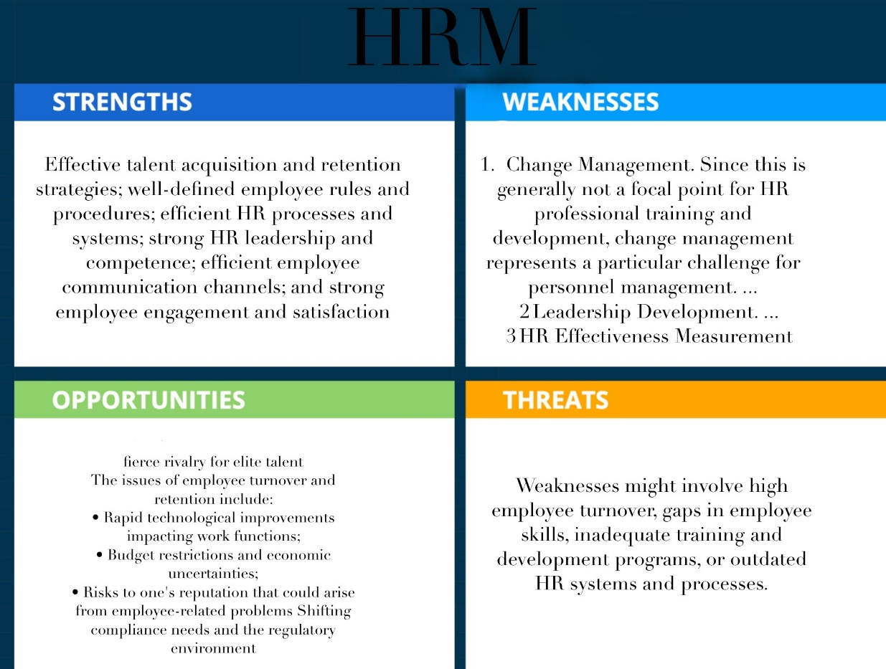

**Customer Relationship Management SWOT**

Customer relationship management offers great possibilities for customer relations, work optimization, and system organization. The opportunities that can be found are that CRM can now be used from a cloud based software, which makes implementation cheaper. The use of CRM can increase communication between employs but also customers too, which can also get the company more customers. Weaknesses found is high implementation cost (Not Cloud Based), extensive training for the system, and data privacy concerns. Threats that can be found are going over budget when using CRM and due to CRM using software and technology it is threated by cyber security concerns.

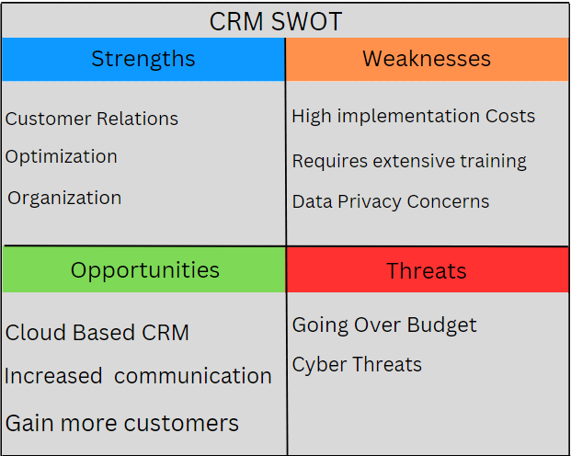

**Point of Sale SWOT**

The Point-of-Sale information system, Comarch, is a highly versatile and expansive information system. It is able to handle many different tasks such as data collection and management and processing transactions but too many features can lead to many weaknesses. To prevent any of those from happening, the option of making an in-house POS system would allow for near unlimited flexibility, ensuring that there are less wasted resources on unused portions of the information system. It would also give the IT team more knowledge of how the information system works, helping them detect threats and fix faulty code.

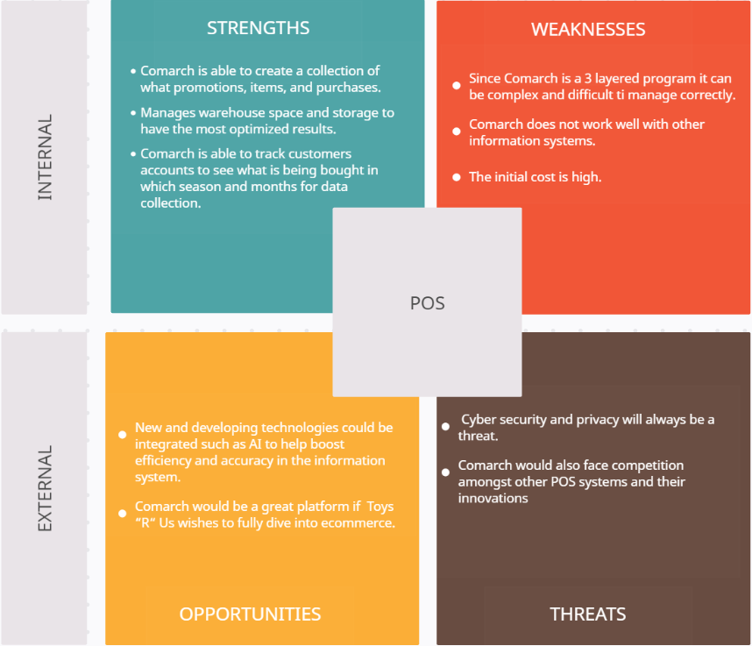

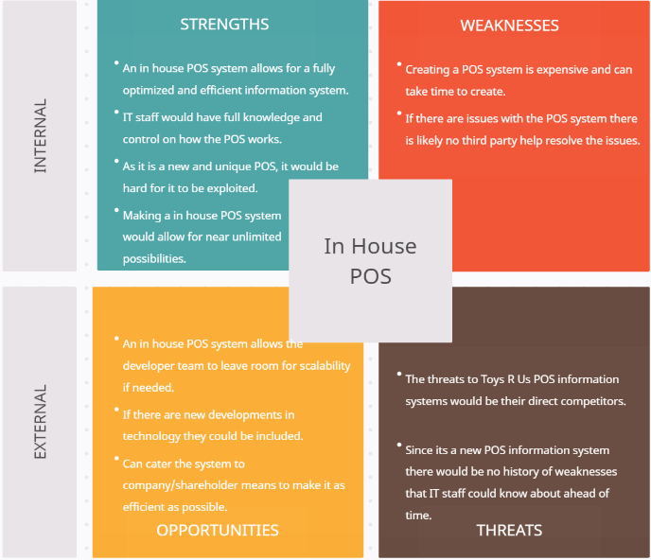

**Transaction Processing Systems**

A good Transaction Processing System is needed in order for a company to become successful. A TPS collects, stores, and processes the data from transactions within an organization. Without a quality TPS it can cause many issues such as slow processing times, inaccurate data collection, and overall security risks.

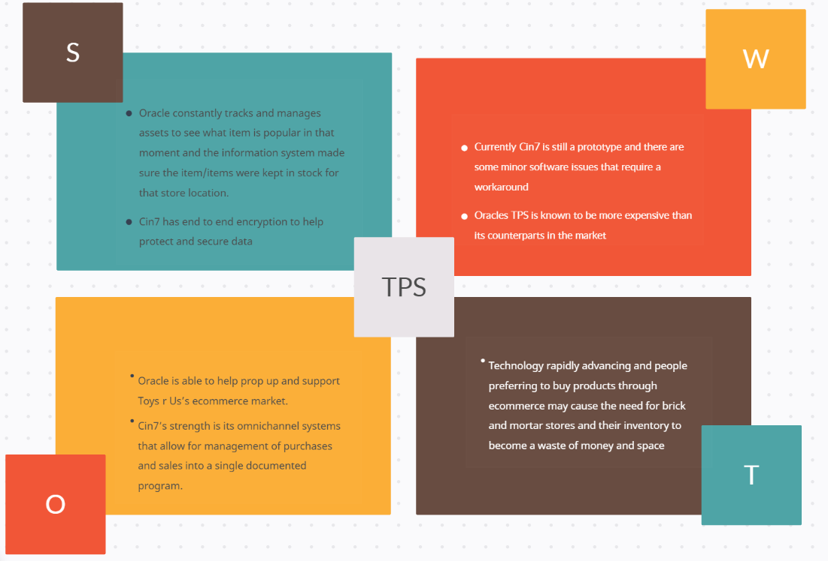

**Legal Team System**

Legal Teams have made businesses so much more proactive in many ways. The legal team is helpful because it has strategies that lowered risks, avoid legal issues, protect intellectual property, and follow all applicable laws and regulations that have caused. They can also help out with making communication easier. However, with that being said, communication will be easier with a legal team because they can inform one another about any new developments. They'll assist you in obtaining compensation in the event of an accident, or a difficult task, and offer legal advice on whether or not certain actions are in the best interests of the organization. It can also help lower risk by being a shield for the business from a range of possible issues. Corporate legal departments may help ensure that their firms are ready for whatever problems the future may bring by adopting a proactive approach to risk management. They also play a huge role in protecting intellectual property because it backs it up in many ways. They can examine each transaction for your property and will offer security. It is crucial to remember that outside legal firms have to get permission before taking on any commercial concern since they have to abide by state and ethical laws. Therefore, be cautious to acquire management's consent before hiring an outside legal firm, since otherwise, the outside attorneys could decide to part ways with your business in the future. In conclusion, any major organization must have an internal legal staff. Having these experts work directly within the company may save a great deal of time and money.

**Proposal for a New Business Design**

Utilizing the information found, this project has compiled the objective best components of each information system together to create a new design for a restructured Toys R Us. For the PIM system, we chose to utilize Sales Layer because of the Excel Sheet capabilities. Even though there is a potential that the service could provide users with unnecessary extra features, the simplistic information upload design is incredibly useful as the service does all the work for the user.

The Management Information System utilizes an in-house system that contains all of the resources mentioned in the SWOT analysis. An ethics line, wage system, and customer tracking system are all important parts to a company design. An ethics line should be made easily accessible for users so that they may inform management of improper work conditions. This service will be made easily accessible with a 24-hour responding system. A wage system will be implemented that employees can access online from a company hub. Wage transparency is important as it ensures that employees know that the company is honest in handling employee salaries. Finally, a consumer tracking system will be utilized that tracks consumer spending habits and information accessing. The idea behind tracking consumer product information is that a company may be better able to supply a product if it is in heavy demand, or a company could remove a product from the system if it isn’t selling well and create an alternative design or function for the product to better market it.

The Marketing Information System will utilize a mixture of digital advertising data and customer input to create successful marketing strategies. Digitally advertising a product is probably one of the most common methods for presenting users with a product. A new website will be designed that utilizes Artificial Intelligence that will be “taught” to gather customer information in such a way that it can generate recommended products for users. Artificial Intelligence will also be implemented into designing product descriptions for products online. This company will also implement advertisements through popular media platforms and television advertisements as these mediums are most likely to reach the targeted audience. Customer input consists of tracking information like consumer transaction history or product viewing, as well as customer surveys or other methods of feedback. As mentioned above, consumer product viewing informs businesses of what products are popular in a market, which helps a company make decisions on what items should be sold or removed. Customer feedback is an incredibly important aspect of marketing as this is consumers telling a producer what their opinion is on a product. This information will be gathered both through a product feedback section attached to each product on their online listing, as well as surveys that are sent out to customers to gather information on products they may have purchased.

Every Company has both a physical and logical security system implemented to protect their assets. Our company will utilize cameras to monitor sensitive areas to prevent unauthorized access. In addition, restricted access locations will require a passcode and keycard to access. Our logical security systems will consist of firewalls on the outside of our networks. We will utilize an intranet system to help restrict access to unapproved websites so that employees do not accidentally infect devices.

Our Human Resources Information System focuses on employee acquisition and communication. This company will conduct thorough interviews with candidates to ensure they are the best match for a job position. In addition, the company’s leadership will be properly trained to help employees learn proper business procedures and offer the best service customers. The highlight of our system though will be its engagement opportunities. Employees should feel like their voice matters within a company, so our company meetings will allow optional attendance for all employees to allow their input on what can be done to improve morale. For example, If an employee states that they feel strained to complete tasks at work, the company may assign extra labor hours for hiring another employee to better manage workload.

The Company’s Point-of-Sale (POS) system will utilize an in-house design as this allows the company to be more versatile in their system usage. Building an in-house system is time-consuming, but if a company’s IT team creates the system themselves, then the company will be able to better implement features or fixes to the POS system in the event that something is broken or needs to be changed. Another major benefit of creating a POS system in-house is that it will be uniquely designed. This is important for security purposes as perpetrators will have a more difficult time in determining how the system works, thereby protecting data integrity. Finally, building a POS system in-house aids in scalability. As the company grows, more complex features may need to be added to systems to accommodate for complexity. If the POS system is designed within the company, the system will be much easier to scale as the company can create plans for business growth.

Oracle will be utilized as the company’s Transaction Processing System. Even though Oracle is expensive to implement, Oracle is well-known and trusted in handling assets. In addition, Oracle contains extensive information that is compiled to help create a proper handling of product and to ensure that items are kept stocked.

Our company will also utilize a legal team to ensure that ethical practices are being maintained within the company as set by government laws. These legal experts will ensure that the company abides by legal standards and that other companies do not steal assets. Some opposing companies may attempt to steal company resources to gain an advantage in the market, but our legal team will be specifically designed to prevent this issue from arising. Lastly, the company’s legal team will be responsible with creating a contract management tool to ensure that any other company that does business with our company will follow proper procedure in completing their tasks. This process ensures that our company will be properly serviced and not taken advantage of if they rely on a third party.

**Suggestions for Future Projects**

If this project were recreated, one of the biggest changes that could be made to this project would be the amount of research. One semester isn’t enough time to do a deep dive into all the factors that make an information system successful. If given more time, a very interesting approach to our research question would be to design an information system from nothing and test it to determine how well it would work with a business like Toys R Us. Research could include looking at how each information system works together and creating resources within those systems with maximum compatibility. Other research could be done on the effectiveness of Artificial Intelligence in the business environment. Because AI is such an important topic at the time of writing, every business should at least have some form of research into AI to determine how it could improve their business system or stimulate customer interaction.

**Conclusions**

Toys “R” Us has potential to become a major competitor in the toy industry. Not only does the company possesses a major nostalgia factor that would attract people of all ages to their stores, but the stores also possess creative displays that attract customers into making purchases. Toys “R” Us struggled before because it lacked a strong e-commerce platform, causing the company to fall to other consumer giants like Amazon or Walmart. If the company can create both a strong brick-and-mortar presence, as well as a powerful e-commerce platform, the company would be able to prosper as this approach is the best answer to most consumer purchasing methods. Furthermore, with the growth of new technologies such as artificial intelligence, Toys “R” Us will have access to more resources that it can use to aid in its regrowth. For example, artificial intelligence can now be used to track customer purchases or product information and store data on this. If a company knows what items are popular at a current time, they can order more of that item to keep up with customer demand. If Toys “R” Us can adapt to these new changes in commerce, then the toy company should be able to grow into a powerful competitor in the market.

# References

akeneo. (2024). *Choosing the right PIM is critical to growing your business*. Retrieved from akeneo: https://www.akeneo.com/compare-editions/

akeneo. (2024). *The World's First Intelligent Product Cloud*. Retrieved from akeneo: https://www.akeneo.com/

Akkio. (2023, November 24). *Cost of AI in 2024: Estimating Development & Deployment Expenses*. Retrieved from Akkio: https://www.akkio.com/post/cost-of-ai

Apps Run The World. (2024). *Toys "R" Us Technographics*. Retrieved from https://www.appsruntheworld.com/customers-database/customers/view/toys-r-us-usa

Astound Commerce. (n.d.). *Toys-R-Us Canada - A Fully Omnichannel Shopping Experience*. Retrieved from Astound Commerce: https://astoundcommerce.com/work/toysrus-canada/

Bhasin, H. (2023, April 17). *12 Types Of Management Information Systems (MIS)*. Retrieved from Marketing91: https://www.marketing91.com/types-of-management-information-system/

Blakemore, E. (2023, May 10). *Inside the Rise and Fall of Toys 'R' Us*. Retrieved from History: https://www.history.com/news/toys-r-us-closing-legacy

Chen, J. (2022, October 2). *Category Killer: Meaning, History, New Examples*. Retrieved from Investopedia: https://www.investopedia.com/terms/c/categorykiller.asp

COMARCH. (2019, October 18). *Toys “R” Us Poland implements ERP and POS system within three months*. Retrieved from https://www.comarch.com/erp/erp-news/toys-r-us-poland-implements-erp-and-pos-system-within-three-months/

Coursera Staff. (2023, November 29). *What is Management Information System (MIS)? Your Career Guide*. Retrieved from coursera: https://www.coursera.org/articles/management-information-system

de Oca, B. M. (2020, February 4). *Why did Toys R' Us close down for good?* Retrieved from slidebean: https://slidebean.com/story/when-did-toys-r-us-close

Google. (n.d.). *Issues with TPS Systems*. Retrieved from Google Slides: https://docs.google.com/presentation/d/1bodYHLROVs8-dGtvLBSvRHjDUr9qnCyCm8gP3UzvlHc/htmlpresent

Google Workspace. (2024). *Duet AI in Workspace is entering the Gemini era*. Retrieved from https://workspace.google.com/solutions/ai/

Layerise. (2023, May 1). *7 Customer Data Collection Methods in Business Analytics*. Retrieved from Layerise: https://www.layerise.com/resources/blog/post/7-customer-data-collection-methods-in-business-analytics

lumavate. (2024). *Pricing That Doesn’t Break Your Budget*. Retrieved from lumavate: https://www.lumavate.com/pricing

lumavate. (2024). *Product Information System Examples*. Retrieved from lumavate: https://www.lumavate.com/product-information-system-examples#:~:text=What%20Is%20an%20Example%20of%20a%20PIM%3F%201,Layer.%20...%207%20Pimworks.%20...%208%20Lumavate.%20

Manchanda, A. (2023, March 8). *What is PIM, its benefits, and the best PIM software for eCommerce?* Retrieved from net solutions: https://www.netsolutions.com/insights/product-information-management-pim/

Matsakis, L. (2019, December 11). *Toys “R” Us Is Back—Now With More Surveillance!* Retrieved from Wired: https://www.wired.com/story/toys-r-us-surveillance/

*Principles of Marketing*. (2015). Retrieved from M Libraries: https://open.lib.umn.edu/principlesmarketing/chapter/10-2-steps-in-the-marketing-research-process/

*Principles of Marketing*. (2015). Retrieved from M Libraries: https://open.lib.umn.edu/principlesmarketing/chapter/10-1-marketing-information-systems/

SalaryCube Editorial Team. (2023, December 3). *What are pay structures? (Definition and How To Develop One)*. Retrieved from salarycube: https://www.salarycube.com/academy/pay-structures/

Sales Layer. (2023, June 26). *Free trial Overview - New Interface*. Retrieved from Youtube: https://www.youtube.com/watch?v=pYF8M1-YSrA&t=62s

Salesforce. (2021, May 27). *Toys “R” Us redefines customer experience with a unified digital solution*. Retrieved from InsideRetail: https://insideretail.asia/2021/05/27/toys-r-us-redefines-customer-experience-with-a-unified-digital-solution/

Salesforce. (2022). *What Is CRM?* Retrieved from Salesforce: https://www.salesforce.com/crm/what-is-crm/

salesforce. (2024). *Marketing AI*. Retrieved from https://www.salesforce.com/products/ai-for-marketing/?d=7013y000002EldbAAC&utm_source=bing&utm_medium=paid_search&utm_campaign=amer_us_mktlobd_&utm_content=sfdc-pg-medialabcons-en-marketing-cloud---txt_ai-for-marketing_7013y000002eldbaac_7013y000002EldbAA

Segal, T. (2022, December 26). *Management Information Systems vs. Information Tech: What's the Difference?* Retrieved from Investopedia: https://www.investopedia.com/ask/answers/040315/what-difference-between-mis-management-information-system-and-information-technology.asp

Titus, R. (2024, January 23). *Essential Guide to Ethics Hotlines: Best Practices, Benefits, and Policies*. Retrieved from CMS: https://www.continentalmessage.com/blog/ethics-hotline-guide/#:~:text=5%20benefits%20of%20ethics%20hotlines%201%201.%20Effective,5.%20Saves%20Money%20%26%20Protects%20Your%20Organization%20

Zapanta, T. (2023, February 28). *The impact of AI on business*. Retrieved from microsourcing: https://www.microsourcing.com/learn/blog/the-impact-of-ai-on-business/