|  |  |
| --- | --- |
|  | Version  1 |

All Hazards Waste Logistics Tool

U.S. Environmental Protection Agency

User’s Guide

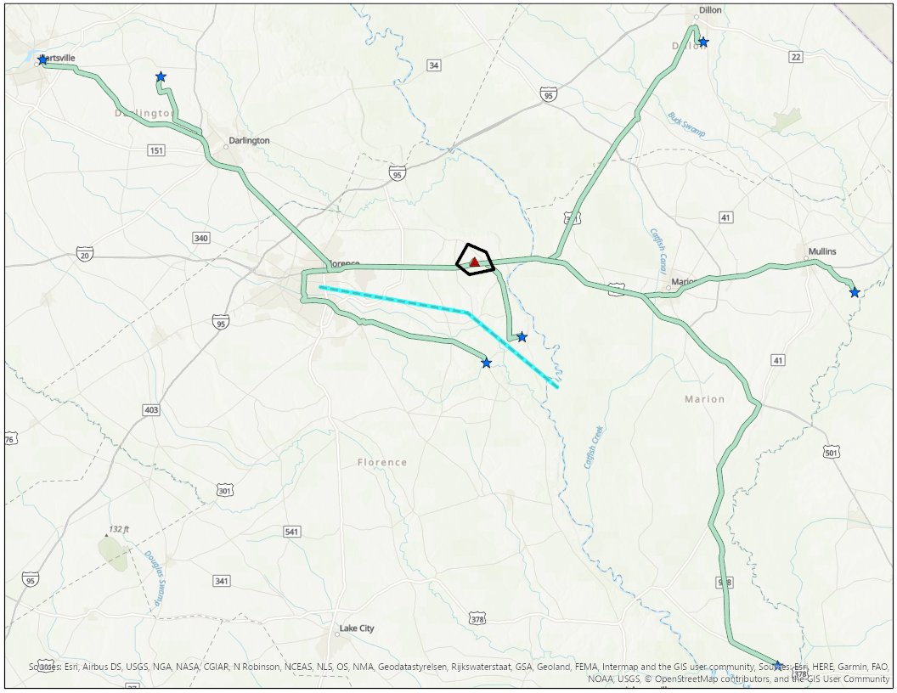

u.s. Environmental protection agency

ALL HAZARDS WASTE LOGISTICS TOOL

U.S. Environmental Protection Agency

Homeland Security Research Program

Research Triangle Park, NC 27711

**Disclaimer**

The U.S. Environmental Protection Agency (EPA) through its Office of Research and Development funded and managed the research described herein under Contract EP-C-16-015, Task Order 0005 with ERG. It has been subjected to the Agency’s review and has been approved for publication. Note that approval does not signify that the contents necessarily reflect the views of the Agency. Any mention of trade names, products, or services does not imply an endorsement by the U.S. Government or EPA. The EPA does not endorse any commercial products, services, or enterprises. This is a work of the U.S. Government and is not subject to copyright protection in the United States.

**Acknowledgements:**

US Environmental Protection Agency (EPA)

Timothy Boe, Dr. Paul Lemieux

Eastern Research Group, Inc. (ERG)

Molly Rodgers, Paul Dziemiela, Colin Hayes

Acronym/Abbreviation List

| **Acronym** | **Definition** |
| --- | --- |
| AGO | ArcGIS Online |
| CBRN | Chemical, Biological, Radiological, or Nuclear |
| EPA | U.S. Environmental Protection Agency |
| GIS | Geospatial Information Science |
| HIFLD | Homeland Infrastructure Foundation-Level Data |
| HSRP | Homeland Security Research Program |
| I-WASTE | Incident Waste Decision Support Tool |
| JSON | JavaScript Object Notation |
| LARW | Low-Activity Radioactive Waste |
| MSW | Municipal Solid Waste |
| PIL | Pillow |
| PIV | Personal Identity Verification |
| RAD | Radioactive Waste |
| RAM | Random Access Memory |
| RCRA | Resource Conservation and Recovery Act |
| XLS | Microsoft Excel Spreadsheet |

**Table of Contents**

1. Introduction 1

How to Use This Guide 1

Point of Contact 1

Description 2

Systems Approach 3

1. Design and Methodology 4

Design Components 4

Methodology to Estimate Resource Demands 5

User Inputs 5

Adjustable User Inputs (Defining a Scenario Condition) 5

Resource Demand Calculations 6

Factors 7

1. Installation and Setup 10

Minimum System and Software Requirements 10

Install Pillow (Optional) 10

Extract the Tool 11

Project Setup 11

1. Waste Storage and Disposal Locations 12

Default Disposal Facility Data 12

User-Defined Facilities 13

Staging and Storage Locations 15

1. Routing Network 16

Network Dataset Options 16

ArcGIS Pro License, Routing, and Network: Configuration Scenarios 16

Configuration Scenario #1 17

Configuration Scenario #2 18

Configuration Scenario #3 19

Configuration Scenario #4 20

1. Run the Tool 21

Load Project 21

Step 1: Create Work Environment 23

Review Work Environment Settings 24

Step 2: Set Scenario Conditions 27

Step 3: Draw Incident Area 27

Step 4: Draw Support Area 28

Step 5: Define Scenario and Load to Network 29

Step 6: Load Facilities to the Network 30

Select Disposal Facility Types 31

Load Default Facilities 31

Load User-Defined Facilities 32

Exclude Facilities 33

Limit by Support Area 33

Truncate Existing Facilities 33

Adjust Quantity Accepted 33

Step 7: Draw Routing Barriers 34

Step 8: Solve Routing Scenario 34

Step 9: Eliminate Routes 35

Step 10: Calculate Logistics Planning Estimates 37

Specify Map Settings 37

Step 11: Export Logistics Planning Results 38

Results Output 38

Create and Compare More than One Scenario 38

1. Troubleshooting 40

**List of Figures**

Figure 1. General Tool Workflow 2

Figure 2. Systems Thinking Approach for CBRN Incidents 3

Figure 3. All Hazards Waste Logistics Tool Design Components 4

Figure 4. Extracted Tool Assets 11

Figure 5. Configuration Scenario #1 Flow 17

Figure 6. Configuration Scenario #2 Flow 18

Figure 7. Configuration Scenario #3 Flow 19

Figure 8. Configuration Scenario #4 Flow 20

Figure 9. Authentication Examples 21

Figure 10. Open the All Hazards Waste Logistics Tool Tasks Pane 22

Figure 11. Create Work Environment Pane 23

Figure 12. Work Environment Settings 25

Figure 13. Edit Factor Set Example 26

Figure 14. Set Scenario Conditions Pane 27

Figure 15. Draw Incident Area Controls 28

Figure 16. Save Sketching - Pending Edits Alert 28

Figure 17. Draw Support Area Controls 28

Figure 18. Define Scenario Pane 29

Figure 19. Load Facilities to the Network Pane 30

Figure 20. Facility Selection Grid 31

Figure 21. Add User-Defined Facilities 32

Figure 22. Save Sketching - Pending Edits Alert 32

Figure 23. Draw Routing Barriers Tools 34

Figure 24. Solve Routing Scenario Pane 35

Figure 25. Eliminate Routes Editing Tools 36

Figure 26. Calculate Logistics Planning Estimates Pane 37

Figure 27. Map Settings 37

Figure 28. Export Logistics Planning Results Pane 38

**List of Tables**

Table 1. Default Values for Scenario Conditions 5

Table 2. Minimum System and Software Requirements 10

Table 3. Default Facility Types and Sources 12

Table 4. Default Facility Waste Quantity Accepted 13

Table 5. Facility Schema 14

Table 6. Overview of Waste Types, Medium and Volumetric Units 30

# Introduction



1

CHAPTER

Learn about this Geographical Information System (GIS) tool that applies spatial information and analysis technologies to evaluate resource demands associated with transporting large volumes of waste

Large-scale disasters have the potential to generate a significant amount of waste. For example, Hurricane Katrina and the Joplin Missouri tornado resulted in 100 million and 1.5 million cubic yards of waste, respectively. Man-made chemical, biological, radiological or nuclear (CBRN) incidents either by way of terrorism, war, or accident have the potential to generate as much waste or more, and both natural and man-made incidents are prone to generate some form of hazardous waste. Recovery is profoundly impacted by waste management issues and the strategies selected to manage those issues.

The quantification, segregation, transportation, and storage of waste can be an arduous and costly undertaking. Furthermore, these processes are intricately linked with the decisions made throughout the recovery timeline. Therefore, the remediation, including waste management, must be holistically considered. Understanding these complex interactions can be facilitated by using models and tools that adhere to the “system-of-systems” approach. To better understand and predict waste management issues, the U.S. Environmental Protection Agency’s (EPA’s) Homeland Security Research Program (HSRP) is developing a suite of tools and resources for planning and recovery purposes. EPA’s All Hazards Waste Logistics Tool uses spatial information and analysis techniques to support evaluating resource demands associated with transporting large volumes of waste. The tool was developed to help decision makers better understand potential options for managing waste and to illuminate potential capacity constraints, transportation considerations, and impact of waste categorization to inform increased preparedness.

**icon keY**

 Valuable Tip

 Important Note

Hourglass Estimated Processing Time

## How to Use This Guide

The purpose of this guide is to provide the necessary information to operate the tool. Described in this guide are methods for installing, configuring, and operating the tool. It is **highly recommended** that users have previous experience with and a working knowledge of ArcGIS*®* before operating the tool.

The “icon key” to the right contains symbols used throughout this guide to highlight important information and additional guidance.

## Point of Contact

Timothy Boe

US EPA Office of Research and Development

Center for Environmental Solutions and Emergency Response   
Systems Tools and Materials Management Branch  
919-541-2617 office  
919-541-0496 fax  
[boe.timothy@epa.gov](mailto:boe.timothy@epa.gov)

## Description

Tools that facilitate planning through scenario-based analyses are necessary to increase preparedness, identify problematic scenarios that may inform earlier decisions to alleviate constraints and encourage discussions to identify effective solutions in advance of an incident. To better understand and predict waste management issues, the Environmental Protection Agency’s (EPA’s) Homeland Security Research Program (HSRP) is developing a suite of tools and resources for planning and recovery purposes, including two newly developed GIS-based tools:

* **Waste Staging and Storage Site Selection Tool**[1] uses spatial information and analysis techniques to support conducting a suitability analysis to identify candidate areas for consideration. The tool was developed to help decision makers better understand potential options for managing waste and to illuminate potential capacity constraints to inform increased preparedness. The tool analyzes siting criteria for a specified geographic area to identify candidate sites and their total available land surface areas to support waste management operations.

**All Hazards Waste Logistics Tool** addresses the need to evaluate considerations related to the resource demands associated with transporting and disposing of large volumes of waste**.** The tool calculates the cost and time to manage a user-specified quantify of waste and allows users to run routing scenarios with user-defined destinations. Factors specific to waste type, hauling rates, and acceptance rates allow users to explore options and evaluate constraints to improve preparedness for managing large volumes of waste. The Waste Staging and Storage Site Selection Tool was designed to work in tandem with the All Hazards Waste Logistics Tool to identify potential staging locations to be included in the logistics decision-making process. Figure 1 below illustrates the general workflow of the tool.

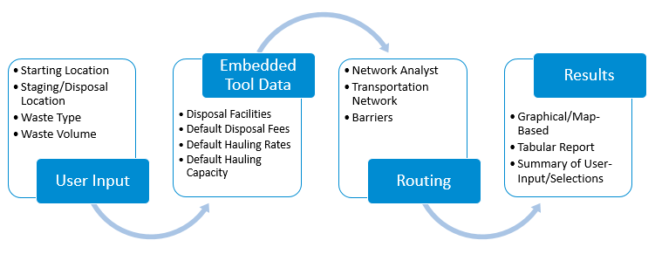

Figure . General Tool Workflow

## Systems Approach

For wide area incidents, response and recovery efforts may begin without collecting or considering essential information. Decisions related to decontamination and waste management, including the disposal strategy, will affect the cost, duration, and effectiveness of the response. The process of understanding how these response activities influence one another and contribute to the overall solution is referred to as a systems approach. The systems approach recognizes that each response activity is coupled with another, where decisions made for one response action impact decisions and options that exist for another. For example, this dynamic is observed where the amount of waste to be managed is profoundly impacted by the decontamination approach that is selected, or when waste management constraints may drive decontamination decisions. Figure 2 demonstrates the balance of operations (e.g., planning, response, and recovery) versus available resources. This figure describes both the systems approach (i.e., processes are interrelated and impact one another) and the cost-benefit of decisions (i.e., the benefit of decisions and their impact on available resources). With time, operationally driven decisions drive or tip the balance in favor of more resources. This approach typically causes remediation to become resource intensive in terms of cost and time (e.g., a specific decontamination method is costly, but is quicker). While EPA waste tools (e.g., Waste Estimation Support Tool) encourage a phased and cohesive approach (i.e., decontamination, waste estimation, and disposal), the tools compile and display results in a way that allows users to see the “big picture” and how small changes in these approaches can greatly impact each individual response activity.

This “big picture” approach facilitates planning through scenario-based analyses that can increase preparedness, identify problematic scenarios, and ultimately identify effective solutions in advance of an incident. The systems approach seeks to balance the overall resource demand by leveraging the system as a whole and predicting an optimal outcome, which in return provides greater insight and improves decision making. The All Hazards Waste Logistics Tool embodies this approach by allowing the users to see how their decisions impact other operations (e.g., the amount of waste generated as a function of decontamination and the classification of waste as it relates to waste disposal facility options) with regard to resource demand (e.g., cost and time).

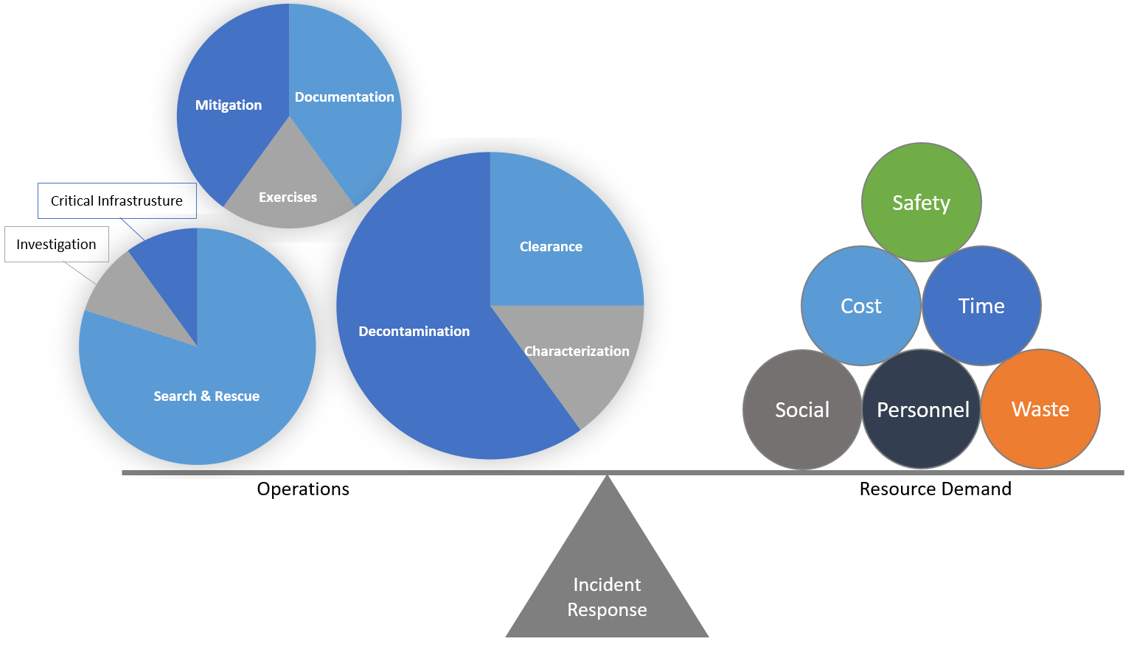

Figure 2. Systems Thinking Approach for CBRN Incidents

# Design and Methodology



2

CHAPTER

*Understand the tool’s underlying methodology, overall workflow, and default data and assumptions that impact results*

## Design Components

Esri’s ArcGIS Pro was used to develop the graphical user interface to support completing tasks required to estimate resource demands associated with transporting large quantities of waste. ArcGIS allows users to: (1) interact with geoprocessing tools, map layers, datasets, and other data types, and connect them to a process; (2) iteratively process feature class modifications or attribute tables in a workspace; (3) visualize the workflow through a task-based user interface; and (4) leverage multiple geoprocessing tools that handle processing steps that are coded using Python scripting. Finally, the results are output into a Microsoft Excel™ dataset that captures the scenario conditions, computational results, and references to default factors used. Figure 3 illustrates the overall tool design.

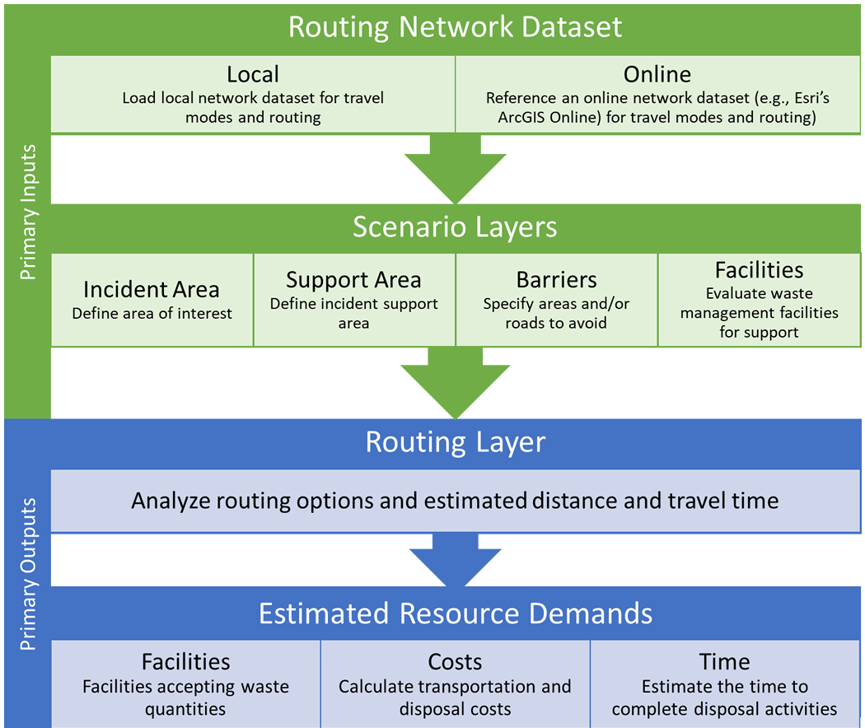

Figure 3. All Hazards Waste Logistics Tool Design Components

The tool is organized into a sequence of steps (described in Chapter 6 of this user’s guide) that guides the user through providing necessary inputs and specifying selections to calculate estimated resource demands for a scenario.

## Methodology to Estimate Resource Demands

Research was conducted to support estimating cost and time calculations related to transporting waste. Factors were developed for seven waste type combinations and are specific to waste type and medium (i.e., solid or liquid):

1. Radioactive: Contact-Handled (Solid)
2. Radioactive: Contact-Handled (Liquid)
3. Radioactive: Remote-Handled (Solid)
4. Radioactive: Remote-Handled (Liquid)
5. Hazardous (Solid)
6. Municipal Solid Waste (MSW) (Solid)
7. Construction and Demolition (C&D) (Solid)

Solid waste amounts are in cubic yards or cubic meters (yd3 or m3), and liquid waste amounts are in gallons or liters (gal or L). Trucks are assumed to have large volume hauling capacity (see Truck Shipment Loading Factors below). Unit conversions are performed as required in the tool and are not reflected below. Resource demand calculations used within the tool are described below. The values provide a starting point and users can adjust the values (see Chapter 6 for guidance on how to change values).

### User Inputs

*W* = Waste Amount (yd3/m3 or gal/L, depending on the waste type)

*D* = Distance (mi)

*S* = Average Driving Speed (mi/h)

### Adjustable User Inputs (Defining a Scenario Condition)

*RT* = Road Tolls ($/shipment)

*MC* = Miscellaneous Costs ($/shipment)[2]

*VDC* = Vehicle Decontamination Cost ($/shipment)

*SSC* = Staging Site Cost ($/day)

*NTA* = Number of Trucks Available (trucks)

*TPD* = Trucks Processed per Day (trucks/day)

*DH* = Driving Hours (h/day)

*TCM* = Total Cost Multiplier (additional percentage of total cost)2

Table 1 presents default values that are provided that can be changed by the user.

Table . Default Values for Scenario Conditions

|  |  |
| --- | --- |
| Conditions | Default Value |
| Road Tolls | $50.00 |
| Miscellaneous Costs | $500.00 |
| Vehicle Decontamination Cost | $1,000.00 |
| Staging Site Cost | $2,000.00 |
| Number Of Trucks Available | 30 |
| Driving Hours | 12 |
| Total Cost Multiplier (Of Total Cost) | 25% |

### Resource Demand Calculations

**Number of Waste Shipments (*N*)**

= Waste Amount (yd3 or gal, depending on the waste type)/Truck Shipment Loading Factor (yd3 or m3/shipment or gal or L/shipment, depending on the waste type)

= *W* / *FTS*

**Transportation? Cost per Loaded Mile (CPLM) Cost ($) (*CCPLM*)**

= Distance (mi) x CPLM Unit Rate ($/mi)

= *D* x *FCPLM*

**Fixed Cost for Transportation ($) (*CF*)**

For:

* Radioactive: Contact-Handled (Solid)
* Radioactive: Contact-Handled (Liquid)
* Radioactive: Remote-Handled (Solid)
* Radioactive: Remote-Handled (Liquid)

Fixed Cost ($)

= Distance (mi) x Fixed Transportation Cost ($/mi)

= *D*/*FTC*

For:

* Hazardous (Solid)
* Hazardous (Liquid)
* MSW (Solid)
* C&D (Solid)

Fixed Cost ($)

= Number of Shipments x Distance (mi) x 2/Average Driving Speed (mi/h) x Fixed Transportation Cost ($/h)

= *N* x *D* x 2/*S* x *FTC*

**Tolls ($) (*CRT*)**

= Road Tools ($/shipment) x Number of Shipments x 2

= *RT* x *N* x 2

**Misc Costs ($) (*CM*)**

= Miscellaneous Costs ($/shipment) x Number of Shipments

= *MC* x *N*

**Total Transportation Cost ($) (*CTRANS*)**

= *CCPLM* + *CF* + *CRT* + *CM*

**Trucks Time to Complete Transportation of Waste (days) (*TT*)**

= Distance (mi) x 2/Average Driving Speed (mi/h) / Driving Hours (h/day) x Number of Shipments / Number of Trucks Available

= *D* x 2/*S*/*DH* x *N*/*NTA*

**Destination Time to Complete Transportation (days) (*TD*)**

= Number of Shipments/Trucks Processed per Day (trucks/day)

= *N* / *TPD*

**Total Transportation Time (days) (*T*)**

= MAX(*TT*,*TD*)

**Waste Staging Site Cost ($) (*CSS*)**

= Total Time (days) x Staging Site Cost ($/day)

= *T* x *SSC*

**Waste Disposal Cost ($) (*CD*)**

= Waste Amount (converted to weight, ton) x Disposal Fees ($/ton)

= W x *FDC*

**Labor Cost ($) (*CL*)**

= Number of Shipments x Distance (mi) x 2 / Average Driving Speed (mi/h) x Labor Cost ($/h)

= *N* x *D* / *S* x *FLC*

**Vehicle Decontamination Cost ($) (*CVD*)**

= Number of Shipments x Vehicle Decontamination Cost ($/shipment)

= *N* x *VDC*

**Additional Cost Due to Multiplier ($) (*CM*)**

= (Total Transportation Cost ($) + Staging Site Cost ($) + Disposal Cost ($) + Labor Cost ($) + Vehicle Decontamination Cost ($)) x (Total Cost Multiplier (%) / 100)

= (*CTRANS* + *CSS* + *CD* + *CL* + *CVD*) x (*TCM* / 100)

**Total Cost ($) (*C*)**

= Total Transportation Cost ($) + Staging Site Cost ($) + Disposal Cost ($) + Labor Cost ($) + Vehicle Decontamination Cost ($) + Additional Cost Due to Multiplier ($)

= *CTRANS* + *CSS* + *CD* + *CL* + *CVD* + *CM*

### Factors

The tool relies upon additional factors to support calculations. The values used are described below. Each scenario is based on a “set” of five factors for a selected waste type. Refer to Chapter 6 for details on how to alter the factors that are included in the tool.

**Truck Shipment Loading Factors** (*FTS*)

|  |  |  |
| --- | --- | --- |
| **Waste Type** | **yd3/shipment** | **gal/shipment** |
| Radioactive: Contact-Handled (Solid) | 23.68 | N/A |
| Radioactive: Contact-Handled (Liquid) | N/A | 4,787.52 |
| Radioactive: Remote-Handled (Solid) | 3.81 | N/A |
| Radioactive: Remote-Handled (Liquid) | N/A | 770 |
| Hazardous (Solid) | 23.68 | N/A |
| Hazardous (Liquid) | N/A | 4,787.52 |
| MSW (Solid) | 40 | N/A |
| C&D (Solid) | 40 | N/A |

**CPLM Unit Rates** (*FCPLM*)

|  |  |  |  |
| --- | --- | --- | --- |
| **Waste Type** | ***Less than 30 mi***  **($/mi)** | ***30-200 mi***  **($/mi)** | ***More than 200 mi***  **($/mi)** |
| Radioactive: Contact-Handled (Solid) | 5.94 | 4.98 | 4 |
| Radioactive: Contact-Handled (Liquid) | 5.94 | 4.98 | 4 |
| Radioactive: Remote-Handled (Solid) | 11.7 | 7.85 | 4.9 |
| Radioactive: Remote-Handled (Liquid) | 11.7 | 7.85 | 4.9 |
| Hazardous (Solid) | 3 | 2.5 | 1.95 |
| Hazardous (Liquid) | 3 | 2.5 | 1.95 |
| MSW (Solid) | N/A | N/A | N/A |
| C&D (Solid) | N/A | N/A | N/A |

**Fixed Transportation Costs** (*FTC*)

|  |  |  |
| --- | --- | --- |
| **Waste Type** | **$/shipment** | **$/h** |
| Radioactive: Contact-Handled (Solid) | 880 | N/A |
| Radioactive: Contact-Handled (Liquid) | 880 | N/A |
| Radioactive: Remote-Handled (Solid) | 2,480 | N/A |
| Radioactive: Remote-Handled (Liquid) | 2,480 | N/A |
| Hazardous (Solid) | N/A | 55.9 |
| Hazardous (Liquid) | N/A | 55.9 |
| MSW (Solid) | N/A | 55.9 |
| C&D (Solid) | N/A | 55.9 |

**Labor Cost** (*FLC*)

|  |  |
| --- | --- |
| **Waste Type** | **$/h** |
| Radioactive: Contact-Handled (Solid) | 21.39 |
| Radioactive: Contact-Handled (Liquid) | 21.39 |
| Radioactive: Remote-Handled (Solid) | 21.39 |
| Radioactive: Remote-Handled (Liquid) | 21.39 |
| Hazardous (Solid) | 21.39 |
| Hazardous (Liquid) | 21.39 |  |
| MSW (Solid) | 21.39 |
| C&D (Solid) | 21.39 |

**Disposal Fees** (*FDC*)

|  |  |
| --- | --- |
| **Waste Type** | **$/ton** |
| Radioactive: Contact-Handled (Solid) | 50 |
| Radioactive: Contact-Handled (Liquid) | 50 |
| Radioactive: Remote-Handled (Solid) | 50 |
| Radioactive: Remote-Handled (Liquid) | 50 |
| Hazardous (Solid) | 40 |
| Hazardous (Liquid) | 40 |  |
| MSW (Solid) | 15 |
| C&D (Solid) | 15 |

# Installation and Setup



3

CHAPTER

Review step-by-step instructions to install and setup the All Hazards Waste Logistics Tool

This chapter explains how to install and set up the tool. Before installation, confirm that your system meets or exceeds the recommended hardware and software requirements.

## Minimum System and Software Requirements

Table 2 describes the minimum system requirements and required software for the tool. Meeting the minimum system requirements does not guarantee that the tool will operate as intended; operation as intended is also tied to the performance of the ArcGIS software package.

| Table 2. Minimum System and Software Requirements | |
| --- | --- |
| **Required Software** | Esri’s ArcGIS Pro 2.4 |
| **Required Extensions\*** | Network Analyst extension |
| **Optional Python Package** | Pillow [Python Imaging Library (PIL) Fork] |
| **Routing Network** | A local network dataset or a network service hosted in ArcGIS Online or ArcGIS Enterprise |
| **Processor** | 2.2 GHz minimum processor |
| **RAM** | 4 GB minimum RAM |
| **Screen Resolution** | 1024 x 768 pixels |
| **Operating System** | Windows 10 |
| **Disk Space** | 1 gigabyte (GB) available |

* Network Analyst extension is only needed if you route using a local file network (see Chapter 5).

## Install Pillow (Optional)

To include a map image in the results export, Pillow, a Python Imaging Library fork, needs to be installed[3]. The tool also provides an option to export results without a map image to provide an option that does not require installation of the optional library.

 Note: Be sure to install Pillow in the ArcGIS Pro Python environments where the tool will be run if you are running multiple instances of Python and/or ArcGIS software.

## Extract the Tool

Extract the contents of the compressed file, EPA-AllHazardsWasteLogisticsTool-master.zip, to your local drive. As shown in Figure 4, the extracted project is comprised of several folders and files.

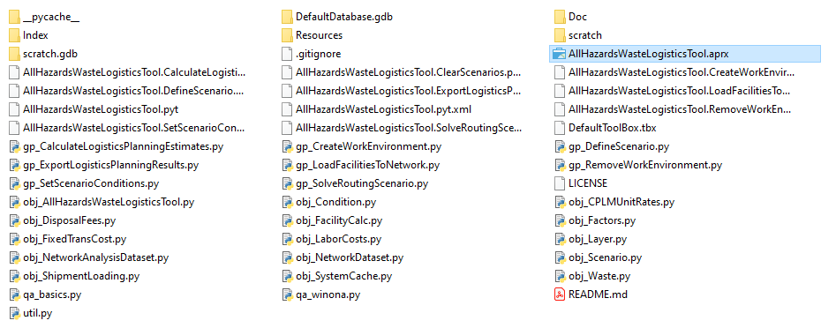

Figure 4. Extracted Tool Assets

## Project Setup

As illustrated in Figure 1, several inputs are required for the resource demand calculations. While default facilities are provided as a starting point, users should consider gathering and/or creating scenario-specific facility data to develop more realistic scenarios. Specifically, the quantity of waste a facility can manage is a significant driver in the analysis, and the more representative facility-specific values are, the better the analysis. Chapter 6 provides detailed instructions and illustrates the necessary steps to run the tool.

 This tool is primarily anticipated to support advanced planning efforts and serve as a catalyst to the start of important conversations. Users should expect to allocate two to four hours, depending on their experience with ArcGIS to install and execute the tool.

# Waste Storage and Disposal Locations



4

CHAPTER

*Understand what facilities are included with the tool and how you can bring your own waste storage and disposal locations*

The tool allows users to load waste storage and staging locations within a scenario to explore options for transporting waste. As discussed in Chapter 2, whether a location is designated as a staging location or a disposal location will impact how costs are estimated. The tool is flexible to allow users to specify whether a location should be treated as a staging or disposal location. The sections that follow describe the default facilities that are included with the tool, how users can load user-defined facilities, and how output from EPA’s Waste Staging and Storage Site Selection Tool can be used as input for this tool.

## Default Disposal Facility Data

Default facility data are provided with the tool. The inventories of facilities that are included are consistent with facility inventories that are available with related HSRP tools such as the Incident Waste Decision Support Tool[4] (I-WASTE). Table 3 provides a description of the facility inventories that are included with the tool.

| Table 3. Default Facility Types and Sources |
| --- |

|  |  |  |
| --- | --- | --- |
| **Facility Type[5]** | **Source** | **Notes** |
| Radiological | I-WASTE (Updated: December 22, 2016) | Includes commercial and federal radioactive waste facilities (11 facilities) |
| RCRA C Hazardous Waste | EPA’s RCRAInfo Database[6] (Updated: 08-15-2019) | Only Active facilities (23 facilities) |
| RCRA C Hazardous Waste with Low-Activity Radioactive Waste (LARW) Authority | I-WASTE and RCRAInfo Database | RCRAInfo facilities were cross-referenced with I-WASTE facilities that previously flagged LARW (4 facilities) |
| Municipal Solid Waste (MSW) | Homeland Infrastructure Foundation-Level Data (HIFLD) - Solid Waste Landfill Facilities, Updated: 08-09-2018 | Only Active facilities (1,684 facilities) |
| Construction and Demolition (C&D) | HIFLD - Solid Waste Landfill Facilities, Updated: 08-09-2018 | Only Active facilities (1,600 facilities) |

As discussed in Chapter 2, the amount of waste a facility can accept and/or store is a key parameter that impacts results. To provide a starting point for users, a default acceptance quantity is supplied. The default values are based on typical daily processing rates for facilities and assume a **90-day** support period for recovery efforts. Table 4 presents the daily acceptance rates that were identified through research for both liquid and solid waste forms for the waste types that are included in the tool. Users can adjust the default acceptance quantities that are included with the tool using the estimated daily acceptance values or obtain more estimates from facilities.

 Capacity is only defined by volume. Users bringing their own facility data will need to process any mass to volume conversions prior to populating the schema for use within the tool.

|  |  |  |
| --- | --- | --- |
| Table . Default Facility Waste Quantity Accepted | | |
| **Waste Type** | **Liquid Amount to Take (gal)** | **Solid Amount to Take (yd3)** |
| Radioactive | 11,549.6 gal/day | 57.2 yd3/day |
| Hazardous | 5,283.4 gal/day | 6,912.8 yd3/day |
| MSW | --- | 4,725.7 yd3/day |
| C&D | --- | 275.0 yd3/day |

For default facilities that accept both C&D and MSW, the tool assumes the larger default acceptance quantity.

## User-Defined Facilities

 The example user-defined facilities included in the feature class template are not actual facilities and should not be used as input for the tool.

The tool allows users to bring their own facility data. Strict adherence to a feature layer specification is required to use this feature. An example schema is included within the tool’s assets. Specifically, the ExampleUserData geodatabase and UserDefinedFacilities can be used as a template to create a user-defined point feature class to import into the tool. Table 5 defines the field attributes.

Key feature layer requirements include:

* Match the template field names and types for correct loading of user facilities as point data.
* Designate each user-defined facility as “Disposal” or “Staging” to support resource demand calculations.
* Update each waste accepted type field to “True” or “False” to specify the type of waste a facility or site can accept.
* Specify the **volumetric** amount of solid and/or liquid waste, and corresponding units, the facility or area can take.
* The tool accepts both units of U.S. Customary as “yd3” and “gal” or Metric as “m3” and “L”.
* Unit abbreviations must be exact.

| Table . Facility Schema | | |
| --- | --- | --- |
| **Field Name** | **Field Type** | **Description** |
| facility_identifier* | Text | Unique identifier code from source data. |
| facility_name | Text | The common name by which is facility is best known. |
| facility_address | Text | Facility street address, may or may not geocode to the actual site. |
| facility_city | Text | Facility city |
| facility_state | Text | Facility state |
| facility_zip | Text | Facility zip |
| facility_telephone | Text | Facility phone information if available. |
| front_gate_longitude | Double | Optional precise longitude ordinate in WGS84 indicating an exact location from which to begin routing (e.g., a preferred gate). |
| front_gate_latitude | Double | Optional precise latitude ordinate in WGS84 indicating an exact location from which to begin routing (e.g., a preferred gate). |
| facility_waste_mgt* | Text | Identifies whether facility is used to “stage” waste or “dispose” waste. |
| facility_capacity_trucks_perday* | Long | The facility daily truck capacity value. A universal default value (30) is assumed that can be modified to a user-defined value. |
| facility_qty_accepted_volume_solid* | Long | The volume of solid waste the facility will accept. |
| facility_qty_accepted_volume_solid_unit* | Text | The units associated with the solid waste volume. Acceptable values are “yd3” or “m3”. |
| facility_qty_accepted_volume_liquid* | Long | The volume of liquid waste the facility will accept. |
| facility_qty_accepted_volume_liquid_unit* | Text | The units associated with the liquid waste volume. Acceptable values are “gal” or “L”. |
| C_D Accepted* | Text | Indication [acceptable value = True or False] that facility accepts construction and demolition (C&D) waste. |
| MSW_accepted* | Text | Indication that facility accepts municipal solid waste (MSW). [True/False] |
| HW_accepted* | Text | Indication that facility accepts hazardous waste. [True/False] |
| LARWRad_accepted* | Text | Indication that facility accepts LARW waste. [True/False] |
| RAD_accepted* | Text | Indication that facility accepts radioactive waste. [True/False] |
| date_stamp | Date | The date on which facility data were extracted from primary source or created by the user. Optional. |
| source | Text | The primary source originating the data. Optional. |
| notes | Text | User-specified notes. Optional. |

* Indicates required fields for tool to execute

## Staging and Storage Locations

The All Hazards Waste Logistics Tool was designed to conveniently accept output from EPA’s Waste Staging and Storage Site Selection Tool without the need for significant pre-processing. During Step 6, the Waste Staging and Storage Site Selection Tool output (specifically the ModelOutput geodatabase) can be added as User-Defined Facilities data in the “Load Facilities to Network” geoprocessing window. See instructions in Chapter 6 for more information on selecting and uploading the data to the tool.

EPA’s Waste Staging and Storage Site Selection Tool allows users to identify candidate areas that are represented as a polygon and whose capacity to stage/store volumes of liquid and solid waste are calculated and output with the results, along with the centroid of the Staging Site polygon. The All Hazards Waste Logistics Tool imports these output areas and populates the “Facility_Waste_Mgt” field as “Staging.” Additional required data are mapped and populated in the waste accepted amounts and units fields in the Facilities Network layer.

 Note: The Staging Site output will always be initially designated as “Staging” in the facility_waste_mgt field. Users can manually change the waste management type in the attribute table of the Facilities layer in the “Contents” pane.

# Routing Network



5

CHAPTER

*Understand how routing resources are used within the tool*

A routing network is required to calculate both distance and travel time for routes that are identified. The tool also leverages Esri’s Network Analyst toolbox to perform network analyses.

 Facility routes are ranked based on the attributes and configuration of the network dataset selected by the user. ArcGIS Online defaults to ranking by distance. Users will need to manually adjust any rank order presented in the results output to reflect different routing priorities. Additionally, as described in Chapter 6, users can prune routes to exclude altogether.

## Network Dataset Options

The tool provides two primary options for defining the network dataset. Users must specify which of the following two methods will be used for a scenario:

* **“Pay-as-you-Go” Model**: Users will leverage Esri’s ArcGIS Online as the source for the network dataset and expend credits based on the licensing construct established for their organization.

**“Bring your Own Network” Model**: Users will leverage a local, file-based organizational network dataset. Typically, this option may leverage a license for Esri StreetMap Premium or a tailored network maintained by the organization that reflects local or regional specific conditions. Esri’s Network Analyst Extension is required.

## ArcGIS Pro License, Routing, and Network: Configuration Scenarios

The following four configuration scenarios may exist and are illustrated in Figures 5 through 9. We expect that users will identify with one of the scenarios to better understand the relationship among key tool components.

* Configuration Scenario #1 – Typical Enterprise User + “Pay-as-you-Go” Network dataset
* Configuration Scenario #2 - Typical Enterprise User + “Bring your Own Network”, along with a Network Analyst license
* Configuration Scenario #3 – Concurrent Pro Licensed User without Network Analyst but having ArcGIS Online credits

Configuration Scenario #4 – Concurrent Pro Licensed User + “Bring your Own Network”, along with a Network Analyst license

### Configuration Scenario #1

Figure 5 illustrates Configuration Scenario #1 where a user holds a named Enterprise ArcGIS Pro license and chooses the “Pay-as-you-Go” model that leverages ArcGIS Online account credits. Considerations include:

* Running the tool will use ArcGIS Online credits
* Routing solutions can be obtained with little to no effort
* Generic ArcGIS Online routing may not be optimal for heavy truck routing, but the network is expected to be current

Network dataset would not automatically reflect scenario-specific avoidance conditions

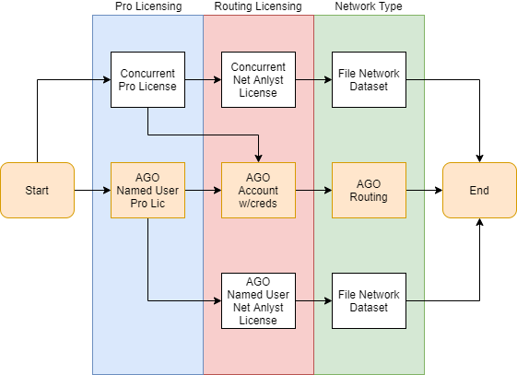

Figure 5. Configuration Scenario #1 Flow

### Configuration Scenario #2

Figure 6 illustrates Configuration Scenario #2 where a user holds a named Enterprise ArcGIS Pro license with a Network Analyst license and chooses the “Bring your own Network”. Considerations include:

* Running the tool will not use ArcGIS Online credits
* Enterprise licensing agreements for large government agencies typically include the Network Analyst license
* Network dataset may not be as good quality or current

Users can reflect scenario-specific avoidance conditions

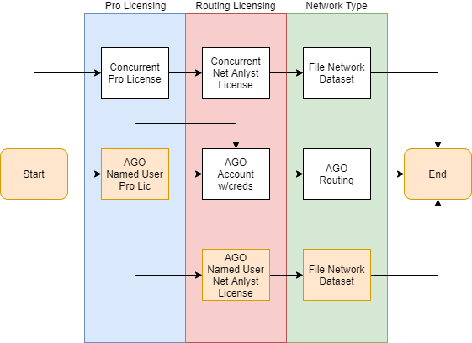

Figure 6. Configuration Scenario #2 Flow

### Configuration Scenario #3

Figure 7 illustrates Configuration Scenario #3 (like #1 aside from extra authentication steps) where a user holds a concurrent ArcGIS Pro license, without a Network Analyst license, but has an ArcGIS Online account with credits. Considerations include:

* User must separately authenticate ArcGIS Pro license and ArcGIS Online account
* Running the tool will use ArcGIS Online credits
* Generic ArcGIS Online routing may not be optimal for heavy truck routing, but the network is expected to be current

Network dataset would not automatically reflect scenario-specific avoidance conditions

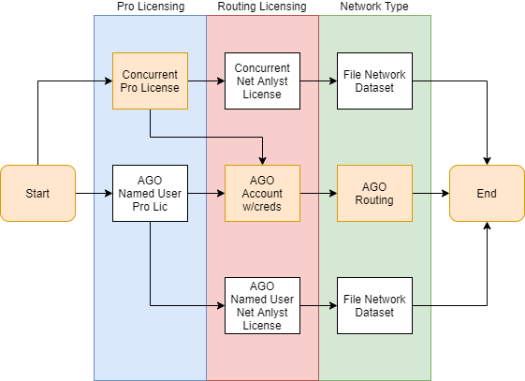

Figure 7. Configuration Scenario #3 Flow

### Configuration Scenario #4

Figure 8 illustrates Configuration Scenario #4 where a user holds a concurrent ArcGIS Pro license that includes the Network Analyst license and chooses the “Bring your own Network” model. Considerations include:

* Running the tool will not use ArcGIS Online credits
* Configuration most likely for smaller organizations
* Network dataset may not be as good of quality or current

Users can reflect scenario-specific avoidance conditions

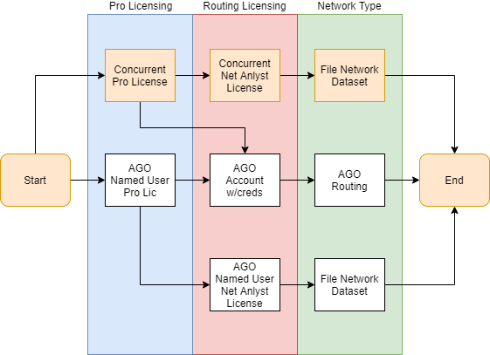

Figure 8. Configuration Scenario #4 Flow

# Run the Tool



6

CHAPTER

Understand the steps that are required to run the tool and generate output

## Load Project

1. Open ArcGIS Pro
2. As shown in Figure 9, users should sign into their ArcGIS Online (AGO) account if planning to leverage ArcGIS Online resources[7]. For EPA users, access your Esri Enterprise login credentials and use your portal ID or PIV card access credentials.

Figure . Authentication Examples

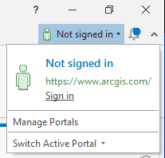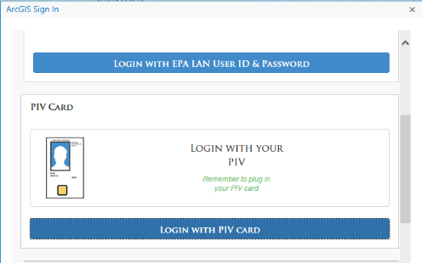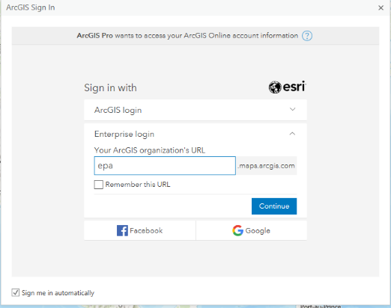

1. Navigate within ArcGIS Pro and select the All Hazards Waste Logistics Tool project (filename: *AllHazardsLogisticsTool.aprx*)
2. Three primary panes are used and can be arranged by the user:
3. Content Pane – May be summoned using the "Content" button under the "View" tab.
4. Tasks Pane – May be summoned using the "Content" button under the "View" tab[8].
5. Geoprocessing Pane -- May be summoned using the "Tools" button under the "Analysis" tab.
6. If not already visible, click the “View” tab and click the “Tasks” icon  to open the Tasks pane. The steps to run the tool are organized in a task “Run the All Hazards Logistics Tool”.

 At any time, users can click the “Reset Panes” button under the “View” tab to restore the default mapping window setup. In addition, users are free to add additional layers to the map for reference purposes.

1. As shown in Figure 10 below, double-click or click the “Open Task” arrow in the Tasks pane to display the task steps. You may need to expand the window to view the arrow.
2. Create Work Environment
3. Set Scenario Conditions
4. Draw Incident Area
5. Draw Support Area
6. Define Scenario and Load to Network
7. Load Facilities to the Network
8. Draw Routing Barriers
9. Solve Routing Scenario
10. Eliminate Routes
11. Calculate Logistics Planning Estimates
12. Export Planning Results

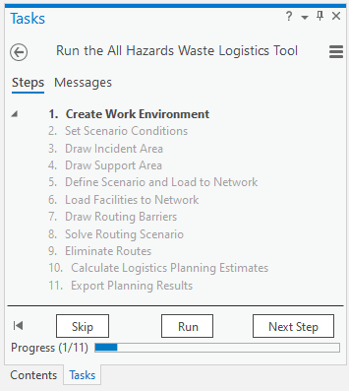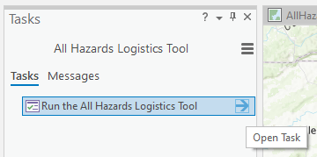

Figure . Open the All Hazards Waste Logistics Tool Tasks Pane

Users should move back and forth between the Tasks and the Geoprocessing panes using the “Next Step”, “Skip”, and “Run” buttons. Clicking “Run” in the Tasks pane will load related items in the Geoprocessing pane. Once selections or actions are complete in the Geoprocessing pane, click “Run”. The tool will alert users once actions are complete. At that point, users can click the “Next Step” or “Skip” buttons in the Tasks pane to advance to the next step in the workflow series.

## Step 1: Create Work Environment

 Processing time to build the work environment is estimated as less than one minute.

Click the “Run” button in the bottom right of the Tasks pane to start Step 1: Create Work Environment. As shown in Figure 11 below, users will specify up to three key elements:

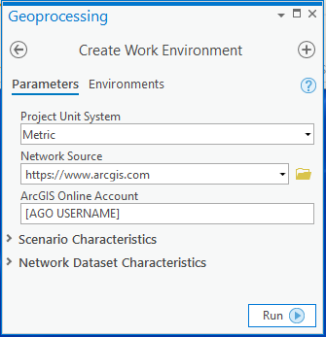

* “Project Unit System”, metric or U.S. customary units:

**Metric**:

Solid Waste Volume: **m3**

Liquid Waste Volume: **L**

**US Customary**:

Solid Waste Volume: **yd3**

Liquid Waste Volume: **gal**

* “Network Source” for routing (see Chapter 5 for a detailed discussion on routing), and

ArcGIS Online Account.

This pane also includes space to display Scenario Characteristics. These elements are populated in Step 5 but are persistently displayed for ease of reference. These values are blank until they are initially specified.

Figure . Create Work Environment Pane

 The tool assumes that most users will use ArcGIS Online credits to perform routing; therefore, the tool defaults to a setup that references [www.arcgis.com](http://www.arcgis.com) as the “Network Source” and the user’s ArcGIS Online Account.

To provide additional flexibility, the tool also supports using a local network (e.g., Navteq Streets). The "Network Source" field can point to a local network dataset, if desired, and the user should ignore the "ArcGIS Online Account" field. This field value will mirror the login credentials active in the upper right corner of ArcGIS Pro. Because a user could have more than one account, this field identifies the account to which credits will be deducted for routing.

Users can also modify the default characteristics of the Network Dataset that is selected. Only options that are available within the network dataset that is loaded will be available. Listed below are example characteristics that are typically available:

* Network Dataset Travel Mode*
* Network Distance Field
* Network Distance Field Unit
* Network Time Field

Network Time Field Unit

Note: The “Travel Mode” field will initially default to “Trucking Distance”. Users can change the “Travel Mode” to any mode available within the network dataset selected. Only travel mode is changeable. The other network characteristics are informational only.

Click the “Run” button in the bottom-right of the Geoprocessing pane to create the work environment needed to run a scenario.

Note: Running Step 1 will create a “fresh” environment. Users can alter scenario conditions and retain any adjustments made to attribute data within the current work environment to generate different results sets. Users can also perform a Save As on the project and retain multiple projects for comparison purposes.

### Review Work Environment Settings

Users should notice that the Network Analyst extension is now visible within the project and several project components are added to the “Contents” pane as shown in Figure 12. Key project components include:

* Network – Contains the network dataset including specifications related to facilities, the incident location, specified barriers, and routes (if any).
* Support Area – Feature class defining the geographic area from which waste management facilities can be identified.
* Incident Area – Feature class defining the incident area location.
* Scenario Results – Feature class that captures the routing and tool calculation results.
* User Provided Facilities – An empty feature class into which users can load their own custom facility dataset, conforming to the specific schema described in Chapter 4.

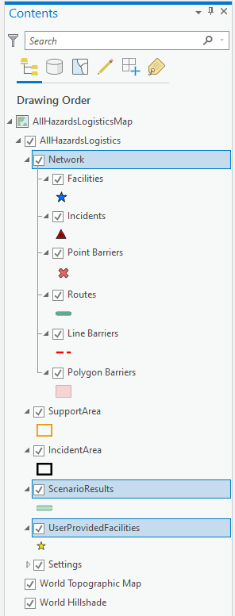Settings – Contains all the reference tables used in calculations. Users can access the attribute table for each reference input and modify default values as needed. Any changes made will persist in the current, local instance of the tool. Download a new copy of the tool to start with defaults. Refer to Chapter 2 for an overview of calculations and defaults used by the tool.

For scenario “Factor Sets” (see Chapter 2), users can modify values using one of two methods (see Figure 13 for an example):

* **Edit via Attribute Tables**: Users can hand it existing values or create a new “set” of values. Users are cautioned that this process is manual and requires careful attention to properly link each of the five factors with a unique objectID to relate the Factor Set. Users may find copying an existing row and modifying values as needed may be helpful. This process needs to be repeated for all five factor tables to generate a complete Factor Set. The tool does not currently contain sophisticated error checking to verify a new Factor Set is complete.
* **Edit Settings.json File**: An alternative method is to edit the .json file directly to modify existing default values and/or create new blocks of code representing a new Factor Set.

Figure . Work Environment Settings

 Advanced editing is only recommended for users with the requisite skills to correctly relate a set of linked data elements. Users should also be mindful of the unit system selected to be sure new entries are normalized to the right units.

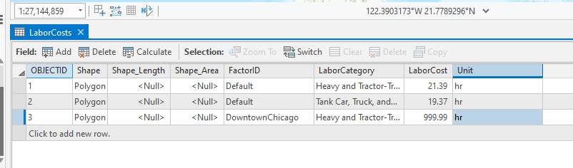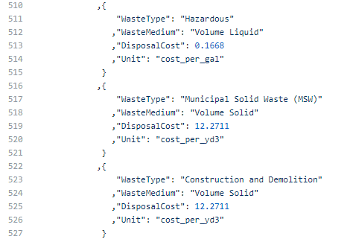

Figure . Edit Factor Set Example

Right-click on any reference table and select “Attribute Table” from the menu to view the underlying data. Note: it may seem confusing to realize that the “reference tables” in the table of contents are feature classes without geometry. ArcGIS Pro does not allow tabular resources to participate in a table of content folder hierarchy, as they do not have a visible aspect. To best organize these attributes, they are treated as feature classes with an empty geometry column and no symbology to mimic a table.

From the “Tasks” pane, click the “Next Step” button at the bottom of the Tasks pane to advance to Step 2.

## Step 2: Set Scenario Conditions

Click the “Run” button in the bottom right of the Tasks pane to start Step 2: Set Scenario Conditions. As shown in Figure 14 below, users can define conditions used to compute resource demands for the scenario (see Chapter 2 for information describing default values). Figure 13 illustrates the default conditions that are initially loaded. Users can adjust values and assign a new Condition Set ID to reference for future scenarios by entering a name in the “New Conditions Set ID” field.

 Users must run separate scenarios for different waste types and quantities. Following completion of Step 10, users can return to Step 2 within the same “session” and make modifications, assign a new Condition Set ID and rename the modified scenario in Step 6.

Users may subsequently analyze and compare different scenario results output external to the tool. See Chapter 6 for more details.

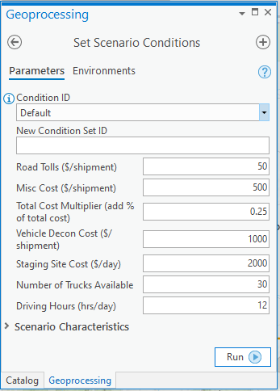

Figure . Set Scenario Conditions Pane

Click the “Run” button in the bottom-right of the Geoprocessing pane to apply the scenario conditions. Click the “Next Step” button located in the bottom-right corner of the Tasks pane to advance to Step 3.

## Step 3: Draw Incident Area

The Draw Incident Area is now active. Users will now specify the incident area using standard Esri editing tools. As shown in Figure 14, clicking the Incident Area feature class will enable the editing mode and present editing tools. Generally, users will make use of the polygon tool to draw the incident area. Draw the boundary of the incident area and click the “Next Step” button located in the bottom-right corner of the Task pane to advance to Step 4.

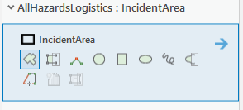

Figure . Draw Incident Area Controls

If you are alerted that edits are pending in the Geoprocessing pane as shown in Figure 15 below, click “Save” to save your sketching.



Figure . Save Sketching - Pending Edits Alert

## Step 4: Draw Support Area

The Draw Support Area is now active. As was done for Step 3, users will now specify the support area using standard Esri editing tools. As shown in Figure 17, clicking the Support Area feature class will enable the editing mode and present editing tools. Generally, users will make use of the polygon tool to draw the support area. Draw the boundary of the support area and click the “Next Step” button located in the bottom-right corner of the Tasks pane to advance to Step 5.

Selecting a support area is optional. A reasonable support area will limit the number of facilities and thus speed up routing. Users may want to select a large enough support area to access more waste management facilities for managing waste. Defining the right size support area is a balance between including enough facilities and removing far too distant, unwanted facilities.

Figure . Draw Support Area Controls

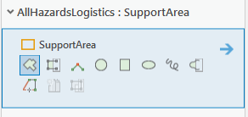

If you are alerted that edits are pending in the Geoprocessing pane as shown in Figure 16 above, click “Save” to save your sketching.

## Step 5: Define Scenario and Load to Network

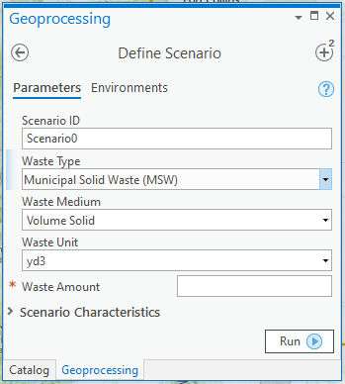Click the “Run” button in the Tasks pane to start Step 5. In this step users will specify scenario parameters as shown in Figure 18 and listed below:

Figure . Define Scenario Pane

* **Scenario ID** – A system-generated ID is created that can be changed to a more meaningful name to identify the scenario.
* **Waste Type** – Choose from one of five waste types included in the tool: Radioactive Contact-Handled (solid or liquid), Radioactive Remote-Handled (solid or liquid), Hazardous Waste (solid or liquid), Municipal Solid Waste (MSW) (solid), and Construction and Demolition (solid) waste.
* **Waste Medium** – Specify the corresponding waste medium associated with the waste type selected. Only valid options are available for selection (e.g., only solid MSW waste is addressed by the tool).
* **Waste Unit** – Valid units will automatically be specified correlating with the selections made when creating the work environment in Task 1.

 All waste amounts in the tool are handled on a volumetric basis.

**Waste Amount** – Specify the numeric quantity (no commas).

Table 6 below provides a quick reference to waste types, medium and units.

|  |  |  |  |
| --- | --- | --- | --- |
| Table . Overview of Waste Types, Medium and Volumetric Units | | | |
| **Waste Type** | **Medium** | **Metric Units** | **U.S. Units** |
| Radioactive: Contact-Handled | Solid | m3 | yd3 |
| Radioactive: Contact-Handled | Liquid | L | gal |
| Radioactive: Remote-Handled | Solid | m3 | yd3 |
| Radioactive: Remote-Handled | Liquid | L | gal |
| Hazardous | Solid | m3 | yd3 |
| Municipal Solid Waste (MSW) | Solid | m3 | yd3 |
| Construction and Demolition (C&D) | Solid | m3 | yd3 |

Click the “Run” button in the bottom-right of the Geoprocessing pane to apply the scenario parameters. Click the “Next Step” button located in the bottom-right corner of the Tasks pane to advance to Step 6.

## Step 6: Load Facilities to the Network

Click the “Run” button in the Tasks pane to start Step 6. In this step users will load facilities to the network as shown in Figure 19 and listed below.

Figure . Load Facilities to the Network Pane

### Select Disposal Facility Types

 Only facility types that accept the waste medium (liquid or solid) specified in Step 5 will be available for selection.

Choose facility types to support waste management efforts. By default, facility types accepting the waste type specified in Step 5 are preselected; however, the tool allows you to add additional facility types. As described in Chapter 4, the tool comes with default facility locations for the universe of facilities addressed by the tool. In this step, users can load the default facilities and/or load a user-provided set of facilities.

Choose one or more facility types to include in a scenario and for which waste amounts will be allocated. Figure 20 illustrates the eight possible waste type/medium combinations (highlighted in red) that the tool prechecks based on waste type/medium. Note that that RCRA Hazardous Waste Landfill with LARW is never pre-checked but offered as a supplemental option.

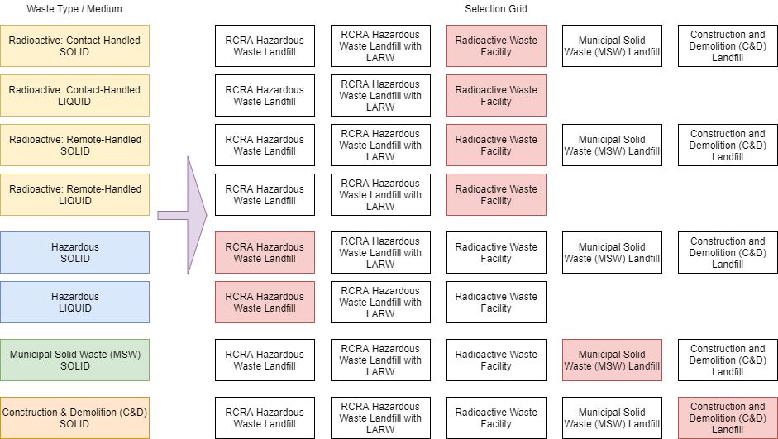

Figure . Facility Selection Grid

### Load Default Facilities

The tool includes a default universe of facilities as a starting point. You can choose to load default facilities or uncheck to include only a user-defined universe of facilities.

 Default facilities include a value for “Quantity Accepted”. This is an estimated value only and does not reflect facility-specific conditions nor agreement by the facility to accept waste.

If a user prefers to analyze only their user-defined facilities, uncheck the “Load Default Facilities” setting and follow the instructions in the next section.

Click the “Run” button in the bottom-right of the Geoprocessing pane to load the facilities into the specified support area. Click the “Next Step” button located in the bottom-right corner of the Tasks pane to advance to Step 7.

### Load User-Defined Facilities

As illustrated in Figure 21, users can add user-defined facilities by clicking on the “Browse” icon to navigate to the user-defined facility feature class of interest. Following the selection of each feature class, a new row will appear. This file input dialog accepts zero to many input files. Add one or more feature classes and use onscreen controls to delete any feature class. Users will need to ensure that user-provided facility data conform to the prescribed schema (see Chapter 4).

 The tool will load only facilities that correspond to the facility types selections made in the checkboxes above.

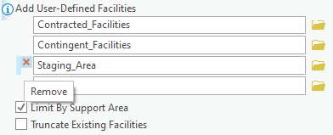

Figure . Add User-Defined Facilities

Users should uncheck the “Load Default Facilities” to limit facilities to only those that are user-defined.

If you are alerted that edits are pending in the Geoprocessing pane as shown in Figure 22 below, click “Save” to save your sketching.

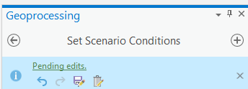

Figure . Save Sketching - Pending Edits Alert

Click the “Run” button in the bottom-right of the Geoprocessing pane to load the facilities into the specified support area. Step 5 can be iteratively repeated by altering choices and rerunning the Geoprocessing tool. Click the “Next Step” button located in the bottom-right corner of the Tasks pane to advance to Step 7.

### Exclude Facilities

 Users are cautioned that any changes made to “local” default facility data will persist with the tool. Users should download a new copy of the tool if original, unedited default data are preferred.

There are several ways a user can exclude facilities from consideration, include:

1. Don’t load them into the facilities layer in the first place. As discussed in earlier sections, the tool provides default facilities. Users can delete facilities as needed or load a user-defined facility data set.
2. Remove them after loading and before routing. As shown in Figure 12, users can view and directly manipulate the work environment. The facilities layer is located with the Network space. Users should ensure they are in editing mode and remember to save any changes (refer to Figure 22).
3. Users can also control whether facilities are considered for routing by establishing barriers (see Step 7).
4. Remove any routes to those facilities after routing. Step 9 provides users with the option to eliminate routes to facilities when computing resource demands.

### Limit by Support Area

As shown in Figure 21, check “Limit by Support Area” to only facilities located within the Support Area defined in Step 4.

### Truncate Existing Facilities

The tool initially starts with an empty facility layer; therefore, checking or unchecking this option only becomes relevant if a user is rerunning a scenario. As shown in Figure 21, the “Truncate Existing Facilities” checkbox is unchecked. If a users chooses to load facilities a second time, this control provides a way to specify whether you prefer to start with a clean map or append additional facilities. Users may also find this feature helpful to make corrections. For example, if the wrong facility layer was loaded.

### Adjust Quantity Accepted

As discussed, default values for “Quantity Accepted” are provided. Users should adjust these quantities to reflect realistic conditions if possible. Users can adjust values by:

* Editing the default GeoJSON file or incoming user datafile to change the “Quantity Accepted” fields for specific facilities. The change would be permanent and persist with the project instance.

Adjusting individual facilities that are loaded to the network facility layer by clicking on a facility pin and manually changing the values before executing the routing solver. The change would not persist with the project instance and would need to be repeated each time the facility is reloaded from source.

## Step 7: Draw Routing Barriers

 Users are cautioned to avoid specifying large barrier areas when using ArcGIS Online routing or when attempting to optimize routing performance. Doing so will exclude all roads under the barriers within the routing solver that could in turn exceed established barrier limits.

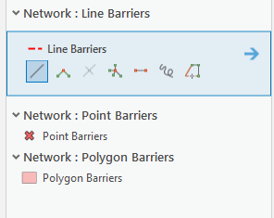Step 7 allows users to define routing barriers as needed. As shown in Figure 23, barriers can be added to the map as points, lines or areas using standard Esri editing tools.

Figure . Draw Routing Barriers Tools

If you are alerted that edits are pending in the Geoprocessing pane, click “Save” to save your sketching. Click the “Next Step” button located in the bottom-right corner of the Tasks pane to advance to Step 8.

## Step 8: Solve Routing Scenario

Step 8 invokes a Geoprocessing tool that executes the network solver task. Figure 24 illustrates key parameters for Step 8. The current Scenario ID is displayed. Users should enter a new Scenario ID if users are iterating again and desire to compare previous results. Doing so will create a new results dataset; otherwise, results will be overwritten.

Users are initially presented with a pre-populated quantity for the “Suggested # of Facilities to Find” parameter. This suggestion is based on the waste quantity to allocate and an average capacity of facilities within the designated support area.

 “Total Estimated Facility Capacity” is the summation of the “Quantity Accepted” field of all facilities loaded within the designated support area. Default facilities included with the tool include a placeholder value for “Quantity Accepted”. This is an estimated value only and does not reflect facility-specific conditions nor agreement by the facility to accept waste.

Selecting enough facilities prior to executing the routing solver will ensure an efficient use of the routing solver. Users can adjust this number as needed. As shown in Figure 24, users can also compare the “Total Estimated Facility Capacity” to the “Waste Amount” value. If “Total Estimated Facility Capacity” is less than or close to the “Waste Amount” entered, users should consider expanding the support area to handle the full waste amount prior to running the routing solver in Step 8.

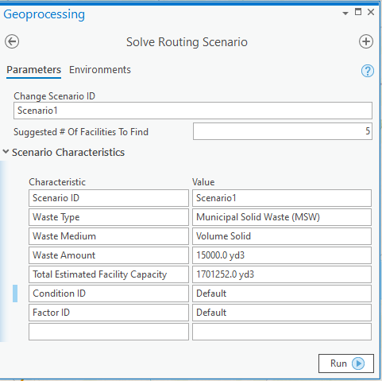

Figure . Solve Routing Scenario Pane

 Users relying on Esri’s ArcGIS Online Network dataset are cautioned that each submission to the network solver (i.e., whenever you click “Run” in Step 8) will use ArcGIS Online credits associated with the user account linked to this session. Users with limited credits may wish to lower the number of facilities in which to route (at the risk of not returning enough facilities to manage the specified waste quantity), while users without credit limitations may choose to increase the number of routes to consider.

Click the “Run” button on the bottom-right of the Geoprocessing pane to execute the routing solver. Click the “Next Step” button located in the bottom-right corner of the Tasks pane to advance to Step 9.

## Step 9: Eliminate Routes

Step 9 is an optional step that provides users with flexibility to prune away unwanted routes. There may be instances where more routes to facilities are returned than are needed or cases where a user needs to eliminate a route. Using standard Esri editing tools, a user can remove a route from further consideration.

Figure 25 illustrates the controls that are available. Click on the “Edit” tab and find the Features and Selection tools. Using the “Select” tool, highlight the route(s) you would like to eliminate. From the Features tool set, click “Delete” to remove the route.

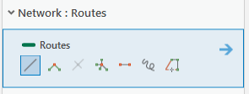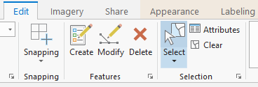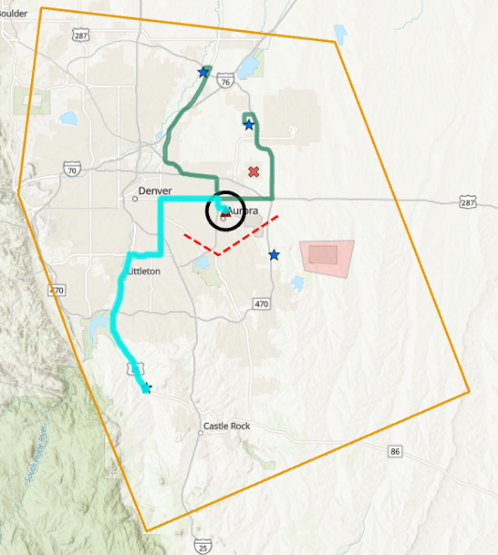

Figure . Eliminate Routes Editing Tools

If you are alerted that edits are pending in the Geoprocessing pane, click “Save” to save your sketching. Click the “Next Step” button located in the bottom-right corner of the Tasks pane to advance to Step 10.

## Step 10: Calculate Logistics Planning Estimates

Click the “Run” button in the Tasks pane to start Step 10. This task involves running a Geoprocessing tool to execute the resource demand calculations that are described in Chapter 2. Calculated results are stored in the Scenario Results feature class. Figure 26 below illustrates the controls available in Step 10.

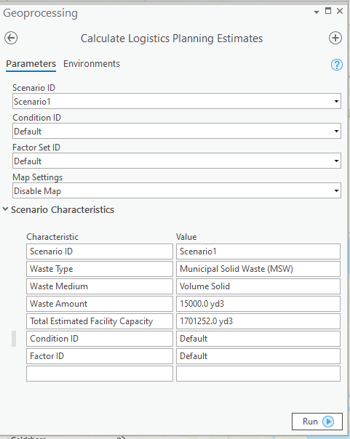

Figure . Calculate Logistics Planning Estimates Pane

 Be sure to compare the “Total Estimated Facility Capacity” and the “Waste Amount” values to ensure enough facilities are included to manage the quantity of waste specified. Note: The tool will remove longer routes if closer facilities satisfy the waste amount specified when calculating and preparing the results output.

### Specify Map Settings

As shown in Figure 27, the tool provides four different map settings from which to select. Each variation controls the clip of the map that is saved to include with the results output. Users should be mindful of the Pillow package discussed in Chapter 3 that is required.

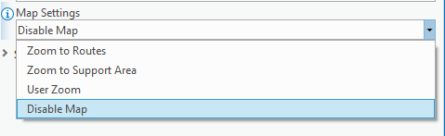

Figure . Map Settings

Click “Run” on the Geoprocessing pane to run the tool. Click the “Next Step” button located in the bottom-right corner of the Tasks pane to advance to Step 11.

## Step 11: Export Logistics Planning Results

Click the “Run” button in the Tasks pane to start Step 11. This task will run a geoprocessing tool to export planning results to an XLS workbook. As shown in Figure 28, users can specify a file name and the location to save results. If more than one scenario was created, users can select the Scenario ID for the results set of interest to export.

 Before running Step 11, be sure to specify the preferred “Map Settings” to specify the type of image to include in your results.

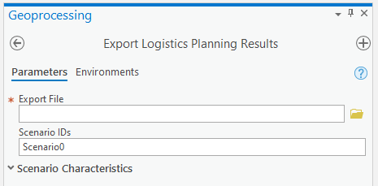

Figure . Export Logistics Planning Results Pane

### Results Output

The tool exports results calculated in Step 10 and saves output into a Microsoft Excel workbook. Refer to Chapter 2 for information on the calculations. The workbook includes three tabs:

* **Summary** – Provides an aggregated view of the amount of waste (allocated and unallocated, if any), a breakdown of costs, and a total cost amount.
* [**ScenarioName**] – Follows the naming convention specified by the users, provides a summary of the scenario and specific facility routing details, and includes a snapshot of the image if option enabled by the user.
* **Reference** – Provides access to underlying values used in the calculations.

Results for individual scenarios will be exported separately. Users can pull worksheets into a single workbook to facilitate comparisons and track how differences in scenario conditions and/or factors impact results.

### Create and Compare More than One Scenario

After completing Step 11 for a specific scenario, users can create additional scenarios to support comparative analyses. For example, a user may want to assess resource and/or logistical tradeoffs if waste is handled as MSW vs Hazardous. Users can return to any steps previously completed and make adjustments. To preserve the adjustments for comparison purposes, the user should assign unique Scenario, Condition and Factor IDs. Step 10 allows users to specify which ID should be referenced when calculating results. Users can make selections using the drop-down menus that are available in the pane.

# Troubleshooting



7

CHAPTER

Read about issues and resolutions to common problems

This chapter provides solutions to commonly found problems that users may encounter using the tool. It is recommended that you confirm software and hardware compatibility (information found in Chapter 3 of this document) before continuing.

| **Problem** | **Cause** | **Remedy** |
| --- | --- | --- |
| ArcGIS version alert “You are using an earlier version of ArcGIS Pro: 2.4.0” | You are using an earlier version of ArcGIS Pro | Click the “x” to hide the warning. |
| Alert: Edits are Pending | Layers were edited but not explicitly saved. | Look for the alert in the Geoprocessing pane and click “Save” to save your sketching. |
| Define Scenario Failed | Layers were edited in Steps 3 and/or 4 but not explicitly saved. | Look for the alert in the Geoprocessing pane and click “Save” to save your sketching. Click “Run” in Step 5 again. |
| User-defined facilities will not load or are not included in results | Required data fields and acceptable values are not correctly specified. | Verify required fields are correctly populated with acceptable values and confirm no typos exist for expected values. Check field property types and layer attributes for spelling mistakes or spaces (e.g., “Treu” instead of “True” or “m 3” instead of “m3”). |
| Number of Facilities to Find is blank | Support area does not have facilities. | Expand support area in Step 4 or uncheck “Limit by Support Area” in Step 6. |
| Solve Routing Scenario Failed | When using the ArcGIS Online network and routing solution, the maximum number of barriers that can be solved is 500. | Reduce support area and/or number of barriers and re-run routing solver. |
| Results fail to export | You chose to include a clip of the map with your export, but you do not have PIL installed in your Python environment to fetch image objects | Install PIL (see Chapter 3) or select “Disable Map” and export results without the map image. |
| Scratch database becomes bloated | Interim results are stashed in the scratch database | Periodically empty the scratch database |

This concludes the User’s Guide. If you have any questions, please email the point of contact listed in Chapter 1.

U.S. Environmental Protection Agency

Homeland Security Research Program

Research Triangle Park, NC 27711

1. [Insert reference to Staging Tool User’s Guide/Report when available.]
2. Miscellaneous Costs and Total Cost Multiplier inputs provide users with flexibility to account for extra costs that may be assessed in transporting CBRN-related waste given the likelihood that “normal” costs would be increased.
3. Documentation and instructions for installing Pillow in your ArcGIS Pro Python environment are available at: <https://pypi.org/project/Pillow/> (Last accessed: October 29, 2019)
4. Only a subset of facility data available within I-WASTE is included with the All Hazards Waste Logistics Tool.
5. Some facilities can accept more than one waste type (e.g., MSW and C&D).
6. Based on facilities with Process Code = D80 Landfill, identified via <https://enviro.epa.gov/facts/rcrainfo/search.html> (Last accessed: 09/26/2019).
7. Refer to Chapter 5 for more details on different access configurations.
8. The Tasks Pane is used to guide the user through the necessary steps to operate the tool.