
TIC-TAC-TOE GAME
A minimal Tic-Tac-Toe game designed to explore modern web development concepts, with a focus on user interface design, including responsive layouts, CSS styling, and interactive layout behavior.

2023-2024

ASANSOL ENGINEERING COLLEGE



Project Report
A minimal Tic-Tac-Toe game designed to explore modern web development concepts, with a focus on user interface design, including responsive layouts, CSS styling, and interactive layout behavior.

Submitted by: | Submitted to:
48) Prachi Shaw: [Roll Number]  00) [Your Name]: [Roll Number]  00) [Your Name]: [Roll Number]  00) [Your Name]: [Roll Number] | ______________________

Academic Year: 2023–2024

ACKNOWLEDGEMENT

We would like to express our sincere gratitude to our course instructor, [Professor’s Name], for the guidance, encouragement, and constructive feedback provided throughout the development of this project. Their support played a significant role in helping us understand both the conceptual and practical aspects of the work.

We are grateful for the opportunity to collaborate on this project, which allowed us to explore and apply modern web development concepts such as user interface design, responsive layouts, and interactive styling techniques. This project enhanced our problem-solving abilities and strengthened our understanding of practical implementation.

We would also like to thank our institution for providing the necessary resources, infrastructure, and learning environment that contributed to the successful completion of this project.

48) Prachi Shaw: [Roll Number]  00) [Your Name]: [Roll Number]  00) [Your Name]: [Roll Number]  00) [Your Name]: [Roll Number] | ______________________

INDEX

A. Acknowledgement
- Introduction
- Objective of the Project
- Game Description
- System Requirements
- Implementation Overview
- Screenshots
- Conclusion
- References
- Codes

INTRODUCTION

Tic-Tac-Toe is a classic strategy game that has long been used as a simple yet effective example for understanding logical decision-making and turn-based interactions. Due to its straightforward rules and clear win conditions, the game provides an ideal foundation for exploring fundamental concepts in software and web application development.

This project focuses on developing a web-based version of the Tic-Tac-Toe game as a learning and experimentation exercise in modern web development. Rather than concentrating solely on gameplay mechanics, the project emphasizes structured implementation, interface design, and interactive behavior. It aims to demonstrate how even a minimal concept can be transformed into a more engaging application through thoughtful design choices and clean architectural planning.

The project also explores responsive design principles, modular development practices, and visual customization techniques. By combining logical game development with user-focused design considerations, the project serves as a practical example of how functionality and presentation work together in a real-world web application.

Overall, the project serves as an experiment in combining logical game development with thoughtful design and structured implementation, demonstrating how even a simple concept can be expanded into a well-organized and visually engaging web application.

OBJECTIVE OF THE PROJECT

The primary objectives of this project are:

- To design and develop a functional, web-based Tic-Tac-Toe game using modern web development techniques.
- To implement core game logic, including turn management, win detection, draw conditions, and adaptable grid handling for multiple board sizes.
- To explore interactive gameplay modes such as Player vs Player and Player vs AI, with configurable difficulty levels.
- To apply user interface design principles by incorporating responsive layouts, interactive components, and visual feedback mechanisms.
- To experiment with CSS-based styling and theme customization, including animated and static visual themes, to enhance user experience.
- To strengthen problem-solving skills and gain practical experience in structured, modular, and scalable programming.

GAME DESCRIPTION

The Tic-Tac-Toe game is implemented as a feature-rich, web-based application that extends beyond the traditional 3×3 grid format. The game supports multiple grid sizes, including 3×3, 5×5, and 7×7 boards, allowing players to experience varied gameplay dynamics and increased complexity.
The application offers both Player vs Player and Player vs AI modes. In single-player mode, users can choose between different AI difficulty levels, providing varying degrees of challenge. The game logic dynamically adapts to the selected grid size and gameplay mode, ensuring consistent and accurate behavior across all configurations.
In addition to gameplay functionality, the project places strong emphasis on user interface design and interaction. Multiple visual themes are available, each featuring distinct styling and background behavior. Themes can be switched during gameplay using an interactive theme selector designed with CSS-based animations and transitions. Animated and static background elements are carefully managed to maintain visual clarity and performance.
The interface is designed to be responsive, ensuring smooth usability across different screen sizes and devices. A floating character element is included as a decorative and interactive component, enhancing user engagement without interfering with gameplay. Visual feedback such as dynamic highlights, score updates, and smooth transitions contributes to an intuitive and engaging user experience.

Overall, the game demonstrates how a simple concept can be expanded into a polished application through structured logic, responsive layouts, and thoughtful visual experimentation, with emphasis placed on the development process and design work rather than gameplay complexity alone.
SYSTEM REQUIREMENTS

Software Requirements

- Operating System: Any operating system capable of running a modern web browser
- Web Browser: Google Chrome, Mozilla Firefox, Microsoft Edge, Safari, or any standards-compliant browser
- Internet Connection: Required only to access the game link

Hardware Requirements

- Device: Desktop, Laptop, Tablet, or Smartphone
- Processor: Any modern processor
- RAM: Minimum 2 GB
- Display: Standard screen resolution suitable for web browsing

IMPLEMENTATION OVERVIEW

The Tic-Tac-Toe game is implemented using a structured and modular approach to ensure clarity, scalability, and ease of maintenance. The application logic is separated into distinct components responsible for game rules, user interaction handling, visual updates, and theme management. This separation allows the game to remain organized while supporting multiple features and configurations.
Game logic such as turn handling, win detection, draw conditions, and grid size management is handled dynamically, enabling the application to support multiple board sizes and gameplay modes. Player interactions are processed through event-driven mechanisms, ensuring smooth and responsive gameplay. In single-player mode, user input is carefully managed during AI turns to maintain consistent game state and prevent unintended actions.
The user interface is generated dynamically based on selected options such as grid size and game mode. Visual feedback, including score updates, highlighted winning combinations, and status messages, is used to enhance clarity and user engagement. Responsive design techniques ensure that the layout adapts seamlessly across different screen sizes and devices.
A dedicated theme management system is incorporated to control multiple visual themes. Each theme is designed to operate independently, with animated and static elements being enabled or disabled as required to maintain performance and visual consistency. CSS variables, transitions, and animations are extensively used to create a cohesive and customizable interface. Additional decorative elements, such as a floating character, are integrated in a way that enhances visual appeal without interfering with gameplay.
Overall, the implementation focuses on combining clean logic, modular structure, responsive design, and interactive visuals to demonstrate a well-organized web application built around a simple game concept.
SCREENSHOTS

This section showcases the visual interface of the Tic-Tac-Toe game, highlighting gameplay modes, multiple grid sizes, and the implementation of various visual themes and interactive design elements.

Figure 1: Default Game Interface (Lavender Theme)
Home screen of the Tic-Tac-Toe game displaying the standard 3×3 grid layout, control panel, and the Lavender theme with soft background effects. The floating character element and interactive controls are visible.
- 3×3 grid
- Control panel (mode, AI, grid size)
- Floating character
- Theme-based background styling

Figure 2: Summer Theme with Interactive Controls
Game interface using the Summer theme, demonstrating CSS-based background design, theme-specific color styling, and interactive buttons for game mode, AI difficulty, and grid size selection.
- 5×5 grid
- Theme switching
- Styled buttons
- Warm color palette
- Visual consistency across UI elements

Figure 3: Parallax Stars Theme
Game interface displayed with the Parallax Stars theme, showcasing animated background elements, contrast-based UI design, and smooth visual transitions during gameplay.
- Animated star background
- Dark-mode UI styling
- Performance-friendly animation handling

Figure 4: Blue Waves Theme and Responsive Layout
Game interface using the Blue Waves theme, demonstrating responsive layout behavior, scalable grid design, and adaptive interface alignment across different screen sizes.
- 7×7 grid
- Responsive layout
- Scalable grid
- Theme-specific styling
- Consistent UI spacing

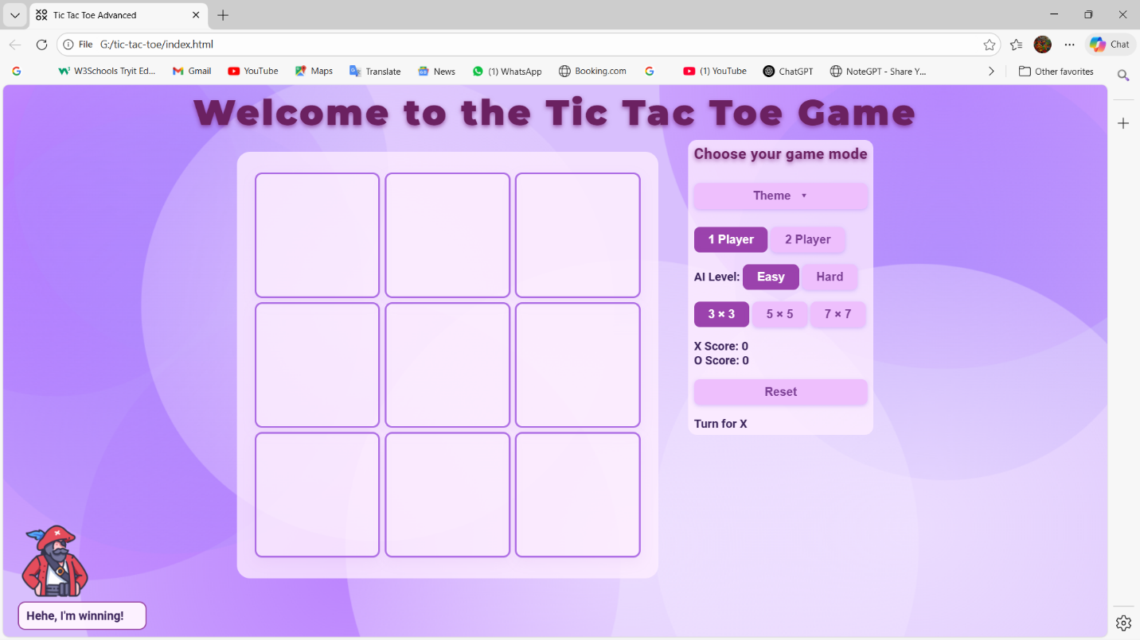
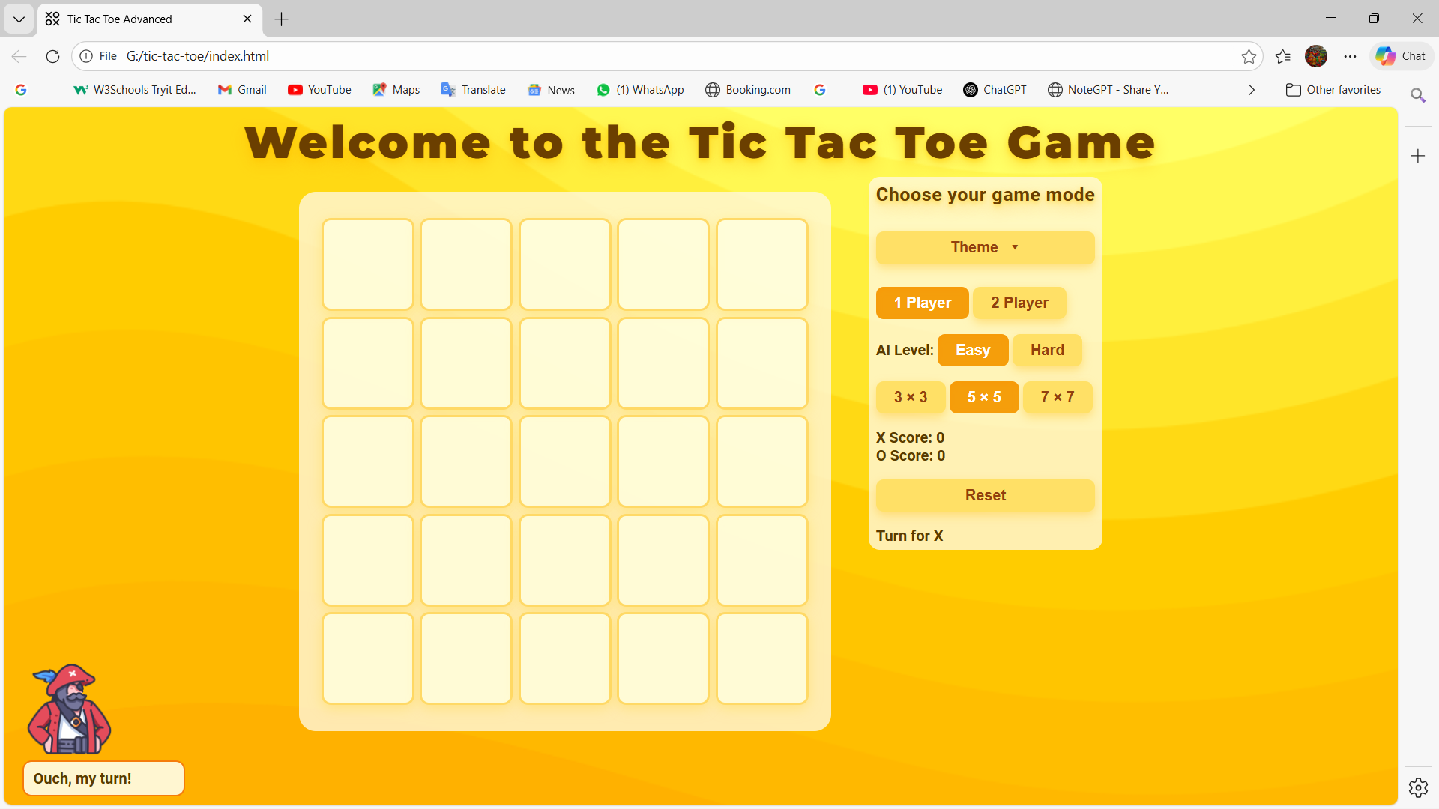
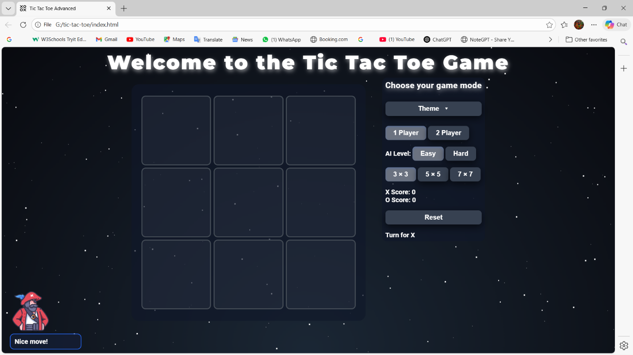
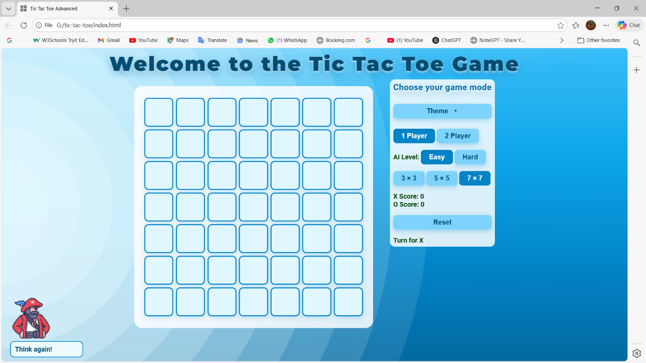

“Simple game idea, but clearly a lot of design and implementation work.”

CONCLUSION

The Tic-Tac-Toe project successfully demonstrates how a simple and well-known game concept can be transformed into a structured and visually engaging web application. While the core gameplay remains minimal, the project emphasizes thoughtful implementation, interactive design, and modular development practices.

Through this project, practical experience was gained in implementing adaptable game logic, managing multiple gameplay modes, and handling dynamic user interactions. The integration of responsive layouts, theme customization, and visual feedback mechanisms highlights the importance of user experience in modern web applications.

Overall, the project provided valuable insights into combining logic, design, and interactivity within a single application. It strengthened understanding of web development principles and demonstrated how careful planning and design considerations can enhance even the simplest applications. The project can be further extended by introducing additional features such as advanced AI behavior, enhanced animations, or online multiplayer functionality.

