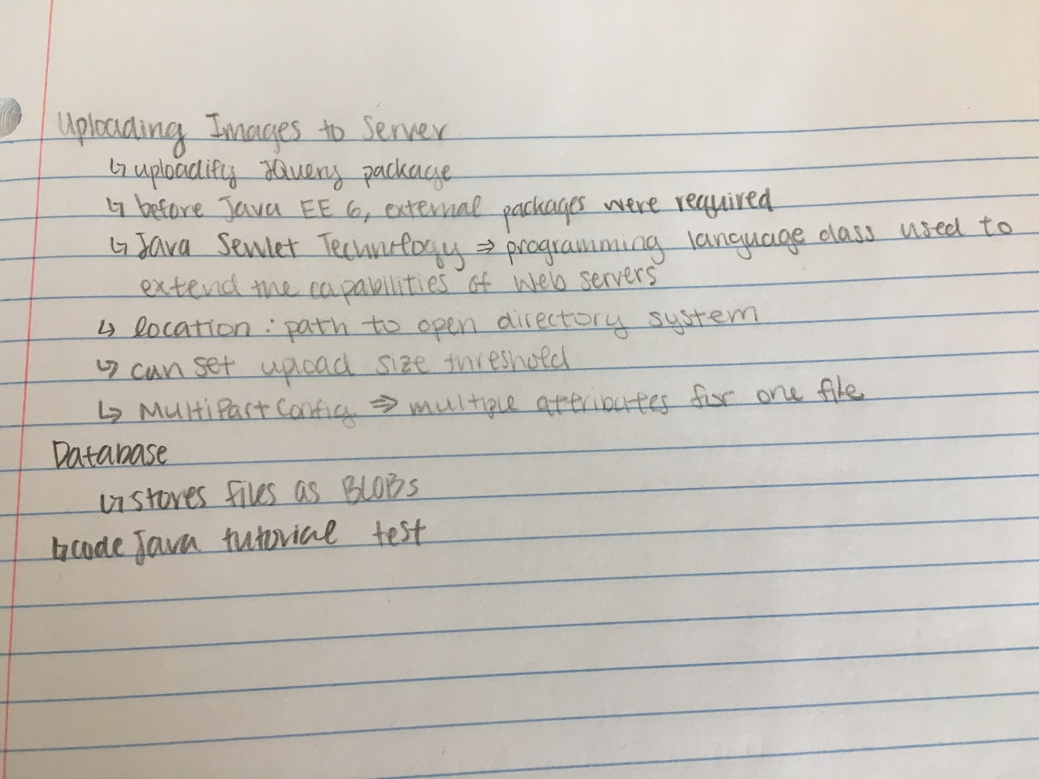

<https://docs.oracle.com/javaee/6/tutorial/doc/gmhba.html>

<http://www.codejava.net/coding/upload-files-to-database-servlet-jsp-mysql>