3D Printing

# Designing your object:

In order to 3D print an object, first you need to either design it or modify an existing design. The recommended tool for designing a model is [TINKERCAD](https://www.tinkercad.com/). TinkerCad has an easy tutorial, and is very self-explanatory. To create an account, hit **sign up** on [www.tinkercad.com](http://www.tinkercad.com). After this, TinkerCad will offer to walk you through a series of tutorials. The tutorials are helpful, and you can pause them to start creating your own object at any time. The TinkerCad interface is very straightforward, however, so usually won’t need the tutorials.

# Modifying an Object:

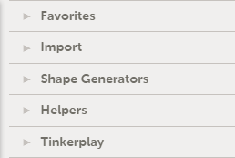If you want to look for an existing design and modify it, [Thingiverse](https://www.thingiverse.com/) is a great place to look. It has a huge number of high quality, 3D printable objects. To download a file as a file that you can 3D print, be sure to **scroll down to the bottom of the page** and click on a **.STL** file to download it. You can also use [TINKERCAD](https://www.tinkercad.com/) to modify a downloaded file. To do this, click **import** in the toolbar. After this, click **choose file** to choose the **.STL** file that you downloaded. TinkerCad will import this into its interface.

# TinkerCad 101:

Select import to modify a downloaded object

In TinkerCad, everything is based on tabs. On the right-hand side, there is a list of expandable tabs. When designing or editing an object, the most important tabs is the **Geometric** tab. This provides basic, drag-and-droppable shapes that can be dragged onto the grid. Another key feature of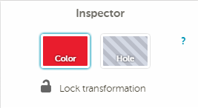 TinkerCad is the ability to cut out pieces of shapes. If you drag a shape onto the grid and click on it, it will open up a section in the top right of the grid titled **Inspector**. In this panel, you can click **Hole** to set the object to cut out a piece of another object it’s placed on to. To download your object, go to the design dropdown in the top left and click on **Download for 3D Printing**. After this, it will bring up a dialog of which file format you want to download in. Click on **.STL**. TinkerCad also has a series of tutorials that are helpful if you wish to explore TinkerCad more.

Select **Hole** to set the object to be a hole

Drag and droppable objects are under the **Geometric** tab