**Developing Soft and Parallel Programming Skills Using Project-Based Learning**

Fall-2018

By: Connor Lacy, China Sanders, Jordan Jackson, Sai Kalavakolanu, Delorian Mateas

|  |  |  |  |  |  |  |
| --- | --- | --- | --- | --- | --- | --- |
| Name | Email | Task | Duration | Dependency | Due Date | Notes |
| China | Csanders29@student.gsu.edu | Slack/GitHub,  Programming basics |  | Creating GitHub and programming basics | 10/03/2018 |  |
| sai | Skalavakolanu1@student.gsu.edu | Planning and scheduling, parallel programming basics |  | Planning the assignment and help with programming basics | 09/19/18,  10/03/18 |  |
| Connor  (coordinator) | Clacy2@student.gsu.edu | PI Installation, programming basics |  | Installing raspberry pi and programming | 09/26/18  10/03/20 |  |
| Jordan | Jjackson209@student.gsu.edu | Report |  | Typing up the report | 10/03/2018 |  |
| Delorian | dmateas1@student.gsu.edu | Video creation and submission |  | Youtube submission | 10/03/2018 | ; |

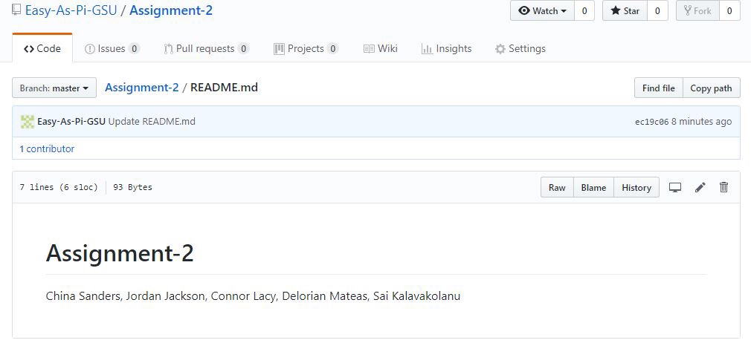

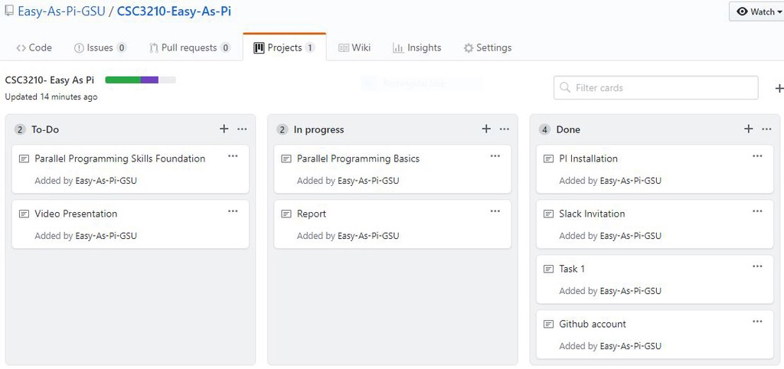

Identifying the components on the raspberry PI:

* CPU/Ram, USB x2, Ethernet, power, camera port, HDMI port, power(micro usb), Displayport, single board computer, Quad-core Multicore CPU, 1GB Ram.

How many cores does the Raspberry Pi’s CPU have:

* The raspberry PI has a 4 core CPU.

List four main differences between X86 (CISC) and ARM Raspberry PI (RISC). Justify you answer and use your own words (do not copy and paste):

* CISC has a processor that has a larger and more capable instruction set which allows more access to memory, therefore having more operation and addressing modes. ARM has a more simplified instruction set that operate only on registers and uses a Load/Store memory model for accessing memory which means that only Load/Store instructions can access memory.
* CISC is more feature-rich and has less registers than ARM.
* CISC processors use little-endian format and ARM processors use BI-endian format.
* ARMs’ reduced instruction set allows for instructions to be executed more quickly but requires a greater emphasis on efficiency when writing.

What is the difference between sequential and parallel computation and identify the practical significance of each?

* Sequential computing is where a problem is broken into a series of instructions that are executed sequentially one after the other. This type of computing happens on a single processor and only one instruction may execute at a time. Parallel computation is where a problem is broken down into parts that can be solved simultaneously. These parts are broken down into instructions and each instruction executes simultaneously on different processors. This is more efficient.

Identify the basic form of data and task parallelism in computational problems.

* Data parallelism is parallelism in which the same computation is applied to multiple data items, which makes the amount of available parallelism is proportional to the input size.
* Task parallelism is where the parallelism applies to solutions where parallelism organized around the functions to be performed rather than around the data.

Explain the differences between processes and threads.

* A process can have several threads. Processes can be divided into smaller independent parts, called threads, and spread across the multiple cores of the CPU. A thread is a lightweight process that allows a single executable/process to be decomposed to smaller independent parts. These threads share common memory of the process they belong to.

What is OpenMP and what is OpenMP pragmas?

* OpenMP is an application programming interface that supports shared memory multiprocessing programming.
* OpenMP pragmas are compiler directives that enable the compiler to generate threaded code

What applications benefit from multi core (list four)?

* Scientific Applications (CAD/CAM)
* Multimedia Applications (Quicktime)
* Database Servers
* Web servers (Web commerce)

Why Multicore? (why not single core, list four)

* Difficult to make single core clock frequencies higher
* Better than deeply pipelined circuits. These have heat problems, speed of light problems, need large teams and require expensive cooling.
* Many new applications are multithreaded
* General trend in computer architecture is towards more parallelism