TECHNICAL DEVELOPMENT PLAN

KidTechies AI Marketing Agent
Senior Developer Implementation Specification

DELIVERY POSITION
Stage 1 is intentionally lightweight and no-code: Claude scheduled tasks, a five-file Markdown knowledge base, Google Drive, and client-side cookieless analytics. Stage 2 is commissioned only after Stage 1 proves which agents create real operational value; it then introduces TypeScript/Node.js, the Claude Agent SDK, SQLite state, and approval-gated MCP publishing connectors.

1. Executive summary
This plan converts the approved technical proposal into an implementation-grade delivery specification. The objective is to give KidTechies the operating output of a small marketing team through six governed Claude agents, while preserving founder judgement and preventing autonomous publishing in Stage 1.
10 working days  Stage 1 | Day 3-4  First drafts | 6 agents  AI roles | Weeks 3-8  Stage 2 | Approval gated  Publisher

CORE ENGINEERING RULE
AI prepares work; policy and product facts constrain it; the founder approves it; publishing remains manual until the publishing step itself becomes the demonstrated bottleneck.

1.1 Delivery outcomes
- A verified, version-controlled KidTechies marketing knowledge base that every agent must use.
- Six role-specific agent workflows with fixed cadences, defined inputs, structured outputs and safety checks.
- Google Drive delivery folders that make drafts easy to review without introducing a new internal tool in Stage 1.
- A repeatable weekly operating rhythm: Monday market brief, three content packages, Tuesday school outreach, Friday funnel analysis, fortnightly creative review and on-demand Arabic localisation.
- A separate Stage 2 production automation path that rebuilds only the proven agents and introduces state, idempotency, connectors and approval-gated publishing.

1.2 Scope boundary
INCLUDED
Agent design, knowledge-base design, Claude skills/tasks, Drive workflow, CSV-driven Funnel Analyst, operator guide, handover, and—if separately commissioned—Agent SDK publishing automation.

NOT INCLUDED IN THIS ENGAGEMENT
Website funnel amendments from Section 04 of the Growth Dossier, campaign/media buying, full content strategy execution, native-speaker Arabic review, or legal/compliance advice. These can be quoted or assigned separately.

2. Architecture and technology decisions
The architecture deliberately separates the low-risk Stage 1 validation environment from the coded Stage 2 publishing environment. This keeps the first two weeks fast, cheap and reversible while still providing a clean upgrade path once usage data identifies the agents worth automating.

2.1 Stage 1 — no-code operating architecture
Stage 1 uses the client’s existing Claude capability as the execution surface. Five approved Markdown files govern the six agents. Drafts are written to dated Google Drive folders. Analytics/payment exports are supplied as CSVs to the Funnel Analyst. Nothing publishes without founder review.
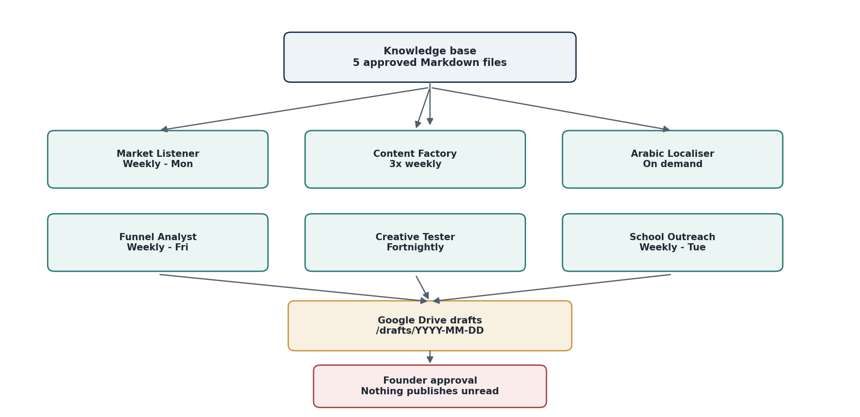
Figure 1 — Stage 1: knowledge-controlled scheduled agents with Google Drive delivery and human approval.
Component | Engineering purpose | Stage
Claude (existing plan) | Scheduled tasks, saved skill(s), built-in web research for Market Listener and School Outreach. | Stage 1
Markdown knowledge base | Five approved text files; human editable; version controlled; no database required. | Stage 1
Google Drive | Dated draft folders; input location for analytics/payment CSV exports. | Stage 1
Cookieless analytics | Plausible, Fathom or self-hosted Umami; configured client-side and exported weekly. | Stage 1

2.2 Stage 2 — coded publishing architecture
Stage 2 is not a rewrite of the strategy. It is an automation of the last mile. The two or three agents that demonstrate the highest practical value are rebuilt as controlled subagents. A state database records campaign and publication history so the same item cannot be sent twice; connectors write to public channels only after an explicit approval record exists.
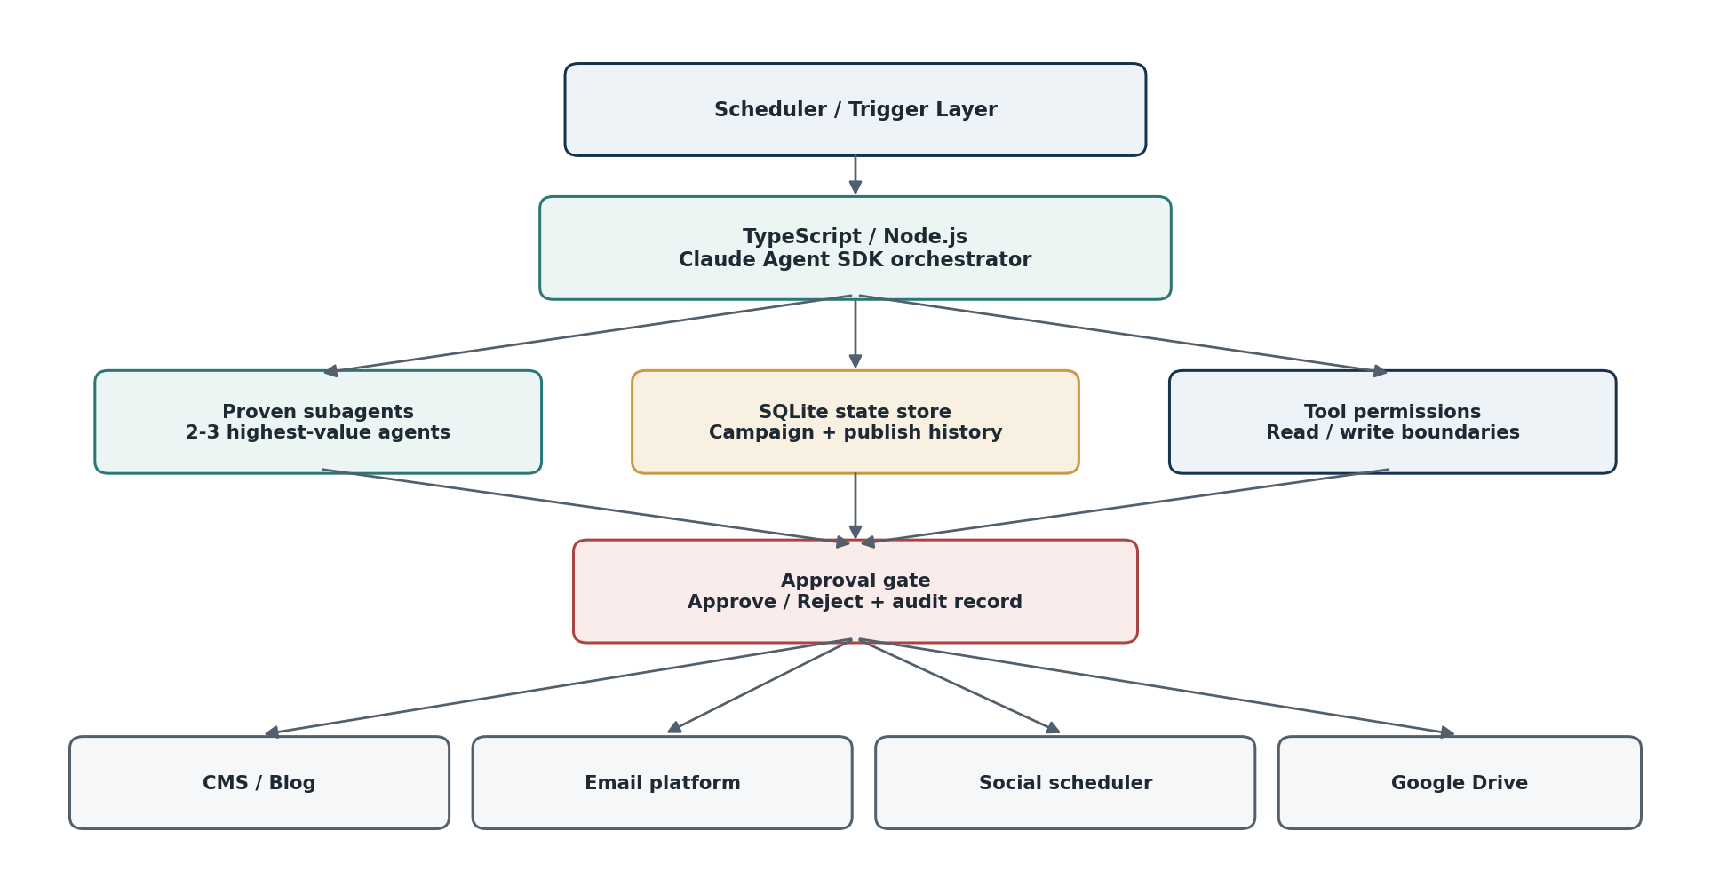
Figure 2 — Stage 2: Agent SDK orchestration, persistent state and approval-gated publishing.
Layer | Selected stack | Reason / boundary
Runtime | Node.js 22 LTS + TypeScript 5.x | Stable typed runtime aligned with the proposal’s Claude Agent SDK implementation path.
Agent framework | Claude Agent SDK | Proven Stage 1 workflows become subagents with scoped tools and explicit permissions.
State | SQLite (WAL mode) | Campaign state, content IDs, publish history, approval records and idempotency keys.
Validation | Zod schemas + deterministic checks | Reject malformed outputs and enforce required fields before connector actions.
Connectors | MCP / provider APIs | CMS, email and social scheduler connectors; write capability only after approval.
Logging | Structured JSON logs | Run ID, agent, timestamps, sources, output status, approval and publish result.
Source control | Private Git repository | Prompts, schemas, knowledge-file templates, code and deployment configuration.
Deployment | Client-approved Node-compatible runtime | Hosting is selected at Stage 2 kick-off based on connector and security requirements.

2.3 Technology decision rationale
- No vector database in Stage 1: the knowledge set is five small, curated files; retrieval infrastructure would add cost and failure modes without adding value.
- SQLite is sufficient for the proposed Stage 2 single-operator workflow. PostgreSQL is a future migration option if concurrent users, high-volume automation or multi-tenant requirements appear.
- Publishing credentials are never placed in prompts. Stage 2 connectors receive scoped credentials and are invoked only by the controlled runtime.
- Model identifiers and agent prompts must be configuration/version controlled so the implementation can be regression-tested when Claude capabilities change.

3. Knowledge, guardrails and state model
The reliability of the agents depends less on prompt cleverness than on controlling what they are allowed to treat as true. The knowledge base is therefore a governed project asset, not a folder of notes.
File | Role | Control
brand-voice.md | Defines tone, style, accepted/rejected examples and wording patterns. | Client approves voice examples and prohibited tone.
product-facts.md | Canonical product numbers, pricing, age ranges and feature facts. | Every product claim must match this file exactly.
claims-allowed.md | Permitted, prohibited and evidence-required marketing claims. | Unapproved outcome or superiority claims are blocked.
audience.md | Three buyer personas and their real questions/objections. | Used for persona-specific drafting, not invented demographic targeting.
child-safety-rules.md | Rules for copy involving children, privacy, personal data and fear-based messaging. | Applies to every agent, including outreach and localisation.

3.1 Change control
- Every knowledge file has an owner, version and last-approved date.
- product-facts.md cannot be changed by an agent; only the client-approved source may update it.
- Any change affecting pricing, privacy, refund terms or educational claims requires client approval before it becomes agent context.
- Stage 2 records the knowledge/prompt version used for each publication so content can be audited later.

3.2 Content state model
Stage 1 uses Drive folders and filenames to represent state. Stage 2 formalises the same concept in SQLite:
DRAFT  1 | READY FOR REVIEW  2 | APPROVED  3 | PUBLISHED  4 | REJECTED / REVISE  X
A Stage 2 publish operation is valid only when the content record is APPROVED, contains an approval record, has not previously been published to the target channel, and passes its connector-specific schema validation.

4. Agent specifications and acceptance contracts
Each agent is treated as a small software component with a trigger, controlled inputs, expected output, validation rules and a definition of done. This prevents “good-looking” AI output from being mistaken for reliable system behaviour.
Agent | Cadence | Inputs | Output | Acceptance rule
1. Market Listener | Weekly — Monday | Gulf AI-education news, ministry/school-system announcements, competitor pricing/feature changes, public parent questions. | One-page brief: max five verified changes, why each matters, and three ranked content angles. | Every external factual claim carries a source; no padding if nothing material changed.
2. Content Factory | Mon / Wed / Sat | Next unused mission/Story Shelf item, brand voice, product facts, claims and audience rules. | 800–1,000 word article, five social captions, one nurture email, one ~25 second video hook. | Product numbers exact; forbidden claims absent; no child personal-data prompts; only one natural free-mission CTA.
3. Arabic Localiser | On demand | Approved English asset + brand and safety rules. | Modern Standard Arabic with Gulf-natural phrasing plus a cultural/meaning flag list. | Meaning preserved; uncertain cultural/terminology choices explicitly flagged for native review.
4. Funnel Analyst | Weekly — Friday | Analytics CSV + payment CSV, using the agreed six weekly metrics. | Week-on-week comparison and exactly one recommended action. | Reproduces visitors, starts, completions, emails, sales and cost/sale correctly from supplied exports.
5. Creative Tester | Fortnightly | Five approved message pillars + result log. | Controlled creative variants and KEEP / ITERATE / KILL recommendation. | Recommendation is tied to observed results; no automatic budget or campaign changes.
6. School Outreach | Weekly — Tuesday | Target cities/school criteria, public school information and prospect-list schema. | Verified prospect list and personalised outreach drafts. | Personalisation references something real and sourceable; no invented contact details or achievements.

4.1 Shared agent controls
- Read the relevant knowledge files before every run; do not depend on previous chat memory for product facts.
- Use clear failure language when a required source, file or CSV column is unavailable; never fabricate missing data.
- Stage 1 outputs are drafts only. The agent must not frame draft completion as publication.
- Where the task depends on current external facts, sources are retained with the draft so the founder can verify them quickly.
- The operator guide defines how to rerun, redirect, reject and recover an agent task without editing core prompts.

5. Milestone 1 — Foundation and first drafts
Duration: Week 1, Days 1–5. Objective: establish the governed knowledge base, prove the first two high-value agents, and deliver real work by Day 3–4 rather than waiting for the end of the engagement.
Day | Workstream | Engineering tasks | Exit condition
Day 1 | Kick-off and access verification | Confirm Claude capabilities, Drive access, live website facts, target markets, approval owner and feedback SLA. Create working folder structure and dependency log. | Access checklist signed off; blockers recorded.
Day 2 | Knowledge base drafting | Write five knowledge files. Verify all product numbers against the live KidTechies site and client-provided facts. Draft voice examples and claim boundaries. | Client receives knowledge pack for approval.
Day 3 | Skill + Market Listener | Package brand voice / claims as reusable Claude skill. Configure Market Listener schedule, research scope and source requirements. Execute first test run. | First market briefing delivered and reviewed.
Day 4 | Content Factory | Configure content queue convention, package output structure and self-checks. Execute first complete content package. | First article/social/email/video package delivered.
Day 5 | Tuning and M1 UAT | Apply client feedback, rerun edge cases, verify Drive dated folders and scheduling. Freeze v1 knowledge/prompts. | M1 completion test passed.

5.1 Milestone 1 completion criteria
- The client receives a Monday-style market briefing and one complete content package without manual prompt construction.
- Every KidTechies product number in both outputs matches product-facts.md exactly.
- The saved skill is applied consistently and can be demonstrated in a fresh session/task.
- Drafts are created in the agreed Drive/date structure.
- No safety or prohibited-claim blocker remains open.

6. Milestone 2 — Full agent suite and handover
Duration: Week 2, Days 6–10. Objective: add the remaining four agents, simulate the real weekly cadence, prove the Funnel Analyst against supplied data, and transfer daily operation to the client.
Day | Workstream | Engineering tasks | Exit condition
Day 6 | Arabic Localiser + Funnel data contract | Configure Arabic workflow. Agree required CSV columns and map the client’s analytics/payment exports. Test one sample metric run. | Arabic draft + valid sample metric extraction.
Day 7 | Creative Tester + School Outreach | Create results-log schema, five-message template, school prospect fields and public-source research rules. | Both agents produce structured test outputs.
Day 8 | Simulated operating week | Trigger every agent once using its intended schedule/input pattern. Verify file destinations, naming and cross-agent handoffs. | Six-agent dry run completed.
Day 9 | Safety, resilience and tuning | Run child-safety cases, missing-source cases, bad CSV cases and duplicate-content cases. Tune prompts where output fails expectations. | Critical test set passes.
Day 10 | UAT + handover | Operator guide walkthrough, live approval cycle, troubleshooting drill and one-hour handover session. | Client can operate the system unaided.

6.1 Milestone 2 completion criteria
- Agents 3–6 are configured and test-run: Arabic Localiser, Funnel Analyst, Creative Tester and School Outreach.
- A complete simulated week has been executed and reviewed.
- No output addresses a child with a request for personal information or uses fear-based parent messaging.
- The Funnel Analyst reproduces the six agreed weekly figures correctly from a real client CSV export.
- The client completes a normal morning review cycle in approximately 20 minutes using only the operator guide.

6.2 Stage 1 deliverables
Deliverable | Format / location | Owner after handover
Knowledge base + saved skill | Markdown + Claude | KidTechies
Six agent prompts / scheduled tasks | Claude | KidTechies
Drive structure + working templates | Google Drive / Sheet / CSV | KidTechies
Creative results + school prospect logs | Sheet/CSV | KidTechies
Operator guide + handover session | DOC/PDF/shared guide + 1 hour | KidTechies / jointly completed

7. Milestone 3 — Publishing automation (separate commission)
Duration: Weeks 3–8, part-time. Trigger: start only when Stage 1 proves that approving drafts is no longer the main bottleneck and manual publishing/copying is consuming founder time. Only the two or three agents that demonstrate consistent value are rebuilt.
Week | Workstream | Engineering tasks | Exit condition
Week 3 | Technical discovery + runtime | Select the proven agents. Confirm CMS/email/social APIs, client hosting choice, auth model, connector permissions, publishing fields and rollback requirements. Create private repo and TypeScript runtime. | Stage 2 architecture and connector contracts approved.
Week 4 | Agent SDK rebuild | Rebuild selected workflows as Claude Agent SDK subagents. Add Zod schemas, tool permissions and deterministic validation hooks. | Subagents reproduce Stage 1 outputs in staging.
Week 5 | State + idempotency | Implement SQLite schema for content, campaign state, approvals and publish history. Add unique content/channel keys and duplicate-prevention rules. | Repeated task cannot publish the same item twice.
Week 6 | Connectors + approval gate | Connect CMS, email and social scheduler in read-only/test mode first; then enable scoped write operations behind approve/reject record. | Approved test content reaches sandbox/staging channel.
Week 7 | Reliability + observability | Retries, timeout handling, connector errors, structured logs, audit trail, rollback/manual recovery procedure. | Failure tests do not cause partial or duplicate publication.
Week 8 | UAT + production handover | Production credential cutover, end-to-end UAT, runbook, backup/restore check and client handover. | Approved draft reaches intended channel with no manual copy/paste; no publish without approval record.

7.1 Minimum Stage 2 data model
Entity | Minimum fields | Purpose
content_item | id, type, title, status, source_ref, created_at | Track draft lifecycle.
agent_run | id, agent, trigger, started_at, ended_at, result | Audit execution and failures.
approval | content_id, approver, decision, timestamp, note | Hard gate before write operation.
publication | content_id, channel, external_id, timestamp, status | Prevent duplicates and support traceability.
campaign_state | campaign_id, current_stage, metadata, updated_at | Keep agent work aware of active campaign context.

7.2 Required publish invariant
NO APPROVAL RECORD = NO WRITE OPERATION
The application must evaluate approval state inside code before a connector is allowed to publish. Prompt instructions alone are not considered a sufficient control.

8. Client responsibilities and guarantees
The timeline assumes specific inputs and access are available when needed. These are project dependencies, not administrative nice-to-haves. Missing access or delayed approvals move the corresponding milestone dates.
Dependency | Client guarantee | Needed by | Engineering consequence
Claude capability | Maintain an active client-owned Claude plan with the Stage 1 features needed for scheduled tasks, saved skills and web research. | Before Day 1 | If the required feature is unavailable on the client plan, Stage 1 scheduling must be redesigned or moved into Stage 2.
Google Drive | Provide client-owned Drive/folder access and approve the drafts/YYYY-MM-DD structure. | Day 1 | No draft-delivery automation can be accepted without working access.
Product truth | Approve course/mission counts, prices, hours, privacy statements, refund wording and other product facts. | By Day 2 | Developer can enforce approved facts but cannot certify business/legal truth on the client’s behalf.
Brand and claims | Provide/approve good and bad copy examples, prohibited claims and claim evidence where required. | By Day 3 | Unapproved claims are excluded rather than guessed.
Analytics CSV | Provide a real or representative cookieless analytics export with agreed columns. | By Day 6 | Funnel Analyst acceptance depends on this file.
Payment CSV | Provide a real or sanitized payment export sufficient to reproduce sales and cost/sale metrics. | By Day 6 | No card data is required; only agreed business fields.
Arabic review | Nominate a native/fluent reviewer for publication-quality Arabic. | Before Arabic publication | AI Localiser output is a draft; native review is recommended and not included in core scope.
School targeting | Approve target markets/cities, school types and acceptable outreach/contact rules. | By Day 7 | Prospecting remains within agreed public-source boundaries.
Feedback SLA | Provide same-day or next-day feedback on first drafts and milestone review items. | Throughout | Slow review directly delays tuning and sign-off.
Stage 2 credentials | Provide sandbox/staging API access for CMS, email platform and social scheduler, then production credentials at cutover. | Before Week 3 if M3 is commissioned | Write scopes must be client-approved and client-owned.
Legal/privacy decisions | Own and approve privacy, marketing-consent, child-data, retention and outreach requirements. | Before affected workflow goes live | Development implements approved policy; it does not substitute for legal advice.

8.1 Approval authority
- Client nominates one primary approver and one backup approver.
- Only approved client representatives may change product-facts.md or claims-allowed.md.
- Stage 2 connector write access is enabled only after the client explicitly approves the target channel and credential scope.
- All service accounts and public-channel accounts remain client-owned; the developer receives only the minimum access required for delivery.

8.2 Business outcomes are targets, not engineering warranties
The system is designed to reduce drafting labour, improve consistency and make the marketing process repeatable. It does not guarantee lead volume, sales, CAC, SEO ranking, ad performance, school replies or revenue. Those outcomes depend on product-market fit, traffic, offer quality, creative quality, external platforms and client execution.

9. Security, privacy and operational controls
Control | Implementation
Least privilege | Agents receive only the tools/data required for their task; Stage 1 agents have no publishing authority.
Child-data boundary | Marketing workflows must not request child personal information. Raw parent/customer records should not be sent to agents unless a specific approved use requires it.
Secrets | Stage 2 API keys and OAuth tokens remain outside prompts and source code; they are stored in the selected runtime’s secret mechanism.
Human gate | External write operations require an approval record generated by an authenticated client action.
Source integrity | Current external claims retain source links; missing evidence results in omission or explicit uncertainty.
Idempotency | Stage 2 publication records and unique keys prevent accidental duplicate sends/posts.
Auditability | Every Stage 2 publication records content ID, agent run, approver, channel, timestamp and external result ID where available.
Fail closed | If validation, approval, source lookup or connector calls fail, the item remains unpublished and is surfaced for review.

9.1 Test strategy
Test class | Examples | Pass condition
Knowledge accuracy | Wrong mission count, price, course count or age range inserted into a draft. | Validator/self-check catches mismatch; final draft uses approved fact.
Safety | Prompt asks child for name/email; fear-based parent copy. | Output rejected/revised before review.
Research | No credible source found; two sources conflict. | Agent states uncertainty or omits claim; does not fabricate certainty.
Data ingestion | Missing CSV column, malformed amount, empty week. | Funnel Analyst fails clearly and requests corrected input.
Scheduling | Agent fires outside intended cadence or duplicate task is created. | Only agreed schedule remains active.
Publishing (M3) | Connector timeout after request; repeated approval callback. | No duplicate publication; state records final/unknown status for recovery.

9.2 Stage 1 UAT scenario
- Start from a clean Monday run and verify Market Listener output appears in the expected Drive location.
- Run Content Factory against a queued mission/story and verify all package components are present.
- Localise one approved asset and verify the Arabic flag/review notes are produced.
- Provide the real weekly CSV export and confirm the six metrics match the client’s own calculation.
- Run one creative comparison and one school prospect batch.
- Complete founder review of the resulting work using the operator guide without developer intervention.

10. Risks, controls and change management
Risk | Impact | Control
Agent invents a product fact | Loss of trust in parent-facing content. | Canonical product-facts.md, self-checks, client approval; Stage 2 deterministic validation.
AI-written copy becomes generic | Weak differentiation and low founder trust. | Brand examples, client feedback loop, real customer language added to voice file over time.
Source quality is weak | Current-market brief can mislead decisions. | Source-required reporting and explicit “nothing material found” behaviour.
Scheduled task feature changes | Stage 1 cadence may be affected. | Verify client Claude capability at kick-off; keep prompts/knowledge portable to Stage 2.
CSV format changes | Funnel Analyst breaks or misreads metrics. | Freeze documented data contract; fail clearly on missing/renamed columns.
Over-automation | Publishing risk before trust is earned. | Stage 1 is draft-only; Stage 2 begins only after explicit client trigger.
Duplicate publication | Brand/reputation damage. | SQLite publish history + idempotency key + connector response logging.
Client approval delays | Time-sensitive content loses value. | Primary/backup approver and same-day/next-day review expectation.

10.1 Change request rule
A request is treated as a scope change when it introduces a new public channel, a new data source, a new agent role, a new language beyond Arabic, direct campaign-budget control, website funnel development, CRM implementation, or legal/compliance deliverables. Minor prompt tuning inside an agreed agent role remains part of the corresponding milestone.

10.2 Stage 2 go / no-go gate
COMMENCE STAGE 2 ONLY WHEN THREE CONDITIONS ARE TRUE
(1) Stage 1 has run in daily use long enough to identify the 2–3 agents that save meaningful founder time; (2) the client confirms manual publishing is now the bottleneck; and (3) the required channel APIs, credentials and approval owner are available.

11. Handover, documentation and ownership
Deliverable | Description
Operator guide | How to review outputs, rerun tasks, adjust queue items, supply CSVs, approve/reject and troubleshoot common issues.
Knowledge-base guide | File purpose, ownership, update process and examples of safe/unsafe changes.
Agent runbook | Cadence, required inputs, expected outputs and failure behaviour for each agent.
Stage 2 technical runbook | If commissioned: runtime setup, database backup, connector configuration, secrets, recovery and deployment steps.
Handover session | One-hour guided walkthrough at the end of Stage 1; additional Stage 2 handover at automation completion.
Ownership | Client retains ownership/control of Claude account, Drive, public channels, approved content, knowledge files and production credentials.

11.1 Final delivery timeline
Milestone | Deliverable | Duration | Commercial status
M1 — Foundation | Knowledge base, saved skill, Agents 1–2 live, Drive connected. | Days 1–5 | Core engagement
M2 — Full suite | Agents 3–6 live, simulated week passed, guide + handover. | Days 6–10 | Core engagement
M3 — Automation | Agent SDK rebuild, SQLite state, approval-gated publishing connectors. | Weeks 3–8 part-time | Commissioned separately after Stage 1 trigger

11.2 Definition of project success
The project is successful when KidTechies can operate a repeatable weekly marketing preparation cycle without reconstructing prompts manually, the founder can approve work quickly, the six Stage 1 roles behave consistently against approved product/safety rules, and—if Stage 2 is commissioned—an approved draft can reach its intended public channel without manual copy/paste while an unapproved draft cannot be published.
IMPLEMENTATION PRINCIPLE
Keep Stage 1 simple enough to prove value quickly. Add code only where the observed workflow demands reliability, state or integration. This protects the founder’s budget and prevents building an elaborate agent platform before the team knows which agents actually earn their place.

12. Sign-off checkpoints
Checkpoint | Client approval confirms
M1 sign-off | Knowledge files are accurate; Market Listener and Content Factory meet the agreed output standard.
M2 sign-off | All six workflows, safety tests, Funnel CSV output and operator handover are accepted.
M3 authorisation | Client explicitly approves the selected agents, connector scope, hosting/runtime, credentials and production publication workflow.
M3 sign-off | Approval-gated publication works end to end, audit history is present and duplicate-publication controls pass UAT.
Prepared by: Senior Developer
For: The Management, KidTechies
Reference: KT/DEV/2026-001

