Using Faults it is now possible to calculate a streak along a reciprocal direction parallel to L axis. Instrumental broadening can be added optionally using pseudo-void approximation.

The other possibility is to fit experimental diffuse scattering data written in a free format. One can put several .dat files to treat them simultaneously. All along L direction.

Part of control file (test.flts):

EXPERIMENTAL

EXPSTREAK 4 1.00 11.0

!fileName h k

faults10_1_0_unbr.dat 1 0

faults10_1_1_unbr.dat 1 1

faults10_1_2_unbr.dat 1 2

faults10_2_1_unbr.dat 2 1

Fformat FREE

Here is an example of fitting 4 streaks simultaneously for Ni2MnGa modulated crystal.

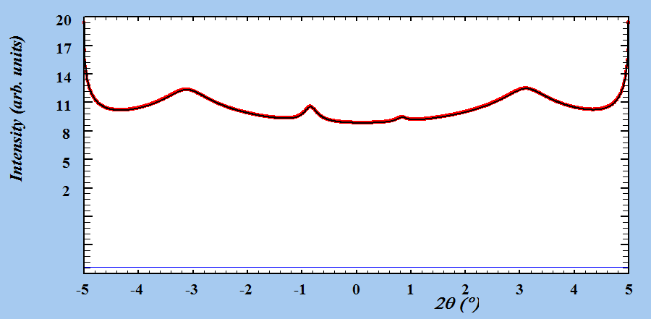

Fig 1. File test_1_0.prf

Description of files in folder:

*.dat – calculated data files using faults10_streak.flts with 10 percent of stacking faults

*_h_k.prf – fitted data using program Faults

Test.flts – control file for starting a fitting using .dat files, rewritten from file 5m_ideal_streak.flts

Test_new.flts – file created by program with new probabilities (fitted parameters)

5m_ideal_streak.flts – file, describing an ideal 5m structure (without stacking faults)