**Flat-cone geometry in D10 (J. Rodríguez-Carvajal)**

The banana detector of radius R is supposed to be fixed to the arm along the **x**L axis and has the possibility to be rotated by an angle *µ* around **x**D=**x**L. We defined a detector frame having the same orientation as the laboratory system when *µ*=0. Notice that for D10 we use a Busing-Levy L-system with the **z**L-axis pointing downwards. For a general position of the detector the relation between the L and D systems is given by the matrix providing the components of a vector in the D system when their components in L are known:



A diffracted beam impinging the detector is shown in the following figure. We can deduce the relations between the angles (*µ*, *α*) of the detector and the angles (*γ*, *ν*) of the diffracted beam from the geometry shown in the figure.

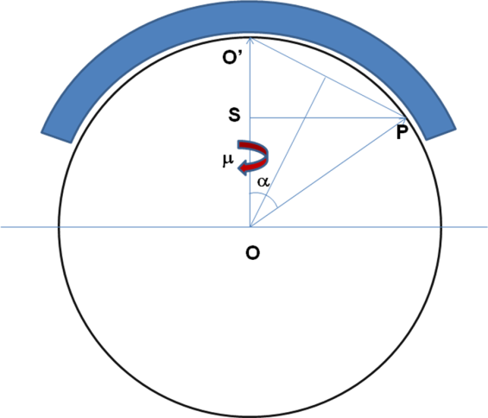

From the figure on the left side one can see that:

OO’=OP=R, OS = R cos*α*, SP = R sin*α*.

So, in the detector system the vector **OP** is **OP** = (Rcos*α*, R sin*α*, 0), when the detector is rotated an angle *µ* the vector moves as shown on the right figure, so **OP** becomes **OP**m. We have the relations: **OP**m = **M** **OP**, and, on the other hand the vector **OP**m has the following components with respect to the L-system **OP**m= R (cos*ν* sin*γ*,cos*ν* cos*γ*, sin*ν* ), so we have the following relation



In which we have dropped the common factor R. Doing that we have the relations between the unitary vectors of the diffracted beam in both the L and D system





The relations between the angles (*µ*, *α*) of the detector and the angles (*γ*, *ν*) of the diffracted beam can be deduced from the equations above, so that:



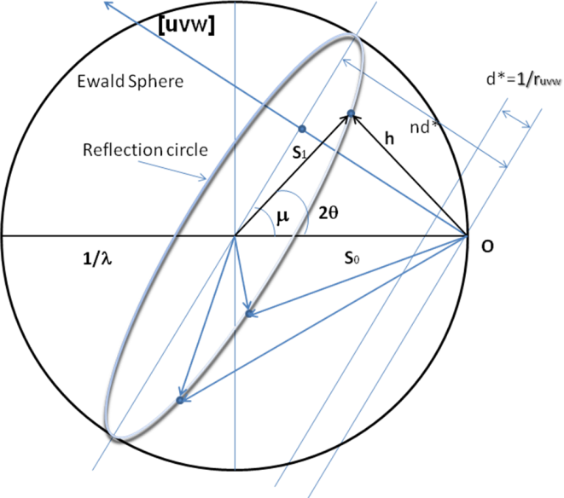The flat cone geometry allows the measurement of a reciprocal plane by rotating the crystal around a direct zone axis. A direct zone axis **r***uvw*=[*uvw*] has a series of perpendicular reciprocal planes with inter-planar spacing *d*\*=1/| **r***uvw* |. The plane passing through the origin of the reciprocal space is called the zero-level plane (*n*=0), the parallel plane situated at the distance *nd*\* from this plane is called the *n*-level plane. By orienting the crystal in such a way as making the *n*-level plane pass through the centre of the Ewald sphere the reflection circle is a maximum circle making an angle *μ* with the incident beam.

The orientation angle is related to the inter-planar spacing and the wavelength by the relation:



This angle can be calculated knowing the cell parameters the desired level (*n*) and the wavelength of the radiation. Rotating the detector by the same angle with respect to the **x**L axis one can record the reflections lying in this plane by rotating the crystal around the zone axis [*uvw*]. In order to record this reciprocal plane in the detector, the direct vector **r***uvw* should be oriented perpendicularly to the detector plane. Let us call the unitary vector along [*uvw*], **n***uvw*. This unitary vector should adopt the form **n**D=(0,0,1) at the desired orientation in the detector system. There is an infinite number of ways of choosing **, ** and ** so as to reach the desired orientation, knowing the **UB** matrix; the Cartesian components of **r***uvw* with respect to the laboratory system when all angles are zero (**-system) can be obtained by the expression:



Where  is the metric tensor () transforming a vector with components referred to the direct lattice to the same vector with components referred to the reciprocal lattice. The four-circle matrix **R** = **Ω** **Χ** **Φ** (active rotations), allows to orient the vector **r**1=**r***L*/| **r***L* | to the desired position



Starting with the relation:

that gives the coordinates of the zone axis [*uvw*] in reciprocal space and with components in the Cartesian L-system when all angles of the orienting device are zero; we can calculate one of the orientation matrices that put the vector **r**L in the direction of the vector normal to the flat-cone detector plane which is, in our case and with respect to the L-system, given by:



For that we use the cross product of **r**1=**r**L/| **r**L |=(*a*, *b*, *c*) (unitary vector along [*uvw*] in L-system) by **d***L*. The result gives the axis of rotation needed to construct the rotation matrix. The angle between the two vectors can be obtained from the dot product.



The general expression of a rotation of angle *ψ* around the axis **n** in the L-system is provided by the Gibbs matrix in terms of the angle *ψ* and the director cosines of **n**=(*nx*, *ny*, *nz*):



In our case the matrix rotating the vector **r**1 (parallel to [*uvw*]) towards the normal to the detector plane, **d***L*, is given by **G**(*δ*, **n**), using the above expressions. This is just a particular rotation; there are an infinite number of rotations that place the vector **r**1 along the vector **d***L*. A rotation matrix given by **R**= **G**(*ψ*, **d***L*) **G**(*δ*, **n**) applied to **r**1, with an arbitrary angle *ψ*, is also a solution. From the total rotation matrix, by varying *ψ*, we can get the Euler (**, **, **) angles that rotates the crystal around **d***L* having first put the zone axis along this vector. The angles (**, **, **) inside the available limits give the region of the reciprocal space that can be measured.

The calculations of the Euler (**, **, **) to make an equivalent rotation matrix **R**(**, **, **) can be done by writing the equality:



We can calculate the angles **, ** and ** by the expressions:



**Calculation of the reciprocal points measured in the detector**

The banana detector in D10 is asymmetric: the angular range has 30 degrees on the high angle side and 90 degrees on the low angle side with respect to the rotation *μ*-axis. Seen from the top the image of the detector appears as in the figure. If we call *α* (*i*) the *α*-angle corresponding to wire number *i* and we have *Nw* wires, we start numbering from 1 (lowest *γ*-angle) to *Nw* (highest *γ*-angle). In the case of D10 we have *α* (1) = 90° and *α* (*Nw*) = *α* (128) = -30°. The total angular range spanned by the banana detector is Δ=*α* (1)–*α*(*Nw*) = 120°.

Once the angle *μ* has been set, the diffracted beam vectors corresponding to the different wires of the detector are fixed and obtained easily from (*α*,*μ*). The (*γ*,*ν*) angles are obtained using the equations:



The *α*-angle is always in the interval [-30°, 90°] for D10. The scattering vectors for each pixel are obtained in the L-system from the (*γ*, *ν*) angles and the wavelength as:



The reciprocal lattice coordinates of the scattering vectors are obtained from the setting angles (**, **, **) and the UB-matrix as:

