

**PROPOSAL TO CONDUCT A STAKEHOLDER SATISFACTION SURVEY**

BID: DSBD/BBSDP-CIS 001/2016/2017

**PREPARED F0R**

PREPARED BY

***INSEDLU BUSINESS COMPANION CC***

17-16TH STREET

ORANGE GROVE

JOHANNESBURG

2192

TEL: 011 640 5899 / 6299

FAX: 086583 5215

EMAIL: [admin@insedlu.com](mailto:admin@insedlu.com)

CC:mthan@insedlu.com

***SUBMITTED ON***

***ORIGINAL***

Table of Contents

1. EXECUTIVE SUMMARY 4

2 COMPANY BACKGROUND 6

Table 1: Major Corporate Clients 6

**2.1** **Mission Statement** 7

**2.2** **Insedlu Business Companion Service Offering:** 7

❑ Business Research 7

❑ Enterprise Development 7

**2.3** **HEAD OFFICE** 7

3 PROJECT TEAM 12

4 RELEVANT PROJECT REFERENCES 14

5 PROJECT MASTER SCHEDULE AND COST PLAN 17

6 WHY CHOOSE INSEDLU BUSINESS COMPANION 19

7 BLACK ECONOMIC EMPOWERMENT 19

8 PROJECT RISK ANALYSIS 20

9 INSEDLU RESOURCE CAPABILITIES 20

10 CONCLUSION 21

STATEMENT OF CONFIDENTIALITY & NON-DISCLOSURE

«CONFIDENTIALITY»

# EXECUTIVE SUMMARY

«EXECUTIVESUMMARY»

# COMPANY BACKGROUND

«COMPANYBACKGROUND»

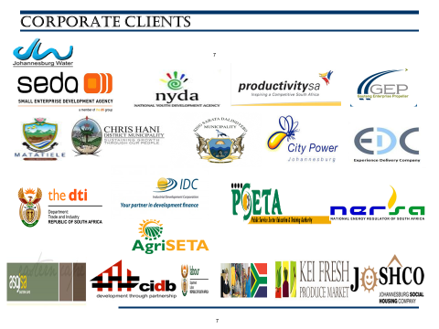

# Table 1: Major Corporate Clients

## **Mission Statement**

“To create a new wave of innovative entrepreneurial development by constantly improving on business development offerings that meet international best practice; to this end Insedlu works hand in glove with major development agencies, financial institutions and educational institutions in designing friendly, affordable and high quality services.”

## **Insedlu Business Companion Service Offering:**

* Business Research
* Enterprise Development
* Business Turnaround

## **HEAD OFFICE**

Orange Grove

Johannesburg

2192

TEL: 011 6405899 / 6299 FAX: 086 583 5215

CEL: 0826766262

EMAIL: [admin@insedlu.com](mailto:admin@insedlu.com) CC: mthan@insedlu.com

**PURPOSE/AIM OF THE PROJECT**

«PURPOSE»

**RELEVANT PROJECT REFERENCES**

* 1. **DELIVERABLES**

«DELIVERABLES»

# PROJECT COST PLAN AND TIMELINE

**PROJECT TEAM AND RESEARCH TEAM MEMBERS**

# WHY CHOOSE INSEDLU BUSINESS COMPANION

«WHYCHOOSE»

«WHYCHOOSEBULLET»

# BLACK ECONOMIC EMPOWERMENT

«BBBEE»

# PROJECT RISK ANALYSIS

«PROJECTRISK»

# INSEDLU RESOURCE CAPABILITIES

|  |  |  |  |
| --- | --- | --- | --- |
| **Resource** | **Quantity** | **Owned** | **Hired** |
| Full-time staff | 8 | n/a | n/a |
| Associates | 10 | n/a | n/a |
| Office with 2 training rooms | 1 | Yes |  |
| Service vehicles | 4 | Yes |  |
| Computers and laptops | 10 | Yes |  |
| Overhead projectors (Proxima) | 2 | Yes |  |

# CONCLUSION

INSEDLU BUSINESS COMPANION CC is confident that our proposal conduct a stakeholder perception survey to assess the current levels of satisfaction with ICASA service and also with the Brand. We sincerely hope that you will consider us as the preferred service provider and allow us to enter into a mutually beneficial relationship. We are available to answer any questions you may have and look forward to discussing this opportunity further.

After reviewing this document, the following steps should be performed in order to come to a final agreement

- Calling us for a face to face interview

- Counter proposal or approval by ICASA

- Negotiation of fees, terms, clauses and conditions

We declare this offer to be binding and free of errors or omissions. Due diligence has been performed in order to ensure compliance with your requirements and particular situation. We agree to hold our proposal open for acceptance until

Thank you for your interest.

Sincerely,

Dr Mtha Ncube

**Chief Executive**