Team 20 Interim Report

Appendix
(CTRL + Click to follow link)

1.0 Project Background & Understanding

1.1 Project Brief

1.2 Additional Interpretations/Innovations

1.3 Contextual Understanding

2.0 Requirements & Critical Analysis

3.0 Initial software implementation & Testing

4.0 Project Management and Progress

4.1 Project Management Plan

4.2 Documentation of Sprints and Meetings

4.3 Use of Project Management Tools

4.4 Approach to development

5.0 Preliminary Reflection

6.0 Conclusion & Summary

1.0 Project Background & Understanding

Project Brief
Insert summary of project brief understanding, brief specification

Additional Interpretations/Innovations
Insert any additional ideas/creativity e.g. gamification, Recapped for clients,

Contextual Understanding
Spotify Wrapped …

2.0 Requirements & Critical Analysis

Use Case Diagram

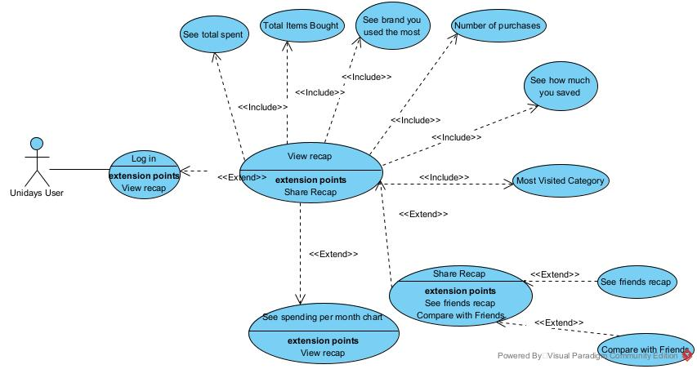

User Stories
1 | As a student user, I want to see my spending per month trend so that I can understand my spending habits over time and identify any patterns.
2 | As a student user, I want to see the total amount I spent throughout the year so that I have a clear picture of my overall expenses.
3 | As a student user, I want to see the total number of items I bought so that I can gauge the volume of my purchases.
4 | As a student user, I want to see the brand I engaged with the most so that I can understand which brands I prefer and spend on frequently.
5 | As a student user, I want to see the total number of purchases I made so that I can track how often I shopped.
6 | As a student user, I want to see how much I saved through discounts so that I know the value of my savings using Unidays.
7 | As a student user, I want to see my most frequently visited category so that I know which types of products or brands I am most interested in.
8 | As a student user, I want to be able to share my recap on social media so that I can showcase my shopping journey to my friends.
9 | As a student user, I want to view my friends' recaps so that I can see what they purchased and potentially discover new brands.
10 | As a student user, I want to compare my recap with my friends' recaps so that I can see how my spending and savings compare to theirs.
11 | As a student user, I want to be able to log into my Unidays with a username and password to make sure that my account is secure and private.

3.0 Initial software implementation & Testing

Front End Implementation

Back End Implementation

4.0 Project Management and Progress

4.1 Project Management Plan
As a team, we aimed to prioritize three main values: collaboration, transparency and adaptability. We believed following a 2-week sprint implementation of Scrum would allow us to effectively achieve frequent deliverables and releases, while adhering closely to our values.
After identifying that each main sprint should be broken down into three key stages: pre-production/planning, implementation, and a reflection period, we came up with the following meeting structure.
- A sprint planning meeting – early on in the first week; to divide up work from the product backlog and divide issues into a way that encourages collaboration
- Standup meetings – at regular intervals during the first and second weeks; to monitor progress and discuss any immediate roadblocks
- A sprint retrospective meeting – at the end of the sprint; to look at our progress in a wider context and share ideas for improving our approach going forward
- A demonstration meeting – at the end of the sprint; to share and celebrate the progress we have made, as well as give UniDays an opportunity to ask any questions and ensure that we are on the same page
This structure is a slightly customized implementation of Scrum, crafted to meet our needs and requirements based on the amount of time we can commit to the group project. For example a daily standup did not make much sense considering we are not working full time. Therefore, we decided to hold two standup meetings at regular intervals in the middle of sprint which more appropriately met our needs

4.2 Documentation of Sprints and Meetings

4.3 Use of Project Management Tools

4.4 Approach to development

5.0 Preliminary Reflection

6.0 Conclusion & Summary

