**Installation Guide for Windows**

**System Requirements**

Operating System: Windows 7 / 8.1 / 10

Processor: 1 gigahertz (GHz) or faster

Memory: 2 GB RAM

Graphics: DirectX 9 graphics device with WDDM 1.0 or higher driver

Storage: 1 GB available hard disk space

**Installing DevilutionX from CDs in Windows**

**Software Requirements**

Diablo and/or Hellfire CDs

**Installing DevilutionX with the Diablo CD**

1. Download the latest release from <https://github.com/diasurgical/devilutionX/releases>

For 32-bit Windows download [**devilutionx-windows-i386.zip**](https://github.com/diasurgical/devilutionX/releases/download/1.4.0/devilutionx-windows-i386.zip)

For 64-bit Windows download [**devilutionx-windows-x86_64.zip**](https://github.com/diasurgical/devilutionX/releases/download/1.4.0/devilutionx-windows-x86_64.zip)

1. Unzip the file in the directory you want to install the game. Here is an example of the zip file extracted to C:\ which leads to the creation of the devilutionx folder:

1. Insert your Diablo CD.
2. Open Windows Explorer (or File Explorer in Windows 10 and above) when prompted to or open it manually from the Start menu. Navigate to the drive where the CD is mounted.

1. Right-click on DIABDAT.MPQ and then left-click on “Copy” from the directory.

1. Now navigate to the devilutionx folder.

1. Right-click on a white area in the folder where there is not an icon and then left-click on “Paste”.

1. The DIABDAT.MPQ file will then be copied into the game directory and installation is now complete.
2. Run the game by double left-clicking on “devilutionx” or “devilutionx.exe” in the devilutionx directory.

**Installing Hellfire from CD**

1. DIABDAT.MPQ must be copied into the devilutionx folder prior to installing Hellfire.
2. Insert your CD.
3. Open Windows Explorer (or File Explorer in Windows 10 and above) when prompted to or open it manually from the Start menu. Navigate to the drive where the CD is mounted.

1. Hold down the Ctrl key and left-click on the following files: hellfire.mpq, hfmonk.mpq, hfmusic.mpq, hfvoice.mpq. Right-click on one of the files and then and then left click on “Copy”.

1. Now navigate to the devilutionx directory. Right-click on a white area in the folder where there is not an icon and then left-click on “Paste”.

1. The Hellfire files will then be copied into the game directory and installation is now complete.
2. Run the game by left-clicking on “devilutionx” or “devilutionx.exe” in the devilutionx directory.

**Installation from GoG Installer for Windows**

**Software Requirements**

GoG installer from <https://www.gog.com/game/diablo>

innoextract from <https://constexpr.org/innoextract/files/innoextract-1.9/innoextract-1.9-windows.zip>

**Installing DevilutionX by extracting game files from the GoG Installer**

1. Download the latest release from <https://github.com/diasurgical/devilutionX/releases>

For 32-bit Windows download [**devilutionx-windows-i386.zip**](https://github.com/diasurgical/devilutionX/releases/download/1.4.0/devilutionx-windows-i386.zip)

For 64-bit Windows download [**devilutionx-windows-x86_64.zip**](https://github.com/diasurgical/devilutionX/releases/download/1.4.0/devilutionx-windows-x86_64.zip)

1. Unzip the file in the directory you want to install the game. Here is an example of the zip file extracted to C:\ which leads to the creation of the devilutionx folder.

1. Download the Diablo/Hellfire setup installer file (setup_diablo_1.09_hellfire_v2_(30038)) from GoG.com using the link above. For this tutorial, the installer will be placed into the Downloads folder on the desktop.
2. Download the innoextract zip file using the link above. Unzip the file into your preferred directory. Here I have extracted it to the Downloads folder on the desktop.

1. Left-click on the innoextract file. Then right-click the file and select “Copy”.

1. Now navigate to the folder containing the GoG installer file. In this case it is in the Downloads folder of the Desktop.

1. Right click on a blank area in the folder and select “Paste” to copy innoextract into the same folder as the GoG installer file.

1. Now click on the Start menu logo in the bottom left or press the Windows key on your keyboard. Type “Command Prompt” and press enter or click on the “Command Prompt” shortcut to open a Command Prompt.

1. In the Command Prompt, navigate to the folder containing the installer by typing in the “cd” command followed by the location of the GoG installer and the innoextract file and pressing enter.

1. Copy the following text: innoextract -I DIABDAT.MPQ -I hellfire.mpq -I hfmonk.mpq -I hfmusic.mpq -I hfvoice.mpq setup_diablo_1.09_hellfire_v2_(30038).exe && move hellfire\h*.mpq .\ && rmdir hellfire
2. Paste the text by right clicking into the Command Prompt. If that doesn’t work, manually type in the text. Text

   Description automatically generated
3. Press enter. This will extract the required game files from the GoG installer.

1. Now navigate to the folder containing the GoG installer and the innoextract file using Windows Explorer (or File Explorer in Windows 10 and above). It will now contain the required game files: DIABDAT.MPQ, hellfire.mpq, hfmonk.mpq, hfmusic.mpq, and hfvoice.mpq.

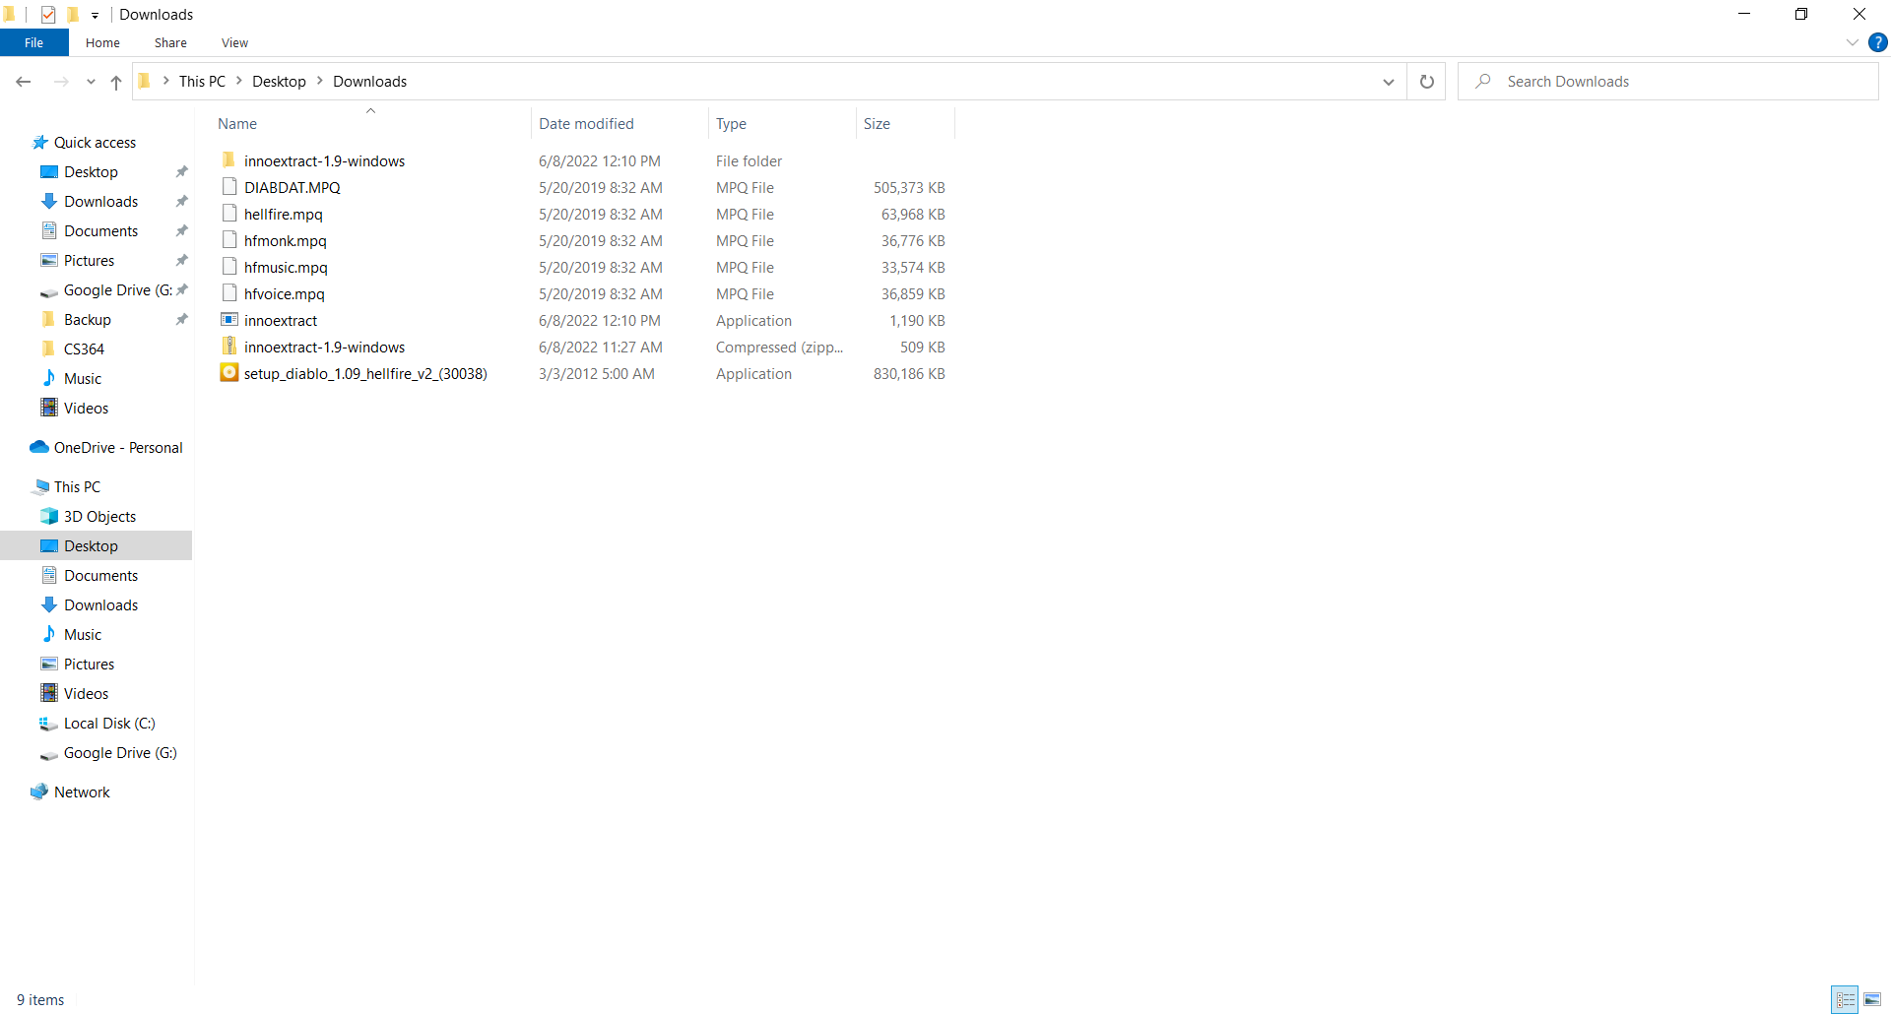

1. Select the required game files by left clicking and highlighting all of them at once.

1. Right-click one of the files and select “Copy”.

1. Now navigate to the devilutionx folder. Right-click into a blank space and select “Paste”.

1. The required files will then be copied into the game directory and installation is now complete.
2. Run the game by double left-clicking on “devilutionx” or “devilutionx.exe” in the devilutionx directory.

**Installation from GoG installation in Windows**

**Installing DevilutionX by copying game files from a GoG installation**

1. Download the latest release from <https://github.com/diasurgical/devilutionX/releases>

For 32-bit Windows download [**devilutionx-windows-i386.zip**](https://github.com/diasurgical/devilutionX/releases/download/1.4.0/devilutionx-windows-i386.zip)

For 64-bit Windows download [**devilutionx-windows-x86_64.zip**](https://github.com/diasurgical/devilutionX/releases/download/1.4.0/devilutionx-windows-x86_64.zip)

1. Unzip the file in the directory you want to install the game. Here is an example of the zip file extracted to C:\ which leads to the creation of the devilutionx folder.

1. Download the Diablo/Hellfire setup installer file (setup_diablo_1.09_hellfire_v2_(30038)) from GoG.com using the link above. For this tutorial, the installer will be placed into the Downloads folder on the desktop.
2. Run setup_diablo_1.09_hellfire_v2_(30038).exe by double-clicking on it. Go through the prompts to install the game.

1. Open Windows Explorer (or File Explorer in Windows 10 and above) and navigate to the default GoG Diablo installation folder which should be C:\GOG Games\Diablo unless you chose to install the game in a different directory.

1. Left-click on DIABDAT.MPQ and then right-click and select “Copy”

1. Now navigate to the devilutionx folder. Right-click into a blank space and select “Paste”.

1. The required files will then be copied into the game directory and installation is now complete.
2. Run the game by double left-clicking on “devilutionx” or “devilutionx.exe” in the devilutionx directory.

**Installing Hellfire from a GoG Installation**

1. DIABDAT.MPQ must be copied into the devilutionx folder prior to installing Hellfire.
2. In Windows Explorer (or File Explorer in Windows 10 and above) navigate to the GoG installation and left click on the hellfire folder.

1. The hellfire folder will now open. Hold down the Ctrl key and left-click on hellfire.mpq, hfmonk.mpq, hfmusic.mpq, and hfvoice.mpq.

1. Right-click on one of the files and select “Copy”.

1. Now navigate to the devilutionx folder. Right-click into a blank space and select “Paste”.

1. The required files will then be copied into the game directory and installation is now complete.
2. Run the game by double left-clicking on “devilutionx” or “devilutionx.exe” in the devilutionx directory.

