# Supplemental Material

Viral inactivation by quaternary ammonium compounds: A systematic review

# Anne Vescovi a, b, Timothy R. Julian a, Elyse Stachler a, *, #

aEawag, Swiss Federal Institute of Aquatic Science and Technology, Ueberlandstrasse 133, CH-8600 Duebendorf, Switzerland

bDepartment of Biological Waste Air Purification, Institute for Sanitary Engineering, Water Quality and Solid Waste Management, University of Stuttgart, Stuttgart, Germany

Running Head: Viral inactivation by quaternary ammonium compounds

# Address correspondence to: Elyse Stachler DermBiont, Inc., Boston, MA 02210, USA (elyse.stachler@gmail.com)

*Present Address: DermBiont, Inc., Boston, MA 02210, USA



## Tables

Table S 1 Backwards elimination multiple Regression model 1, highlighted in **bold** the factors excluded in the next model

|  |  |  |  |  |  |
| --- | --- | --- | --- | --- | --- |
|  | Estimate | Std. Error | t value | P value |  |
| Intercept | -1.13 | 0.44 | -2.58 | 0.01 | * |
| Log 10 (CT factor [mg*min/L]) | 0.56 | 0.06 | 9.70 | < 2e-16 | * |
| Virus size [10 nm] | 0.04 | 0.01 | 5.00 | 6.71E-07 | * |
| Carbon load (relative to without Carbon) | 0.26 | 0.14 | 1.82 | 0.07 |  |
| Temperature [°C] | -0.02 | 0.01 | -2.47 | 0.01 | * |
| Enveloped [relative to non-envelope] | 1.26 | 0.15 | 8.59 | < 2e-16 | * |
| **In Solution (relative to on Surface)** | **-0.09** | **0.16** | **-0.54** | **0.59** |  |
| Measurement in culture (Relative to Molecular) | 0.63 | 0.25 | 2.55 | 0.01 | * |
| *Nucleic Acid (Relative to dsDNA)* |  |  |  |  |  |
| ssRNA(-) | -0.75 | 0.17 | -4.53 | 6.59E-06 | * |
| ssDNA | -0.72 | 0.51 | -1.40 | 0.16 |  |
| ssRNA(+) | -0.32 | 0.15 | -2.07 | 0.04 | * |
| dsRNA | 0.76 | 0.26 | 2.89 | 3.98E-03 | * |
| *QAC Type (Relative to BAC):* |  |  |  |  |  |
| BEC | 0.80 | 0.28 | 2.91 | 3.67E-03 | * |
| DDAB | -0.21 | 0.34 | -0.61 | 0.54 |  |
| DDAC | 0.34 | 0.17 | 2.03 | 0.04 | * |
| MBAT | 0.19 | 0.43 | 0.44 | 0.66 |  |
| others | -0.53 | 0.26 | -2.03 | 0.04 | * |
| QACmix | 0.13 | 0.16 | 0.83 | 0.41 |  |
|  |  |  |  |  |  |
| Adj. R2 | 0.24 |  |  |  |  |
|  |  |  |  |  |  |

Table S 2 Backwards elimination multiple Regression model 2, excluded “In Solution or on Surface”, highlighted in **bold** the factors excluded in the next model.

|  |  |  |  |  |  |
| --- | --- | --- | --- | --- | --- |
|  | Estimate | Std. Error | t value | P value |  |
| Intercept | -1.16 | 0.43 | -2.69 | 7.27E-03 | * |
| Log 10 (CT factor [mg*min/L]) | 0.56 | 0.06 | 9.79 | < 2e-16 | * |
| Virus size [10 nm] | 0.04 | 0.01 | 5.03 | 5.83E-07 | * |
| **Carbon load (relative to without Carbon)** | **0.27** | **0.14** | **1.95** | **0.05** |  |
| Temperature [°C] | -0.02 | 0.01 | -2.50 | 0.01 | * |
| Enveloped [relative to non-envelope] | 1.26 | 0.15 | 8.59 | < 2e-16 | * |
| Measurement in culture (Relative to Molecular) | 0.58 | 0.23 | 2.54 | 0.01 | * |
| *Nucleic Acid (Relative to dsDNA)* |  |  |  |  |  |
| ssRNA(-) | -0.74 | 0.16 | -4.51 | 7.42E-06 | * |
| ssDNA | -0.72 | 0.51 | -1.40 | 0.16 |  |
| ssRNA(+) | -0.31 | 0.15 | -2.05 | 0.04 | * |
| dsRNA | 0.75 | 0.26 | 2.86 | 4.30E-03 | * |
| *QAC Type (Relative to BAC):* |  |  |  |  |  |
| BEC | 0.80 | 0.28 | 2.91 | 3.75E-03 | * |
| DDAB | -0.23 | 0.34 | -0.67 | 0.50 |  |
| DDAC | 0.35 | 0.17 | 2.12 | 0.03 | * |
| MBAT | 0.19 | 0.43 | 0.44 | 0.66 |  |
| others | -0.54 | 0.26 | -2.06 | 0.04 | * |
| QACmix | 0.13 | 0.16 | 0.82 | 0.41 |  |
|  |  |  |  |  |  |
| Adj. R2 | 0.24 |  |  |  |  |
|  |  |  |  |  |  |

Table S 3 Final linear regression model of the subset of enveloped viruses. NA no data for these factors in the subset.

|  |  |  |  |  |  |
| --- | --- | --- | --- | --- | --- |
|  | Estimate | Std. Error | t value | P value |  |
| Intercept | -1.49 | 0.52 | -2.88 | 4.19E-03 | * |
| Log 10 (CT factor [mg*min/L]) | 0.96 | 0.11 | 9.02 | < 2e-16 | * |
| Virus size [10 nm] | 0.03 | 0.01 | 2.12 | 3.49E-02 | * |
| Carbon load (relative to without Carbon) | -0.62 | 0.22 | -2.82 | 5.08E-03 | * |
| Genome size [kilo base] | -0.01 | 0.00 | -1.99 | 4.76E-02 | * |
| Measurement in culture (Relative to Molecular) | 1.20 | 0.53 | 2.28 | 2.32E-02 | * |
| *Nucleic Acid (Relative to dsDNA)* |  |  |  |  |  |
| ssRNA(-) | -1.21 | 0.42 | -2.88 | 4.19E-03 | * |
| ssDNA | NA | NA | NA | NA |  |
| ssRNA(+) | -0.98 | 0.45 | -2.18 | 2.95E-02 | * |
| dsRNA | NA | NA | NA | NA |  |
| *QAC Type (Relative to BAC):* |  |  |  |  |  |
| BEC | 0.76 | 0.41 | 1.86 | 6.35E-02 |  |
| DDAB | 0.16 | 0.37 | 0.42 | 0.67 |  |
| DDAC | 1.09 | 0.21 | 5.31 | 1.67E-07 | * |
| MBAT | 1.42 | 0.95 | 1.49 | 0.14 |  |
| others | -0.27 | 0.33 | -0.83 | 0.41 |  |
| QACmix | 1.21 | 0.30 | 4.04 | 6.29E-05 | * |
| Adjusted R2 | 0.22 |  |  |  |  |

Table S 4 Final linear regression model of the subset of non-enveloped viruses. NA no data for these factors in the subset.

|  |  |  |  |  |  |
| --- | --- | --- | --- | --- | --- |
|  | Estimate | Std. Error | t value | P value |  |
| Intercept | 0.00 | 0.52 | 0.00 | 1.00 |  |
| Log 10 (CT factor [mg*min/L]) | 0.32 | 0.06 | 4.99 | 8.36E-07 | * |
| Virus size [10 nm] | 0.04 | 0.01 | 5.34 | 1.38E-07 | * |
| Carbon load (relative to without Carbon) | -0.04 | 0.01 | -3.64 | 3.01E-04 | * |
| Genome size [kilo base] | 0.60 | 0.17 | 3.58 | 3.81E-04 | * |
| Measurement in culture (Relative to Molecular) | 0.74 | 0.29 | 2.54 | 0.01 | * |
| *Nucleic Acid (Relative to dsDNA)* |  |  |  |  |  |
| ssRNA(-) | NA | NA | NA | NA |  |
| ssDNA | -0.45 | 0.47 | -0.96 | 0.34 |  |
| ssRNA(+) | -0.23 | 0.18 | -1.34 | 0.18 |  |
| dsRNA | 0.55 | 0.28 | 1.97 | 4.99E-02 | * |
| *QAC Type (Relative to BAC):* |  |  |  |  |  |
| BEC | 0.91 | 0.35 | 2.61 | 9.39E-03 | * |
| DDAB | NA | NA | NA | NA |  |
| DDAC | -0.19 | 0.29 | -0.65 | 0.52 |  |
| MBAT | -0.55 | 0.45 | -1.23 | 0.22 |  |
| others | -1.28 | 0.58 | -2.22 | 0.03 | * |
| QACmix | -0.29 | 0.18 | -1.58 | 0.12 |  |
| Adjusted R2 | 0.26 |  |  |  |  |

Table S 5 Overview abbreviation and abundance of QACs in this study

|  |  |  |
| --- | --- | --- |
| Abbreviation | Chemical name | Abundance  [data points] |
| BAC | benzalkonium chloride | 582 |
| BEC | benzethonium chloride | 35 |
| CPC* | cetylpyridinium chloride | 1 |
| CTAB* | cetyltrimethylammonium bromide | 6 |
| DDAB | didecyl dimethyl ammonium bromide | 26 |
| DDAC | didecyl-dimethylammonium chloride | 162 |
| MBAT | mono; bis (tri-methyl ammonium methylene chloride)-alkyl (C9-15) toluene | 14 |
| N-Alk Salt* | dimethylalkonium bromide  [N, N-dimethyl-N-dodecyl-N-octylamonium bromide] | 9 |
| QAC1* | 2-Hexadecanoyloxyethyl)triethylammonium Bromide | 2 |
| QAC2* | 1-(2-Dodecanoyloxyethyl)pyridinium Bromide | 5 |
| QAC3* | Eicosanoyloxyethyl)pyridinium Bromide | 5 |
| QAC4* | 1-(2-Hexadecanoylaminoethyl)pyridinium Chloride | 5 |
| QAC5* | 1-Dodecylcarbamoylmethylpyridinium Chloride | 2 |
| QAC6* | Tributyl-(2-dodecanoyloxyethyl)ammonium Bromide | 5 |
| QACmix | all combinations of different QACs, without any other active ingredients | 151 |

* summarised as “others”, in the regression model

## Figures

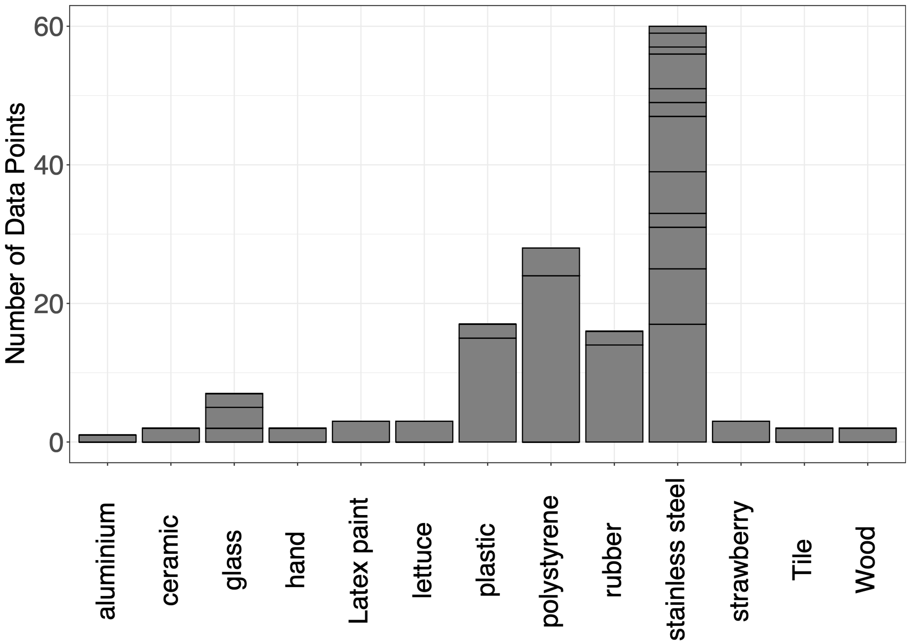

Figure S 1:Distribution of surfaced. y axis: number of unique data points used on different surfaces sorted by the surface material. Squares represent studies; square length represents number of data points.

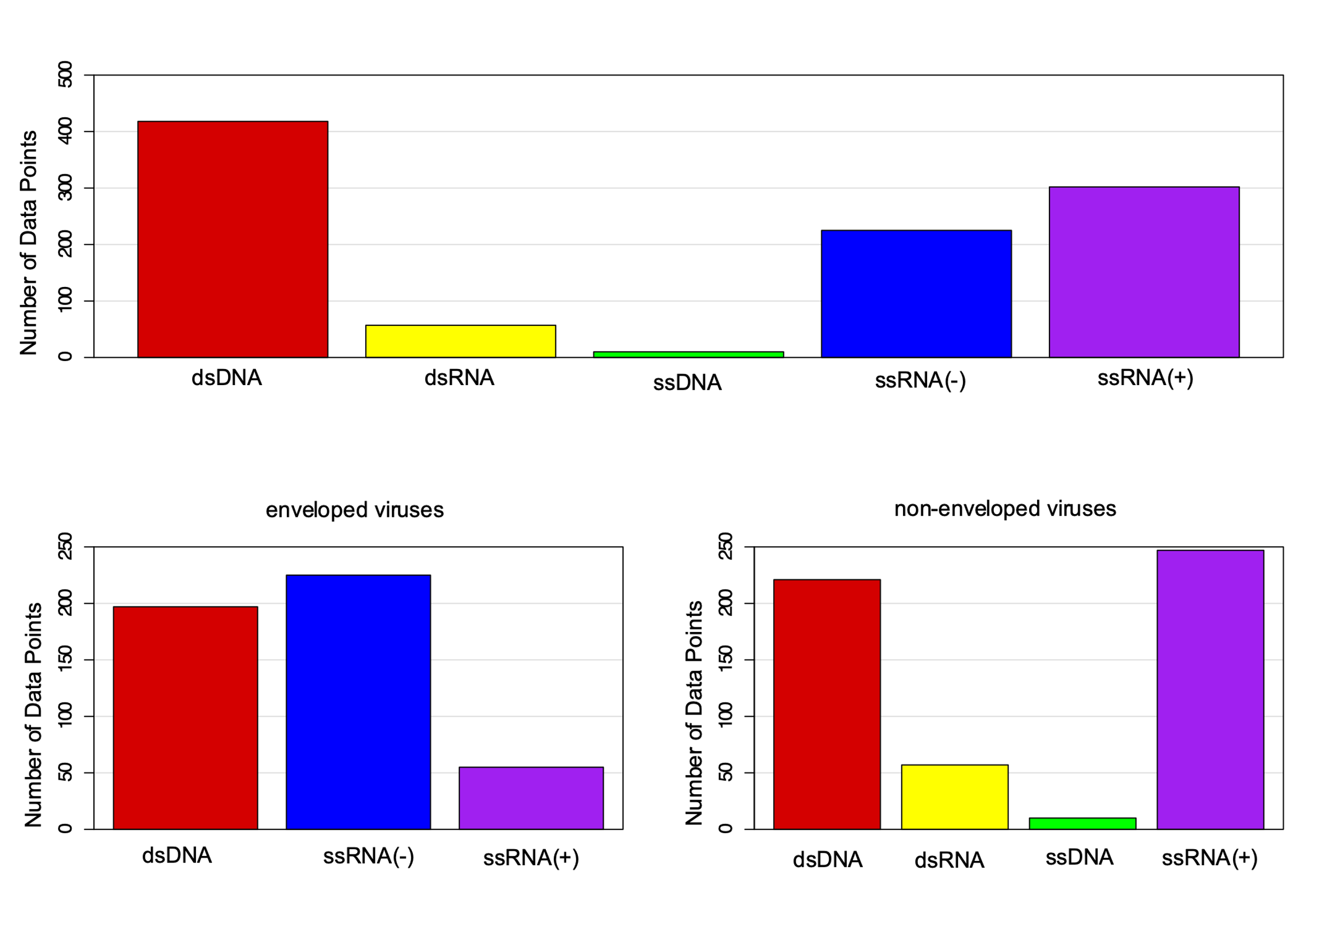

Figure S 2: Distribution of nucleic acid types in the data set, the complete dataset and two subsets: enveloped and non-enveloped

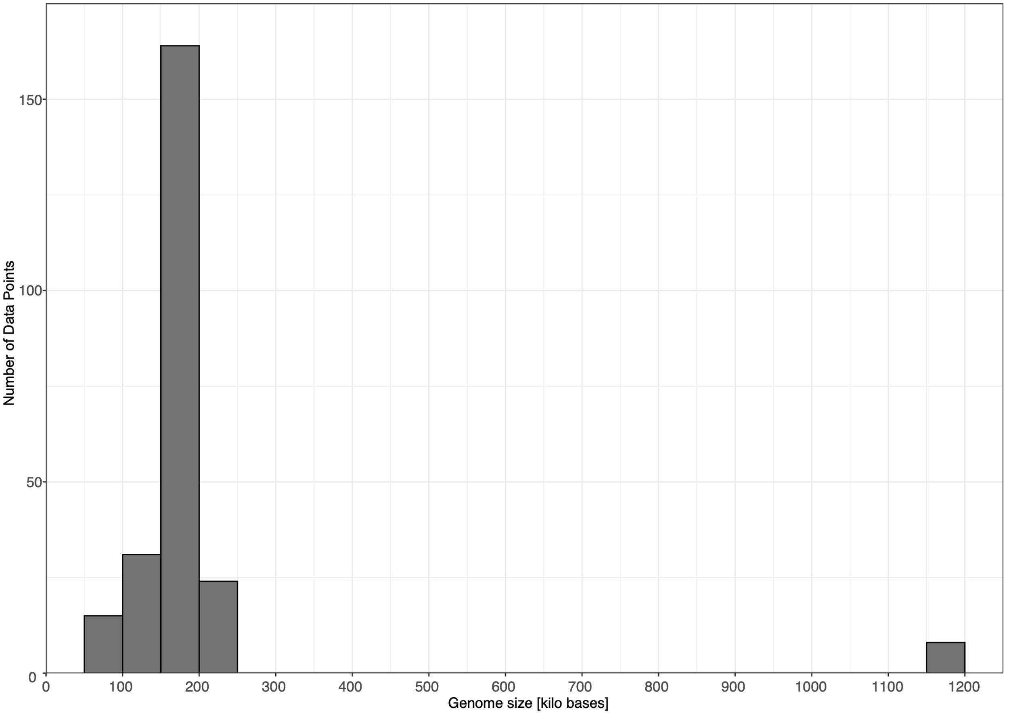

Figure S 3: distribution of genome size in the complete dataset

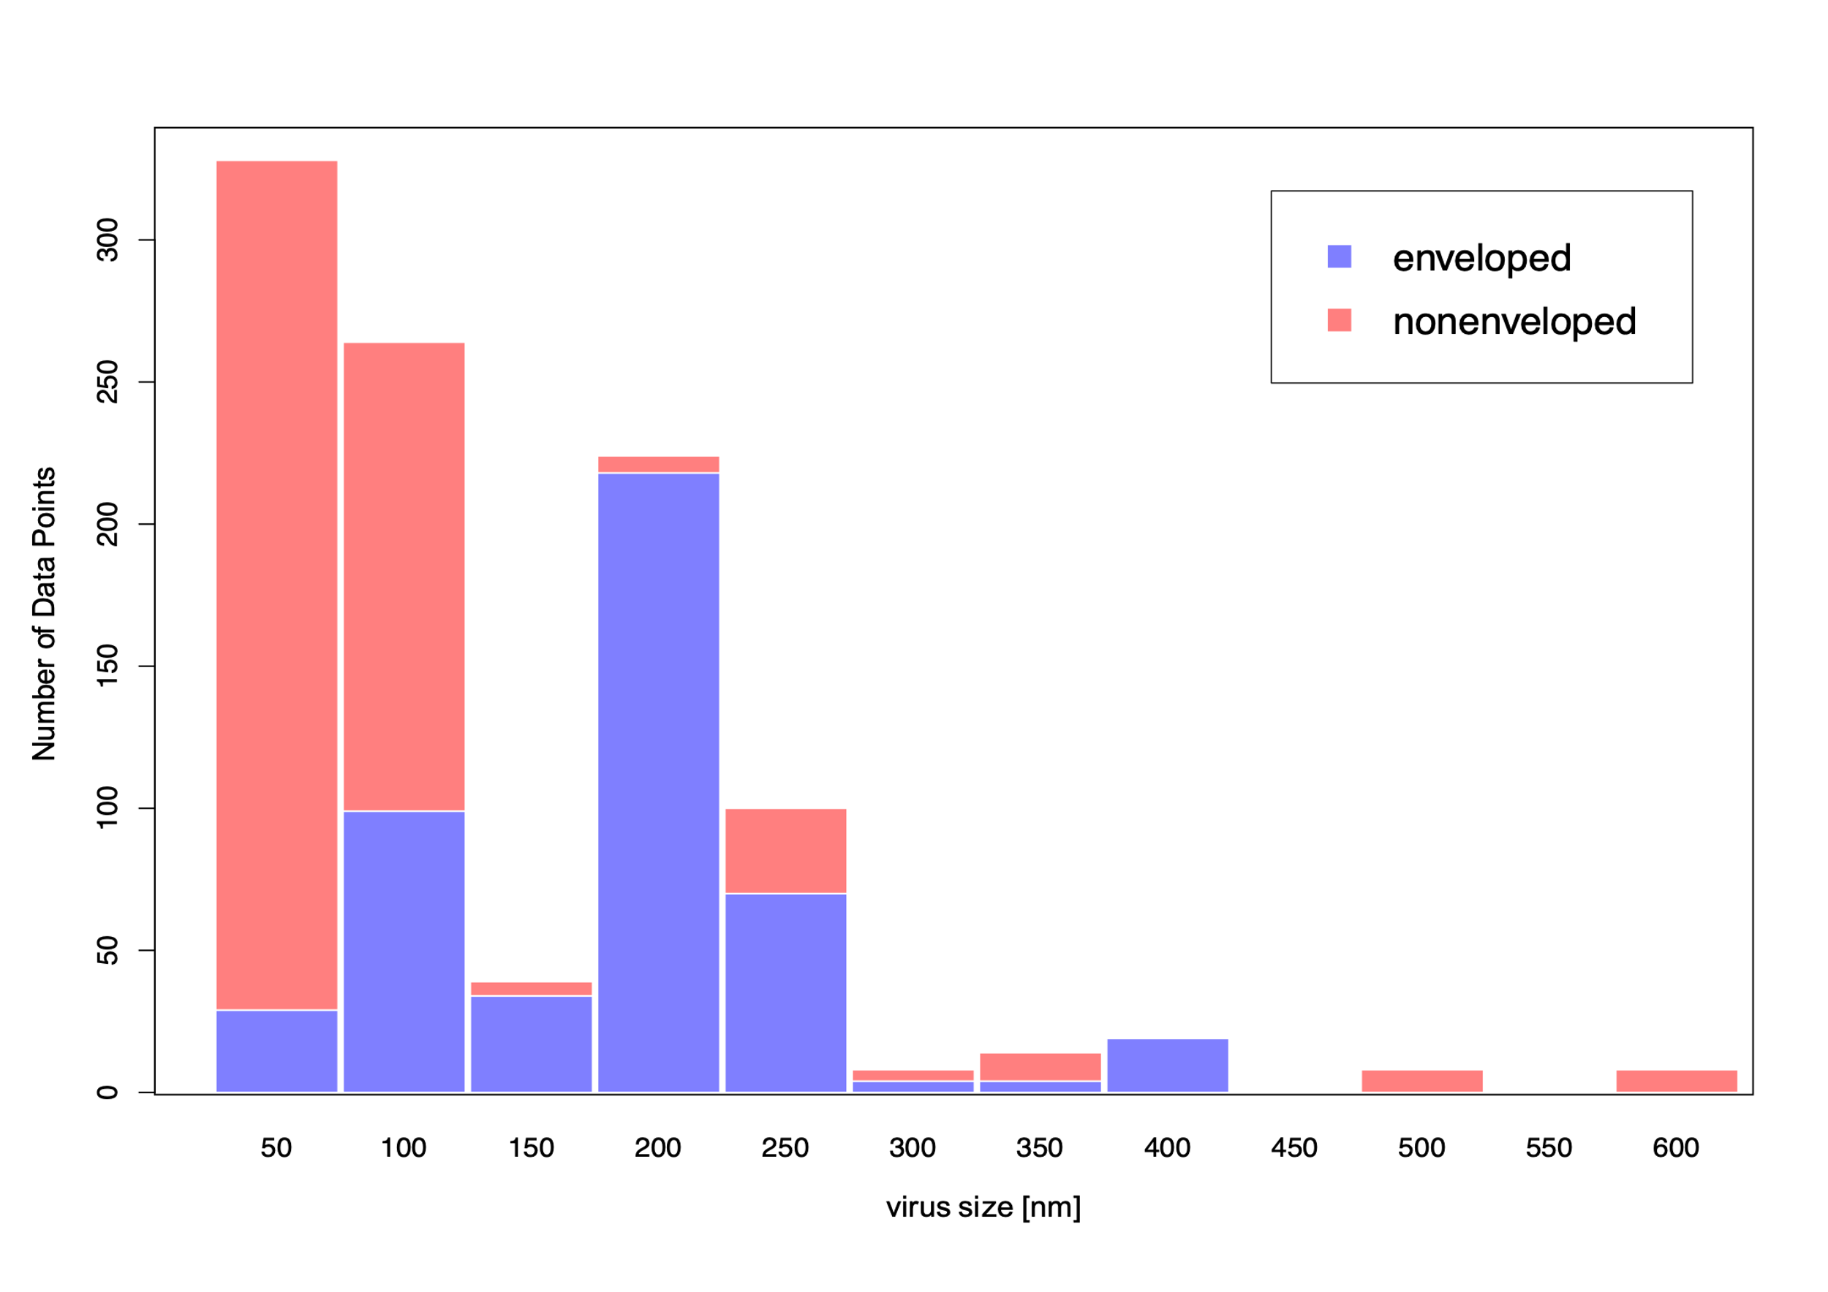

Figure S 4: Distribution of data points by virus sizes in nm, colored by non-enveloped (red) and enveloped (blue) viruses

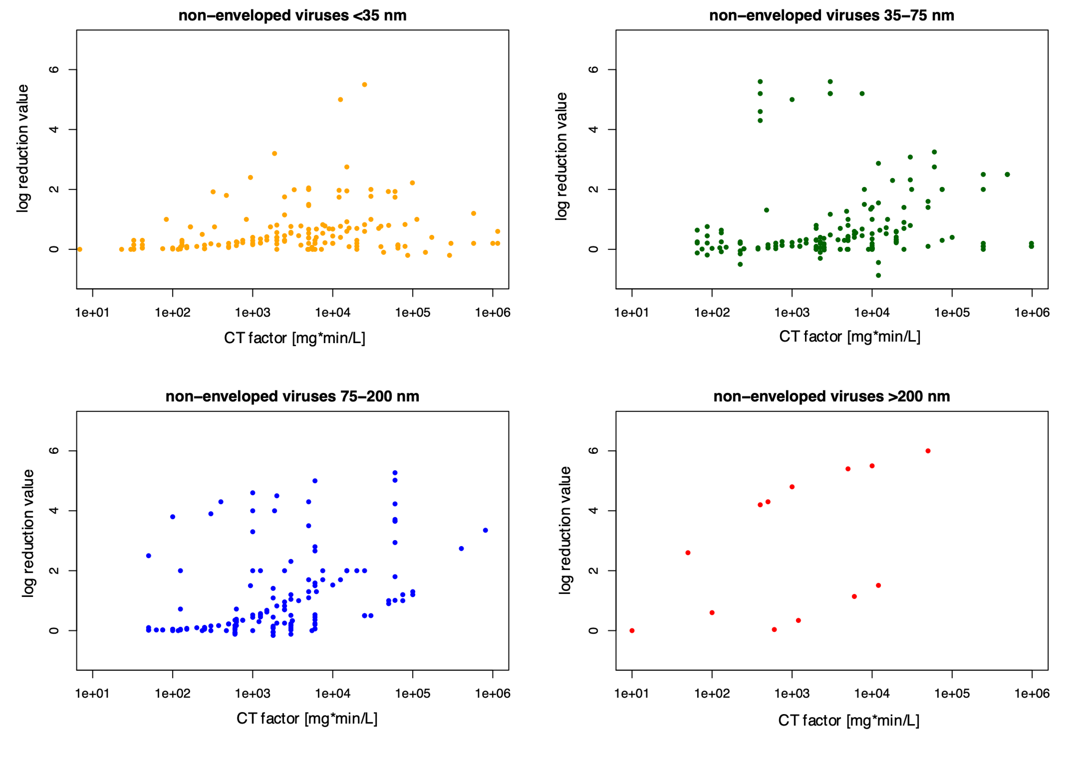

Figure S 5: log reduction value over CT factor of four size groups of non-enveloped viruses.

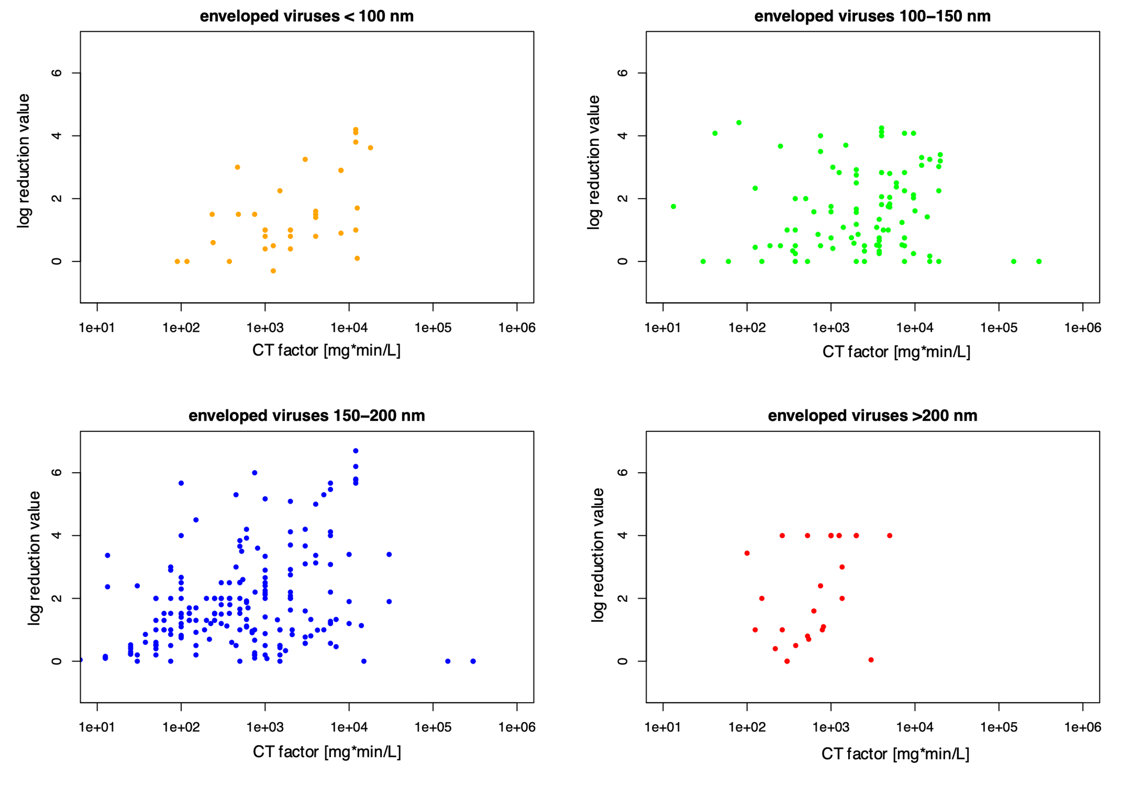

Figure S 6: log reduction value over CT factor of four size groups of enveloped viruses.

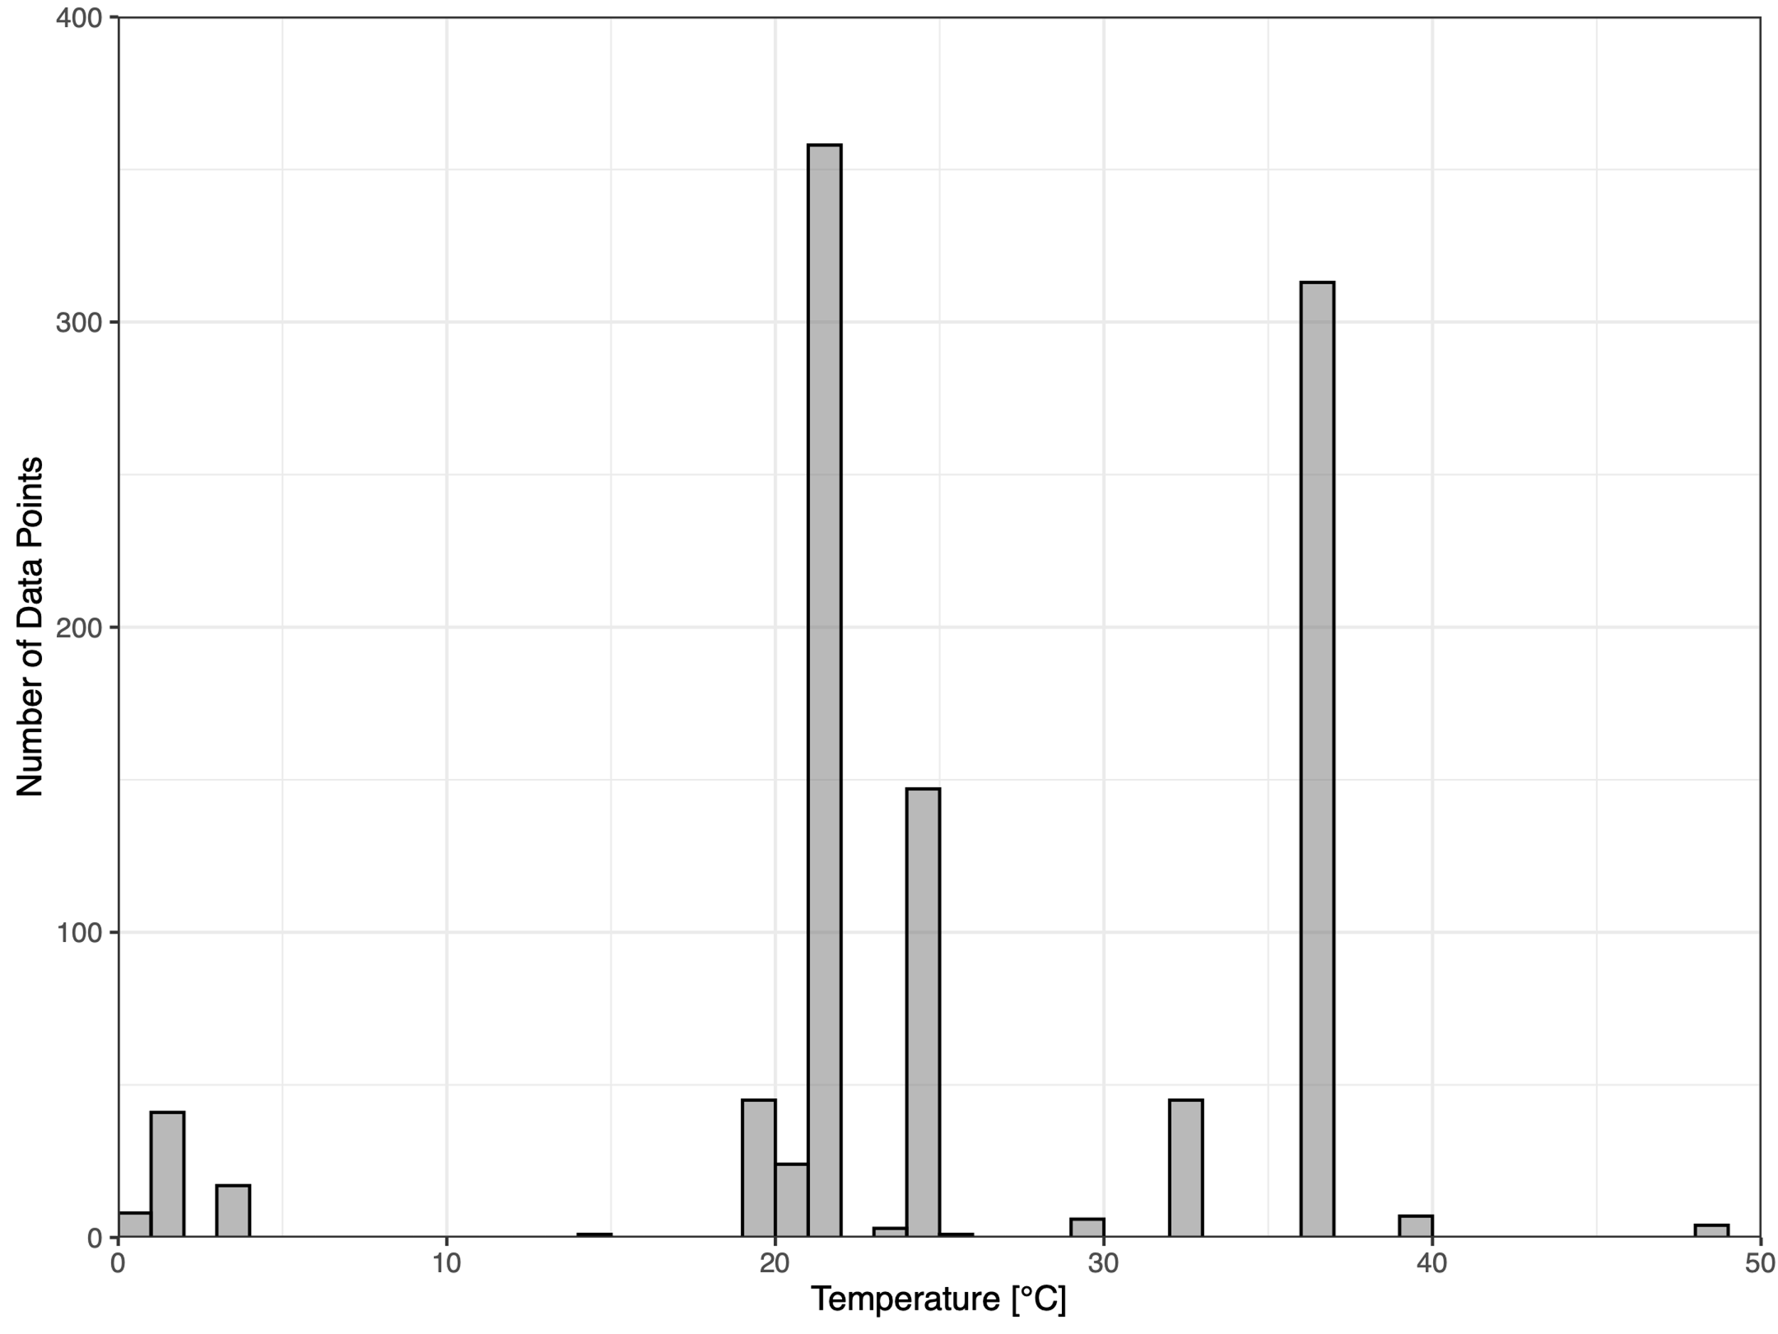

Figure S 7: distribution of temperature

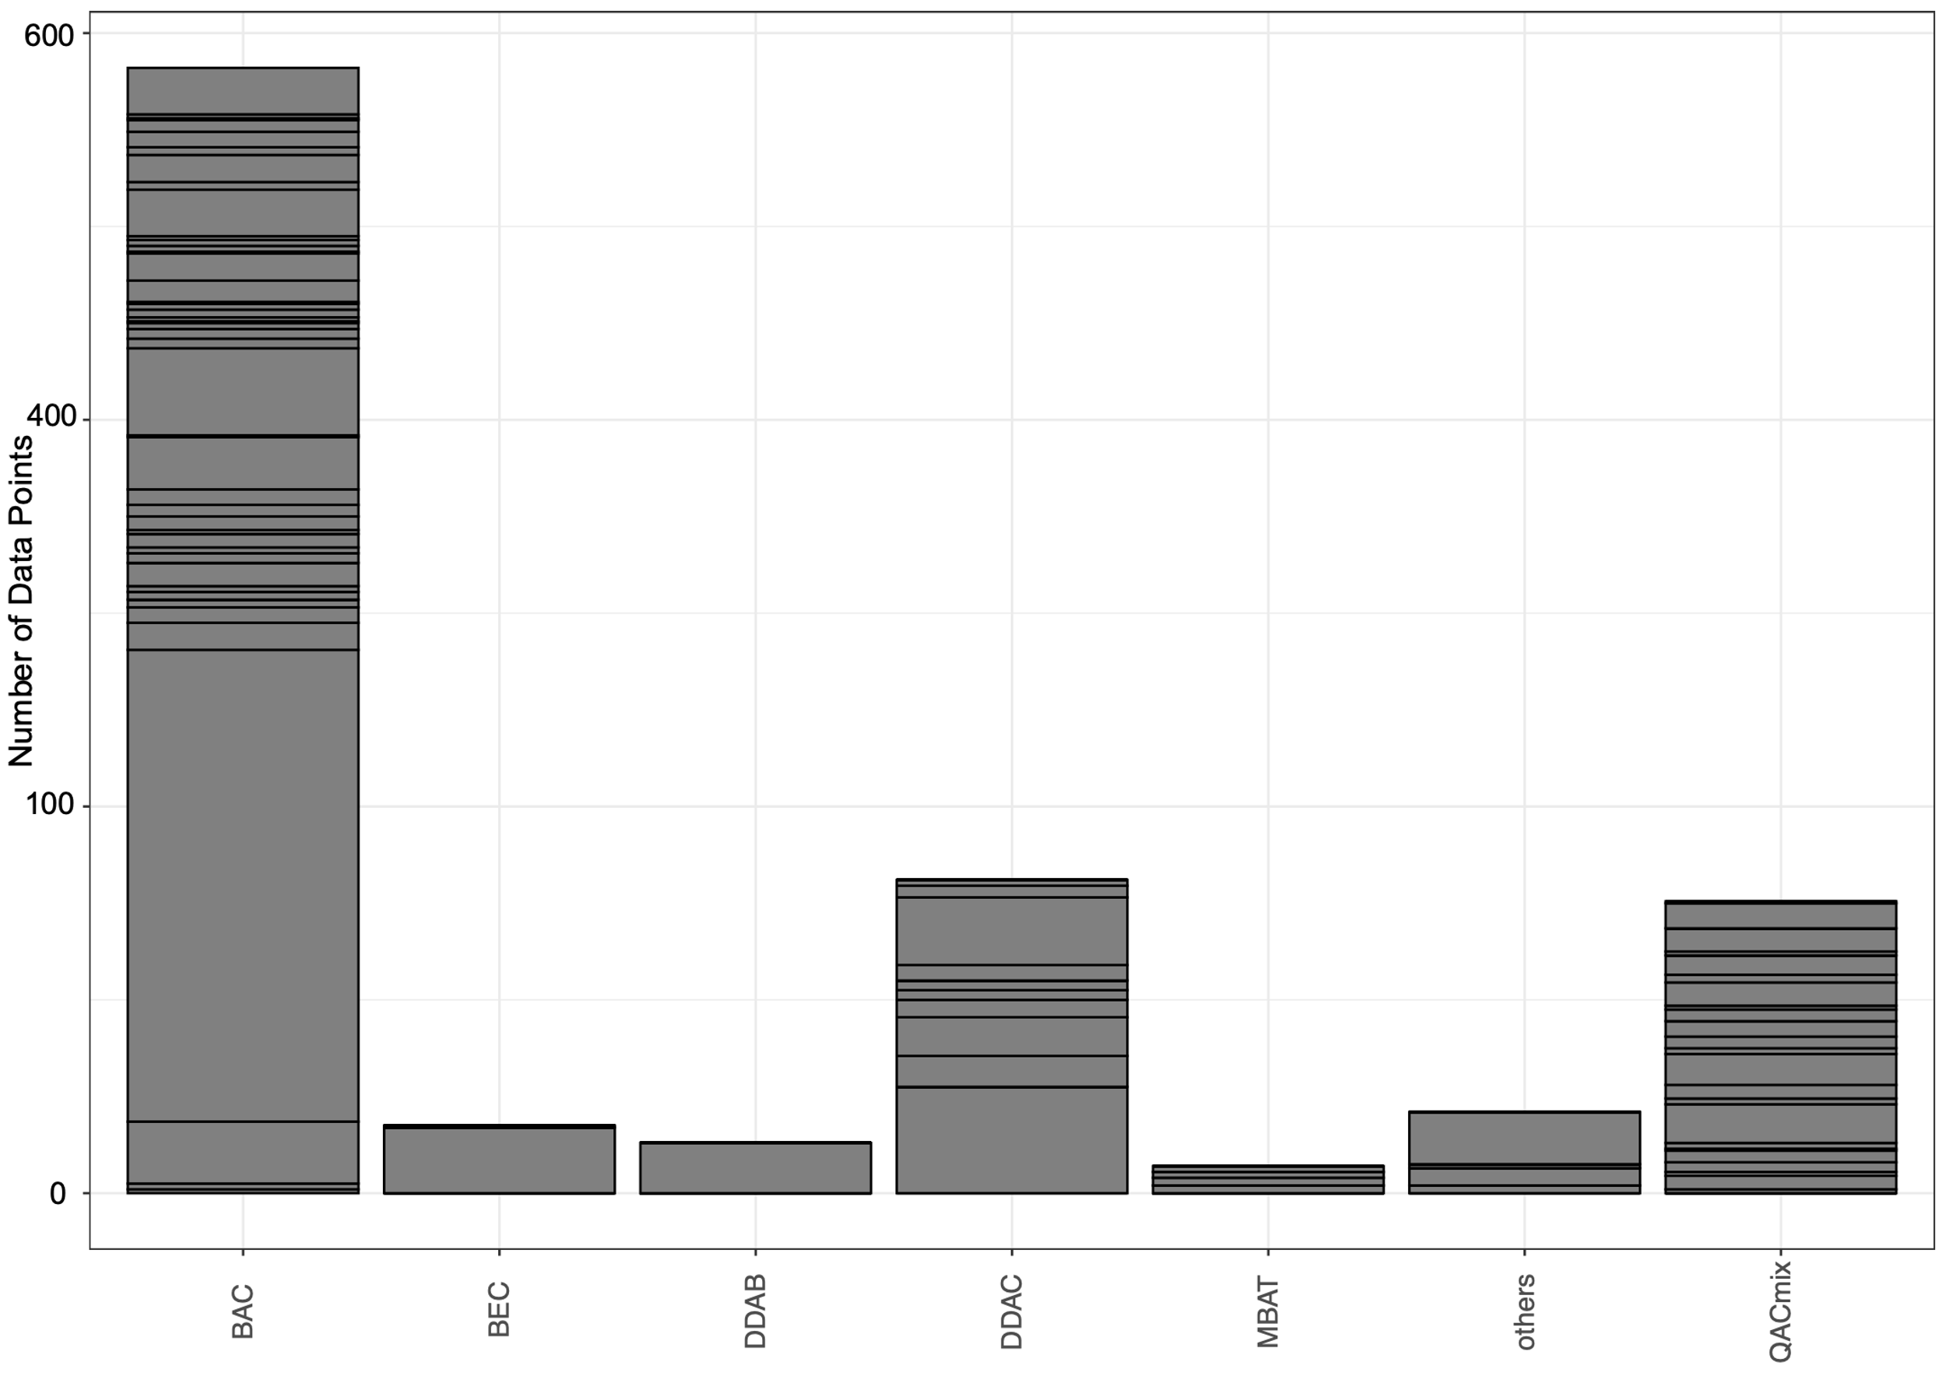

Figure S 8 distribution of different QACs, squares represent studies. Abbreviations: BAC: benzalkonium chloride, BEC: benzethonium chloride, DDAB: didecyl dimethyl ammonium bromide, DDAC: didecyl-dimethylammonium chloride, MBAT: mono; bis (tri-methyl ammonium methylene chloride)-alkyl (C9-15) toluene, others: CTAB: Cetyltrimethylammonium bromide, dimethylalkonium bromide, CPC: cetylpyridinium chloride, QAC1: 2-Hexadecanoyloxyethyl)triethylammonium Bromide, QAC2: 1-(2-Dodecanoyloxyethyl)pyridinium Bromide, QAC3: Eicosanoyloxyethyl pyridinium Bromide, QAC5: 1-(2-Hexadecanoylaminoethyl)pyridinium Chloride, QAC6: Tributyl-(2-dodecanoyloxyethyl)ammonium Bromide, QACmix: a mix of different quaternary ammonium compounds.