**项目测试报告**

**任务一**

**1、准备工作**

**tiny的正则表达式：**

|  |
| --- |
| letter = [a-zA-Z]  digit = [0-9]  _number100=digit+  _identifier200=letter(letter|digit)*  _keyword300 = if | then | else | end | repeat | read | until | write  _special400S = \+ | - | \* | / | ^ | < | <> | <= | >= | > | = | ; | :=  _annotation500={( digit | letter | _special )*} |

**sample.tny文件：**

|  |
| --- |
| read x ;  {  多行注释  }  if x < 10 then  y := x * 3 / 2 ;  write y  end  else  repeat  x := x + 1 - 2  until x = 0  end ;  {符号部分}  if x <= 99 then  x := 1  end  else  x := 1  end ;  if x <> 100 then  x := 1  end ;  if x > 99 then  x := 1  end ;  if x >= 100 then  x := x ^ 2  end  else  x := 0  end |

**输入正则表达式：**

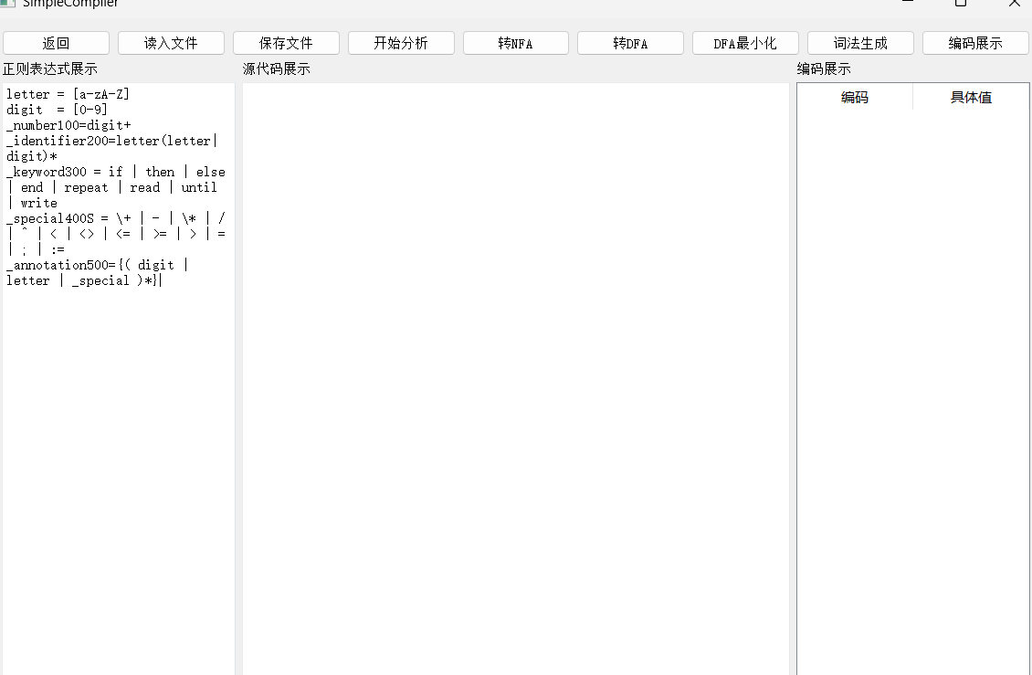

**2、NFA**

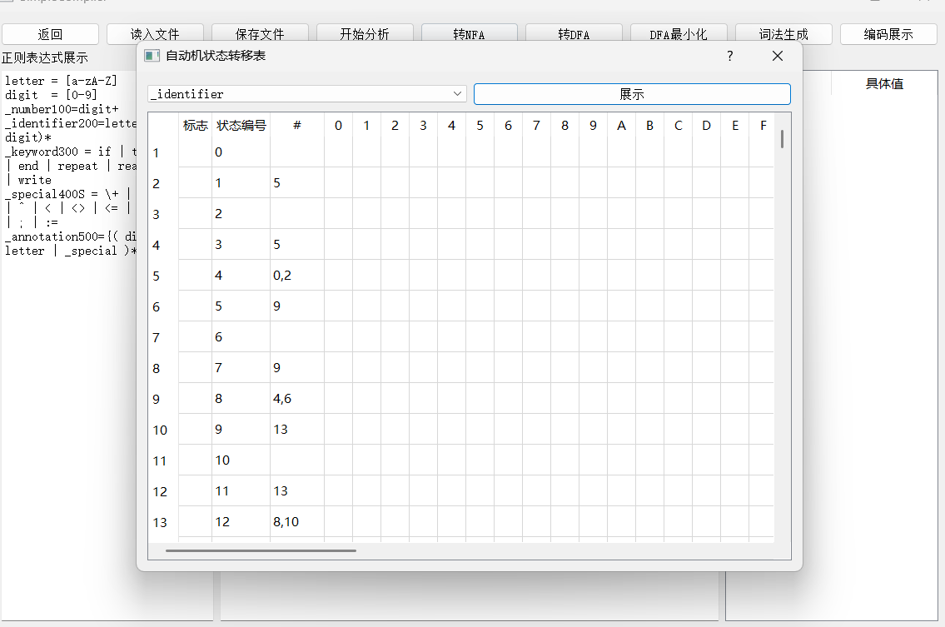

**3、DFA图**

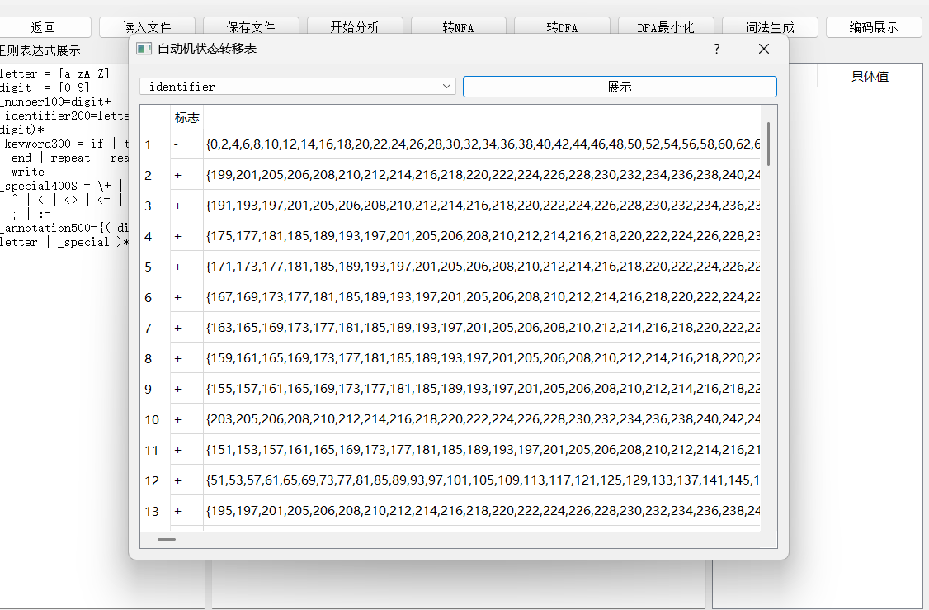

**4、DFA图最小化**

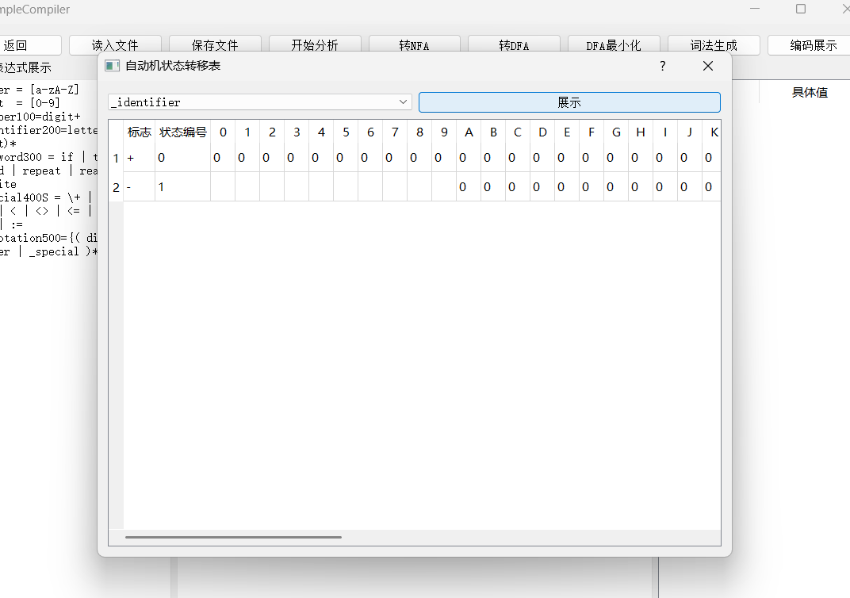

**5、生成词法程序**

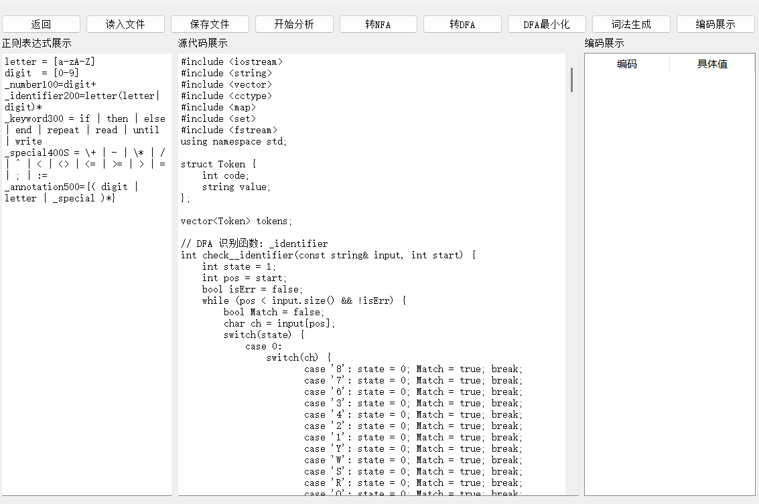

**6、编译cpp文件并运行**

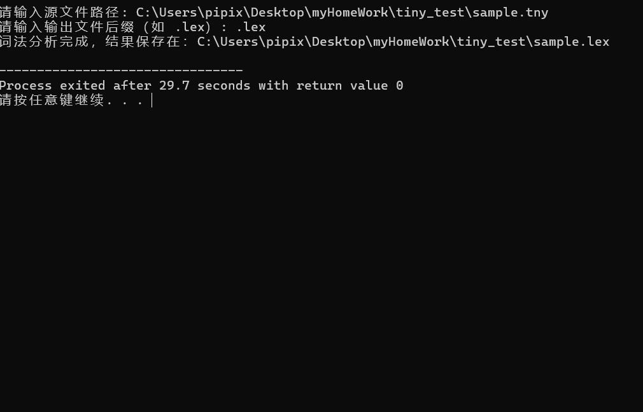

上图可知：编译成功

并成功生成lex文件：

**7、查看lex文件**

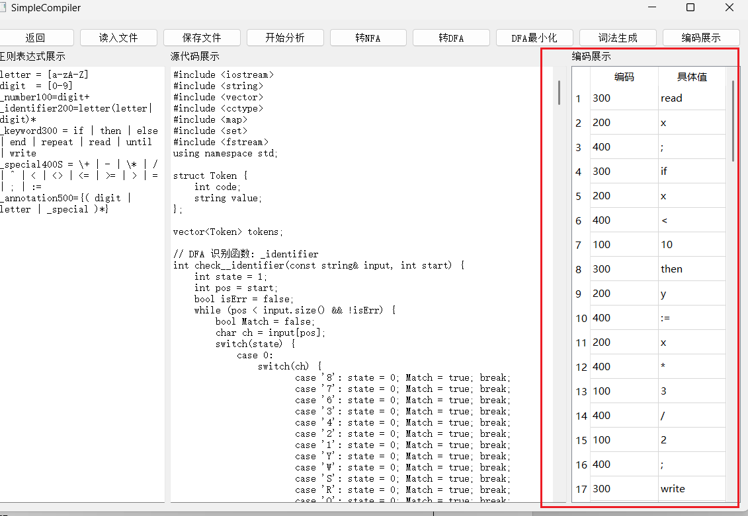

具体lex如下：

|  |
| --- |
| (300, 'read')  (200, 'x')  (400, ';')  (300, 'if')  (200, 'x')  (400, '<')  (100, '10')  (300, 'then')  (200, 'y')  (400, ':=')  (200, 'x')  (400, '*')  (100, '3')  (400, '/')  (100, '2')  (400, ';')  (300, 'write')  (200, 'y')  (300, 'end')  (300, 'else')  (300, 'repeat')  (200, 'x')  (400, ':=')  (200, 'x')  (400, '+')  (100, '1')  (400, '-')  (100, '2')  (300, 'until')  (200, 'x')  (400, '=')  (100, '0')  (300, 'end')  (400, ';')  (300, 'if')  (200, 'x')  (400, '<=')  (100, '99')  (300, 'then')  (200, 'x')  (400, ':=')  (100, '1')  (300, 'end')  (300, 'else')  (200, 'x')  (400, ':=')  (100, '1')  (300, 'end')  (400, ';')  (300, 'if')  (200, 'x')  (400, '<>')  (100, '100')  (300, 'then')  (200, 'x')  (400, ':=')  (100, '1')  (300, 'end')  (400, ';')  (300, 'if')  (200, 'x')  (400, '>')  (100, '99')  (300, 'then')  (200, 'x')  (400, ':=')  (100, '1')  (300, 'end')  (400, ';')  (300, 'if')  (200, 'x')  (400, '>=')  (100, '100')  (300, 'then')  (200, 'x')  (400, ':=')  (200, 'x')  (400, '^')  (100, '2')  (300, 'end')  (300, 'else')  (200, 'x')  (400, ':=')  (100, '0')  (300, 'end') |

**任务一测试完全通过**