Connecting and Managing Your Odoo Integration with WhatsApp
This comprehensive guide will walk you through the process of integrating your Odoo account with WhatsApp. You'll learn how to establish the connection, obtain necessary API keys from Odoo, manage contact data and leads directly from WhatsApp, and verify the integration within your Odoo instance.

Click on CRM/Integrations on WhatsApp extension
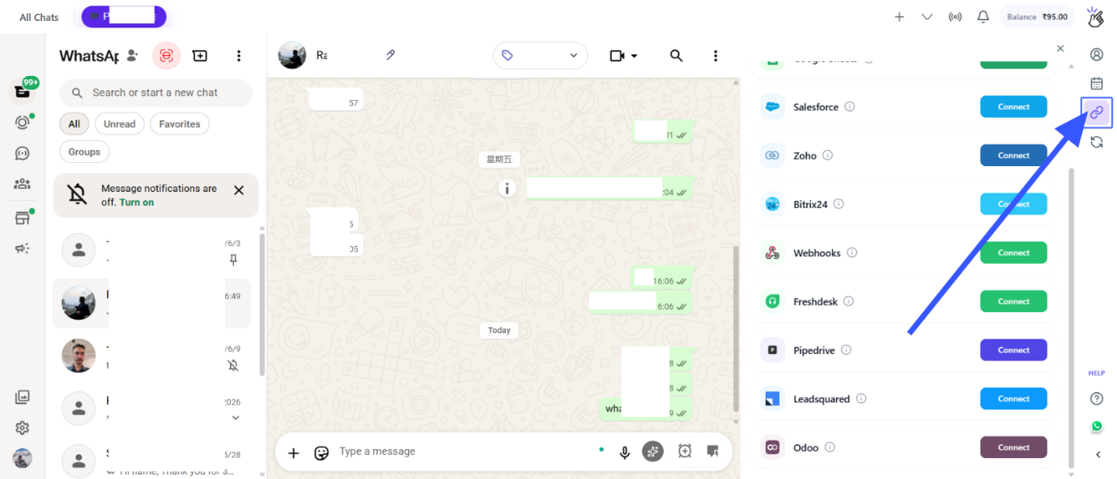

Click on Odoo Connect button
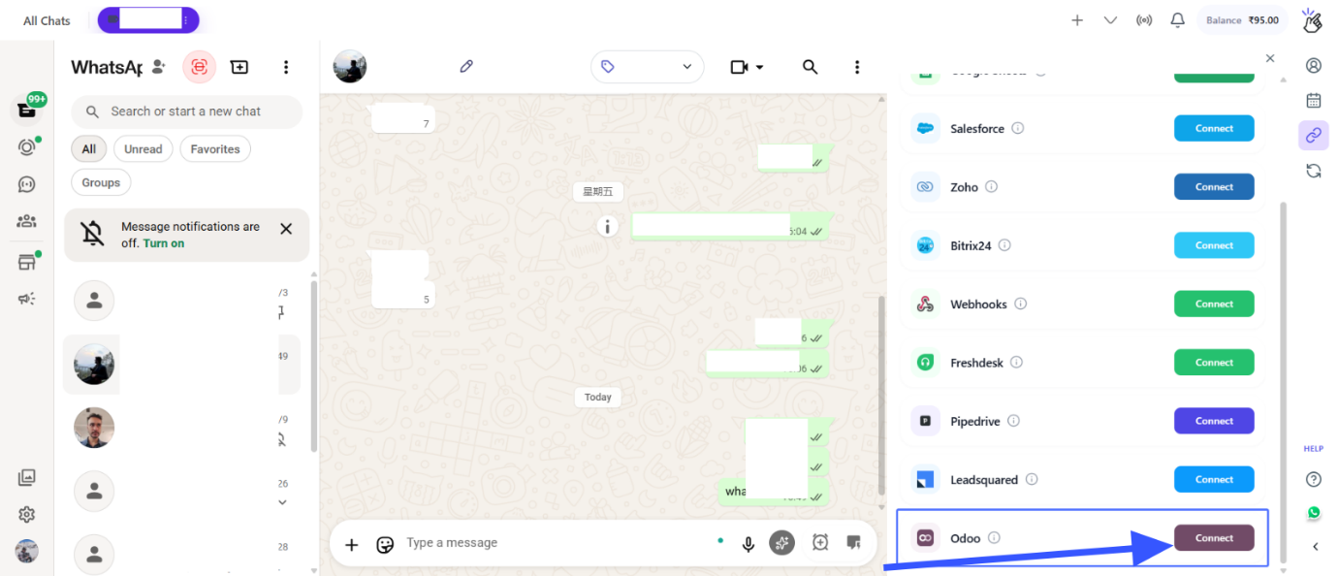

Enter the Odoo Instance URL and API Key and then click on Connect
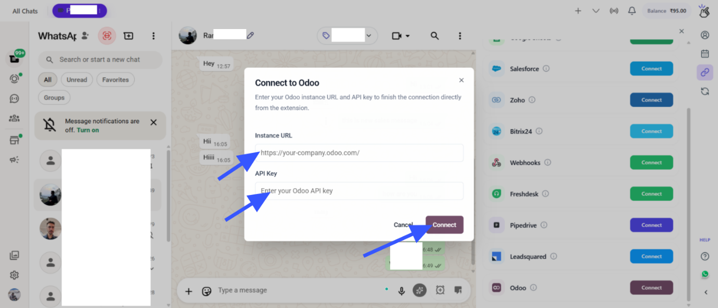

Retrieve Odoo API Key: Go the Odoo settings, Then click on Users & Companies, then on Users
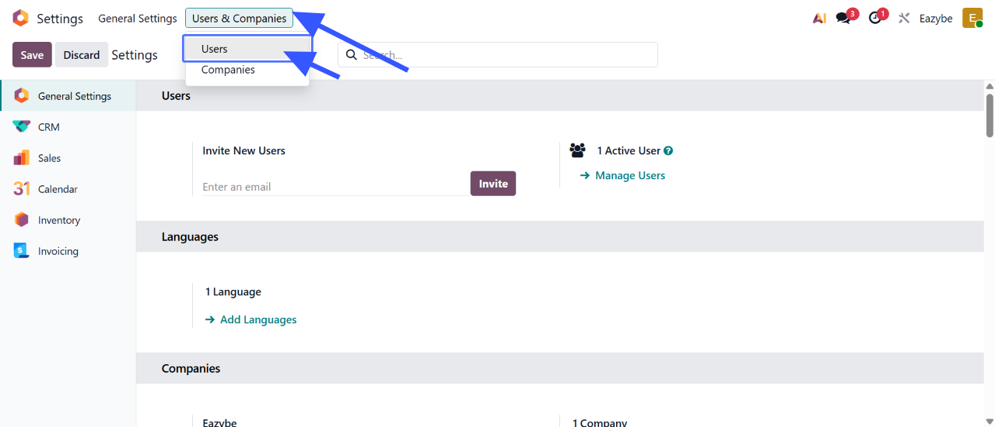

Then Select the user
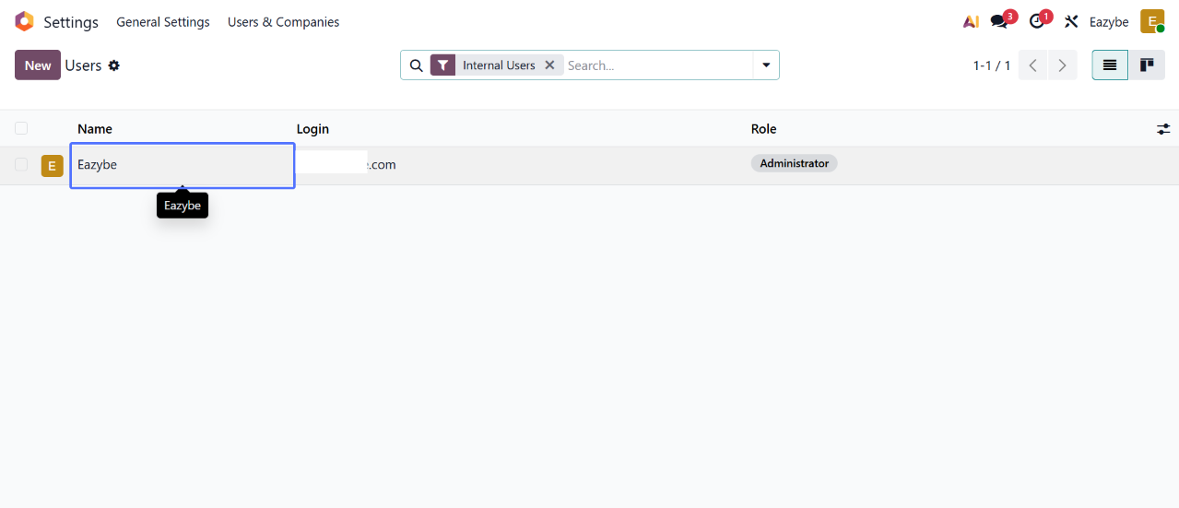

Then click on Security
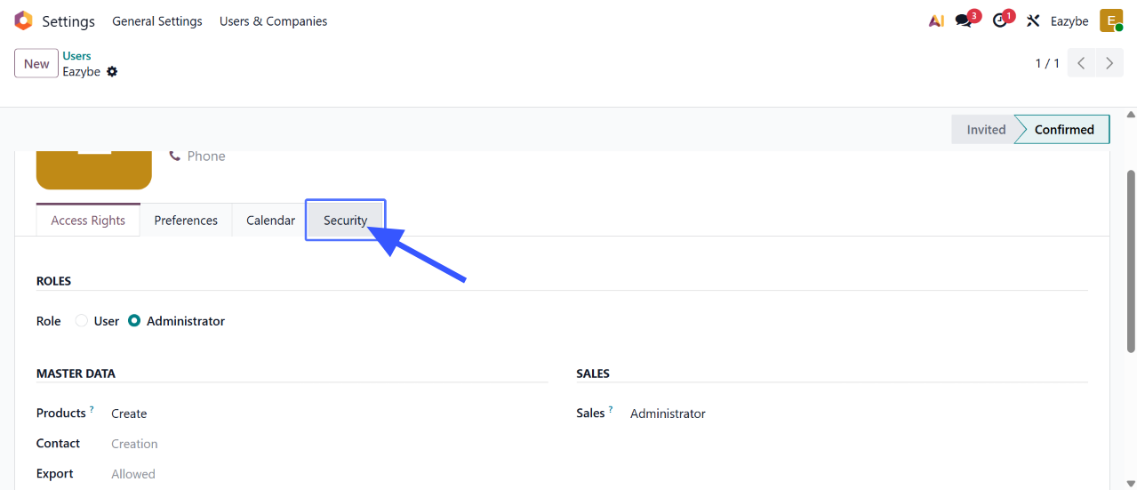

Under API Keys, click on add API Key and generate
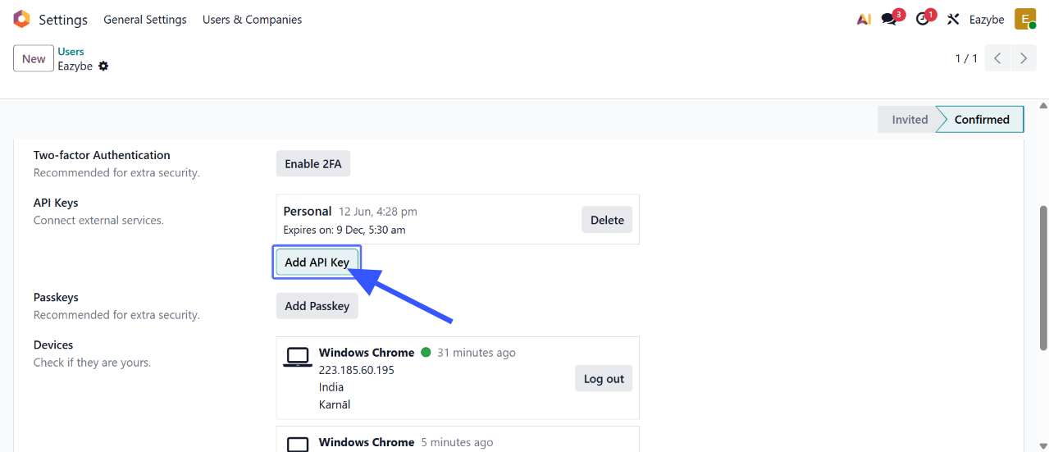

Click on the Odoo icon to open the Mini CRM. Based on the opened chat, you can create a new Contact, Lead, Notes and any property from here
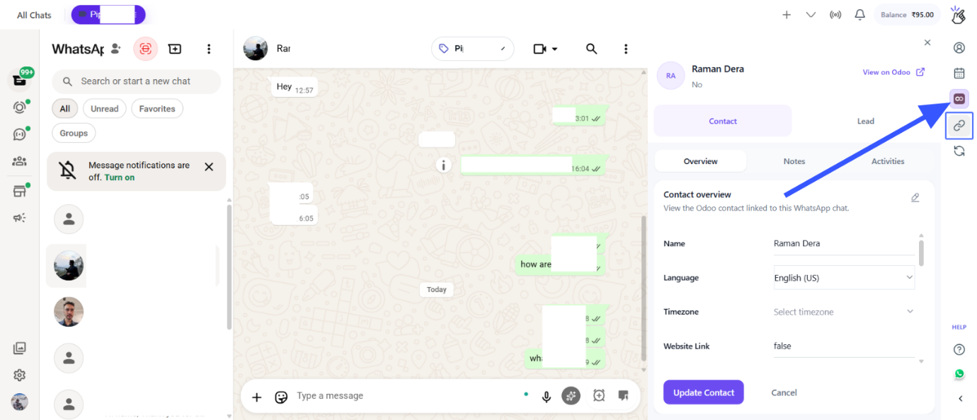

Click on the button "Edit properties" to structure the Mini CRM property view
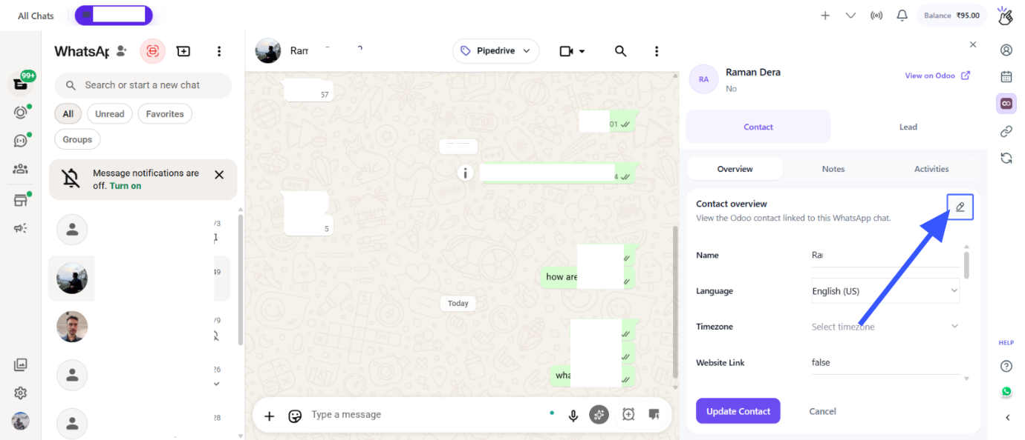

For chat backup, Click on the Sync Button, You have the label based Sync control, Here you can add you contact and turn the Chat Backup sync based on that
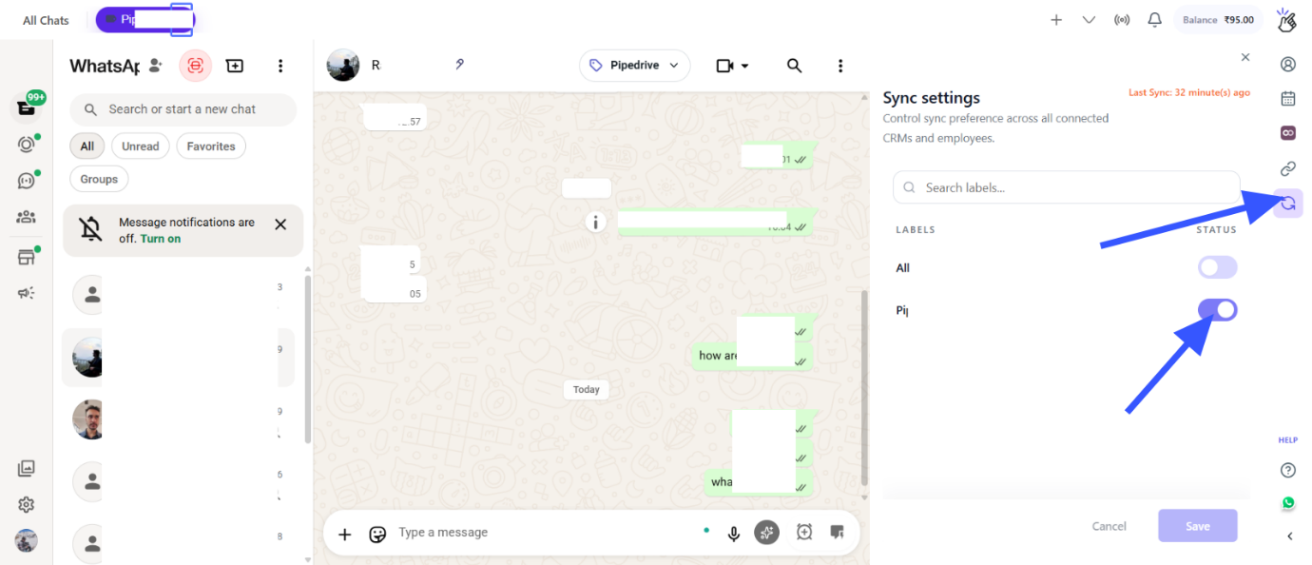

Click on the "View on Odoo", to redirect to that contact on your Odoo CRM.
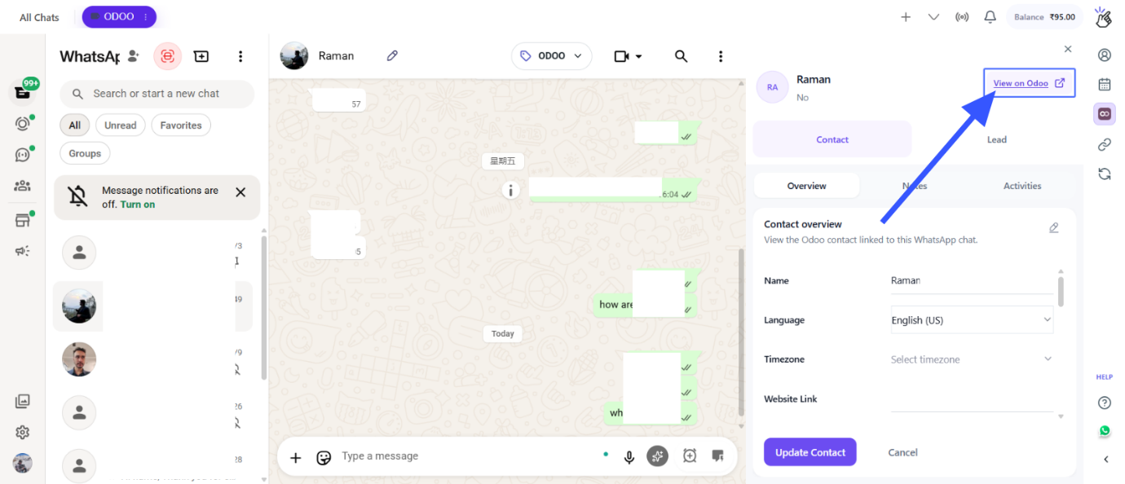

Click on the "WhatsApp Chats by Eazybe", to view all the chat backup on your Odoo CRM.
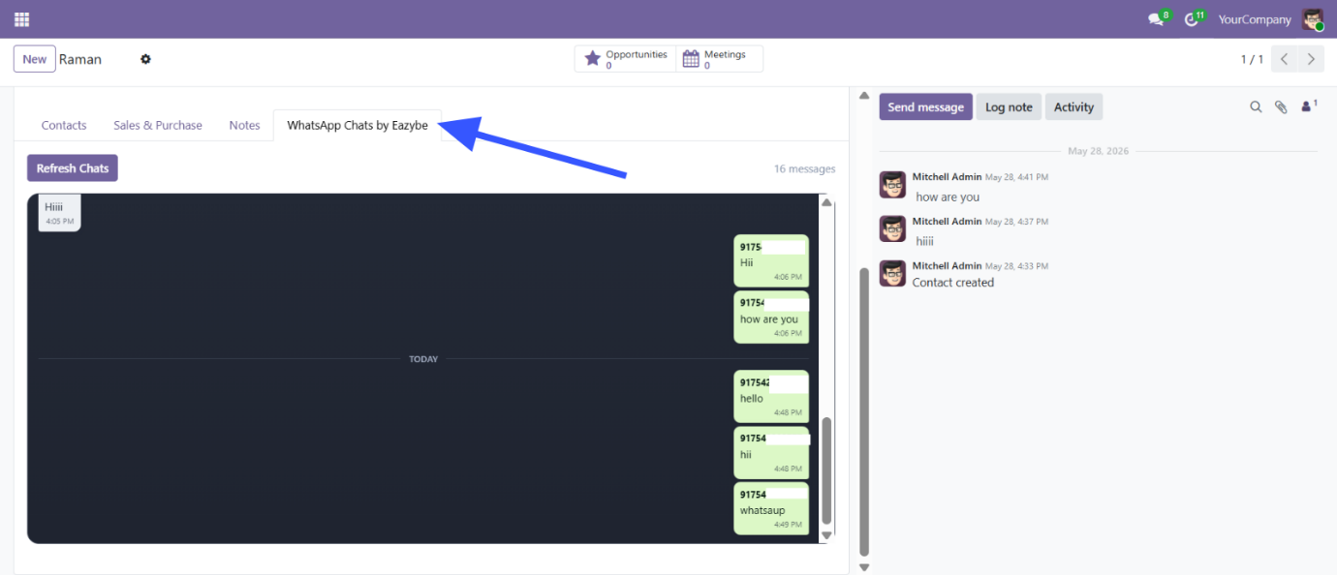

Click on the disconnect button to disconnect with the integrtion
