Starlight Like Intuition Pierced the Twelve

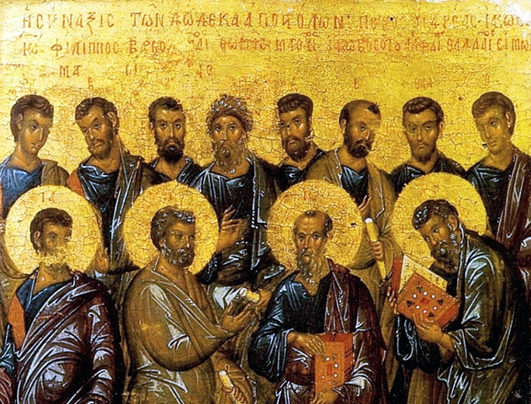

by Delmore Schwartz

The starlight's intuitions pierced the twelve,

The brittle night sky sparkled like a tune  
Tinkled and tapped out on the xylophone.  
Empty and vain, a glittering dune, the moon  
Arose too big, and, in the mood which ruled,  
Seemed like a useless beauty in a pit;  
And then one said, after he carefully spat,  
"No matter what we do, he looks at it!"  
  
"I cannot see a child or find a girl  
Beyond his smile which glows like that spring moon."  
--"Nothing no more the same," the second said,  
"Though all may be forgiven never quite healed  
The wound I bear as witness, standing by,  
No ceremony surely appropriate,  
Nor secret love, escape or sleep because  
No matter what I do, he looks at it--"  
  
"Now," said the third, "no thing will be the same;  
I am as one who never shuts his eyes,  
The sea and sky no more are marvelous,  
I know no more true freshness or surprise!"  
"Now," said the fourth, "nothing will be enough,  
--I heard his voice accompanying all wit;  
No word can be unsaid, no deed withdrawn,  
--No matter what is said he measures it!"  
  
"Vision, imagination, hope or dream,  
Believed, denied, the scene we wished to see?  
It does not matter in the least; for what  
Is altered, if it is not true?  That we saw  
Goodness as it is, *this* is the awe  
And the abyss which we will not forget,  
His story now the sky which holds all thought:  
No matter what I think, I think of it!"  
  
"And I will never be what I once was,"  
Said one for long as narrow as a knife,  
"And we will never be what we once were;  
We have died once; this is a second life."  
"My mind is spilled in moral chaos," one  
Righteous as Job exclaimed; "now infinite  
Suspicion of my heart stems what I will  
--No matter what I choose, he stares at it!"  
  
'I am as one native in summer places  
--Ten weeks' excitement paid for by the rich;  
Debauched by that and then all winter bored,"  
The sixth declared.  "His peak left us a ditch!"  
"He came to make this life more difficult."  
The seventh said, "No one will ever fit  
His measure's heights; all is inadequate;  
No matter what I do, what good is it?"  
  
"He gave forgiveness to us--what a gift!"  
The eighth chimed in. But now we know much  
Must be forgiven. But if forgiven, what?  
The crime that was will be; and the last touch  
Revives the memory: what is forgiveness worth?"  
The ninth spoke thus: "Who now will ever sit  
At ease in Zion at the Easter feast?  
No matter what the place, he touches it!"  
  
"And I will always stammer, since he spoke,"  
One who had been most eloquent said, stammering.  
"I looked too much at the sun; like too much light,  
So too much goodness is a boomerang,"  
Laughed the eleventh of the troop.  "I must  
Try what he tried: I saw the infinite  
Who walked the lake and raised the hopeless dead:  
No matter what the feat, he first accomplished it!"  
  
So spoke the twelfth, and then the twelve in chorus:  
"Unspeakable unnatural goodness is  
Risen and shines, and never will ignore us;  
He glows forever in all consciousness;  
Forgiveness, love and hope possess the pit,  
And bring our endless guilt, like shadow's bars;  
No matter what we do he stares at it!  
What pity then deny? what debt defer?  
We know he looks at us like all the stars,  
And we shall never be as we once were,  
This life will never be as once it was."  
  
**Delmore Schwartz** (December 8, 1913 – July 11, 1966) was an American [poet](https://en.wikipedia.org/wiki/Poet) and [short story](https://en.wikipedia.org/wiki/Short_story) writer. Schwartz was born in 1913 in [Brooklyn, New York](https://en.wikipedia.org/wiki/Brooklyn,_New_York), where he also grew up. His parents, Harry and Rose, both [Romanian Jews](https://en.wikipedia.org/wiki/Romanian_Jews), separated when Schwartz was nine, and their divorce had a profound effect on him.

Soon thereafter, he made his parents' disastrous marriage the subject of his most famous short story, "[In Dreams Begin Responsibilities](https://en.wikipedia.org/wiki/In_Dreams_Begin_Responsibilities)", which was published in 1937 in [*Partisan Review*](https://en.wikipedia.org/wiki/Partisan_Review).This story and other short stories and poems became his first book, also titled *In Dreams Begin Responsibilities*, published in 1938 when Schwartz was only 25 years old. The book was well received, and made him a well-known figure in New York intellectual circles. His work received praise from some of the most respected people in literature, including [T. S. Eliot](https://en.wikipedia.org/wiki/T._S._Eliot), [William Carlos Williams](https://en.wikipedia.org/wiki/William_Carlos_Williams), and [Ezra Pound](https://en.wikipedia.org/wiki/Ezra_Pound), and Schwartz was considered one of the most gifted and promising young writers of his generation. According to James Atlas, [Allen Tate](https://en.wikipedia.org/wiki/Allen_Tate) responded to the book by stating that "[Schwartz's] poetic style marked 'the first real innovation we've had since [Eliot](https://en.wikipedia.org/wiki/T.S._Eliot) and [Pound](https://en.wikipedia.org/wiki/Ezra_Pound).'" [https://en.wikipedia.org/wiki/Delmore\_Schwartz](https://en.wikipedia.org/wiki/Delmore_Schwartz" \l "cite_note-6)