First Letter of Paul to the Corinthians
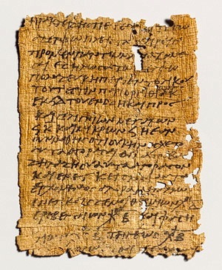

If I speak in the tongues of men and of angels, but have not love,
I am a noisy gong or a clanging cymbal.
And if I have prophetic powers, and understand all mysteries and all
knowledge, and if I have all faith, so as to remove mountains,
but have not love, I am nothing.
If I give away all I have, and if I deliver up my body to be burned,
but have not love, I gain nothing.
Love is patient and kind; love does not envy or boast;
it is not arrogant or rude.
It does not insist on its own way; it is not irritable or resentful;
it does not rejoice at wrongdoing, but rejoices with the truth.
Love bears all things, believes all things, hopes all things,
endures all things. Love never ends.
As for prophecies, they will pass way.
For we know partially and we prophesy partially,
but when the perfect comes, the partial will pass away.
When I was a child, I used to talk as a child, think as a child,
reason as a child; when I became a man, I put aside childish things.
At present we see indistinctly, as in a mirror, but then face to face.
At present I know partially; then I shall know fully, as I am fully known.
So now faith, hope, and love remain, these three;
but the greatest of these is love.

Love's Letter
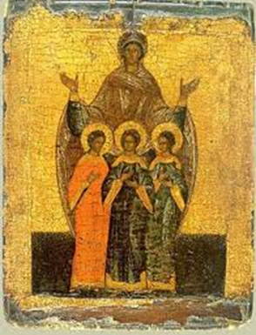

by Frank Thomas Smith

My sister Faith was first to go,
Her blood was staunched and ceased to flow.
Never was she the worldly type,
And won't return till time is ripe.
My other sister's name is Hope;
Never was she one to mope.
Her eyes, once fawn's, now sadly droop,
She walks with an ancient's wary stoop.
Hard it'll be to linger on
When blissful sister Hope is gone.
Retreat I'll then, I'll take cover,
With my ever-constant lover.
A generation will rise and when
My sisters will be born again,
They'll care too much not to persist,
Hope's trembling lips insist.
We three will roam the world's wide web
Repeating what the Savior said,
We'll cast away our mourning clothes,
Leave them where the wild rose grows:
Being heard above the din,
Calling out and drawing in,
Welcoming the circling dove,
Honoring the name of Love.
The Evil One will be here too,
Our waking giving him the cue
His wicked efforts to redouble.
The world will groan: toil and trouble!
Perhaps too few will we three be.
Faith, Hope and Love agree
That human help is needed sorely,
That gods alone must render poorly.

