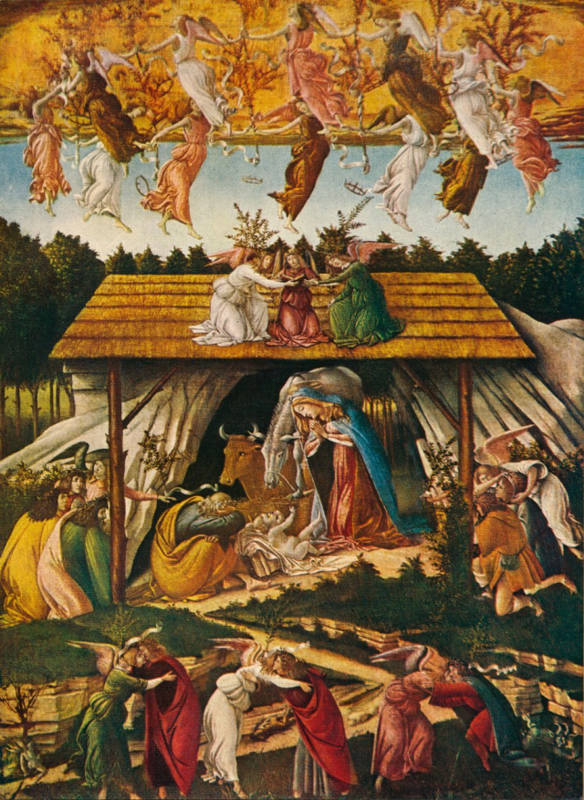

Natividad Mística - Sandro Botticelli

Christmas: A Festival of Inspiration

by Rudolf Steiner

21 December 1911, Berlin
From within our work in the Anthroposophical movement we look forward into the future of humanity and we let our souls and hearts be permeated with what we believe will embody itself in the streams and forces of evolution in the future of humanity. When we contemplate the great truths of existence, when we look up to the Forces, Powers and Beings who reveal themselves to us in the spiritual worlds as the cause and foundation of all that meets us in the sensory world. We rejoice to know that the truths which we bring down from the spiritual worlds will and must be gradually realized more and more in the souls and hearts of the people of the future. Thus for the greater part of the year our spiritual gaze is directed either to the immediate present or the future.
All the more do we feel ourselves impelled on the special days of the year, on the Festivals which come through to us from time and its changes as reminders of what earlier humanity imagined and devised. On these feast days we feel ourselves impelled to realise our union with this earlier humanity, to sink ourselves a little into what led people of the past time out of fullness of heart and soul to place these marks in the course of time which come down to us as the ‘Festivals of the year.’ If the Easter Festival is such as to awaken in us, when we understand it, thoughts of human powers and of the power of overcoming all the lower through the higher, everything externally physical through the spiritual, if the Easter Festival is a festival of resurrection, of awaking, a festival of hope and confidence in the spiritual forces which can be awakened in the human soul; so, on the other hand, the Christmas Festival is a festival of the realization of harmony with the whole cosmos, a festival of the realization of Grace. It is a festival that can again and again bring home the thought: No matter how doubtful everything around us may appear, however much the bitterest doubts may enter into faith, however much the worst disappointments may mingle with the most aspiring hopes, however much all that is good around us in life may weaken, there is something in human nature and essence—the rightly understood thought of the Christmas Festival may say—that only needs to be brought livingly, spiritually, before the soul, which reveals to us that we are descended from the powers of good, from the forces of right, from the forces truth. Easter points us to our victorious forces in the future; Christmas points us, in a certain sense, to the origin of man in the primeval past.
In such a case one can clearly see how the unconscious or subconscious reason or spirituality of humanity stands far, higher than man with his consciousness can wholly encompass. We have often reason to admire what people have established in the past out of the hidden depths of the soul more than what they have established out of their intellectual thoughts and understanding. How infinitely wise it appears to us, when we open the calendar, and for the 25th December we find registered the Birth-Festival of the Christ Jesus, and then we see registered in the calender for the 24th December “Adam and Eve”. How clearly reasonable and spiritual it appears that out of the dim subconscious work of the Middle Ages, when Christmas plays were performed here or there about Christmas time by people from different places, when the ‘singers’ as they were called gathered for their Christmas plays, that the Paradise Tree should be brought forward. As in the calender ‘Adam and Eve’ appeared before the Christ Birthday Festival, so in the Christmas plays of the Middle Ages, the Tree of Paradise was brought forward by the troupe which took part in the performance. In short, there was something in the deep hidden soul-depths of men which caused them to place directly together the earthly beginning of humanity and the Jesus Birth Festival.
In the year 353, even in ecclesiastical Rome, the 25th December was not kept as the Festival of the birth day of Jesus. Only in 354 the Jesus Birthday Festival was celebrated for the first time in ecclesiastical Rome. Previous to this, there was a festival which caused a consciousness similar to the Jesus Birth Festival, namely, January the 6th, the day of remembrance of the baptism by John in the Jordan, the day which was commemorative of the Descent of the Christ from the spiritual heights, and the self-immersion of the Christ into the body of Jesus of Nazareth. That was originally the Birth of the Christ in Jesus, the remembrance of the great historical moment which is symbolically presented to us as the hovering dove over the head of Jesus of Nazareth. The 6th of January was the commemorative day of the birth of Christ in Jesus of Nazareth.
In the fourth century, however, it had for a long time been impossible for the materialistic philosophy of the West to understand the incarnation of Christ in Jesus. The Gnostics, who were in a certain respect contemporaries or direct followers of the Event of Golgotha, realized this as a powerful illumination. They were in the position of finding it unnecessary to seek the depth of this wisdom of the ‘Christ’ in ‘Jesus’ as we have to seek this wisdom again through modern clairvoyance. The Gnostics were able, by means of the last flickering of those old, original human clairvoyant powers to see in the light of grace what we must acquire again for ourselves: the great secrets of Golgotha. Much was clear to the Gnostics which we have to acquire again, in particular the secret of the birth of Christ in Jesus during the baptism by John in the Jordan.
Just as the old clairvoyance faded away for humanity generally, so did also the kindling of the highest clairvoyant power, of the highest Christmas light of humanity, which the Gnostics possessed. In the fourth century western Christianity was no longer able to understand this great thought. Hence in the fourth century the true meaning of the festival of the appearance of the Christ in Jesus was lost to Western civilization. Humanity had forgotten what this Festival of the 6th of January actually meant. They had for a time, right into our time, buried under much materialistic intellectual rubbish what indeed would not allow itself to be destroyed, the feeling toward the Christ-Figure in human evolution.
If man could not understand that a highest one, as compared with humanity, had manifested Himself in the Baptism by John in the Jordan, yet he could understand—for that did not contradict materialistic knowledge—that the bodily organism which was selected for the reception of the Christ was something significant. Hence they put back the Spirit-birth, which indeed took place in the John-Baptism in the Jordan, to the birth of the Jesus child, and set the ‘Jesus-Birth-Festival’ in place of the ‘Festival of the Appearing.’ To represent quite rightly and in detail, what became the Christmas Festival, always aroused significant feelings, exalted feelings. Something significant lived in the human soul at the approach of Christmas, which may be expressed as follows: If man contemplates the world in the right sense, he can, by belief in humanity, fortify himself against certain things, against all life’s dangers and blows of fate; in the feeling of love and peace man can fortify himself in his deepest soul against all of life’s disharmony and strife. This is something which becomes ever more clearly bound up with the Christmas Festival. What was it actually which humanity remembered?
We know what significant, real and powerful preparations human evolution had to go through in order that the Mystery of Golgotha could enter this evolution. The human being who was the reincarnated Zarathustra, had to be born as one of the two Jesus children. He also had to be born for whom the real Jesus-Birth-Festival was the commemorative festival; he had to be born whose soul-substance had remained in the spiritual worlds. So long as humanity went through all that was possible within heredity through the generations up to the Mystery of Golgotha, so long had man been absorbing the destructive forces that crept right into the blood. One single soul substance had remained behind in the spiritual worlds, guarded by the purest Mysteries and Mystery-centers, and then it was poured out into humanity as the soul of the second Jesus-child, the child of the Luke Gospel, that Jesus-child to whose birth all the commemorations and representations of the Christ-Festival, of Christmas, belong.
At Christmas people’s thoughts went back to the origin of humanity, to the human soul, which had not yet descended, not even into Adam’s nature. They would say: In Bethlehem, in Palestine was born that soul-substance which had not taken part in the descent of humanity, but had remained behind, and for the first time in fact entered into a human body, in incarnating in Jesus, as described by Luke. The human soul, when its thinking is directed to this fact, may feel: One can believe in humanity, one can have faith in humanity; however much conflict, however much disbelief, however much disharmony has entered into it from the time of Adam to the present—when one looks back on what in olden times was called ‘Adam Kadmon,’ which became later the ‘Christ’ conception, there was kindled in the human soul confidence in the soundness of humanity, and there was kindled confidence in the primeval peaceful and loving nature of humanity. Hence the subconscious soul of man brought together the Jesus-birth Festival and the Adam and Eve Festival because he saw in fact his own nature, but in its innocence and its purity, in the Christ Child who was born.
Why then was the Divine Child placed before humanity for hundreds and thousands of years as the highest there was for the human soul to revere? For the reason that when person looks at a child and sees the child not yet able to say ‘I’ to himself, he can know that the child is still working on the human body, the Temple of the Eternally Divine, and because the human child who cannot yet say ‘I’ nevertheless clearly shows the sign of his origin from the spiritual world. Through this contemplation of the child’s nature one learns to have full trust in human nature. Here, where he can most easily gather with others, when the sun shines least and warms the earth least, when he is not busied with the ordering of his outer affairs, here, when the days are shortest and the nights longest, when the earth gives him the best opportunity to enter into himself, when all outer brightness, all outer beauty withdraws for a while from outward view—here, Western civilisztion places the Birth-Festival of the Divine Child, that is, of the Human Being who enters the world pure and unsullied—and through the innocent entrance into the world can give to man at the time of his closest assembling with others, the strongest, the highest confidence through the knowledge of his own divine origin.
To the anthroposophist it is a confirmation of the great truth that one can learn most from the child, when one sees that a festival of a child’s birth is placed in the course of time as a great significant festival of confidence in human evolution. So we admire the subconscious, the spiritual reason of the human beings of the past, who have placed such sign posts in the path of time. We feel then like those who decipher wonderful hieroglyphs, produced by the people of old through the placing of such festivals in the writing of the times and we feel one with these folks of old. While at other times our gaze is directed towards the future, while at other times we are willing to place our best powers at the disposal of the future, to strengthen and increase all faith in the future, here, on such festival days, we seek to live in remembrance, to draw towards us as though incarnated the old thoughts teaching us at the present time that we can think about what lies in the spiritual foundation of the external world. But in earlier times—in a different way, it is true, but not less right, not less magnificent and significant—the True and Sublime was thought and experienced through the realization of the oneness of humanity and the great possibilities that then lay ahead of humanity. This is our anthroposophical ideal, to be able to feel one with what the folks of old produced—often from the most hidden depths of the soul. These festivals, particularly the great ones, encourage this, if we can only through the anthroposophical truths imprint in our souls the significance of the hieroglyphic signs written in the path of time.
A wonderful thought unites with a wonderful emotion in our souls when we see how, in those centuries which followed the fourth which first transferred the Jesus-Birth Festival to the 25th of December, how there flowed into the souls of those people the feeling of confidence awakened through the child-nature, so that in painting, in the Christmas plays, everywhere, is shown how all the creatures of the Earth-kingdom bow before the Jesus Child, before the Divine Child, before the divine origin of man.
There comes before us the wonderful picture of the manger, how the beasts bow before this primal man; to these may be added those wonderful stories, as for instance that when Mary had taken the Child Jesus on the way to Egypt a tree bowed, a very ancient tree, as the border was crossed by Mary with the child. Traditionally the legends of almost the whole of Europe relate that the trees in a remarkable way, in the Holy Night, bow to this great event. We could go to Alsace, to Bavaria, everywhere we find legends, how certain trees bear fruit on the Holy Night. All wonderful symbols which proclaim in fact how the birth of the Jesus-Child reveals itself as something which is connected with the whole life of the earth. When we recollect what we have so often said—that the ancient spiritual streams were given by the Gods to mankind, and how in ancient times people had clairvoyant insight into the divine spiritual world, how this clairvoyance gradually vanished from humanity in order that human beings might be able to gain the “I”. If we picture how here, in the whole human organization, something like a drying-up, a withering, of the old divine forces was taking place, and how through the Christ-Impulse which came through the Mystery of Golgotha there was a flooding of the withering divine forces with a new water of life; then there appears to us in a wonderful picture what the Christmas legends relate to us: how the dried up and withered roses of Jericho shoot up of themselves in the Holy Night. That is a legend which we find everywhere noted down in the Middle Ages, that the roses of Jericho blossom in the Christ-night and unfold, because they first unfolded under the footsteps of Mary, who, when she carried the Child Jesus on the journey to Egypt, stepped over a place where a rose tree was growing. A wonderful symbol of what happened to human divine powers, that even things so dry and lifeless as that which one usually finds on the wayside, as the roses which apparently are dead, can spring up again and shoot forth through the Christ-Impulse which entered into evolution.
That in the festival of the Birth of the Jesus infant was first given to humanity what was destined from the beginning. Before Adam and Eve existed, was destined for humanity—so the Christmas legend says—what yet lies in the quite unspoilt divine child-nature of man. In truth however—and on account of the influence of Lucifer—man has only been able to attain it after the period of time from Adam and Eve to the Mystery of Golgotha.
A deep emotion awakens in our souls when we take for our meditation a feeling, compressed into the one night of the 24th and 25th of December, of what mankind has become from Adam and Eve to the birth of Christ in Jesus, through the Luciferic powers. If we can realize that, we shall really grasp the significance of this Festival, and understand the goal before humanity. It is as though humanity, if it would use its opportunity and take these sign posts of time as material for meditation, could really become aware of its pure origin in the cosmic forces of the universe. Here, looking up into the cosmic forces of the universe and penetrating a little by means of Anthroposophy, through true spiritual wisdom into the secrets of the universe, humanity can first become mature to understand this, that what as the Christ-Birth Festival was once understood by the Gnostics, was in fact the festival celebrated on January the 6th, the Festival of the Birth of Christ in the body of Jesus of Nazareth, as a higher stage of the Birth-Festival of Jesus. To enable us to plunge into the twelve great Forces of the universe, the twelve Holy Nights are set between the Christmas Festival and the festival which is to be celebrated on the sixth of January, which now is the festival of the Three Holy Kings, and which in fact is the festival we have been speaking about.
Again, without man’s really knowing it in present knowledge, these twelve Holy Nights are established out of the hidden wise depths of the soul of mankind, as though they would say: ‘Realise the depths of the Christmas Festival, but sink during the twelve Holy Nights into the holiest secrets of the cosmos, that is, in the realms of the universe out of which Christ descended to the Earth.’ Only when mankind wills to be inspired through the thought of the holy childlike divine origin of man, to let himself be inspired by the wisdom that works through the twelve forces, through the twelve holy forces of the universe, symbolically presented in the twelve signs of the Zodiac, due in truth to spiritual wisdom—only when mankind sinks into true spiritual wisdom and learns to discern the course of time in the great cosmos and in the single human being, only then will the mankind of the future, fructified through Spiritual Science, find to its own salvation the inspiration which can come from the Jesus-Birth Festival so that thoughts for the future may be permeated with fullest confidence and hope.
Thus we may as anthroposophists allow the Christmas Festival to work on our souls as an inspiration festival, as a festival that brings the thought of human origin in the holy divine primeval human child so wonderfully before our souls. That light which appears to us in the Holy Night as the symbol of the light of humanity at its source, that light which is symbolically presented to us later in the lights of the Christmas-tree, rightly understood, is the Light that can give to our striving souls the best and strongest forces for our true world-peace, for the true blessedness and hope for the world.
Let us feel ourselves strengthened for the needs of the future by such thoughts on the facts of the past, on the establishing of the festivals in the past; Christmas thoughts, remembrance of the origin of humanity, thought that will unfold to real, to mighty soul implants for the true future of humanity.

