The Prophet

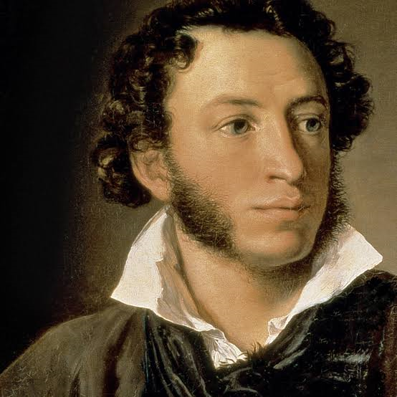

By Alexander Pushkin
My spirit wracked by thirst for grace,
I wandered in a darkling land
Till at a crossing of the ways
I saw a six-wing'd Seraph stand.
With fingers light as dream at night
He brushed mine eyes and they grew bright
Opening unto prophecies
Wild as a startled eaglet's eyes.
He touched mine ears. Then noise and sound
Poured into me from all around:
I heard the shudders of the sky,
The sweep of angel hosts on high,
The creep of beasts below in the seas,
The seep of sap in valley trees.
Then leaning to my lips he wrung
Thereout my sinful little tongue
Of guile and idle caviling;
And with his bloody fingertips
He set between my wasting lips
A Serpent's wise and forkèd sting.
And with his sword he cleft my chest
And ripped my quaking heart out whole,
And in my sundered breast he pressed
A blazing shard of living coal.
There in the desert I lay dead
Until the voice from heaven said:
"Arise O Prophet! Work My will,
Thou that hast now perceived and heard.
On land and sea thy charge fulfill
And burn Man's heart with this My Word."

Translated by A.Z. Foreman
Alexander Sergeyevich Pushkin 6 June 1799 – 10 February 1837) was a Russian poet, playwright, and novelist of the Romantic era. He is considered by many to be the greatest Russian poet, as well as the founder of modern Russian literature. He published his first poem at the age of 15, and was widely recognized by the literary establishment by the time of his graduation from the Tsarskoye Selo Lyceum. Upon graduation from the Lycée, Pushkin recited his controversial poem "Ode to Liberty", one of several that led to his exile by Emperor Alexander I. While under strict surveillance by the political police and unable to publish, Pushkin wrote his most famous play, Boris Godunov. His novel in verse Eugene Onegin was serialized between 1825 and 1832. Pushkin was fatally wounded in a duel with his wife's alleged lover, Georges-Charles de Heeckeren d'Anthès, also known as Dantes-Gekkern, a French officer serving with the Chevalier Guard Regiment.

