Title

Web programming class project, acadimec year 202 /202

|  |  |  |  |  |
| --- | --- | --- | --- | --- |
| Student Name in English | Student Name in Arabic | Student ID | Section time as shown in zajel | Work percentage |
| Eba Jamal Mohammad Khalil | اباء جمال محمد خليل | 12027796 | اتنين-اربعا  8-9:30 | 50% |
| Samah Asem Hasan Sheeha | سماح عصام حسن شيحة | 12029877 | اتنين-اربعا  8-9:30 | 50% |
|  |  |  |  |  |

Date/time

---------------------------------------------This section is intended for the Instructor---------------------------------------

|  |  |
| --- | --- |
| **Topic** | **Mark** |
| Project Idea |  |
| Project Complexity |  |
| Project Tools |  |
| Project Requirements and Modeling |  |
| Project Discussion |  |
| Project Completeness |  |
| Project Output Results or reporting |  |
| Project Administration and Management |  |
| Project Report |  |
| Team work |  |
|  |  |
|  |  |
|  |  |
|  |  |
|  |  |

***List of content***

1- *Abstract*

2- *Introduction*

*3- Project problem*

4- Project importance

5- Existing system and comparison

*6- Project objective*

*7- System idea*

*8-goal*

*9- Need of the system*

*10-tools*

*11- Techniques*

12- Reference

*13- conclusion*

*14- future works*

*15- Project UML*

*16- Responsive Real-Estate Website requirements*

*17- SQL DDL and DML statements*

*18- discussion about project GUI work, what each interface do*

*19-List of tables*

*20-* Difference between front and back end

***List of tables***

1.admins

2.messages

3.property

4.requests

5.saved

6.users

***Abstract***

should provide a brief overview of the project, including its objectives, methods, and results. It should highlight the main features and functionalities of the website and how they were implemented using the mentioned technologies. The abstract should also include any significant challenges encountered during the development process and how they were overcome. Additionally, it should briefly discuss the potential impact and benefits of the website for its intended audience.

***Introduction***

In this report, we will discuss the process of creating a responsive real-estate website design using HTML, CSS, and JavaScript. We will cover the steps involved in creating the design from scratch, including the tools and techniques used in the process.

Step 1: Planning and Preparation The first step in creating a responsive real-estate website design is planning and preparation. This involves defining the project goals, identifying the target audience, and gathering the necessary resources.

Step 2: Creating the HTML Structure Once the planning and preparation are done, the next step is to create the HTML structure of the website. This involves creating the basic layout, defining the header, footer, and content areas, and adding the necessary HTML elements.

Step 3: Styling with CSS After the HTML structure is complete, the next step is to add CSS styles to create a visually appealing design. This involves defining the color scheme, typography, and layout of the website.

Step 4: Making the Website Responsive The next step in the process is to make the website responsive. This involves using CSS media queries to adjust the layout and design based on the screen size of the device being used to view the website.

Step 5: Adding Interactivity with JavaScript The final step in creating a responsive real-estate website design is adding interactivity with JavaScript. This involves using JavaScript to create animations, transitions, and other interactive elements on the website.

***project requirements***

The project requirements section of your report should outline the specific goals and objectives of your project, as well as the features and functionalities that your responsive real-estate website design should include. This section should include information on the target audience for your website, as well as any technical specifications or constraints that you need to consider.

For example, your project requirements might include:

•A responsive design that looks great on desktop and mobile devices

•A user-friendly interface that allows users to search for properties, view property details, and contact the real estate agency

•Integration with a MySQL database to store property listings and user information

•Use of PHP PDO to connect to the database and perform CRUD (create, read, update, delete) operations

•Use of HTML, CSS, and JavaScript to create a dynamic and visually appealing website

•Compliance with web standards and accessibility guidelines

Overall, this section should provide a clear and detailed overview of the project goals and requirements, so that readers understand what your project is aiming to achieve.

***The tools used in the project***

1.HTML: Hypertext Markup Language is used for creating the web pages and structuring the content on the website.

2.CSS: Cascading Style Sheets is used to define the presentation and layout of the web pages.

3.JavaScript: A scripting language that is used for creating interactive and dynamic web pages.

4.PHP: Hypertext Preprocessor is used for server-side scripting and for creating dynamic web pages.

5.PDO: PHP Data Objects is used for accessing the MySQL database from the PHP script.

6.MySQL: An open-source relational database management system used for storing and managing the website's data.

7.Code editor: A code editor such as Visual Studio Code or Sublime Text is used for writing and editing the HTML, CSS, JavaScript, and PHP code.

8.Web browser: A web browser such as Chrome, Firefox, or Safari is used for testing and viewing the website.

**In the references section of your project report**

you should include a list of all the resources you have used for your project. This may include books, online articles, video tutorials, code libraries, and other sources that have helped you in designing and developing your project.

Each reference should be cited in a standard citation format, such as APA or MLA, and include the author, title, publisher, publication date, and any other relevant information. You can use online citation tools to help you with formatting your references.

Make sure to give credit to all the sources you have used in your project and avoid plagiarism by properly citing all the information you have used.

**Difference between front and back end**

In web development, the term "front-end" refers to the part of the website or application that the user interacts with directly, including the design, layout, and functionality that is visible in the web browser. The front-end is responsible for presenting the content to the user and enabling them to interact with the site or application.

The "back-end," on the other hand, refers to the part of the website or application that is responsible for processing and storing data and performing complex operations behind the scenes. This includes the server, database, and application logic that work together to support the front-end functionality.

Together, the front-end and back-end form the full web development stack, with each layer working together to provide a seamless experience for users.

***Project problem***

Check the responsiveness of the website design: Test the website on different devices and screen sizes to ensure that it is fully responsive and adjusts to different screen sizes.

Check the user experience: Test the website's user experience to ensure that it is easy to use and navigate.

Check for any broken links, missing pages, or errors.

Check the speed and performance: Test the website's speed and performance using tools like Google PageSpeed Insights or GTmetrix.

Check for any slow-loading pages, large image sizes, or other factors that may affect the website's speed.

Check the code quality: Review the code quality of the website and ensure that it follows best practices and standards.

Check for any coding errors, security vulnerabilities, or other issues.

Check the database connection: Test the database connection using PHP PDO and ensure that it is properly connected to MySQL.

Check for any other issues: Check for any other issues that may affect the functionality or usability of the website.

***Project importance***

The importance of your project, "Responsive Real-Estate Website Design Using HTML/CSS/JS/PHP PDO/MySQL," lies in its potential to provide a useful and user-friendly platform for real estate buyers, sellers, and agents. Real estate websites are critical for the success of real estate businesses as they allow users to search for properties, compare prices, and access information about properties and neighborhoods. Having a responsive design ensures that the website can be accessed on different devices, including desktops, laptops, tablets, and smartphones. This means that users can access the website from anywhere and at any time, which is crucial for attracting and retaining users. Moreover, using HTML/CSS/JS/PHP PDO/MySQL ensures that the website is dynamic, interactive, and can handle a vast amount of data. This means that users can easily search for properties based on their specific criteria and get results quickly. Overall, your project has the potential to provide a valuable service to the real estate industry, making it easier for people to buy, sell, and find properties.

***Existing system and comparison***

Comparison:

When comparing your project, "Responsive Real-Estate Website Design Using HTML/CSS/JS/PHP PDO/MySQL," with the existing systems, it is important to consider the following factors:

Design and User Experience: Evaluate the visual appeal, intuitiveness, and ease of navigation of both the existing systems and your project. Look for ways to enhance the user experience through responsive design, attractive layouts, and intuitive interfaces.

Functionality: Compare the features and functionalities offered by the existing systems with those in your project. Identify any additional features or improvements that your project brings, such as advanced property search options, interactive maps, virtual tours, or integration with social media platforms.

Performance and Speed: Assess the performance and loading speed of the existing systems and your project. Aim to optimize page loading times, database queries, and overall system performance to provide a seamless browsing experience.

Technology Stack: Compare the technologies used in the existing systems with the technologies you have employed in your project, such as HTML, CSS, JavaScript, PHP, PDO, and MySQL. Evaluate the suitability, scalability, and security of the technology stack in meeting the requirements of a real estate website.

Database Management: Analyze the efficiency and organization of the databases in the existing systems and your project. Consider factors such as data normalization, data retrieval speed, and data security measures.

Mobile Responsiveness: Assess the mobile-friendliness and responsiveness of both the existing systems and your project. Ensure that the website is optimized for various screen sizes and provides a seamless experience across different devices.

***Project objective***

Project Objective: The objective of your project, "Responsive Real-Estate Website Design Using HTML/CSS/JS/PHP PDO/MySQL," is to create a responsive and user-friendly website for the real estate domain. The project aims to provide a platform that allows users to search, browse, and interact with real estate listings effectively. The following are the key objectives of your project: Responsive Design: Develop a website that is fully responsive and adapts seamlessly to different screen sizes, including desktops, laptops, tablets, and mobile devices. The objective is to ensure an optimal viewing experience and user interface across all devices. User-Friendly Interface: Design an intuitive and user-friendly interface that enables users to navigate through the website easily. Focus on creating a visually appealing layout, clear navigation menus, and interactive elements to enhance the overall user experience. Property Search and Filtering: Implement robust search and filtering functionalities that allow users to search for properties based on various criteria such as location, price range, property type, amenities, and more. The objective is to provide users with accurate and relevant search results. Property Listings: Develop a system to display detailed property listings, including property images, descriptions, key features, floor plans, and contact information. The objective is to present property information in a comprehensive and visually appealing manner to attract potential buyers or renters. User Registration and Authentication: Implement a user registration and authentication system that allows users to create accounts, save their preferences, and access additional features. The objective is to provide a personalized experience and enable users to save and manage their favorite properties. Contact and Inquiry Management: Incorporate a contact and inquiry management system that allows users to contact property owners or agents directly through the website. The objective is to streamline communication and facilitate property inquiries, ensuring a smooth interaction between buyers or renters and property owners or agents. Database Management: Design and implement a well-structured database using PHP PDO and MySQL to store and retrieve property data efficiently. The objective is to ensure data integrity, optimize database queries, and provide a scalable solution for managing property listings. Security and Privacy: Implement security measures to protect user data, prevent unauthorized access, and ensure the privacy and confidentiality of user information. The objective is to build trust and confidence among users in using the website for their real estate needs.

***System idea***

System Idea: The system idea for your project, "Responsive Real-Estate Website Design Using HTML/CSS/JS/PHP PDO/MySQL," is to create a comprehensive online platform for real estate purposes. The system aims to provide a user-friendly interface and efficient functionality for property buyers, renters, and real estate professionals. The following are the key components of the system idea: Property Listing Management: The system allows property owners, agents, or administrators to add, edit, and manage property listings. They can input essential details such as property type, location, price, amenities, descriptions, images, and other relevant information. The system provides a structured and organized approach to manage property data effectively. Property Search and Filtering: The system enables users to search and filter properties based on their preferences. Users can specify criteria such as location, price range, property type, number of bedrooms, amenities, and more. The system retrieves and presents relevant property listings based on the user's search parameters, providing a streamlined property search experience. User Registration and Profiles: The system allows users to create accounts and build personal profiles. Users can register as buyers, renters, property owners, or agents. The system collects user information such as name, contact details, and preferences. Registered users gain access to additional features like saving favorite properties, tracking inquiries, and receiving personalized recommendations. Inquiry and Communication Management: The system facilitates communication between users and property owners/agents. Users can inquire about specific properties through contact forms or direct messaging. The system tracks inquiries, manages communication threads, and provides notifications to ensure effective and timely interactions. Responsive Design and User Experience: The system incorporates responsive web design principles to ensure optimal user experience across various devices, including desktops, laptops, tablets, and mobile devices. The system's layout, navigation menus, and interactive elements are designed to be user-friendly and visually appealing, enhancing usability and engagement. Secure Data Management: The system prioritizes the security and privacy of user data. It employs encryption techniques, secure user authentication, and safeguards against common vulnerabilities. User information and property data are stored securely in a MySQL database using PHP PDO for efficient data management and retrieval. Admin Dashboard: The system includes an administrative dashboard accessible only to authorized administrators. The admin dashboard provides functionalities to manage user accounts, monitor property listings, handle inquiries, and generate reports. It offers administrative tools for maintaining the overall system and ensuring smooth operations.

***Goal***

Goal: The goal of your project, "Responsive Real-Estate Website Design Using HTML/CSS/JS/PHP PDO/MySQL," is to develop a dynamic and user-friendly website that serves as a comprehensive platform for real estate activities. The project aims to achieve the following objectives: Provide a Responsive User Interface: The primary goal is to create a website that offers a seamless user experience across multiple devices and screen sizes. The website should adapt and adjust its layout and design elements to ensure optimal viewing and interaction for users accessing it from desktops, laptops, tablets, and mobile devices. Enable Property Listing and Management: The project aims to allow property owners, agents, and administrators to add, edit, and manage property listings easily. The website should provide a user-friendly interface to input property details, including location, price, amenities, descriptions, images, and other relevant information. Efficient property management tools should be implemented to handle the addition, modification, and removal of property listings. Facilitate Property Search and Filtering: The website should offer robust search and filtering capabilities to help users find their desired properties quickly. Users should be able to search based on location, price range, property type, number of bedrooms, amenities, and other criteria. The search results should be accurate, relevant, and presented in an organized manner, allowing users to refine their search further. Enable User Registration and Personalization: The project aims to implement user registration functionality, allowing users to create accounts and personalize their experience on the website. Registered users should be able to save favorite properties, track their inquiries, receive personalized recommendations, and manage their profiles. User registration helps in fostering user engagement and providing a tailored experience. Implement Secure User Data Management: The project emphasizes the importance of data security and privacy. User information should be securely stored and transmitted using encryption techniques. Proper user authentication mechanisms should be implemented to ensure authorized access to user accounts and protect sensitive data. The project should follow best practices for secure coding and database management using PHP PDO and MySQL. Facilitate Communication and Inquiries: The website should provide channels for communication between users and property owners/agents. Users should be able to inquire about properties through contact forms or direct messaging. The project should implement efficient inquiry management tools to track and organize inquiries, ensuring prompt and effective communication between parties. Provide an Admin Dashboard for System Management: The project should include an administrative dashboard accessible only to authorized administrators. The admin dashboard should provide functionalities to manage user accounts, monitor property listings, handle inquiries, and generate reports. It should offer tools for system maintenance, ensuring smooth operations and efficient management of the website.

***Need of the system***

The "Responsive Real-Estate Website Design Using HTML/CSS/JS/PHP PDO/MySQL" project addresses several key needs in the real estate industry. These needs can be summarized as follows: Online Presence and Accessibility: With the increasing use of the internet and digital platforms, it has become essential for real estate businesses to establish a strong online presence. The system provides a responsive website design that ensures accessibility across various devices, allowing potential buyers, sellers, and agents to access property information anytime, anywhere. Property Listing and Management: The system fulfills the need for an efficient and organized property listing and management platform. It allows property owners and agents to showcase their properties with detailed information, including images, descriptions, amenities, and pricing. This centralized system simplifies the process of adding, editing, and managing property listings, making it convenient for real estate professionals. Effective Property Search and Filtering: The system addresses the need for an advanced property search functionality. Users can search for properties based on specific criteria such as location, price range, property type, and amenities. The system provides filtering options that refine search results, helping users find properties that match their preferences and requirements more effectively. User Engagement and Personalization: The system caters to the need for user engagement and personalization. By allowing users to create accounts and personalize their experience, it enhances user satisfaction and loyalty. Registered users can save favorite properties, receive recommendations based on their preferences, and track their inquiries, providing a personalized and interactive experience. Secure Data Management: The system meets the need for secure data management in the real estate industry. It ensures that user information and property data are securely stored, transmitted, and managed. By implementing encryption techniques and robust user authentication mechanisms, the system protects sensitive data and maintains the privacy of users. Communication and Inquiry Management: The system addresses the need for effective communication between users and property owners/agents. It provides contact forms or direct messaging features, allowing users to inquire about properties directly. The system includes inquiry management tools to track and organize inquiries, facilitating prompt and efficient communication. Administrative Control and Reporting: The system fulfills the need for administrative control and reporting. It provides an admin dashboard that enables authorized administrators to manage user accounts, monitor property listings, handle inquiries, and generate reports. This centralized control enhances system management, ensuring smooth operations and informed decision-making.

***Techniques***

Techniques Used in the Project: The "Responsive Real-Estate Website Design Using HTML/CSS/JS/PHP PDO/MySQL" project employs various techniques to achieve its goals of creating a responsive and functional real estate website. These techniques include: Responsive Web Design: The project implements responsive web design techniques to ensure that the website adapts and displays appropriately across different devices and screen sizes. This involves using fluid grids, flexible layouts, and media queries to provide an optimal viewing experience for users on desktops, tablets, and smartphones. User Interface Design: The project focuses on creating an intuitive and visually appealing user interface (UI) to enhance user experience. UI design techniques such as visual hierarchy, color schemes, typography, and consistent styling are employed to create an aesthetically pleasing and easy-to-navigate website. Client-Side Validation: JavaScript is used to implement client-side form validation techniques to validate user input before submitting it to the server. This ensures that the data entered by users meets the required criteria and reduces the need for server-side validation and unnecessary round trips to the server. Server-Side Validation: PHP is used to perform server-side validation of user input to ensure data integrity and security. Server-side validation techniques are implemented to validate and sanitize user input, preventing potential security vulnerabilities and ensuring that only valid and safe data is processed and stored in the database. Database Management: The project utilizes PHP PDO (PHP Data Objects) to interact with the MySQL database. PDO provides a secure and efficient way to handle database operations, such as querying, inserting, updating, and deleting data. Techniques such as prepared statements and parameterized queries are used to prevent SQL injection attacks and enhance data security. Session Management: PHP session management techniques are employed to maintain user sessions and handle user authentication and authorization. Sessions are used to store and retrieve user-specific data, such as login credentials and user preferences, throughout the user's interaction with the website. Secure Password Storage: The project implements secure password storage techniques using PHP's built-in password hashing functions. Passwords are hashed and salted before being stored in the database, ensuring that user passwords are securely protected and not stored in plain text. Code Organization and Modularization: The project follows modular coding practices to enhance code reusability, maintainability, and scalability. Code is organized into separate files and directories based on functionality, ensuring a clean and structured codebase that is easier to manage and update. Error Handling and Logging: The project incorporates error handling and logging techniques to identify and handle runtime errors and exceptions. Proper error messages and logging mechanisms are implemented to help developers debug issues and provide a smooth user experience by gracefully handling errors. Testing and Debugging: Various testing and debugging techniques are employed throughout the development process. Techniques such as manual testing, unit testing, and browser debugging tools are used to identify and fix issues, ensuring the website functions as intended and delivers a high-quality user experience.

***Reference***

*References for the "Responsive Real-Estate Website Design Using HTML/CSS/JS/PHP PDO/MySQL" project: MDN Web Docs - HTML: https://developer.mozilla.org/en-US/docs/Web/HTML This reference provides comprehensive documentation and examples for HTML elements, attributes, and best practices. MDN Web Docs - CSS: https://developer.mozilla.org/en-US/docs/Web/CSS This resource offers detailed information on CSS properties, selectors, layouts, and techniques for styling web pages. JavaScript MDN Web Docs: https://developer.mozilla.org/en-US/docs/Web/JavaScript The MDN JavaScript documentation covers the core features of the language, including syntax, objects, functions, and DOM manipulation. PHP Manual: https://www.php.net/manual/en/ The PHP manual is an official reference for PHP programming language, providing documentation on functions, syntax, and usage. MySQL Documentation: https://dev.mysql.com/doc/ The MySQL documentation is a comprehensive resource for MySQL database management system, covering topics like SQL syntax, database design, and queries. PHP Data Objects (PDO) Manual: https://www.php.net/manual/en/book.pdo.php The PDO manual offers detailed information and examples on using PHP PDO for database access, including connecting to databases, executing queries, and handling transactions. W3Schools: https://www.w3schools.com/ W3Schools is an online learning platform that provides tutorials, examples, and references on various web development technologies, including HTML, CSS, JavaScript, PHP, and MySQL. Stack Overflow: https://stackoverflow.com/ Stack Overflow is a popular question and answer website for programmers. It can be a valuable resource to find solutions to specific coding problems or to seek guidance on specific issues encountered during development. Online developer communities and forums: Participating in online communities like Reddit's r/webdev, forums like SitePoint, or developer communities specific to HTML, CSS, JavaScript, PHP, and MySQL can provide insights, tips, and discussions related to web development.*

***Conclusion***

Conclusion for the "Responsive Real-Estate Website Design Using HTML/CSS/JS/PHP PDO/MySQL" project: In conclusion, the project "Responsive Real-Estate Website Design Using HTML/CSS/JS/PHP PDO/MySQL" successfully achieved its objectives of creating a responsive and dynamic website for real estate purposes. The utilization of HTML, CSS, JavaScript, PHP, PDO, and MySQL played a significant role in developing a robust and functional web application. Through the implementation of responsive design techniques, the website ensures optimal user experience across various devices and screen sizes, enhancing accessibility and usability. The combination of HTML and CSS facilitated the creation of structured and visually appealing web pages, while JavaScript added interactivity and enhanced user interactions. The integration of PHP and PDO enabled seamless communication with the MySQL database, allowing for efficient storage, retrieval, and manipulation of real estate data. The utilization of PHP also facilitated server-side processing and dynamic content generation, enhancing the website's functionality. Throughout the project, various tools and techniques were employed to enhance the website's performance, security, and scalability. Proper validation and sanitization of user inputs were implemented to mitigate potential security risks. Additionally, the use of optimized database queries and caching mechanisms improved the website's speed and responsiveness. The project's success was also influenced by thorough research and reference to industry-standard documentation and resources. Leveraging the knowledge and best practices shared by the web development community, the project team ensured the adherence to established coding standards and practices.

***Responsive Real-Estate Website requirements***

Requirements for a Responsive Real-Estate Website: User Registration and Authentication: Allow users to register and create accounts. Implement a secure authentication system for user login. Property Listings: Provide a user-friendly interface for users to browse and search property listings. Include filters and sorting options to refine search results based on criteria such as location, price, property type, etc. Display detailed property information, including descriptions, images, amenities, and contact details of the seller/agent. Property Details and Images: Present comprehensive details about each property, including its specifications, features, and amenities. Allow users to view high-quality images or virtual tours of the property. Property Search: Implement an advanced search functionality to help users find properties based on specific criteria such as location, price range, number of bedrooms/bathrooms, etc. Provide an intuitive interface for refining search results and displaying matching properties. Responsive Design: Ensure the website is fully responsive, adapting to different screen sizes and devices. Optimize the layout and content presentation for mobile devices, tablets, and desktops. Maintain a consistent user experience across all devices. Contact and Inquiry Forms: Include contact forms or inquiry forms on property listings, allowing users to express their interest or request more information. Implement a secure and reliable system for handling user inquiries and forwarding them to the respective property owners or agents. User Dashboard: Provide registered users with a personalized dashboard where they can manage their saved properties, property alerts, and preferences. Allow users to save properties, track their favorites, and receive notifications for new listings matching their preferences. Property Management: Include an administration panel for property owners or agents to add, edit, and manage property listings. Enable property owners or agents to update property details, upload images, and track property inquiries. Mortgage Calculator: Integrate a mortgage calculator to help users estimate monthly payments based on property price, down payment, interest rate, and loan term. Map Integration: Integrate maps to display property locations and nearby amenities. Allow users to view properties on the map and explore the surrounding area. Social Media Integration: Enable users to share property listings on social media platforms. Integrate social media buttons for easy sharing and engagement. SEO Optimization: Implement search engine optimization techniques to improve the website's visibility and ranking in search engine results. Optimize meta tags, URLs, and content for relevant keywords. Performance and Security: Ensure the website is fast-loading and optimized for performance. Implement security measures to protect user data, prevent unauthorized access, and secure transactions. Compliance with Web Standards: Follow web development best practices and adhere to coding standards. Ensure compatibility with different web browsers and devices. Documentation and Support: Provide comprehensive documentation and user guides for website administrators and users. Offer reliable customer support to address any technical issues or inquiries.

***Project Uml***

+--------------+ +---------------+

| Admin | | Users |

+--------------+ +---------------+

| id: varchar | | id: varchar |

| name: varchar| | name: varchar |

| password: varchar| | number: varchar |

+--------------+ | email: varchar |

| password: varchar |

+---------------+

^

|

|

+---------------+

| Property |

+---------------+

| id: varchar |

| user_id: varchar |

| property_name: varchar |

| address: varchar |

| price: varchar |

| type: varchar |

| offer: varchar |

| status: varchar |

| furnished: varchar |

| bhk: varchar |

| deposite: varchar |

| bedroom: varchar |

| bathroom: varchar |

| balcony: varchar |

| carpet: varchar |

| age: varchar |

| total_floors: varchar |

| room_floor: varchar |

| loan: varchar |

| lift: varchar |

| security_guard: varchar |

| play_ground: varchar |

| garden: varchar |

| water_supply: varchar |

| power_backup: varchar |

| parking_area: varchar |

| gym: varchar |

| shopping_mall: varchar |

| hospital: varchar |

| school: varchar |

| market_area: varchar |

| image_01: varchar |

| image_02: varchar |

| image_03: varchar |

| image_04: varchar |

| image_05: varchar |

| description: varchar |

| date: date |

+---------------+

^

|

|

+---------------+

| Messages |

+---------------+

| id: varchar |

| name: varchar |

| email: varchar |

| number: varchar |

| message: varchar |

+---------------+

^

|

|

+---------------+

| Requests |

+---------------+

| id: varchar |

| property_id: varchar |

| sender: varchar |

| receiver: varchar |

| date: date |

+---------------+

^

|

|

+---------------+

| Saved |

+---------------+

| id: varchar |

| property_id: varchar |

| user_id: varchar |

+---------------+

***SQL statements***

-- phpMyAdmin SQL Dump

-- version 5.2.0

-- https://www.phpmyadmin.net/

--

-- Host: 127.0.0.1

-- Generation Time: May 13, 2023 at 06:10 PM

-- Server version: 10.4.27-MariaDB

-- PHP Version: 8.0.25

SET SQL_MODE = "NO_AUTO_VALUE_ON_ZERO";

START TRANSACTION;

SET time_zone = "+00:00";

/*!40101 SET @OLD_CHARACTER_SET_CLIENT=@@CHARACTER_SET_CLIENT */;

/*!40101 SET @OLD_CHARACTER_SET_RESULTS=@@CHARACTER_SET_RESULTS */;

/*!40101 SET @OLD_COLLATION_CONNECTION=@@COLLATION_CONNECTION */;

/*!40101 SET NAMES utf8mb4 */;

--

-- Database: `home_db`

--

-- --------------------------------------------------------

--

-- Table structure for table `admins`

--

CREATE TABLE `admins` (

`id` varchar(20) NOT NULL,

`name` varchar(20) NOT NULL,

`password` varchar(50) NOT NULL

) ENGINE=InnoDB DEFAULT CHARSET=utf8mb4 COLLATE=utf8mb4_general_ci;

--

-- Dumping data for table `admins`

--

INSERT INTO `admins` (`id`, `name`, `password`) VALUES

('BcjKNX58e4x7bIqIvxG7', 'admin', '6216f8a75fd5bb3d5f22b6f9958cdede3fc086c2'),

('LTrRmmartMUleiepQr1p', 'ali', '8cb2237d0679ca88db6464eac60da96345513964');

-- --------------------------------------------------------

--

-- Table structure for table `messages`

--

CREATE TABLE `messages` (

`id` varchar(20) NOT NULL,

`name` varchar(50) NOT NULL,

`email` varchar(50) NOT NULL,

`number` varchar(10) NOT NULL,

`message` varchar(1000) NOT NULL

) ENGINE=InnoDB DEFAULT CHARSET=utf8mb4 COLLATE=utf8mb4_general_ci;

--

-- Dumping data for table `messages`

--

INSERT INTO `messages` (`id`, `name`, `email`, `number`, `message`) VALUES

('PLkon1pWCa5vF2tbg0Hv', 'eba', 'Khalil-eba@hotmail.com', '0598766545', 'can you help me');

-- --------------------------------------------------------

--

-- Table structure for table `property`

--

CREATE TABLE `property` (

`id` varchar(20) NOT NULL,

`user_id` varchar(20) NOT NULL,

`property_name` varchar(50) NOT NULL,

`address` varchar(100) NOT NULL,

`price` varchar(10) NOT NULL,

`type` varchar(10) NOT NULL,

`offer` varchar(10) NOT NULL,

`status` varchar(50) NOT NULL,

`furnished` varchar(50) NOT NULL,

`bhk` varchar(10) NOT NULL,

`deposite` varchar(10) NOT NULL,

`bedroom` varchar(10) NOT NULL,

`bathroom` varchar(10) NOT NULL,

`balcony` varchar(10) NOT NULL,

`carpet` varchar(10) NOT NULL,

`age` varchar(2) NOT NULL,

`total_floors` varchar(2) NOT NULL,

`room_floor` varchar(2) NOT NULL,

`loan` varchar(50) NOT NULL,

`lift` varchar(3) NOT NULL DEFAULT 'no',

`security_guard` varchar(3) NOT NULL DEFAULT 'no',

`play_ground` varchar(3) NOT NULL DEFAULT 'no',

`garden` varchar(3) NOT NULL DEFAULT 'no',

`water_supply` varchar(3) NOT NULL DEFAULT 'no',

`power_backup` varchar(3) NOT NULL DEFAULT 'no',

`parking_area` varchar(3) NOT NULL DEFAULT 'no',

`gym` varchar(3) NOT NULL DEFAULT 'no',

`shopping_mall` varchar(3) NOT NULL DEFAULT 'no',

`hospital` varchar(3) NOT NULL DEFAULT 'no',

`school` varchar(3) NOT NULL DEFAULT 'no',

`market_area` varchar(3) NOT NULL DEFAULT 'no',

`image_01` varchar(50) NOT NULL,

`image_02` varchar(50) NOT NULL,

`image_03` varchar(50) NOT NULL,

`image_04` varchar(50) NOT NULL,

`image_05` varchar(50) NOT NULL,

`description` varchar(1000) NOT NULL,

`date` date NOT NULL DEFAULT current_timestamp()

) ENGINE=InnoDB DEFAULT CHARSET=utf8mb4 COLLATE=utf8mb4_general_ci;

--

-- Dumping data for table `property`

--

INSERT INTO `property` (`id`, `user_id`, `property_name`, `address`, `price`, `type`, `offer`, `status`, `furnished`, `bhk`, `deposite`, `bedroom`, `bathroom`, `balcony`, `carpet`, `age`, `total_floors`, `room_floor`, `loan`, `lift`, `security_guard`, `play_ground`, `garden`, `water_supply`, `power_backup`, `parking_area`, `gym`, `shopping_mall`, `hospital`, `school`, `market_area`, `image_01`, `image_02`, `image_03`, `image_04`, `image_05`, `description`, `date`) VALUES

('Nu3VfI692jFF1pyccbZ3', 'v1lUHhgm6zZSJDqqu0EG', 'home', 'nablus,palestine ', '500', 'flat', 'sale', 'ready to move', 'furnished', '1', '4', '3', '2', '1', '300', '4', '16', '3', 'available', 'no', 'no', 'yes', 'yes', 'no', 'no', 'yes', 'no', 'no', 'no', 'no', 'no', 'eOMeE6TP7g85oOOmUHwh.jpg', '2RHd2PyfeHTa26tDAtow.png', 'WxuReYucAyrtwNG4mqEG.jpg', '', '', '3 bedroon ,2 bathroom,garden', '2023-05-13');

-- --------------------------------------------------------

--

-- Table structure for table `requests`

--

CREATE TABLE `requests` (

`id` varchar(20) NOT NULL,

`property_id` varchar(20) NOT NULL,

`sender` varchar(20) NOT NULL,

`receiver` varchar(20) NOT NULL,

`date` date NOT NULL DEFAULT current_timestamp()

) ENGINE=InnoDB DEFAULT CHARSET=utf8mb4 COLLATE=utf8mb4_general_ci;

--

-- Dumping data for table `requests`

--

INSERT INTO `requests` (`id`, `property_id`, `sender`, `receiver`, `date`) VALUES

('bFPX0DCJuUaGmti5wGK3', 'Nu3VfI692jFF1pyccbZ3', 'v1lUHhgm6zZSJDqqu0EG', 'v1lUHhgm6zZSJDqqu0EG', '2023-05-13');

-- --------------------------------------------------------

--

-- Table structure for table `saved`

--

CREATE TABLE `saved` (

`id` varchar(20) NOT NULL,

`property_id` varchar(20) NOT NULL,

`user_id` varchar(20) NOT NULL

) ENGINE=InnoDB DEFAULT CHARSET=utf8mb4 COLLATE=utf8mb4_general_ci;

--

-- Dumping data for table `saved`

--

INSERT INTO `saved` (`id`, `property_id`, `user_id`) VALUES

('QEf3OThbShYWvIyYU4Qz', 'Nu3VfI692jFF1pyccbZ3', 'v1lUHhgm6zZSJDqqu0EG');

-- --------------------------------------------------------

--

-- Table structure for table `users`

--

CREATE TABLE `users` (

`id` varchar(20) NOT NULL,

`name` varchar(50) NOT NULL,

`number` varchar(10) NOT NULL,

`email` varchar(50) NOT NULL,

`password` varchar(50) NOT NULL

) ENGINE=InnoDB DEFAULT CHARSET=utf8mb4 COLLATE=utf8mb4_general_ci;

--

-- Dumping data for table `users`

--

INSERT INTO `users` (`id`, `name`, `number`, `email`, `password`) VALUES

('dHW0uc61JOVjch0xR9CX', 'eba', '0598766545', 'eba@gmail.com', '7110eda4d09e062aa5e4a390b0a572ac0d2c0220'),

('v1lUHhgm6zZSJDqqu0EG', 'saly', '0598765432', 'saly@gmail.com', 'f56d6351aa71cff0debea014d13525e42036187a');

COMMIT;

/*!40101 SET CHARACTER_SET_CLIENT=@OLD_CHARACTER_SET_CLIENT */;

/*!40101 SET CHARACTER_SET_RESULTS=@OLD_CHARACTER_SET_RESULTS */;

/*!40101 SET COLLATION_CONNECTION=@OLD_COLLATION_CONNECTION */;

***discussion about project GUI work, what each interface do***

The admin responsible for the page, They tell them dashboard

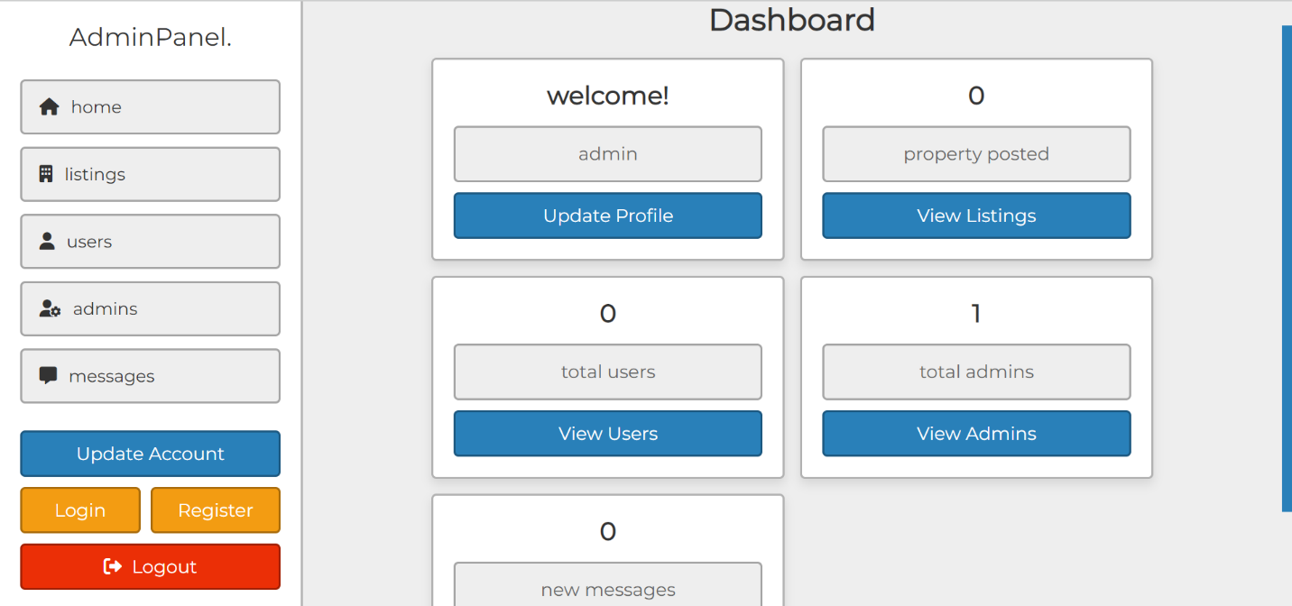

Here is the role offered for sale

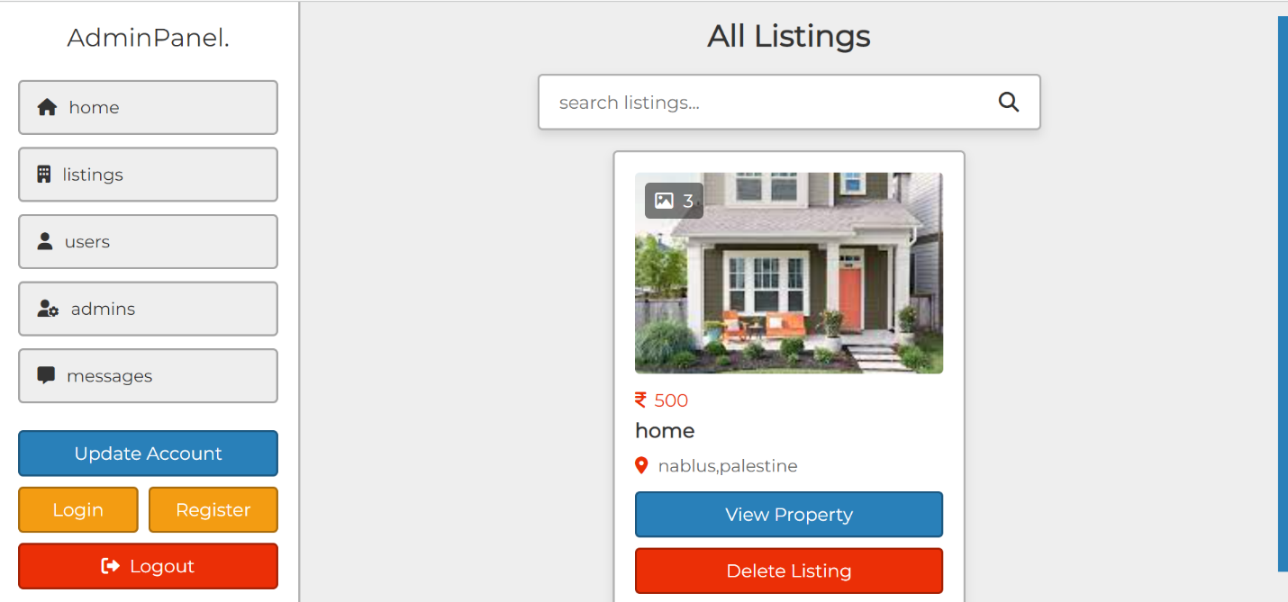

Here I show all the users registered on the site and they can offer homes and buy homes

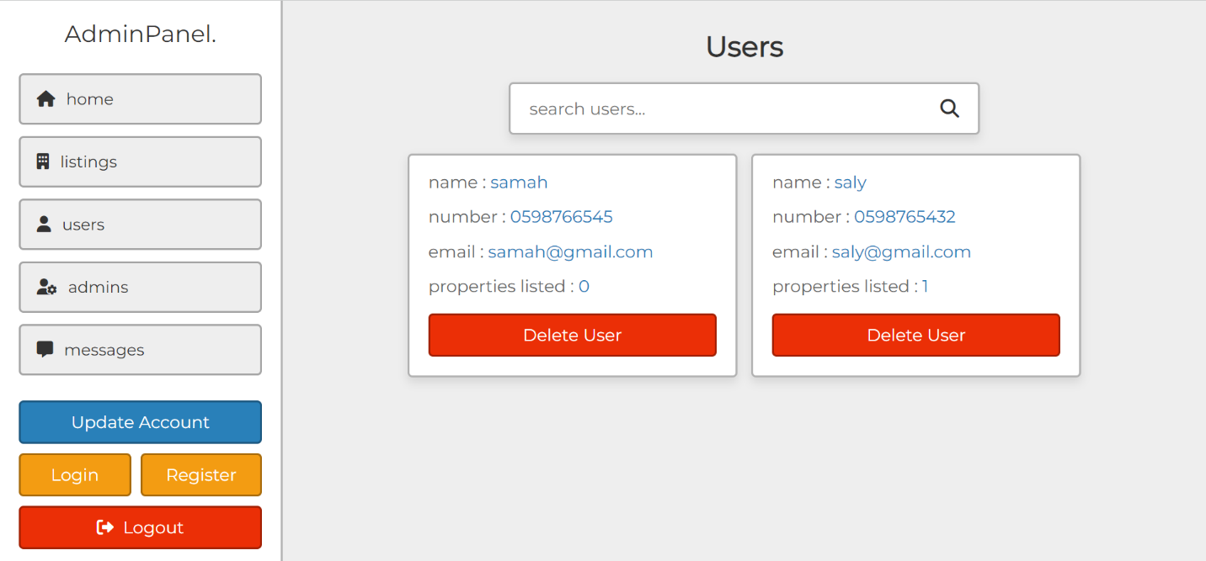

Here I show all the admins responsible for the site

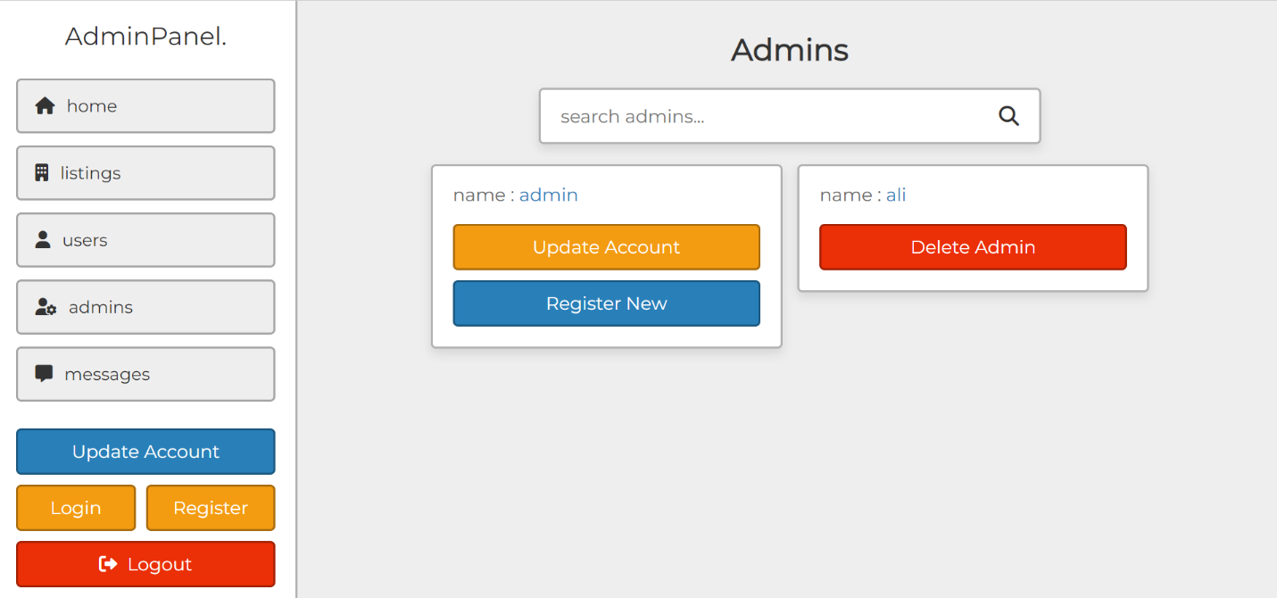

Here I show the messages that users sent to ADMIN

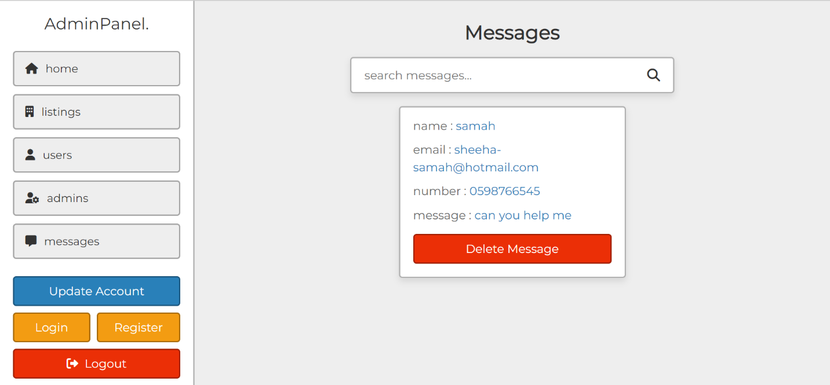

Here, if we want to update the admin information, for example, if you want to change the password

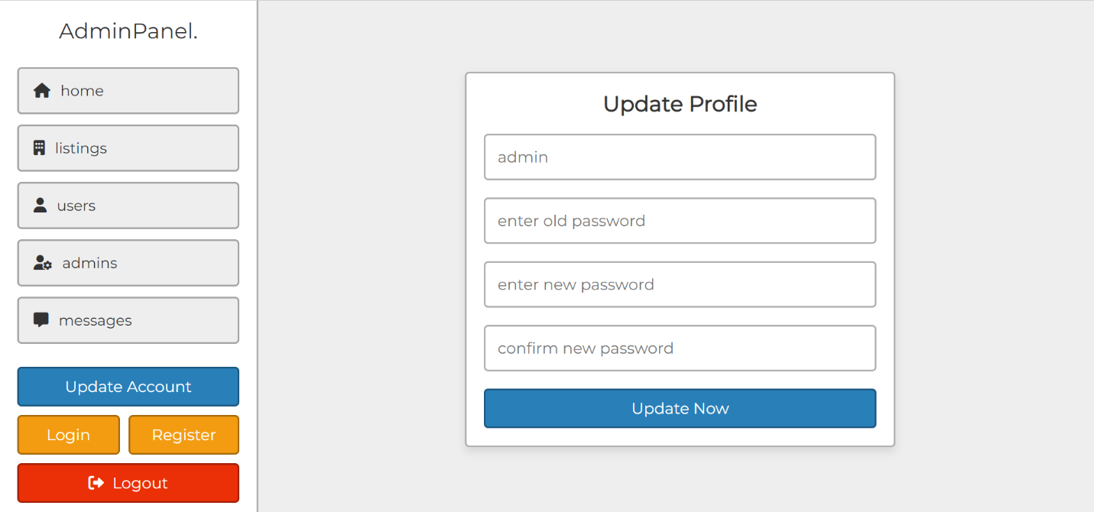

Here you make login for admin

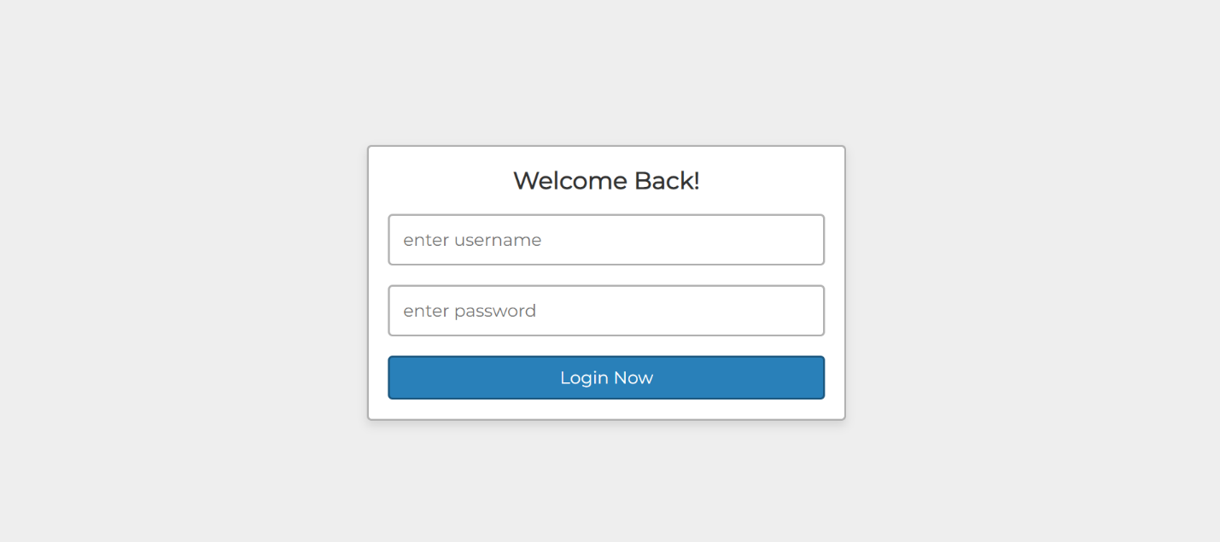

Here if you want to register a new admin

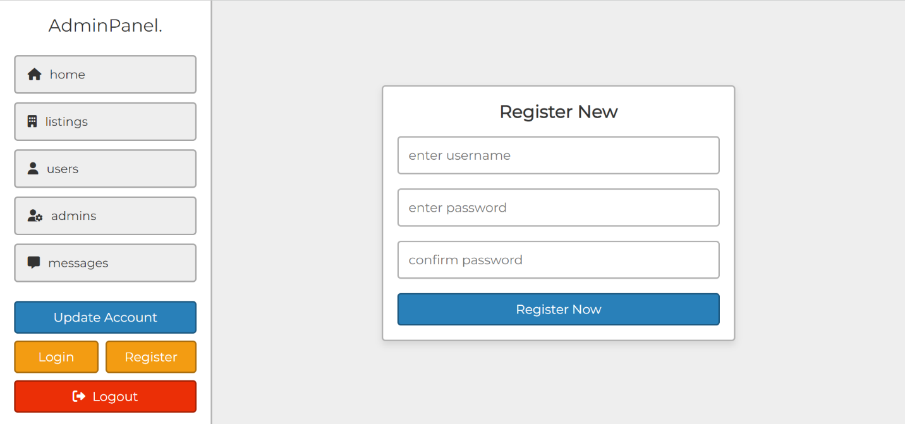

………………………………………………………………………………………………….

*To log in the user*

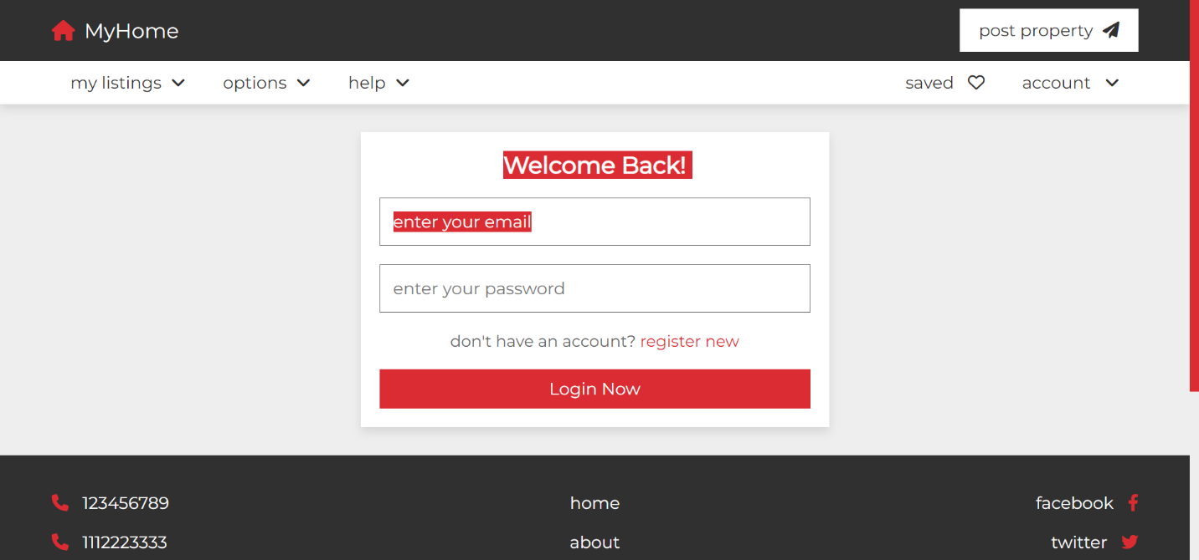

Log in a new user

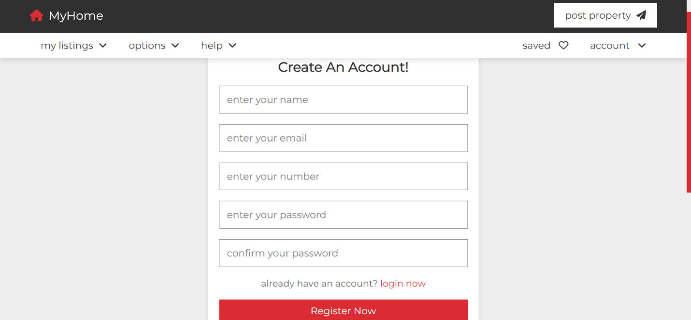

Modify user information

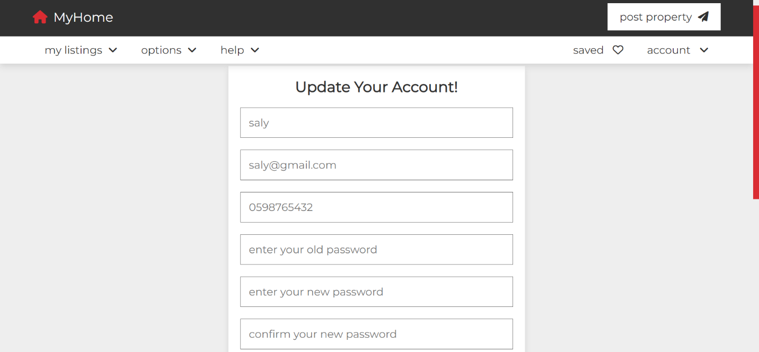

This is a saved listing page that contains the homes you liked, and you can also delete a house if you change your opinion about it. You don't want it.

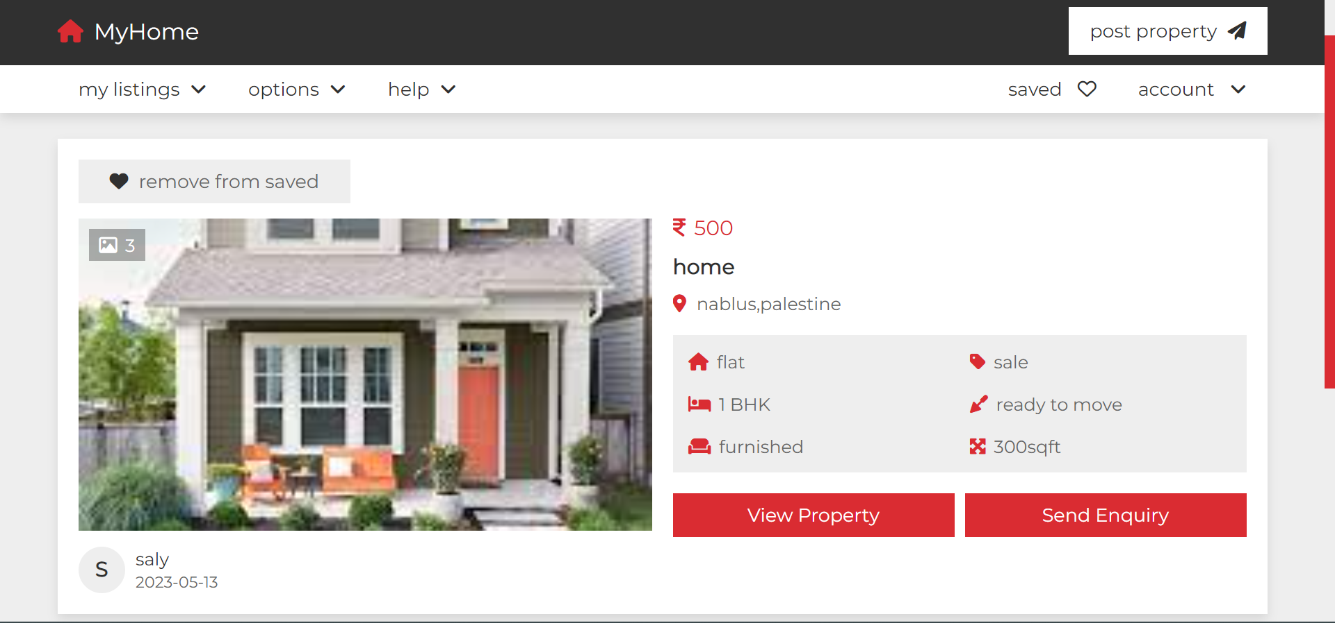

If you click on view property, you will see the details of this house, its price, how many rooms there are, and so on

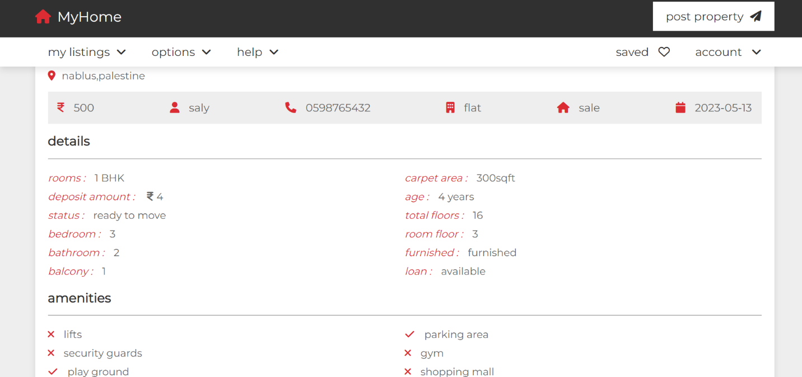

This page explains information about the site and contains feedback from users

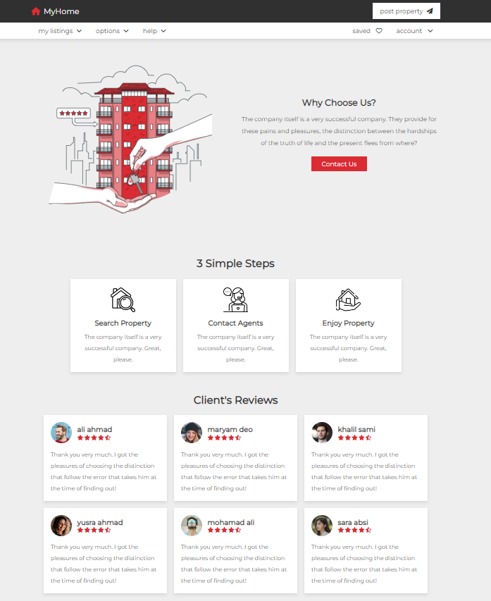

This is the contact page where the user communicates with the admin

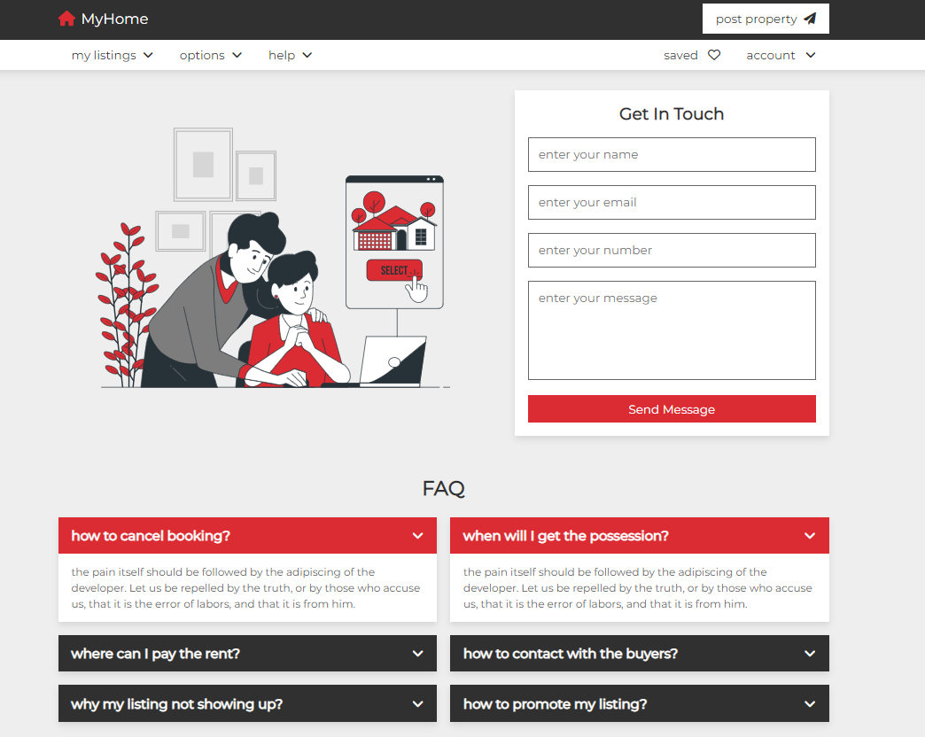

Here is the search page, where you can search for the specifications of the house you want, and if it is available, I will find it for you

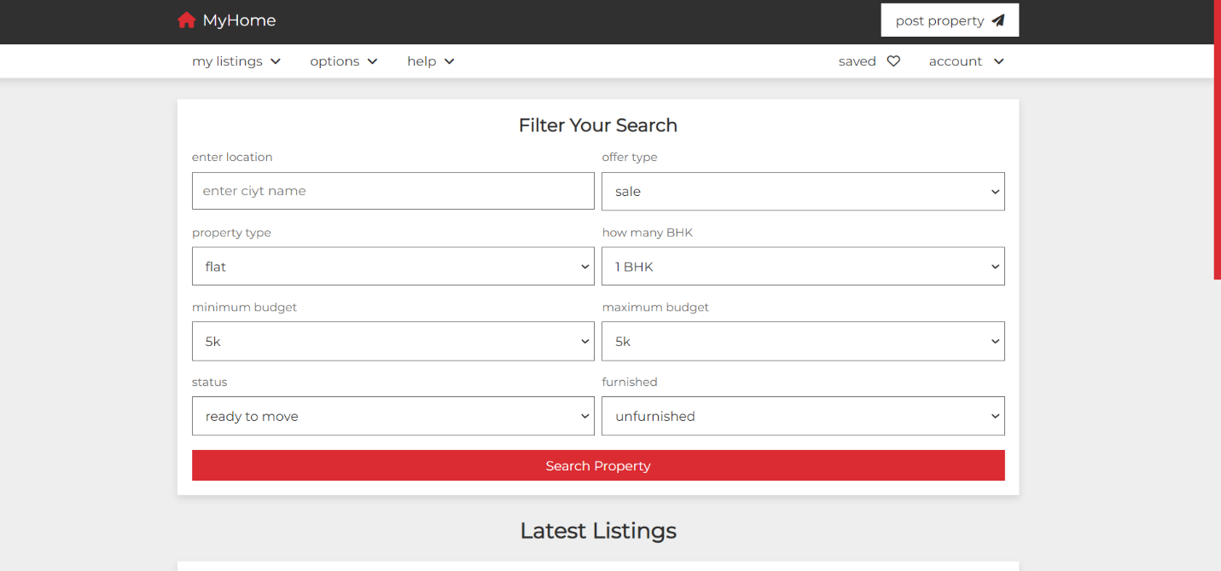

Here is the user dashboard page

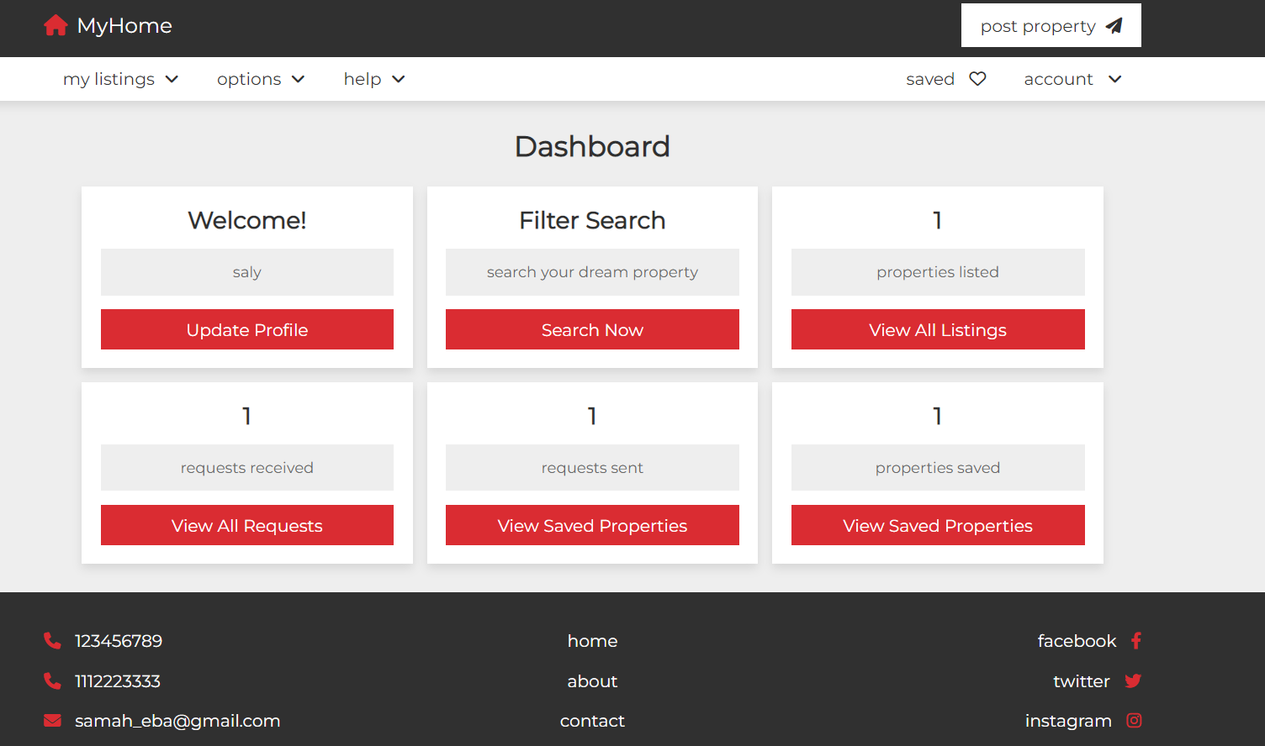

This page, if you want to offer a house for sale, put your information

