Software Requirements Specification

for

CAR SHOWROOM MANAGEMNT SYSTEM

Table of Contents

Table of Contents ii

Revision History ii

1. Introduction 1

1.1 Purpose 1

1.2 Document Conventions 1

1.3 Intended Audience and Reading Suggestions 1

1.5 References 1

2. Overall Description 2

2.1 Product Perspective 2

2.2 Product Functions 2

2.3 User Classes and Characteristics 2

2.4 Operating Environment 2

2.5 Design and Implementation Constraints 2

2.6 User Documentation 2

2.7 Assumptions and Dependencies 3

2.8 Class diagram-----------------------------------------------------------------------------------------3

2.9 Sequence diagram-----------------------------------------------------------------------------------3

3. External Interface Requirements 3

3.1 User Interfaces 3

3.2 Hardware Interfaces 3

3.3 Software Interfaces 3

3.4 Communications Interfaces 3

4. System Features 4

4.1 System Feature 1 4

4.2 System Feature 2 (and so on) 4

5. Other Nonfunctional Requirements 4

5.1 Performance Requirements 4

5.2 Safety Requirements 5

5.3 Security Requirements 5

5.4 Software Quality Attributes 5

5.5 Business Rules 5

6. Other Requirements 5

Appendix A: Glossary 5

Appendix B: Analysis Models 5

Appendix C: To Be Determined List 6

GROUP MEMBERS

|  |  |  |  |
| --- | --- | --- | --- |
| **Name** | **Date** | **COURSE** | **ID** |
| Farwa abbas | 12/11/20 | SE | 9456 |
| Asra hareem | 12/11/20 | SE | 9208 |

# Introduction

## Purpose Basically the purpose of Car showroom Management system is to save daily records of showroom fast and easy and get rid of old traditional way and through this project we will get closer to efficiency..

## Document Conventions This document uses the following Conventions e.g; database,C# etc.

## Intended Audience and Reading Suggestions This project is a prototype for the car showroom management system and it is restricted within the college premises. This has been implemented under the guidance of college professors. This project is useful for the car showroom management team.

## References [https://www.academia.edu/10159567/DESIGN_AND_IMPLEMENTATION_OF_CAR SHOWROOM_MANAGEMENT_SYSTEM](https://www.academia.edu/10159567/DESIGN_AND_IMPLEMENTATION_OF_CAR%20SHOWROOM_MANAGEMENT_SYSTEM)

# Overall Description

## Product Perspectivewhere admin can add any new item in Showroom. He also has the right to modify or delete the item from the application. A user can view information regarding items present in showroom.

## Product FunctionsThe major features of car showroom management system are following: 1-Login 2-sale a car 3-purchase car 4-delete car 5-add customer 6-calculate profit/loss

## User Classes and Characteristics

The main functions of this project are user can add(purchase) a new item(cars) with full specifications and can sale an item. Also, user can delete an item Moreover this software can calculate the profit/loss when you will sale an item it also manages the customer records it saves record of all time (sale, purchased, profit or loss on every item) these are the main functions of this application.

## Operating Environment1-Distributed Database 2-client/sever system 3-OS/windows 4-

## Design and Implementation Constraints

Describe any items or issues that will limit the options available to the developers. These might include: corporate or regulatory policies; hardware limitations (timing requirements, memory requirements); interfaces to other applications; specific technologies, tools, and databases to be used; parallel operations; language requirements; communications protocols; security considerations; design conventions or programming standards (for example, if the customer’s organization will be responsible for maintaining the delivered software

**External Interface Requirements**

## User Interfaces 1-Front end user 2-Back end software:SQL

## Hardware Interfaces 1-Laptop/Desktop

## Software Interfaces Following are the software used for the Car showroom management 1-OS 2-DBMS(SQL) 3-visual studio/C#

## Communications Interfaces This project support a unique GUI. We have simply use database to save different showroom records .

## System Features The Car showroom management maintain the information of the cars calculate profit/loss while sale a car. you can add a customer.

## System Feature 1

4.1.1 Description and Priority

Provide a short description of the feature and indicate whether it is of High, Medium, or Low priority. You could also include specific priority component ratings, such as benefit, penalty, cost, and risk (each rated on a relative scale from a low of 1 to a high of 9

4.1.2 Stimulus/Response Support

Search for different record of items

Delete the record and save record

## System Feature 2 (and so on)

2**.8 Class diagram**

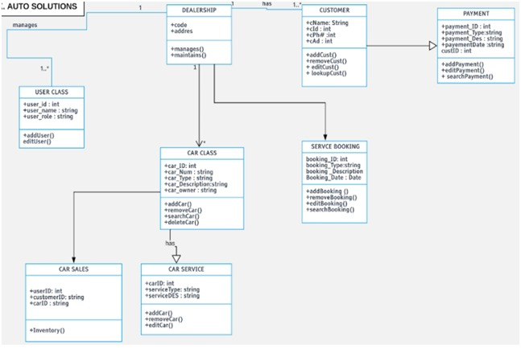

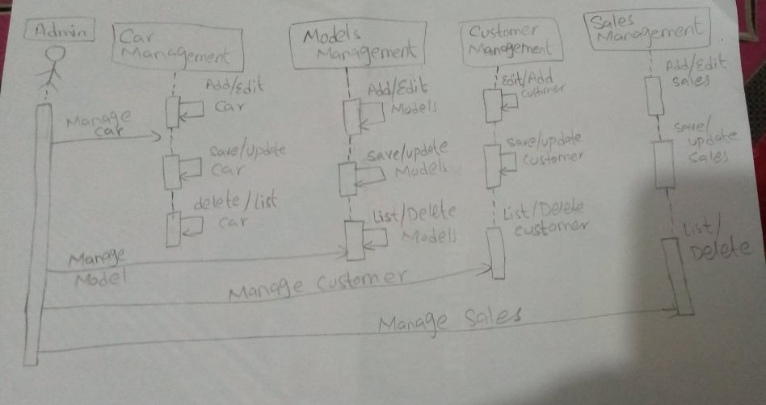**2.9 Sequence Diagram**

# Other Nonfunctional Requirements

## Safety Requirements If there is extensive damage to a wide portion of the database due to catastrophic failure, such as a disk crash, the recovery method restores a past copy of the database that was backed up to archival storage (typically tape) and reconstructs a more current state by reapplying or redoing the operations of committed transactions from the backed up log, up to the time of failure.

## Security Requirements We have protected our software by password only admin know the password only he can login it.

# Other Requirements

Appendix A: Glossary  
 we only need to analysis and start work on project while we will save our all work in database for that we need SQL server management studio.

