PROJECT REPORT

KG-Enhanced Intelligent Diagnostic Chatbot
Symptom Guide: knowledge-grounded symptom interviews with informed search and a local language model

Group 12
Name | Student ID
Yang Ruihan | A0356537U
Liu Hengyu | A0353701M
Yang Peixin | A0357227Y

October 2026

1 Business Case and Market Research

1.1 The problem: a fragmented follow-up journey
A typical outpatient episode is not a single visit but a chain of separate steps: an initial consultation, a diagnostic test (blood test, ECG or imaging), the release of the result hours or days later, finding a clinician to review it, and finally a follow-up decision. These steps often happen on different days and in different places. In the gaps between them the patient is on their own: symptoms may change, new questions arise, and uncertainty about what the result means accumulates.
What happens in these gaps is easily lost. Patients remember medical information poorly: a widely cited review reports that 40–80% of the medical information given by practitioners is forgotten immediately, and that almost half of what is remembered is incorrect [1]. When the follow-up appointment arrives, the history is often reconstructed from memory, and the short consultation time is partly spent recovering information that could have been recorded as it happened.
Unmet need. Patients need a simple way to preserve symptom changes, questions and uncertainty between a test and the next appointment, so that a licensed clinician can review them together with the result. This is the need Symptom Guide addresses.

1.2 Market context in Singapore
Singapore already has the digital foundations for such a tool, and several trends increase the demand for it.
- Patients can already see their results, but are told to interpret them with a doctor. The national HealthHub platform shows laboratory, radiology, histology and other reports from the National Electronic Health Record, together with discharge summaries [2]. It explicitly advises that laboratory reports "should be interpreted in consultation with your doctor", and some report types are released only after a minimum six-week delay so that patients can discuss them with their doctor first [2]. Access to results is solved; preparation for the conversation about them is not.
- An ageing population with more chronic conditions and follow-ups. The share of citizens aged 65 and above rose from 13.1% in 2015 to 20.7% in 2025, and about one in four citizens (23.9%) is projected to be 65 or older by 2030 [3]. Older patients have more tests, more follow-up appointments and more difficulty keeping track of symptoms and questions between them; caregivers often manage this on their behalf.
- Remote and continuous care is established. Telemedicine is licensed under the Healthcare Services Act, and in April 2024 the Ministry of Health (MOH) reported that 19 providers offered telemedicine without physical premises [4]. Patients are increasingly used to digital touchpoints between visits.
- Primary care is moving towards a continuous relationship. Under Healthier SG, residents enrol with one family doctor as their first point of contact and develop a health plan with that doctor, with plans made digital on HealthHub [5]. A structured symptom summary fits this model of ongoing care rather than one-off visits.

1.3 Target users and value proposition
The primary users are adults waiting between a diagnostic test and a follow-up appointment, including older patients and the family members who help them. The secondary beneficiaries are the clinicians who receive a clearer starting point for the follow-up conversation. Table 1 summarises what changes for the patient.
Table 1. Value proposition across the follow-up journey.
Moment | Without support | With Symptom Guide
During the wait | Symptoms are remembered separately and inaccurately | Changes are recorded when they happen, as present, absent or uncertain
Before follow-up | Questions and uncertainty are easy to forget | Questions and the evidence behind them are kept in one place
At the appointment | The history starts again from memory | An organised, exportable summary gives the discussion a clearer starting point

The expected value is less uncertainty for the patient and a more structured, efficient follow-up conversation. The chatbot's targeted questions (Section 2.5) serve this goal: they prompt the patient to report the symptoms that matter most for the possible conditions, which a free-text diary would not capture. The ranked list of possible conditions is presented as material to discuss with a doctor, never as a diagnosis.

1.4 Competitive landscape and differentiation
Three groups of existing products address parts of this journey (Table 2). Consumer symptom checkers focus on self-diagnosis and triage before care is sought. Their accuracy is limited: an evaluation of 23 symptom checkers on 45 standardised vignettes found the correct diagnosis listed first in 34% of cases and within the top three in 51%, with appropriate triage advice in 57% [6]. Telemedicine services provide access to a clinician but do not help the patient organise information between contacts. Record portals such as HealthHub provide results but deliberately leave their interpretation to doctors.
Table 2. Positioning against existing product categories.
 | Symptom checkers | Telemedicine apps | Record portals | Symptom Guide
Main purpose | Self-diagnosis and triage | Remote consultation | Access to results and records | Preparation for follow-up
Patient can review and correct what was understood | Limited | Not applicable | Not applicable | Yes: editable symptom log
Keeps context across turns and sessions | Usually single session | Within a consultation | Not applicable | Yes: versioned sessions
Shows the basis of each output | Rarely | Not applicable | Not applicable | Yes: supporting symptoms, sources
Data stays on the user's device | Usually cloud-based | Cloud-based | Government cloud | Yes: local language model

Symptom Guide differentiates on three properties: the patient can correct the system, because the symptom log stays visible beside the conversation; the conversation keeps its context, across turns and page reloads; and knowledge-based answers show their basis, so users can see which reported symptoms and which knowledge-graph relations support each output. Running the language model locally adds a privacy advantage, as conversation text does not leave the user's computer.

1.5 Business model and adoption path
The most realistic route to adoption is business-to-business-to-consumer: clinics, polyclinics or telemedicine providers offer Symptom Guide to their patients between a test and the follow-up visit, and receive the exported summary at the appointment. The patient uses it free of charge; the provider pays a licence or subscription fee justified by shorter history-taking and better-prepared consultations. Alignment with Healthier SG health plans and HealthHub would be a longer-term integration option. Operating costs are low, because the language model runs on commodity hardware and the knowledge graph and recall model are static files; the main costs are clinical validation, content maintenance and regulatory work. A pilot with one clinic, measuring consultation time and clinician-rated summary usefulness, would be the first step.

1.6 Regulatory and risk considerations
Positioning matters for regulation. Singapore's Health Sciences Authority (HSA) regulates software whose intended use meets the definition of a medical device, and its guidelines treat software that provides information "to triage or identify early signs of a disease or condition" as driving clinical management, requiring clinical evidence [7]. Symptom Guide is therefore positioned as a preparation and record-keeping tool: it never presents a diagnosis, shows medication relations only as information to discuss with a doctor, and carries a disclaimer on every result. Any future claim of diagnostic or triage performance would require registration and clinical validation. Personal data handling must comply with the Personal Data Protection Act; local processing and pseudonymised logs reduce this risk. The main residual risks, analysed in Section 5, are missed red-flag symptoms and over-reliance on the ranked conditions.

2 System Design and Model

2.1 Design overview
The chatbot treats symptom triage as a sequential decision problem. At every turn it holds a probability distribution over diseases, asks the one question expected to separate the most likely candidates, and stops when the probability has concentrated on a short differential diagnosis. Figure 1 shows the resulting pipeline of six stages: language understanding, symptom state, disease recall, a stopping decision, either informed search (next question) or drug retrieval (final result), and reply generation.
Three principles shaped the design:
- The language model never makes clinical decisions. The large language model (LLM) only proposes symptom observations, which deterministic validators must confirm, and writes the conversational wording. Ranking, question choice, stopping and medication information are computed by inspectable components.
- Every output is traceable. Each candidate disease lists the user-confirmed symptoms that support it, each question carries the reason it was chosen, and each drug relation carries its relation type and knowledge source.
- Evidence has three states. A symptom is present, absent or unknown. "Not sure" is never converted into "absent", because absence is evidence while uncertainty is not.

2.2 Medical knowledge graph
The knowledge graph is a subset of PrimeKG [8], which integrates 20 biomedical resources. We kept disease, phenotype and drug nodes and the relations between them, and removed node types without relevant links (for example anatomy). The preprocessed reasoning store contains 6,683 diseases with 142,704 disease–phenotype edges and 1,021 explicit "lacks phenotype" edges; 1,548 diseases with 11,956 drug relations (9,388 indications and 2,568 off-label uses) over 1,855 drugs; and 30,675 disease–drug contraindication pairs. The graph serves three purposes: its 15,135 phenotype terms, based on the Human Phenotype Ontology (HPO) [9], form the chatbot vocabulary; its drug relations and contraindications drive drug retrieval; and it powers the knowledge-graph reasoning baseline described in Section 2.8.
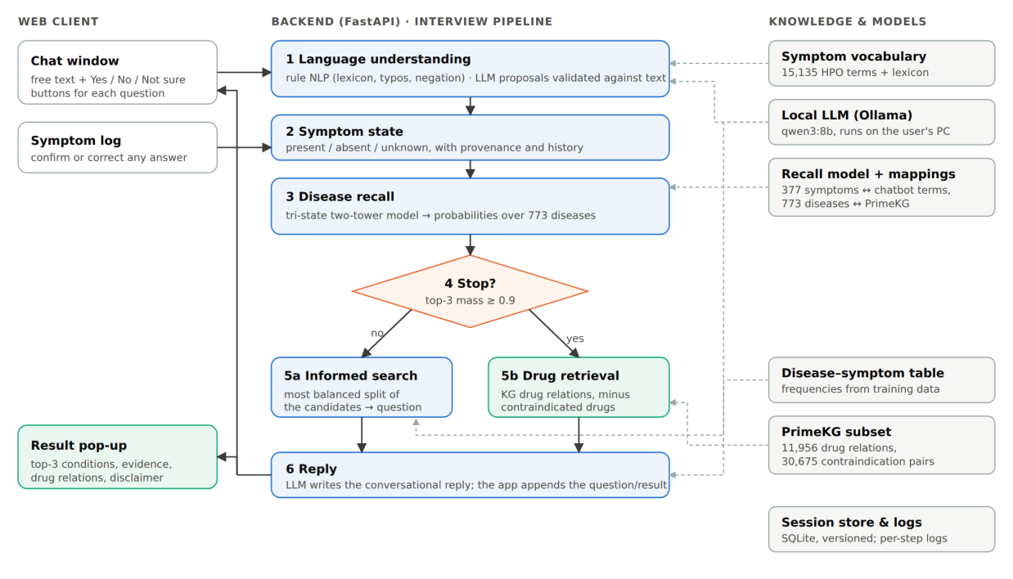
Figure 1. System architecture. Solid arrows show the interview loop; dashed arrows show which knowledge source each stage uses.

2.3 Disease recall model
Candidate diseases are produced by a tri-state two-tower retrieval model developed by team member Liu Hengyu. It was trained on a public Disease–Symptom dataset [10] of 246,945 records covering 773 disease labels and 377 binary symptoms. After exact duplicates were removed (189,647 records), the data were split 80/10/10 so that identical symptom vectors never cross splits (151,899 / 18,774 / 18,974 records).
The patient is encoded as a 754-dimensional vector: the first 377 entries mark symptoms reported present, the second 377 mark symptoms reported absent, and an unknown symptom is zero in both halves. A patient tower (a multilayer perceptron, 754 → 128 → 64) maps this vector to an embedding, which is scored against a learned 64-dimensional embedding of each disease:
score(d) = ⟨ f(x), e_d ⟩ / 8, p(d | x) = softmax(score)
On the held-out test split, with three present symptoms per case, the model reaches Hits@1 0.558, Hits@3 0.817, Hits@5 0.898, Hits@10 0.972 and MRR 0.704. For deployment we re-implemented the forward pass in NumPy, reading the same weight file, so the chatbot runs without PyTorch; the two implementations agree to within 10⁻⁵.

2.4 Linking the model to the knowledge graph
The model speaks in lay symptom labels (for example "sharp chest pain"), while the dialogue works with HPO terms (for example "Chest pain"). A generated mapping links the two using the knowledge-graph node attached to each model symptom (Table 3). Broad terms receive an asymmetric rule: a Yes to "Chest pain" is recorded as the group's representative symptom ("sharp chest pain"), while a No rules out every member of the group. In addition, 19 reviewed synonyms connect common colloquial terms to the model, for instance "Pharyngitis" (what users mean by "sore throat") to the model symptom "sore throat". On the output side, 291 of the 773 diseases are linked to a PrimeKG disease, 231 of which have drug relations.
Table 3. Mapping of the 377 model symptoms to the chatbot vocabulary.
Mapping type | Model symptoms | Example
Exact name match | 47 | cough → Cough
One-to-one through the shared graph node | 151 | coughing up sputum → Productive cough
Representative of a broad term | 19 | sharp chest pain ← Chest pain
Model-only term added to the vocabulary | 160 | diarrhea, toothache
Total | 377

2.5 Informed search
Questions are chosen by a greedy best-first heuristic. Let C be the current candidate set with model probabilities p(d), and S(d) the symptoms associated with disease d. S(d) is taken from the training data: a symptom belongs to a disease when at least 20% of that disease's records contain it (5,389 disease–symptom pairs; a median of 7 symptoms per disease). For every symptom s that has not been asked yet:
P_yes(s) = Σ_{d ∈ C, s ∈ S(d)} p(d) / Σ_{d ∈ C} p(d), h(s) = min( P_yes(s), 1 − P_yes(s) )
The symptom with the largest h(s), the most balanced split of the probability mass, is asked next, with ties broken alphabetically so that runs are reproducible. Whatever the answer, roughly half of the remaining probability mass is either supported or contradicted. Because the choice depends only on how evenly a question splits the candidates, the heuristic does not need to estimate how many diseases each answer would exclude. If the disease–symptom associations are treated as certain, maximising h(s) is equivalent to maximising the entropy of the expected answer, that is, the expected information gain of the question. A Yes or No answer is then written into the recall model input and the ranking is recomputed, so candidates are down-weighted rather than deleted. A "Not sure" answer is recorded as unknown, leaves the model input unchanged and marks the symptom as asked, and the next question is chosen in the same way. The question is shown together with its rationale, for example "5 of 10 candidates (52% of the ranking weight) have this symptom".

2.6 Stopping rule
The interview stops when the three most likely diseases together hold at least τ = 0.9 of the probability. The result is then presented as a three-item differential diagnosis together with drug relations. Otherwise at least four candidates are kept and the interview continues, up to 12 follow-up questions. Two further stop conditions cover the case where no question can still split the candidates and the case where no disease matches. Interviews that end without meeting the probability criterion are reported as inconclusive, without drug information and with advice to see a doctor. The threshold was selected experimentally (Section 4.3).

2.7 Dialogue layer and LLM
A locally hosted Qwen3-8B model [11], served by Ollama, keeps all conversation data on the user's computer. For understanding, the LLM receives the latest message and a short list of candidate concepts (vocabulary matches and retrieval hits) and returns JSON observations. Each observation must quote the user's words exactly, refer to a candidate concept, and be a personal assertion rather than a question or a statement about another person. Observations that fail validation are rejected, and plausible but unconfirmed interpretations are shown as suggestions for the user to confirm. For replies, the LLM writes a short answer and is instructed not to ask questions itself; the application appends the informed-search question with Yes / No / Not sure buttons. Button answers bypass the LLM entirely, which keeps the questioning loop deterministic and fast.

2.8 Alternative reasoning modes
The three reasoning services sit behind common interfaces (recall, search, drugs), so the reasoning back end can be switched by configuration. Two earlier modes are kept for comparison (Table 4).
Table 4. Reasoning modes implemented behind the same interfaces.
 | kg | ddxplus | recall773 (final)
Candidate ranking | Symptom overlap in PrimeKG, weighted by specificity (IDF) | Tri-state model trained on DDXPlus [12] | Tri-state model, 773 diseases
Disease coverage | 6,683 | 49 | 773
Effect of a "No" answer | Deletes the diseases that have the symptom | Soft: absent input channel | Soft: absent input channel
Stopping | ≤ 2 candidates | ≤ 2 candidates | Top-3 mass ≥ 0.9
Main limitation | No probabilities; graph annotations are incomplete | Narrow scope (respiratory and cardiac) | Synthetic training data

3 System Development and Implementation

3.1 Architecture and technology stack
The back end is written in Python with FastAPI and Pydantic. A single orchestrator, ChatbotService, owns the dialogue state and calls the three reasoning interfaces, so each reasoning mode is a separate, testable adapter. Sessions are stored in SQLite with a version number on every state (optimistic concurrency) and a request identifier on every call, so a retried request is replayed instead of being applied twice. The front end is a Vue 3 single-page application written in TypeScript, using Pinia for state, Element Plus for components and Vite for builds. The FastAPI server serves the front end itself, so the whole system starts with one command. The LLM runtime connects to Ollama with a fixed context window and a keep-alive period, which removed model reloads between turns.

3.2 Integrating the team's components
- Knowledge graph. A preprocessing script turns the filtered PrimeKG tables into a compressed reasoning store (disease–symptom, "lacks", drug and contraindication maps) that loads in about one second.
- Informed search and drug retrieval. The group's search and drug-retrieval modules are used unchanged behind the service interfaces. We added candidate weighting by model score and a contraindication filter, which removes a drug if it is contraindicated for any remaining candidate.
- Recall model. The model bundle is copied into the repository with checksum verification of all 30 files. Mapping tables and the disease–symptom frequency table are produced by scripts, so they can be regenerated when the model changes.

3.3 Robust language understanding
Rule-based extraction remains the first layer, because it is fast and explainable, and because the LLM's candidate list depends on it. It detects assertion status (present, absent, uncertain, another person, past) around every matched term. During development we added four improvements:
- a lay lexicon of 431 colloquial phrases for 101 terms ("the runs", "throwing up", "stuffy nose");
- one-edit typo tolerance restricted to 69 common symptom words, with an exclusion list of real English neighbours ("couch" is not "cough", "thirty" is not "thirsty"); every correction is shown to the user;
- informal negation such as "dont" and "havent";
- a stop-list of 65 HPO modifier terms ("Severe", "Chronic", "Left") that must not be recorded as symptoms.

3.4 User interface
The interface (Figure 2a) combines a chat window, Yes / No / Not sure buttons for each question, and a symptom log grouped by status, where any answer can be corrected and the result is recomputed. When the interview ends, a result pop-up (Figure 2b) presents the top-3 conditions with their supporting symptoms, drug relations grouped by condition, the user's answers and a disclaimer. Two usability defects found in testing were fixed: the interview stalled after the user confirmed a suggested symptom or made small talk. The pending question is now asked again in both cases. The whole session, including the answers and the result, can be exported as a summary to bring to the follow-up appointment (Section 1.3).

3.5 Observability, testing and reproducibility
Each pipeline stage writes structured log entries (startup, flow, NLP, agent, LLM, recall, search, drugs), so a single consultation can be traced from the user's words to the model input, the top-5 probabilities, the chosen question and the stopping decision. Logs carry a hash of the session identifier and do not record the user's raw text unless this is explicitly enabled. The back end has 234 automated tests, including 16 dedicated to the stopping rule. These cover configuration, exact boundary values (top-3 mass 0.900 versus 0.899), full sessions and the real model. Three evaluation scripts reproduce every number in Section 3, and the stop-rule validation fails with an error if accuracy or efficiency falls below fixed regression thresholds.
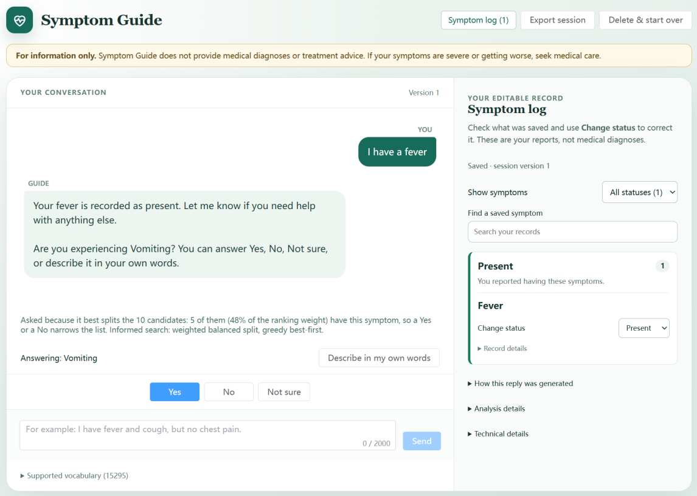
Figure 2a. Conversation view: the follow-up question with its rationale, Yes / No / Not sure buttons, and the editable symptom log.
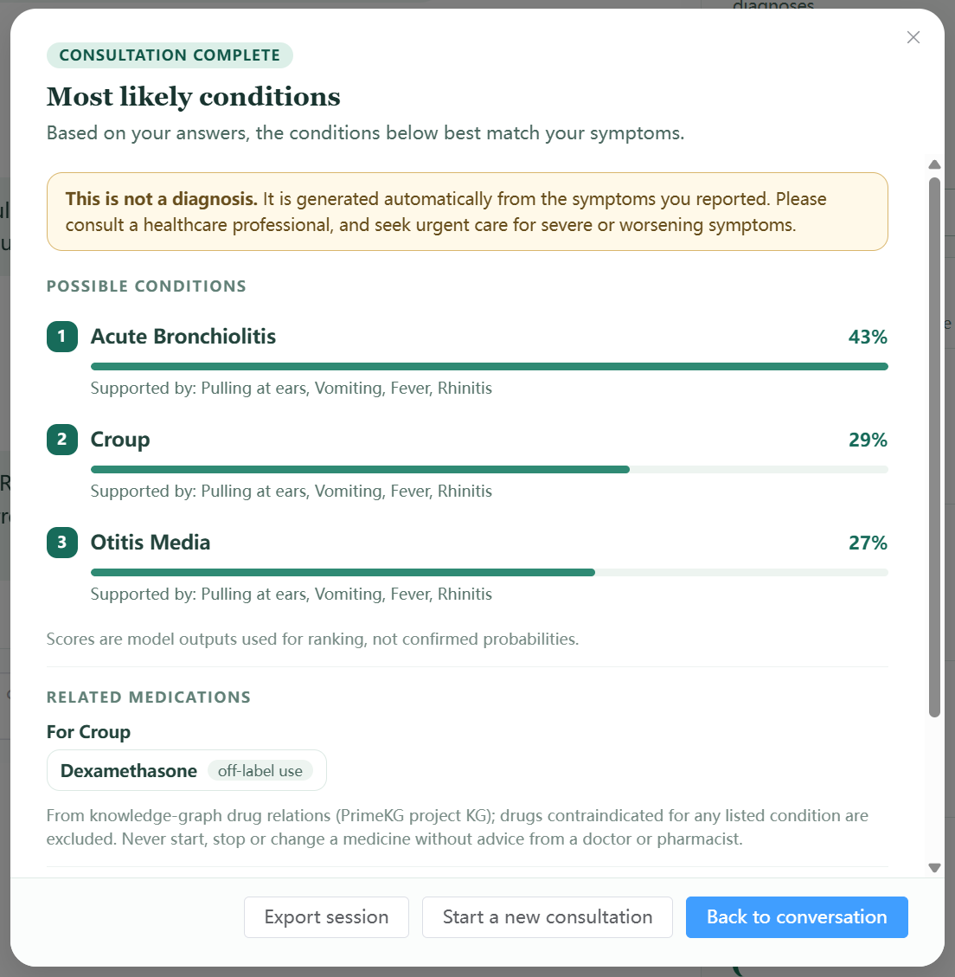
Figure 2b. Result pop-up after a converged interview: top-3 conditions with supporting symptoms, related drugs from the knowledge graph, and the disclaimer.

4 Experiments

4.1 Evaluation protocol
The experiments follow the five evaluation objectives defined at the start of the project: retrieval accuracy, questioning efficiency, robustness, explainability and overall task performance. Real patients could not be used, so interviews were run with a simulated patient. The patient opens with two symptoms and then answers each question Yes if the asked term covers one of its symptoms and No otherwise. Three test sets were used (Table 5).
The main metrics are Hits@k (the correct disease is among the top k), "acceptable@3" for D2 (the diagnosis or an accepted alternative is in the top 3), the average number of follow-up questions, and the share of interviews ended by the stopping rule rather than by the 12-question limit.
Table 5. Test sets. D1 records come from the model's test split and were never used for training. The D2 patients' symptom lists were written independently of the model. The D3 blind probes were written by an independent agent that saw only the symptom list.
Test set | Size | Gold standard | Purpose
D1 Held-out records | 500 records, 256 diseases | Record label | In-distribution accuracy and efficiency; stop rule
D2 Clinical vignettes | 38 cases, 13 body systems | Diagnosis plus clinically acceptable alternatives | Out-of-distribution check; safety and explainability
D3 Language probes | 20 development, 20 held-out, 40 blind | Expected symptom and status | Robustness of language understanding

4.2 Retrieval accuracy
Table 6 compares ranking after the opening message with ranking at the end of the interview. On D1 the interview raises Hits@3 from 59.0% to 85.4% and Hits@1 from 32.4% to 49.8%, with 5.0 questions on average. On the clinical vignettes, accuracy is much lower: the correct diagnosis is in the top 3 in 42.1% of cases, and a clinically acceptable diagnosis in 63.2%.
Table 6. Accuracy after the opening message (2 symptoms) and at the end of the interview.
Test set | Hits@1 (opening) | Hits@3 (opening) | Hits@1 (final) | Hits@3 (final)
D1 500 held-out records | 32.4% | 59.0% | 49.8% | 85.4%
D2 38 clinical vignettes | 5.3% | 13.2% | 13.2% | 42.1% (63.2% acceptable)
Reference: static ranking, 3 symptoms [model test set] | – | – | 55.8% | 81.7%

4.3 Choosing the stopping threshold
To compare stopping rules fairly, every D1 interview was first recorded for the full 12 questions. Each rule was then replayed on the same recordings (Table 7, Figure 3). Our first rule, which stopped only when the leading disease reached 0.80 and the top two reached 0.95, needed 7.5 questions on average. Rules based on the top-3 mass trade questions for accuracy smoothly. At τ = 0.9 Hits@3 equals that of the first rule (87.0%) with 2.5 fewer questions, and when the rule fires the correct disease is in the top 3 in 99% of interviews. We therefore adopted τ = 0.9. Run end to end with the deployed system, it gave 5.0 questions, 77.8% of interviews stopped by the rule and Hits@3 of 85.4%, close to the replayed values.
Table 7. Stopping rules replayed on the same 500 recorded interviews (D1).
Stopping rule | Avg questions | Stopped by rule | Hits@3 | Hits@3 when rule fired | Stopped although every answer was No
First rule (top-1 ≥ 0.8, top-1 + top-2 ≥ 0.95) | 7.5 | 62% | 87.0% | 99% | 14%
Top-3 mass ≥ 0.70 | 3.6 | 88% | 80.4% | 88% | 53%
Top-3 mass ≥ 0.80 | 4.4 | 85% | 83.6% | 93% | 44%
Top-3 mass ≥ 0.85 | 4.7 | 83% | 86.4% | 97% | 39%
Top-3 mass ≥ 0.90 (adopted) | 5.0 | 81% | 87.0% | 99% | 35%

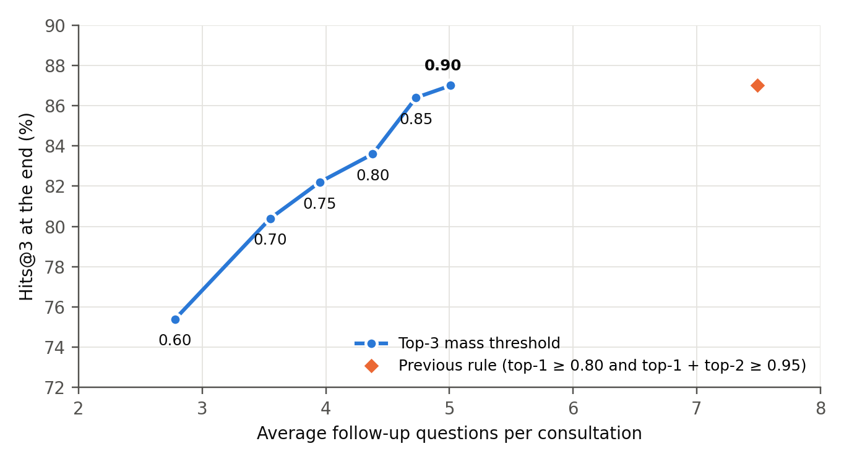
Figure 3. Accuracy against interview length for top-3 mass thresholds 0.60–0.90 on D1. The first rule needs 2.5 more questions for the same Hits@3.

4.4 Question selection
To measure the value of informed search, it was replaced by a baseline that asks a random question from the same pool of candidate symptoms; the baseline was run three times on D1. Informed search needed 9% fewer questions (5.0 against 5.5), ended more interviews through the stopping rule (77.8% against 70.7%) and improved Hits@3 by 3.3 points (85.4% against 82.1%). Hits@1 was, however, 3 points lower (49.8% against 52.9%; Figure 4).

4.5 Robustness to noisy and incomplete answers
Three perturbations were applied to D1 (Figure 4). When 30% of the answers were "Not sure", Hits@3 fell only from 85.4% to 81.2% and the interview grew by 0.8 questions. A single wrong answer to the first question was far more harmful: Hits@3 fell to 66.0%, and the stopping rule fired with only 75% precision, because the interview stopped early on misleading evidence. Opening with one symptom instead of two needed 9.1 questions and reached a Hits@3 of 67.2%.
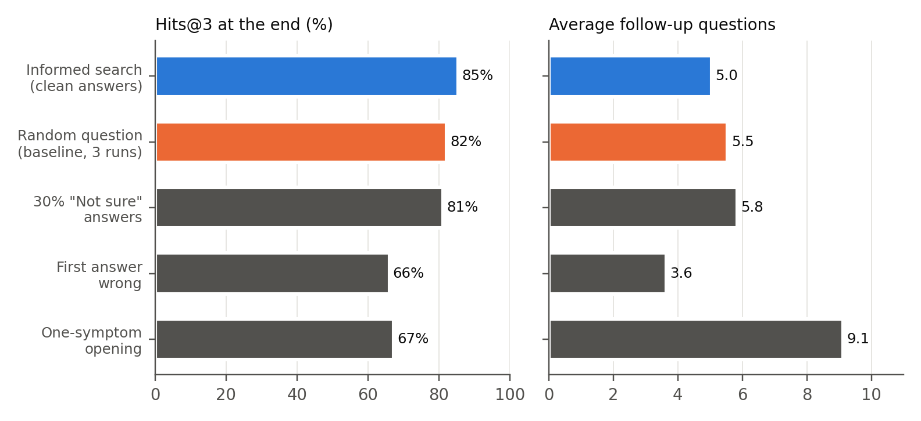
Figure 4. Question selection and answer noise on D1 (500 records): accuracy (left) and interview length (right). The random baseline is the mean of three runs.

4.6 Robustness of language understanding
On the 40 blind probes, the language-understanding changes of Section 3.3 raised the pass rate from 20% to 55% (Figure 5). Typos rose from 0/6 to 5/6, negation from 1/6 to 3/6 and colloquial wording from 0/14 to 4/14. The development probes, which guided the changes, rose from 45% to 100%, and the held-out probes from 20% to 90%; both figures are optimistic for that reason. End to end, the share of D2 vignettes whose correct diagnosis enters the candidate list after a natural-language opening rose from 28.9% to 47.4%. It now matches the rate obtained when the symptoms are entered as exact vocabulary terms. These results use the rule-based path; the LLM path was not evaluated quantitatively, because its outputs are not deterministic.

4.7 Explainability and safety
Automatic checks over all D2 sessions are summarised in Table 8. All explainability checks passed. The safety checks show two weaknesses: a recommendation for urgent care in red-flag cases, which is not implemented, and conclusions reached from denials alone.
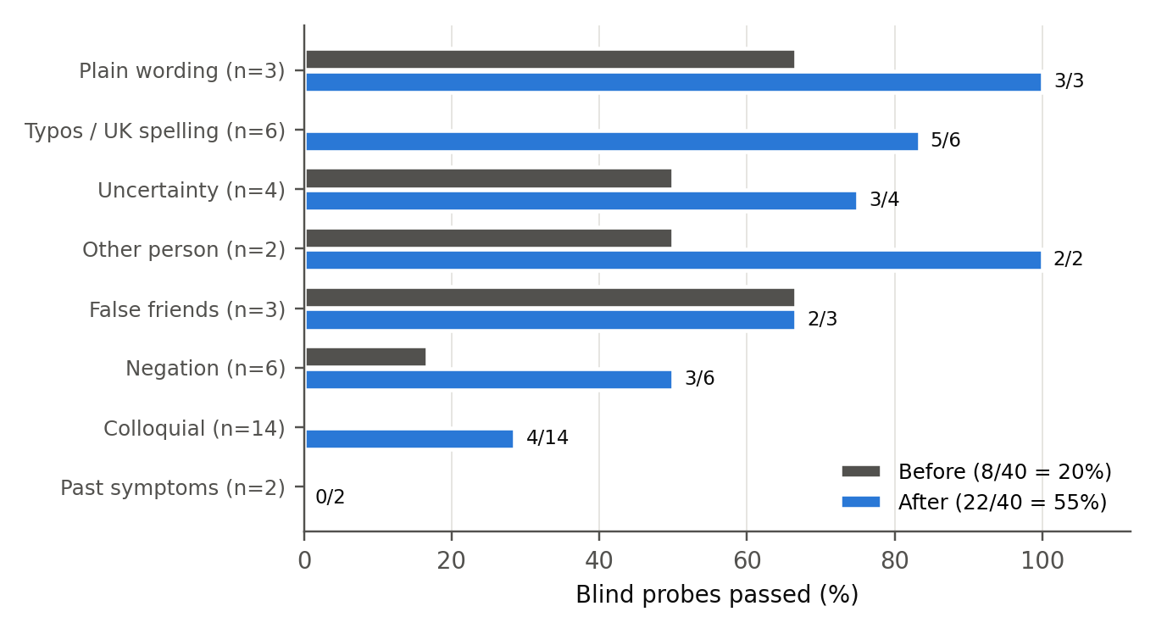
Figure 5. Blind language probes passed before and after the improvements, by type of input.
Table 8. Explainability and safety checks.
Check (D2, 38 vignettes) | Result
Top candidate has at least one supporting, user-confirmed symptom | 100%
Every question shows the reason it was chosen | 100%
Every drug relation shows its relation type and source | 100%
Every result carries the "not a diagnosis" statement | 100%
No medication shown before the interview concludes | 100%
Recommended drugs contraindicated for a listed condition | 0 cases
Off-topic or symptom-free input produces no candidates | Pass
No confident result when the patient answers No to everything | 84%
Urgent-care advice in red-flag cases (heart attack, stroke, meningitis) | 0% (not implemented)

5 Findings and Discussion

5.1 Main findings
Asking questions is what makes the system accurate. With two opening symptoms, the model alone places the correct disease in the top 3 for 59% of D1 cases. After about five targeted questions this rises to 85%, which is higher than the static model given three symptoms (82%). The negative half of the input explains why. In static testing, adding up to five denied symptoms changed the model's Hits@1 by less than 0.3 points (0.558–0.560), whereas the denials collected during the interview, combined with targeted positive questions, account for much of the gain. Absence evidence is useful when it is gathered selectively, not when it is listed at random.
Top-3 probability mass is a reliable stopping signal. When the rule fired, the top 3 contained the correct disease in 99% of D1 interviews; when it did not, in only 36%. The way an interview ends therefore tells the user how confident the system is. This justifies presenting only converged results with medication information and labelling the others as inconclusive. Framing the output as a differential diagnosis rather than a single answer also matches how clinicians reason under uncertainty, and it was the change that made interviews finish in reasonable time.
Informed search helps, but less than expected. The balanced-split heuristic shortened interviews by 9% and improved Hits@3 by 3.3 points over random questions, but it did not improve Hits@1. The heuristic is myopic: it splits the candidates using a fixed disease–symptom table and does not ask the model how much each answer would change the ranking. A natural next step is to choose questions by expected information gain computed with the model itself, simulating a Yes and a No through the recall model for each candidate symptom.
Wrong answers cost far more than uncertain ones. Thirty percent "Not sure" answers cost 4 points of Hits@3, whereas a single wrong answer cost 19 points and made the stopping rule unreliable. In practice this argues for making "Not sure" an easy and clearly legitimate choice, and for asking for confirmation when one answer reverses the leading diagnosis. An aggregation scheme that treats answers as noisy observations rather than facts would also help.
Performance on realistic cases is much lower than on the training distribution. On the clinical vignettes the correct diagnosis reached the top 3 in 42% of cases (63% when clinically acceptable alternatives are counted), compared with 85% on held-out records. Cardiovascular (25%) and neurological (20%) cases were weakest. The training records are synthetic, so the model learns their regularities rather than clinical presentation. The 85% figure should therefore be read as an upper bound for this model, not as clinical accuracy.
Language understanding limits real use. The lexicon, typo tolerance and negation rules resolved most errors that follow a fixed pattern, but only 4 of 14 blind colloquial sentences were understood ("my head has been absolutely pounding", "wiped out") and neither past-symptom probe passed. Paraphrases of this kind are what the LLM path is intended to handle; measuring it reliably requires repeated runs and is left for future work.
Safety relies on deterministic guards, with one important gap. Disclaimers, medication shown only after a converged result, and contraindication filtering held in every test. However, the system does not recognise red-flag symptoms that require urgent care. Under the adopted threshold it can also conclude from denials alone: when the simulated patient answered No to every question, 35% of D1 interviews still ended through the stopping rule. Such results should at least be marked as based on limited evidence.

5.2 Limitations
- All evaluation used simulated patients, and the main dataset is synthetic. No clinician reviewed the outputs, and no real users were tested.
- The 38 clinical vignettes were written by the team, and the "acceptable" alternatives reflect the team's own judgement.
- Model probabilities are not calibrated, so the 0.9 threshold is an empirical setting rather than a 90% confidence level.
- Only 291 of the 773 diseases are linked to the knowledge graph, so medication information is unavailable for the rest.
- The LLM components are not deterministic and were evaluated only qualitatively.

5.3 Future work
- Add red-flag detection with explicit urgent-care advice, independent of the model.
- Choose questions by expected information gain using the recall model, and ask for confirmation when an answer changes the leading diagnosis.
- Calibrate the model (for example with temperature scaling on the validation split) so that thresholds have a probabilistic meaning.
- Retrain or fine-tune on clinically grounded data (for example DDXPlus-style patient simulations) and evaluate with clinician-written cases.
- Evaluate the LLM understanding path with repeated runs and add uncertainty-aware handling of conflicting answers.

References
[1] R. P. C. Kessels, "Patients' memory for medical information," Journal of the Royal Society of Medicine, vol. 96, no. 5, pp. 219–222, 2003, doi: 10.1258/jrsm.96.5.219.
[2] HealthHub, "View and access health records in one place," HealthHub Support. [Online]. Available: https://support.healthhub.sg/hc/en-us/articles/60562942315673
[3] National Population and Talent Division (Strategy Group, Prime Minister's Office), Singapore Department of Statistics, Ministry of Home Affairs, Immigration & Checkpoints Authority and Ministry of Manpower, Population in Brief 2025, Singapore, Sep. 2025.
[4] Ministry of Health Singapore, "Telemedicine services," Parliamentary reply, 3 Apr. 2024. [Online]. Available: https://www.moh.gov.sg/newsroom/telemedicine-services/
[5] Ministry of Health Singapore, "White Paper on Healthier SG," press release, 21 Sep. 2022.
[6] H. L. Semigran, J. A. Linder, C. Gidengil and A. Mehrotra, "Evaluation of symptom checkers for self diagnosis and triage: audit study," BMJ, vol. 351, h3480, 2015, doi: 10.1136/bmj.h3480.
[7] Health Sciences Authority, Regulatory Guidelines for Software Medical Devices – A Lifecycle Approach, Singapore, Dec. 2019.
[8] P. Chandak, K. Huang and M. Zitnik, "Building a knowledge graph to enable precision medicine," Scientific Data, vol. 10, art. 67, 2023, doi: 10.1038/s41597-023-01960-3.
[9] S. Köhler et al., "The Human Phenotype Ontology in 2021," Nucleic Acids Research, vol. 49, no. D1, pp. D1207–D1217, 2021, doi: 10.1093/nar/gkaa1043.
[10] B. Stark, "Disease and symptoms dataset 2023," Mendeley Data, V1, 2025, doi: 10.17632/2cxccsxydc.1.
[11] A. Yang et al. (Qwen Team), "Qwen3 technical report," arXiv preprint arXiv:2505.09388, 2025.
[12] A. Fansi Tchango, R. Goel, Z. Wen, J. Martel and J. Ghosn, "DDXPlus: A new dataset for automatic medical diagnosis," in Advances in Neural Information Processing Systems 35 (NeurIPS 2022), Datasets and Benchmarks Track, 2022. arXiv:2205.09148.

Appendix A: Project Proposal
Date of proposal: 13/09/2026
Project Title: KG-Enhanced Intelligent Diagnostic Chatbot
Group ID (As Enrolled in Canvas Class Groups):
Group 12
Group Members (name , Student ID):
YANG PEIXIN A0357227Y,
YANG RUIHAN A0356537U,
LIU HENGYU A0353701M
Sponsor/Client: NO
Background/Aims/Objectives:
Medical diagnosis is an iterative decision-making process in which clinicians progressively collect symptoms and other evidence to narrow down possible conditions. Patients increasingly use online symptom checkers and AI-based conversational systems to obtain preliminary health information before seeking professional consultation. Recent advances in LLMs, medical Knowledge Graphs, retrieval models, and intelligent search techniques provide opportunities to build more interactive and knowledge-grounded diagnostic support systems.
Project Descriptions:
This project proposes an AI-assisted intelligent diagnostic support system that integrates knowledge discovery, knowledge graphs, informed search, rule-based reasoning, and large language models (LLMs). The system aims to support patients and healthcare professionals by identifying potential diseases from reported symptoms and progressively collecting relevant information through an interactive consultation process.
A learned disease retrieval model will first analyse the patient’s reported symptoms and rank the most likely candidate diseases. The model is trained using a large-scale disease–symptom dataset and evaluated using Top-K retrieval metrics such as Hits@K and MRR.
A domain-specific medical Knowledge Graph (KG) is constructed from PrimeKG and biomedical ontologies such as MONDO and HPO. It represents structured relationships among diseases, phenotypes, drugs, and exposures, while preserving disease and phenotype hierarchies. The KG provides explicit medical knowledge to support candidate disease interpretation and subsequent reasoning.
Based on the retrieved diseases and KG evidence, an informed search algorithm selects the most informative unanswered symptom or question to reduce diagnostic uncertainty. Patient responses are incorporated as new evidence, allowing the system to iteratively update the disease ranking. Rule-based reasoning is used to enforce predefined decision and safety rules, while an LLM-based conversational interface translates between natural-language patient descriptions and the system’s structured representations and presents the final results in an understandable form.
The project focuses on developing an interpretable, interactive, and knowledge-enhanced diagnostic support system rather than replacing professional medical diagnosis.
The system architecture diagram will be presented below.
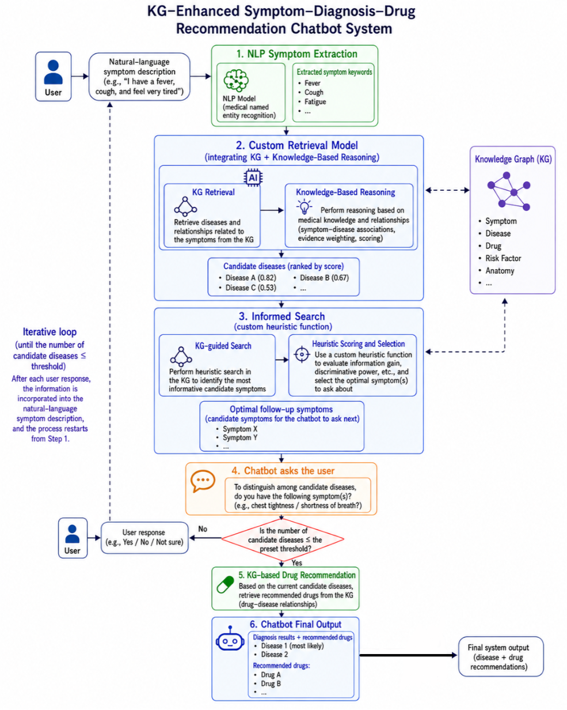

Appendix B: Mapped System Functionalities against Knowledge, Techniques and Skills
The proposed system combines disease retrieval, adaptive symptom questioning, explicit workflow rules, and knowledge-supported conversational interaction. These components correspond to the four technique groups specified in the course requirements. The mapping below identifies their methodological contributions and the evidence required for demonstration.
Required technique group | Corresponding system functionality | Techniques and methodological contribution | Relevant modular knowledge and skills | Demonstration and evaluation
Decision automation: Business rules and process | Control the consultation workflow and determine whether questioning should continue or terminate. | Explicit condition–action rules evaluate candidate availability, the question budget, candidate-count thresholds, and the availability of further informative questions. Evidence validation supports consistent state updates. | MR: knowledge-based reasoning and explicit rules. RS: hybrid reasoning architecture and process integration. | Demonstrate different stopping conditions and inspect the recorded decision trace, including the evidence state and stopping reason.
Business resource optimization: Informed search | Select the next symptom question according to the current disease candidates and accumulated evidence. | Candidate questions are generated from disease–symptom relationships. A weighted balanced-split heuristic guides greedy best-first selection within a limited question budget. | MR/RS: heuristic reasoning, search formulation, action selection, and optimization under resource constraints. | Compare adaptive selection with random and fixed-order questioning using the same cases and budgets. Measure retrieval performance after each question and the number of questions required to reach a predefined target.
Knowledge discovery and data mining | Retrieve and rank candidate diseases from incomplete symptom observations. | A Two-Tower model learns symptom–disease matching representations. Training incorporates symptom masking and class weighting; a separate experiment evaluates a pairwise auxiliary objective. | MR: inductive learning, neural representation learning, and model evaluation. RS: data-driven reasoning and recommendation methods. | Evaluate Hits@K, MRR, and performance across disease-support groups. Demonstrate the trained model through the recall773 configuration and verify its contribution to downstream questioning.
Cognitive techniques and tools | Interpret natural-language descriptions, maintain structured symptom evidence, and communicate through an interactive interface. | PrimeKG supports medical concept representation and relationship retrieval. Contextual language processing maps patient statements to present, absent, or uncertain symptom states. Users can inspect and correct their records. | MR: knowledge graphs and knowledge representation. RS: integration of symbolic and learned components. CGS: contextual interpretation and natural-language interaction. | Demonstrate symptom extraction, entity mapping, evidence correction, and context-dependent dialogue. Inspect agreement between the displayed response and the saved evidence.

1. Decision Automation
The decision automation component implements an explicit consultation policy. Following an evidence update, the system retrieves candidate diseases and evaluates predefined conditions governing the next action. The inspected controller supports termination when the candidate set is empty, the maximum number of questioning rounds has been reached, the candidate-count threshold has been satisfied, or no further informative question is available.
These rules establish a traceable relationship between the consultation state and the resulting system action. The recorded stopping reason supports inspection and reproducibility. Separating workflow decisions from learned disease scores also permits changes to the consultation policy without retraining the retrieval model.
The current implementation provides evidence of automated process control. Its stopping conditions require further validation before they can support claims concerning diagnostic certainty. Proposed policies based on cumulative Top-3 scores and minimum positive-answer counts should be reported as experimental alternatives until their implementation and evaluation have been verified.

2. Business Resource Optimization through Informed Search
Adaptive questioning treats the question budget and the user’s interaction effort as constrained resources. At each turn, the search state comprises the accumulated symptom evidence, the ranked disease candidates, and the previously asked questions. Available actions consist of eligible, unanswered symptom questions. Each answer updates the evidence and initiates another retrieval step.
The implemented selection policy uses a weighted balanced-split heuristic. Let $w(d)$ denote the normalized ranking weight of candidate disease $d$, and let $R(s)$ denote the candidates associated with symptom $s$. The heuristic is:
$$q(s)=\sum_{d∈R(s)}{w(d)}, h(s)=min\{q(s),1-q(s)\}.$$
The system selects the eligible symptom with the highest heuristic value. This favors questions that divide the current candidate weight relatively evenly. The method constitutes informed search because domain relationships and the current ranking guide question selection.
The quantity $q(s)$ is an annotation-derived proxy. Its interpretation as an answer probability depends on assumptions about disease–symptom relationships and ranking calibration. Quantitative evaluation should therefore establish whether the heuristic improves retrieval efficiency relative to random and fixed-order policies.

3. Knowledge Discovery through Learned Disease Retrieval
The retrieval component learns associations between observed symptoms and disease labels. The patient tower encodes the available evidence, while learned disease embeddings represent the retrieval candidates. Their matching scores determine the disease ranking.
The model supports 773 disease labels and 377 symptom types. Its tri-state representation uses separate positive and negative channels, producing 754 input dimensions; unknown symptoms activate neither channel. Symptom masking exposes the model to incomplete observations during training. Class weighting addresses unequal training support, while the pairwise experiment examines the contribution of additional contrastive supervision.
Evaluation includes Hits@K, MRR, and disease-level support analysis. These measures assess ranking quality and reveal limitations obscured by aggregate performance. The selected model in the documented tri-state experiment uses cross-entropy training; the pairwise variant did not outperform it under the validation criterion.
The provenance of negative evidence remains relevant to interpretation. Negative states derived from the original binary dataset are simulated under the documented assumption. Explicitly excluded phenotypes in the additional Phenopacket data are retained as source-recorded negative observations and evaluated in a separate research branch.

4. Cognitive System Design
The cognitive component connects human communication with structured medical representations. Patient descriptions are interpreted in conversational context and mapped to medical concepts. The system maintains distinct present, absent, and uncertain states, preserving differences between reported symptoms, explicit denials, and unresolved evidence.
PrimeKG supplies relationships supporting candidate interpretation and question generation. The conversational interface presents responses and follow-up questions, while the editable symptom panel supports user inspection and correction. Together, these functions provide an interaction loop in which user feedback can revise the evidence used for subsequent reasoning.
A recorded KG-mode test identified cough as present and fever as absent, returned candidate diseases, and selected a follow-up question concerning chest pain. This demonstrates an integrated workflow involving cognitive interaction, informed search, and rule-controlled consultation. A corresponding end-to-end demonstration in recall773 mode is required to establish the trained retrieval model’s participation in the same workflow.
The observed unsupported symptom suggestion further identifies a limitation in semantic validation and record-grounded communication. Such findings should inform the evaluation of conversational consistency and the design of confirmation mechanisms.

Appendix C: Installation and User Guide
This guide covers the Windows deployment of the symptom-based chatbot. The recommended demonstration combines Ollama language processing with the 773-disease recall model. KG-only reasoning remains available as a comparison configuration.

1. Prerequisites and package contents
Component | Requirement
Operating system | Windows 10 22H2 or newer, or Windows 11
Python | Python 3.11 or 3.12, with pip. Verification machine: 3.11.9
Frontend tools | Node.js LTS with npm. Existing frontend build verified with Node 24
Language model | Ollama for Windows and the qwen3:8b model
Inference resources | Recall can use CPU / NumPy. GPU acceleration for Ollama is recommended for responsive dialogue
Storage and connectivity | Internet for initial package/model downloads. qwen3:8b download is approximately 5.2 GB, with additional installation and working space required

Install Python, Node.js and Ollama from their official websites. Reopen PowerShell after installation so PATH changes take effect. The reference computer uses an RTX 5070 Laptop GPU with approximately 8 GB VRAM. This is an observed configuration, not a certified minimum specification.
Keep these repository assets when transferring the application:
- backend/app/data/kg_nodes.csv and kg_reasoning.json.gz.
- backend/app/data/recall773/, including feature_map.csv, synonym_map.csv, disease_map.csv, extra_symptom_nodes.csv and disease_symptom_frequency.csv.
- backend/app/recall_model_773/artifacts/disease_retrieval_773_tristate_v2/, including weights, vocabulary and selection.json.
- backend/app/data/knowledge.json, symptom aliases, backend source, frontend source and dependency lock files.
Create a new virtual environment on each computer. Downloaded Ollama models and frontend/dist are separate from the Git checkout. Raw training CSVs are unnecessary for ordinary inference.

2. First installation
Open PowerShell in the repository root. The example below assumes the checkout is stored at C:\Projects\SymptomGuide. Replace that path with your actual project folder.
$ProjectRoot = 'C:\Projects\SymptomGuide'
Set-Location -LiteralPath $ProjectRoot
python --version
node --version
npm.cmd --version
ollama --version
Create the environment, install the backend, and add the recall runtime dependency:
python -m venv .venv
.\.venv\Scripts\python.exe -m pip install `
-r backend/requirements-lock.txt
.\.venv\Scripts\python.exe -m pip install numpy==2.4.6
The inspected lock file omits NumPy although recall773 imports it. The separate installation above is required for this release. The NumPy backend loads the bundled recall weights without requiring PyTorch. Training and the optional Transformers language-model path have additional dependencies and are outside this installation path.
Build the frontend:
Push-Location frontend
npm.cmd ci
npm.cmd run build
Pop-Location
Test-Path .\frontend\dist\index.html
The last command should return True. The backend serves this build directly. After pulling frontend changes, repeat npm ci when the lock file changes and run npm run build again.
Install and prepare the language model:
ollama pull qwen3:8b
ollama list
Invoke-RestMethod http://127.0.0.1:11434/api/tags
If the API is unavailable, launch Ollama from the Windows Start menu. If no background Ollama server is running, use ollama serve in a separate terminal. Wait for the model download to finish before starting a conversation.

3. Start, verify and stop
Run these commands in the same PowerShell session, from the project root:
$env:PYTHONUTF8 = '1'
$env:OLLAMA_MODEL = 'qwen3:8b'
$env:OLLAMA_TIMEOUT_SECONDS = '360'
$env:RECALL773_BACKEND = 'numpy'
& .\scripts\run.ps1 -Profile ollama -Reasoning recall773 `
-Python (Join-Path $PWD '.venv\Scripts\python.exe')
Open http://127.0.0.1:8000. Keep the terminal open. The first model request can take considerably longer than later requests. Set timeout variables before startup, since the application reads its settings when importing the backend.
In another terminal, check the active configuration:
Invoke-RestMethod http://127.0.0.1:8000/api/health
ollama ps
Expected health fields include status=ok, mode=recall773, dialogue_engine=agent and generator=ollama:qwen3:8b. ai_profile=local is expected for the Ollama profile. Vocabulary size can exceed 15,135 because recall773 appends model-only symptom nodes. Startup logs should identify 773 diseases, 377 model symptoms, the selected CE variant and the active disease-symptom table source.
Configuration | Command / purpose
Recommended integrated demonstration | -Profile ollama -Reasoning recall773
KG comparison | -Profile ollama -Reasoning kg
Deterministic reasoning smoke test | -Profile offline -Reasoning recall773
Optional bundled Transformers model | -Profile local, after separately installing its dependencies and model directories

Always specify the profile and reasoning mode. Calling run.ps1 without parameters selects the local Transformers profile; it does not automatically select Ollama. The .env.example file documents variables but run.ps1 does not automatically load a .env file.
Press Ctrl+C in the application terminal to stop FastAPI. This leaves the independent Ollama background service running. For a busy port, select -Port 8001 and open the matching address.

4. Start a consultation and answer questions

4.1 Initial symptom report
Enter a concise English description, for example: I have a cough and fever, but no chest pain. State each symptom separately where possible. The current interface supports a limited English medical vocabulary. Duration and severity can appear in records, but the recall model uses its fixed symptom vocabulary rather than a general clinical narrative.
Inspect the Symptom log after each response. Present indicates a reported symptom, Absent indicates an explicit denial, and Not sure indicates uncertainty. A symptom that has never been mentioned remains unknown. An unmatched phrase does not establish absence.

4.2 Follow-up questions
When the system asks about a symptom, choose Yes, No or Not sure. Yes and No update the corresponding model input channels. Not sure remains unresolved and does not enter the positive or negative recall input. The controller avoids asking the same resolved question again.
Choose Describe in my own words to answer in free text. Show answer choices returns to the buttons. Wait for the pending request to complete before submitting another operation.

4.3 Inspect and correct the interpretation
Use Change status on an existing record to correct its state. The backend saves the correction and recomputes the reasoning result. Record details display the source text and concept ID. Other-person and historical mentions appear separately when identified.
A suggested match is an unconfirmed interpretation. Confirm it only when the named symptom matches the intended meaning. Ignore suggestion dismisses that proposal without recording a denial. General statements such as I feel good may contain no recordable symptom. If the system proposes an unrelated concept, ignore it and describe the intended symptom explicitly.

4.4 Inspect the reasoning trace
How this reply was generated shows the language-processing trace. Analysis details shows the ranking mode, candidates, follow-up count and stop reason. Technical details exposes stage timings and evidence history. Use these views to check whether an unexpected result originated in language understanding, concept mapping, retrieval or question selection.

5. Results, persistence and session management
The result dialog opens when the consultation transitions to COMPLETE. A restored completed session can be reopened with View result. The dialog shows the first three candidates by default and offers Show all when more candidates remain.
Outcome | Interpretation
Most likely conditions | The candidate-threshold rule fired. Scores support ranking within the configured model
Not enough information for a clear result | The question budget or available questions were exhausted
No matching condition found | The active model produced no candidates from the supported evidence

In recall773 mode, the current default ends questioning when the top three model scores sum to at least 0.9. It then returns three candidates and the controller uses finish_threshold=3. The ordinary budget is 12 follow-ups. KG mode retains a candidate-count threshold of two. These controls differ by reasoning mode.
Model score mass is uncalibrated. A threshold of 0.9 does not establish a 90% clinical likelihood. The inspected recall773 implementation has no separate minimum-Yes counter. Existing early-stop risks and all-No evaluation results remain relevant to interpretation.
Related medications are knowledge-graph relationships. The backend requests them when the candidate-threshold rule fires and filters contraindicated relationships against the remaining candidate set. Availability depends on disease mapping and KG coverage. The prototype does not generate individualized prescribing instructions.
Use Export session to download dialogue-session.json. It contains messages, evidence, model outputs and technical traces. Browser sessionStorage holds the session identifier, while SQLite stores the authoritative state in backend/runtime/sessions-fullkg.sqlite3. Refreshing the browser attempts to restore that session.
Delete & start over deletes the active backend session and resets the view. Start new local view, shown during recovery, clears the browser reference without deleting an inaccessible backend record. Do not publish session exports or the database with the project submission. Use fictional inputs for classroom demonstrations.

6. Configuration and technical operation
Variable | Current behavior
OLLAMA_MODEL / OLLAMA_URL | Language-model name and endpoint; default URL http://127.0.0.1:11434
OLLAMA_TIMEOUT_SECONDS | Per-call timeout; application default 180 seconds, recommended cold-start allowance 360
RECALL773_BACKEND | numpy for CPU inference without PyTorch; auto may select Torch when installed
RECALL773_STOP_TOP3_MASS | Current default 0.9; requires restart after changing
MAX_ROUNDS | Default 12 in kg, ddxplus and recall773 modes
DISEASE_SYMPTOM_TABLE | CSV table override; bundled recall773 frequency table is auto-selected when present
SESSION_DB | Optional SQLite path override; use a separate file for testing
LOG_LEVEL / LOG_USER_TEXT | INFO or DEBUG; raw text logging is disabled by default

Core API routes are /api/health, /api/vocabulary, /api/chat/start, /api/chat/message, /api/chat/answer, /api/chat/correct and /api/chat/session/{session_id}. Swagger documentation is available at /docs.
The browser sends request_id and expected_version with state-changing requests. The backend rejects stale versions and replays completed duplicate requests. Retry same request preserves its original identity. These mechanisms reduce duplicate state updates after an interrupted response.
The frontend is Vue 3 / TypeScript with Pinia and Element Plus. FastAPI orchestrates interchangeable recall, search and drug-relation adapters. The local Ollama API supplies language processing. SQLite provides local persistence. The default configuration needs no external paid API key or database service.
For development, start FastAPI and the Vite development server separately. The Vite configuration proxies /api to port 8000. Rebuild frontend/dist before using the single-process demonstration path. Keep model bundles and vocabulary mappings aligned when upgrading the repository.
Changing REASONING_MODE also changes symptom mapping, ranking and stopping behavior. Save the chosen configuration alongside any recorded demonstration or experiment.

7. Logs and troubleshooting
Application events appear in the startup terminal and backend/logs/chatbot.log. The log rotates at approximately 5 MB with three backups. A short hashed sid links events from the same conversation.
Get-Content .\backend\logs\chatbot.log -Tail 100 -Wait
# Set before restarting when detailed diagnosis is needed:
$env:LOG_LEVEL = 'DEBUG'
# Optional for fictional test inputs only:
$env:LOG_USER_TEXT = 'true'
agent and nlp describe interpretation, recall records model inputs and ranking, search records question selection, flow records state transitions and stopping, and llm records model latency and failures. Ollama server logs are located at $env:LOCALAPPDATA\Ollama\server.log.
Symptom | Corrective action
No module named numpy | Install numpy==2.4.6 using the same .venv Python passed to run.ps1
Local model directory missing | Select -Profile ollama explicitly, or install the optional Transformers model assets
Frontend build missing / stale page | Run npm.cmd ci and npm.cmd run build inside frontend, then restart the application
Ollama unreachable / model missing | Launch Ollama, check /api/tags and confirm ollama list includes qwen3:8b
First response times out | Allow model warm-up; set OLLAMA_TIMEOUT_SECONDS=360 before restart; check ollama ps and server.log
Wrong reasoning mode | Restart with explicit -Reasoning recall773 and inspect /api/health
409 conflict | Reload session before further edits; retry an interrupted operation with Retry same request
404 session not found | Use Start new local view; the previous database/session may no longer be available
503 adapter error | Inspect model/mapping paths and dependency errors; the application does not silently substitute a successful model result

For an unrelated suggested symptom, inspect the original phrase, pending_evidence and agent trace. A proposed concept and a saved observation are different states. Preserve the session export and hashed log identifier when reporting the issue.

8. Verification and release notes
Run the focused integration checks from the project root:
.\.venv\Scripts\python.exe -m pytest `
backend/tests/test_recall773_reasoning.py `
backend/tests/test_api.py `
backend/tests/test_kg_reasoning.py `
backend/tests/test_ollama_runtime.py -q
On 15 October 2026, these checks returned 35 passed and 1 skipped. The skipped test compares Torch and NumPy when Torch is unavailable. This is implementation evidence, not a medical accuracy estimate. A separate in-process smoke check in this package records recall773 health, evidence states, candidate source and follow-up behavior without creating a persistent user session.
For recording, confirm the mode in /api/health, wait for Ollama warm-up, start a fictional case, inspect the symptom log, answer a follow-up, correct one observation and export the session. Record the actual question and ranking rather than promising a fixed diagnosis or sequence.
The repository includes a 500-record synthetic replay report and a smaller hand-authored vignette evaluation. The symptom-frequency exporter aggregates all distinct input records without enforcing a training-only split. Accordingly, the bundled table and any evaluation using it require a leakage audit before independent generalization claims. The documentation preserves this limitation.
The separate rare-disease research branch in the parent GC1 workspace is outside this application installation. It has not replaced the 773-class adapter. Chest-X-ray analysis is outside the current symptom-chatbot implementation.

9. Reference documents
- Repository: scripts/run.ps1, backend/app/config.py, backend/app/dependencies.py and frontend/src/views/ChatView.vue, commit 74408e7.
- Runtime: backend/app/services/recall773_reasoning_service.py, ddxplus_reasoning_service.py and ddxplus_runtime.py.
- Ollama Windows installation: https://docs.ollama.com/windows
- Python virtual environments: https://docs.python.org/3/library/venv.html
- Node.js distribution: https://nodejs.org/en/download
- Locked frontend installation: https://docs.npmjs.com/cli/v11/commands/npm-ci/
- Course briefing v2.17, slides 6 and 9: technique coverage and separate five-minute design video.
For a reproducible handover, include the repository commit, dependency versions, selected profile, reasoning mode, model variant and known limitations. Exclude virtual environments, private session databases and personal test transcripts.

