**ABSTRACT**

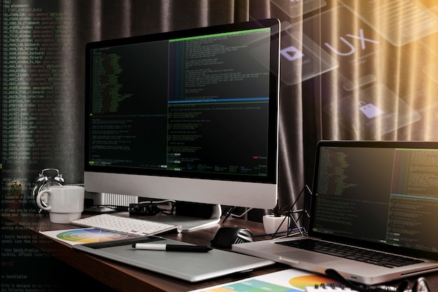

**ABSTRACT**

The document contains the software project named “PHYSICS NUMERICAL SOLVER”. This project is mainly focussed on helping out the student who is struggling to solve the physics numericals and graphs. This is designed in such a way that; the user can easily search the required formula to solve the given numerical.The user also gets the respective formula to solve the problem along with the final answer,So that the user can use it for solving the problems of such types in the future,this can solve multiple types of numerical questions related to a single concept so this will reduce the effort made by the user to search a numerical by just asking them to enter what he needs to find and enter the given values from the question,and the user can add or remove any formula if requiredwhich makes it as an advantage for the software over some other softwares.

.

**“PHYSICS NUMERICAL SOLVER”**

**INTRODUCTION**



**INTRODUCTION**

The name of the project is **“PHYSICS NUMERICAL SOLVER”**. The main objective of the project is to make an easy way for the student to solve or check a physics numerical or a graph. We have designed the project in such a way that everyone can easily acess and give the required input from the question and find the solution along with an appropriate formula for solving the same kind of question in the future.

This project will help the users to find solution even if they are out of network as the project is working with help of python, which is a big advantage for the users who are suffering to find the solution when the they are out network which makes them use the software seamlessly.

This software helps the student to free up themselves from the stress of solving the difficult physics numericals and graphs, which also helps in bringing an interest in solving them as the solutions are now made easily available along with the appropriate formula with this project made by us. Now let us see a detailed explanation of the project made by us along with the runtime screenshots and backround and foreground codes used.

**OBJECTIVE**



**OBJECTIVE**

The main objective of the project is to create interest in solving physics numerical by helping out the user to find a solution for a difficult numerical by just simply searching the concept from which the question is from. As the the problem of finding a solution is now made simple, the user will get a positive notion on solving physics numericals and graphs.

When the user starts the application he will get a window showing the concepts, the user also gets an option to search for the required concept. And also the user will get the appropriate formula to solve any question related to the concept in the future.

If the user wants to add or remove any concept if and if not required an option for that is also given.Since,the project is made after more trials there will be very less chance for the program to give the user a wrong solution.Hence the application is more accurate for a twelth grader to refer for a solution in the tough concepts of physics.

**LIMITATIONS**

**OF**

**EXISTING SYSTEM**



**LIMITATIONS OF EXISTING SYSTEM**

The existing system of finding a solution for the physics numerical is way harder than solving by our own as we are required to type the question fully,even though there are many options for searching a question using the image with the help of image search and lens etc,..it is not working in all the occasions as we may have question paper which is not clear or we may be working with a PC and the webcam couldn’t have supported.This project can be operated withouted any limitations that was mentioned above.

**IMPORTANCE**



**IMPORTANCE**

**ENHANCEMENT:**

The main objective of PHYSICS NUMERICAL SOLVER is to develop the interest in physics by redusing the problem of finding a solution for a numerical or a graph.

**ACCURACY:**

In the existing system of finding a solution for a particular problem is having even more limitations by giving the user with approximate values. But our system will enhance it by giving full answer without any approximation.

**USER-FRIENDLY:**

>>>>>There are many things which makes our system user-friendly,some of them are,

The user gets a option to se.

**INPUTDATA**



**INPUT DATA**

The main objective of making input data is to make the user and his friends to enter the information error free. The user has to follow the correct steps:

* Giving the name without any special characters in it.
* Must not save the player’s name without entering anything

**TYPES OF OUTPUT**

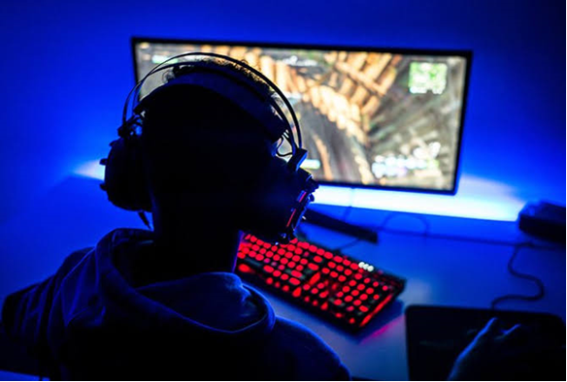

**TYPES OF OUTPUT**

In this project the system has only one output. The common output name and age queries and a sign in option. The output varies depending upon the difficulty level and the age entered. So, we have kept in mind the easier understanding of the game and controls and outputs will be user friendly and easy to understand. By achieving these objectives users can get the best possible experience ever. Users have no control to the application output. Only the admin has the power to change and configure the output given by the application. Also, information such as age, mail, name etc given by the users should follow the terms and conditions.

**IMPLEMENTATION**



**IMPLEMENTATION**

The implementation process is a long process. We firstinstall and check whether the application has the perfect client requirements. Then, we run every mode of the application and check it has 0% error or glitch which would be a headache for the users. We make this coding very simple so that it only uses a less working space and supports every mobile model and system. After hours of checking and confirming, we can now definitely assure you that it is 100% error free and could give you a good time.

**FURTHER LOOKING FORWARD**

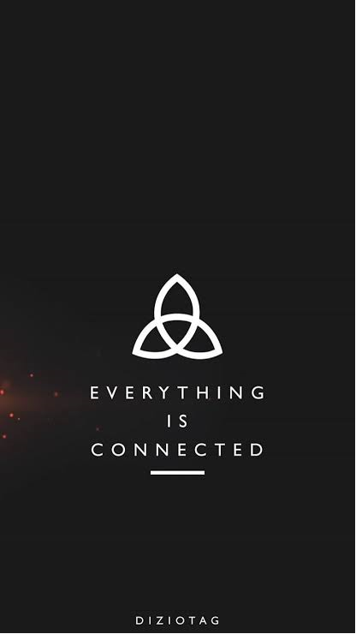

**FURTHER LOOKING FORWARD**

In our project, users have the option to report a error or some suggestion so that we can give our best possible updates in the future. The complaint reported will be taken forward to us and we will do consider all our users opinions and rectify our mistakes. Not only we are giving good gaming experience also we assure you safety that your data goes nowhere away from us.

Also it is virus free and no one can configure the application’s safety measures. The main characteristics that we should look forward about a gaming application are security, extensibility and maintainability. These features are included in this project. The implementation includes of user account creation, daily rewards and allowing users to report the problems. Our project is capable of handling load at the server even in the peak hours without lagging or terminating the application.

**SOURCE CODE**

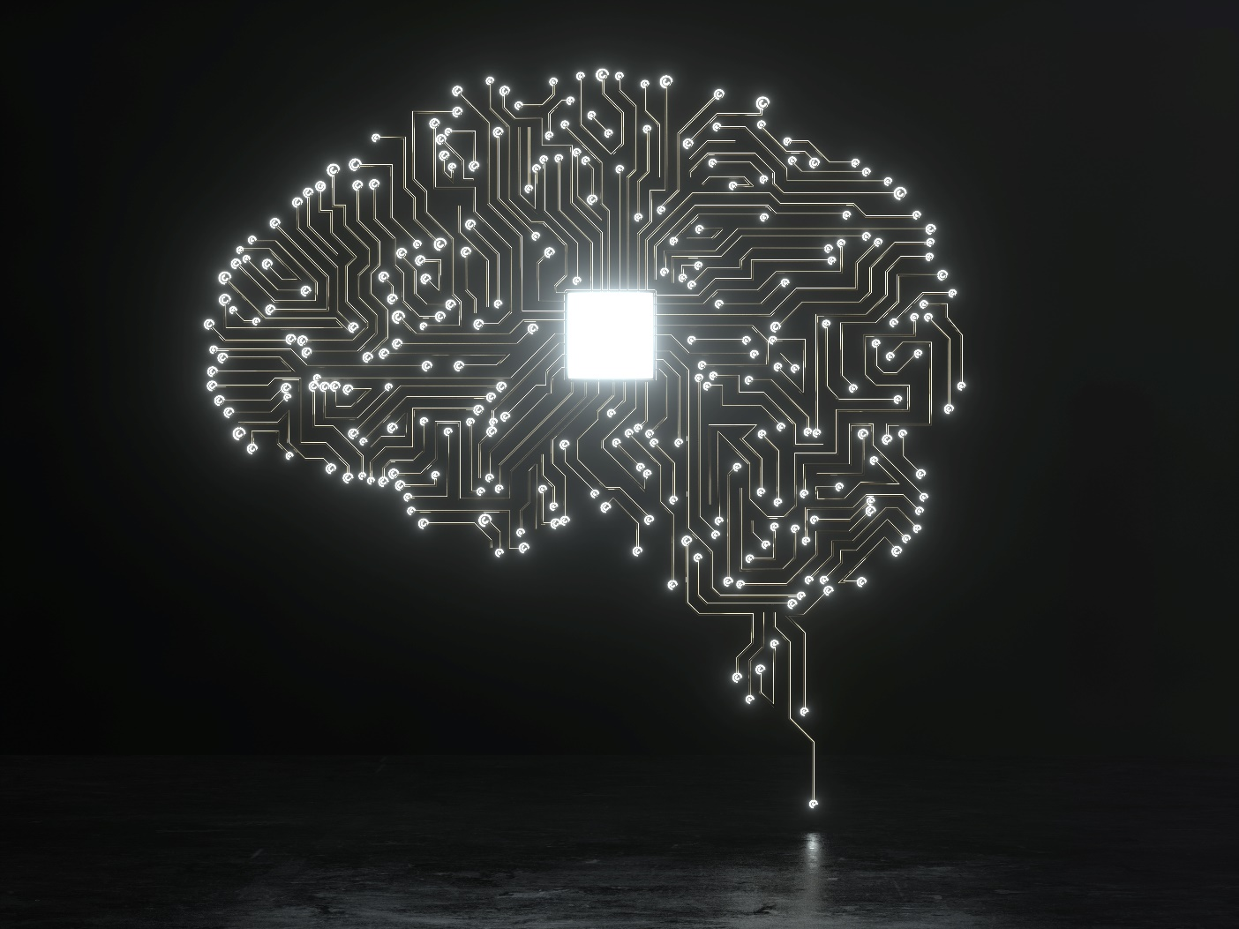

**SCREENSHOTS**



**SCREENSHOTS**

**CONCLUSION**



**CONCLUSION**

Life without entertainment is like a body without soul. This game helps you to remove all your mental worries and have good time that you wont regret. We ensure that this program is purly for stress releaf and for making good relationship with the teammate. Each stage is designed to entertain you and to know how to pass through the difficulties in your life

We ensure that every data that you pass in the application is totally secured in encroyped form.

**BIBLIOGRAPHY**