PROJECT TITLE: CONTACT MANAGER

Ebenehi U Simeon - Bhu/23/04/05/0025

Edet Aniekan Godwin - Bhu/23/04/10/0015

Agbeen Jeese - Bhu/23/04/09/0059

Hope Aluwong - Bhu/23/04/05/0027

Victor - Bhu/23204/05/0063

EBENEHI U SIMEON BHU/23/04/05/0025 CONTRIBUTION

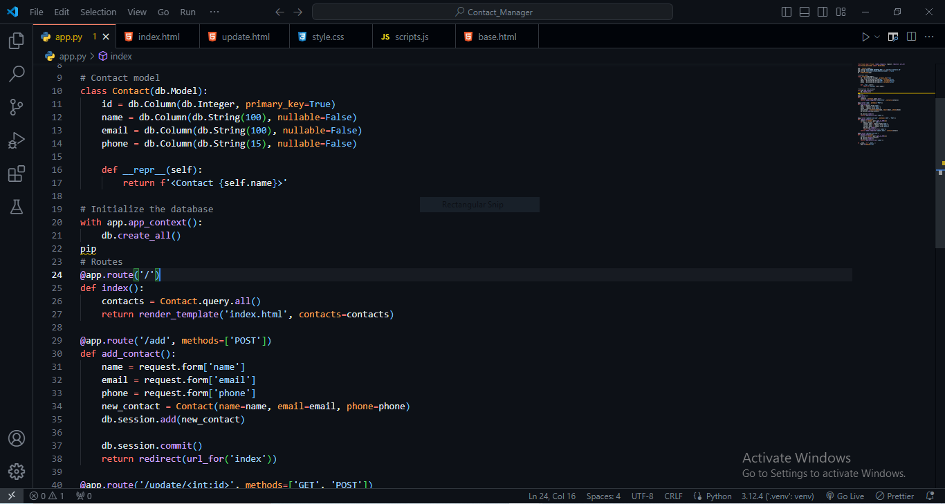

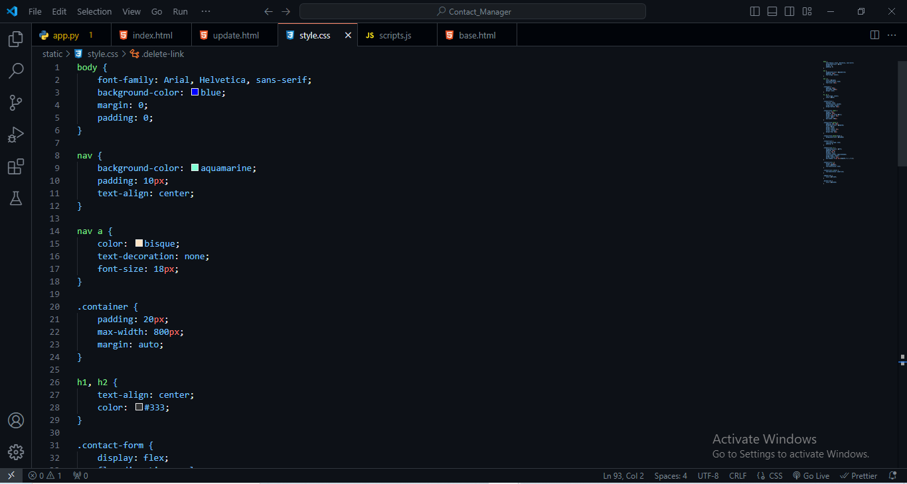

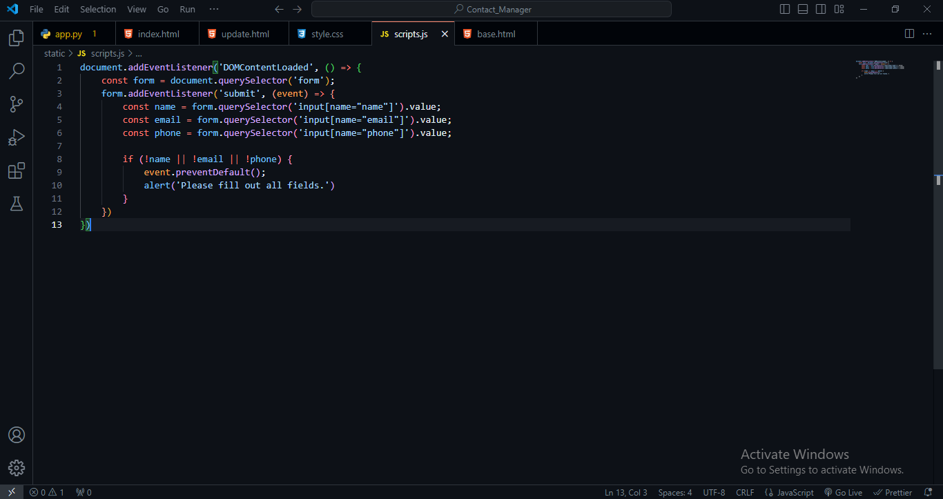

EDET ANIEKAN GODWIN BHU/23/04/10/0015 CONTRIBUTION

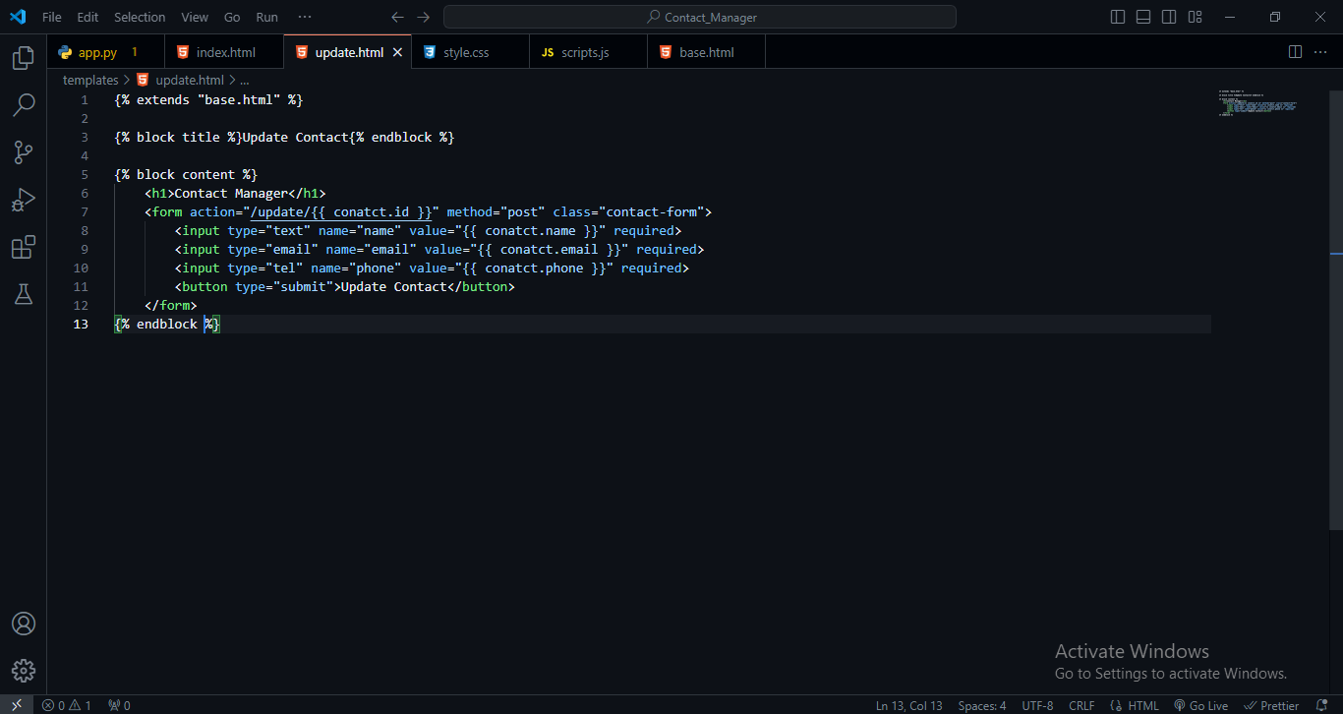

AGBEEN JEESE BHU/23/04/09/0059 CONTRIBUTION

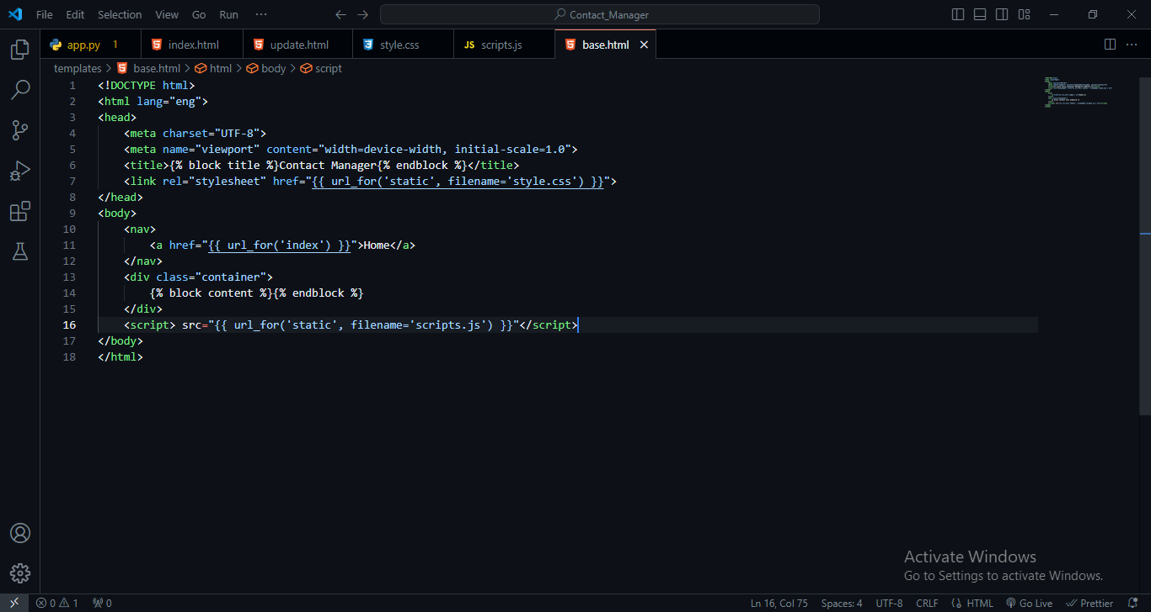

HOPE ALUWONG BHU/23/04/05/0027 CONTRIBUTION

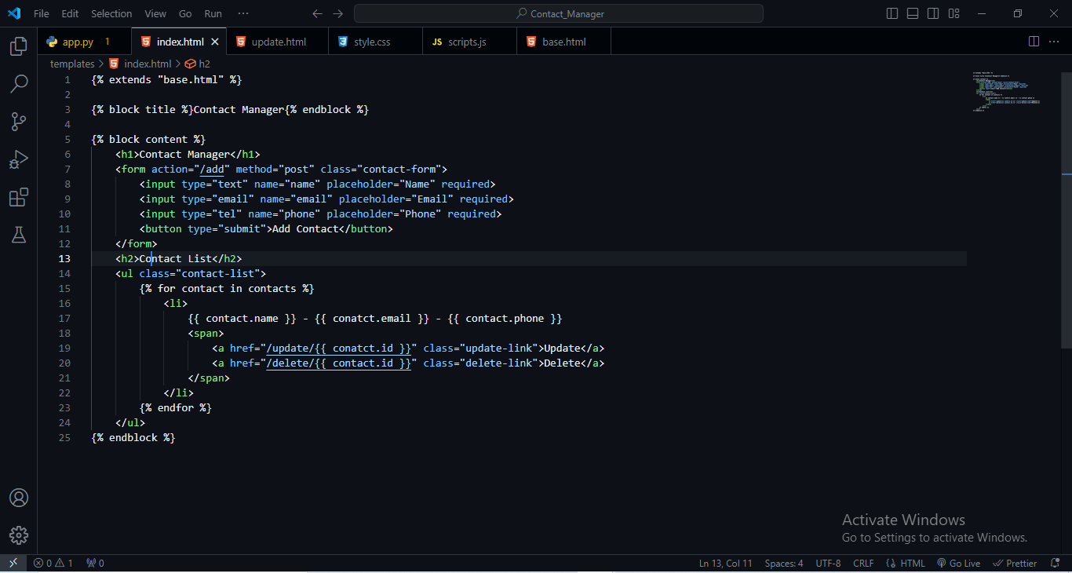

SCREENSHOT OF CONTRIBUTION ON GITHUB

