Blockchain Based Cheque Verification & Clearance System
In this project you ask to implement cheque clearance system using Blockchain Ethereum where banks and users can sign up with the application and then user can login to system. After login user will perform below operations
- In cheque generation module user will select desired bank name and then select desired receiver name and then enter amount. After giving input values then system will generate QR code with user given values and then hashed QR code and then hash values will be saved in Blockchain as Digitally signed cheque.
- View status: using this module user can view list of all cheques sent or received by him and can see status.
- Clear Cheque: After login bank will use this module to view all pending cheques list. This module will display all details of cheque like hash code, QR code, sender, receiver and bank details. In Blockchain only has values will be saved but application scan QR code obtained from Blockchain and then retrieve details. Once after all verification Bank will click on option to clear cheques. Once after clearance both sender and receiver will get notification via emails.
- Daily Transaction: using this module bank will see list of amount cleared daily
To implement above concept we have designed following smart contract using solidity code
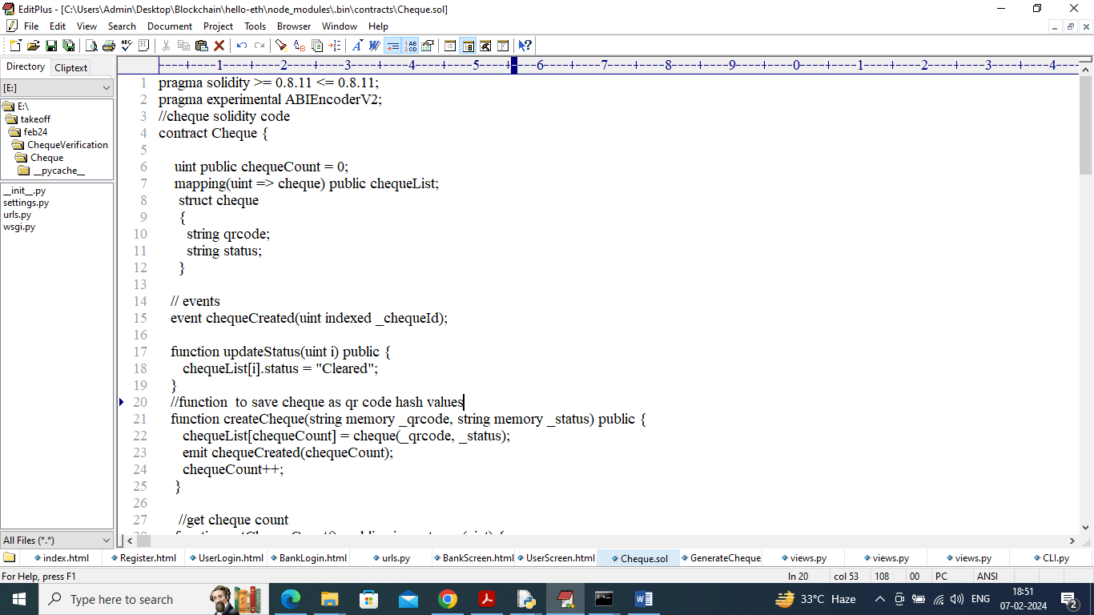
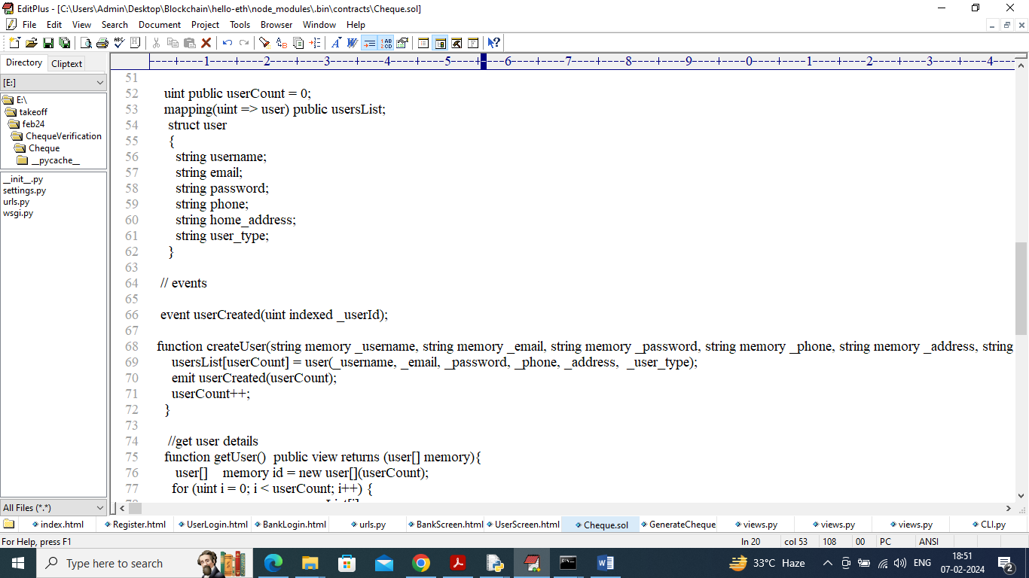
In above solidity code we have defined all functions to save and get Users and Cheque details. Now we need to deploy above contract to Ethereum using following steps
- First go inside ‘hello-eth/node-modules/bin’ folder and then look for ‘runBlockchain.bat’ file and then double click on it to get below screen
- 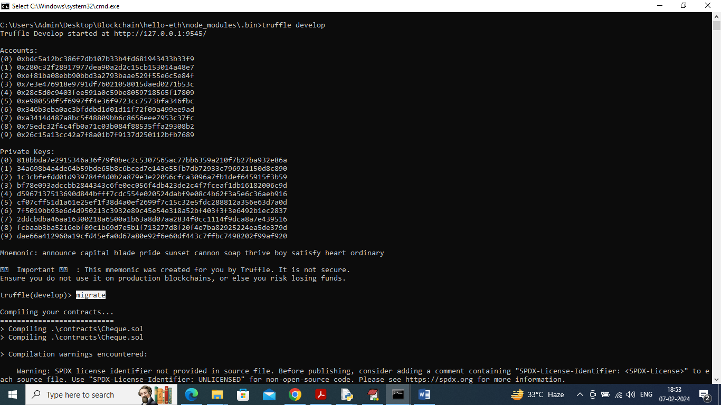
- In above screen Ethereum started with defaults account and keys and now type command as ‘migrate’ and then press enter key to get below page
- 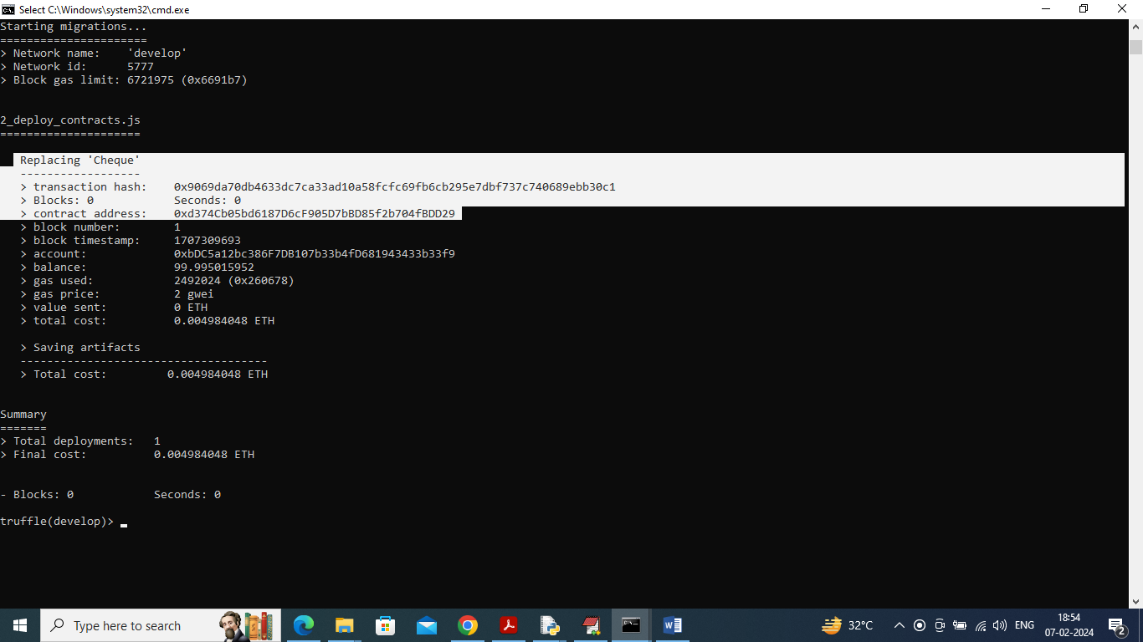
- In above screen in white colour can see ‘Cheque’ contract deployed in Ethereum and got contract address also and this address need to specify in python program to call contract to save and get data and in below screen showing python code calling contract using address
- 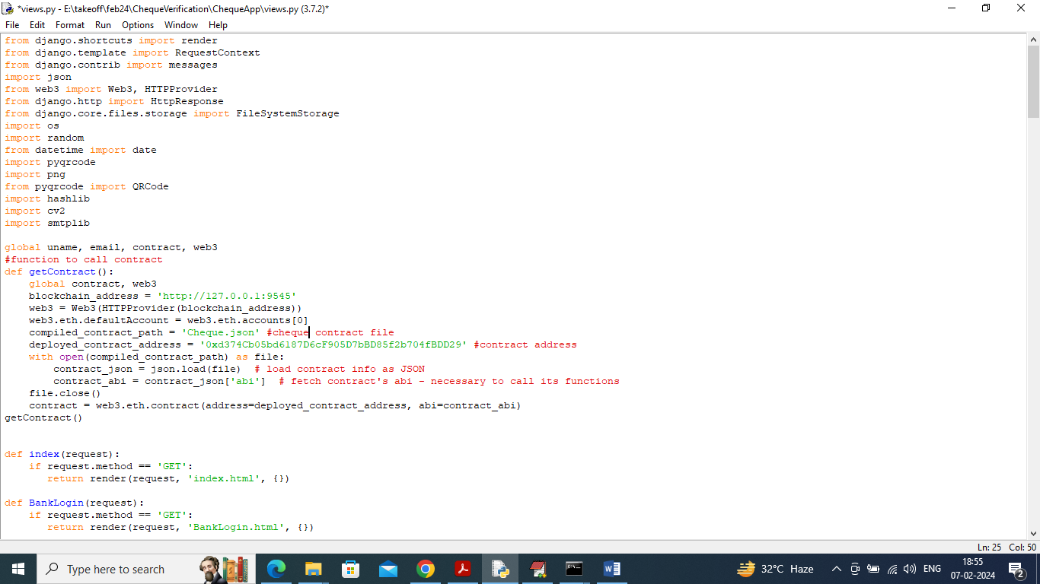
- In above screen read red colour comments to know about contract calling using python. Now contract deployed and running successfully.
SCREEN SHOTS
To run project double click on ‘runServer.bat’ file to start python server and get below page
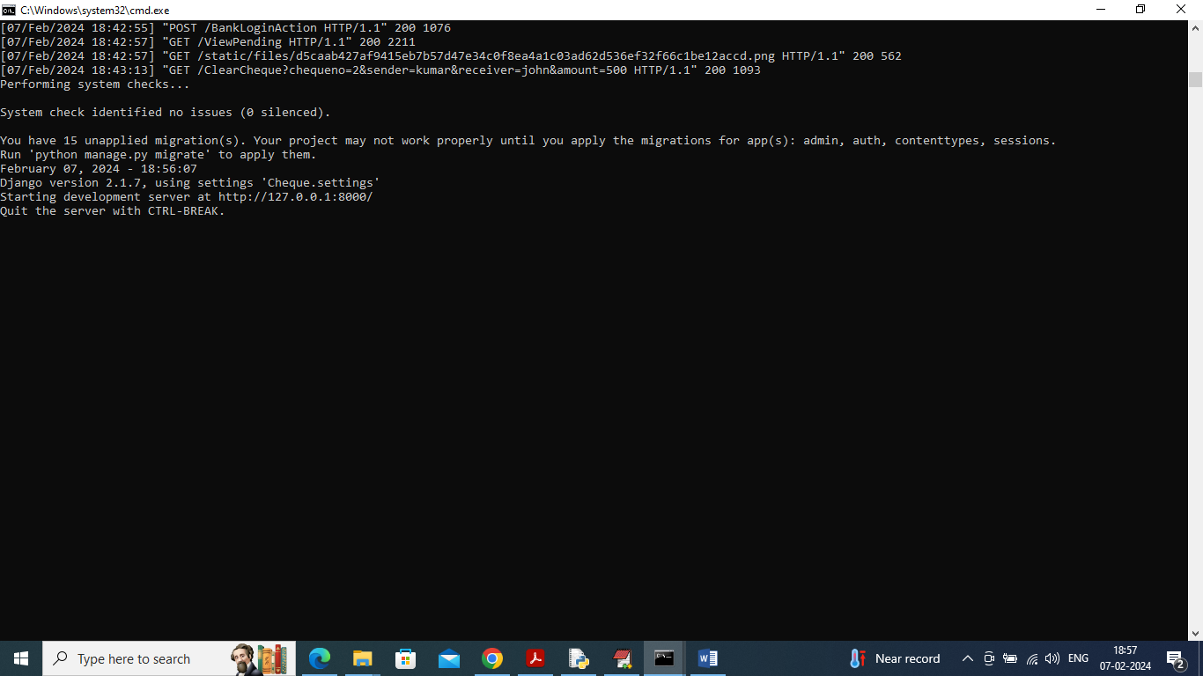
In above screen python server started and now open browser and enter URL as http://127.0.0.1:8000/index.html and then press enter key to get below page
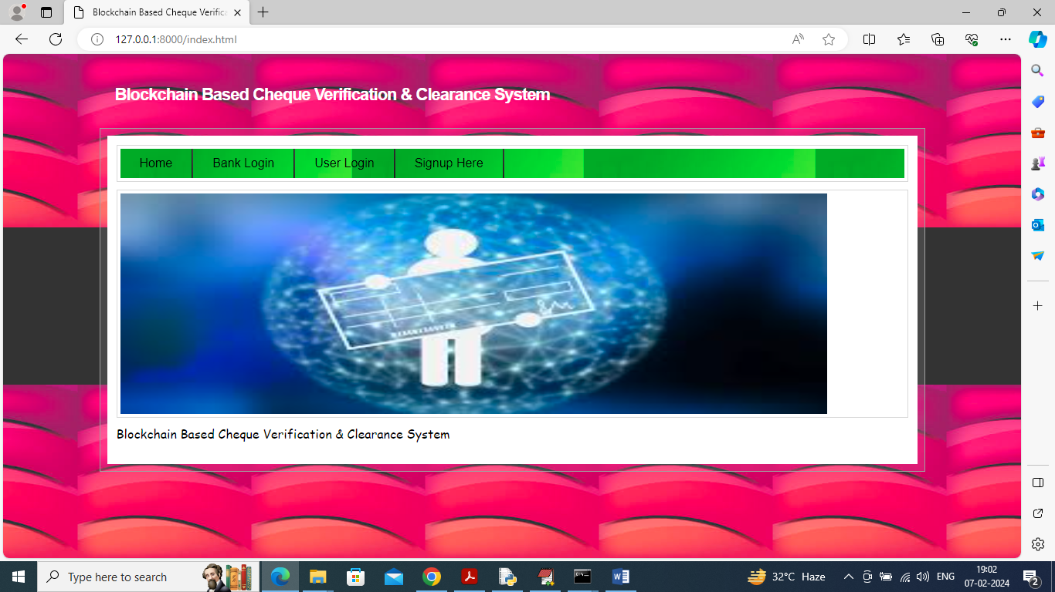
In above screen click on ‘Signup Here’ link to get below page
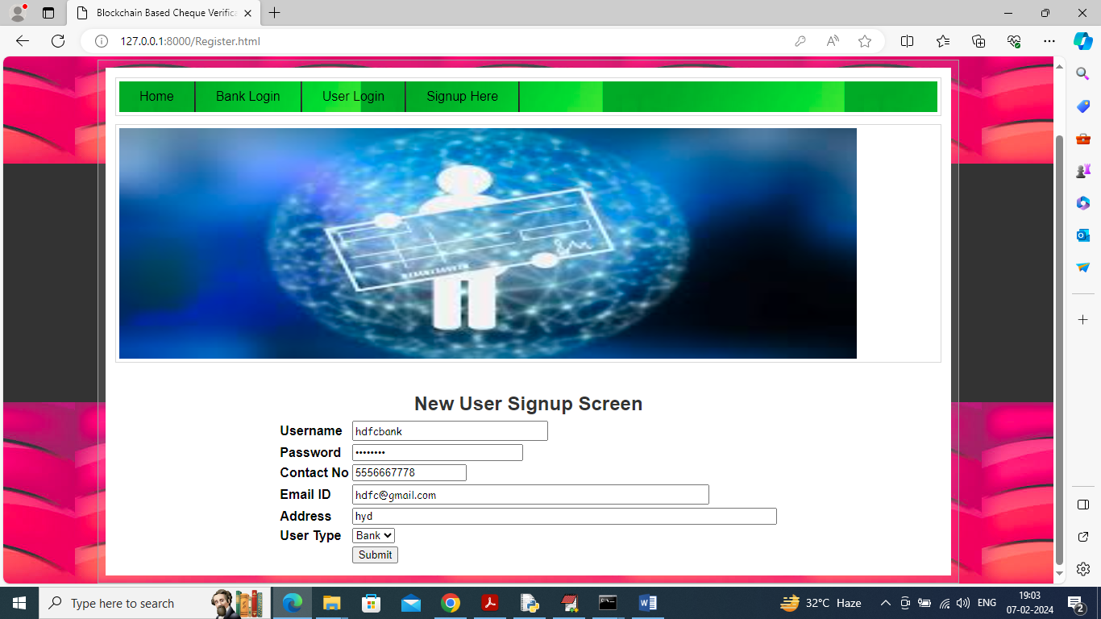
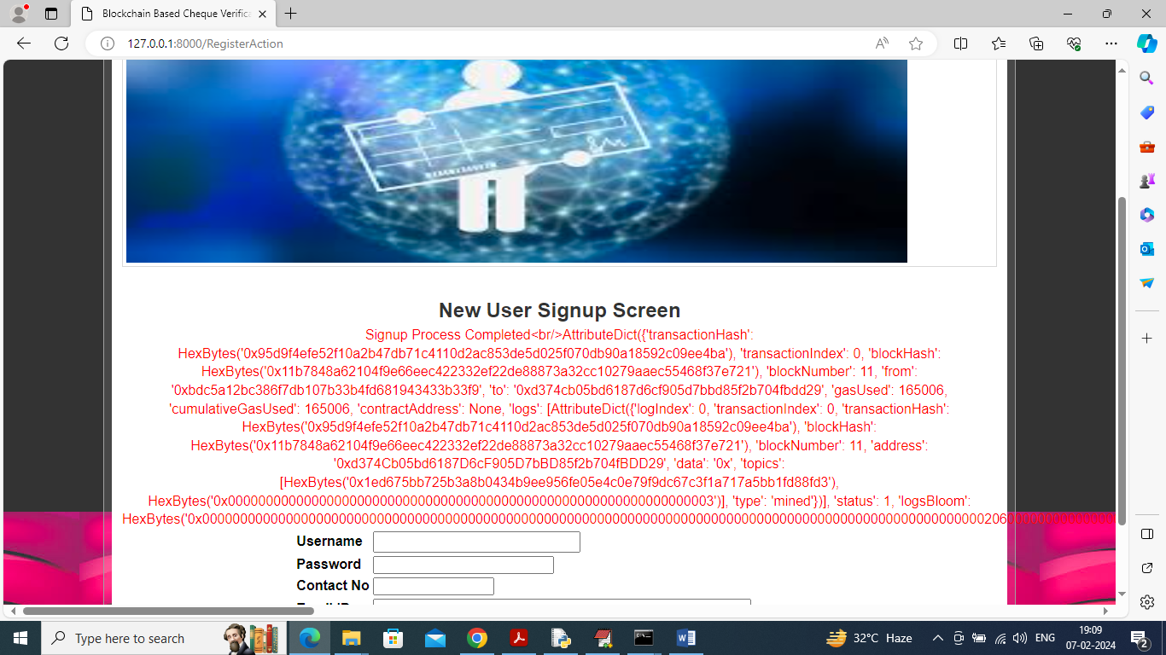
In above screen sign up data saved in Blockchain and will get above red colour output from Blockchain as confirmation and normally will display transaction hash code for you and your guide understanding I am display all output. Similarly we can add users also
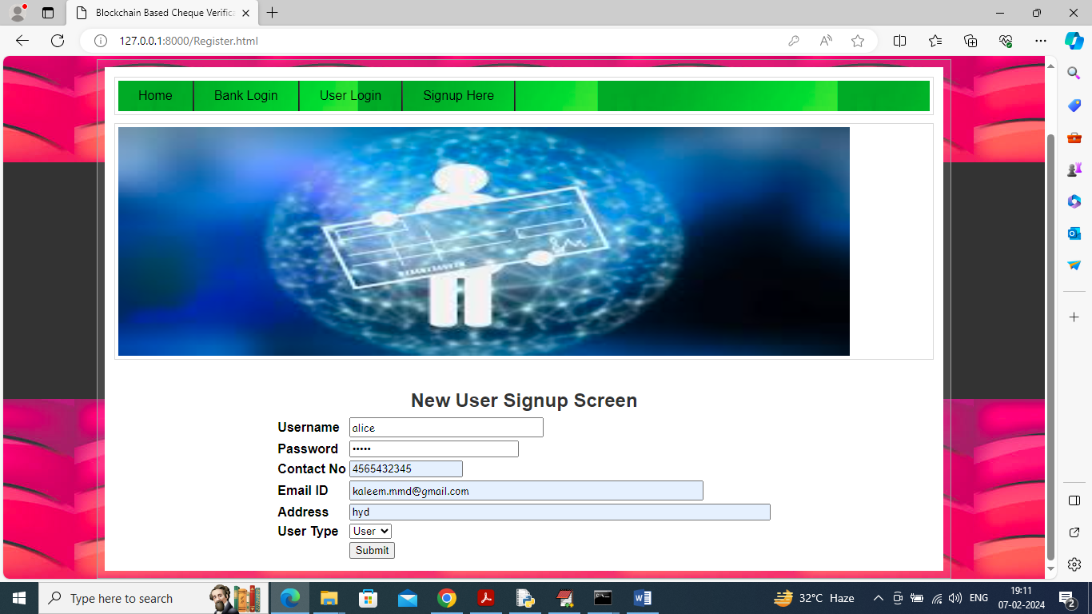
In above screen I adding user details and give valid email id so application send email after clearance and now click button to get below details
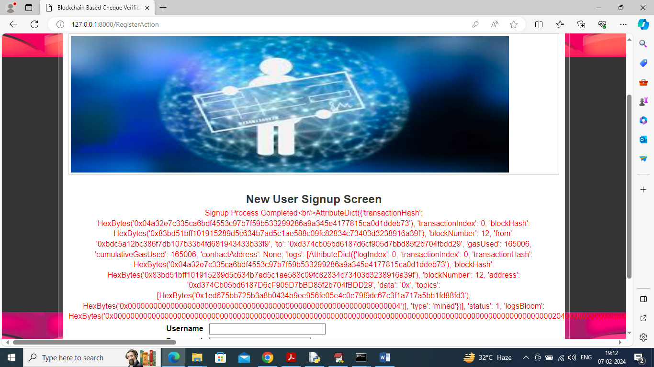
In above screen user details also saved in Blockchain and can see Block number counter increased and now click on ‘User Login’ link to login
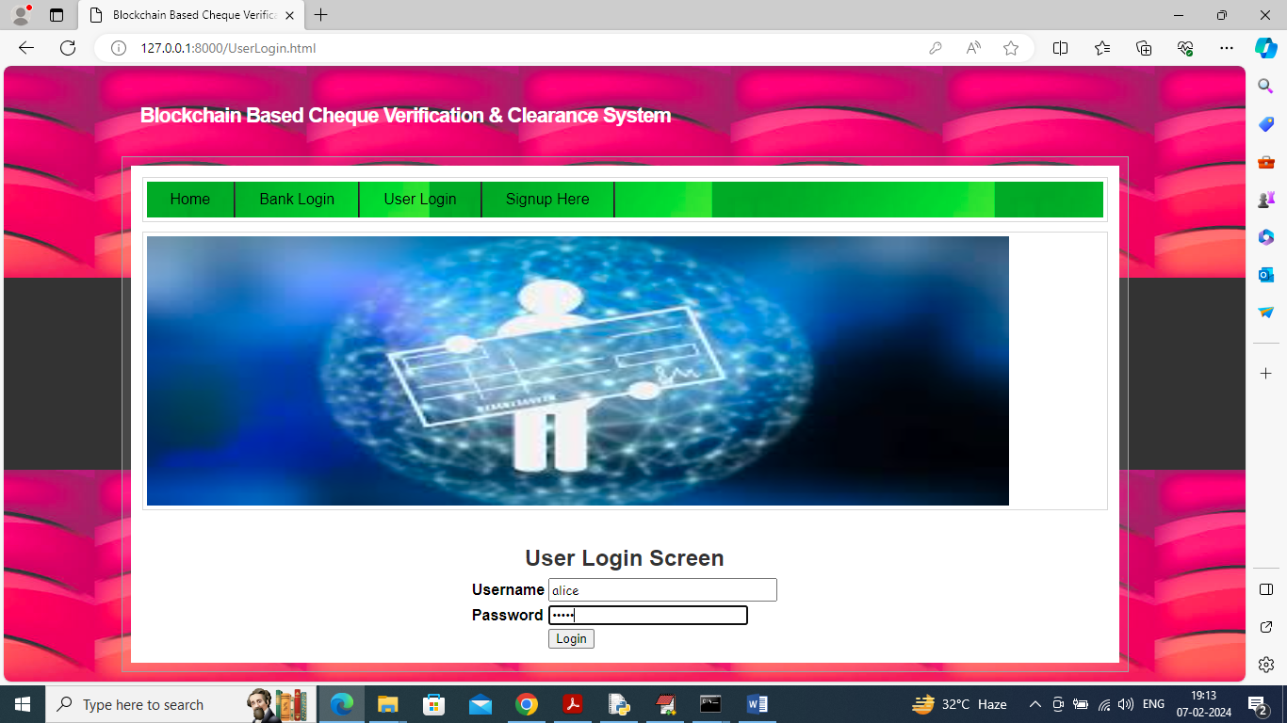
In above screen user is login and after login will get below screen
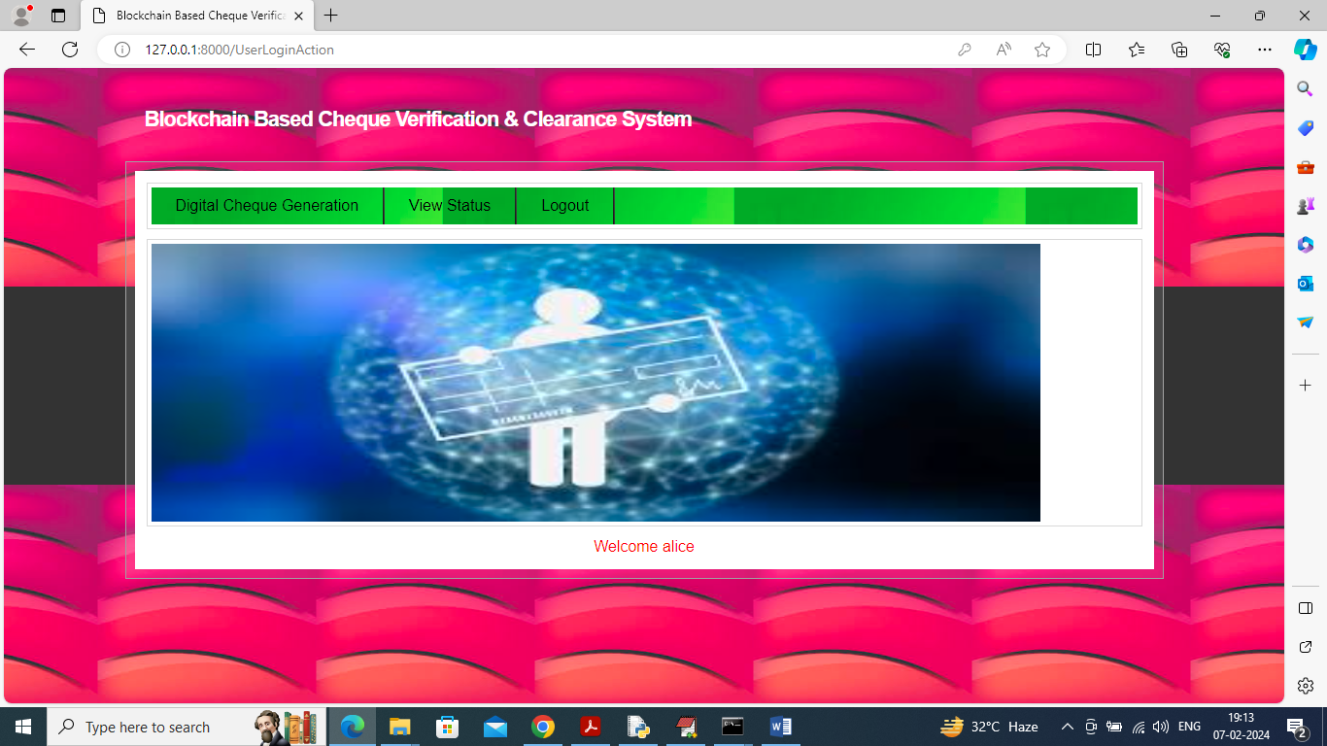
In above screen user can click on ‘Digital Cheque Generation’ link to get below page
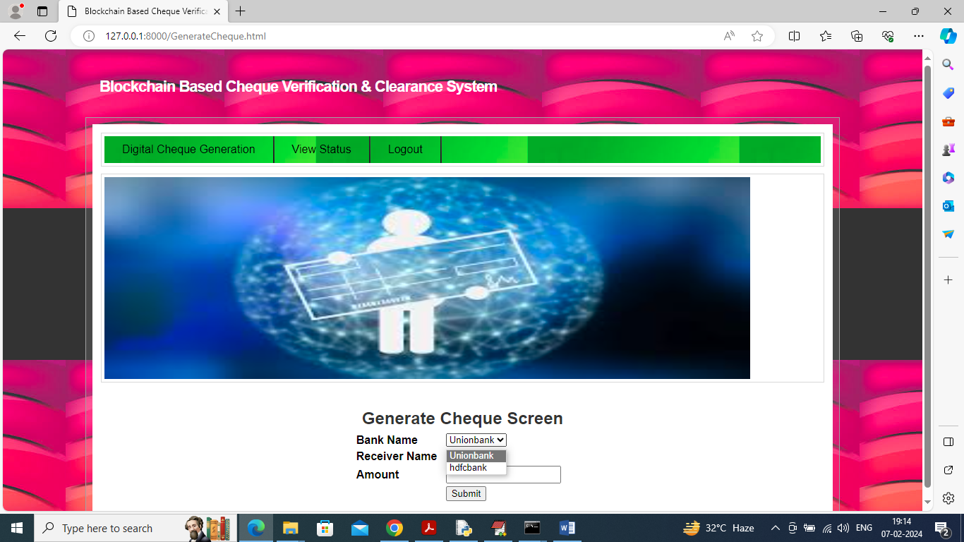
In above screen user can select desired bank and receiver name and then enter amount to generate cheque
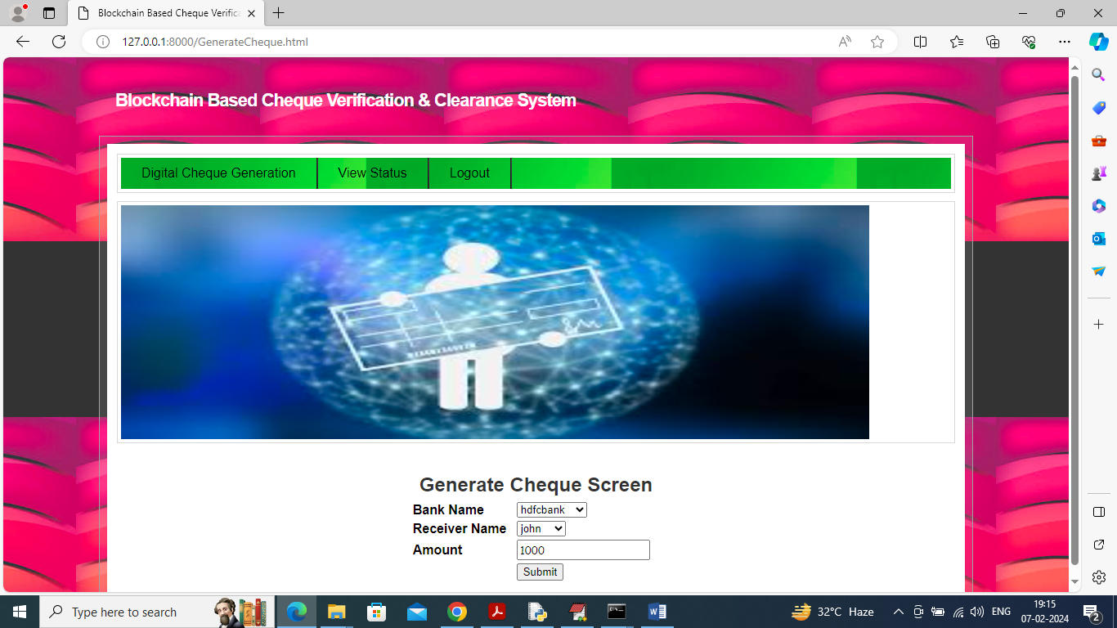
In above screen enter amount and press button to get below page
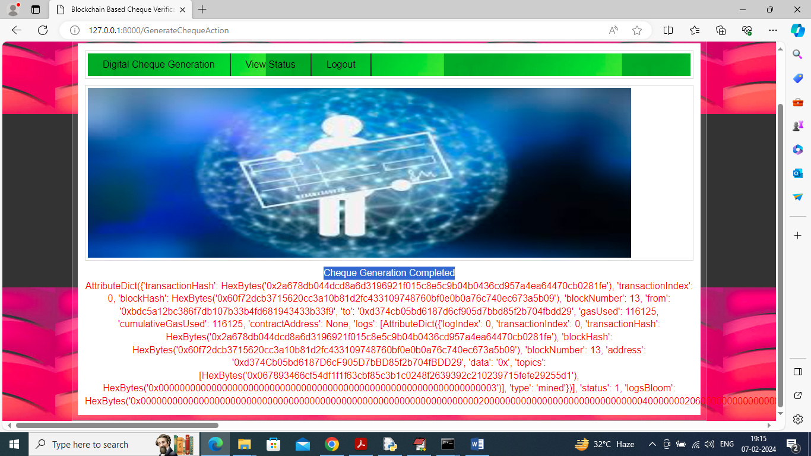
In above screen cheque generation completed and can see all output and now click on ‘View Status’ link to get status of cheque.
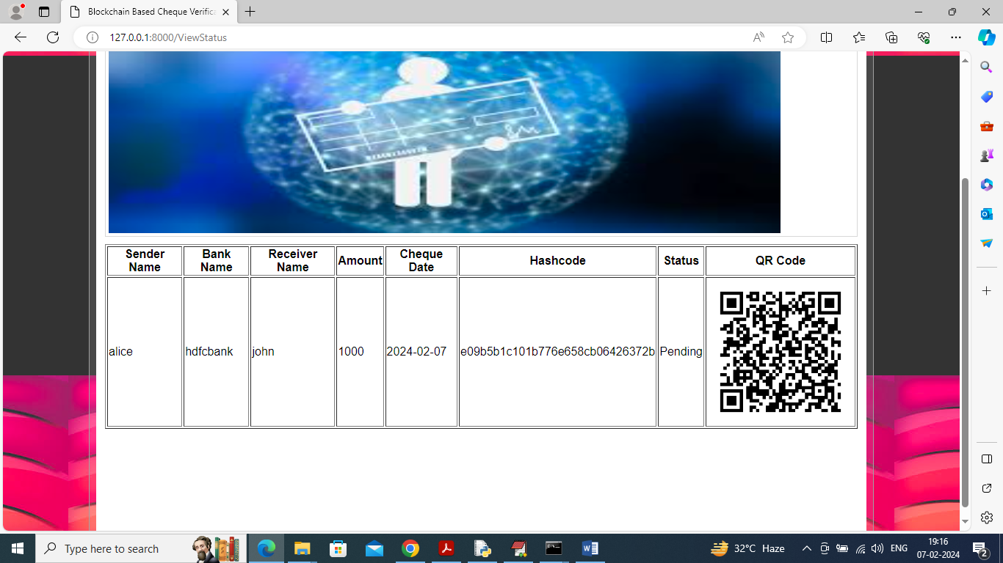
In above screen user can see details from generated cheque whose status is pending as bank has not yet cleared so logout and login as bank.
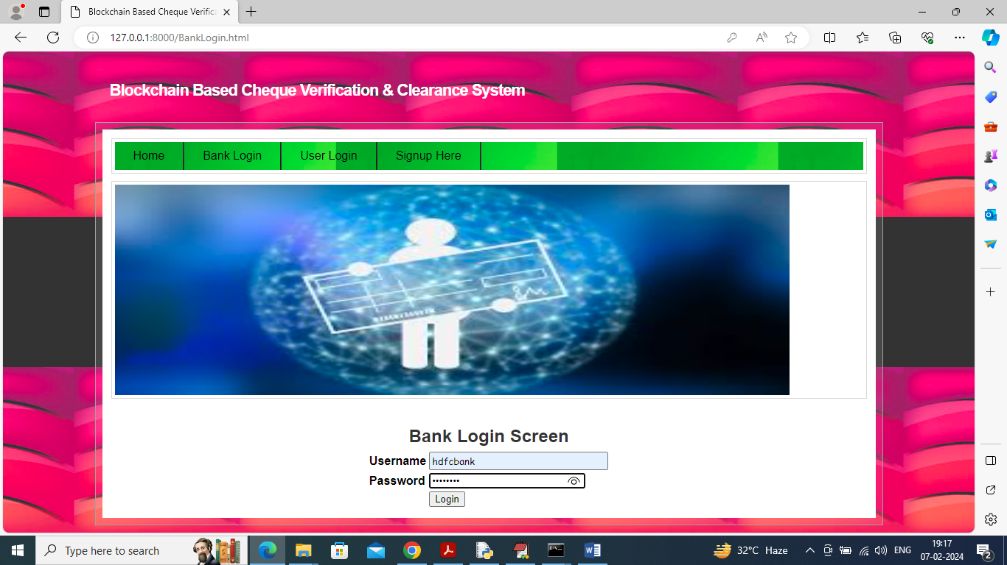
In above screen bank is login and after login will get below page
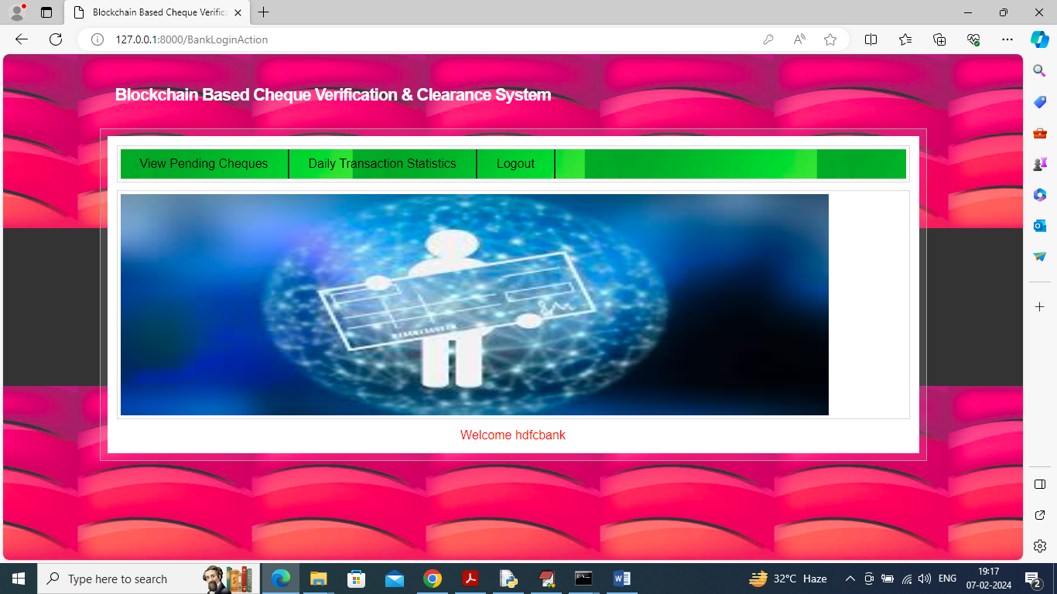
In above screen bank can click on ‘View Pending Cheques’ link to get below page
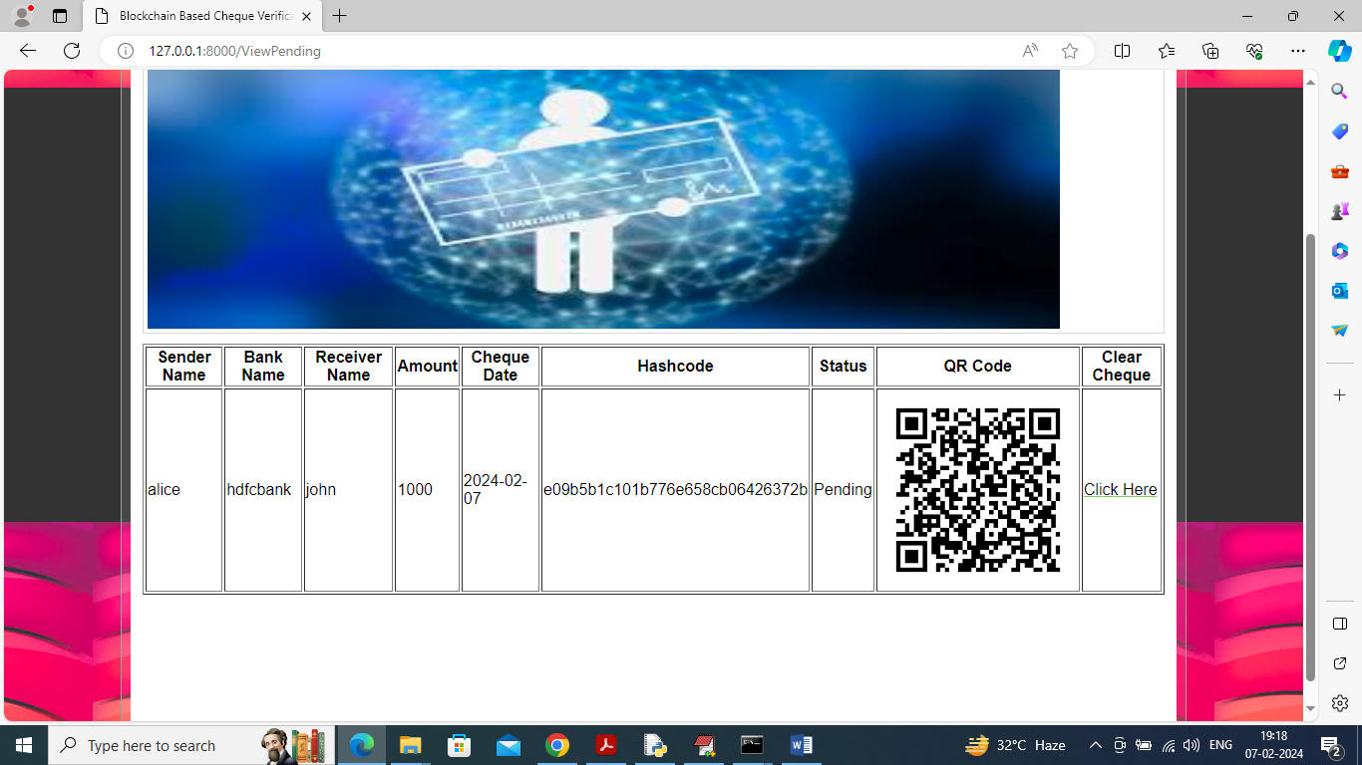
In above screen bank will verify all details and then click on ‘Click Here’ link to clear cheque and get below output
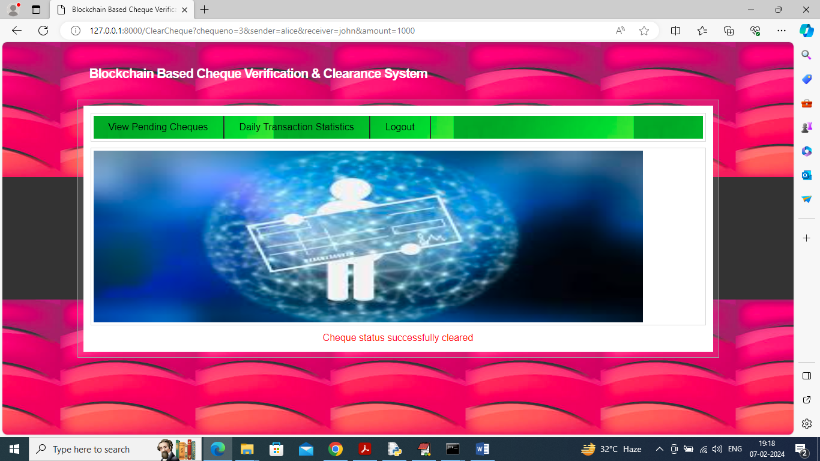
In above screen cheque cleared successfully and now bank can click on ‘Daily Transaction Statistics’ link to get below report
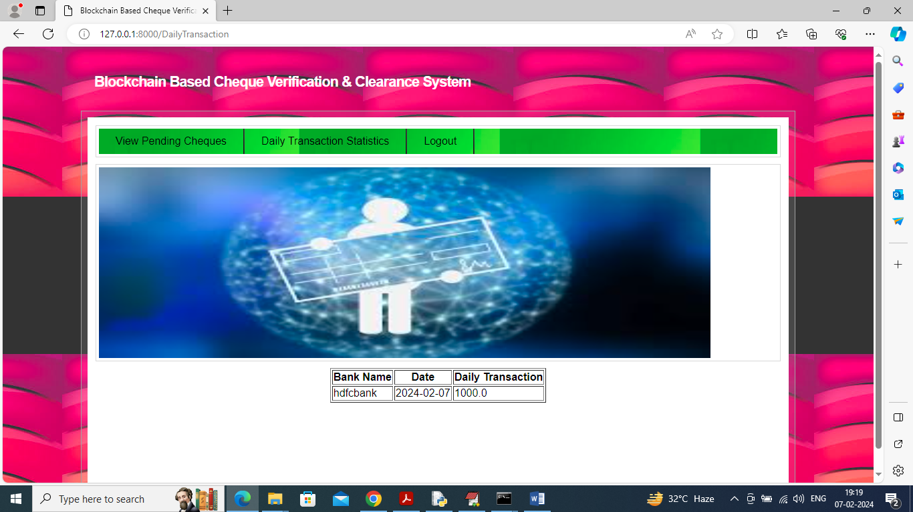
In above screen bank can see list of transaction day wise and in below screen can see email notification
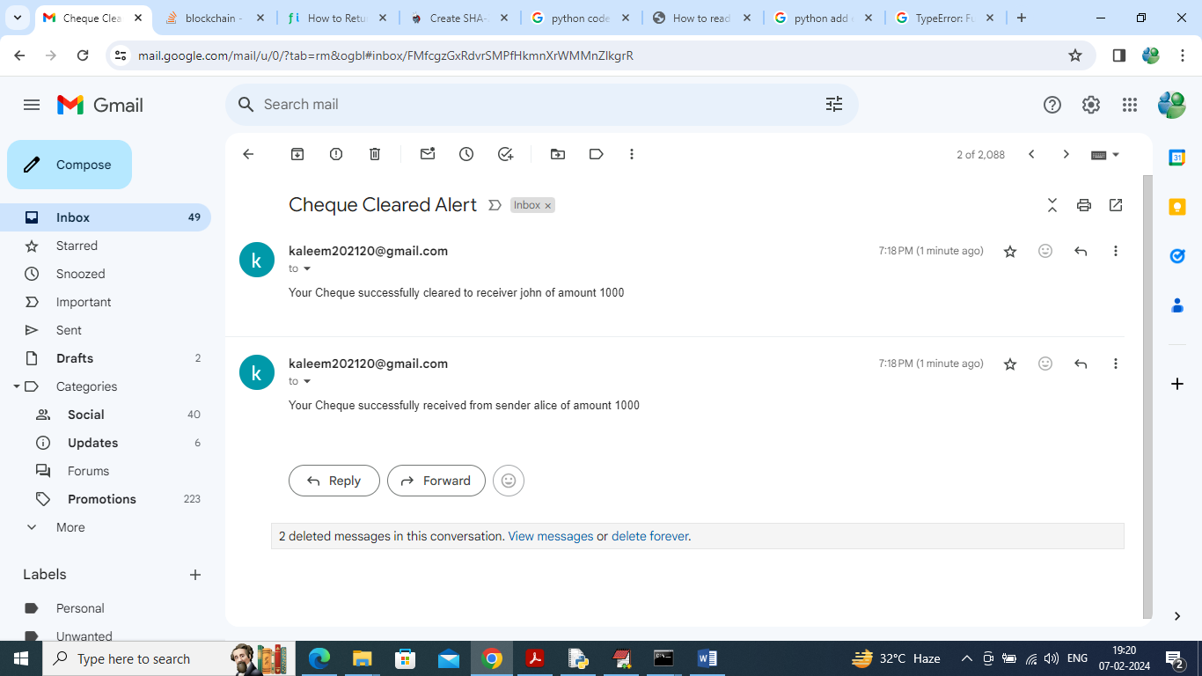
In above screen both sender and receiver can see email notification and in below screen user can see status as cleared
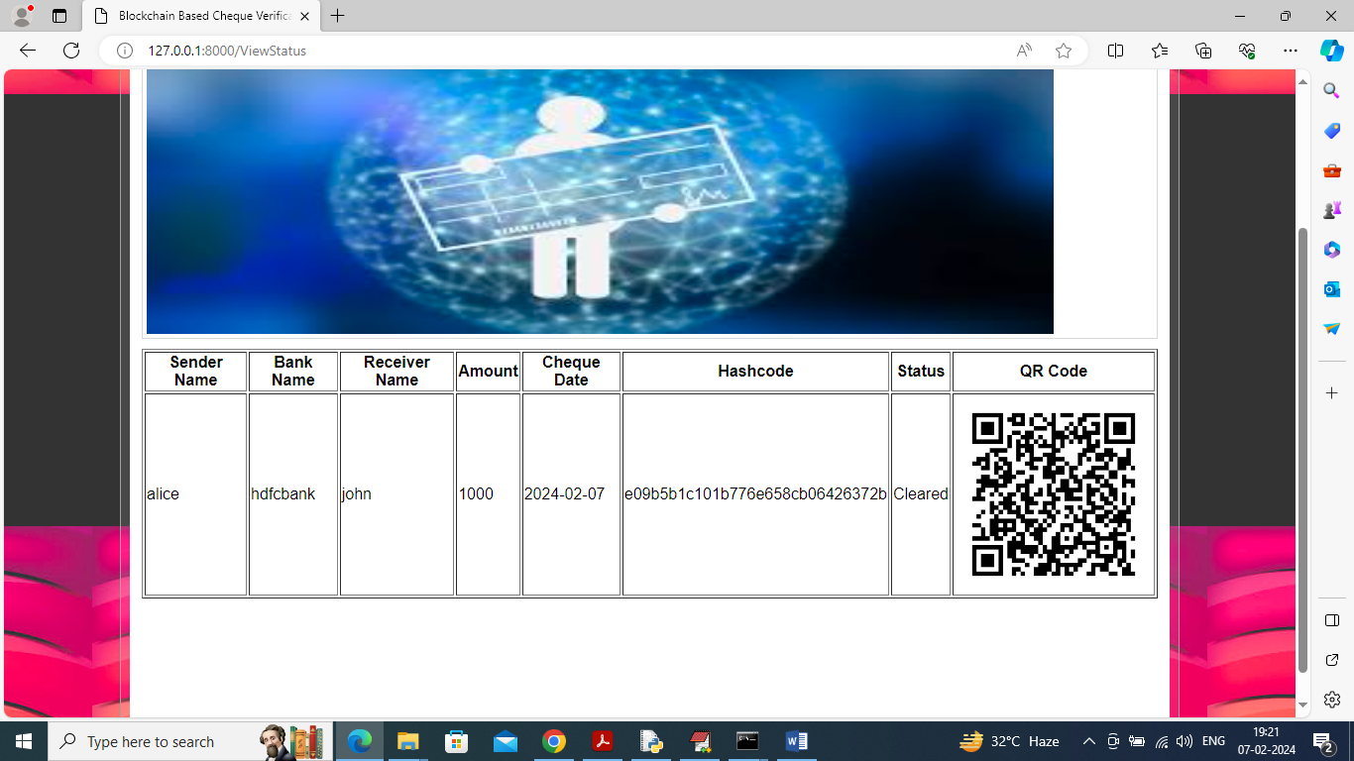
In above screen can see cheque clearance status is updated to ‘Cleared’.
Similarly by following above screens you can make any number cheque transactions.
All the transaction you can see using Metamask or Ganache or any other Blockchain tools

