CS 1073
FR04A
Assignment 1
Ebrahim Arefi
3621326

Way Finding Algorithm:

Exit GE128
Turn left into hallway
Walk straight until you see the exit door
Stop at the exit door (do not go outside)
Turn left
Take four steps forward
Turn left again and you will see the elevator
Press elevator button
Wait until elevator arrives
Walk into the elevator
Press button for Main Floor (1st floor)
Wait until elevator stops
Exit elevator on Main Floor
Turn left into hallway
Walk straight until you see the exit door
Open door and PASS through
Enter small study hallway (TV on right)
Walk straight through hallway
Continue past blue garbage bins
Walk until you see exit sign next to ITC308 with women’s label on the door.
Turn left and walk straight to end of hallway
Until you reach the 4th door on the left
ARRIVE at ITC317
END

Puzzle Problems:
Scenario A:
- Start in the Safe Room.
- Move one room south, activate, then move one room north back to the Safe Room.
- Move one room east, activate.
- Move one room east, activate.
- Move one room east, activate.
- Move one room south, activate.
- Move one room west, activate.
- Move one room west, activate.
- Move one room south, activate.
- Move one room west, activate.
- Move one room south, activate.
- Move one room east, activate.
- Move one room east, activate.
- Move one room north, activate.
- Move one room east, activate.
- Move one room south into the Exit, activate, and exit safely

Scenario B:
1) Send the child down first.
Put the statue (75 lbs) in Bucket A (at the top).
The child (90 lbs) enters Bucket B (on the ground).
Difference is 15 lbs, so is safe.
Then the statue comes up.

2) Send the professor down.
Now, Bucket A has the student (105 lbs) + statue (75 lbs) = 180 lbs.
Bucket B has the professor (195 lbs).
Difference is 15 lbs, so is safe.
Professor goes down safely and student + statue rise.

3) Send the student down.
Leave the statue in the room.
Put the student (105 lbs) in Bucket A (top).
Put the child (90 lbs) in Bucket B (bottom).
Difference is 15 lbs so is safe.
Student goes down safely, and child rises.

4) Send the child down again.
Put the statue (75 lbs) back into the bucket at the top.
Child (90 lbs) goes in the opposite bucket.
Difference is 15 lbs so is safe.
Child goes down and statue comes up.

Part IV
Ebrahim Arefi
Bachelor of computer science
From Kuwait

Part V
/**
@author Ebrahim Arefi 3621326
**/
public class MyFirstProgram {
public static void main(String[] args) {
System.out.println("Hello World");
}
} //MyFirstProgram
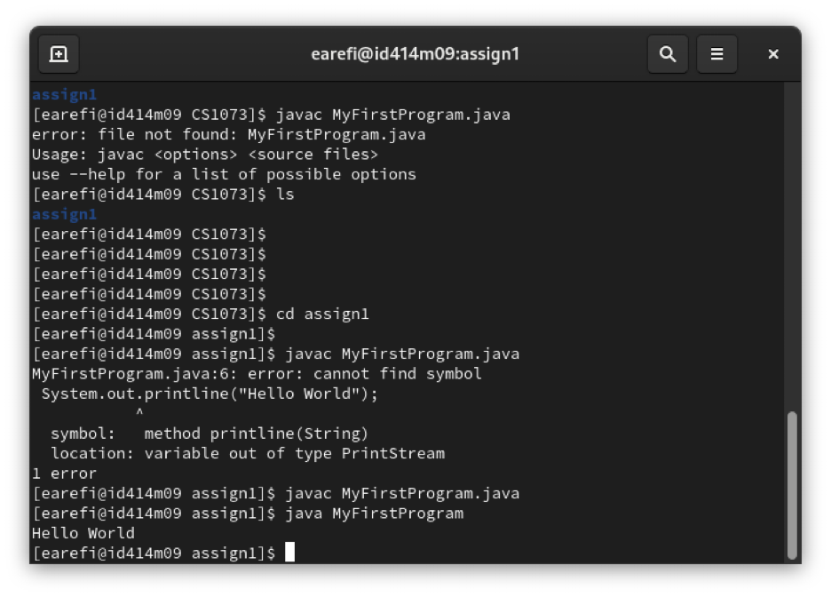

Part VI)
import java.util.Scanner;
/**
@author Ebrahim Arefi 3621326
**/
public class InputAndOutput {
public static void main(String[] args) {
Scanner sc = new Scanner(System.in);
System.out.println("My name is TOM. What is your name?");
String userInput = sc.nextLine();
System.out.println("Pleased to meet you, " + userInput);
System.out.println("In which program are you enrolled?");
String programInput = sc.nextLine();
System.out.println("Nice to meet you " + userInput + ", " + "good luck with " + programInput);
}
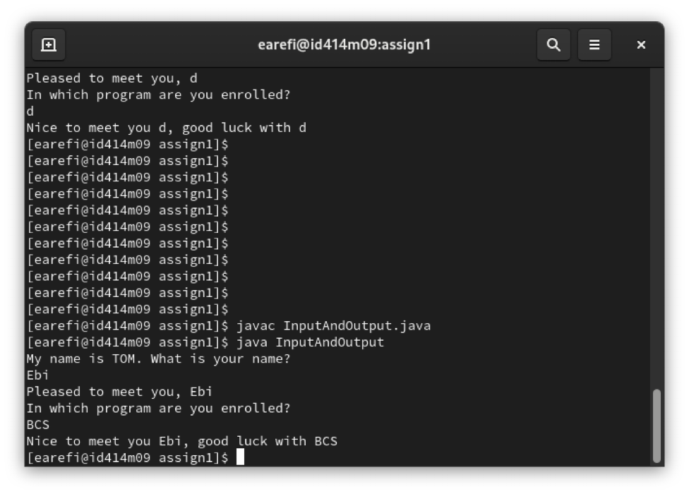
}

Part VII)
/**
@author Ebrahim Arefi 3621326
**/
public class Initials {

public static void main(String[] args) {
System.out.println("**************** *");
System.out.println("* * *");
System.out.println("* * *");
System.out.println("* * *");
System.out.println("* * *");
System.out.println("* * *");
System.out.println("* * *");
System.out.println("**************** ****************");
System.out.println("* * *");
System.out.println("* * *");
System.out.println("* * *");
System.out.println("* * *");
System.out.println("* * *");
System.out.println("* * *");
System.out.println("* * *");
System.out.println("**************** * *");
}
}

