Formative 2: Multimodal Data Preprocessing Assignment

User Identity and Product Recommendation System
Team: Divine Ifechukwude, David Akintoya, Bakhit Mahamat, Serein

Course: Software Engineering, African Leadership University

Date: July 2026

GitHub Repository: https://github.com/Ebi-Tech/Multimodal-Data-Preprocessing

System Simulation Video: https://youtu.be/gN9kRqzV0zg

1. Project Overview
This project implements a multimodal user authentication and product recommendation pipeline. A user is verified through two sequential biometric checkpoints, facial recognition and voiceprint verification, before being shown a personalized product recommendation generated from merged customer data. If either checkpoint fails, access is denied immediately and the flow stops, ensuring predictions are only surfaced to verified individuals.

The system integrates three independently trained models into a single decision pipeline:

- A product recommendation model (Random Forest) trained on merged social profile and transaction data, predicting the product category a customer is most likely to purchase.
- A facial recognition model (Random Forest) trained on augmented team member photos, identifying which team member is presenting their face or rejecting unknown individuals.
- A voiceprint verification model (Random Forest) trained on augmented team member voice recordings, verifying the speaker's identity or rejecting unknown voices.

The pipeline enforces a strict sequence: face recognition must pass before the product model runs, and voice verification must pass before the predicted product is displayed. This two-factor biometric design ensures that compromising a single modality is never sufficient to gain access.
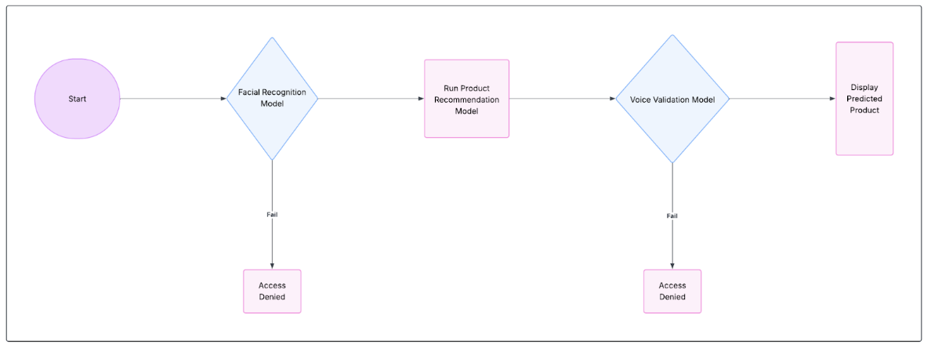

System flow diagram

2. Methodology

2.1 Data Merge and Product Recommendation Model (Task 1)
Owner: Serein

Notebook: notebooks/task1_data_merge.ipynb

Two source datasets were loaded: customer_social_profiles (155 rows, 5 columns) and customer_transactions (150 rows, 6 columns), both provided as .xlsx files.

Cleaning: 5 duplicate rows were removed from the social profiles dataset. 10 missing customer_rating values were filled with the median. Data types were verified before and after cleaning.

Aggregation: Both datasets were aggregated to one row per customer before merging. The social profiles table was collapsed using mean engagement and purchase interest scores, mode of platform and sentiment, and a count of unique platforms. The transactions table was collapsed using total spend, average and max purchase amount, average rating, and number of unique categories. The target variable (product_category) was set to each customer's most frequently purchased category.

Merge: The two ID systems were reconciled: customer_id_new ("A151") maps to customer_id_legacy (151) by extracting the numeric portion. An inner join was chosen because the supervised target only exists for customers who transacted, and predictive features only exist for customers with a social profile. Only customers present in both tables are usable for training. Post-merge shape: 61 rows. Assertions confirmed the customer key is unique and no target values are null.

Feature engineering: Three new features were created: spend_per_txn (total spend divided by transaction count), interest_x_engagement (product of purchase interest and engagement scores), and is_high_value (binary flag for customers above median total spend).

EDA: Four labeled plots were produced and interpreted:

- Distribution of total spend per customer, showing a right-skewed pattern with most customers spending under 2000.
- Standardized boxplots of all numeric features, identifying outliers in max_amount and total_spend.
- Correlation heatmap showing strong positive correlation between total_spend, avg_amount, and max_amount.
- Target balance bar chart showing Electronics as the most common category, roughly 3x more frequent than Groceries and Sports.

Model: A RandomForestClassifier (n_estimators=300, class_weight="balanced") was trained [4] via a ColumnTransformer pipeline with StandardScaler for numeric features and OneHotEncoder for categorical features. Train/test split: 80/20.

Results: Accuracy 0.4375, weighted F1 0.373, log-loss 1.54 on a 16-row test set. The majority baseline accuracy was 0.3125, so the model outperforms random guessing but is limited by the small dataset size (61 rows across 5 product classes). The confusion matrix showed reasonable recall for Electronics but poor performance on rare classes like Groceries and Sports.

The trained pipeline was saved to models/product_recommender.pkl and exposed for CLI use via scripts/predict_product.py.

2.2 Image Pipeline and Facial Recognition Model (Task 2)
Owner: David

Notebook: notebooks/B_image_face_model.ipynb

Each team member contributed three facial photos: neutral, smiling, and surprised expressions. All 12 photos (4 members x 3 expressions) were loaded and displayed in a 4x3 grid. One unauthorized photo of a person outside the team was also collected for the deny-path test.

Face detection: A Haar cascade [1] was applied to detect and crop the face region from each photo, using OpenCV [7], resizing all crops to 128x128 pixels. All 12 images had a face successfully detected. No fallback to the full frame was needed.

Train/test split: The split was done at the expression level before augmentation to prevent data leakage. For each member, one expression was held out for testing and the other two were assigned to training. This ensures that no augmented copy of a test photo appears in the training set, forcing the model to generalize to genuinely unseen expressions.

Augmentation: Four transformations were applied to each training image only: rotation by 15 degrees, horizontal flip, grayscale conversion, and Gaussian blur. This produced 8 original training images + 32 augmented = 40 training images total. The 4 test images remained unaugmented.

Feature extraction: Two feature types were concatenated per image: color histograms (32 bins per RGB channel, 96 features) capturing skin tone and color distribution, and HOG descriptors [2] (orientations=9, pixels_per_cell=16x16, cells_per_block=2x2, producing 1764 features) capturing edge and gradient patterns encoding facial structure. Total feature vector: 1860 dimensions. All features were saved to data/image_features.csv (44 rows).

Model comparison: Random Forest, SVM (RBF kernel with StandardScaler), and KNN (k=3 with StandardScaler) were tested on the same train/test split. All three achieved 1.000 accuracy and 1.000 weighted F1 on the 4-photo test set. Log-loss broke the tie: KNN 0.000, SVM 0.238, Random Forest 0.263. Random Forest was selected because a perfect score from all three models on only 4 test photos does not provide strong evidence of generalization [4], and Random Forest's continuous probability estimates support reliable threshold-based authentication gating.

Authentication gate: The held-out David_surprised.jpg was correctly identified at 0.590 confidence (above the 0.55 threshold). The unauthorized photo was correctly rejected at 0.325 confidence. The trained model was saved to models/face_recognition_model.pkl and exposed via scripts/predict_face.py.

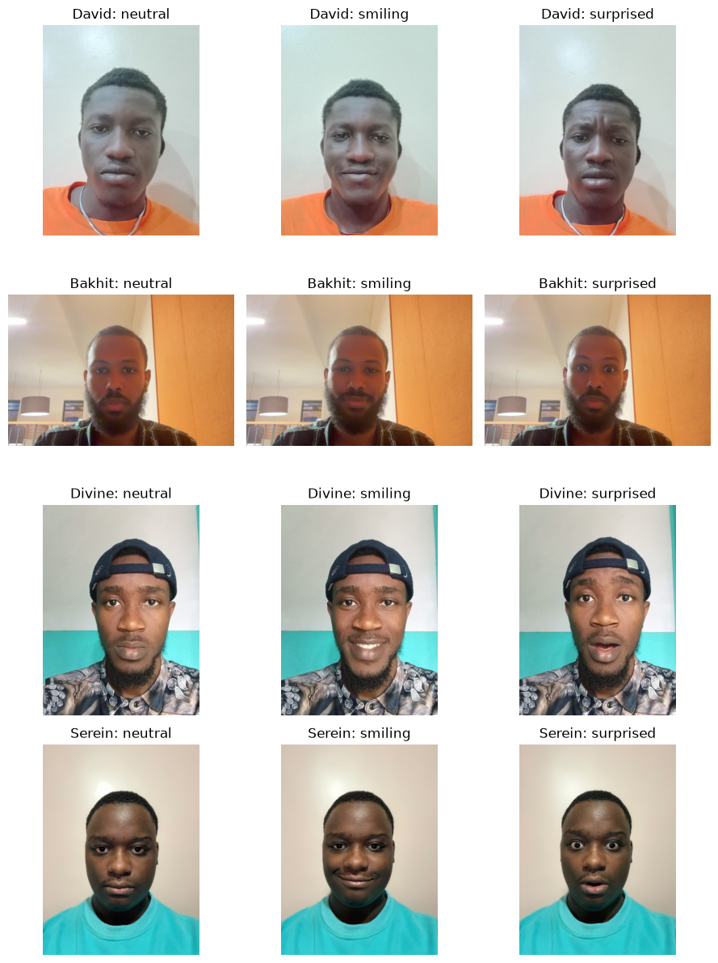
4x3 photo grid of all team members
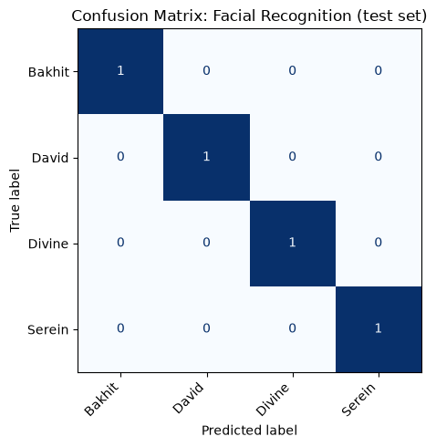

Face model confusion matrix

2.3 Audio Pipeline and Voiceprint Verification Model (Task 3)
Owner: Divine

Notebook: notebooks/C_audio_voice_model.ipynb

Each team member recorded voice clips: David (4 clips), Bakhit (4 clips), Divine (3 clips), Serein (3 clips), totalling 14 recordings. Initial recordings used the phrases "Yes, approve" and "Confirm transaction." Additional clips collected to expand the training set used varied phrases, which strengthens the model since the voiceprint classifier identifies who is speaking, not what is said, and varied content prevents the model from relying on phoneme patterns instead of voice identity. Two stranger clips were collected from a person outside the team for the unauthorized demo.

Visualization: All 14 clips were loaded and displayed as waveforms and mel spectrograms in 4x4 grids, with dedicated interpretation for each. Bakhit's clips 3 and 4 showed a distinctive two-burst structure with a silent gap between phrases. David4 was the loudest clip at a peak amplitude near 1.0. Divine's clips were consistently the quietest in the set.

Preprocessing: Two steps were applied before feature extraction. Silence trimming (librosa.effects.trim, top_db=20) [5] removed leading, trailing, and dead-air silence so features only capture actual speech. Peak normalization (dividing by max absolute amplitude) removed volume differences between members, forcing the model to learn from timbre and vocal tract shape instead of mic distance or recording volume.

Train/test split: The split was done at the clip level before augmentation. For each member, one clip was held out for testing and the rest were assigned to training, giving 10 training originals and 4 test originals. This prevents data leakage: no augmented version of a test clip appears in training.

Augmentation: Three transformations were applied to each training clip only: pitch shift by +2 semitones, time stretch by factor 1.2, and additive Gaussian noise at approximately 20dB SNR [6]. This produced 10 originals + 30 augmented = 40 training samples. The 4 test clips remained unaugmented.

Feature extraction: 15 features were extracted per sample: 13 MFCCs (mean across time) [3], spectral roll-off (mean), and RMS energy (mean). MFCCs encode vocal tract shape, spectral roll-off captures voice brightness, and RMS energy captures loudness profile. All features were saved to audio_features.csv (56 rows, including both train and test samples with a split column for transparency). Delta MFCCs (13 additional features) were also extracted and tested but did not improve model performance and were excluded from the final model.

Model comparison: Six combinations were tested: Random Forest, SVM (RBF), and KNN (k=3), each on 15 static features and 28 features (static + delta). KNN on 15 features scored highest on accuracy (0.750) and log-loss (0.477). However, KNN with k=3 can only output confidence values in steps of 0.333 (it counts how many of 3 neighbors agreed), and any 2-out-of-3 vote gives 0.667, which clears the 0.6 authentication threshold regardless of whether the prediction is correct. When tested through verify_voice(), both stranger clips were accepted at 0.667 confidence, defeating the purpose of the gate.

Random Forest on 15 static features was selected instead: it scores lower on accuracy (0.500) and F1 (0.333), but its continuous probability estimates correctly rejected both stranger clips at 0.340 and 0.365 confidence. For an authentication gate, blocking unknown voices matters more than maximizing classification accuracy.

Voice model results: Accuracy 0.500, weighted F1 0.333, log-loss 1.111 on the 4-clip test set. Bakhit and Divine's held-out clips were classified correctly. David and Serein's were misclassified. The limited accuracy is a data volume problem: with only 2-3 real training clips per member, the model cannot build strong confidence on genuinely unseen speech. The honest 50% result reflects this constraint rather than a pipeline flaw. The trained model was saved to models/voice_model.pkl and exposed via scripts/verify_voice.py.

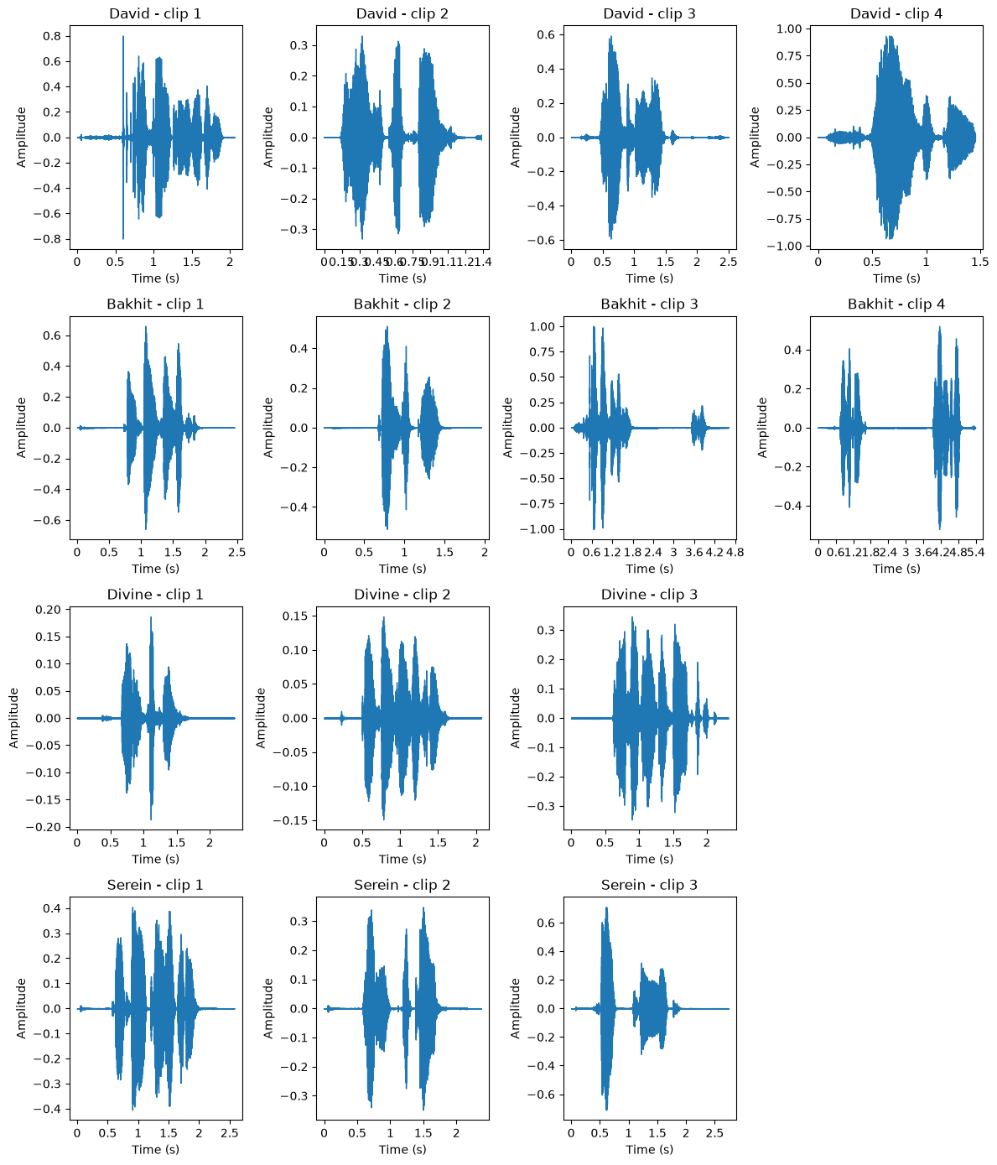
Audio waveform grid

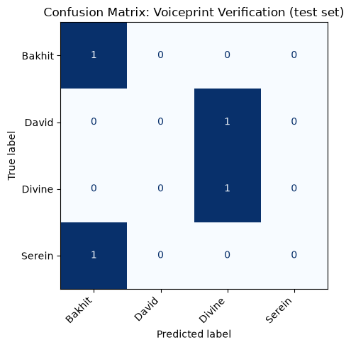
Voice model confusion matrix

2.4 System Integration and Simulation (Task 6)
Owner: Bakhit

Notebook: notebooks/D_system_simulation.ipynb

CLI Script: scripts/system_demo.py

The three models were integrated into a single sequential pipeline matching the assignment's system flow diagram. The pipeline enforces the following decision logic:

- Step 1: A face image is passed to predict_face(). If the confidence falls below 0.55, access is denied and the flow stops.
- Step 2: If the face is recognized, sample customer features are passed to predict_product() to generate a product recommendation.
- Step 3: A voice sample is passed to verify_voice(). If the confidence falls below 0.6, access is denied even though the face check passed.
- Step 4: If both biometric checks pass, the recommended product is displayed.

Bakhit was used as the authorized user in all demos because he is the only team member reliably recognized by both the face model (0.925 confidence) and the voice model (0.960 confidence).

Four simulations were run:

Simulation 1, Authorized Transaction: Bakhit's face photo passed at 0.925 confidence. The product model predicted Electronics. Bakhit's voice clip passed at 0.960 confidence. Transaction approved.

Simulation 2, Unauthorized Face Attempt: A stranger's photo was submitted. The face model returned 0.325 confidence, below the 0.55 threshold. Access denied at step 1. The product model and voice gate never ran.

Simulation 3, Unauthorized Voice Attempt: Bakhit's face passed at 0.925 confidence and the product model ran (predicting Electronics), but a stranger's voice clip was submitted. The voice model returned 0.340 confidence, below the 0.6 threshold. Access denied at step 3.

Simulation 4, Second Unauthorized Voice Attempt: Same as simulation 3 but with the second stranger clip. The voice model returned 0.365 confidence. Access denied at step 3, confirming the gate consistently rejects unknown voices.

The two-factor design proved its value: a system with only face recognition would have allowed the voice stranger through once Bakhit's photo was shown, and a system with only voice verification would have allowed the face stranger through if a valid voice clip had been paired with it.

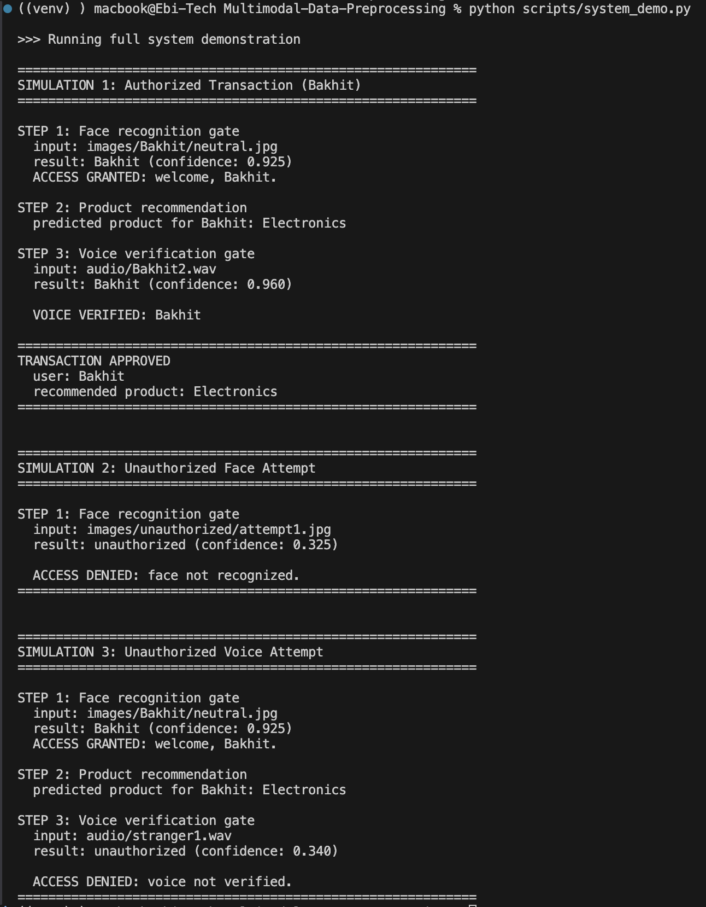

CLI output of system_demo.py showing all 3 simulations

3. Results Summary
Model | Accuracy | Weighted F1 | Log-Loss | Test Set Size
Product Recommendation (Task 1) | 0.4375 | 0.373 | 1.54 | 16
Facial Recognition (Task 2) | 1.000 | 1.000 | 0.263 | 4
Voiceprint Verification (Task 3) | 0.500 | 0.333 | 1.111 | 4

Simulation | Face Result | Voice Result | Outcome
Authorized (Bakhit) | Bakhit, 0.925 | Bakhit, 0.960 | APPROVED
Unauthorized Face | unauthorized, 0.325 | not reached | DENIED (face)
Unauthorized Voice (stranger1) | Bakhit, 0.925 | unauthorized, 0.340 | DENIED (voice)
Unauthorized Voice (stranger2) | Bakhit, 0.925 | unauthorized, 0.365 | DENIED (voice)

4. Challenges and Limitations
Small dataset sizes: The product model was trained on 61 merged rows across 5 classes, and both biometric models were evaluated on only 4 test samples each. These test sets are too small to draw strong conclusions about generalization. Cross-validation would give more robust estimates but was not used because the biometric splits needed to enforce a grouped, leak-free structure.

Voice model accuracy: At 0.500 accuracy, the voice model correctly identifies only Bakhit and Divine. David and Serein are consistently misclassified. The root cause is data volume: 2-3 real training clips per member, recorded under varying conditions (different phones, distances, background noise), do not give the model enough variation to build confident representations. A production system would need significantly more recordings per enrolled user.

Recording condition variance: The additional clips collected to expand the training set were recorded at different times, with different devices and environments. This introduced within-member variance that exceeded between-member variance for some features. Peak normalization and silence trimming mitigated this, but could not fully compensate for the underlying data quality variation.

Threshold sensitivity: The confidence thresholds (0.55 for face, 0.6 for voice) were tuned to this specific dataset. The voice threshold in particular sits in a narrow gap: Bakhit's voice passes at 0.960 while strangers sit at 0.340 and 0.365, but David's held-out clip sits at 0.375, only 0.010 above the higher stranger. A different user base or recording environment would require its own threshold calibration.

Hardcoded product features: The system simulation uses a fixed sample feature vector for the product model rather than looking up real customer data from the merged dataset. In a real deployment, the features would come from the authenticated user's actual social media profile and transaction history.

5. Team Contributions
Team Member | Task | Key Deliverables
Serein | Task 1: Data Merge + Product Recommendation Model | Merged dataset (merged_dataset.csv), EDA with 4 interpreted plots, feature engineering, trained RandomForest product model (product_recommender.pkl), predict_product() function
David | Task 2: Image Pipeline + Facial Recognition Model | 12 team photos (3 expressions each), face detection and cropping, 4 augmentations, image_features.csv (44 rows, 1860 features), trained RandomForest face model (face_recognition_model.pkl), predict_face() function
Divine | Task 3: Audio Pipeline + Voiceprint Verification Model | 14 voice recordings, waveform and spectrogram visualizations, 3 augmentations, audio_features.csv (56 rows, 15 features), 6-combination model comparison, trained RandomForest voice model (voice_model.pkl), verify_voice() function
Bakhit | Task 6: System Integration + Simulation | CLI pipeline (system_demo.py) chaining all three models, simulation notebook with 4 scenarios (1 authorized + 3 unauthorized), demo video, report

6. Deliverables
- GitHub Repository: https://github.com/Ebi-Tech/Multimodal-Data-Preprocessing
- System Simulation Video: https://youtu.be/gN9kRqzV0zg
- Notebooks: notebooks/task1_data_merge.ipynb, notebooks/B_image_face_model.ipynb, notebooks/C_audio_voice_model.ipynb, notebooks/D_system_simulation.ipynb
- CLI Script: scripts/system_demo.py
- Datasets: data/merged_dataset.csv, data/image_features.csv, audio_features.csv
- Models: models/product_recommender.pkl, models/face_recognition_model.pkl, models/voice_model.pkl

7. References
[1] P. Viola and M. Jones, "Rapid Object Detection using a Boosted Cascade of Simple Features," in Proc. IEEE Conf. Computer Vision and Pattern Recognition (CVPR), 2001, pp. 511-518.

[2] N. Dalal and B. Triggs, "Histograms of Oriented Gradients for Human Detection," in Proc. IEEE Conf. Computer Vision and Pattern Recognition (CVPR), 2005, pp. 886-893.

[3] S. Davis and P. Mermelstein, "Comparison of parametric representations for monosyllabic word recognition in continuously spoken sentences," IEEE Trans. Acoust., Speech, Signal Process., vol. 28, no. 4, pp. 357-366, 1980.

[4] L. Breiman, "Random Forests," Machine Learning, vol. 45, no. 1, pp. 5-32, 2001.

[5] B. McFee, C. Raffel, D. Liang, D. P. W. Ellis, M. McVicar, E. Battenberg, and O. Nieto, "librosa: Audio and Music Signal Analysis in Python," in Proc. 14th Python in Science Conf., 2015, pp. 18-24.

[6] J. Salamon and J. P. Bello, "Deep Convolutional Neural Networks and Data Augmentation for Environmental Sound Classification," IEEE Signal Process. Lett., vol. 24, no. 3, pp. 279-283, 2017.

[7] G. Bradski, "The OpenCV Library," Dr. Dobb's Journal of Software Tools, 2000.

