## **Mobile Access Control Survey**

Join a study to help improve mobile access control. Download the ***MithrilAC*** app from <https://mithril.online> and let us help you by going from policies like:

DON’T launch Facebook at work or school

To “please allow Facebook at work or school during lunch” in two easy steps!

**Violation annotation:** Tell us if detected violations are “True” violations or if you expected the behavior (i.e. “False violations”).

**Policy modifications:** Let us assist you in capturing your preferences through a user friendly app, MithrilAC.

Study participants are required to be at least 18 years of age. All feedback collected will be completely **anonymous** and contains **no personally identifiable information**.

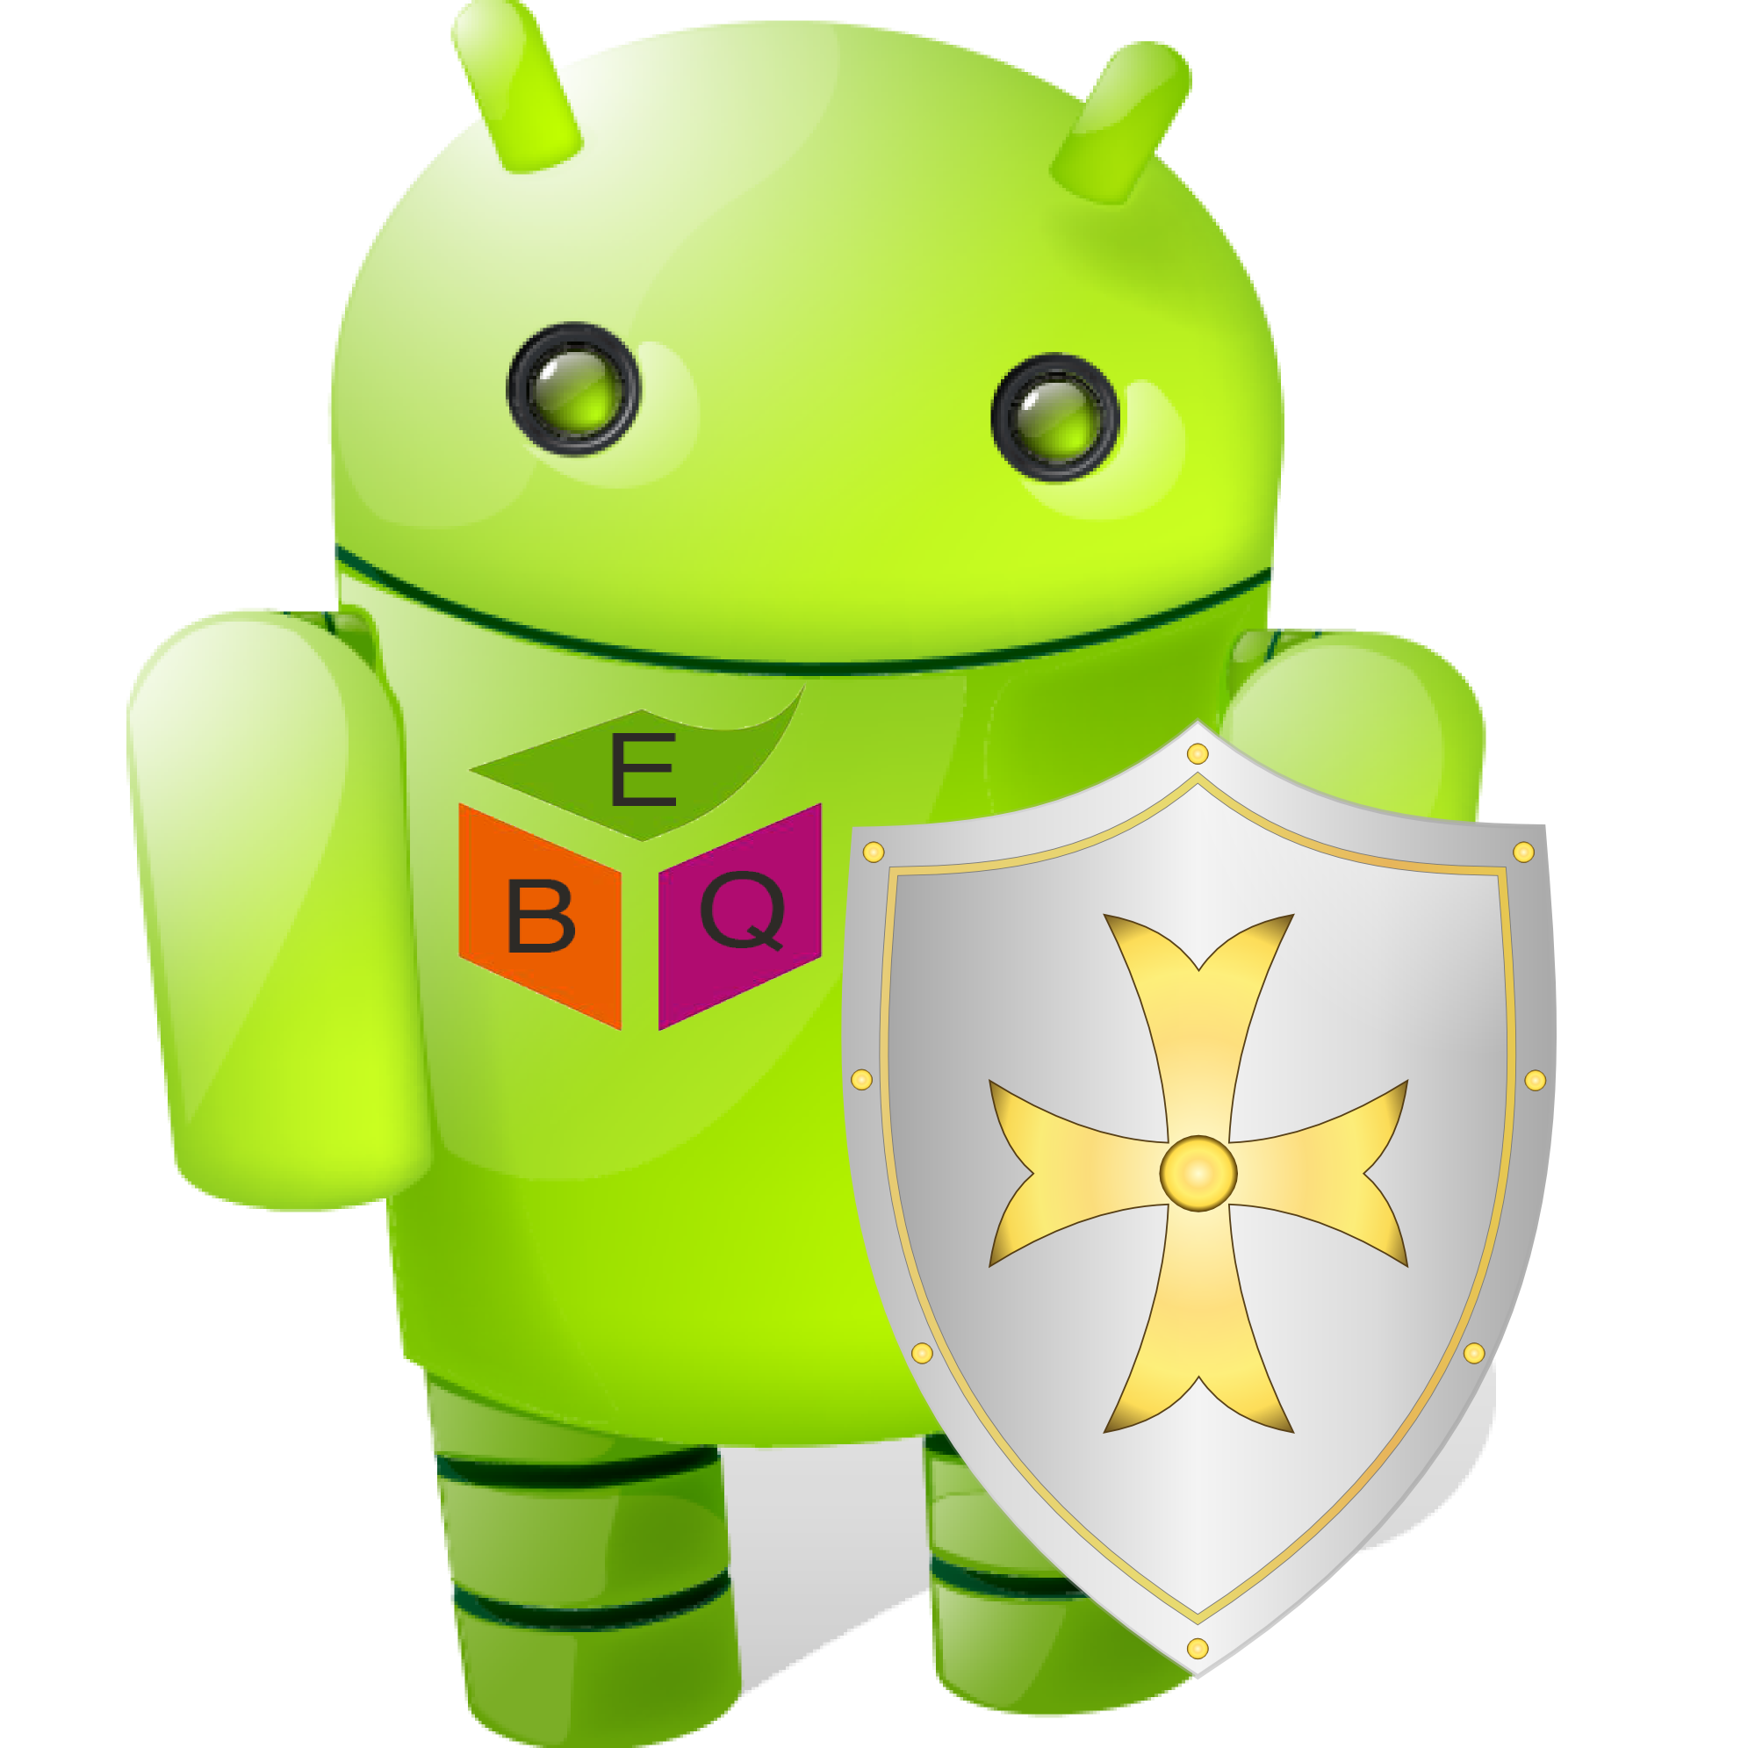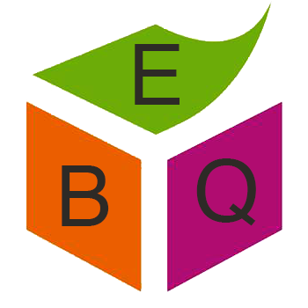

Ebiquity Research Group

Department of Computer Science and Electrical Engineering, UMBC

Contact person: Prajit Kumar Das

Email: [prajit1@umbc.edu](mailto:prajit1@umbc.edu)

Phone: (410) 455-2668

Website: <https://mithril.online>