## **Mobile Access Control Survey**

Mobile access control policy generation is a complex research domain. We intend to streamline part of the process of determination of access control policies. In this study, you will be asked to install the ***MithrilAC*** app its website @ <https://mithril.online>. The app installs an initial default privacy policy.

The goal of the study is to detect “violations” of an installed policy. An example violation would be:

Policy was: DON’T launch Facebook at work or school but it WAS launched

Here the “work or school” phrase is a policy condition. In our study, policies are defined using such conditions as location or activity etc. The app collects two categories of information:

1. **Violation annotation:** for this we will ask you, if the detected violations are “True violations” in your mind or if you consider them to be non-violations (i.e. “False violations”) under certain circumstances.
2. **Required policy modifications:** for this we will request you to use the policy condition options available in our app and either add, delete or modify them. The changes should reflect your perceived circumstance under which the launch behavior should be allowed in the future. Modification to policy condition could be done by generalizing or specializing the conditions as available in the app.

The study is completely **anonymous** and feedback will contain **no personally identifiable information**. You are required to enter certain information, for the app to function properly, in the settings of the app. Such information includes your work/home locations, work hours, do-not-disturb hours etc. This information is **private** to you and thus will NEVER leave your phone.

The upload screen will allow you to upload the information collected, in the app, by explicitly clicking the upload button. Before you upload anything, you would be able to see what information will be currently uploaded, as well as, logs of previously uploaded information.

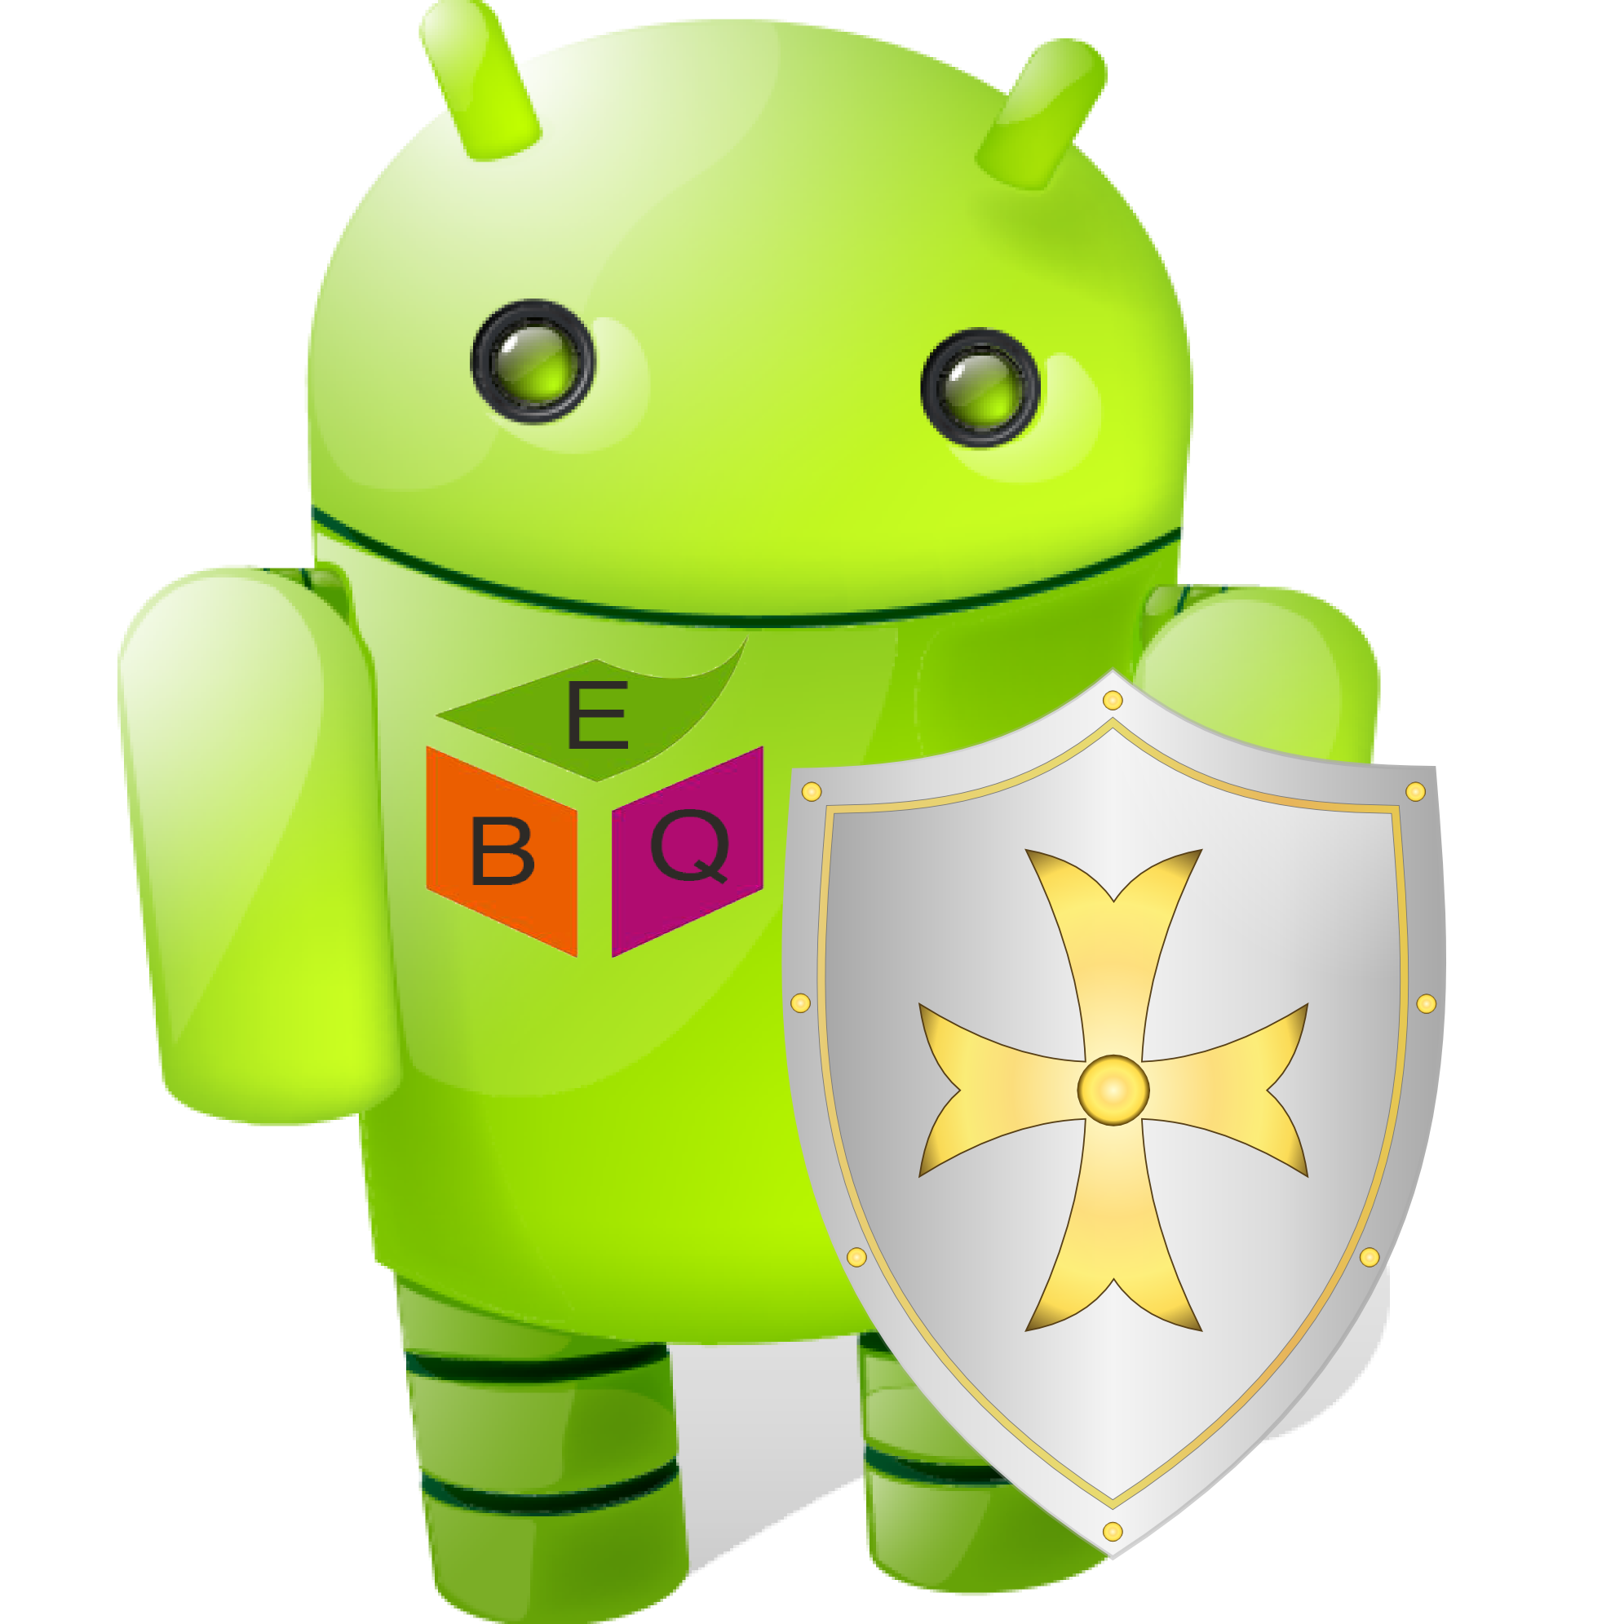

Ebiquity Research Group

Department of Computer Science and Electrical Engineering, UMBC

Contact person: Prajit Kumar Das

Email: prajit1@umbc.edu

Website: <https://mithril.online>